UNSW Sydney – School of the Built Environment
REST0010 Property Industry Application – Term 3, 2026
Assessment 2 – Market Reports (Group Assessment, 30%)
Peer Analysis of Major Listed Australian Property Asset Managers:
Charter Hall Group (CHC), Dexus (DXS) and Mirvac Group (MGR), FY21–FY26
Submission to the Board and Chief Executive Officer of Southern Cross Property Group (SCPG)
SCPG is a fictional institutional fund used to represent 'the Fund' in the assessment brief. It is not an ASX-listed entity, and all SCPG figures are hypothetical.
Group number: [insert]
Student names and zIDs: [insert]
Submission date: [insert] | Due: Sunday 8 November 2026, 23:50 (Moodle Turnitin)
Main-body word count: approx. 4,397 words (Executive Summary to Part F; excludes tables, figures, references and appendices; limit 5,000)
File name: REST0010_A2_GroupNumber_StudentFirstName_FamilyName_ZID.docx

[INSERT OFFICIAL REST0010 COVERSHEET FROM MOODLE HERE]
[INSERT UNSW ACADEMIC INTEGRITY / PLAGIARISM DECLARATION, COMPLETED AND SIGNED BY EACH GROUP MEMBER]
The brief states that assessments without the standard university plagiarism declaration will not be marked. These forms were not supplied with the drafting materials and must be added by the group before submission.

Contents

Right-click the table of contents and choose 'Update field' if page numbers do not display.

Executive Summary
This submission compares three major listed Australian property asset managers, Charter Hall Group (CHC), Dexus (DXS) and Mirvac Group (MGR), over FY21 to FY26, and recommends a group property strategy for our Fund. We refer to the Fund as Southern Cross Property Group (SCPG). SCPG is fictional: every SCPG figure in this paper is a hypothetical illustration, not company data or a forecast.
The three peers run three different models. CHC is a capital-light funds manager that owns about 3% of the $94.3bn it manages. DXS is balanced, owning $15.3bn (30%) of a $51.4bn platform. MGR is integrated, combining a $10.4bn investment portfolio with funds management and residential development.
What the evidence shows
- The 2022–24 rate shock drove almost everything. The RBA cash rate rose from 0.10% to 4.35%, cap rates widened by roughly 70–140bp, and all three groups reported statutory losses in FY24.
- The business model decided how much of that shock reached securityholders. Over the period CHC's statutory profit realised 85% of its operating earnings; DXS and MGR realised only 24% and 25%.
- Income held up better than values. Occupancy stayed above 92% throughout. Office was the weakest sector at all three groups; industrial produced the strongest rental growth.
- Financing capacity tightened. Debt ratios peaked at 35.8% (DXS) and 39.9% (MGR), DXS's average debt maturity shortened from 6.2 to 4.2 years, and the RBA lifted the cash rate again to 4.85% on 3 November 2026.
Recommendation. SCPG should adopt a capital-efficient balanced model: DXS's mix of owned and managed capital, CHC's discipline of judging performance on operating earnings, and much less development than MGR. The Board is asked to approve ten decisions (Table 14), chiefly:
- a target allocation of 35% industrial and logistics, 20% prime office, 20% convenience and net-lease retail, 12% social infrastructure, 5% living and 8% development, cutting office from 38% today;
- about 75% of platform capital managed for third parties, with co-investment capped at 25% of the balance sheet;
- balance-sheet gearing of 20–30% (breach at 35%), operating interest cover of at least 4.0x (breach below 3.0x), 70–90% of debt hedged and an average debt maturity of at least five years; and
- development capped at 10% of the balance sheet, with no speculative office and no for-sale residential.
An illustrative stress test (+50bp cap rates, +100bp funding costs, five-point occupancy fall) shows the proposed structure staying inside its gearing limits, while SCPG's current office-heavy, under-hedged structure would breach its interest-cover and liquidity limits.

1. Introduction and Approach

1.1 Purpose and peer selection
As the Fund's new Fund Manager, we were asked to benchmark the Fund against the major listed Australian property asset managers and recommend a group strategy for Board and CEO approval. We selected CHC, DXS and MGR because together they cover the three models open to SCPG: capital-light funds management, a balanced owner-manager and an integrated investor-developer. All three report on a 30 June year end, so FY21–FY26 can be compared year by year.

1.2 Data and method
The primary inputs are the three company analyses prepared for this submission, which recalculate each ratio from the groups' annual reports and results presentations (Charter Hall Group 2026; Dexus 2026a; Mirvac Group 2026a). We filled gaps in Mirvac's FY21–FY25 portfolio and debt metrics from its ASX results releases and press coverage (Mirvac Group 2021a, 2022, 2025a, 2026d; Australian Property Journal 2023) and took interest-rate data from the RBA (2026a). Every ratio was recalculated in a formula-driven workbook (supporting file). Where the sources disagree, we report the source figure and record the issue in Appendix A rather than silently correcting it.

1.3 Ratio definitions and comparability
The ratios in Parts C–E follow the formulas required by the brief (Table 1), but the three groups' accounts are not built the same way, so some comparisons need care. Four issues matter most. First, AUM and FUM measure managed capital and fee capacity, not ownership, so they cannot be compared with balance-sheet assets. Second, CHC's revenue excludes equity-accounted results and fair-value gains, so its operating and net margins can exceed 100% when valuations rise. Third, the DXS analysis uses year-end balances while CHC and MGR use averages; we recalculated DXS on averages where FY20 data were not needed. Fourth, CHC's own finance costs are small because most of its debt sits inside its funds, so statutory interest cover overstates its capacity. Table 2 shows which comparisons we treat as valid.
Table 1: Ratio definitions applied in Parts C–E
Ratio | Formula | Company-specific basis
Gross profit margin (GPM) | (Revenue – direct costs) ÷ revenue × 100 | CHC: development costs only; DXS: property expenses + development costs; MGR: development expenses + direct development costs (proxy), revenue includes other income
Operating profit margin (OPM) | Operating profit ÷ revenue × 100 | CHC and MGR: EBIT (PBT + finance costs); DXS: gross profit – management, corporate and admin costs (excludes fair-value items). DXS EBIT-basis margin shown for comparison
Net profit margin (NPM) | Statutory NPAT attributable ÷ revenue × 100 | Same for all three
Return on assets (ROA) | NPAT ÷ average total assets × 100 | DXS analysis uses year-end assets; average basis recalculated FY22–FY26
Return on equity (ROE) | NPAT ÷ average equity × 100 | As for ROA
Debt ratio | Total liabilities ÷ total assets × 100 | CHC analysis uses borrowings ÷ total assets (18.2% FY26); total-liabilities basis recalculated for comparability (25.8%)
Interest coverage ratio (ICR) | EBIT ÷ finance costs | Statutory basis for all three; supplemented by CHC look-through, DXS covenant and MGR ex-revaluation cover
Financial leverage | Average total assets ÷ average equity | DXS analysis uses year-end balances
Sources: CHC, DXS and MGR company analyses; authors' recalculation (supporting workbook).
Table 2: Comparability matrix
Metric | Status | Reason / treatment
Occupancy, WALE, WACR | Conditional | Bases differ (CHC co-investment portfolio; DXS by sector; MGR stabilised portfolio, occupancy by area). Compare direction and level, not small gaps
AUM / FUM vs balance sheet | Not comparable | Managed capital is not owned capital; owned share shown separately
WARR (weighted average IRR) | Not comparable | None of the three discloses it; CHC's 'WARR' is a rent-review rate
GPM, OPM | Not comparable for ranking | Different cost and revenue scopes; analysed for each company's trend
NPM, ROA, ROE | Conditional | Same statutory numerator; valuation gains and equity-accounted results dominate
Debt ratio (total liabilities basis) | Comparable | Harmonised for all three
Statutory ICR | Conditional | Same formula; CHC excludes fund-level interest
Company-reported gearing | Not comparable | CHC balance sheet, DXS look-through, MGR headline net-debt definitions differ
Financial leverage | Comparable (approx.) | DXS recalculated on average balances FY22–FY26
Source: authors' assessment.

2. Part A – Group and Sector Property Portfolios, FY26
Table 3 summarises the Group Portfolio metrics required by the brief, and Table 4 breaks the owned portfolios into sectors. The first thing to notice is how differently the three groups own what they manage (Figure 1b). CHC's $3.2bn of co-investment is 3.4% of its $94.3bn Group FUM, yet it produced 49% of FY26 segment EBITDA because it is a geared equity stake (Charter Hall Group 2026). DXS owns 30% of its platform, and management fees reached 47% of revenue (Dexus 2026a). MGR reports AUM of $23.7bn, FUM of $14.3bn and third-party capital of $18.1bn on separate definitions; its $10.4bn stabilised investment portfolio is the owned core (Mirvac Group 2026b).
Table 3: FY26 Group Portfolio metrics (30 June 2026)
Metric (brief item) | Charter Hall (CHC) | Dexus (DXS) | Mirvac (MGR)
B. AUM / FUM | Group FUM $94.3bn; property FUM $76.0bn | Platform FUM $51.4bn | AUM $23.7bn; FUM $14.3bn; third-party capital $18.1bn
Owned (balance sheet) | Co-investment $3.2bn (3.4% of Group FUM); total assets $3.9bn | Listed portfolio $15.3bn (30%) | Stabilised investment portfolio $10.4bn; total assets $14.9bn
C. Number of assets | n/d in analysis | 396 (platform); 175 owned investment properties | 39 direct commercial assets + 5 BTR and 34 land lease communities
D. Occupancy | Platform by sector: 95.2% (office) to 99.8% (social infrastructure) | Office 93.8% (95.7% after agreed sales); industrial 94.6% | 98.0% (by area, stabilised)
E. WALE | 8.7 years (co-investment portfolio) | Office 4.0 yrs (4.1); industrial 4.3 yrs | 5.0 years (by income)
F. WACR | 5.6% | 6.06% (office 6.22%; industrial 5.58%) | 5.78%
G. WARR (weighted average IRR) | Not disclosed. Proxy: discount rate (WADR) 7.0%; rent-review rate 3.5% | Not disclosed. Context: discount rates 5.75–10.50%; ROCE 7.2% | Not disclosed
Sources: Charter Hall Group (2026); Dexus (2026a, pp. 4–5, 35, 38–39); Mirvac Group (2026b, 2026c). n/d = not disclosed in documents used.
Table 4: FY26 Sector Property Portfolios (owned or co-invested capital)
Sector | CHC co-investment | DXS listed portfolio | MGR investment portfolio
Office | $1,299m (40.6%); WALE 7.3; WACR 6.1%; occ. 95.2% | $9.8bn (64%); WALE 4.0; WACR 6.22%; occ. 93.8% | $5.0bn (~50%); WALE 5.5; WACR 6.08%; occ. 96.2%; leasing spread –0.1%
Industrial & logistics | $459m (14.4%); WALE 8.9; WACR 5.2%; occ. 98.7% | $3.6bn (24%); WALE 4.3; WACR 5.58%; occ. 94.6%; rents 8.1% below market | $2.0bn (~20%); WALE 5.9; WACR 5.23%; occ. 99.2%; LFL NOI +10.7%; spread +33.7%
Retail | Net lease $730m (22.8%), WALE 10.5, WACR 5.0%, occ. 99.7%; convenience $188m (5.9%), WALE 4.3 | Mostly third-party ($8.9bn of $10.0bn platform retail) | $2.2bn (~22%); WALE 3.2; WACR 5.65%; occ. 99.0%; LFL NOI +4.5%
Social infrastructure / living | Social infra. $522m (16.3%); WALE 13.5; WACR 6.0%; occ. 99.8% | Healthcare, infrastructure and other mainly third-party | Living $0.8bn (~8%); BTR WACR 4.30%, land lease 5.32%
Sources: Charter Hall Group (2026), Directors' report; Dexus (2026a, pp. 38–41); Mirvac Group (2026b, pp. 13–16; 2026c). Shares are of each group's owned portfolio.
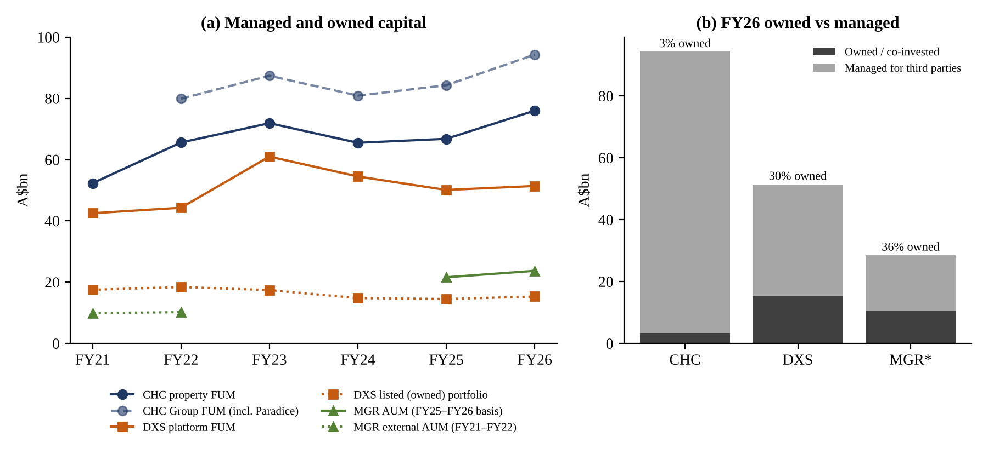
Figure 1: (a) Managed and owned capital, FY21–FY26; (b) FY26 owned versus managed capital (A$bn). *MGR shows investment portfolio against third-party capital, which Mirvac reports on separate bases. Sources: Tables 3 and 5.
On quality, all three portfolios are well let. CHC has the longest WALE (8.7 years) because of its net-lease retail and social infrastructure leases. DXS has the shortest, about four years in both main sectors, and the highest WACR (6.06%) because office dominates what it owns. MGR sits between them, with the highest stabilised occupancy (98.0%). None of the three discloses a weighted average IRR, so we use discount rates only as context and do not rank them.
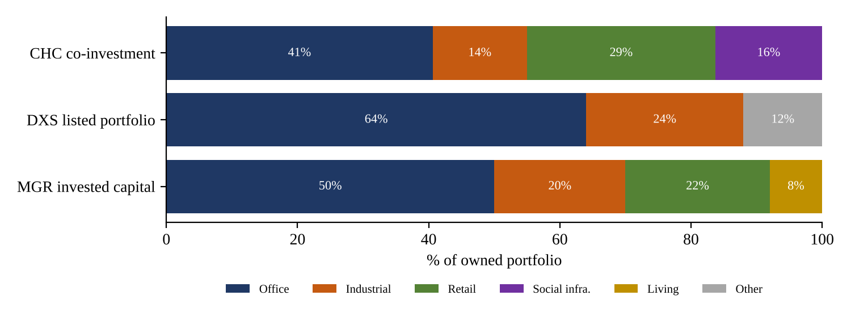
Figure 2: FY26 sector mix of owned capital (%). MGR shares are approximate. Sources: Table 4.
Figure 2 shows the key strategic difference: office is 64% of what DXS owns, about half of MGR's and 41% of CHC's co-investment. As Part B shows, that office weight explains much of the gap in their FY23–FY24 results.

3. Part B – Portfolio Comparison, FY21–FY26
This part compares how the three portfolios grew, shrank and changed shape over six years. The period falls into three phases set by interest rates: cheap money (FY21–FY22), the rate shock (FY23–FY24) and repricing and recovery (FY25–FY26). Table 5 brings the Part A metrics together year by year.
Table 5: Group and sector portfolio metrics, FY21–FY26
Metric | FY21 | FY22 | FY23 | FY24 | FY25 | FY26
Managed capital (A$bn)
CHC property FUM | 52.3 | 65.6 | 71.9 | 65.5 | 66.8 | 76.0
DXS platform FUM | 42.5 | 44.3 | 61.0 | 54.5 | 50.1 | 51.4
MGR external AUM / FUM¹ | 9.9 | 10.2 | n/d | n/d | 12.4 | 14.3
Owned portfolio (A$bn)
CHC co-investment portfolio | 2.41 | 2.92 | n/d | 2.76 | 2.70 | 3.20
DXS listed portfolio | 17.5 | 18.4 | 17.4 | 14.8 | 14.5 | 15.3
DXS third-party share of FUM | 58.8% | 58.5% | 71.5% | 72.8% | 71.1% | 70.2%
DXS number of assets (platform)² | 182 | 394 | 452 | 432 | 419 | 396
Occupancy (%)
CHC platform | n/d | n/d | n/d | 97.9 | 97.7 | 95.2–99.8³
DXS office / industrial | 95.2 / 97.7 | 95.6 / 98.1 | 95.9 / 99.4 | 94.8 / 96.8 | 92.3 / 96.2 | 93.8⁴ / 94.6
MGR investment portfolio | 97.4 | 97.3 | 96.9 | 97.0 | 98.0 | 98.0
WALE (years)
CHC co-investment portfolio | 9.1 | 8.2 | n/d | 7.2 | 7.6 | 8.7
DXS office / industrial | 4.6 / 4.4 | 4.7 / 4.7 | 4.8 / 4.8 | 4.7 / 4.3 | 4.2 / 4.5 | 4.0⁴ / 4.3
MGR investment portfolio | 5.6 | 5.6 | 5.2 | 5.3 | 5.4 | 5.0
WACR (%)
CHC co-investment portfolio | 4.9 | 4.6 | n/d | 5.7 | 5.8 | 5.6
DXS portfolio (office / industrial) | 4.91 (4.91/4.92) | 4.64 (4.75/4.29) | 5.11 (5.21/4.76) | 5.90 (6.05/5.45) | 6.03 (6.18/5.56) | 6.06 (6.22/5.58)
MGR investment portfolio | 5.14⁵ | n/d | n/d | n/d | 5.75 | 5.78
RBA cash rate, 30 June (%) | 0.10 | 0.85 | 4.10 | 4.35 | 3.85 | 4.35
Notes: ¹ FY21–FY22 external AUM; FY25–FY26 FUM; definitions differ and FY21 Group AUM was reported as 'over $25bn' including active capital. ² FY23 onwards counts assets including infrastructure. ³ Range across sectors; no aggregate disclosed. ⁴ 30 June actual; 95.7% / 4.1 years after agreed divestments. ⁵ Office only. Sources: Charter Hall Group (2025, 2026); Dexus (2021, 2022, 2023, 2024, 2025, 2026a); Mirvac Group (2021a, 2021b, 2022, 2025a, 2026b, 2026c); Australian Property Journal (2023); RBA (2026a).

3.1 Growth and contraction of managed capital
The groups grew in different ways and at different speeds (Figure 1a). CHC's property FUM rose from $52.3bn to $76.0bn, a compound 7.8% a year, while its own balance sheet grew only 3.5% a year (Charter Hall Group 2026). It dipped 8.8% in FY24 as revaluations outran new equity, then recovered on a record $6.7bn of equity inflows in FY26. DXS grew mainly by acquisition. The APN purchase lifted its asset count from 182 to 394 in FY22, and the AMP Capital platform took FUM to a $61.0bn peak in FY23. Since then FUM has fallen $9.6bn, $7.5bn of it in third-party funds, as values dropped and investors redeemed, forcing asset sales to meet withdrawals (Dexus 2026a, p. 41). MGR grew external AUM of $9.9bn in FY21 into third-party capital of $18.1bn in FY26 (a broader measure), partly by winning the management rights to the $7.7bn AMP Wholesale Office Fund after FY22 (Mirvac Group 2022).
The lesson is that scale in managed capital is not the same as resilience. CHC's FUM recovered fastest because its investors kept committing new equity. DXS's acquired FUM proved the least sticky, and its owned portfolio fell from $18.4bn to $15.3bn. Funds-management growth bought through acquisitions carries integration, redemption and governance risk, as DXS's AMP Capital and APAC experience shows (Dexus 2026a).

3.2 Capitalisation rates: how interest rates reached valuations
Cap rates are the channel through which interest rates reach property values (Chervachidze & Wheaton 2013). In FY22, with the cash rate under 1%, CHC's WACR reached a low of 4.6% and DXS's industrial cap rate fell 63bp to 4.29%. As the RBA raised the cash rate to 4.10% in FY23 and 4.35% in FY24, cap rates widened at all three: DXS by 142bp from its FY22 low to 6.06%, and CHC by 120bp to a 5.8% peak (Figure 3). Higher rates lower the present value of future rent and make investors demand a larger risk premium, so values fall even when buildings stay full (Lim et al. 2023).
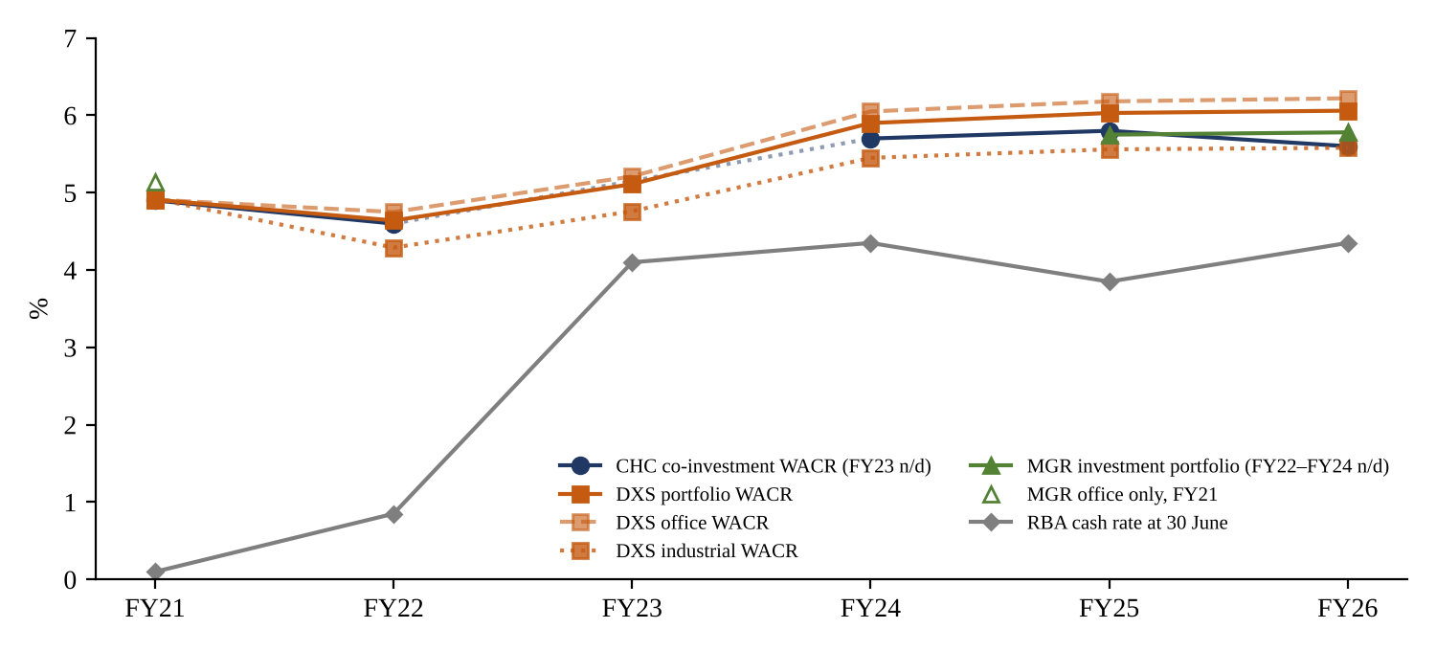
Figure 3: Weighted average capitalisation rates against the RBA cash rate, FY21–FY26 (%). Sources: Table 5.
The impact differed sharply by sector. DXS's office WACR widened 147bp (4.75% to 6.22%), more than its industrial WACR (129bp), and each 25bp on its office cap rate moves value by about $370–400m (Dexus 2026a, p. 162). CHC recorded like-for-like valuation growth of +36.5% for industrial and –5.0% for office between June 2020 and June 2025 (Charter Hall Group 2025). MGR showed the same split in FY23, with office down 5.6% and retail down 5.3% while industrial rose 6.2% (Australian Property Journal 2023). In industrial, rental growth offset cap-rate expansion; in office it did not. Since FY24 cap rates have broadly stabilised (DXS moved only 16bp across FY25–FY26), but the cash rate rose to 4.85% in November 2026 and the RBA expects inflation to stay above 3% (RBA 2026b), so a further leg of expansion cannot be ruled out.

3.3 Occupancy and lease expiry
Income proved far more stable than values (Figure 4). MGR kept occupancy between 96.9% and 98.0% across the six years, and CHC's platform stayed near 98%. DXS was the exception in office: occupancy fell to 92.3% in FY25 in a weak leasing market (national office vacancy reached 16.1% by mid-2026), before recovering through more leasing and sales of weaker buildings (Dexus 2026a, p. 38; Jones 2026). Its industrial occupancy has slipped from 99.4% to 94.6%, which shows that even the strongest sector can soften as new supply arrives.
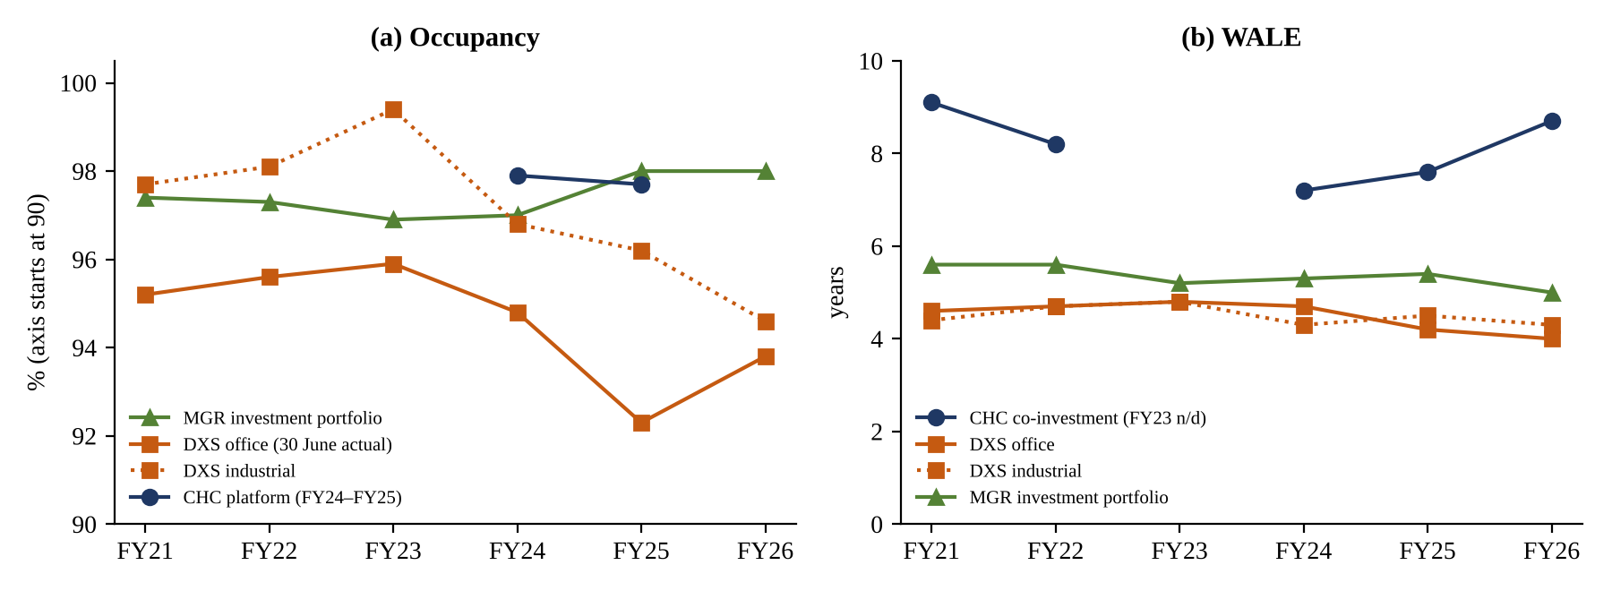
Figure 4: (a) Occupancy and (b) WALE, FY21–FY26. Occupancy axis starts at 90%. Sources: Table 5.
Lease length tells a similar story. DXS's office WALE shortened from 4.8 to 4.0 years and MGR's portfolio WALE from 5.6 to 5.0 years, so more income rolls over in a high-rate market. CHC moved the other way: its WALE fell to 7.2 years in FY24, then rebuilt to 8.7 years as it added long-lease net-lease and social infrastructure assets. A long WALE protects cash flow; it does not protect value, as CHC's FY24 loss shows.

3.4 Sector allocation and portfolio repositioning
All three groups spent FY24–FY26 reducing office. MGR cut office from 66% of invested capital in FY23 to about 50% through roughly $3bn of non-core disposals (Mirvac Group 2026b). DXS sold about $2bn of assets and now plans to cap any single sector at 50% (Dexus 2026a, p. 38). CHC's recommendation is to recycle co-investment from office into net-lease and industrial (Charter Hall Group 2026). The groups that had the most office going into the rate shock had to sell into a weak market, which crystallised losses and shrank their owned portfolios.

3.5 Why the portfolios diverged: the yield spread over cash
A simple way to link the macro cycle to these portfolios is the spread between portfolio cap rates and the cash rate. In FY22 DXS's WACR of 4.64% sat 379bp above a 0.85% cash rate, and CHC's 4.6% sat 375bp above it. Property yields therefore had plenty of room to absorb rate rises, but buyers had been pricing in cheap debt. By FY23 DXS's spread had collapsed to 101bp, and by FY24 it was 155bp (CHC 135bp) even after 110–126bp of cap-rate expansion. It recovered only modestly by FY26 (171bp for DXS, 125bp for CHC and 143bp for MGR). Measured against the current 4.85% cash rate, the FY26 spreads are just 121bp, 75bp and 93bp, close to or below the FY23 trough that preceded the largest revaluation losses.
Two implications follow. First, there is little cushion left between property yields and the cost of money, so a +50bp cap-rate shock is a realistic planning case, not a tail risk (RBA 2026b). Second, the groups that grew income fastest (CHC's long-lease and industrial co-investments, MGR's industrial book with +33.7% leasing spreads) are best placed to absorb that sensitivity through rent rather than valuation. DXS, whose office income has been flat while its office cap rate moved from 4.75% to 6.22%, has the least protection. The comparison is therefore not only about which portfolio is largest, but about which can grow rent faster than its cap rate expands.
Table 6: Comparative assessment of portfolio performance, FY21–FY26
Dimension | CHC | DXS | MGR | Main driver
Managed-capital growth | Strongest (7.8% p.a.) | Acquisition-led peak, then –16% | Steady third-party growth | Investor inflows; acquired platforms less sticky
Owned portfolio | Grew $2.4bn to $3.2bn | Shrank $17.5bn to $15.3bn | Repositioned; ~$3bn sold | Disposals to fund redemptions and cut debt
Cap-rate expansion from FY22 low | +120bp to peak | +142bp | Office 5.14% (FY21) to 6.08% | Cash rate +4.25pp; office risk premium
Occupancy | ~98%, office 95.2% | Office low of 92.3% | 96.9–98.0% | Office demand; prime quality protected
WALE trend | Lengthened to 8.7 yrs | Shortened to ~4 yrs | Shortened to 5.0 yrs | Long-lease acquisitions vs roll-off
Office exposure FY26 | 40.6% | 64% | ~50% | Legacy allocation; pace of recycling
Source: Tables 3–5; authors' analysis.
Overall, CHC's platform proved most resilient in growth, MGR's in occupancy, and DXS was the most exposed because it combined the highest office weight with the shortest WALE. For SCPG the transferable lesson is about mix: industrial and long-lease sectors protected both income and value, while office protected income only where it was prime.

4. Part C – Margin Ratios
Table 7 sets out the three margin ratios with each group's underlying margin, which strips out revaluations. Because the definitions differ (Table 1), we compare each group's trend rather than ranking levels.
Table 7: Margin ratios, FY21–FY26 (%)
Ratio | FY21 | FY22 | FY23 | FY24 | FY25 | FY26
Charter Hall
GPM | 63.2 | 72.8 | 77.8 | 97.4 | 99.6 | 100.0
OPM (EBIT ÷ revenue) | 85.0 | 102.1 | 40.1 | –15.8 | 82.1 | 92.6
NPM | 71.4 | 83.0 | 22.5 | –37.2 | 60.1 | 76.9
Underlying (operating earnings ÷ revenue) | 43 | 49 | 51 | 60 | 71 | 88
Dexus
GPM | 59.7 | 67.9 | 76.7 | 74.1 | 76.9 | 82.1
OPM (calculated operating profit) | 45.6 | 46.6 | 50.4 | 38.3 | 45.6 | 38.0
OPM (EBIT basis, harmonised) | 129.1 | 202.8 | –66.9 | –157.9 | 36.2 | 100.6
NPM | 112.1 | 184.8 | –88.7 | –175.5 | 14.3 | 67.9
Underlying (FFO ÷ revenue) | 70.6 | 86.7 | 87.0 | 78.0 | 71.2 | 94.3
Mirvac
GPM (proxy) | 66.0 | 58.1 | 56.2 | 36.6 | 38.4 | 47.0
OPM (EBIT proxy ÷ revenue) | 44.0 | 38.0 | –1.5 | –19.2 | 7.7 | 29.8
NPM | 37.8 | 31.9 | –8.4 | –26.5 | 2.5 | 22.0
Underlying (operating profit after tax ÷ revenue) | n/d | 21.0 | 29.4 | 18.2 | 17.4 | 16.5
Expense categories as % of revenue (authors' calculations)
CHC development costs | 36.8 | 27.2 | 22.2 | 2.6 | 0.4 | 0.0
CHC employee costs | 22.2 | 16.5 | 21.5 | 32.2 | 34.1 | 42.4
CHC finance costs (balance sheet) | 1.5 | 1.4 | 3.1 | 5.6 | 5.0 | 6.0
DXS property expenses | 16.3 | 16.3 | 16.1 | 12.9 | 13.1 | 14.8
DXS development costs | 24.1 | 15.9 | 7.2 | 13.0 | 10.0 | 3.0
DXS management, corporate & admin | 14.1 | 21.3 | 26.2 | 35.8 | 31.3 | 44.1
DXS finance costs | 13.0 | 16.2 | 20.5 | 18.8 | 22.0 | 32.9
MGR development expenses | 32.7 | 40.5 | 39.4 | 61.5 | 57.7 | 51.3
MGR finance costs | 4.7 | 3.4 | 7.7 | 6.5 | 6.6 | 6.0
FY26 worked examples: CHC NPM = 427.9 ÷ 556.7 = 76.9%; DXS GPM = (710.0 – 105.3 – 21.6) ÷ 710.0 = 82.1%; MGR OPM = (732 + 185) ÷ 3,075 = 29.8%. Underlying margins and DXS EBIT basis are authors' calculations. Sources: company analyses; Mirvac Group (2022, 2025a) and Australian Property Journal (2023) for operating profit; supporting workbook.
Gross margins reflect mix, not cost control. CHC's GPM rose to 100% because development revenue and costs disappeared from its consolidated accounts, leaving fee income with no direct cost. DXS's GPM rose from 59.7% to 82.1% for a similar reason: fees grew from 17% to 47% of revenue while development costs fell. MGR moved the other way. Development expenses grew from $779m to $1,867m in FY24 (61% of revenue), so its GPM fell from 66.0% to 36.6% and only partly recovered to 47.0%. A rising share of development work dilutes gross margins, because building and selling property has a far higher direct cost than collecting rent or fees.
Overheads are the real cost-control test. CHC's employee costs were stable at $186–192m for three years, then jumped 27% in FY26 against revenue growth of 2.2% (Charter Hall Group 2026). DXS's management, corporate and admin costs more than doubled from $143m to $323m by FY24 after the AMP Capital acquisition and stayed high as the business shrank; when performance and transaction fees fell from $76.4m to $3.4m in FY26, OPM dropped from 45.6% to 38.0%, because most overheads are fixed (Dexus 2026a, p. 156). Finance costs rose fastest of all: DXS's grew 78% to $234m even with 91% of debt hedged.
Looking across the expense categories in Table 7, each group controlled a different cost well. DXS managed its property expenses best, cutting them from 16.3% to 14.8% of revenue and holding its NOI margin between 61.5% and 69.4%. CHC removed development costs almost entirely by moving development into fair-valued co-investments. MGR's finance costs stayed near 6% of revenue, partly because its development revenue is large relative to its debt. The weak spots were also different. At CHC, employee costs rose from 22% to 42% of a shrinking revenue base. At DXS, overheads and finance costs together consumed 77% of FY26 revenue, against 27% in FY21. At MGR, development expenses absorbed more than half of revenue from FY24, which left margins exposed to construction costs and settlement timing.
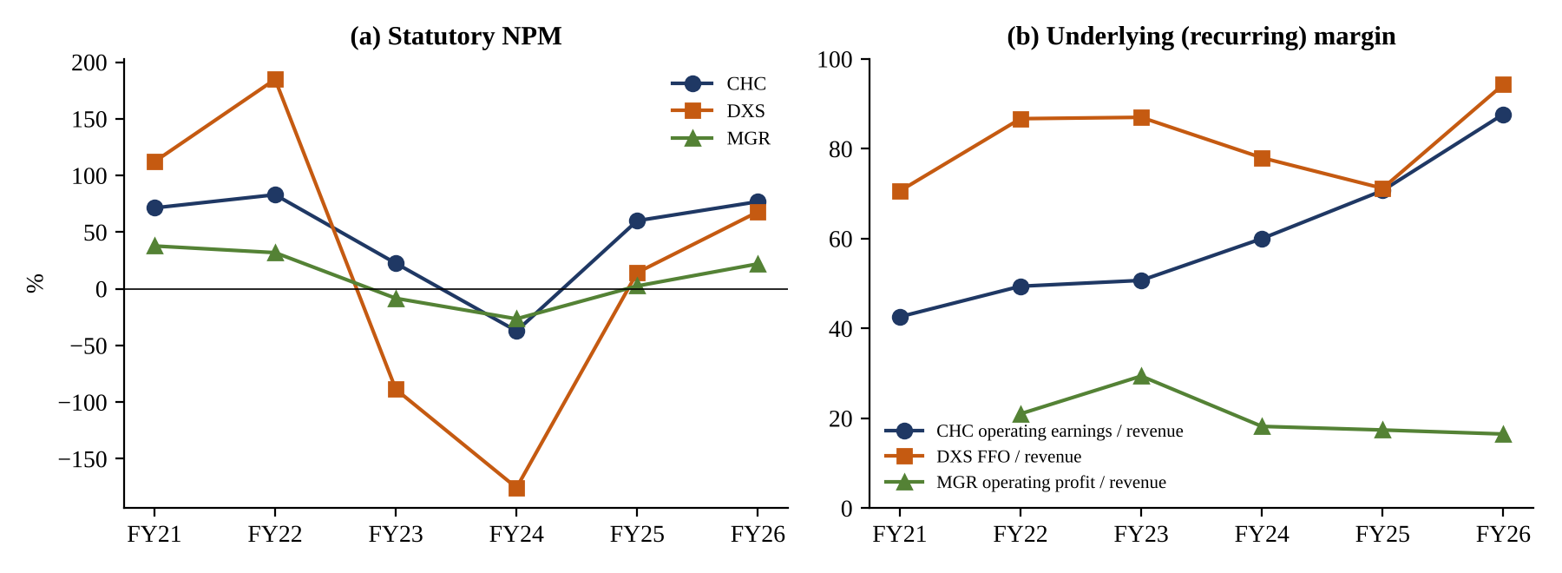
Figure 5: (a) Statutory NPM and (b) underlying margin, FY21–FY26 (%). Sources: Table 7.
Statutory margins measure valuations. NPM swung from +184.8% to –175.5% at DXS, while its FFO margin stayed between 71% and 94% (Figure 5). MGR's NPM moved from 37.8% to –26.5% and back to 22.0%, and $253m of its FY26 statutory profit of $677m came from revaluations (Mirvac Group 2026b, p. 9). The recurring margins tell a different story: CHC's improved steadily, DXS's held up, and MGR's drifted from 29.4% to 16.5% as revenue grew faster than operating profit. For SCPG, statutory NPM alone cannot show whether costs are under control.

5. Part D – Profitability
Table 8: Profitability ratios, FY21–FY26 (%)
Ratio | FY21 | FY22 | FY23 | FY24 | FY25 | FY26 | Avg.
Charter Hall
ROA | 15.8 | 24.4 | 4.7 | –5.8 | 9.4 | 11.5 | 10.0
ROE | 21.4 | 32.4 | 6.0 | –7.3 | 12.3 | 15.3 | 13.4
NPM | 71.4 | 83.0 | 22.5 | –37.2 | 60.1 | 76.9 | –
Operating-earnings ROE* | 12.8 | 19.3 | 13.6 | 11.8 | 13.9 | 17.4 | 14.8
Dexus
ROA (year-end basis) | 6.3 | 8.4 | –4.1 | –10.0 | 0.9 | 3.2 | 0.8
ROE (year-end basis) | 9.1 | 11.9 | –6.1 | –15.6 | 1.4 | 4.8 | 0.9
ROE (average basis)* | n/a | 12.4 | –5.8 | –14.1 | 1.4 | 4.9 | –
NPM | 112.1 | 184.8 | –88.7 | –175.5 | 14.3 | 67.9 | –
FFO-based ROE | 5.7 | 5.6 | 6.0 | 6.9 | 6.8 | 6.7 | 6.3
Mirvac
ROA | 5.6 | 5.5 | –1.0 | –5.0 | 0.4 | 4.5 | 1.7
ROE | 8.4 | 8.3 | –1.5 | –8.1 | 0.7 | 7.4 | 2.5
NPM | 37.8 | 31.9 | –8.4 | –26.5 | 2.5 | 22.0 | –
* Authors' calculation. Formulas: ROA = NPAT ÷ average total assets; ROE = NPAT ÷ average equity. FY26 CHC ROE = 427.9 ÷ ((2,710.6 + 2,897.0) ÷ 2) = 15.3%. CHC FY25 uses restated FY24 opening balances; MGR FY21 uses closing balances only (Appendix A). Averages are simple six-year means. Sources: company analyses; supporting workbook.
The common driver was valuation, not operations. All three groups' ROE peaked in FY22 and turned negative in FY24, the year cap rates peaked. DXS booked revaluation losses of $1,175m in FY23 and $1,634m in FY24; MGR lost $816m on revaluations and $237m on joint ventures in FY24; CHC's share of equity-accounted results swung from +$545m in FY22 to –$350m in FY24. A DuPont breakdown confirms that NPM drove the swings: financial leverage barely moved, and asset turnover changed far less than NPM (Penman 2013).
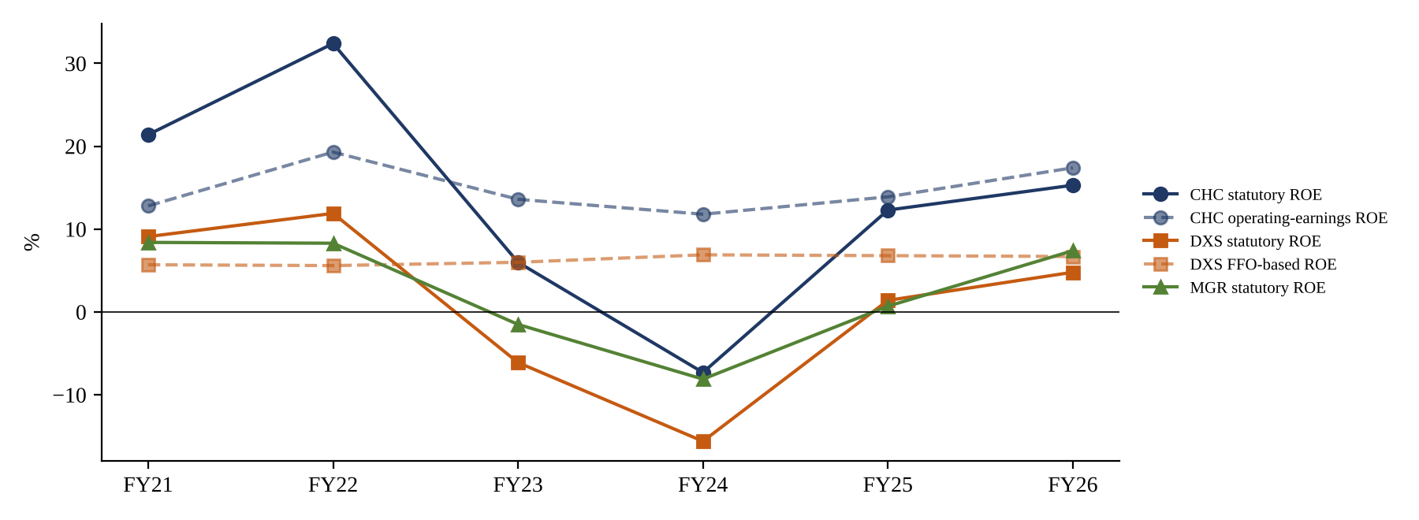
Figure 6: Statutory and underlying ROE, FY21–FY26 (%). Sources: Table 8.
The business model determined how big the swings were. CHC's ROE never fell below –7.3% and averaged 13.4%, because most of its earnings are fees on capital it does not own. Its operating-earnings ROE stayed between 11.8% and 19.3% throughout (Figure 6). DXS, owning more property and more office, fell furthest (–15.6%), and the loss also shrank its equity by 26.5% between FY22 and FY26, which then flattered later ratios. Its FFO-based ROE rose to 6.9% partly because equity was smaller, while FFO itself fell 11.7% from FY22 (Dexus 2026a). MGR's losses were smaller than DXS's, but its development business added a second source of volatility: residential EBIT depends on settlement timing and housing demand, and its operating profit fell from $596m in FY22 to $474m in FY25 before recovering to $508m.
Earnings quality is the clearest separator. Over the period, CHC's cumulative statutory profit equalled 85% of its cumulative operating earnings. For DXS the figure was 24% (statutory profit $1,036m against FFO $4,263m), and for MGR 25% over FY22–FY26. Underlying earnings grew 11.4% a year at CHC but fell 1.4% a year at DXS and 3.9% a year at MGR (FY22–FY26). FY26 statutory recoveries at DXS and MGR came mainly from revaluation gains, which can reverse if rates keep rising. SCPG should therefore judge profitability on recurring operating earnings, with statutory results reconciled to them (Property Council of Australia 2019).
In summary, the main reason for each group's profitability path differs. CHC's returns fell in FY23–FY24 because its geared co-investments were revalued down, and recovered as fee-earning FUM and inflows rebuilt (Parts A–B). DXS's fell furthest because its owned portfolio is office-heavy with short leases, and its recovery has been held back by rising overheads and finance costs (Part C). MGR's fell because revaluation and joint-venture losses coincided with lower-margin development, and recovered in FY26 through revaluation gains and stronger residential and commercial EBIT (Mirvac Group 2026b).

6. Part E – Financing Capacity
Table 9: Financing capacity ratios, FY21–FY26
Ratio | FY21 | FY22 | FY23 | FY24 | FY25 | FY26
Debt ratio: total liabilities ÷ total assets (%)
CHC* | 23.6 | 21.5 | 20.1 | 22.6 | 23.5 | 25.8
DXS | 30.9 | 29.3 | 33.6 | 35.8 | 35.6 | 34.5
MGR | 33.0 | 34.9 | 37.5 | 39.9 | 39.9 | 37.3
Interest coverage: statutory EBIT ÷ finance costs (x)
CHC | 57.4 | 74.8 | 13.0 | –2.8 | 16.3 | 15.5
DXS | 9.96 | 12.50 | –3.26 | –8.41 | 1.64 | 3.05
MGR | 9.34 | 11.26 | –0.20 | –2.96 | 1.17 | 4.96
Interest coverage: alternative basis (x)
CHC look-through operating | 43.0 | 57.5 | 8.2 | 5.5 | 5.3 | 5.9
DXS covenant | 5.1 | 6.0 | 4.4 | 4.3 | 4.4 | 4.3
MGR excluding revaluation* | – | – | – | – | – | 3.6
Financial leverage: average assets ÷ average equity (x)
CHC | 1.36 | 1.33 | 1.27 | 1.27 | 1.31 | 1.33
DXS (year-end basis) | 1.45 | 1.41 | 1.51 | 1.56 | 1.55 | 1.53
MGR | 1.49 | 1.52 | 1.57 | 1.63 | 1.66 | 1.63
Company-reported gearing (%) – definitions differ
CHC balance sheet | 5.0 | 0.0 | 2.2 | 3.0 | 6.0 | 14.2
DXS look-through (target 30–40%) | 26.7 | 26.9 | 30.3 | 32.6 | 31.7 | 33.4
MGR headline (target 20–30%) | n/d | n/d | n/d | 26.7 | 27.6 | 24.1
* Authors' calculation: CHC debt ratio from total liabilities in the CHC analysis (the analysis itself reports borrowings ÷ total assets of 18.2% in FY26); MGR FY26 cover = (917 – 253) ÷ 185. FY26 worked example: MGR debt ratio = 5,572 ÷ 14,927 = 37.3%. Sources: company analyses; Mirvac Group (2025b); supporting workbook.
Debt ratios rose because asset values fell, not because the groups borrowed more. Between FY22 and FY24 DXS's total assets fell 17.6% while borrowings hardly moved, so its debt ratio climbed from 29.3% to 35.8% (Dexus 2026a). MGR's equity fell from about $11.1bn to $9.1bn and its debt ratio peaked at 39.9% in FY24–FY25. This is the textbook mechanism: higher rates lift required yields, lower values and raise leverage automatically, which is why highly geared A-REITs fared worst in the global financial crisis (Newell & Peng 2009; De Francesco 2007). CHC is the exception, with a debt ratio of 20–26%. Even so, its borrowings rose 47.6% to $712m in FY26, and the reasons for that increase are not disclosed.
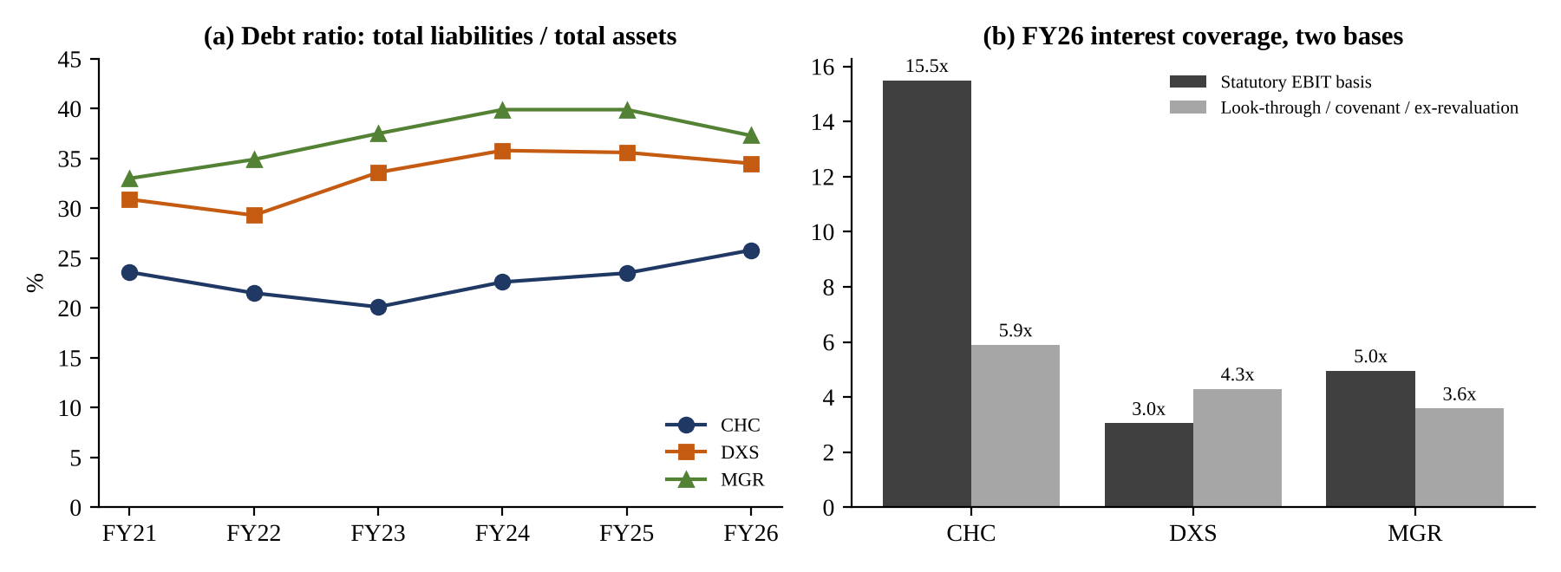
Figure 7: (a) Debt ratio, FY21–FY26; (b) FY26 interest coverage on statutory and alternative bases. Sources: Table 9.
Interest cover must be read on the right basis. Statutory ICR includes revaluations, so it turned negative for all three in FY24 even though none had trouble paying interest. On the measures lenders and managers use, the decline is real but manageable: CHC's look-through cover fell from 57.5x to 5.3x as look-through net interest rose from $13m to $115m, and DXS's covenant cover eased from 6.0x to 4.3x, still more than twice its 2.0x minimum. MGR's statutory 4.96x in FY26 falls to about 3.6x once the $253m revaluation gain is removed, the tightest of the three. CHC's statutory 15.5x is misleading on its own because most of its debt sits in its funds.
Table 10: Debt profile and refinancing capacity (latest disclosed)
Metric | CHC (platform, FY25) | DXS (FY26) | MGR (FY26)
Average cost of debt | 4.5% | 4.8% (2.7% in FY22) | 5.7% (5.4% in FY25)
Debt hedged | 57% | 91% incl. caps; 65% excl. caps | 66% (57% in FY25)
Weighted average debt maturity | 3.4 years | 4.2 years (6.2 in FY21) | 4.4 years (5.0 in FY23)
Liquidity / capacity | $5.1bn undrawn (platform); $1.0bn balance sheet | $500m subordinated notes issued Dec 2025 | ~$1.6bn cash and undrawn facilities
Credit rating | Baa1 (Moody's) | A- / A3 | A- / A3
Sources: Charter Hall Group (2025); Dexus (2026a, pp. 37, 172); Mirvac Group (2026d); Australian Property Journal (2023).
Refinancing risk is now the main financing concern. Table 10 shows that maturities have shortened at all three. DXS's average debt life fell from 6.2 to 4.2 years and CHC's platform debt has only 3.4 years. Hedging explains much of the difference in cost: DXS hedged only 65% in FY22 and its cost of debt jumped from 2.7% to 3.7% the next year, while MGR, at 57–66% hedged, now pays 5.7%. With the cash rate at 4.85% after five rises in 2026 and markets pricing further increases (RBA 2026b), debt that rolls off older hedges will reprice upwards. Financing capacity is therefore adequate today at all three, but the margin for further cap-rate expansion is thinnest at MGR and DXS.
The macroeconomic link differs by model. For DXS and MGR, which own most of their assets, higher rates acted twice: values fell, which raised debt ratios, and interest costs rose, which lowered cover. For CHC the effect was largely off balance sheet, showing up in fund gearing (36.9% across the platform) and in look-through interest, not in its own debt ratio. MGR has an extra channel: residential settlements and presales depend on household borrowing capacity, so rate rises hit development cash flow just as finance costs rose. This is why MGR's interest cover excluding revaluations (3.6x) is the lowest of the three, despite headline gearing of only 24.1%.

7. Part F – Conclusions and Recommendations

7.1 What the peer evidence means for the Fund
Parts A–E point to five conclusions. (1) Recurring, fee-based and long-lease income protected securityholders; revaluation-dependent earnings did not. (2) Office concentration, not leverage alone, explains most of the FY23–FY24 damage. (3) Industrial delivered the best income growth, but at lower cap rates it is the most rate-sensitive per basis point: a 50bp expansion cuts value by 8.8% at a 5.2% cap rate against 7.4% at 6.22% (supporting workbook). (4) Debt ratios that looked comfortable at FY22 values rose 5–7 points when values fell. (5) Development added earnings at MGR but also volatility and a heavier cost base.
These lessons do not all point the same way, so we reconcile them rather than copying any one peer. CHC's 10–20% gearing suits a manager whose own balance sheet is small, but its co-investments sit in funds geared at about 37%, so look-through leverage matters more than the headline (Charter Hall Group 2025). DXS's 30–40% look-through range suits a large owner, but a repeat of its 17.6% asset fall would push 33.4% gearing to about 40.5%. MGR's 20–30% headline target is the closest fit for a balanced owner-manager. SCPG should therefore combine DXS's structure, CHC's earnings discipline and MGR's sector diversification, while keeping development small.

7.2 Recommended group property strategy for SCPG
SCPG (fictional) is assumed to start as a $20bn platform: $6.0bn on balance sheet, of which 38% is office and 10% development, and $14.0bn managed for third parties. Its debt is only 60% hedged (Appendix C). We recommend that it become a capital-efficient balanced platform: around 75% of platform capital managed for third parties, a $6–6.5bn balance sheet focused on income-secure sectors, and growth funded mainly by recycling capital and raising third-party equity, not by new debt.
Table 11: Recommended sector allocation of SCPG's balance-sheet property portfolio
Sector | Current* | Target | Range | Max. | Evidence and rationale
Industrial & logistics | 24% | 35% | 30–40% | 45% | Best rental growth (MGR LFL +10.7%, spread +33.7%; CHC LFL value +36.5%); capped because of low cap rates and DXS occupancy slippage to 94.6%
Prime office | 38% | 20% | 15–25% | 30% | Highest yields and prime held up (DXS 93.8% against 16.1% market vacancy) but drove FY23–FY24 losses; prime CBD only
Convenience & net-lease retail | 18% | 20% | 15–25% | 30% | CHC net lease 99.7% occupied, WALE 10.5 yrs; MGR retail 99.0%, LFL +4.5%
Social infrastructure | 6% | 12% | 8–15% | 20% | CHC 99.8% occupied, WALE 13.5 yrs, WACR 6.0%; evidence from one peer only, so moderate weight
Living (BTR, land lease) | 4% | 5% | 0–8% | 10% | MGR living EBIT growing but yields low (4.30–5.32%); limited evidence
Development (all sectors) | 10% | 8% | 5–10% | 12% | MGR shows earnings volatility; pre-committed projects only
Total | 100% | 100%
* Current = hypothetical SCPG starting position. Concentration limits: single asset ≤7.5% of the balance-sheet portfolio; single tenant ≤10% of gross income (≤15% for government or investment-grade tenants); top ten assets ≤50%; at least four sectors above 5%. The 45% sector cap is below DXS's planned 50% because SCPG is smaller. These are proposed policy settings for Board approval.
Ownership versus funds management. We recommend that third parties hold 70–80% of platform capital (75% by Year 3), against CHC's 97% and DXS's 70%. CHC shows that fee income scales without proportional equity, but also that half its EBITDA still came from geared co-investment. DXS shows that relying on performance fees and acquired mandates is fragile. SCPG should therefore co-invest 5–20% in each fund, cap total co-investment at 25% of its balance sheet, limit sponsored-fund gearing to 35% (target 30%), and launch a fund only with at least $500m of commitments from two or more third-party investors.
Acquisitions and disposals. SCPG should buy stabilised assets with occupancy of at least 95% and sector-appropriate WALEs (at least 4 years for industrial, 5 for office, 8 for net lease and 10 for social infrastructure, giving a portfolio WALE of 6 years or more). Those thresholds sit within the peer range of 4.0–8.7 years. With industrial yielding about 5.2–5.6% and SCPG's assumed marginal floating debt cost about 6.35%, debt-funded acquisitions would currently dilute earnings. They should therefore be funded through recycling and fund equity. Return hurdles and pricing require market validation and are not set here. Assets should be sold when they are non-core, when forecast returns fall below hurdle, or when they are secondary-grade office.
Development should be capped at 10% of the balance sheet (breach at 12%) and 15% of operating EBITDA. It should require at least 70% pre-leasing (CHC 79–94%, DXS 84%), allow no speculative office and no for-sale residential on the balance sheet, carry contingency of at least 5% on fixed-price contracts (10% otherwise), and be fully funded at approval. Earnings should be managed on FFO per security, with performance fees left out of budgets, funds-management cost-to-income no higher than 50%, and employee cost growth no faster than fee revenue.

7.3 Financing and risk policy
Table 12: Proposed financial limits (consistent definitions)
Measure (definition) | Target | Warning | Breach | Peer evidence
Balance-sheet gearing: (borrowings – cash) ÷ (total tangible assets – cash) | 20–30% | 32.5% | 35% | MGR target 20–30%; DXS 17.6% asset fall lifts 30% to 36.4%
Look-through gearing (incl. share of fund debt) | ≤33% | 37.5% | 40% | CHC platform 36.9%; DXS 33.4%
Debt ratio: total liabilities ÷ total assets | ≤32% | 36% | 40% | DXS peak 35.8%; MGR peak 39.9%
Operating ICR: operating EBITDA ÷ net interest | ≥4.0x | 3.5x | 3.0x | DXS covenant 4.3x; MGR ex-revaluation 3.6x
Look-through ICR | ≥3.5x | 3.0x | 2.5x | CHC fell to 5.3x as fund interest rose
Financial leverage: average assets ÷ average equity | ≤1.45x | 1.60x | 1.70x | CHC 1.33x; DXS 1.53x; MGR 1.63x
Debt hedged (fixed and caps; ≥55% fixed excl. caps) | 70–90% | <70% | <60% | DXS 65% in FY22 preceded +100bp cost jump
Weighted average debt maturity; max. due in 12 months | ≥5.0 yrs; ≤20% | <4.5 yrs | <4.0 yrs | DXS 6.2 to 4.2 yrs; CHC platform 3.4 yrs
Liquidity coverage: (cash + undrawn) ÷ 12-month needs | ≥2.0x | 1.5x | 1.25x | MGR ~$1.6bn; CHC $1.0bn capacity
Thresholds are proposed management-policy settings derived from peer evidence; they require Board approval and validation against lender covenants. At least three funding sources, none above 50% of debt.
To test whether these limits hold up, we applied the brief's adverse scenario to SCPG's hypothetical target structure. The shock combines cap rates +50bp, funding costs +100bp, occupancy down five percentage points, third-party FUM down 10%, development profit halved and $150m of liquidity drawn to support funds (Table 13; full formulas in the supporting workbook).
Table 13: Illustrative SCPG stress test (hypothetical, one-year outcomes)
Outcome | Current – adverse | Target – base | Target – adverse (hedges in place) | Target – adverse (full repricing) | Target – adverse + $400m disposals
Change in property value | –11.2% | +1.5% | –11.4% | –11.4% | –11.4%
Operating ICR | 2.90x (breach) | 4.51x | 3.45x (warning) | 2.97x (breach) | 3.55x
Balance-sheet gearing | 32.6% (warning) | 25.0% | 31.1% | 31.1% | 26.0%
Look-through gearing | 38.0% (warning) | 30.9% | 37.2% | 37.2% | 33.0%
Debt ratio | 36.4% (warning) | 30.5% | 35.4% | 35.4% | 30.8%
Liquidity coverage | 0.80x (breach) | 1.99x | 1.62x | 1.62x | 1.84x
SCPG is fictional; outputs are illustrations, not forecasts. Value change = cap/(cap + 0.5%), with 50% of the NOI decline reflected in value. Growth scenario (cap rates –25bp, FUM +15%): ICR 4.96x, gearing 23.5%, capacity of about $650m to reach 30% gearing.
The results support the policy. SCPG's current structure, with 60% hedging and 38% office, breaches its interest-cover and liquidity limits in the first year. The target structure stays within every gearing and debt-ratio limit, and hedging holds interest cover in the warning band (3.45x). If the shock persisted beyond hedge expiry, cover would fall just below 3.0x. For that reason the Board should pre-approve a contingent disposal program of $300–500m, which restores cover to 3.55x. Risks should be reviewed quarterly against these triggers, alongside tenant concentration, development cost and delay, investor redemptions, and due diligence on any acquired platform (DXS's AMP Capital and APAC matters cost about $60m).
The Board should revisit these settings if any of three conditions arise: the cash rate falls below about 3.5% and cap-rate spreads widen (which would allow higher gearing or more development); industrial occupancy across the peers falls below 95% (which would justify a lower industrial ceiling); or third-party inflows fall for two consecutive years (which would require a slower shift to funds management).

7.4 Board decisions and implementation
Table 14 sets out the ten decisions we ask the Board to approve, in priority order. Financial-resilience decisions come first because the peers show that leverage and hedging are hardest to fix once values fall. Table 15 summarises the implementation sequence.
Table 14: Board Decision Matrix (priority order)
No. | Decision and target / limit | Evidence (CHC, DXS, MGR) | Rationale and expected benefit | Principal risk | Priority / timing | Board KPI
1 | Gearing policy: balance-sheet gearing 20–30% (warning 32.5%, breach 35%); look-through ≤33% (breach 40%); debt ratio ≤32% (breach 40%) | DXS 17.6% asset fall lifted debt ratio 29.3% to 35.8%; MGR peak 39.9%; CHC platform gearing 36.9% | From 27.5%, a DXS-scale value fall leaves gearing at about 33%, below the 35% breach | Lower ROE from less leverage | 1 – 0–6 months | Gearing on three bases vs limits
2 | Interest cover: operating ICR ≥4.0x (warning 3.5x, breach 3.0x); look-through ≥3.5x; report statutory, operating and look-through cover together | Statutory ICR negative for all three in FY24; CHC look-through 57.5x to 5.3x; DXS covenant 4.3x; MGR ex-revaluation 3.6x | Measures true debt-service capacity and triggers action before covenants bind | Lender definitions may differ | 1 – 0–6 months | ICR, three bases
3 | Hedging: 70–90% of drawn debt hedged, ≥55% fixed excluding caps, weighted hedge tenor ≥3 years | DXS hedged 65% in FY22, cost of debt then rose 2.7% to 3.7%; MGR 57–66% hedged at 5.7%; cash rate 4.85% | Holds stressed ICR at 3.45x rather than 2.97x (Table 13) | Hedge and break costs; 10–20% left unhedged for disposals | 1 – 0–6 months | % hedged; cost of debt
4 | Maturity and liquidity: average debt maturity ≥5 years; ≤20% due in any 12 months; liquidity coverage ≥2.0x; ≥3 funding sources | DXS maturity 6.2 to 4.2 yrs; CHC platform 3.4 yrs; MGR ~$1.6bn liquidity | Avoids refinancing a large share of debt at peak rates | Longer debt carries higher margins | 1 – 6–18 months | WADM; liquidity coverage
5 | Sector allocation: industrial 35%, prime office 20%, convenience/net-lease retail 20%, social infrastructure 12%, living 5%, development 8%; sector max 45%; single asset ≤7.5%; single tenant ≤10% | DXS 64% office drove FY23–FY24 losses; MGR industrial LFL +10.7%; CHC net lease/social 99.7–99.8% occupied, WALE 10.5–13.5 yrs | Higher rental growth and lower value volatility; portfolio WALE ≥6 yrs | Industrial repricing; limited evidence for social and living | 2 – 0–36 months | Weights vs ranges
6 | Office reduction and recycling: cut office from 38% to 20% via ~$1.0bn of sales and sell-downs into funds; pre-approve $300–500m contingent disposal list | DXS ~$2bn and MGR ~$3bn disposals; CHC office LFL value –5.0% vs industrial +36.5% | Funds the industrial shift without new debt; restores stressed ICR to 3.55x | Selling into a weak office market | 2 – 6–36 months | Office %; sale price vs book
7 | Business model: 70–80% of platform capital third-party (75% by Year 3); co-invest 5–20% per fund, total ≤25% of balance sheet; sponsored-fund gearing ≤35% | CHC 97% third-party but 49% of EBITDA from geared co-investment; DXS 70%, performance fees fell from $76.4m to $3.4m | Fees scale with less equity; co-investment aligns SCPG with investors | Investor inflows are cyclical (CHC FY24 dip; DXS redemptions) | 2 – 18–36 months | Third-party share; fee EBITDA share
8 | Development: ≤10% of balance sheet (breach 12%) and ≤15% of operating EBITDA; ≥70% pre-leased; no speculative office or for-sale residential; contingency ≥5% (fixed price) or ≥10%; fully funded | MGR development expenses reached 61% of revenue and GPM fell from 66.0% to 36.6%; CHC 79–94% and DXS 84% pre-leased | New prime stock and margin without settlement-driven volatility | Cost overruns and delays | 2 – 0–6 months (policy) | Development %; pre-lease %
9 | Earnings quality and costs: FFO per security as primary KPI; quarterly statutory to FFO to AFFO reconciliation; performance fees not budgeted; FM cost-to-income ≤50%; employee cost growth ≤ fee revenue growth | Statutory/underlying realisation: CHC 85%, DXS 24%, MGR 25%; CHC employee costs +27% vs revenue +2.2%; DXS overheads 44% of revenue | Focuses management on recurring income; protects margins when fees fall | Incentive design and staff retention | 3 – 0–6 months | FFO per security; cost ratios
10 | Risk and governance: quarterly stress test (+50bp cap rates, +100bp debt, –5pp occupancy); independent investment committee and due diligence for platform acquisitions; no debt-funded acquisitions while marginal debt cost exceeds initial yield | Cash rate 4.85% with further rises priced; DXS APAC/AMP matters ~$60m cost | Early warning; avoids dilutive or poorly governed deals | Model and judgement risk | 3 – 0–6 months | Stress results vs limits
Priority 1 = financial resilience; 2 = portfolio and model; 3 = earnings quality and governance. Targets are proposed policy settings derived from the peer evidence in Parts A–E; market-dependent thresholds require validation.

Table 15: Implementation roadmap
Period | Key actions | Owner | Milestone KPI
0–6 months | Adopt financial policy (Table 12); lift hedging to ≥70%; adopt the FFO reporting reconciliation; approve office sell-down and contingent disposal list | CFO / Treasury; Board | Hedging ≥70%; quarterly dashboard live
6–18 months | Sell or sell down $0.5bn of office into funds; issue 7–10-year debt to extend maturity; launch industrial partnership fund | CIO; Funds Management; Treasury | Office ≤30%; WADM ≥5 yrs; fund ≥$500m
18–36 months | Complete reweighting to target; grow third-party share to 75%; review limits annually | CEO; CIO | Allocation within ranges; ICR ≥4.0x
Source: authors' recommendation.

7.5 Final recommendation
SCPG should not copy any single peer. Copying CHC would leave it dependent on continuous fund inflows and exposed to geared co-investment. Copying DXS would repeat its office concentration and reliance on fees. Copying MGR would tie earnings to housing demand and settlement timing. The recommended strategy takes each peer's proven strength (CHC's earnings discipline, DXS's hedging and recycling, MGR's sector diversification and prime quality) and sets explicit limits against each one's demonstrated weakness. If approved, SCPG would finish the 36-month program with a smaller office book, a longer and more hedged debt profile, and earnings that rely on rent and fees rather than revaluations.

References
Australian Property Journal 2023, [Report on Mirvac Group FY23 full-year results], Australian Property Journal archive, August, viewed 7 November 2026, <https://greenstreetnews.com/?p=599077>.
Charter Hall Group 2025, Charter Hall Group 2025 full year results, results presentation, 21 August, Charter Hall Group, Sydney.
Charter Hall Group 2026, Annual report 2026, Charter Hall Group, Sydney.
Chervachidze, S & Wheaton, W 2013, 'What determined the great cap rate compression of 2000–2007, and the dramatic reversal during the 2008–2009 financial crisis?', Journal of Real Estate Finance and Economics, vol. 46, no. 2, pp. 208–231, doi:10.1007/s11146-011-9334-z.
De Francesco, AJ 2007, 'Gearing and the Australian real estate investment market', Journal of Property Investment & Finance, vol. 25, no. 6, pp. 579–602.
Dexus 2021, 2021 annual report, ASX release, 17 August, Dexus Funds Management Limited, Sydney, viewed 5 November 2026, <https://announcements.asx.com.au/asxpdf/20210817/pdf/44zcn29v3vkr72.pdf>.
Dexus 2022, 2022 annual report, ASX release, 17 August, Dexus Funds Management Limited, Sydney, viewed 5 November 2026, <https://announcements.asx.com.au/asxpdf/20220817/pdf/45cxy52vkbrsc7.pdf>.
Dexus 2023, 2023 annual report, ASX release, 16 August, Dexus Funds Management Limited, Sydney, viewed 5 November 2026, <https://announcements.asx.com.au/asxpdf/20230816/pdf/05sp4kv4zdw0dq.pdf>.
Dexus 2024, 2024 annual report, ASX release, 20 August, Dexus Funds Management Limited, Sydney, viewed 5 November 2026, <https://announcements.asx.com.au/asxpdf/20240820/pdf/066spnl40g6t48.pdf>.
Dexus 2025, 2025 annual report, 20 August, Dexus Funds Management Limited, Sydney, viewed 5 November 2026, <https://www.dexus.com/content/dam/dexus/documents/investing/sustainability-reports/2025/2025%20Dexus%20Annual%20Report%201.pdf>.
Dexus 2026a, 2026 annual report (updated), ASX release, 20 August, Dexus Funds Management Limited, Sydney, viewed 5 November 2026, <https://announcements.asx.com.au/asxpdf/20260820/pdf/0730c3st7zgx2v.pdf>.
Dexus 2026b, 2026 annual results presentation and property synopsis, ASX release, 20 August, Dexus Funds Management Limited, Sydney, viewed 5 November 2026, <https://announcements.asx.com.au/asxpdf/20260820/pdf/072z666yd8gpjz.pdf>.
Jones, K 2026, 'National office vacancy rate hits 16.1% as empty space reaches post-pandemic high', commercialrealestate.com.au, 6 August, viewed 5 November 2026, <https://www.commercialrealestate.com.au/news/national-office-vacancy-rate-june-2026-property-council-1541434/>.
Lim, J, McCormick, M, Roche, S & Smith, E 2023, 'Financial stability risks from commercial real estate', Bulletin, September, Reserve Bank of Australia, viewed 5 November 2026, <https://www.rba.gov.au/publications/bulletin/2023/sep/financial-stability-risks-from-commercial-real-estate.html>.
Mirvac Group 2021a, Mirvac Group full year results – 30 June 2021, ASX release, 12 August, Mirvac Group, Sydney.
Mirvac Group 2021b, Property compendium FY21, ASX release, 12 August, Mirvac Group, Sydney, viewed 7 November 2026, <https://www.asx.com.au/asxpdf/20210812/pdf/44z7f8cf2zd725.pdf>.
Mirvac Group 2022, FY22 results, ASX release and results presentation, 11 August, Mirvac Group, Sydney.
Mirvac Group 2025a, Mirvac Group FY25 results, ASX release, 15 August, Mirvac Group, Sydney, viewed 7 November 2026, <https://announcements.asx.com.au/asxpdf/20250815/pdf/06mx3g5f1pb8ck.pdf>.
Mirvac Group 2025b, FY25 fact sheet, ASX release, 15 August, Mirvac Group, Sydney, viewed 7 November 2026, <https://announcements.asx.com.au/asxpdf/20250815/pdf/06mx5g7kv3yht0.pdf>.
Mirvac Group 2026a, Annual report 2026, ASX release, 19 August, Mirvac Group, Sydney, viewed 7 November 2026, <https://announcements.asx.com.au/asxpdf/20260819/pdf/072x0w4glcp0v8.pdf>.
Mirvac Group 2026b, FY26 results presentation, ASX release, 19 August, Mirvac Group, Sydney, viewed 7 November 2026, <https://announcements.asx.com.au/asxpdf/20260819/pdf/072x1x49frfgbt.pdf>.
Mirvac Group 2026c, FY26 additional information, ASX release, 19 August, Mirvac Group, Sydney.
Mirvac Group 2026d, Mirvac Group FY26 results, ASX release, 19 August, Mirvac Group, Sydney, viewed 7 November 2026, <https://announcements.asx.com.au/asxpdf/20260819/pdf/072x0qwnwyw9ss.pdf>.
Newell, G & Peng, HW 2009, 'The impact of the global financial crisis on A-REITs', Pacific Rim Property Research Journal, vol. 15, no. 4, pp. 453–470.
Penman, SH 2013, Financial statement analysis and security valuation, 5th edn, McGraw-Hill Education, New York.
Property Council of Australia 2019, Voluntary best practice guidelines for disclosing FFO and AFFO, version 2.1, Property Council of Australia, Sydney.
Reserve Bank of Australia (RBA) 2026a, Cash rate target, Reserve Bank of Australia, Sydney, viewed 7 November 2026, <https://www.rba.gov.au/statistics/cash-rate/>.
Reserve Bank of Australia (RBA) 2026b, Statement on Monetary Policy – November 2026: overview, Reserve Bank of Australia, Sydney, viewed 7 November 2026, <https://www.rba.gov.au/publications/smp/2026/nov/overview.html>.

Appendix A – Data Limitations and Source Discrepancies
Where sources disagree we report the source figure, explain the difference and state the treatment used. No source figure has been silently changed.
Table A1: Discrepancy and limitation register
No. | Issue | Source position | Treatment in this report
1 | CHC FY25 ROA/ROE | CHC analysis: 9.4% / 12.3% using restated FY24 opening balances after AASB 18 (original basis: 9.1% / 11.9%) | Source figures reported; operating-earnings ROE uses balances as originally issued
2 | CHC accounting changes | AASB 18 early-adopted FY25; investment-entity status from 1 July 2025 | FY25–FY26 CHC margins and returns not strictly like-for-like with FY21–FY24
3 | CHC debt ratio definition | Borrowings ÷ total assets (18.2% FY26) | Total-liabilities basis recalculated (25.8%) for comparison with DXS and MGR
4 | CHC number of assets | Not disclosed in the CHC analysis | Shown as n/d; not estimated
5 | DXS ROA/ROE basis | Year-end balances (FY26 ROE 4.8%); CHC analysis peer table quotes 4.9% | Average-basis recalculation (4.9%) reconciles the two; both shown
6 | DXS average ROE and FUM growth in CHC analysis peer table | Peer table: average ROE 1.3%, managed-capital CAGR 4.1%; DXS analysis series give 0.9% and 3.9% | DXS analysis series used; peer-table figures were taken from a reference report and not re-derived
7 | DXS OPM definition | Calculated operating profit excludes fair-value items | EBIT-basis margin added for comparability
8 | DXS FY26 office occupancy / WALE | 95.7% / 4.1 yrs after agreed divestments; 93.8% / 4.0 yrs actual | Both shown in tables; actual used in charts
9 | DXS asset count | FY23 onwards includes infrastructure assets | Trend interpreted with caution
10 | MGR managed-capital measures | AUM $23.7bn, FUM $14.3bn and third-party capital $18.1bn use different scopes (third-party capital exceeds FUM) | Reported separately; not reconciled or ranked
11 | MGR AUM history | FY21 Group AUM 'over $25bn' including active capital vs FY26 $23.7bn | Not treated as a decline; definition change
12 | MGR FY26 revaluation | MGR analysis cites $253m revaluation in FY26 profit and separately a '+$355m' revaluation change | $253m used as FY26 level; $355m appears to be the year-on-year swing
13 | MGR FY21 ratios | FY21 ROA, ROE and leverage use closing balances only | FY21 not like-for-like with FY22–FY26
14 | MGR FY22 statutory profit | $907m (analysis table) vs $906m (ASX release) | Rounding; $907m used
15 | MGR FY21–FY25 portfolio metrics | Not in MGR analysis | Sourced from Mirvac ASX releases and Australian Property Journal (2023); WACR FY22–FY24 not found (n/d)
16 | Occupancy and WALE bases | MGR occupancy by area, WALE by income; DXS by income; CHC co-investment portfolio | Compared by direction and broad level only
17 | WARR | No peer discloses a weighted average IRR; CHC's 'WARR' is a rent-review rate | Not ranked; discount rates shown as context only

Appendix B – FY26 Worked Calculations (A$m)
Table B1: FY26 substitutions for the required ratios
Ratio | CHC | DXS | MGR
GPM | (556.7 – 0.0) ÷ 556.7 = 100.0% | (710.0 – 105.3 – 21.6) ÷ 710.0 = 82.1% | (3,075 – 1,576 – 53) ÷ 3,075 = 47.0%
OPM | (482.1 + 33.3) ÷ 556.7 = 92.6% | (583.1 – 313.2) ÷ 710.0 = 38.0%; EBIT basis 714.3 ÷ 710.0 = 100.6% | (732 + 185) ÷ 3,075 = 29.8%
NPM | 427.9 ÷ 556.7 = 76.9% | 482.2 ÷ 710.0 = 67.9% | 677 ÷ 3,075 = 22.0%
ROA | 427.9 ÷ ((3,544.2 + 3,905.5) ÷ 2) = 11.5% | 482.2 ÷ 15,218.5 = 3.2% (average basis 3.2%) | 677 ÷ ((15,078 + 14,927) ÷ 2) = 4.5%
ROE | 427.9 ÷ ((2,710.6 + 2,897.0) ÷ 2) = 15.3% | 482.2 ÷ 9,969.4 = 4.8% (average basis 4.9%) | 677 ÷ ((9,055 + 9,355) ÷ 2) = 7.4%
Debt ratio | 1,008.5 ÷ 3,905.5 = 25.8% (borrowings basis 712.2 ÷ 3,905.5 = 18.2%) | 5,249.1 ÷ 15,218.5 = 34.5% | 5,572 ÷ 14,927 = 37.3%
ICR (statutory) | 515.4 ÷ 33.3 = 15.5x; look-through 696.2 ÷ 117.3 = 5.9x | 714.3 ÷ 233.9 = 3.05x; covenant 4.3x | 917 ÷ 185 = 4.96x; ex-revaluation 664 ÷ 185 = 3.6x
Financial leverage | 3,724.8 ÷ 2,803.8 = 1.33x | 15,218.5 ÷ 9,969.4 = 1.53x (average basis 1.54x) | 15,002.5 ÷ 9,205.0 = 1.63x
Sources: company analyses; supporting workbook (Peer_Ratios sheet).

Appendix C – SCPG Hypothetical Baseline and Scenario Assumptions
All figures in this appendix are hypothetical and are used only to test the proposed policy limits. They are not forecasts and must not be read as actual company data. Every calculation is formula-driven in the supporting workbook (SCPG_Assumptions, SCPG_Scenarios and SCPG_Stress sheets).
Table C1: SCPG illustrative starting position and target structure (A$m unless stated)
Item | Current (hypothetical) | Target, Year 3 (hypothetical) | Basis
Balance-sheet property portfolio | 6,000 | 6,300 | Incl. co-investment and development
Of which co-investment (equity) | 900 | 1,300 | ≤25% of balance-sheet property
Of which development | 600 (10%) | 504 (8%) | Cap 10%
Third-party FUM | 14,000 | 18,000 | Third-party share 70% to 74–75%
Borrowings / cash | 1,800 / 150 | 1,850 / 200
Hedge ratio | 60% | 80% | Policy 70–90%
Sponsored-fund gearing | 35% | 30% | Policy ≤35%
Office share of portfolio | 38% | 20% | Table 11
Stabilised WACR (calculated) | 5.75% | 5.63% | Sector cap rates anchored to FY26 peer WACRs
Balance-sheet gearing (base) | 26.2% | 25.0% | Net debt ÷ (TTA – cash)
Operating ICR (base) | 3.96x | 4.51x | Operating EBITDA ÷ net interest
Table C2: Scenario levers
Lever | Base | Adverse | Growth
Cap-rate change | 0bp | +50bp | –25bp
Occupancy change | 0pp | –5pp | +1pp
Rental growth | 3% | 0% | 5%
Third-party FUM change | +5% | –10% | +15%
Finance cost: unhedged / hedged debt | 0 / 0 | +100bp / 0 (Year 1); +100bp / +100bp (full repricing) | 0 / 0
Development profit / value | 0% / 0% | –50% / –10% | +25% / +5%
Liquidity draw for fund support | 0 | $150m | 0
Contingent disposals | 0 | $400m (contingency case only) | 0
Global assumptions: fixed hedged rate 5.10%; floating base 4.85% (RBA cash rate from 3 November 2026) plus 1.50% margin; fee margin 0.70% of third-party FUM; 50% of NOI change capitalised into value. All hypothetical.

Appendix D – Quarterly Board KPI Dashboard
Table D1: Proposed quarterly reporting framework
KPI | Definition | Limit / target | Owner
FFO per security | Statutory NPAT adjusted for revaluations, derivatives, impairments and one-offs (PCA 2019) | Primary earnings measure | CFO
Statutory-to-FFO reconciliation | Line-by-line bridge, statutory NPAT to FFO to AFFO | Reported every quarter | CFO
Gearing (balance sheet / look-through) | As Table 12 | 20–30% / ≤33% | Treasury
Operating and look-through ICR | As Table 12 | ≥4.0x / ≥3.5x | Treasury
Hedging; debt maturity; liquidity coverage | As Table 12 | 70–90%; ≥5 yrs; ≥2.0x | Treasury
Sector weights and concentration | Share of balance-sheet portfolio; top asset; top tenant | Table 11 ranges; ≤7.5%; ≤10% | CIO
Occupancy and WALE | By income, stabilised portfolio | ≥95%; ≥6 yrs | Head of Asset Management
Development exposure and pre-leasing | WIP + committed cost ÷ balance-sheet portfolio | ≤10%; ≥70% pre-leased | Head of Development
Third-party share; fund inflows | Third-party FUM ÷ platform FUM | 70–80% | Head of Funds Management
FM cost-to-income; employee cost growth | FM costs ÷ fee revenue; growth vs fee revenue | ≤50%; ≤ fee growth | COO
Stress test | +50bp cap, +100bp debt, –5pp occupancy | No breach of Table 12 limits | Chief Risk Officer

