**SSCBS**

**MAYANK CHOPRA**

**ROLLNO -23719**

**What is FOOTPRINITNG**

**Foot printing is the first step of any attack on information system in which any attacker collects information about the target network for identifying various ways to intrude in the system.**

**Types of foot printing->**

**Passive Foot Printing- gathering information about the target without direct interaction**

**Active Foot Printing- gathering information with direct interaction.**

**TOOL used – netcraft - It is a website for finding information of sub-domains.**

**Step1 – go on google -> type netcraft ->go on resources -go on resource tools**

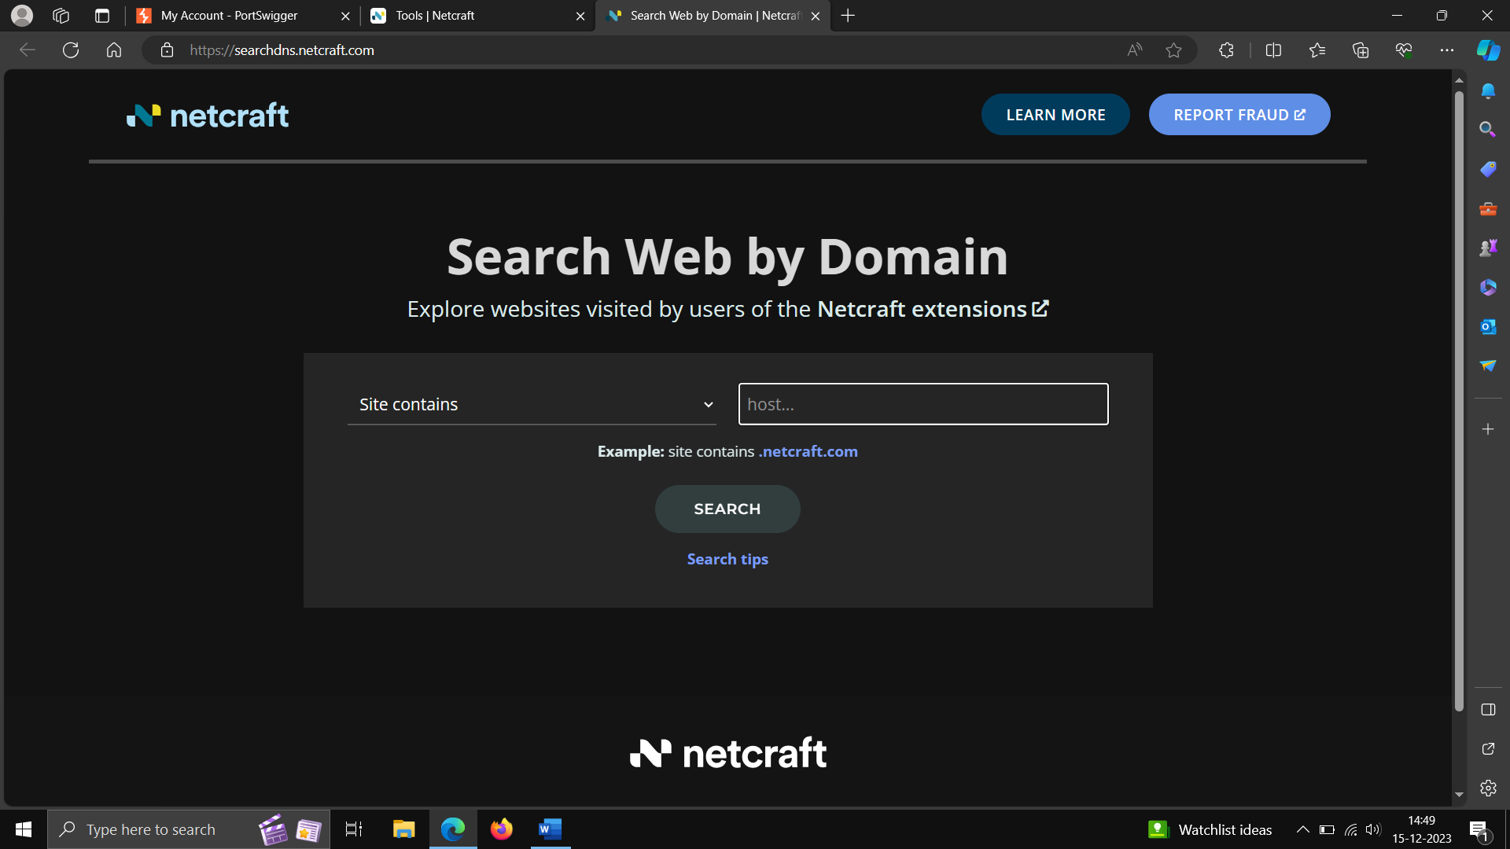

**GOOGLE HACKING DATABASE – it is used for searching and creating complex search engines in order to extract sensitive or hidden information that helps attacker to find the vulnerable targets.**

