**Test**

**Report**

| **Orange OG555 DC Motor** | |
| --- | --- |
| **Model** | **OG-555129000-20K** |
| **Speed (RPM)** | **10 RPM** |
| **Operating Voltage** | **12V DC** |

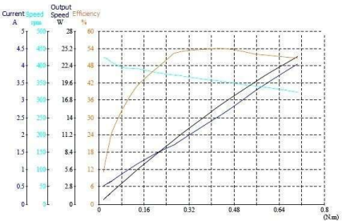

| **Specifications** | Voltage | Current | Input  Power | Torque | Speed | Output  Power | Efficiency | Time |
| --- | --- | --- | --- | --- | --- | --- | --- | --- |
| **V** | **A** | **W** | **N.cm** | **rpm** | **W** | **%** | **S** |
| **No Load** | 12.03 | 0.535 | 6.43 | 1.7 | 9.4 | 0.71 | 11 | 0 |
| **Max Efficiency Point** | 11.55 | 2.691 | 31.08 | 45.8 | 8.7 | 16.88 | 54.3 | 40.14 |
| **Max Output**  **Power Point** | 11.61 | 4.05 | 47.04 | 70.6 | 323 | 23.88 | 50.8 | 55.19 |
| **Maximum**  **Torque Point** | 11.61 | 4.05 | 47.04 | 70.6 | 323 | 23.88 | 50.8 | 55.19 |
| **End Point** | 11.61 | 4.05 | 47.04 | 70.6 | 323 | 23.88 | 50.8 | 55.19 |