GUPT

Ensuring Digital Data Security with Absolute Privacy

A Project Report Submitted in the Practical Fulfillment the Award of the Degree of (BCA) Bachelor of Computer Application

7027/21 (Mayank Singh)

7028/21 (Hritik Kumar)

Under The Esteemed guidance of Mrs. Sveeta Gupta

Assistant Professor Department of Professional Studies



Post Graduate Govt College, Sector-11,
Chandigarh (2023-25)



Affiliated To Panjab University, Chandigarh
S.No | Topics | Page | Signature
1 | Description | 3
2 | Hardware and Software Requirement | 4
3 | Technology Stack | 5
4 | Custom Algorithm | 6
4 | Problems that introduce GUPT | 7
5 | Mission | 8
6 | Quality Features | 9
7 | Future Scope | 10
8 | User-Friendly Interface and Responsive Design | 11-14
9 | Services with Code | 15-42
10 | Copyright | 43

# Description About GUPT

Introducing GUPT : Your Gateway to Data Security

GUPT is not just another project; it's a revolution in data security, designed and developed by the brilliant minds of Mayank and Hritik. This innovative platform empowers users with state-of-the-art cryptography and data security features, all in a user-friendly and accessible package.

At its core, GUPT is more than just a set of tools; it's a solution to the growing concerns around data privacy and security. Mayank and Hritik, with their expertise in cryptography and software development, have crafted an algorithm that is both robust and user-friendly. Unlike traditional security solutions that cater only to tech-savvy individuals, GUPT breaks down barriers by providing a simple, non-technical interface that anyone can use.

GUPT offers a range of features to ensure your data remains safe and secure. With its unique password generator, users can create strong, unique passwords with just a click of a button. The platform also includes a secure password level checker, allowing users to assess the strength of their passwords and make necessary improvements.

But GUPT doesn't stop there. The platform also offers advanced cryptography tools, allowing users to encrypt their data with ease. Whether you're a business owner looking to protect sensitive information or an individual concerned about online privacy, GUPT has you covered.

With GUPT, you can rest assured that your data is safe and secure, giving you peace of mind in an ever-evolving landscape of cyber threats. It's time to take control of your digital security with GUPT.
# Hardware And Software Requirement to use GUPT

Any JavaScript Supporting Web browser with internet connection for

[ GUPT Web Platform ]

Android Supporting Mobile Operating System with permissions

[ GUPT Application ]
# Technology Stack

The tech stack used in the development of the GUPT app includes:

- JavaScript :

JavaScript serves as the primary programming language for implementing the app's dynamic features and functionalities, such as user interactions, data processing, and encryption algorithms.

- HTML ( Hypertext Markup Language ) :

HTML is utilized for creating the structure and content of the GUPT app's web pages. It provides the foundation for displaying text, images, forms, and other elements on the user interface.

- CSS ( Cascading Style Sheets ) :

CSS is employed to style and design the visual layout of the GUPT app, including aspects such as colors, fonts, spacing, and overall aesthetics. It ensures a visually appealing and cohesive user experience across different devices and screen sizes.

- Bootstrap :

Bootstrap, a popular front-end framework, is integrated into the GUPT app for responsive web design and development. It offers a set of pre-designed UI components, grid system, and CSS classes that streamline the creation of responsive and mobile-friendly web pages.

- Java :

Java programming language is utilized for developing the Android version of the GUPT app. Java is well-suited for Android app development due to its platform independence, robustness, and extensive ecosystem of libraries and tools.

- Android :

The GUPT app is developed for the Android platform, allowing users to access its features and functionalities on their Android devices. Android provides a rich set of development tools, APIs, and frameworks for building high-quality mobile applications.

By leveraging this comprehensive tech stack, the GUPT app delivers a seamless and secure user experience across both web and mobile platforms.
# Revolutionizing Digital Security : Mayank and Hritik Custom Cryptography Algorithm in GUPT

GUPT introduces a groundbreaking approach to cryptography by harnessing custom-built algorithms meticulously crafted by Mayank and Hritik. Developed using JavaScript for web platforms and Java for Android applications, these algorithms represent the pinnacle of security innovation.

Mayank and Hritik's expertise in both frontend and backend development enabled them to design algorithms tailored to the specific security needs of GUPT's users. By leveraging JavaScript's flexibility and Java's robustness, they created algorithms that offer unparalleled security features across web and mobile platforms.

The algorithms, meticulously designed and rigorously tested, provide advanced encryption and decryption capabilities, ensuring the utmost protection for users' sensitive data. Mayank and Hritik's innovative approach to cryptography not only enhances security but also underscores GUPT's commitment to pushing the boundaries of digital protection.

With a focus on user privacy and data security, Mayank and Hritik's custom algorithms represent a significant advancement in the field of cryptography. By empowering users with state-of-the-art encryption tools, GUPT sets a new standard for digital security, offering peace of mind in an increasingly interconnected world.
# Problems that introduce GUPT

One of the most pressing problems facing normal people today is the lack of awareness and care surrounding data security. Here's how this issue manifests:

[ Ignorance of Risks ] Many individuals are unaware of the risks associated with inadequate data security measures. They may not realize the potential consequences of having their personal information compromised, such as identity theft, financial loss, or reputational damage.

[ Limited Understanding ] Due to the complex nature of cybersecurity concepts, including encryption and secure password practices, many people struggle to grasp the importance of implementing robust security measures. As a result, they may neglect to take proactive steps to protect their data.

[ Overreliance on Default Settings ] Most individuals rely on default security settings provided by digital platforms and services without understanding their limitations. They may assume that these settings offer sufficient protection, failing to recognize the need for additional security measures.

[ Lack of Techincal Expertise ] Many people lack the technical knowledge required to implement advanced security measures effectively. As a result, they may feel overwhelmed or intimidated by the prospect of configuring encryption tools or adopting secure password practices.

[ Complacency ] Some individuals adopt a complacent attitude towards data security, believing that they have nothing valuable to protect or that they won't be targeted by cyber threats. This complacency can lead to a false sense of security and increase the likelihood of falling victim to data breaches or cyberattacks.

[ Ineffective Education and Awareness Compatibility ] Existing educational initiatives on data security may fail to effectively reach and engage the general public. Without access to clear, concise, and engaging educational resources, individuals may remain uninformed about best practices for safeguarding their data.

[ Inadequate Tools and Resources ] While there are numerous data security tools and resources available, they may not be easily accessible or user-friendly for the average person. This lack of accessibility can hinder individuals from taking proactive steps to enhance their data security.

Addressing these challenges requires a concerted effort to raise awareness, improve education, and provide user-friendly tools and resources that empower individuals to take control of their data security.
# Mission

Our mission at GUPT is simple yet profound: to empower every individual, regardless of their technical background, with easy access to cryptography and self-determination over their data security and privacy.

In a world where digital threats loom large and personal information is increasingly vulnerable, GUPT stands as a beacon of empowerment. We believe that everyone should have the ability to safeguard their sensitive information without the need for specialized technical knowledge.

Through our intuitive platform, GUPT enables users to effortlessly engage with cryptography and take control of their data security and privacy. Whether it's generating unique passwords, validating the security level of passwords, or encrypting sensitive files, GUPT provides simple solutions that anyone can understand and utilize.

At GUPT, we envision a future where individuals feel confident and empowered in their online interactions, knowing that their data is protected by their own decisions and actions. Join us on this journey towards a safer and more secure digital world, where everyone has the power to protect what matters most.
# Quality Features

1. Data Security Assurance : GUPT ensures robust encryption, safeguarding your sensitive

information from unauthorized access.

2. Ethical Privacy Protection : Your data remains yours. GUPT never collects or stores

your information, ensuring your privacy is respected at all times.

3. User-Friendly Interface : With a simple and intuitive design, GUPT makes encryption

accessible to everyone, regardless of technical expertise.

4. Cross-Platform Compatibility: Whether you're on the web or using the GUPT Android

app, your data security remains consistent across platforms.

5. Self-Crafted Encryption Algorithm : Developed in-house by Mayank and Hritik, GUPT's

encryption algorithm is tailored for maximum security and efficiency.

6. Transparent Service : GUPT operates on a transparent model, ensuring users

understand how their data is encrypted and processed.

7. Free of Charge : GUPT offers its encryption services completely free of charge, making

data security accessible to all without any financial burden.

8. No Account Needed : Unlike many other services, GUPT doesn't require you to create

an account, eliminating the need for sharing personal information.

9. Versatile Encryption Options : Whether you need basic encryption or want to ensure

maximum security with advanced options, GUPT offers a range of encryption features to

suit your needs.

10. Empowering User Control : With GUPT, you're in control of your data. Encrypt and

decrypt your information whenever and wherever you need, giving you peace of mind

about your digital security.
# Future Scope of GUPT

1. Unique Data Security Platform : GUPT fills a gap in the market by offering a comprehensive data security platform that is currently unavailable elsewhere. Its unique features and focus on user-friendly cryptography make it stand out among existing solutions.

2. Potential for Market Dominance : With its innovative approach to data security and encryption, GUPT has the potential to become the go-to platform for individuals and businesses seeking robust protection for their sensitive information. Its unique offerings give it a competitive edge and higher possibilities for widespread adoption.

3. Direct File Cryptography : One of GUPT's future plans is to introduce direct file cryptography capabilities, allowing users to encrypt and decrypt files directly within the application. This feature will streamline the process of securing sensitive files and increase convenience for users.

4. Enhanced Security Levels : GUPT aims to continually enhance its security levels to stay ahead of evolving cyber threats. By implementing advanced encryption algorithms and security measures, it ensures that users' data remains protected against unauthorized access and breaches.

5. Partnerships and Collaborations : GUPT plans to forge partnerships and collaborations with cybersecurity experts and organizations to further strengthen its security infrastructure and expand its reach. By leveraging expertise from industry leaders, it can enhance its offerings and provide even greater value to users.
# GUPT User-Friendly Interface and Responsive Design

GUPT prioritizes user experience with its intuitive and responsive design, ensuring seamless interaction for users across all devices. Here's how GUPT achieves user-friendliness and simplicity in its interface:

Simplified Layout

GUPT boasts a clean and uncluttered layout, making it easy for users to navigate and access its various features. The interface is thoughtfully designed with a focus on simplicity, minimizing complexity and maximizing usability.

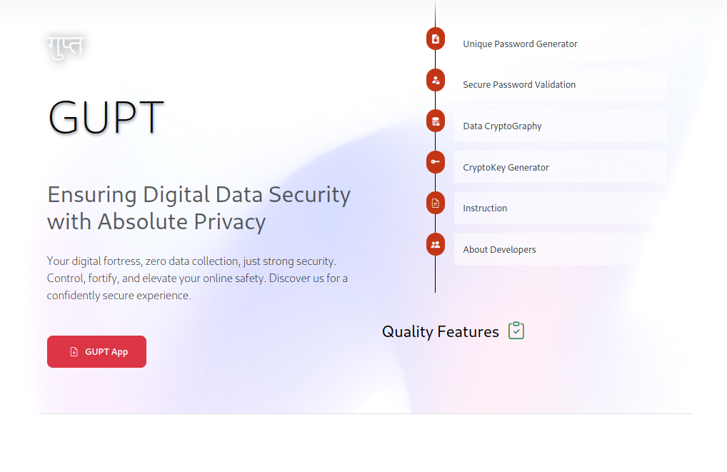

Intuitive Navigation

Users can effortlessly explore GUPT's functionalities thanks to its intuitive navigation system. Clear menu structures and easily accessible buttons guide users to their desired actions, reducing confusion and enhancing user satisfaction.

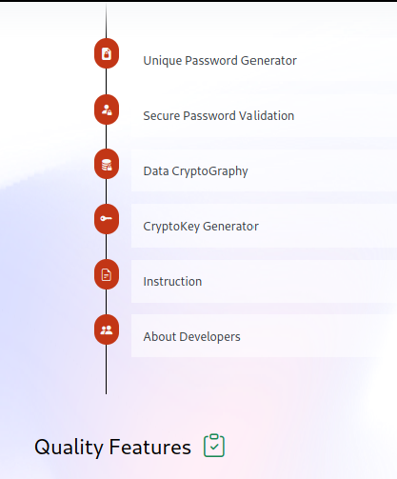

Responsive Design

GUPT adapts seamlessly to different screen sizes and devices, ensuring a consistent and enjoyable experience for users whether they're accessing the platform on a desktop, tablet, or smartphone. Its responsive design optimizes layout and content presentation for each device, eliminating the need for separate mobile apps.

Easy Interaction

GUPT prioritizes ease of interaction, with intuitive controls and straightforward workflows that minimize the learning curve for users. Actions such as generating unique passwords, validating password security, and encrypting data are performed with just a few clicks or taps, streamlining the user experience.

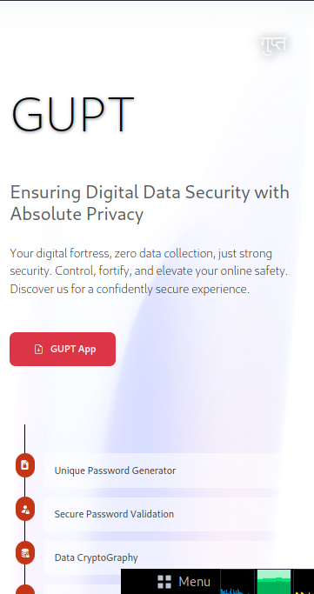

Accessibility

GUPT is designed to be accessible to users of all abilities, with considerations for factors such as color contrast, font size, and keyboard navigation. It strives to ensure that everyone can comfortably use the platform, regardless of any accessibility challenges they may face.

Overall, GUPT's user-friendly interface and responsive design make it a pleasure to use, empowering users to protect their data with confidence and ease.

# GUPT Services

1 . Unique Password Generator

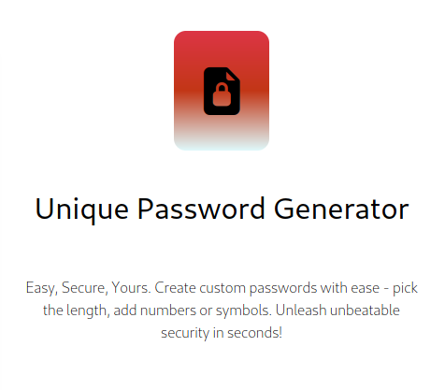
Easy, Secure, Yours. Create custom passwords with ease - pick the length, add numbers or symbols. Unleash unbeatable security in seconds!
** HTML Code **

<!-- { password generator } -->
<div class="col-md-6 col-12 py-5">
<div class="shadow-lg rounded my-5 p-3" id="password_generator_box">

<!-- ( random password field ) -->
<input type="text" class="fld form-control my-3" id="unique_password_fld" placeholder="Unique Password"/>

<!-- ( set key length field ) -->
<label for="key_length" class="d-flex align-items-center justify-content-between pl-2 my-5 border-bottom">

<input type="number" min="4" max="30" placeholder="[4-30]" class="p-2 w-25" id="key_length"> SET LENGTH

<button class="copy p-3" id="copy_password_btn"> <span class="bi bi-files"></span> copy </button>

</label>

<!-- ( password generator button ) -->
<button class="btn btn-dark" id="unique_password_btn">Generate New Password</button>

<!-- ( select number ) -->
<div class="my-3">
<div class="form-check py-3 px-3 d-block border border-dark rounded">

<input class="form-check-input" type="checkbox" name="num" id="number_check" value="1">

<label class="form-check-label" for="number_check" class=""> remove Number between password </label>

</div>
</div>
<!-- ( select symbol ) -->
<div class="my-2">
<div class="form-check py-3 px-3 d-block border border-dark rounded">

<input class="form-check-input" type="checkbox" name="sym" id="symbol_check" value="1" >
<label class="form-check-label" for="symbol_check"> remove Symbol between password </label>
</div>
</div>
</div>
</div>
** Output **

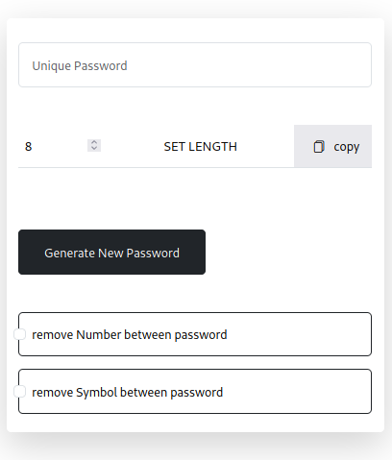

** JavaScript Code **

try {
/*
======================================
[ unique password generator function ]
======================================
*/

let key_length = document.getElementById('key_length');

let unique_password_fld = document.getElementById("unique_password_fld")

let unique_password_btn = document.getElementById("unique_password_btn")

let copy_password_btn = document.getElementById('copy_password_btn')

let number_check = document.getElementById('number_check')

let symbol_check = document.getElementById('symbol_check')

unique_code = null

character_set = null

hasNumber = false

hasSymbol = false

key_length.value = 8 // default legnth

/*
------------------------------------------------------------------------------
} key length function : onchange key length value set between 4 and 30
------------------------------------------------------------------------------
*/

key_length.onchange = () => {

const n = key_length.value

if(n < 4 || n > 30)
{
alert(`range between { 4 to 30 } character`)

console.warn(` ALERT : range between { 4 to 30 } character`)

key_length.value = 8
}
else
{
key_length.value = n
}
}

/*
-----------------------------------------------------------------------------
} number check : on change isNumber value toggle true and false
-----------------------------------------------------------------------------
*/

number_check.onchange = () => {

hasNumber = (hasNumber)? false : true;

console.log(`\n _[has Number : ${hasNumber}]`)
}

/*
-----------------------------------------------------------------------------
} symbol check : on change isSymbol value toggle true and false
-----------------------------------------------------------------------------
*/

symbol_check.onchange = () => {

hasSymbol = (hasSymbol)? false : true;

console.log(`\n _[has Number : ${hasSymbol}]`)
}

/*
-----------------------------------------------------------------------------
} unique password function : onclick loop getRandom() argument characterset
-----------------------------------------------------------------------------
*/

unique_password_btn.onclick = function()
{
unique_code = ' '

character_set = letter

if (hasNumber)
{
character_set += number
}
if (hasSymbol)
{
character_set += symbol;
}

for (let i = 0; i < key_length.value; i++)
{
unique_code += getRandom(character_set)
}
unique_password_fld.value = unique_code

copy_password_btn.innerHTML = '<span class="bi bi-files"></span> copy'

console.log(`\n_[generated : unique password]`)
}

/*
-----------------------------------------------------------------
| copy password button onclick copy unique password field value |
-----------------------------------------------------------------
*/

copy_password_btn.onclick = (event) => {

try
{
unique_password_fld.select()

document.execCommand("copy")

copy_password_btn.innerHTML = '<span class="bi bi-check"></span> copied'

console.log(`\n_[copied] : unique password \n`)
}
catch(error)
{
window.alert(`_[copy failed]`)
}
}
}
catch(error)
{
console.error(` ERROR ${ error }`)
}
// the end

2. Secure Password Validation

Elevate your password's robustness effortlessly. Fortify your online security with a swift and simple strength check.

** HTML Code **

<!-- { password validation } -->
<div class="w-100">

<div class="text-center" id="secure_password">

<input type="text" name="secure_password_fld" class="fld form-control mb-3" id="secure_password_fld" placeholder="Secure Password Level"/>

<button class="btn btn-dark" id="secure_password_btn"> Secure Password Validation </button>

</div>

<!-- ( validation output result ) -->
<div class="my-5" id="validation"></div>

</div>

</div>
<div class="col"></div>

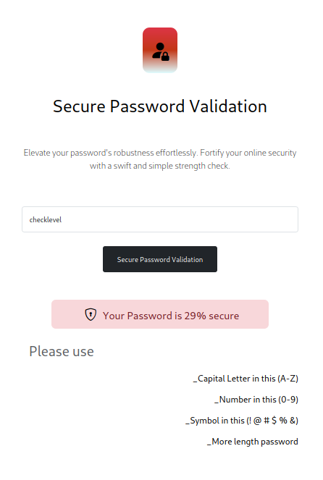

** JavaScript Code **

try
{
/*
=======================================
[ secure password validation function ]
=======================================
*/

let secure_password_fld = document.getElementById("secure_password_fld")

let secure_password_btn = document.getElementById("secure_password_btn")

let secure_alert = document.getElementById('validation')

/*
-----------------------------------------------------------------------------
} secure password function : onclick multiple check validate security
-----------------------------------------------------------------------------
*/

secure_password_btn.onclick = function()
{
let secure = 0 // default security level

alert_statement = `<div class='h2 text-muted p-3'> Please use </div>`

if (secure_password_fld.value == '')
{
secure_alert.innerHTML = `<div> <div class="isUnvalid"> Please! Enter Password </div> </div>`

secure_alert.classList.add('isUnvalid')
}
else if (/[ ]/.test(secure_password_fld.value))
{
secure_alert.innerHTML = `<div> <div class="isUnvalid"> _Space_ Not Allowed </div> </div>`

secure_alert.classList.add('isUnvalid')
}
else
{
if (/[A-Z]/.test(secure_password_fld.value))
{
secure += 20
}
else
{
alert_statement += `<div class="h5 text-end py-2"> _Capital Letter in this (A-Z) </div>`
}
if (/[a-z]/.test(secure_password_fld.value))
{
secure += 20
}
else
{
alert_statement += `<div class="h5 text-end py-2"> _Small Letter in this (a-z) </div>`
}
if (/\d/.test(secure_password_fld.value))
{
secure += 20
}
else
{
alert_statement += `<div class="h5 text-end py-2"> _Number in this (0-9) </div>`
}
if (/[!@#$%^&*(),.?":{}|<>]/.test(secure_password_fld.value))
{
secure += 20
}
else
{
alert_statement += `<div class="h5 text-end py-2"> _Symbol in this (! @ # $ % &) </div>`
}
if (true)
{
secure += random(5)
}
if (secure_password_fld.value.length >= 8)
{
secure += 5
}
if (secure_password_fld.value.length > 14)
{
secure += 5
}
if (secure_password_fld.value.length > 21)
{
secure += 5
}
else
{
alert_statement += `<div class="h5 text-end py-2"> _More length password </div>`
}

secure_alert.innerHTML = ``

secure_alert.classList.remove('isUnvalid')

if (secure > 50)
{
secure_alert.innerHTML = `<div class="h4 text-center py-3 isValid"> <span class="bi bi-shield-lock"></span> Your Password is ${secure}% secure </div> ${alert_statement} `
}
else
{
secure_alert.innerHTML = `<div class="h4 text-center py-3 isUnvalid"> <span class="bi bi-shield-lock"></span> Your Password is ${secure}% secure </div> ${alert_statement} `
}
}
console.log(`this ${secure_password_fld.value} level is ${secure}% secure`)
}
}
catch(error)
{
console.error(` ERROR ${ error }`)
}
// the end
3.Cryptography

Your Secure Haven - Super Features, Cryptography for Free, and Zero Data Collection. Because your privacy matters, always.

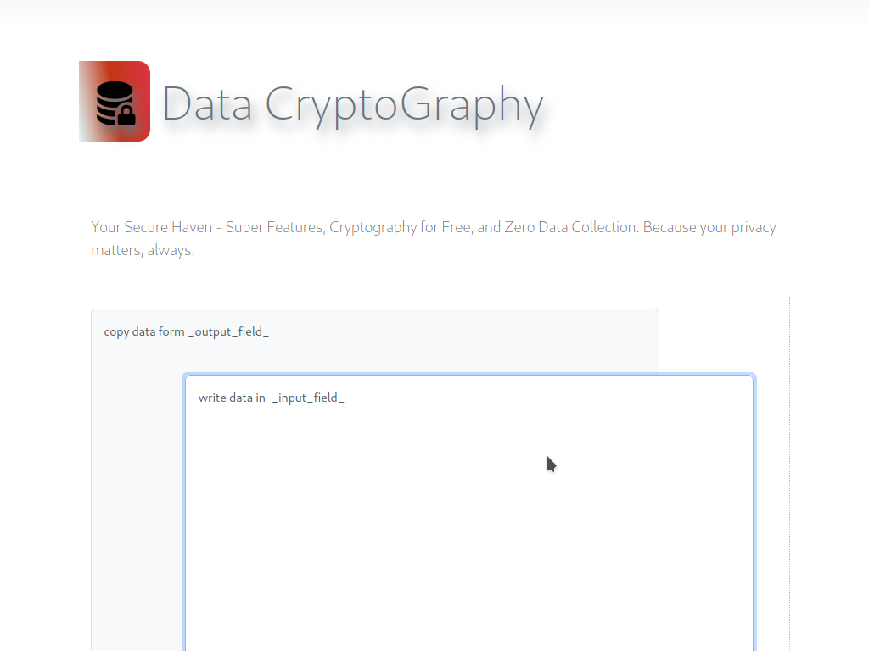
** Look and Feel **
** HTML code **

<div class="container">
<div class="row">

<!-- { io field } -->
<div class="col-12">

<div class="display-3 my-5 py-5"> <span class="bi bi-database-fill-lock icon"></span> Data CryptoGraphy </div>

<div class="lead text-muted m-3 my-5"> Your Secure Haven - Super Features, Cryptography for Free, and Zero Data Collection. Because your privacy matters, always. </div>

<div class="" id="data_io">

<!-- ( data input field ) -->
<textarea name="data_input_fld" id="data_input_fld" class="form-control isActiveField" placeholder="write data in _input_field_"></textarea>

<!-- ( data output field ) -->
<textarea name="data_output_fld" id="data_output_fld" class="form-control" placeholder="copy data form _output_field_"></textarea>

</div>

</div>

<!-- { crypto key field } -->
<div class="col-12">

<input type="text" name="crypto_key_fld" class="form-control" id="crypto_key_fld" placeholder="input OR generat Crypto Key">

</div>
<!-- { operation field } -->
<div class="col-12 py-5 btn-group" id="button_group">

<button class="btn btn-outline-dark" id="crypto_key_btn" title="Generat the new crypto key"> Crypto Key </button>

<button class="btn btn-outline-dark" id="key_copy_btn" title="Copy the crypto key"> Copy Key </button>

<button class="btn btn-outline-dark" id="encode_btn" title="encode your input field data that show encrypted in output field"> Encrypt </button>

<button class="btn btn-outline-dark" id="decode_btn" title="decode your input field data that show decrypted in output field"> Decrypt </button>

<button class="btn btn-outline-dark" id="input_copy_btn" title="copy the input field data"> Copy Input </button>

<button class="btn btn-outline-dark" id="output_copy_btn" title="copy the output field data"> Copy Output </button>

<button class="btn btn-outline-dark" id="all_clear" title="clear input field , output field and key field"> All Clear </button>

</div>

</div>

</div>
** JavaScript code **

// todocode logic application here

let input_fld = document.getElementById('data_input_fld')

let output_fld = document.getElementById('data_output_fld')

let crypto_key_fld = document.getElementById('crypto_key_fld')

let crypto_key_btn = document.getElementById('crypto_key_btn')

var step = document.getElementById('step')

var isHindi = false

/*
[ io Z-index ] ==========
*/

input_fld.onclick = () => {

input_fld.style.zIndex = 10
input_fld.classList.add('isActiveField')
output_fld.style.zIndex = 5
output_fld.classList.remove('isActiveField')
}

output_fld.onclick = () => {

output_fld.style.zIndex = 10
output_fld.classList.add('isActiveField')
input_fld.style.zIndex = 5
input_fld.classList.remove('isActiveField')
}

/*
--------------------------------------------------------------------------------
| cyrpto key button onclick set field value shuffled character_set data |
--------------------------------------------------------------------------------
*/

crypto_key_btn.onclick = function()
{
crypto_key_fld.value = shuffle(letter+number+space+symbol).toString()

console.log(`\n_[success] : cyrpto key generated`)
}

/*
--------------------------------------------------------------------------------
} getCryptoKey function : return crypto key as stirng
--------------------------------------------------------------------------------
*/

function getCryptoKey()
{
return crypto_key_fld.value
}

/*
--------------------------------------------------------------------------------
} isEmpty function : if key is empty return true else false
--------------------------------------------------------------------------------
*/

function isEmpty(key)
{
return (key == '')
}

/*
--------------------------------------------------------------------------------
| encode button onclick encode function argument data & key return encode data |
--------------------------------------------------------------------------------
*/

document.getElementById('encode_btn').onclick = () => {

// output_fld.value = enCode(input_fld.value,getCryptoKey()).toString()

output_fld.value = encrypt(input_fld.value, getCryptoKey()).toString()

console.log(`_[data encoded]`)
}

/*
--------------------------------------------------------------------------------
| decode button onclick decode function argument data & key return decode data |
--------------------------------------------------------------------------------
*/

document.getElementById('decode_btn').onclick = () => {

// output_fld.value = deCode(input_fld.value,getCryptoKey()).toString()

output_fld.value = decrypt(input_fld.value, getCryptoKey()).toString()

console.log(`_[data decoded]`)
}

/*
-------------------------------------
| all clear button clear all field |
-------------------------------------
*/

document.getElementById('all_clear').onclick = () => {

input_fld.value = ``

output_fld.value = ``

crypto_key_fld.value = ``

console.log(`_[all clear]`)
}

/*
-------------------------------------------------------------------------
| input copy button onclick input field select AND execute copy command |
-------------------------------------------------------------------------
*/

document.getElementById('input_copy_btn').onclick = () => {

try
{
input_fld.select()
document.execCommand("copy")

console.log(`\n_[copied] : input field data \n`)
}
catch(error)
{
window.alert(`_[copy failed]`)
}
}

/*
---------------------------------------------------------------------------
| output copy button onclick output field select AND execute copy command |
---------------------------------------------------------------------------
*/

document.getElementById('output_copy_btn').onclick = () => {

try
{
output_fld.select()
document.execCommand("copy")

console.log(`\n_[copied] : output field data \n`)
}
catch(error)
{
window.alert(`_[copy failed]`)
}
}

/*
---------------------------------------------------------------------------
| output copy button onclick output field select AND execute copy command |
---------------------------------------------------------------------------
*/

document.getElementById('key_copy_btn').onclick = () => {

try
{
crypto_key_fld.select()
document.execCommand("copy")

console.log(`\n_[copied] : cryptography key \n`)
}
catch(error)
{
window.alert(`_[copy failed]`)
}
}

/*
------------------------------------------------------
| language button onclick if is hindi set innerHTML |
------------------------------------------------------
*/

document.getElementById('lang_btn').onclick = () => {

if (isHindi)
{
rule = `<li class="text-muted py-3"> Please use the <span class="text-primary"> button </span> to Copy OR Clear OR <b>Crypto Key</b> </li>
<li class="text-muted py-3"> <b>_input_field_</b> allow users to <span class="text-primary"> Insert Data </span> if they are empty </li>
<li class="text-muted py-3"> <b>_output_field_</b> is specifically for <span class="text-primary"> Copy Data </span> OR <span class="text-primary"> Display </span> the outcome </li>
<li class="text-muted py-3"> generating Key is not a must, but Key provide <span class="text-primary"> more_secure_data </span> </li>
<li class="text-muted py-3"> Key encrypted data is decrypt by <span class="text-primary"> same Key </span> </li>
<li class="text-muted py-3"> don't be <span class="text-primary"> loss </span> AND <span class="text-primary"> corrupt </span> Key OR Data </li>
<li class="text-muted py-3"> before Key (<b>encrypt</b>ion AND <b>decrypt</b>ion) be Generated AND Inserted <span class="text-primary"> Crypto Key </span> </li>
<li class="text-muted py-3"> <b>copyed</b> Key OR Data before <span class="text-primary"> all clear </span> </li>
<li class="text-muted py-3"> clear All to reuse <b>GUPT</b> </li>`

isHindi = false
}
else
{
rule = `<li class="text-muted py-3"> कृपया <span class="text-primary"> बटन </span> का उपयोग करें Copy या Clear या <b> Crypto Key </b> </li>
<li class="text-muted py-3"> <b>_input_field_</b> उपयोगकर्ताओं को <span class="text-primary"> डेटा डालने </span> की अनुमति देते हैं अगर वे खाली हैं </li>
<li class="text-muted py-3"> <b>_output_field_</b> विशेष रूप से <span class="text-primary"> डेटा कॉपी </span> या <span class="text-primary"> प्रदर्शन </span> के लिए है </li>
<li class="text-muted py-3"> Key उत्पन्न करना आवश्यक नहीं है, लेकिन कुंजी <span class="text-primary"> अधिक सुरक्षित डेटा </span> प्रदान करती है </li>
<li class="text-muted py-3"> कुंजी एन्क्रिप्टेड डेटा को <span class="text-primary"> वही कुंजी </span> द्वारा डिक्रिप्ट करती है </li>
<li class="text-muted py-3"> Key और Data को <span class="text-primary"> खोने </span> या <span class="text-primary"> बिगाड़ने </span> से बचें </li>
<li class="text-muted py-3"> Key (<b>Encrypt</b>ion और <b>Decrypt</b>ion) करने से पहले <span class="text-primary"> क्रिप्टो कुंजी </span> उत्पन्न करें या डालें </li>
<li class="text-muted py-3"> <span class="text-primary"> सभी साफ </span> करने से पहले कुंजी या डेटा को <b>Copy</b> करें </li>
<li class="text-muted py-3"> <b>GUPT</b> पुनः उपयोग के लिए clear All करें </li>`

isHindi = true
}

step.innerHTML = rule.toString()

console.log(`\n _[language is Hindi : ${isHindi}]`)
}

// [ character set ] -----

capital_letter = "ABCDEFGHIJKLMNOPQRSTUVWXYZ"

small_letter = capital_letter.toLowerCase()

number = "0123456789"

symbol = "!@#$%^&*()_+-=[]{};:'\"\\|,<.>/?`~"

letter = capital_letter + small_letter

space = ' '

// [ shuffle_key ] -----

shuffle_key = (letter+number+space+symbol)

/*
----------------------------------------------------------------------------------------
| setData function : get character or iterate argument to return set_character_iterate |
----------------------------------------------------------------------------------------
*/

function setData(character, iterate)
{
let ch = character, n = iterate

if (isSymbol(ch))
{
ch = shiftSymbol(ch, n)
}
else if (isNumber(ch))
{
ch = shiftNumber(ch, n)
}
else if (isLetter(ch))
{
ch = shiftLetter(ch, n)
}
return ch
}

/*
====================
| encrypt function |
====================
*/

function encrypt(data, key)
{
const data_set = data.split('')

for (let i = 0; i < data_set.length; i++)
{
let character = data_set[i]

if ((i%7) == 0)
{
if (isLower(character))
{
character = character.toUpperCase()
}
else if (isUpper(character))
{
character = character.toLowerCase()
}
else if (isNumber(character))
{
character = shiftNumber(character, 1)
}
}
if (isSymbol(character))
{
data_set[i] = shiftSymbol(character,1)
}
else if (isNumber(character))
{
data_set[i] = shiftNumber(character,-7)

if (i%9 == 0)
{
data_set[i] = shiftLetter(character,-7)
}
}
else if (isLetter(character))
{
data_set[i] = shiftLetter(character,9)

if (i%2 == 0)
{
data_set[i] = shiftLetter(character,-3)
}
}
if (isPrime(i))
{
let n = getPrimeIndex(i)

if (isSymbol(character))
{
character = shiftSymbol(character, n)
}
else if (isNumber(character))
{
character = shiftNumber(character, n)
}
else if (isLetter(character))
{
character = shiftLetter(character, n)
}
}
}

if (isEmpty(key))
{
return data_set.join('');
}
else
{
return enCode(data_set.join(''), key).toString()
}
}

/*
====================
| decrypt function |
====================
*/

function decrypt(data, key)
{
if (!isEmpty(key))
{
data = deCode(data, key).toString()
}

const data_set = data.split('')

for (let i = 0; i < data_set.length; i++)
{
character = data_set[i]

if ((i%7) == 0)
{
if (isLower(character))
{
character = character.toUpperCase()
}
else if (isUpper(character))
{
character = character.toLowerCase()
}
else if (isNumber(character))
{
character = shiftNumber(character,-1)
}
}
if (isPrime(i))
{
let n = getPrimeIndex(i)

if (isSymbol(character))
{
data_set[i] = shiftSymbol(character, n)
}
else if (isNumber(character))
{
data_set[i] = shiftNumber(character, n)
}
else if (isLetter(character))
{
data_set[i] = shiftLetter(character, n)
}
}
if (isSymbol(character))
{
data_set[i] = shiftSymbol(character,-1)
}
else if (isNumber(character))
{
data_set[i] = shiftNumber(character, 7)

if (i%9 == 0)
{
data_set[i] = shiftLetter(character, 7)
}
}
else if (isLetter(character))
{
data_set[i] = shiftLetter(character,-9)

if (i%2 == 0)
{
data_set[i] = shiftLetter(character,3)
}
}
}
return data_set.join('');
}

/*
-----------------------------------------------------------------
| enCode function : argument data OR key to return encode data |
-----------------------------------------------------------------
*/

function enCode(data, key)
{
data = data.split('')

for (o = 0; o < data.length; o++)
{
for (i = 0; i < key.length; i++)
{
if (shuffle_key[i] == data[o])
{
data[o] = key[i]

break
}
}
}
return data.join('')
}

/*
-----------------------------------------------------------------
| deCode function : argument data OR key to return decode data |
-----------------------------------------------------------------
*/

function deCode(data, key)
{
data = data.split('')

for (o = 0; o < data.length; o++)
{
for (i = 0; i < key.length; i++)
{
if (data[o] == key[i])
{
data[o] = shuffle_key[i]

break
}
}
}
return data.join('')
}
/*
--------------------
[ isSpace function ] if space return true else false
--------------------
*/

function isSpace(character)
{
// return (character == space)

return /[ ]/.test(character)
}

/*
---------------------
[ isLetter function ] if letter return true else false
---------------------
*/

function isLetter(character)
{
// return (character >= 'A' && character <= 'Z') || (character >= 'a' && character <= 'z')

return /[a-zA-Z]/.test(character)
}

/*
--------------------
[ isUpper function ] if Uppercase return true else false
--------------------
*/

function isUpper(character)
{
// return (character >= 65 && character <= 90)

return /[A-Z]/.test(character)
}

/*
--------------------
[ isLower function ] if Lowercase return true else false
--------------------
*/

function isLower(character)
{
// return (character >= 97 && character <= 122)

return /[a-z]/.test(character)
}

/*
---------------------
[ isNumber function ] if number return true else false
---------------------
*/

function isNumber(character)
{
// return typeof character === 'number' && isFinite(character)

return (/\d/.test(character))
}

/*
-------------------
[ isReal function ] if number is 0 or greater than 0 return true else false
-------------------
*/

function isReal(number)
{
return (number >= 0)
}

/*
---------------------
[ isSymbol function ] if symbol return true else false
---------------------
*/

function isSymbol(character)
{
// return symbol.includes(character)

return /^[!@#$%^&*()_+\-=\[\]{};':"\\|,.<>\/?`~]$/.test(character)
}

/*
--------------------
[ isPrime function ] whole number greater than 1 & only two positive divisors
--------------------
*/

function isPrime(number)
{
if (number <= 1) return false

for (let i = 2; i <= Math.sqrt(number); i++)
{
if (number%i === 0)
{
return false
}
}
return true;
}

/*
--------------------
[ isGmail function ] if gmail format return true else false
--------------------
*/

function isGmail(email)
{
return /^[a-zA-Z0-9._%+-]+@gmail\.com$/.test(email);
}

/*
----------------------
[ isComplex function ] if complex word return true else false
----------------------
*/

function isComplex(password)
{
return (/^(?=.*[a-z])(?=.*[A-Z])(?=.*\d)(?=.*[!@#$%^&*()_+])[A-Za-z\d!@#$%^&*()_+]{8,}$/.test(password))
}

/*
--------------------------
[ getPrimeIndex function ] return index of prime number
--------------------------
*/

function getPrimeIndex(number)
{
let prime_index = 0

for (n = 2; n <= number; n++)
{
if (prime_index = 9)
{
prime_index = 0
}
else if (isPrime(n))
{
prime_index++
}
}
return (prime_index--)
}

/*
--------------------
[ shuffle function ] get data argument return equal unique or unorder data
--------------------
*/

function shuffle(data)
{
let data_array = data.split('');

for (let i = data_array.length - 1; i > 0; i--)
{
let randomIndex = random(i + 1);

[data_array[i], data_array[randomIndex]] = [data_array[randomIndex], data_array[i]];
}
return data_array.join('');
}

/*
-----------------------
[ numberCode function ] pass data return in random number format
-----------------------
*/

function numberCode(data)
{
let num = 11

for (let i = 0; i < data.length; i++) num = (num << 3) - num + data.charCodeAt(i)

return num
}

/*
--------------------------------------------------------------------------------
} random function : return random number between pass arugment range
--------------------------------------------------------------------------------
*/

function random(range)
{
return Math.floor(Math.random() * range)
}

/*
--------------------------------------------------------------------------------
} getRandom function : return random_index_data by pass argument data object
--------------------------------------------------------------------------------
*/

function getRandom(data)
{
return data[random(data.length)]
}

// charCodeAt(0) // works with UTF-16 (16-bit units)

// charPointAt(0) // handles full Unicode (32-bit units)

// fromCharCode() // convert code to character

// isNaN() // if isNumber || Convertable inNumber so return false else true

// isFinite() // if isNumber || COnvertable inNumber & Finite so return true else false

/*
------------------------------------------------------------------
| function argument character AND iterate to return shift number |
------------------------------------------------------------------
*/

function shiftNumber(character, iterate)
{
if (isReal(iterate))
{
return number[((number.indexOf(character) + iterate) % number.length)]
}
else
{
return number[(number.length + ((number.indexOf(character) + iterate) % number.length)) % number.length]
}
}

/*
------------------------------------------------------------------
| function argument character AND iterate to return shift symbol |
------------------------------------------------------------------
*/

function shiftSymbol(character, iterate)
{
if (isReal(iterate))
{
return symbol[((symbol.indexOf(character) + iterate) % symbol.length)]
}
else
{
return symbol[(symbol.length + ((symbol.indexOf(character) + iterate) % symbol.length)) % symbol.length]
}
}

/*
------------------------------------------------------------------
| function argument character AND iterate to return shift letter |
------------------------------------------------------------------
*/

function shiftLetter(character, iterate)
{
if (isUpper(character))
{
if (isReal(iterate))
{
return capital_letter[((capital_letter.indexOf(character) + iterate) % capital_letter.length)]
}
else
{
return capital_letter[((capital_letter.length + ((capital_letter.indexOf(character) + iterate) % capital_letter.length)) % capital_letter.length)]
}
}
else if (isLower(character))
{
if (isReal(iterate))
{
return small_letter[((small_letter.indexOf(character) + iterate) % small_letter.length)]
}
else
{
return small_letter[((small_letter.length + ((small_letter.indexOf(character) + iterate) % small_letter.length)) % small_letter.length)]
}
}
}
# Copyright Notice

Copyright (c) 2024 by Mayank & Hritik . All Rights Reserved.

This GUPT Project is the property of Mayank & HRitik and is protected under copyright law. Unauthorized reproduction, distribution, or disclosure of this Project , or any part of its contents, is strictly prohibited.

For permissions, please contact the repository owners through their GitHub profiles:

https://github.com/MayankDevil/

https://github.com/Hritikkumar975/

Any unauthorized use of the material within this repository may constitute a violation of copyright law. Use only services.

