 | SANJIVANI UNIVERSITY  (Established Under Govt. of Maharashtra Act No XX of 2024)  At: Kopargaon, Dist.: Ahmednagar (MH), Pin-423601  Ph: 9130191301, 9137700700 Email: sanjivani.edu.in  Website: www.sanjivani.edu.in | ACAD-F-__
A.Y. - 2026-2027 | School of Engineering and Technology | Date: 16/10/2026
SEM: ODD | School of Engineering and Technology | Date: 16/10/2026
Department of Cyber Security
Ref. No: SU/SET/26-27/FMT/002
ICS LABORATORY PROJECT REPORT: REPORT FORMAT
Cryptography and Information Security (24UCYPC301), T.Y. B.Tech Cyber Security
Dear Students,
Each of you must prepare an individual short report on the ICS Laboratory project allotted to you. This file is the official format. Type your report directly into the template pages that follow this page, replace all text in [square brackets] with your own content, and delete this instruction page before submission. Reports that do not follow this format will not be accepted for evaluation.
Mandatory Rules
Item | Requirement
Font and colour | Times New Roman only, black text. Body 12 pt, chapter headings 14 pt bold, sub-headings 12 pt bold. Diagrams must be readable in black and white print
Page setup and length | A4, left margin 1.25 inch, other margins 1 inch, line spacing 1.5 (already set in this file). 8 to 12 pages including cover page and certificate
Figures and tables | Number them section-wise (Figure 3.1, Table 5.1). Caption below figures and above tables
References | IEEE style, minimum 5 references from journals, conferences, books or standards (NIST, RFC, ISO)
Source code | Do not paste full code. Use short key snippets only (maximum 30 lines each). Upload full code to GitHub and give the link in Section 6
Submission | Soft copy as PDF named PRN_PSCode_ICSReport.pdf (example: 2124UCSM1126_CIS-001_ICSReport.pdf) and one spiral bound hard copy

How Your Report Will Be Evaluated (50 Marks)
Sr. | Criterion | Marks
1 | Problem understanding and objectives | 5
2 | Literature review and choice of technique | 5
3 | System design and methodology | 10
4 | Implementation quality and correctness | 15
5 | Results, testing and security analysis | 10
6 | Report quality and adherence to this format | 5
 | Total | 50

Submission Deadline: 24/10/2026. Late submissions will not be accepted without prior approval of the course coordinator.
Dr. Chetan D. Bawankar
Head, Department of Cyber Security
SET, Sanjivani University, Kopargaon

A Project Report on
INSIDER THREAT DETECTION USING USER AND ENTITY BEHAVIOUR ANALYTICS (UEBA)
PS Code: CIS-120
Domain: D__: Insider Threat Detection / Security Analytics
Complexity: Advanced
Submitted in partial fulfilment of the requirements of the course
Cryptography and Information Security (24UCYPC301) Laboratory
T.Y. B.Tech Cyber Security, Semester V
Submitted by
[Student Full Name]
PRN: [__________] Roll No.: [__]
Under the guidance of
Dr Chetan Bawankar
Head of Department of Cyber Security
Department of Cyber Security
School of Engineering and Technology
Sanjivani University, Kopargaon
Academic Year 2026-2027
CERTIFICATE
This is to certify that the project report entitled "Insider Threat Detection using User and Entity Behaviour Analytics (UEBA)" (PS Code: CIS-120) submitted by [Student Full Name] (PRN: [__________]) is a bonafide record of the laboratory project work carried out by him/her under my guidance, in partial fulfilment of the requirements of the course Cryptography and Information Security (24UCYPC301) Laboratory, T.Y. B.Tech Cyber Security, during the Academic Year 2026-2027 at the Department of Cyber Security, School of Engineering and Technology, Sanjivani University, Kopargaon. The similarity index of this report is [__]%.
(Signature)  Mr Kunal Makar  Subject Teacher | (Signature)  Dr. Chetan D. Bawankar  Head, Department of Cyber Security

Place: Kopargaon
Date: __/__/____

Insider Threat Detection using User and Entity Behaviour Analytics (UEBA)
Student: [Name] PRN: [__________] PS Code: CIS-120
Abstract
Insider threats are difficult to detect because the actor is a trusted, authorised user whose malicious actions blend into normal activity. This project implements a User and Entity Behaviour Analytics (UEBA) system on the CMU/SEI CERT r4.2 insider-threat dataset that learns each employee's normal behaviour rather than relying on fixed rules. Raw logon, device, web, email and file logs are aggregated into fifteen behavioural features per user per day. Each day is scored three ways - a self z-score against the user's own baseline, a peer z-score against their role group, and an unsupervised Isolation Forest - which are fused into a 0-100 daily risk and a trailing-seven-day weekly risk, with the top-3 contributing features stored as an explanation. Users are ranked for an analyst in a Streamlit dashboard, and detection quality is measured against ground-truth labels using recall@k, precision@k and PR-AUC. The system is offline, explainable, and validated on the real dataset.
Keywords: Insider threat, UEBA, anomaly detection, Isolation Forest, CERT r4.2, behavioural baselines
1. Introduction and Problem Statement
Organisations face significant risk from insider threats - employees or contractors who misuse their legitimate access to exfiltrate data, sabotage systems, or leave for a competitor with sensitive information. Unlike external attacks, insider activity has no malware signature; the only reliable signal is a change in the person's own behaviour. User and Entity Behaviour Analytics (UEBA) addresses this by building a statistical profile of normal behaviour for every user and flagging deviations.
The problem allotted (PS Code CIS-120) is to build a UEBA system on the CMU/SEI CERT r4.2 test dataset that learns normal behaviour, scores later activity, ranks users by risk, explains each flag, and measures detection quality against the dataset's labelled insiders. This matters because insider incidents are costly and hard to catch, and an explainable, ranking-based tool helps a human analyst triage efficiently. The dataset encodes three realistic attack scenarios - data exfiltration via removable media, leaving for a competitor, and sabotage/impersonation - which the chosen behavioural features are designed to surface.
2. Objectives
[List 3 to 4 specific and measurable objectives.]
1. Ingest and aggregate the large CERT r4.2 logs into per-user-per-day behavioural features without loading whole files into memory.
2. Learn per-user and per-role baselines and score each later day using fused statistical and machine-learning anomaly signals.
3. Rank users by risk and explain every flag with its top contributing features in an interactive dashboard.
4. Evaluate detection quality against ground-truth labels using recall@k, precision@k and PR-AUC, comparing scoring variants.
3. Methodology and System Design
The system follows a five-stage pipeline (Figure 3.1). (1) A profiling step inspects each raw CSV so parsers follow the real column layout. (2) Ingestion reads the logs in fixed-size chunks and aggregates them to one row per user per calendar day, so no file is ever loaded whole. (3) Feature extraction computes fifteen behavioural features per user-day across four families - logon, removable-media/USB, web and email. (4) Baselines are learned from each user's first 60-90 days and from their role group; only this early period trains the baseline, so later days are judged against a stable notion of normal. (5) Scoring compares each later day to the baseline three ways and fuses them.
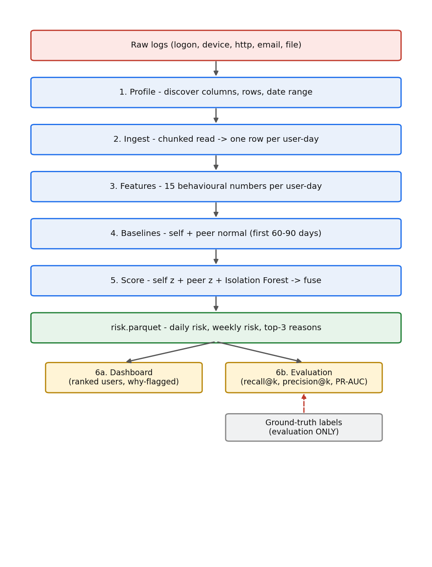
Figure 3.1: End-to-end pipeline flow.
Two statistical scores are computed as z-scores - how many standard deviations each feature is from the baseline mean, capped at 5, taking the mean of the top-3 - against the user's own history (self) and their role group (peer). An unsupervised Isolation Forest, trained only on baseline-period days, provides a third, machine-learned anomaly score. The three 0-1 scores are fused into a daily risk, daily_risk = 100 x (0.5*self + 0.3*iso + 0.2*peer); a weekly risk sums the last seven daily risks so a slow build-up outranks a single noisy day, and the three strongest features are stored as the explanation. Ground-truth labels are used only for evaluation, never for training. The scoring fusion is shown in Figure 3.2.
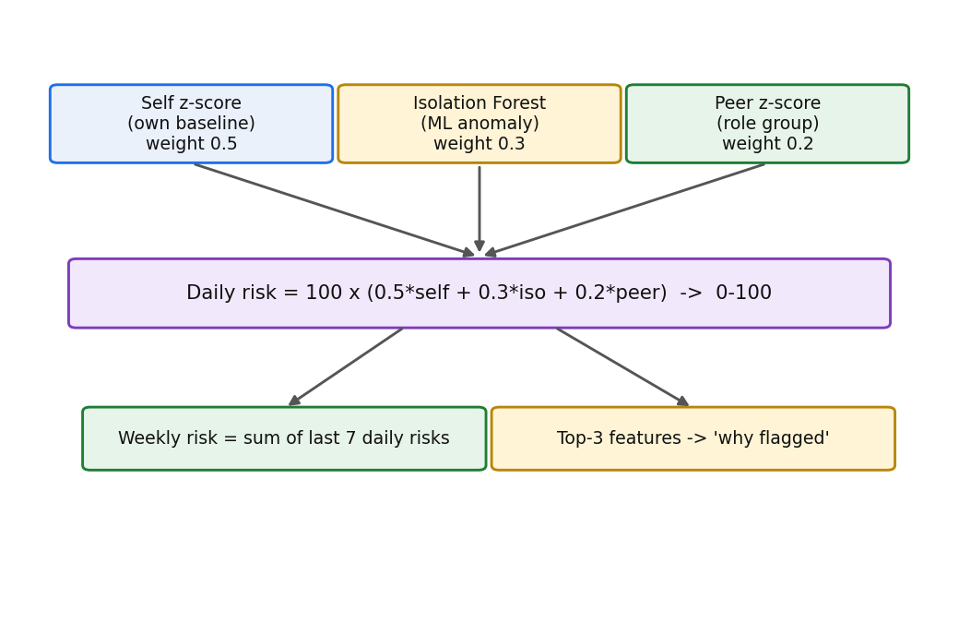
Figure 3.2: Risk scoring - three signals fused.
4. Implementation
The system is implemented in Python 3.11 (also runs on 3.13) as a modular package (src/ueba) driven by a single config.yaml file. Key libraries with versions: pandas 2.2.2 and pyarrow 16.1.0 / duckdb 1.0.0 for chunked data handling and Parquet storage; scikit-learn 1.5.0 for the Isolation Forest; Streamlit 1.36.0 and Plotly 5.22.0 for the dashboard; PyYAML 6.0.1 for configuration; joblib 1.4.2 for model persistence; and pytest 8.2.2 with Hypothesis 6.103.1 for testing. The pipeline is split into modules - ingestion, features, baselines, models, scoring, evaluation, dashboard and a near-real-time 'live' scorer. No cloud services or runtime network calls are used. A representative code snippet of the risk fusion is shown below.
daily_risk = 100.0 * (w.self_w * self_score
+ w.iso_w * iso_score
+ w.peer_w * peer_score) # weights 0.5 / 0.3 / 0.2 from config
5. Results and Security Analysis
The system was validated on the real CERT r4.2 dataset (1,000 users, ~330,000 user-days, 70 labelled insiders). Table 5.1 lists representative test cases. Figure 5.1 shows the detection metrics for the three scoring variants and Figure 5.2 the user-day precision-recall curves. On the real data the statistical (z-score) signal was the strongest single detector, the Isolation Forest the weakest alone, and the fused score sat between them - consistent with the literature finding that feature engineering matters more than model complexity. Plain accuracy is deliberately not reported: with insider user-days under 1%, accuracy would exceed 99% while revealing nothing, so ranking metrics and user-day PR-AUC are used instead. In a worked case the system flagged user RAR0725, whose distinct-domain, attachment and job-site activity on 2010-07-16 were far above their own baseline (z-score capped at 5), matching the 'leaving for a competitor' scenario. From a security standpoint the tool is decision-support that surfaces anomalies for human review: it is explainable and auditable, uses labels only for evaluation, and runs fully offline.
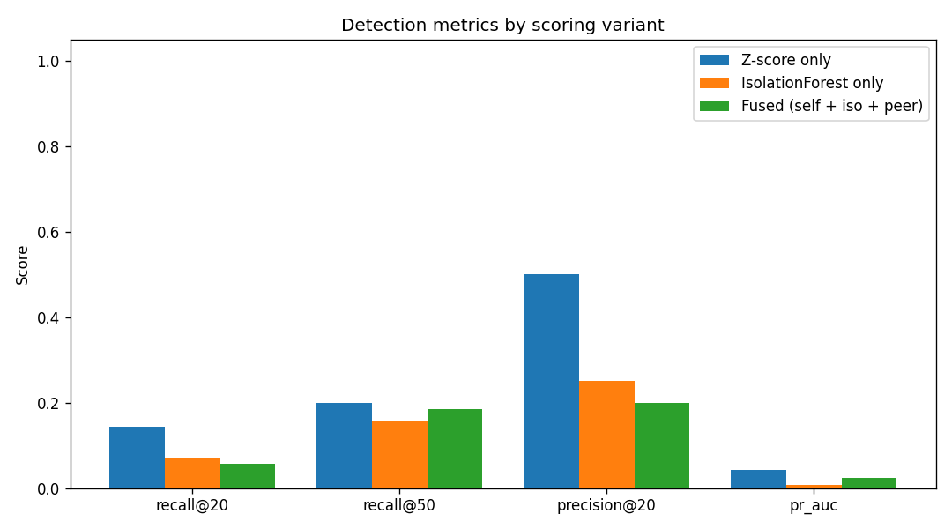
Figure 5.1: Detection metrics by scoring variant (real r4.2).
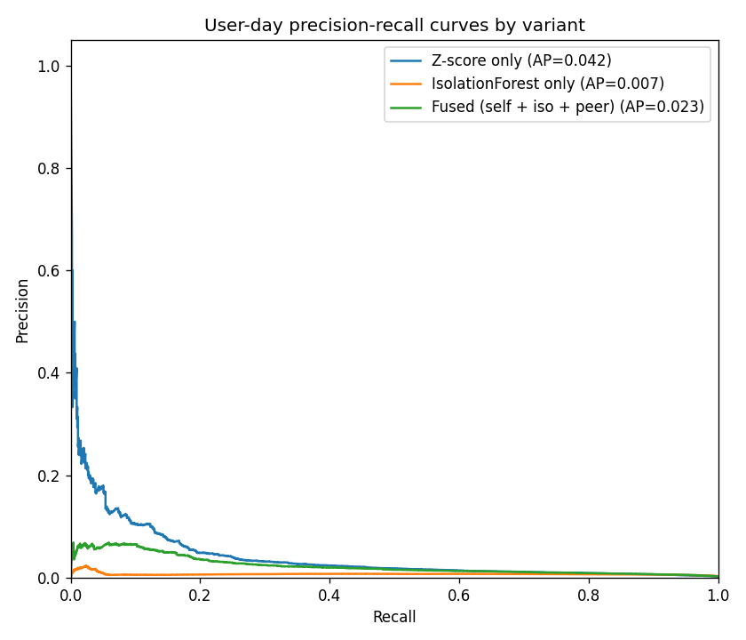
Figure 5.2: User-day precision-recall curves by variant.
Table 5.1: Test Cases
Test ID | Input / Action | Expected Output | Actual Output | Status
TC01 | Ingest real r4.2 logs (~15 GB) | One row per user-day; no null users; bounded memory | 330,452 user-days, 1,000 users; ~300 MB peak | Pass
TC02 | Score a day with a planted USB burst | Spiked feature z-score > 4; user flagged | usb_connect_count z = 5.0 (capped); flagged | Pass
TC03 | Train Isolation Forest (baseline only) | No training row dated after the baseline cutoff | 0 post-cutoff rows; model reload identical | Pass
TC04 | Evaluate on real labels | recall@k, precision@k, PR-AUC for 3 variants; no accuracy | z-only / iso-only / fused report produced | Pass
TC05 | Run automated test suite | All unit and property tests pass | 121 passed | Pass
6. Conclusion and Future Scope
All four objectives were met: the pipeline ingests the full CERT r4.2 dataset efficiently, learns per-user and per-role baselines, fuses three signals into an explainable 0-100 risk, ranks users in an interactive dashboard, and is evaluated honestly against ground truth, backed by 121 automated tests. Limitations: the r4.2 data is synthetic and intentionally dense with malicious activity, so results are optimistic relative to a real deployment; the baseline is static; and scoring is at daily granularity rather than per event. Future scope: online baselines with concept-drift handling, richer sequence/graph features, tuning the fusion weights on a validation set, and validation on real enterprise logs.
GitHub Repository Link: [https://github.com/your-username/your-repository]
References
[1] J. Glasser and B. Lindauer, "Bridging the Gap: A Pragmatic Approach to Generating Insider Threat Data," in Proc. IEEE Security and Privacy Workshops, 2013, pp. 98-104.
[2] Carnegie Mellon University, Software Engineering Institute, "Insider Threat Test Dataset," 2020. doi: 10.1184/R1/12841247.
[3] F. T. Liu, K. M. Ting, and Z.-H. Zhou, "Isolation Forest," in Proc. IEEE Int. Conf. Data Mining (ICDM), 2008, pp. 413-422.
[4] D. C. Le and A. N. Zincir-Heywood, "A Machine Learning Based Framework for User-Centered Insider Threat Detection," Ph.D. dissertation, Dalhousie University, 2021.
[5] L. Liu, O. De Vel, Q.-L. Han, J. Zhang, and Y. Xiang, "Deep Learning for Insider Threat Detection: Review, Challenges and Opportunities," arXiv:2005.12433, 2020.
[6] F. Pedregosa et al., "Scikit-learn: Machine Learning in Python," Journal of Machine Learning Research, vol. 12, pp. 2825-2830, 2011.

