UEBA Insider Threat Detection (CIS-120)
Features, Pipeline, Risk Scoring, and Flow Diagrams

1. Overview
This system detects insider threats on the CMU/SEI CERT r4.2 dataset. Instead of fixed rules, it learns each employee's normal behaviour from their activity logs, scores each later day for how far it departs from that baseline, ranks the riskiest users, and explains every flag. It runs entirely offline. The three sections below describe the 15 behavioural features, the end-to-end pipeline, and how the risk score is computed.

2. The 15 Behavioural Features (per user, per day)
Each user-day is summarised as 15 numbers across four families. 'After-hours', 'weekend', and the site lists are all defined in config.yaml (not hard-coded).
# | Feature | Family | Source | Why it matters
1 | logon_count | Logon | logon.csv | Daily logon activity; baseline for the rest
2 | after_hours_logon_count | Logon | logon.csv | Logons outside working hours - classic insider start
3 | weekend_logon_count | Logon | logon.csv | Unusual weekend access
4 | distinct_machines | Logon | logon.csv | Using other people's machines / credential misuse
5 | usb_connect_count | USB / removable | device.csv | Removable media is the top exfiltration route
6 | after_hours_usb_count | USB / removable | device.csv | USB use late at night is more suspicious
7 | files_to_removable | USB / removable | file.csv | Files copied off-network - direct exfiltration
8 | job_site_visits | Web | http.csv | Job hunting -> flight risk (leaving for a competitor)
9 | upload_leak_site_visits | Web | http.csv | Uploading to leak / cloud sites
10 | file_upload_count | Web | http.csv | Web upload exfiltration channel
11 | distinct_domains | Web | http.csv | Breadth of browsing; a spike can mean recon
12 | total_web_requests | Web | http.csv | Overall web activity baseline
13 | emails_sent | Email | email.csv | Outbound communication volume
14 | external_recipients | Email | email.csv | Data leaving the company by email
15 | email_attachments | Email | email.csv | Attachments carry the payload

3. The Pipeline
- 1. Profile - inspect the raw CSVs first (columns, row counts, date ranges) so parsers match the real data.
- 2. Ingest - read the logs in chunks (never whole) and aggregate to one row per user per calendar day.
- 3. Features - compute the 15 behavioural features above for every user-day.
- 4. Baselines - learn each user's and each role's normal (mean + spread) from their first 60-90 days; this is frozen.
- 5. Score - compare every later day to the baseline three ways and fuse into a 0-100 daily risk (see section 4).
- 6. Use - rank users by weekly risk in the dashboard, and evaluate detection quality against ground-truth labels.
Design rules: profile before parsing (no hard-coded columns); split by time, not randomly (the baseline never sees the future); and ground-truth labels are used only for evaluation, never for training.

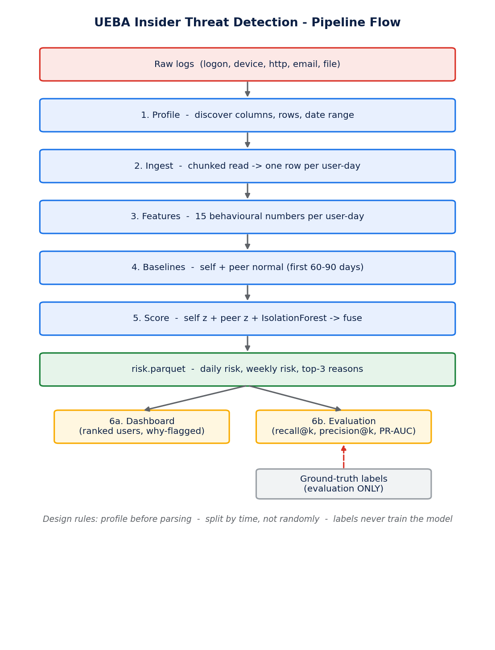
Figure 1 - End-to-end pipeline flow.

4. Risk Scoring
Every user-day gets three independent scores, each scaled to 0-1:
- Self z-score - how many standard deviations each feature is from the user's OWN baseline, capped at 5; the score is the mean of the top-3 feature z-scores divided by 5. (weight 0.5)
- Peer z-score - the same comparison against the user's ROLE-group baseline. (weight 0.2)
- Isolation Forest - an unsupervised model trained on baseline-period days; its raw anomaly score is min-max scaled to 0-1. (weight 0.3)
The three are fused into a daily risk on a 0-100 scale:
daily_risk = 100 x (0.5 x self + 0.3 x iso + 0.2 x peer)
Weekly risk is the sum of a user's last 7 daily risks, so a slow build-up outranks one noisy day. For every flagged user-day the top-3 contributing features (value, baseline mean, z-score) are stored as the 'why flagged' explanation. An analyst sets a risk threshold to decide which scores count as alerts.
Worked example: self 0.8, iso 0.6, peer 0.4 -> 100 x (0.40 + 0.18 + 0.08) = 66 / 100.

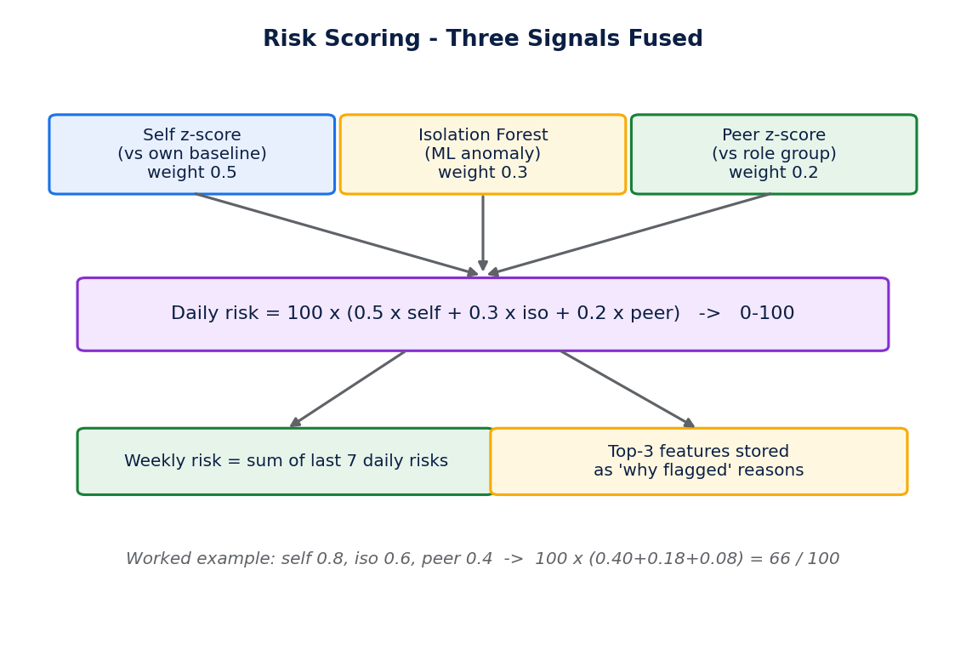
Figure 2 - Risk scoring: three signals fused.

