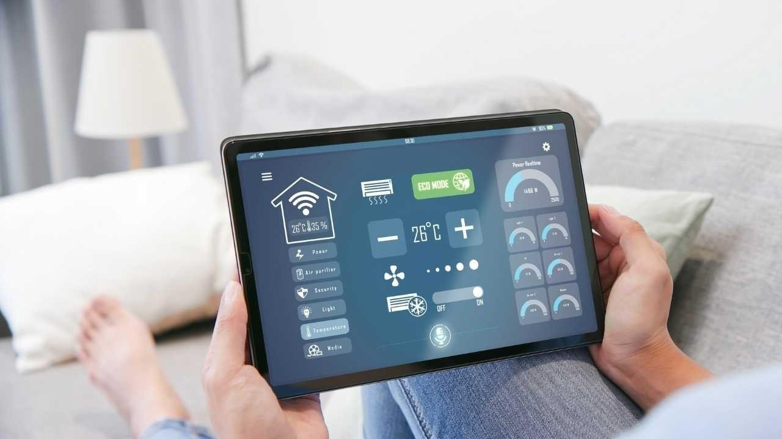

**Synopsis: Temperature Monitoring System**

**Title: Temperature Monitoring System**

**Overview:**

**The Temperature Monitoring System is designed to provide real-time monitoring of temperature levels in homes, greenhouses, and industrial spaces. The system ensures that temperatures are within safe limits to improve comfort, safety, and efficiency.**

**Objectives:**

**Accurate Measurement: Use a reliable temperature sensor to give accurate temperature readings at any time.**

**Data logging: this is a method whereby the device logs temperature information over time and allows for easy trend or change analysis of the temperatures.**

**Alerting notifications: this is when a device is set to notify its users of high temperatures against a set limit. Therefore, the issue will be corrected in advance.**

**Simple user interface: provide a friendly interface that the user may use to easily view and monitor temperature conditions without difficulty, set the device parameters, etc.**

**Sensor Integration: The system integrates with a temperature sensor (mocked in this implementation), which feeds real-time values of temperature.**

**Data Logging: Each temperature reading has a timestamp so that the users can refer to historical data.**

**User Alerts: There are alerts sent when the temperatures go beyond safe limits so that the users know of critical changes.**

**Real-Time Monitoring: Users can easily view current temperature readings and historical logs.**

**All of this is built using Object-Oriented Programming (OOP) principles in C++. Therefore, the main parts in this system are the Temperature Sensor Class, Logger Class, Alert System Class, Monitoring System Class, and their interconnection. Expected Results:**

**With the Temperature Monitoring System, users should be able to have a trusted and effective way to monitor temperature level conditions. Users can keep their surroundings at optimal conditions through appropriate data logging and timely warnings.**

**Conclusion:**

**The principle of OOP applied demonstrates that these are highly workable in producing a full-proof Temperature Monitoring System. Module-functionality being segmented across the system leaves the organized aspect along with making the future upgrade and further improvements at will within easy reach, offering control back to users of their need to monitor temperatures.**