Cricket World Cup 2019

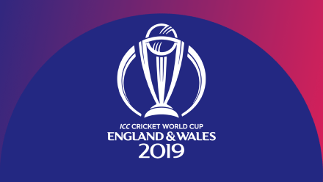

Match Scorecard

|  |  |
| --- | --- |
| Match |  |
| Team 1 |  |
| Team 2 |  |
| Team 1 - score |  |
| Team 2 - score |  |
| Result |  |