PROTOCOL REPORT
Colorectal Cancer Survival Analysis
Exploratory Data Analysis, Statistical Hypothesis Testing & Predictive Modeling
89,945  Patients analyzed | 28  Variables tested | None  Predictive signal found

Prepared as a data analyst portfolio project · scikit-learn, pandas, SciPy

Contents
01 Executive Summary
02 Dataset & Methodology
03 Exploratory Data Analysis
04 Statistical Hypothesis Testing
05 Predictive Modeling
06 Conclusion & Recommendations

01 · EXECUTIVE SUMMARY

Every risk factor was tested. None of them predict survival.
This report presents a full analytical pipeline — exploratory data analysis, statistical hypothesis testing, and predictive modeling — applied to a colorectal cancer dataset of 89,945 patient records across 28 demographic, clinical, and lifestyle variables. The objective was to identify which factors predict patient survival.
The central finding is a negative result, reached with rigor rather than assumed: no variable in this dataset — including clinically intuitive ones such as Stage at Diagnosis, Tumor Aggressiveness, and Recurrence — shows a statistically reliable relationship with survival status. Two classification models (Logistic Regression and Random Forest) were trained and both converged to simply predicting the majority class, with ROC-AUC scores indistinguishable from random guessing (0.50).
74.87%  Baseline / model accuracy | 0.5055  Best ROC-AUC achieved | 1 of 28  Features significant at p<0.05
Key takeaways
— The dataset is clean (zero missing values) and well-documented, but the outcome variable appears to be generated independently of the recorded features — consistent with a synthetic dataset built without an embedded feature-outcome relationship.
— 24 of 25 Chi-Square tests and all 3 t-tests came back non-significant; the single exception (Radiotherapy_Received, p=0.044) is within the range expected from chance alone when running 28 independent tests.
— Both models, evaluated on an identical held-out test set, predicted "Survived" for virtually every patient — the confusion matrices are effectively identical because neither model found a signal to differentiate on.
— 5-fold cross-validation confirms the flat ~0.50 ROC-AUC holds across every data split, ruling out an unlucky train/test partition as the explanation.

02 · DATASET & METHODOLOGY

Dataset & Methodology
The dataset contains 89,945 patient records with 29 columns covering demographics (age, gender, race, region), clinical history (family history, previous cancer history, stage at diagnosis, tumor aggressiveness), lifestyle factors (smoking, alcohol, diet, physical activity), treatment (chemotherapy, radiotherapy, surgery, treatment access), and outcomes (survival status, recurrence, time to recurrence). No missing values were found in any column.

Preprocessing pipeline
— Patient ID dropped (identifier only, no predictive value).
— Binary Yes/No fields (e.g. Family History, Chemotherapy Received) label-encoded to 0/1.
— Ordinal fields (Stage, Tumor Aggressiveness, Screening Regularity, etc.) mapped to integers preserving natural order.
— Nominal fields with no inherent order (Race, Region, Diet Type) one-hot encoded.
— Numerical features (Age, BMI, Time to Recurrence) standardized with z-score scaling.
— Data split 80/20 into train and test sets, stratified by survival status to preserve class balance.

Modeling approach
Two classifiers were trained on the full feature set: Logistic Regression (linear baseline, max_iter=1000) and Random Forest (300 trees, max depth 8, to capture potential non-linear relationships). Both were evaluated on accuracy, ROC-AUC, and a full classification report, then validated with 5-fold stratified cross-validation to confirm robustness beyond a single train/test split.

03 · EXPLORATORY DATA ANALYSIS

Exploratory Data Analysis

Cohort overview
The cohort skews toward survival: 67,341 patients (74.87%) survived, while 22,604 (25.13%) did not. This 74.9% figure becomes the baseline accuracy that any useful predictive model must beat.

Figure 1. Overall survival status distribution.

Age & BMI distribution by outcome
Both age and BMI distributions are visually near-identical between survivors and non-survivors — an early visual hint that these factors carry little discriminative power for this outcome.
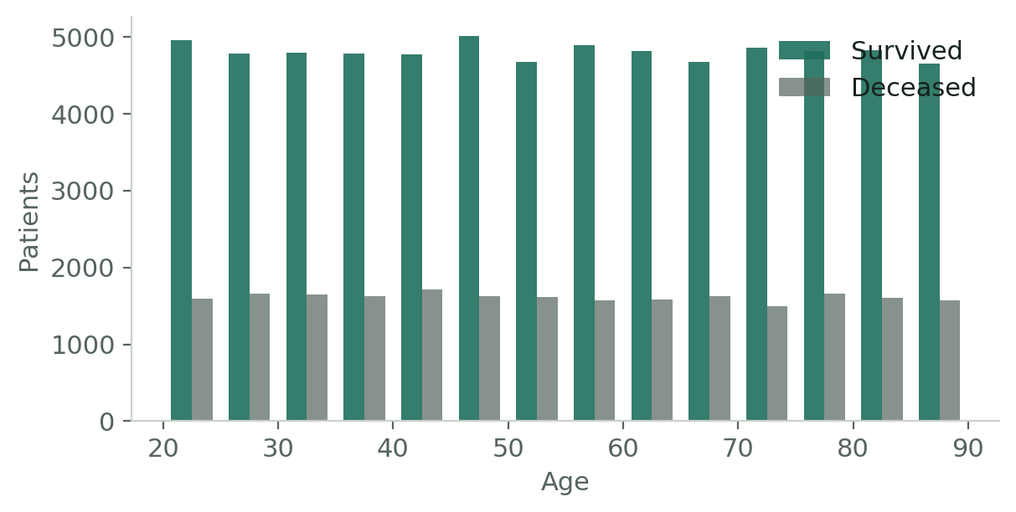
Figure 2. Age distribution split by survival status.
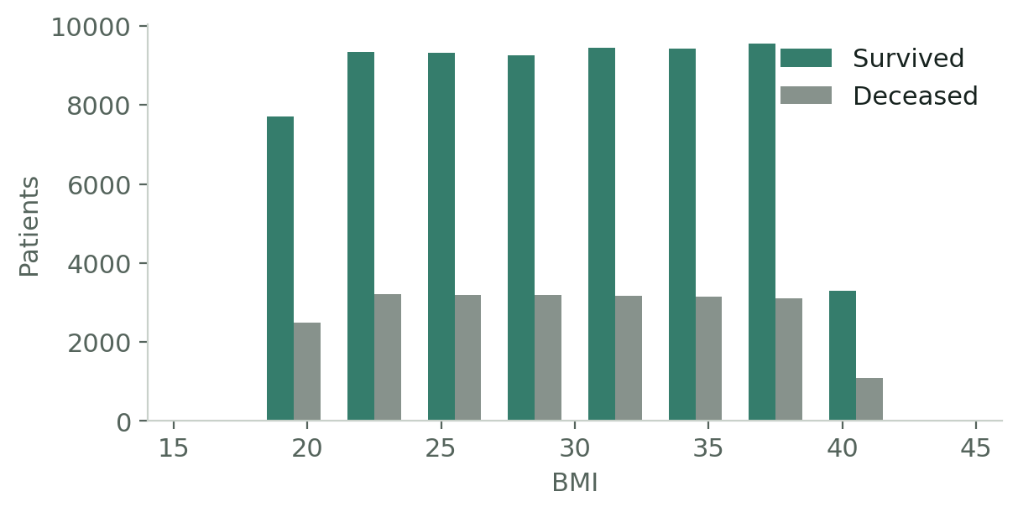
Figure 3. BMI distribution split by survival status.

Survival rate by subgroup
Across every clinically relevant grouping — cancer stage, tumor aggressiveness, smoking status, and recurrence — the survival rate within each subgroup lands within roughly half a percentage point of the 74.87% cohort average (dashed line). No subgroup stands out as meaningfully higher- or lower-risk.
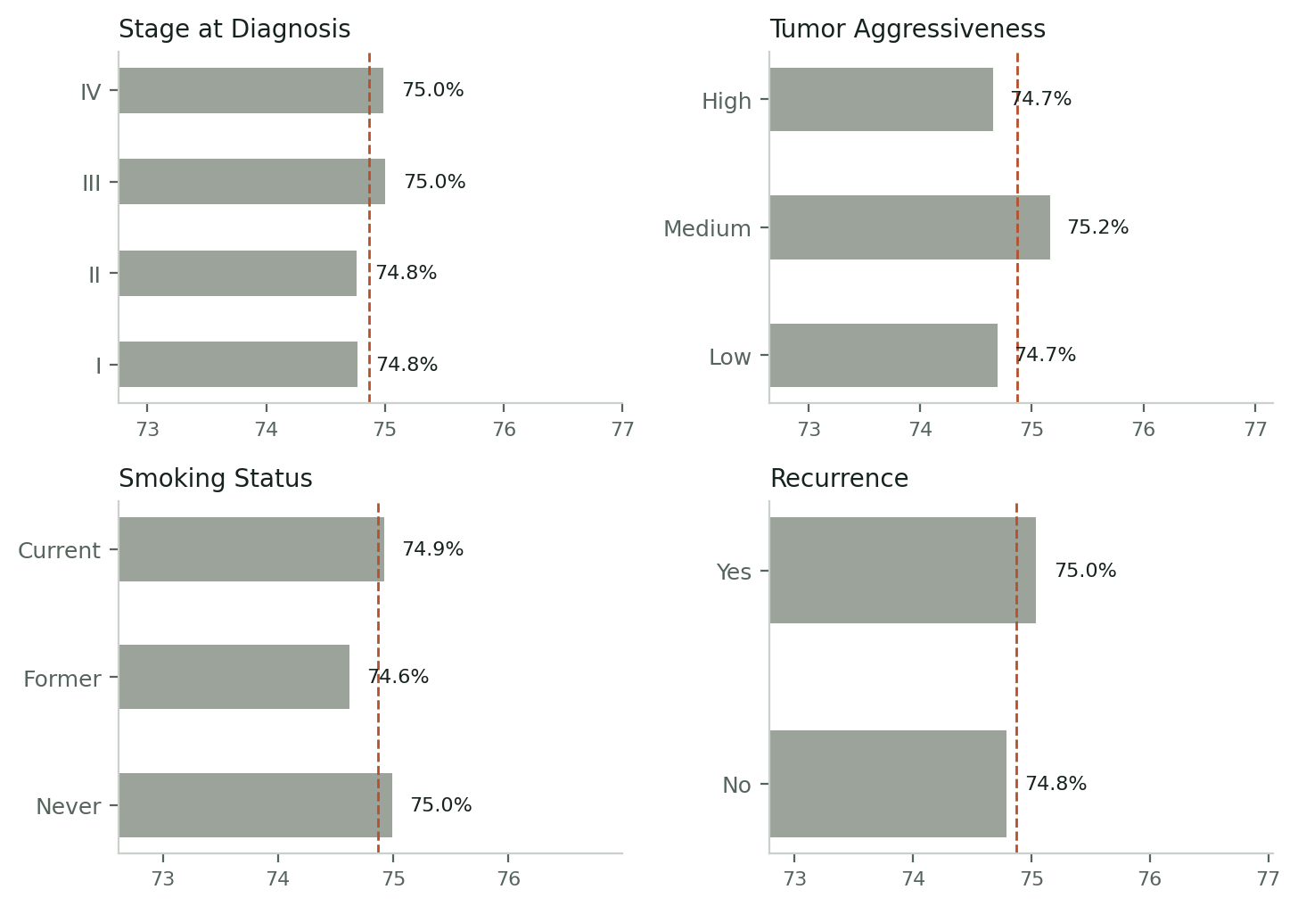
Figure 4. Survival rate (%) by subgroup vs. cohort average, selected variables.

04 · STATISTICAL HYPOTHESIS TESTING

Statistical Hypothesis Testing
Visual similarity across subgroups can be misleading at a glance, so every categorical feature was formally tested against Survival Status with a Chi-Square test of independence, and every numerical feature with a Welch's t-test. A p-value below 0.05 would indicate a statistically significant association.
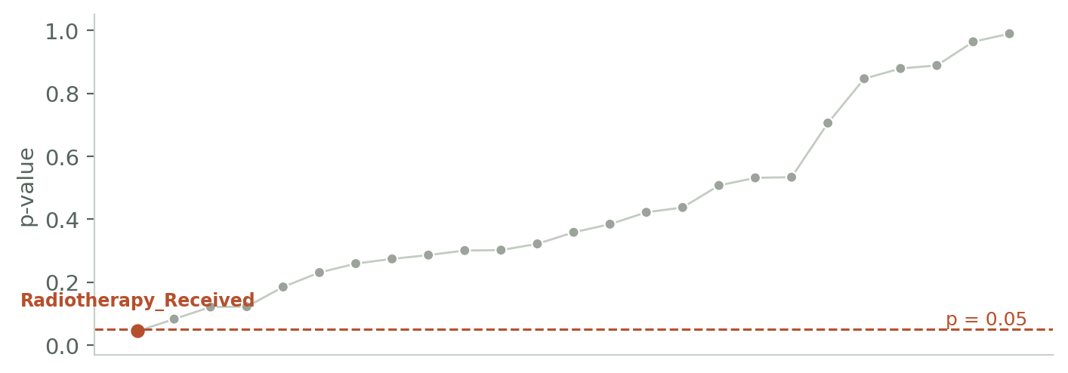
Figure 5. All 25 Chi-Square p-values, sorted ascending, against the p=0.05 threshold.
With α = 0.05 and 28 independent tests run, roughly 1–2 false positives are expected from chance alone. Exactly one came back significant (Radiotherapy_Received, p = 0.044) — consistent with statistical noise rather than a genuine effect, and not something a clinician would treat as a reliable finding on its own.

Chi-Square results — categorical features (n=25)
Feature | Chi² | p-value | Result (α=0.05)
Radiotherapy Received | 4.042 | 0.0444 | Significant
Surgery Received | 3.013 | 0.0826 | Not significant
Gender | 2.405 | 0.121 | Not significant
Region | 7.276 | 0.122 | Not significant
Follow Up Adherence | 1.759 | 0.1847 | Not significant
Diet Type | 2.935 | 0.2305 | Not significant
Tumor Aggressiveness | 2.702 | 0.2589 | Not significant
Socioeconomic Status | 2.59 | 0.2738 | Not significant
Race | 5.013 | 0.286 | Not significant
Red Meat Consumption | 2.405 | 0.3004 | Not significant
Fiber Consumption | 2.397 | 0.3017 | Not significant
Insurance Coverage | 0.983 | 0.3215 | Not significant
Chemotherapy Received | 0.844 | 0.3583 | Not significant
Treatment Access | 0.757 | 0.3842 | Not significant
Screening Regularity | 1.726 | 0.4219 | Not significant
Recurrence | 0.604 | 0.4372 | Not significant
Colonoscopy Access | 0.44 | 0.5072 | Not significant
Family History | 0.392 | 0.5314 | Not significant
Smoking Status | 1.257 | 0.5335 | Not significant
Alcohol Consumption | 0.698 | 0.7055 | Not significant
Urban or Rural | 0.037 | 0.8465 | Not significant
Time to Diagnosis | 0.023 | 0.8789 | Not significant
Stage at Diagnosis | 0.635 | 0.8885 | Not significant
Previous Cancer History | 0.002 | 0.9638 | Not significant
Physical Activity Level | 0.021 | 0.9894 | Not significant

Welch's t-test results — numerical features (n=3)
Feature | t-statistic | p-value | Result
Age | 0.752 | 0.4518 | Not significant
BMI | 0.784 | 0.4328 | Not significant
Time to Recurrence | 0.623 | 0.533 | Not significant

05 · PREDICTIVE MODELING

Model Performance
Both models were trained on the full preprocessed feature set and evaluated on the held-out 20% test set.
Model | Accuracy | ROC-AUC | Beats baseline?
Baseline (majority class) | 74.87% | 0.5000 | —
Logistic Regression | 74.87% | 0.5055 | No
Random Forest | 74.87% | 0.5055 | No

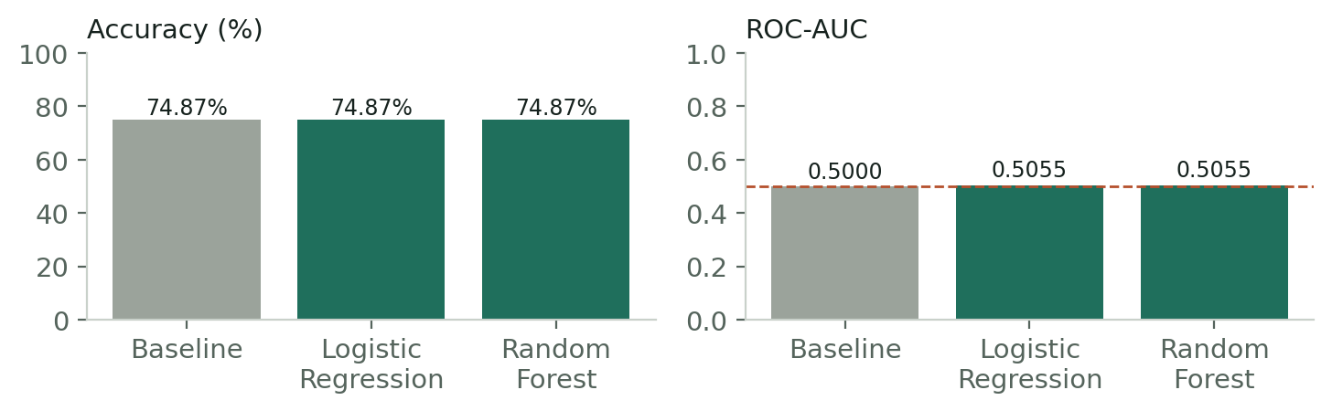
Figure 6. Accuracy and ROC-AUC — both models vs. baseline.

ROC curve
Both curves sit almost exactly on the diagonal — the signature of a classifier with no discriminative power. Random Forest's curve bows very slightly off the diagonal but not meaningfully so.
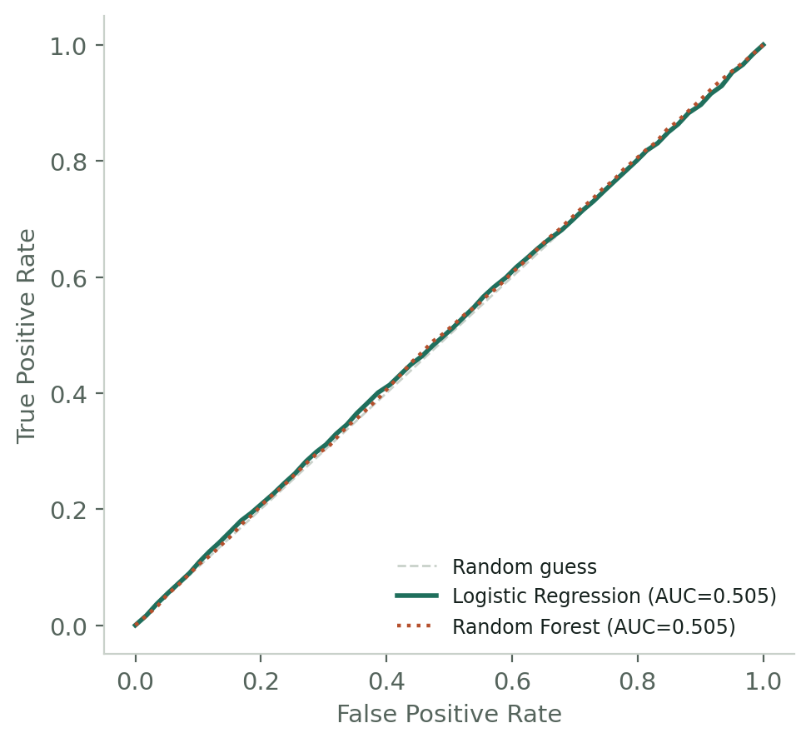
Figure 7. ROC curves for Logistic Regression and Random Forest.

Confusion matrix
The two models' confusion matrices are effectively identical: both predict "Survived" for almost every patient in the test set, and correctly identify zero "Deceased" cases. This is what happens when a classifier learns only the class balance and nothing else — it defaults to the majority class every time.
 | Predicted: Deceased | Predicted: Survived
Actual: Deceased | 0 (0.0%) | 4,521 (25.1%)
Actual: Survived | 0 (0.0%) | 13,468 (74.9%)

5-fold cross-validation
To rule out an unlucky train/test split as the explanation, both models were re-evaluated with 5-fold stratified cross-validation on ROC-AUC. The result holds: both models sit at chance level (~0.50) across every fold, not just the original split.
Model | Mean ROC-AUC | Std Dev | Folds
Logistic Regression | 0.5001 | 0.0019 | 0.4989 · 0.5012 · 0.4981 · 0.4991 · 0.5033
Random Forest | 0.5021 | 0.0038 | 0.5064 · 0.4978 · 0.4984 · 0.5012 · 0.5065

06 · CONCLUSION & RECOMMENDATIONS

Conclusion & Recommendations
As provided, this dataset does not contain a learnable signal for Survival Status using the recorded features. The outcome behaves as though it was generated independently of demographics, clinical history, lifestyle, and treatment variables — a pattern consistent with a synthetic or simulated dataset built without an embedded feature-outcome relationship.

Evidence summary
— Baseline accuracy (always predict "Survived"): 74.87% — both trained models matched this exactly, no better.
— ROC-AUC for both Logistic Regression and Random Forest: 0.5055 — statistically indistinguishable from 0.500 (a coin flip).
— 24 of 25 Chi-Square tests and all 3 t-tests came back non-significant at α = 0.05; the one exception is consistent with chance.
— 5-fold cross-validation confirms the flat result holds across every data split.

Recommended next steps
— Verify the data source or generation process for an intended feature-outcome relationship.
— Engineer interaction features (e.g. Stage × Tumor Aggressiveness) in case the signal is non-additive.
— Try gradient boosting models (XGBoost, LightGBM) with hyperparameter tuning as a final check.
— Apply SMOTE or class-weighting for the imbalance if a genuine signal is found in a revised dataset.
Reporting an honest null result — backed by hypothesis testing, multiple models, and cross-validation — is a more defensible analytical outcome than forcing a narrative onto a 74.9% accuracy figure that merely reflects class imbalance.

