MARKETING CHANNEL ROI ANALYSIS
Business Insights Report — Exploratory Data Analysis · 200,000 campaigns, 2021

200,000  Campaigns Analyzed | 14.05%  Overall CTR | 5.00x  Overall Avg. ROI | $2.50B  Total Ad Spend

Executive Summary
After cleaning and profiling 200,000 campaign records across six channels (Google Ads, Facebook, Instagram, YouTube, Email, Website), the data shows no statistically significant difference in ROI, conversion rate, click-through rate, or cost-per-conversion between channels (ANOVA, all p > 0.17). The current allocation — roughly 16.4%–16.8% of spend per channel — is therefore already close to optimal given the evidence available, and we do not recommend a large reallocation of budget on ROI grounds alone.

The Funnel & ROI by Channel
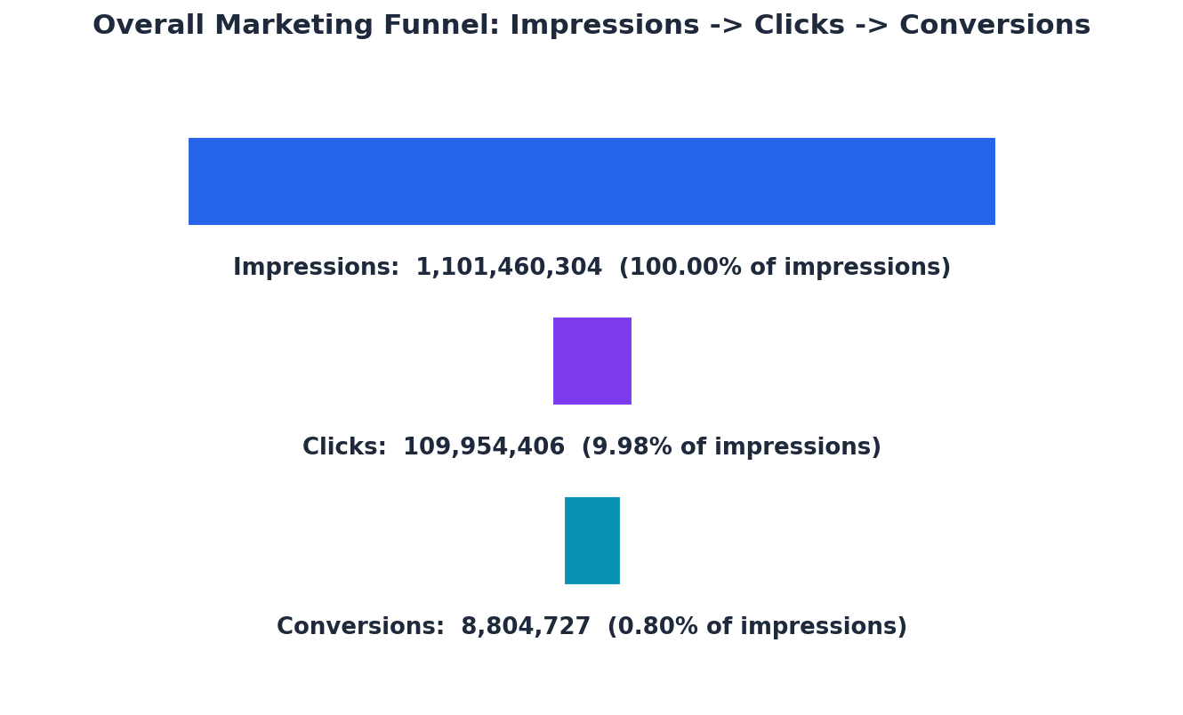 | 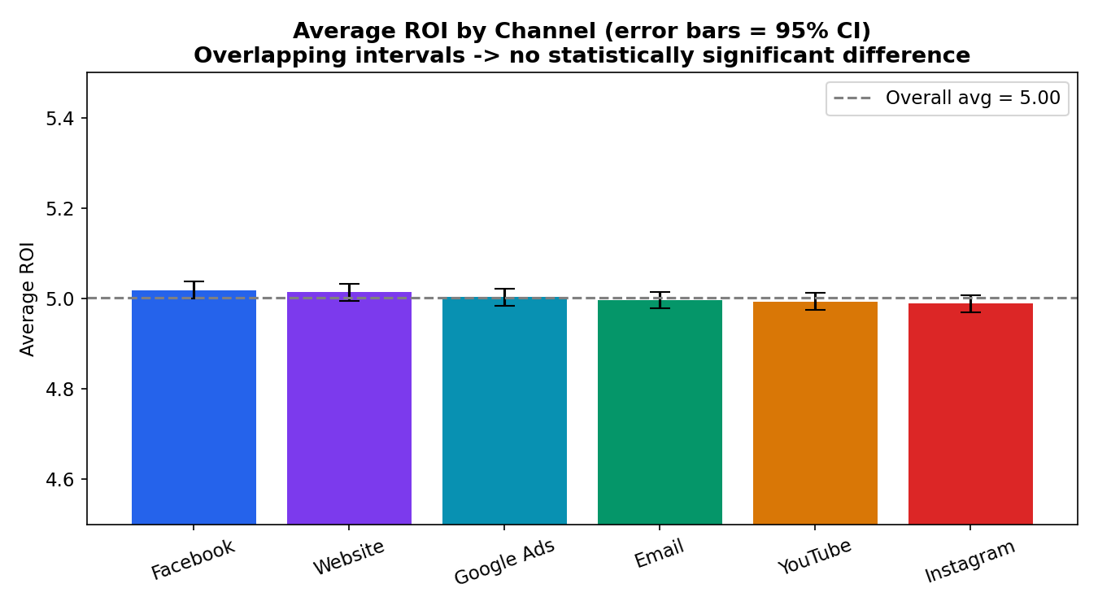
Of every 1,000 impressions, ~141 become clicks and ~11 become conversions — a pattern consistent across all six channels (CTR range: 13.9%–14.1%). ROI averages cluster tightly around 5.0x with fully overlapping 95% confidence intervals — visual confirmation that no channel outperforms.

Key Findings
- Influencer and Search campaign types edge out Social Media and Email (5.01x vs 4.99x), but the gap is inside the margin of statistical noise (ANOVA p = 0.40).
- Website (5.014x) and Facebook (5.019x) post the highest average channel ROI; Instagram is lowest (4.989x) — a spread of only 0.03, well within the confidence intervals shown.
- Website has the lowest average cost-per-conversion (~$637); Google Ads is highest (~$648), a ~1.7% gap that is directionally favorable but not significant (p = 0.76).
- No audience, location, or customer-segment cut showed a robust ROI effect either — only Target_Audience (p = 0.037) was marginally significant, with an effect too small to act on alone.

Recommendation
Do not make a large, ROI-driven budget shift between channels — the evidence doesn't support one, and doing so would be optimizing on noise. Instead:
- Maintain the current near-even spend split, with a small (~5–10%) tilt toward Website and Facebook, which show the most consistent (if modest) edge on ROI and cost-efficiency.
- Stop relying on ROI alone as the decision metric — it isn't currently distinguishing channels. Track incrementality (holdout/geo experiments) and downstream revenue quality.
- Re-run quarterly as data accumulates, and segment by creative/offer type, which may hold more explanatory power than channel alone.
Methodology: Currency/duration parsed, dtypes fixed (0 nulls/duplicates found); conversions estimated as Clicks × Conversion_Rate; group differences tested via one-way ANOVA (α = 0.05).

