Walmart Store Sales: Demand Forecasting & Inventory Insights
Capstone Business Report | Data Analytics Portfolio Project

Executive Summary
Walmart operates 45 stores whose weekly sales data (Feb 2010 – Oct 2012, 6,435 records) was analyzed to help inventory planning teams better match supply with demand. The dataset was clean — no missing values, no duplicate rows — so analysis moved straight to exploratory work and forecasting.
The headline finding: sales are overwhelmingly driven by the retail calendar, not by macroeconomic conditions. Unemployment, temperature, and the Consumer Price Index (CPI) each show only weak or inconsistent relationships with weekly sales at the chain level. What matters most is Thanksgiving week specifically — the single biggest sales event of the year at +41% over a normal week — while the flagged “Christmas” week (the week after Christmas Day) actually dips slightly below average, since the real pre-Christmas rush falls in the unflagged weeks just before it. A 12-week-ahead sales forecast was built for every store using this seasonal pattern, beating a seasonal-naive baseline with a median forecast error of about 3% in back-testing.

1. Data Quality
The raw dataset (Store, Date, Weekly_Sales, Holiday_Flag, Temperature, Fuel_Price, CPI, Unemployment) required no missing-value treatment — every field was fully populated and there were no duplicate rows. Dates were converted to a proper datetime type, and Year, Month, and ISO week fields were derived to support the seasonality analysis.
Outlier screening (per-store IQR on Weekly_Sales, since baseline volume differs widely store to store) flagged about 4.7% of weeks (300 of 6,435). Notably, 28.3% of those flagged weeks were holiday weeks — genuine demand spikes rather than data errors. All rows were retained for analysis and forecasting rather than removed, since stripping out holiday spikes would erase the very signal inventory planning needs to anticipate.

2. What Drives Weekly Sales?

a. Unemployment
Across the chain, the correlation between the local unemployment rate and weekly sales is weak (r = -0.11), meaning unemployment is not a strong driver of sales chain-wide. However, a small subset of stores show a much stronger negative relationship — store #38 (r = -0.79) and store #44 (r = -0.78) stand out well above the rest of the chain — indicating those two locations are far more exposed to local labor-market swings and warrant closer monitoring or more conservative inventory buffers when local unemployment rises.
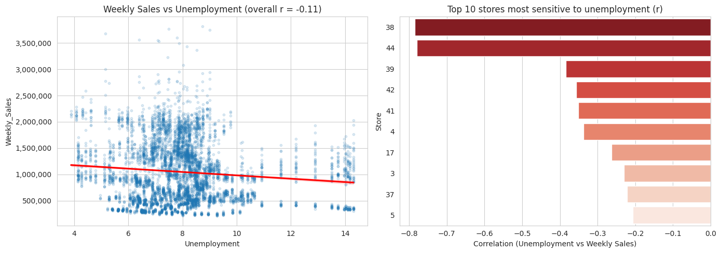

b. Seasonal Trend — and Which Specific Holiday Matters
Yes — there is a clear, repeating annual sales cycle layered on a mild upward trend, peaking around November and dipping in January-February. A statistical test confirms holiday weeks overall have significantly different average sales than non-holiday weeks (p < 0.01).
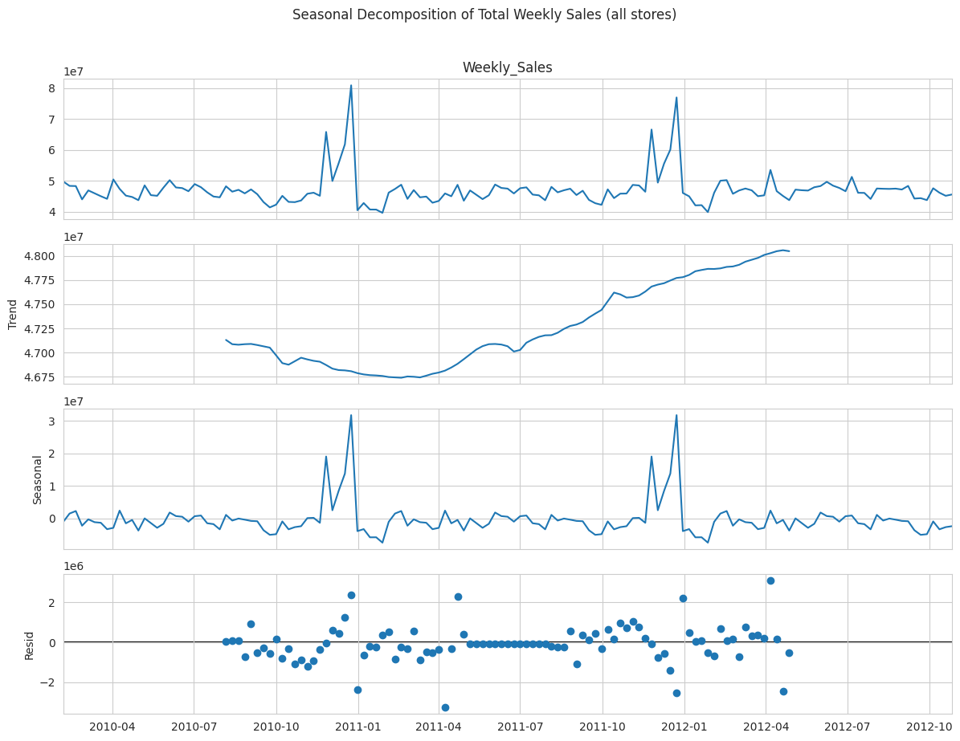
Breaking the four flagged holiday events out individually tells a sharper story: Thanksgiving week runs about 41% above an average week — by far the single biggest sales event in the calendar. Super Bowl and Labor Day weeks are close to a normal week. The week flagged as “Christmas” in this dataset is the week ending December 31 — i.e. the week after Christmas Day — and it actually comes in about 8% below an average week, since the real pre-Christmas buying rush happens in the unflagged weeks just before it. This matters operationally: ordering heavily for the flagged Christmas week alone would miss the actual pre-Christmas demand peak.
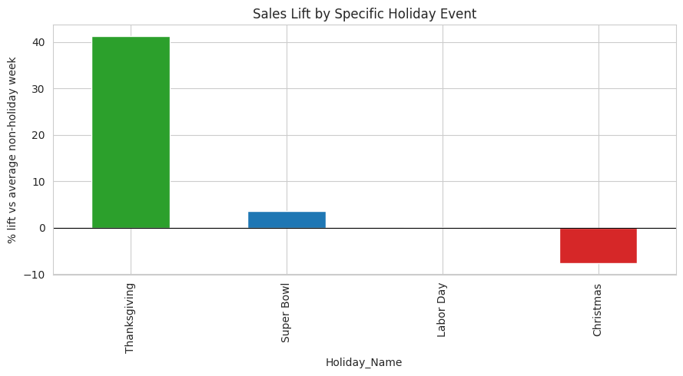

c. Temperature
Temperature shows a weak, largely negligible direct relationship with weekly sales (r = -0.06) once the holiday calendar is accounted for. Weather is not a meaningful independent driver of demand for this chain.
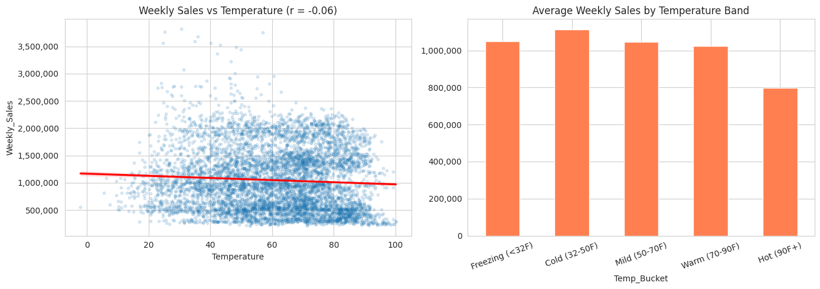

d. Consumer Price Index (CPI)
CPI's relationship with sales is inconsistent from store to store — overall correlation is close to zero (r = -0.07), but store #36 shows a strong negative relationship (r = -0.92) while stores #38 and #44 show a strong positive one (r = 0.81, 0.74). This suggests regional cost-of-living pressure affects individual store performance unevenly rather than acting as a single chain-wide lever, likely reflecting differences in local customer income sensitivity.
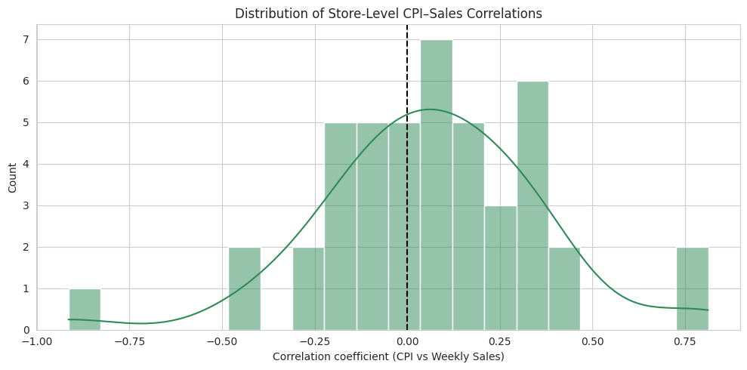

Putting all drivers side by side
A full correlation heatmap confirms the pattern across all four candidate macro drivers at once: none of Unemployment, Temperature, CPI, or Fuel_Price correlates strongly with Weekly_Sales. The simple binary Holiday_Flag has a visibly stronger relationship than any of them — reinforcing that the calendar, not the economy or the weather, is what actually moves sales in this dataset.
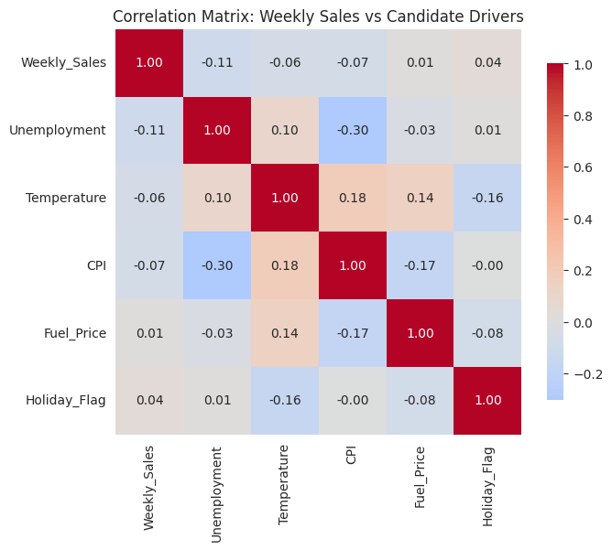

3. Store Performance: Tiers, Best, Worst, and the Gap
Rather than relying on a single ranked list, stores were grouped into three performance tiers using K-Means clustering on average sales, volatility, and holiday sensitivity. This gives planners a more actionable segmentation than volume alone:
Tier | # Stores | Avg Weekly Sales | Volatility (CV) | Holiday Lift
High-Volume | 23 | $1,477,010 | 0.13 | +7.6%
Mid-Volume | 14 | $690,937 | 0.16 | +11.7%
Low-Volume | 8 | $433,633 | 0.09 | -0.5%

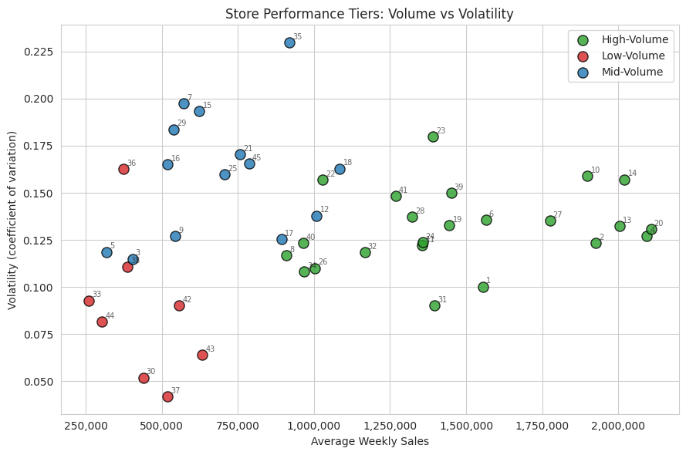
High-Volume stores carry the most revenue with fairly consistent week-to-week demand — safe to run leaner, more just-in-time inventory. Mid-Volume stores are the largest group and show the strongest relative holiday lift, making holiday-week stocking especially valuable there. Low-Volume stores are smaller but not necessarily more erratic in relative terms; their smaller base means a bad forecast week still hurts proportionally, so they benefit from a larger relative safety-stock buffer.
Store #20 is the top historical performer with roughly $301M in total sales over the period, closely followed by stores #4, #14, #13, and #2. Store #33 is the weakest performer, with roughly $37M in total sales — 8.1x less than the top store, a gap of about $264M (87.7% lower than store #20).
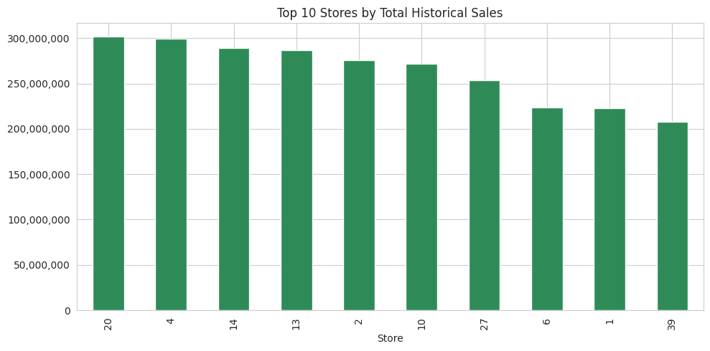
This spread is far too large to be explained by the weak/inconsistent macro drivers above. It more likely reflects structural differences between stores — store size or format, catchment population, or regional demand density — factors not captured in this dataset but worth investigating with store metadata for a targeted turnaround plan at the lowest-performing locations.
Rank | Store | Total Sales | Avg Weekly Sales
1 (Best) | #20 | $301,397,792 | $2,107,677
2 | #4 | $299,543,953 | $2,094,713
3 | #14 | $288,999,911 | $2,020,978
… | … | … | …
44 | #5 | $45,475,689 | $318,012
45 (Worst) | #33 | $37,160,222 | $259,862

4. 12-Week Sales Forecast
Because each store has a strong annual seasonal pattern but a relatively short history (~143 weeks), a Holt-Winters (triple exponential smoothing) model — additive trend, 52-week additive seasonality — was fit independently for each of the 45 stores. This approach is well suited to short weekly retail series, is cheap enough to run for every store, and doesn't require forecasting future values of exogenous variables (temperature, fuel price, CPI, unemployment) that wouldn't actually be available at forecast time.
To confirm the model earns its complexity, it was benchmarked against a simple seasonal-naive baseline (forecast = the actual value from 52 weeks earlier) using a 12-week holdout per store. Holt-Winters achieved a median MAPE of 3.0% versus 4.1% for the naive baseline, and beat the naive baseline outright on 35 of the 45 stores.
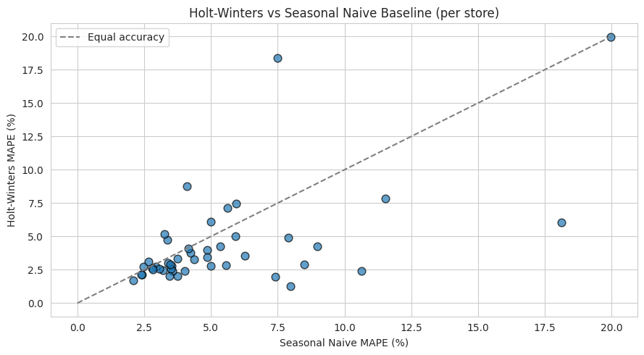
Models were then refit on each store's full history to produce the forward-looking 12-week forecast, together with an 80% confidence interval, delivered as walmart_12week_forecast.csv (540 rows: 45 stores × 12 weeks) and summarized per store in walmart_store_summary.csv, which also includes each store's performance tier and validation accuracy.
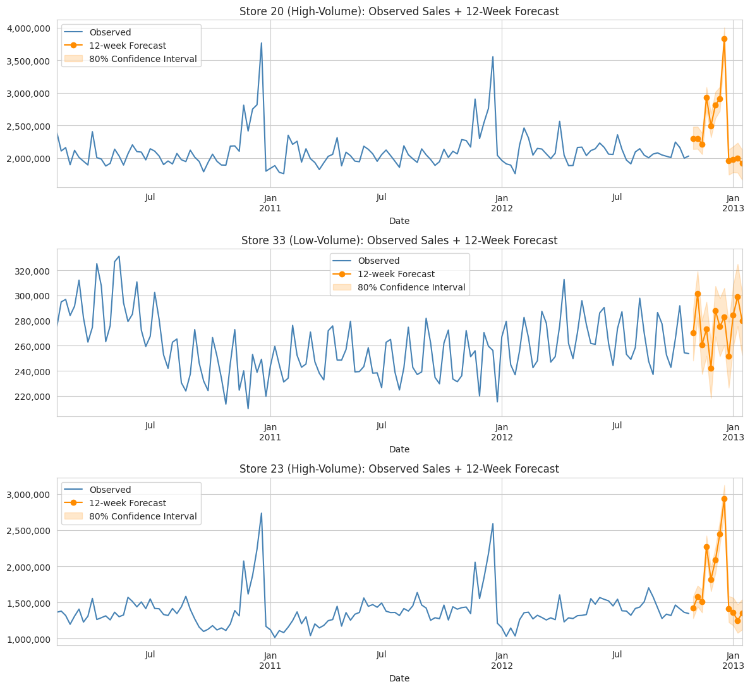
The confidence band matters as much as the point forecast for inventory decisions: a wide band signals a store where planners should lean toward a safety-stock buffer rather than ordering to the point estimate alone.

5. Recommendations for Inventory Planning
- Build the sharpest inventory buffer specifically around Thanksgiving week (the single biggest sales event, +41% over normal), and treat the two weeks immediately before December 31 — not that week itself — as the real Christmas peak.
- Use the per-store 12-week forecasts and confidence intervals (not a single chain-wide number) to size orders, since store performance varies by up to 8x and a uniform plan would over-stock weak stores and under-stock strong ones.
- Apply the High/Mid/Low-Volume tiers as a stocking policy starting point: leaner, more just-in-time ordering for High-Volume stores; extra holiday-week stock for Mid-Volume stores (largest holiday lift); proportionally larger safety buffers for Low-Volume stores.
- Flag stores #38 and #44 for closer tracking of local unemployment trends, given their outsized sensitivity relative to the rest of the chain.
- Investigate store-level metadata (format, size, catchment) for the lowest performers (e.g., store #33) to determine whether the gap versus top stores is addressable or structural.
- Re-validate the forecasting models periodically (e.g., quarterly) as new weeks of data arrive, since Holt-Winters accuracy depends on the seasonal pattern remaining stable.

