Functional Specification



Innovation Foundation

Prepared for

[insert customer name]

4/11/2018

Version 1 Final

Prepared by

**[insert author name]**

[insert author title]

[insert author emails]

Contributors

**[insert author name, title]**

**John Gemkow, Associate Consultant**

Revision and Signoff Sheet

Change Record

|  |  |  |  |
| --- | --- | --- | --- |
| Date | Author | Version | Change Reference |
|  |  | 1 | Initial draft for review/discussion |
|  |  |  |  |
|  |  |  |  |

Reviewers

|  |  |  |  |
| --- | --- | --- | --- |
| Name | Version Approved | Position | Date |
|  |  |  |  |
|  |  |  |  |
|  |  |  |  |

Table of Contents

1 Executive Summary 7

2 Project Vision/Scope Summary 8

3 Project History 9

4 Project Justification and Design Goals 10

4.1 Operations Requirements Summary 10

4.1.1 Installation/Setup Requirements Summary 10

5 Solution Design 11

5.1 Overview 11

5.2 Technical Solution 11

5.3 Roles and Security Groups 13

5.4 List Summary 13

5.4.1 Challenges List 13

5.4.2 Comments List 15

5.4.3 EmployeeList List 15

5.4.4 Questions List 15

5.4.5 QuestionsConfiguration List 16

5.4.6 Answers List 17

5.4.7 IdeaReviewHistory List 17

5.4.8 IdeaState List 18

5.4.9 MailTemplates List 19

5.4.10 ReviewerDirectorate List 19

5.4.11 Ideas List 20

5.5 Code Summary 23

5.5.1 Innovation Foundation Workflow 23

5.5.2 Web.config 23

5.5.3 Deployment Helper 23

5.5.4 PowerShell Scripts (in …\Deployment-PowerShell) 23

5.6 Workflows 24

5.6.1 Idea Review Workflow 24

6 Planned Features and Capabilities 25

6.1 Landing Page 25

6.2 Innovation Foundation OOTB Customizations 25

6.3 Site Metrics 26

6.4 Active User 27

6.5 Create a Challenge 28

6.6 View Ideas Under a Specific Challenge 29

6.7 Create an Idea 32

6.8 View Detailed Idea Description 35

6.9 Rate an Idea 36

6.10 Comment on an Idea 37

6.11 Change an Idea State 38

6.12 Review Ideas 38

6.13 Search Ideas 39

6.14 View Questions 39

6.15 Change Idea Questions & Question Branching Logic 41

6.16 Change Idea Reviewers 42

6.17 Show Idea State Progression 42

6.18 Email Notifications 43

6.19 Challenge Report 43

6.20 Yammer Integration 45

6.21 Idea Duration Report 47

7 Feature Cuts and Unsupported Scenarios 52

8 Assumptions and Dependencies 53

9 References 54

1. Executive Summary

The application entitled “Innovation Foundation” is a SharePoint Online provider-hosted application that enables ideation using SharePoint lists, custom C# code, custom JavaScript code, custom CSS code, SharePoint workflow, and PowerBI integration. The solution enables administrators to create challenges which users can offer solutions, known as Ideas towards. Additionally, the solution enables all ideas to be reviewed for merit and feasibility.

1. Project Vision/Scope Summary

Innovation is one of the primary drivers for growth and profitability in business today, sitting at the top of many corporate agendas. Why? Companies have recognized that efficiency and world-class operational performance alone are not enough to create sustained competitive differentiation and advantage in today’s challenging, global markets. Instead, consumers and businesses alike reward innovation. The Innovation Foundation enables the development of new customer value through solutions that meet new needs, inarticulate needs, or old customer and market needs in new ways.

1. Project History

The Innovation Foundation is a new iteration on the Innovation Hub. The Innovation Foundation comes with a brand-new look-and-feel powered by the Angular Framework, state based reviews, notifications via SharePoint workflows, reporting via PowerBI, and a new Idea Search Center.

1. Project Justification and Design Goals

This project exists to create an ideation platform that allows for users to collaborate on identifying challenges and crowd source ideas to those challenges that impact the enterprise. The design goal of the Innovation Hub is to put information and metadata first to foster user engagement. A user with no prior knowledge of what ideation should be able to jump right in and participate without any blockers.

The major drivers behind the to upgrade from the prior Innovation Hub to the new Innovation Foundation are:

* Existing idea review workflow is perceived to be too slow. The new idea review process will be state driven enabling a reviewer the following benefits:
  + Can act on a newly submitted idea immediately
  + Can view pending actions on a dashboard
  + Notified of a new review via email
  + Can work back and forth with an idea submitter to gather additional information
* Search results aren’t useful. The new Idea Search Center will be configured to only return ideas and will also be easily filterable on predefined idea metadata.
* Reports cannot be updated by system administrators. The current system was built before PowerBI was available in the GCC and as a result a workaround was developed to copy the Ideas list to SQL tables for SSRS reporting.
  1. Operations Requirements Summary
     1. Installation/Setup Requirements Summary

To take advantage of the Innovation Foundation solution, a subscription for Office 365 with SharePoint and optionally, PowerBI (free or Pro) for built in reporting, are required.

Additionally, the SharePoint Application Package for Innovation Foundation is required. If you do not have the Application Package, please contact you Microsoft representative or authorized Microsoft Solution Partner.

The installation typically requires 60 minutes of time. Configuration of the solution may require several hours, depending on your needs and processes.

1. Solution Design
   1. Overview

Innovation Foundation is modeled from an internal system within Microsoft that facilitates Innovation by engaging a social community of members and focusing their efforts on specific business challenges, opportunities or discovery. As Innovation Foundation must cater to many different audiences and goals, it is designed to be configured and customized by the Enterprise to suit their needs or used as is with its baseline capabilities and processes.

Innovation Foundation utilizes three main constructs:

1. **Idea:** A description of a novel concept, or a solution proposal, with relevant supporting content and feedback from the enterprise’s social network such as rating and discussions.
2. **Challenge:** An event containing many ideas in response to a specific topic, goal, or business challenge that utilizes basic game mechanics to increase participation such as limited time, popularity, progress and awards.
3. **Hub:** A collection of Challenges and associated ideas that are evaluated according to business parameters, and accessible by authorized participants.

There is an intrinsic relationship between all three main constructs. A Hub serves as the host for Challenges, and in turn Challenges host Ideas. This relationship ensures that Ideas are always aligned to a goal or objective of a specific Challenge, and that Hubs are dedicated to hosting sets of Challenges over time. Additionally, Hubs control branding, and accessibility via permissions

* 1. Technical Solution

The Innovation Foundation solution utilizes a provider-hosted add-in architecture. **Figure 1** below shows the differences between a SharePoint-hosted add-in and a Provider-hosted add-in.

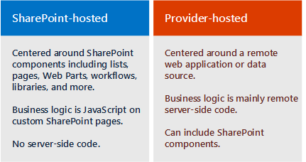

Figure 1: SHA vs PHA

A provider-hosted add-in/app is distinguished from SharePoint-hosted add-ins because they include at least one remote component, such as a web application, service, or database, which is hosted externally from the SharePoint farm or SharePoint Online subscription. This could be a server in the same corporate network as a SharePoint farm or a cloud service

The remote components for the Innovation Foundation solution include:

* Console Application configured as a scheduled task powering the state-driven workflow
* Business logic via AngularJS Model-View-Controller (MVC) architecture

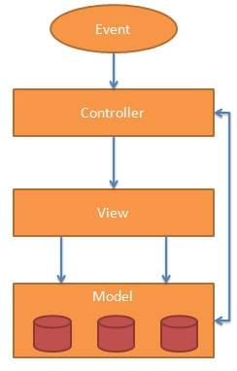

Figure 2: AngularJS MVC Architecture

The Innovation Foundation PHA can be deployed to either:

* Azure Web Site (**NOTE: App MUST be registered with Azure AD to work correctly if you go with this deployment option)**
* On-Premises IIS Site (**NOTE: web.config must be updated to properly reflect IIS Site path if you go with this deployment option)**

The Innovation Foundation utilizes both server-side and client-side caching to improve application performance.

* 1. Roles and Security Groups

Three main security groups drive the role assignments in the Innovation Foundation. Each has recommended permissions which can be modified to suit your needs.

1. **Innovation Hub Visitors** – Visitors have READ ONLY access to the Innovation Hub. They cannot create ideas.
2. **Innovation Hub Members** – Members have contribute-level access to the Innovation Hub. They can create ideas and participate in discussions. They cannot create challenges.
3. **Innovation Hub Owners** – Owners have full access to the Innovation Hub. They can administrate the site, create challenges, create ideas, as well as participate in discussions.
4. **Admins –** Admins can create challenges, create ideas, as well as participate in discussions. This is a limited access SharePoint group.



9. 4. List Summary
      1. Challenges List

The ‘Challenges’ list is a critical list to operation of the Innovation Foundation solution. Users in the Innovation Hub Owners group can create new challenges. Newly created challenges that are marked as “Published”, with an active start and end date appear on the Innovation Foundation landing page for users to submit Ideas against.

|  |  |  |
| --- | --- | --- |
| Column Name | Type | Purpose |
| Title | Single line of text | The name of the challenge that will appear on the homepage |
| Text | Single line of text | The name of the challenge that will appear on the homepage. |
| Description | Multiple lines of text | The description of the challenge. Will appear in the Challenge tile after the user clicks on the challenge to seek more information / add an idea |
| Start Date | Date and Time | Helps to determine whether a challenge is active. If a start date is less than the current date, a user will not be able to add ideas against the challenge |
| End Date | Date and Time | Helps to determine whether a challenge is active. If an end date is after than the current date, a user will not be able to add ideas against the challenge |
| Background Color | Single line of text | RGB color code for the background color of the challenge box |
| Foreground Color | Single line of text | RGB color code for the text color of the challenge box |
| Status | Single line of text | A challenge that is marked as New or Closed will not appear on the homepage. A challenge that is marked as Published will appear on the homepage. |
| Ideas | Number | Used to count the amount of ideas submitted to the challenge. Treat this field as READ ONLY. |
| Comments | Number | Used to count the amount of comments about the challenge. Deprecated Feature. DO NOT USE. |

* + 1. Comments List

The “Comments” list contains all the comments that were submitted by users against a specific idea.

|  |  |  |
| --- | --- | --- |
| Column Name | Type | Purpose |
| ObjId | Number | This corresponds to the ID of the Idea the idea the comment was submitted under. |
| Title | Multiple lines of text | The comment, plain text only. |
| Text | Multiple lines of text | The comment, plain text only. |
| Created By | Person or Group | The person who submitted the comment |
| Created | Date and Time | The date/time the comment was submitted |
| Type | Single line of text | Used to reference whether the comment was a comment about an idea or challenge. |

* + 1. EmployeeList List

The “EmployeeList” list contains all the users who have visited the site. Used to enable the counter feature. READ ONLY.

|  |  |  |
| --- | --- | --- |
| Column Name | Type | Purpose |
| Title | Single line of text | Contains the email for the employee that visited the site |
| Email | Single line of text | Contains the email for the employee that visited the site |

* + 1. Questions List

The “Questions” list populates the routing questions that appear after a user submits an idea.

|  |  |  |
| --- | --- | --- |
| Column Name | Type | Purpose |
| Title | Multiple lines of text | This contains the question text that will appear on the screen |
| Text | Multiple lines of text | This contains the question text that will appear on the screen |
| Type | Single line of text | This contains the type of question (Choice is the only type supported at this time) |
| ID | List Item ID | Automatically generated list item ID used for reference in “Questions Configuration List |

* + 1. QuestionsConfiguration List

The “Questions Configuration” list allows for an administrator to specify which options a specific question should have, the branching logic (if applicable), and the reviewer group to assign (if applicable.

|  |  |  |
| --- | --- | --- |
| Column Name | Type | Purpose |
| QuestionId | Number | Reference to the ID field for the corresponding question in the “Questions” list. |
| QuestionText | Multiple lines of text | Reference to the Text field for the corresponding question in the “Questions” list. |
| Choice | Single line of text | This contains the text for one of the choices for the corresponding question. |
| BranchQuestionId | Number | Reference to the ID field for the corresponding question in the “Questions” list to branch to based on the selected choice |
| BranchQuestionText | Multiple lines of text | Reference to the Text field for the corresponding question in the “Questions” list to branch to based on the selected choice |
| ReviewerGroup | Single Line of Text | This contains the Reviewer Group to be assigned to the idea based on the choice selected. An empty value means that no Reviewer Group is assigned on that selected choice |
| MaxQuestions | Number | Used to display the percentage calculation as users go through the idea questionnaire. |

* + 1. Answers List

The “Answers” list contains the answers the questions for a given idea. This list is not meant to be edited by Administrators. Treat this list as READ ONLY.

|  |  |  |
| --- | --- | --- |
| Column Name | Type | Purpose |
| IdeaId | Number | Reference to the corresponding Idea |
| QuestionId | Number | Reference to the corresponding Question |
| QuestionText | Multiple lines of text | Reference to the text for the corresponding Question |
| AnswerToQuestion | Single line of text | This contains the choice that the user selected to the corresponding question. |
| ReviewerGroup | Single line of text | ReviewerGroup that was set based on the choice the user made |

* + 1. IdeaReviewHistory List

The “IdeaReviewHistory” list contains the entire review history for a given idea

|  |  |  |
| --- | --- | --- |
| Column Name | Type | Purpose |
| IdeaId | Number | Reference to the corresponding Idea |
| State | Single line of text | Refers to the state the idea was in when the review action took place |
| NextState | Single line of text | Refers to the next state the idea will be placed in |
| Option | Single line of text | This contains the choice that the reviewer selected |
| Comment | Multiple lines of text | Contains the optional comment that a reviewer can leave |
| Created | Date and Time | Contains the date the action took place. Can be used to calculate state duration. |

* + 1. IdeaState List

The “IdeaState” list configures the various idea states that an idea may pass through as it is reviewed for merit and feasibility. All new ideas are put in the “New” IdeaState and will proceed to Merit Review after a predetermined amount of time. When a review action takes place, the code references this list to check for the current state and the option selected. From those two options the idea is moved to the Next state with a Due Date as defined by the DueInDays.

|  |  |  |
| --- | --- | --- |
| Column Name | Type | Purpose |
| Current | Single line of text | Refers to the current state the idea is in when the review option is selected |
| Next | Single line of text | Refers to the next state the idea will be placed in based on the review option selected. |
| Option | Single line of text | Refers to the option the reviewer can select which will transition the idea from the Current to Next state |
| DueInDays | Number | Calculates due date for next state based on the amount of days input here. Automatically considers business days in calculations. |

* + 1. MailTemplates List

The “MailTemplates” list contains the various E-mail templates the system uses as the idea progress through the idea review process. There can only be 1 (one) mail template per idea state. Each idea state is referenced in the Type column

|  |  |  |
| --- | --- | --- |
| Column Name | Type | Purpose |
| Title | Single line of text | Refers to the current internal name for the idea state; can be changed to be more descriptive |
| Subject | Multiple lines of text | Contains the subject text for the email that is going to be sent out. |
| MailBody | Multiple lines of text | Contains the body text for the email that is going to be sent out. The “Click Here” link is case sensitive. This will automatically enable a user to be routed to the review from their email. The {0} special character will automatically input the Idea Title and the {1} special character will automatically input the Idea ID. |
| Type | Single line of text | Refers to the current internal name for the idea state. |

* + 1. ReviewerDirectorate List

The “ReviewerDirectorate” list contains the various Directorates that can be assigned to review an idea based on the QuestionConfiguration

|  |  |  |
| --- | --- | --- |
| Column Name | Type | Purpose |
| Title | Single line of text | Contains the name of the directorate that is referenced in the Question Configuration list |
| Directorate | Single line of text | Contains the name of the directorate that is referenced in the Question Configuration list |
| Reviewers | Person or Group | Contains the list of people who can act as reviewers for idea for the directorate |
| State | Single line of text | State is the IdeaState to which the reviewers for the directorate are to review ideas for.  For example, one row might be HR; John Smith, John Doe; New  While another row might be HR; Joe Smith, Rick Smith; Review.  This means, as part of the HR department John Smith is one of the reviewers for the New stage where as Rick is one of the reviewers for the Review stage. |

* + 1. Ideas List

The “Ideas” list is critical to the operation of the Innovation Hub. The list contains all ideas that are submitted by users as solutions to the Challenges proposed. This list stores all relevant metadata for each idea submission including status and rating information.

The process uses the ReviewersDirectorate list to determine who the reviewers are for the next stage that the idea is moving to. The solution sets the CurrentReviewer field on the Idea item. When the workflow runs, it sends reminders/overdue notices using that field.

|  |  |  |  |
| --- | --- | --- | --- |
| Column Name | Type | Purpose |  |
| Title | Single line of text | The name of the idea that will appear under the idea. | |
| Text | Single line of text | The name of the idea that will appear under the idea. | |
| Description | Multiple lines of text | The description of the idea. | |
| Rating (0-5) | Rating (0-5) | Contains the average star rating (1 -5) for the current idea. | |
| State | Single line of text | Text field containing the possible current idea state (New, Merit, Feasibility, Author, End) | |
| PreviousState | Single line of text | Text field containing the possible previous idea state | |
| ChallengeID | Number | Lookup to the Challenges list. This corresponds to the ID of the challenge the idea was created under. READ ONLY unless you desire to the move the idea under a new challenge. | |
| ChallengeText | Multiple lines of text | Reference to the Challenges list. This corresponds to the title of the Challenge the idea was created under. READ ONLY unless you desire to the move the idea under a new challenge. | |
| ChallengeDescription | Multiple lines of text | Reference to the Challenges list. This corresponds to the description of the Challenge the idea was created under. READ ONLY unless you desire to the move the idea under a new challenge. | |
| ReviewerGroup | Single Line Of Text | Contains the name of the reviewer directorate based on how the idea submitter answered the Idea Questions. | |
| Views | Number | Contains the number of times the idea has been viewed. READ ONLY. | |
| Comments | Number | Contains the number of comments the idea has received. READ ONLY. | |
| MailSent | Yes/No | Specifies whether or not that mail has been sent regarding this idea. | |
| DueDate | Date and Time | References the due date of the current idea state based on the configuration in the Idea States list | |
| FirstAction | Date and Time | References the date the first action was taken | |
| LastAction | Date and Time | References the date the last action was taken | |
| StateOption | Multiple lines of text | Contains the text of the option the merit or feasibility reviewer selected. More descriptive than the State field. | |
| IPUrl | Single Line of Text | This field is used during the submission of the idea. It captures URLs for IP content hosted online. | |
| AppUrl | Single Line of Text | This field is used during the submission of the idea. It captures the URL for the application that is related to the idea (e.g. Proof of Concept) | |
| Contributors | People picker field | Allows submitters of ideas to include team members that work on the idea. This enables visibility of the idea for those team members. | |
| CurrentReviewer | Person or Group | Contains the list of people who can review the ideas. | |
| TimeZoneApprover | Person or Group | In the default idea review/approval process, the first step after initial review is assigning to a time zone approver. | |
| GlobalApprover | Person or Group | In the idea review/approval process, the second step after initial review is moving to a global approver. | |
| PriorityAreaApprover | Person or Group | This field is no longer used. | |

* 1. Code Summary
     1. Innovation Foundation Workflow

Using SharePoint lists, handles the various states of Ideas for the site, admin tasks (e.g. is something overdue), sends reminder emails, and fixing/adjusting the dates for Ideas. This is not a SharePoint workflow, but a separate, console app timer workflow.

* + 1. Web.config

Holds all the key/value pairs of the site configuration and specifications. This includes references to the Yammer, PowerBI, SharePoint site, mail, and Redis cache IDs. This is automated if the user is using the PowerShell scripts to deploy the solution to Azure.

* + 1. Deployment Helper

After following **[FINAL NAME OF AZURE DEPLOYMENT GUIDE HERE]** to identify and create the appropriate resources under an Azure subscription, the Deployment Helper connects to the SharePoint site to create the appropriate site resources. It then creates lists, setting the appropriate restricted permissions for lists that should be accessed/modified by and only by admins.

* + 1. PowerShell Scripts (in …\Deployment-PowerShell)

These scripts are responsible for identifying the user and tenant the app will be deployed to, as well as setting and finalizing the IDs stored in *web.config*. If the resources in Azure don’t exist for the application, these scripts will create the resources. Their intent is to automate as much of the deployment process as possible.

* 1. Workflows
     1. Idea Review Workflow

The solution provides a configurable console application state driven workflow. The console application automatically routes the idea between the various states based on the state configuration. The console application also sends out email notifications on each state change (if configured to not send in realtime), sends out overdue notices, and updates reviewers should reviewers be changed in the middle of the idea review. The workflow is customizable via switches in a config file.

1. Planned Features and Capabilities

If the advanced version of this engagement is being executed, be sure to update the features and capabilities to align with any customizations.

Use this section to identify unambiguously which features are in scope for this release of the solution. Each feature or capability should be described in sufficient detail that all roles can work out what they will need to create/test for the solution to work as designed.

Justification: This is the heart of the Functional Specification and provides the tool that the project team will use to control changes to scope as the project progresses. It will clarify the current project emphasis and deliverables, and prevent possible misunderstanding or confusion.

* 1. Landing Page

The solution provides a landing page that showcases one-to-many challenges, the top 10 ideas by rating, winning ideas, an administrative panel for privileged users, a count of active challenges and ideas, and the ability to add additional web parts and content as needed

* 1. Innovation Foundation OOTB Customizations

The solution provides SharePoint lists that allows for considerable customizations of the solution simply by editing the lists such as:

* Challenge Background Color
* Challenge Status
* Idea States
* Reviewers
* Questions
* Questions Branching Configuration
* Email templates for each idea state

Widgets make up the contents of the User Interface. Each widget can be configured, can be placed in different areas on the page.

Editing the Dashboard:

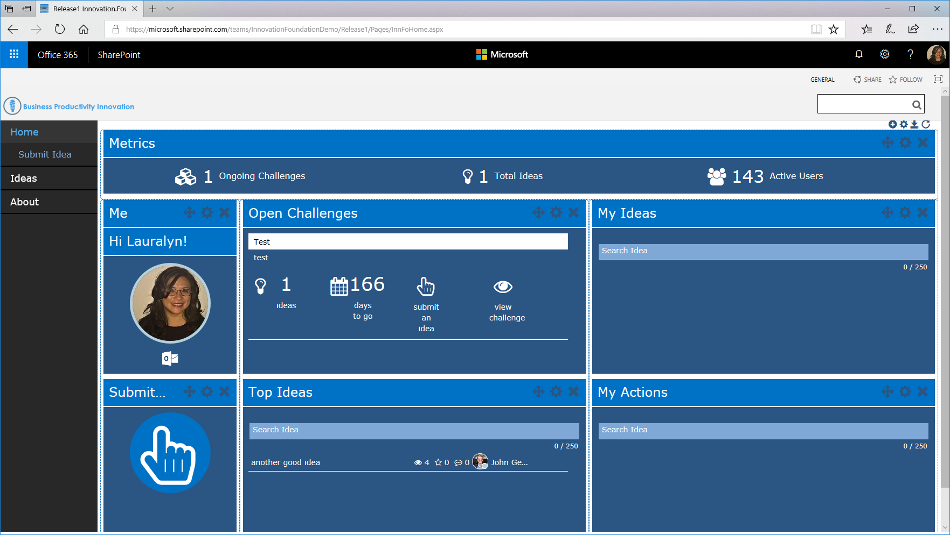

Adding Widgets:

* 1. Site Metrics

The Site Metrics provides a non-editable, non-customizable or non-clickable display of the number of Challenges that are active, the number of site users in the site and the number of ideas

Metrics Widget Settings:

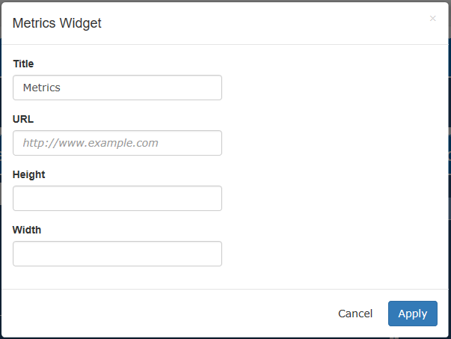



* 1. Active User

The solution includes a picture of the User and a link to get to their Outlook. The New Hire Name Widget will include the picture of the user from Office 365.

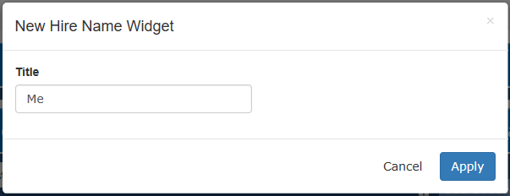

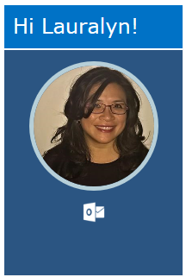

* 1. Create a Challenge

The solution provides a way to create a challenge with a specific start date, end date, and status. The solution stores these challenges in a corresponding SharePoint list.

Create Challenge Widget Settings:

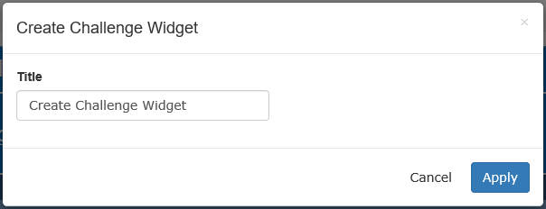

Create Challenge Widget:

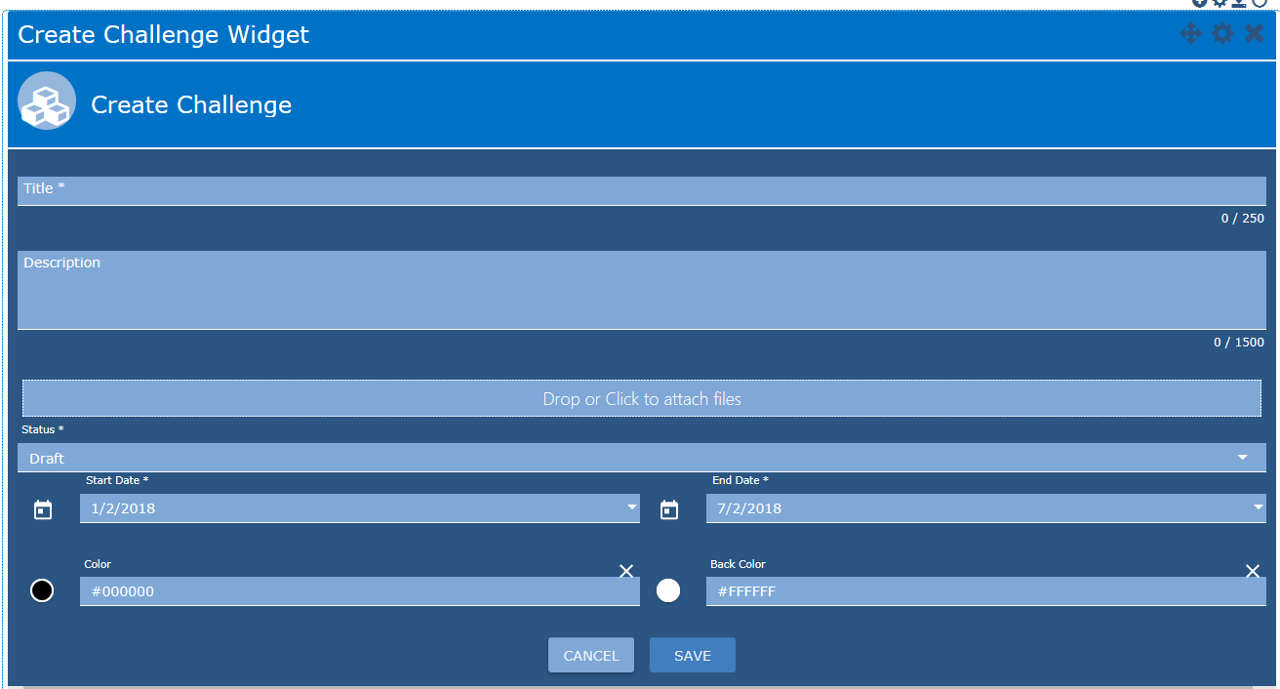

* 1. View Ideas Under a Specific Challenge

The solution provides a way to view all ideas under a specific challenge. The display has the challenge title and detailed description and then a paged view of all the ideas under the challenge. The ideas contain a title and short description.

Ideas Widget Settings:

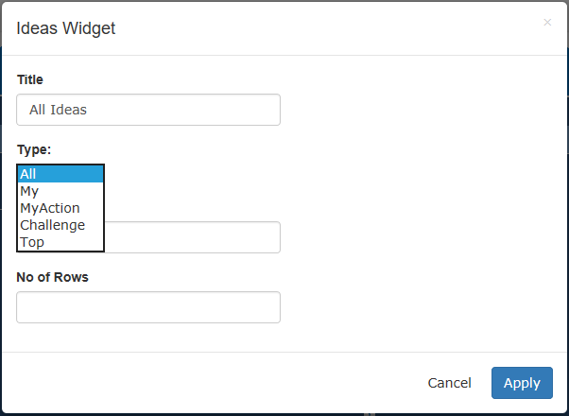

There are multiple Types of Ideas:

* All
* My
* MyAction
* Challenge
* Top

All Ideas:

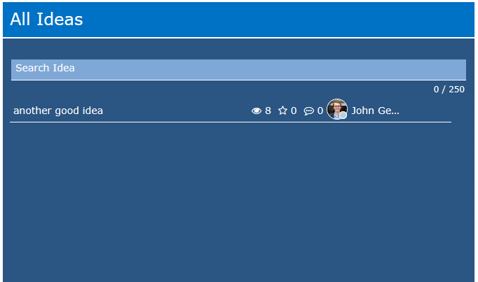

The Users Ideas:

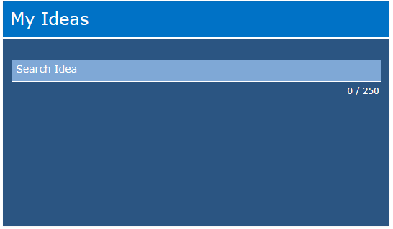

Reviewers Actions for an Idea:

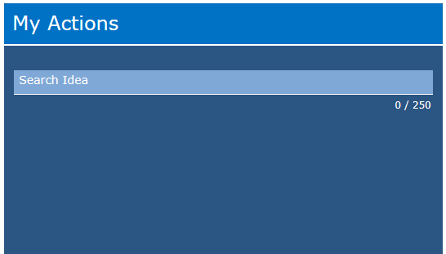

Top Ideas:

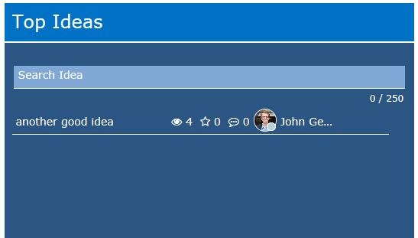

* 1. Create an Idea

The solution provides a way to create an idea and link it to a corresponding challenge. The idea contains a title and a description, as well as, the challenge information for the corresponding challenge. The solution stores these challenges in a corresponding SharePoint list.

From the Landing Page the user can click on the Submit Idea Icon within the Submit Idea Widget to get to the Submit an Idea page.

Submit Idea Widget Settings:

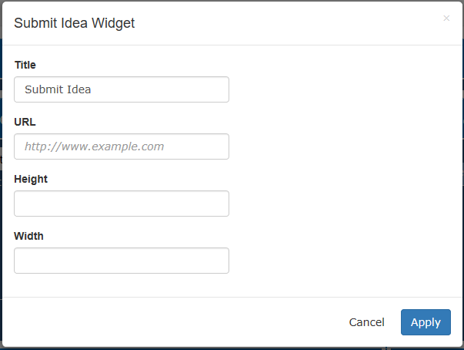

Submit Idea Widget:



Submit Idea Page Dashboard:

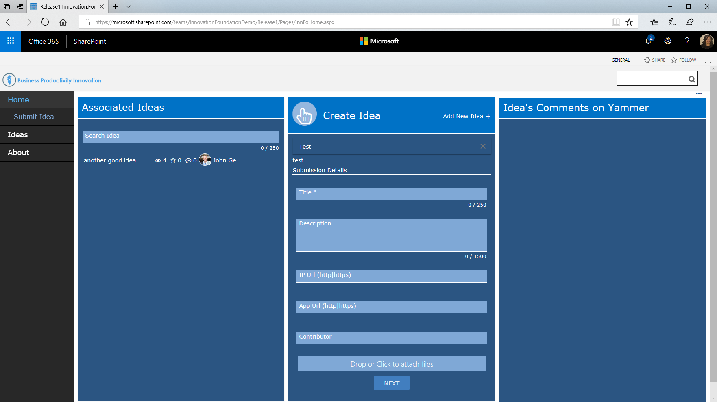

Create Idea Widget Settings:

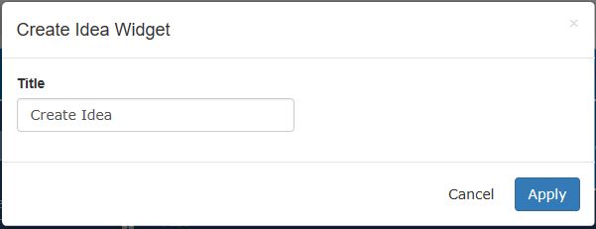

Create Idea Widget:

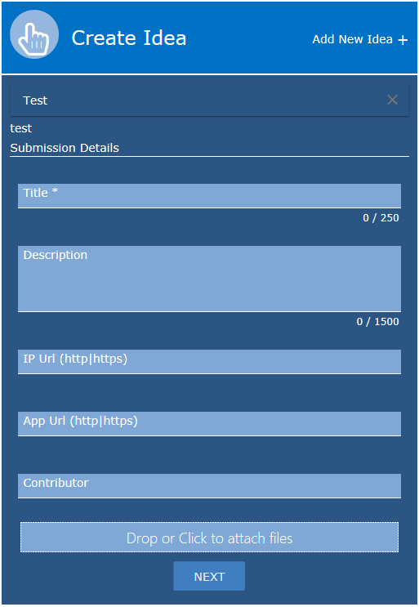

* 1. View Detailed Idea Description

The solution provides a way to view a detailed description of a given idea. The detailed description contains an idea title, full idea description, idea state, idea author, idea rating, and all comments posted towards that idea.

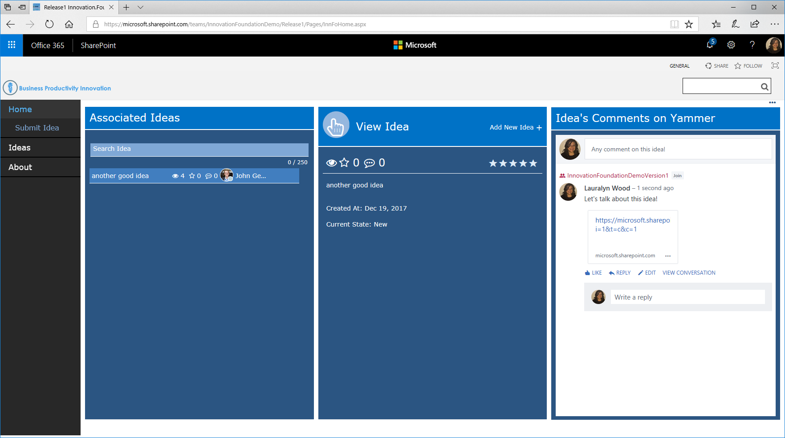

* 1. Rate an Idea

The solution provides the means for a user to rate an idea from 1 to 5 stars. The solution stores the amount of ratings and average rating metrics for each idea.

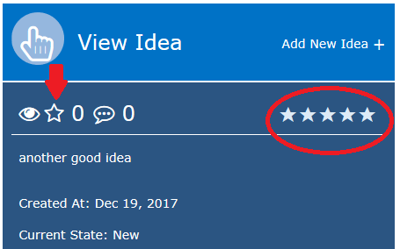

* 1. Comment on an Idea

The solution provides the means for a user to comment on an idea. The new solution will be powered by a custom comments list. This enables comments to be far more visual.

Comments Widget Settings:

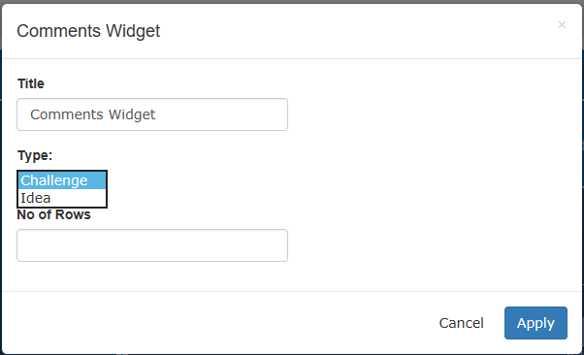

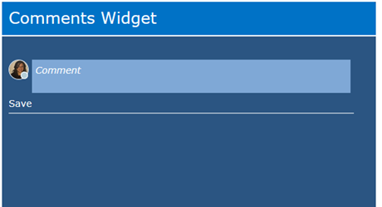

* 1. Change an Idea State

The solution provides the means for an administrator to change an idea state.

* 1. Review Ideas

The solution provides the means for an administrator to review an idea.

Review Idea Widget Settings:

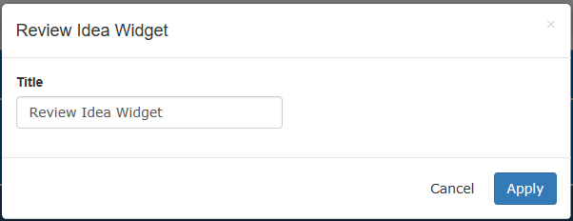

Review Idea Widget:

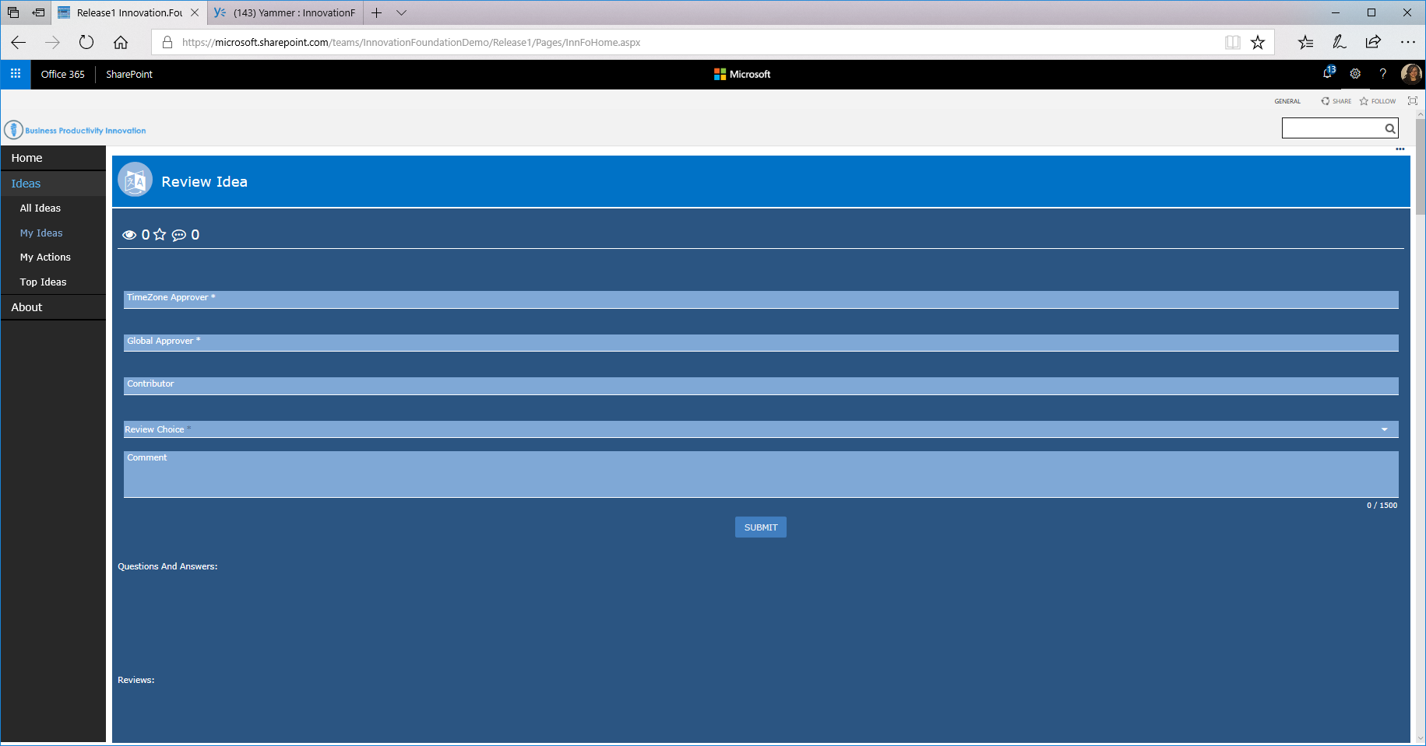

* 1. Search Ideas

The solution provides the ability to search for an idea. It searches using the title, description or status fields.

Search Ideas Widget Settings:

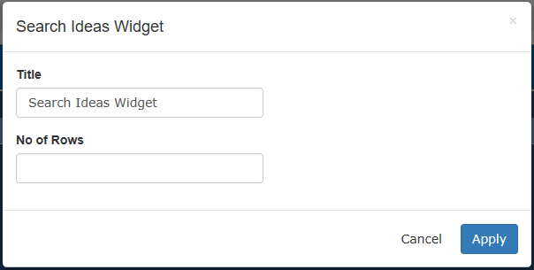

Search Ideas Widget:

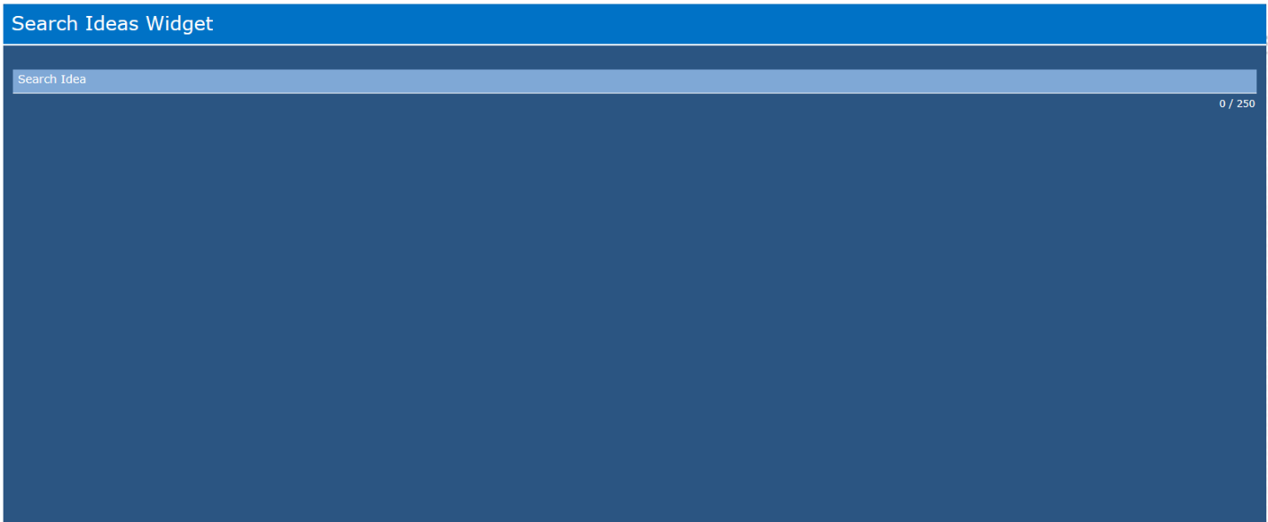

* 1. View Questions

The solution provides a means to view the questions related to the ideation.

Question Widget Settings:

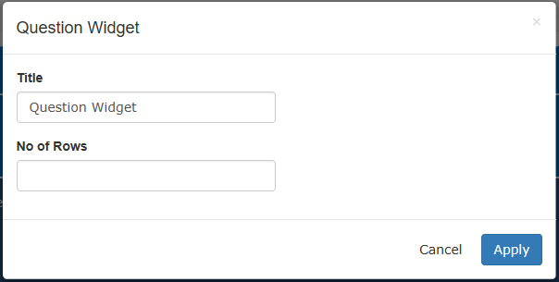

Question Widget:

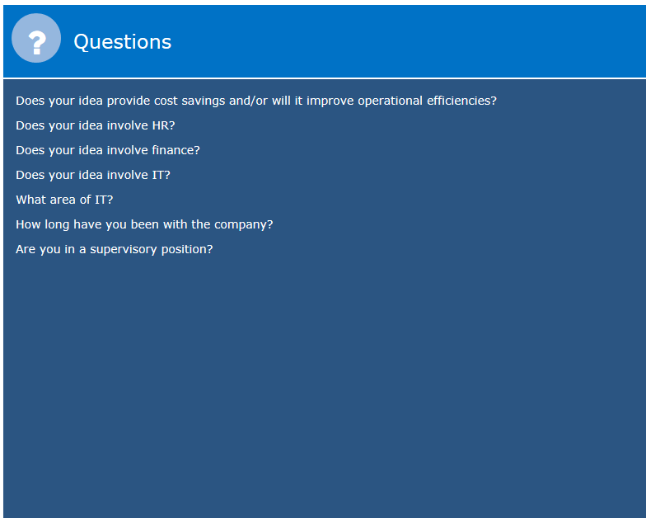

* 1. Change Idea Questions & Question Branching Logic

The solution provides a means for an administrator to change the question tree and branching logic that handles routing the idea to the correct reviewer after an idea is submitted. See the Administrators Guide for more details.

Question Choices Widget Settings:

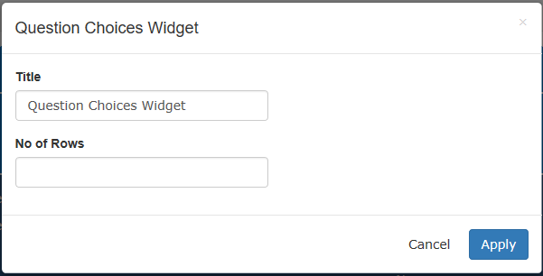

Question Choices Widget: 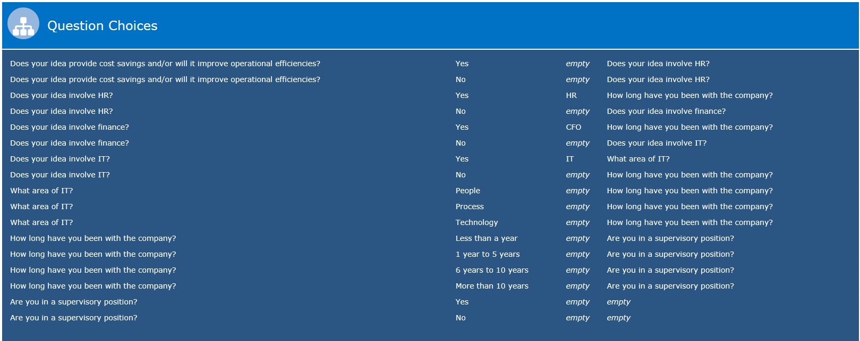

* 1. Change Idea Reviewers

The solution provides a means for an administrator to uniquely specify the reviewers for each idea state. The solution also provides a means to specific admin reviewers which can review the idea should an idea review go overdue.

* 1. Show Idea State Progression

The solution provides a means to display an idea state progression bar on the detailed idea description to inform a user as to the current state of that selected idea.

* 1. Email Notifications

The solution provides a means to customize the email template for each idea state. This customization includes a customizable subject and body, as well as, a special wild card link that automatically routes a user to the idea review by clicking on the link in the email. See the Administrators Guide for more details.

* 1. Challenge Report

The solution provides a report which shows the count of ideas by status by challenge.

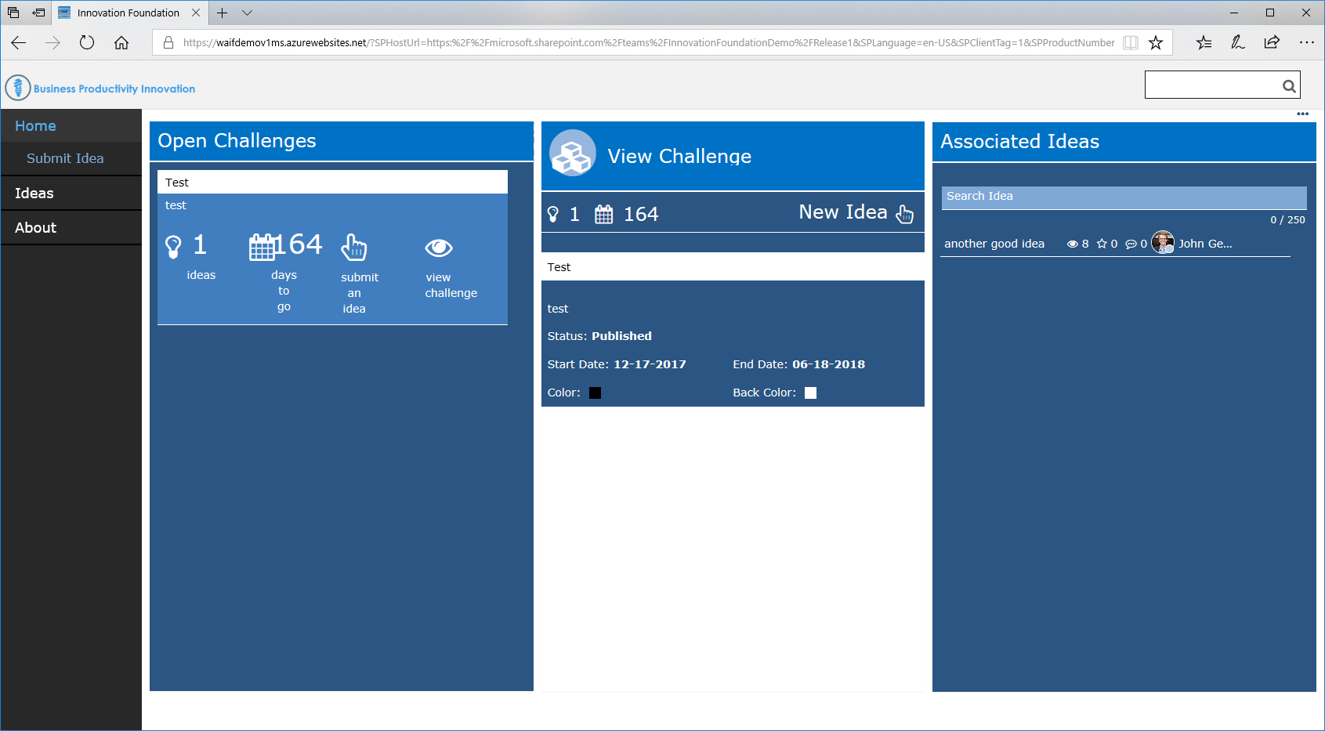

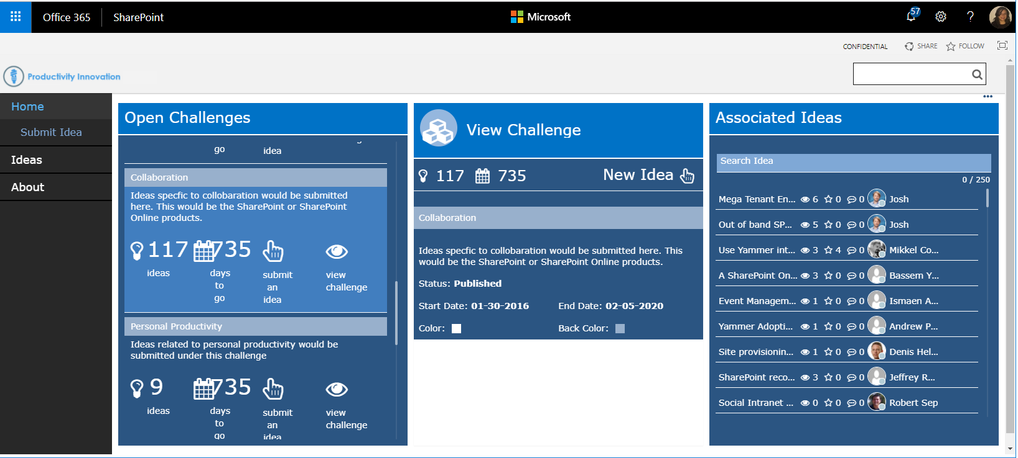

Challenges Widget Settings:

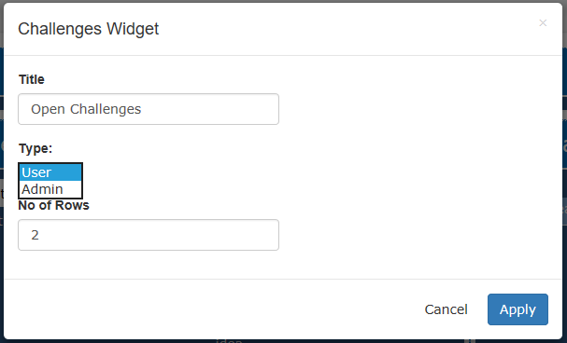

Challenges Widget:

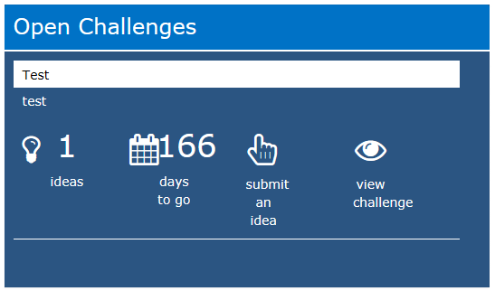

* 1. Yammer Integration

The solution provides integration with Yammer. The user can comment on an idea in the Yammer widget which will be sent to the Yammer group for the Innovation Hub.

Yammer Comments Widget Settings:

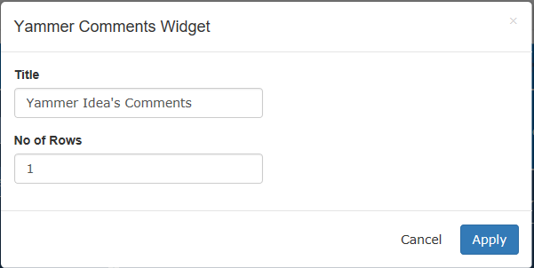

Yammer Comments Widget:

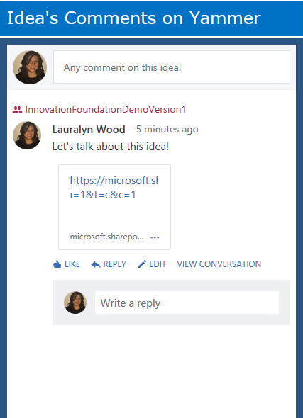

Yammer Site for the Innovation Hub:

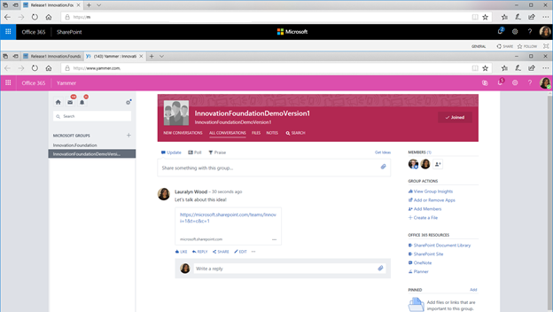

* 1. Idea Duration Report

The solution provides a PowerBI report which displays the average duration time by idea state.

For Administrators, the PowerBI report is visible and shows the Quarterly Report, the Quarterly Report by Directorate, and Ideas by Directorate:

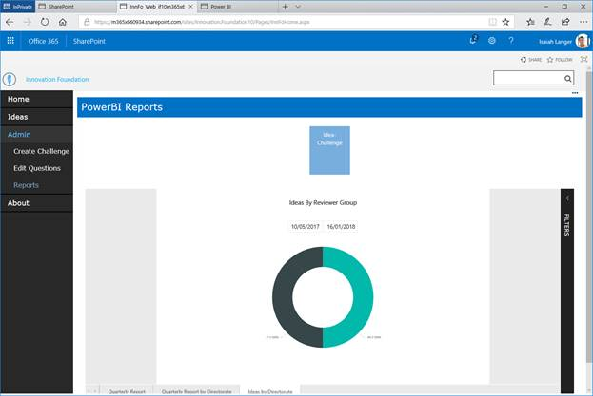

The report can be seen within the PowerBI Workspace within the browser:

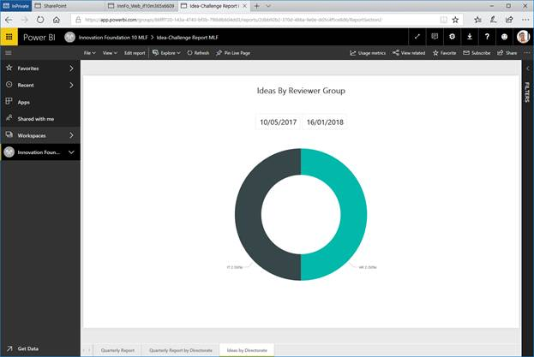

 And by using the PowerBI desktop app:

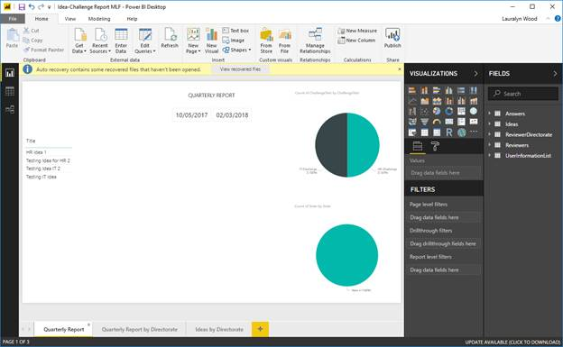

 The PowerBI Widget is also available to use within the solution as well.

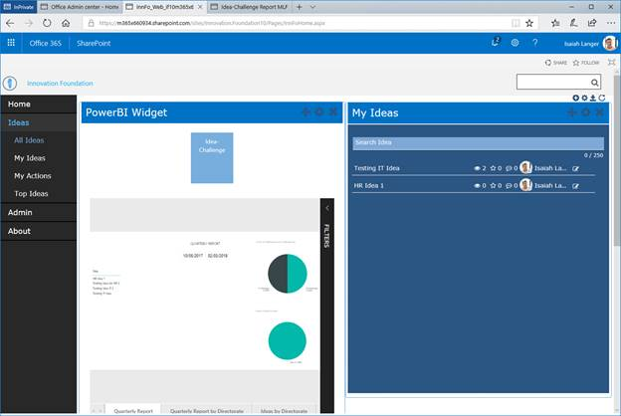

1. Feature Cuts and Unsupported Scenarios

Be specific about any scenarios that may not be included within the effort. Often time there are additional integration, reporting or automation tasks that maybe desired by the customer but may not be in-scope.

1. Assumptions and Dependencies

* A SharePoint Online tenant that allows for custom solutions to be uploaded
* A knowledgeable SharePoint administrator that knows how to create a new site and deploy a custom solution to that site
* A knowledge front-end developer that knows how to work with JavaScript and for Innovation Foundation page manipulation

1. References