Administrator’s Guide



Innovation Foundation

Prepared for

[insert Customer name]

4/11/2018

Version 1 Final

Prepared by

**[insert author here]**

[insert author title]

[insert author emails]

Contributors

**[insert contributor name, title]**

**John Gemkow, Associate Consultant**

Revision and Signoff Sheet

Change Record

|  |  |  |  |
| --- | --- | --- | --- |
| Date | Author | Version | Change Reference |
|  |  | 1 | Initial draft for review/discussion |
|  |  | 1.1 | Updated for release 2 |
|  |  |  |  |

Reviewers

|  |  |  |  |
| --- | --- | --- | --- |
| Name | Version Approved | Position | Date |
|  |  |  |  |
|  |  |  |  |
|  |  |  |  |

Table of Contents

1 Summary 5

2 Solution Design 6

2.1 Overview 6

3 Common Scenarios 7

3.1 Create Challenge 7

3.2 Adding Questions 9

3.2.1 Manual method in SharePoint lists 9

3.2.2 Questions View for Administrators 17

3.3 Edit Question 20

3.4 Edit Question Configuration 20

3.5 Edit Reviewers for a Directorate 21

3.6 Edit Email Templates 22

3.7 Reset IdeaState 22

4 Assumptions and Dependencies 25

1. Summary

The application entitled “Innovation Foundation” is a SharePoint Online provider-hosted application that enables ideation using SharePoint lists, custom C# Web API code, custom JavaScript code, custom CSS code, and PowerBI integration. The solution enables administrators to create Challenges, to which users can respond and offer solutions, known as Ideas. Additionally, the solution enables all ideas to be reviewed for merit and feasibility. Within SharePoint Online hosted environments, reporting via PowerBI is also available.

1. Solution Design
   1. Overview

Innovation Foundation is modeled from an internal system within Microsoft that facilitates Innovation by engaging a social community of members and focusing their efforts on specific business challenges, opportunities or discovery. As Innovation Foundation must cater to many different audiences and goals, it is designed to be configured and customized by the enterprise to suit their needs. Innovation Foundation can also be used ‘as is’ with its baseline capabilities and processes.

Innovation Foundation utilizes three main constructs:

1. **Idea:** A description of a novel concept, or a solution proposal, with relevant supporting content and feedback from the enterprise’s social network such as rating and discussions.
2. **Challenge:** An event containing many ideas in response to a specific topic, goal, or business challenge that utilizes basic game mechanics to increase participation such as limited time, popularity, progress and awards.
3. **Hub:** A collection of Challenges and associated ideas that are evaluated according to business parameters, and accessible by authorized participants.

There is an intrinsic relationship between all three main constructs. A Hub serves as the host for Challenges, and in turn Challenges host Ideas. This relationship ensures that Ideas are always aligned to a goal or objective of a specific Challenge, and that Hubs are dedicated to hosting sets of Challenges over time. Additionally, Hubs control branding, and accessibility via permissions.

1. Common Scenarios
2. 1. Create Challenge

Click on “Admin” on the sidebar

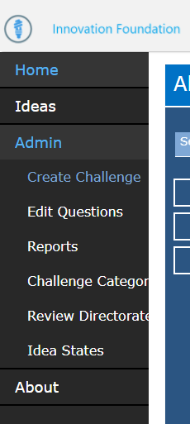

Click on “Create Challenge”

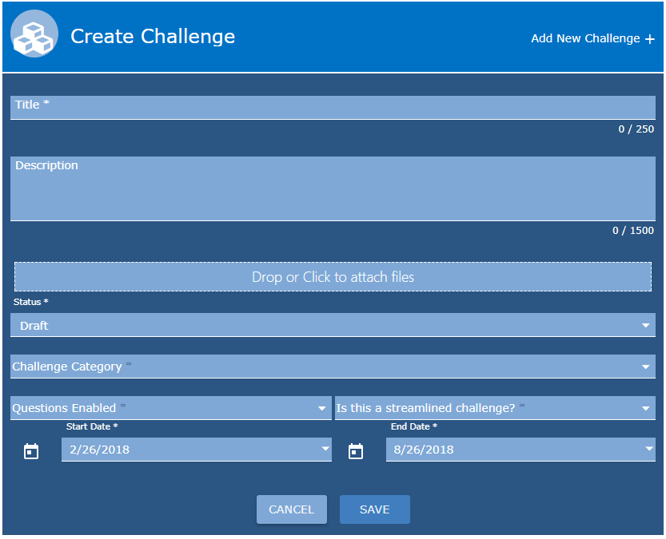

Specify a “Title” and “Description” for the Challenge.

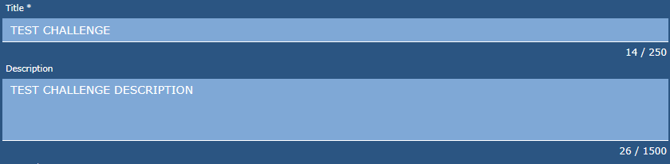

Select a “Status.” Options include “Draft,” “Closed,” and “Published.”

**NOTE: A Challenge that is not in the “Status” of “Published” will NOT appear on the landing page.**



Select a “Start Date” and “End Date.”

**Note: A user cannot submit an idea against an challenge that has not started or has already expired**



Click “Save”

* 1. Adding Questions

Two options exist for configuring the Question flow of the solution: manually in SharePoint lists or through the application’s questions view for administrators

* + 1. Manual method in SharePoint lists

Navigate to the “Questions” list by entering the URL of https://<tenantName>.sharepoint.com/<pathToSiteCollection>/Lists/Questions, where tenantName is your Office 365 tenant and pathToSiteCollection is your site collection path (i.e. ‘/sites/InnovationFoundation.’

Click “New”

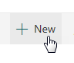

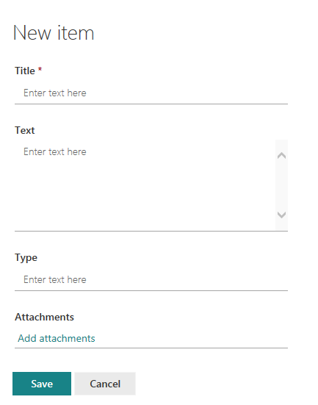

Input the text you want for the question in the “Text” field.

Input a title which can descriptive in the “Title” field

Input a Type of “Choice”

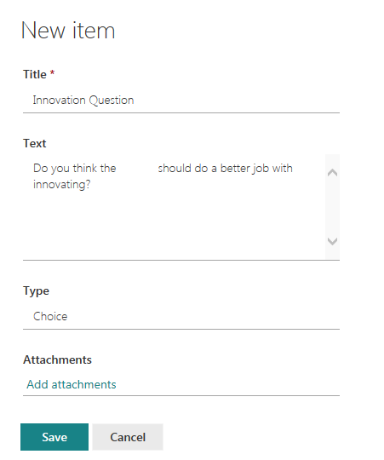

Click “Save”

**IMPORTANT! Adding a question without configuring it will BREAK THE REVIEW PROCESS. You MUST also add the corresponding Question to the QuestionConfiguration list**

**Once the new Question is created, take note of the ID**



Navigate to the “Questions Configuration” list by entering the URL of https://<tenantName>.sharepoint.com/<pathToSiteCollection>/Lists/QuestionsConfiguration, where tenantName is your Office 365 tenant and pathToSiteCollection is your site collection path (i.e. ‘/sites/InnovationFoundation.’

**The QuestionsConfiguration list requires questions to appear in a certain order, if you add a question into the middle of a flow you must fix the links before and after the new question:**

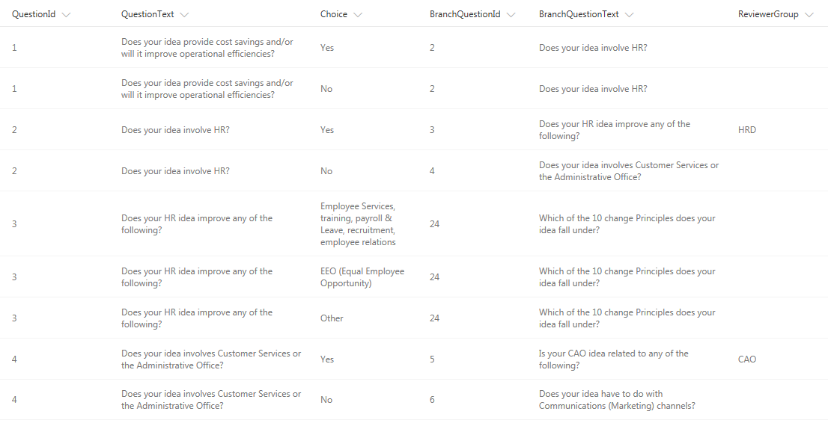

**FOR EXAMPLE: If you were to add a new question 2 – you would change the BranchQuestionId for both QuestionId = 1s to the new Question ID you took note of above. You would also change the BranchQuestionText for both QuestionId = 1s to the new Question you created.**

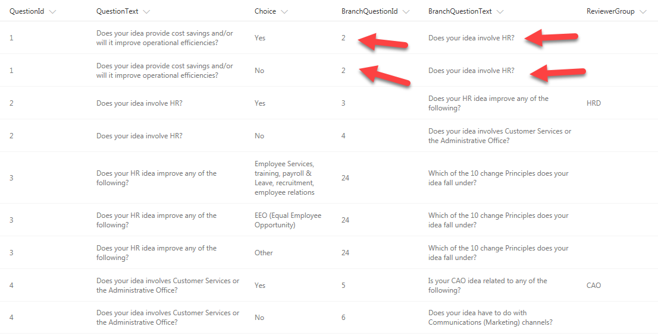

**Next, you would create the new configuration for the New Question**

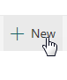

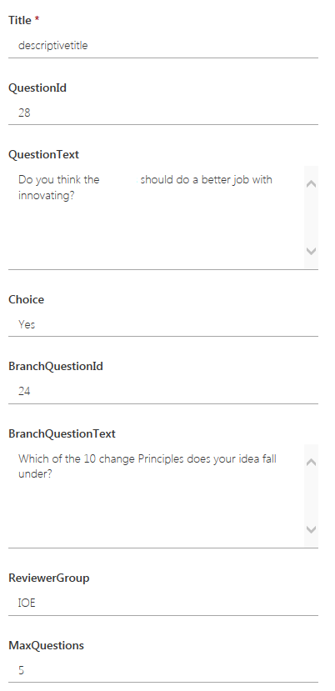

**QuestionId** references the ID of your newly created question

**QuestionText** references the text for your newly created question

**Choice** references the option a user can select for this question

**BranchQuestionId** references the QuestionId the question will branch to if the user selects this choice

**ReviewerGroup (can be blank)** references the reviewer group the idea will be assigned to if the user selects this option

**MaxQuestions** references how many more questions are left after selecting this option (for populating percentage)

**NOTE: This branches to the end questions and assigns to the IOE reviewer group**

**You would create a no option:**

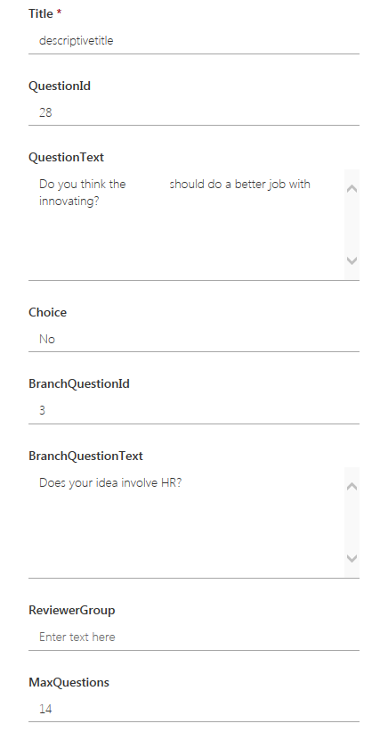

**NOTE: This branches to the question that you inserted this question between and does not assign to a Reviewer Group.**

* + 1. Questions View for Administrators

Navigate to the “Edit Questions View.”

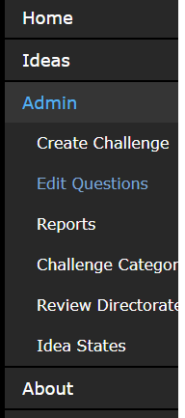

Click “Add Question”

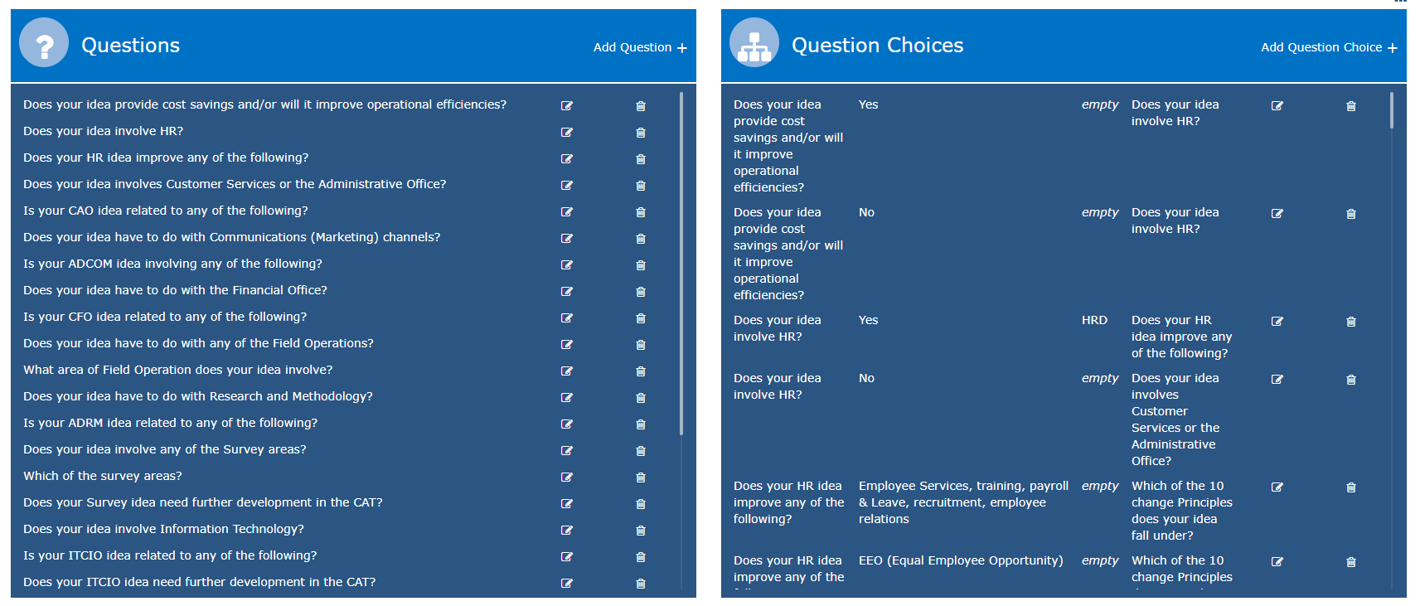

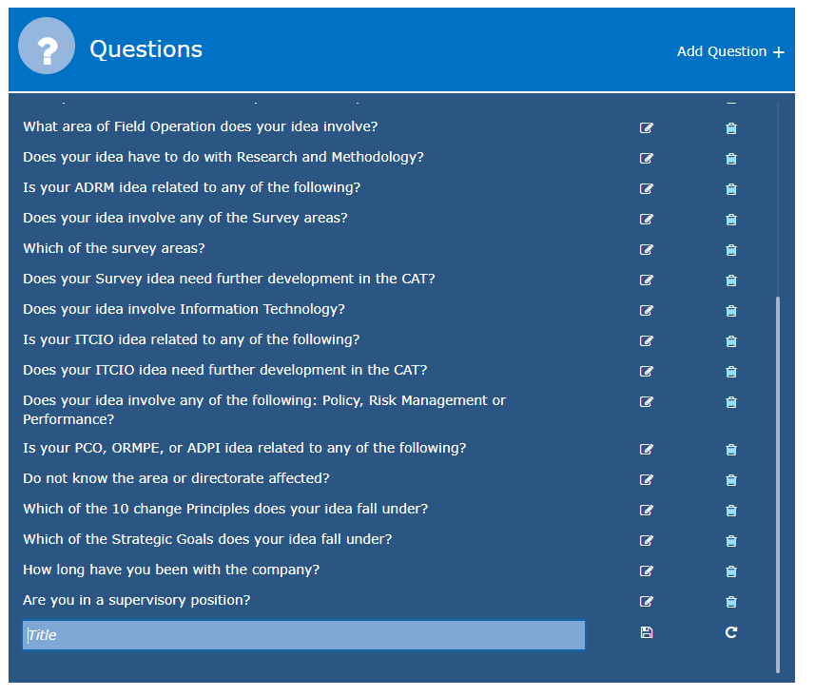

Enter your question into the “Title” field and hit the floppy disk icon to save.

**NOTE: You may need to allow a few minutes for the new question to propagate through the cache before adding Question Choices.**

Click “Add Question Choice.”

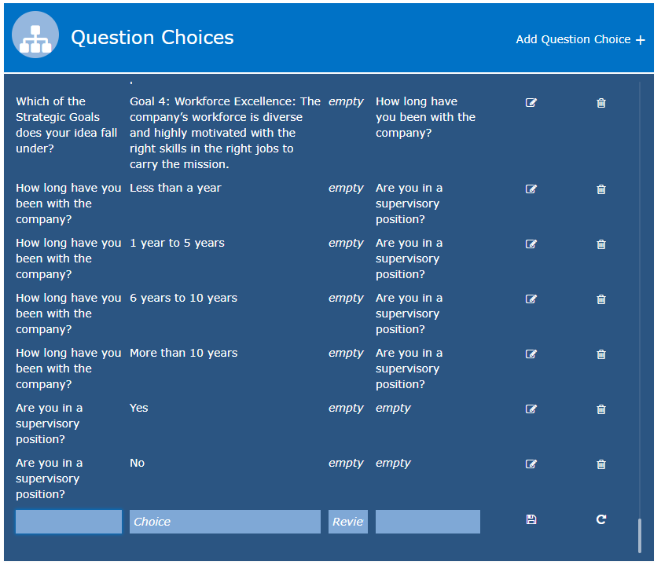

In the first box, enter your question that you added to the left Questions lists. The field should attempt to autocomplete. If the field does not autocomplete, allow more time for the cache to propagate changes.

Enter your question choice, i.e. “Yes” in the second ‘Choice’ field.

In the third ‘Reviewer’ box, enter the reviewer group that the choice should assign the idea to, if any.

In the fourth box, enter the next question to direct the user to in the flow. The field should attempt to autocomplete. If the field does not autocomplete, allow more time for the cache to propagate changes.

Finally, hit the floppy disk icon to save.

* 1. Edit Question

Navigate to the “Questions” list by entering the URL of https://<tenantName>.sharepoint.com/<pathToSiteCollection>/Lists/Questions, where tenantName is your Office 365 tenant and pathToSiteCollection is your site collection path (i.e. ‘/sites/InnovationFoundation.’

Click the radio button next to the question you want to edit then click Edit

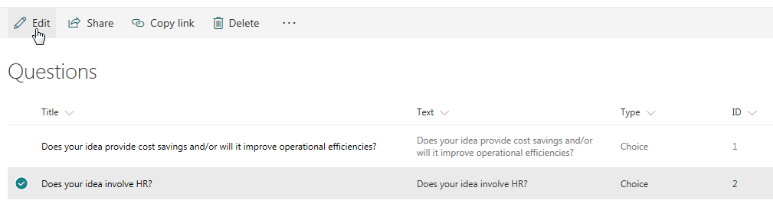

* 1. Edit Question Configuration

Navigate to the “Questions Configuration” list by entering the URL of https://<tenantName>.sharepoint.com/<pathToSiteCollection>/Lists/QuestionsConfiguration, where tenantName is your Office 365 tenant and pathToSiteCollection is your site collection path (i.e. ‘/sites/InnovationFoundation.’

Click the radio button next to the question configuration you want to edit then click Edit

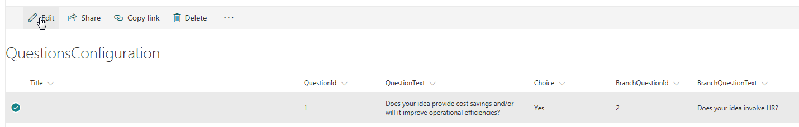

* 1. Edit Reviewers for a Directorate

Navigate to the “Reviewer Directorate” list by clicking the “Reviewer Directorate” link under Admin on the Innovation Foundation navigation bar

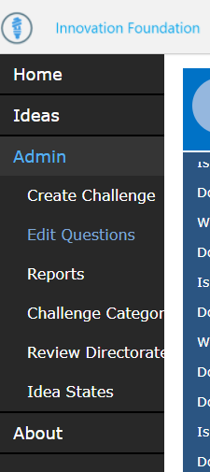

**NOTE: This is only viewable by administrators who are part of the Admins group in the SharePoint Site Collection.**

Click on the Reviewer Directorate you want to change the reviewers for and click “Edit”

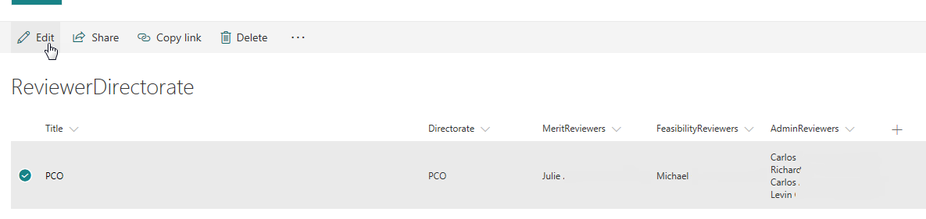

* 1. Edit Email Templates

Navigate to the “Mail Templates” list by entering the URL of https://<tenantName>.sharepoint.com/<pathToSiteCollection>/Lists/MailTemplates, where tenantName is your Office 365 tenant and pathToSiteCollection is your site collection path (i.e. ‘/sites/InnovationFoundation.’

Click on the radio button next to the mail template you want to update and then click “Edit”

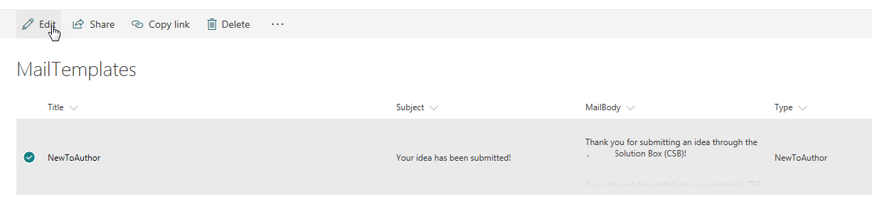

**NOTE: The Type field should NOT be changed. This is an internal reference to the given state. You can quickly and easily change the Subject or MailBody. The “Click Here” link in the MailBody is case sensitive. It is not recommended that you change this link in any way as this is the link that enables reviewers to get right to the pending action from their email. The {0} special character can be used to inject the Idea Title into the MailBody. The {1} special character can be used to inject the Idea ID into the MailBody.**

* 1. Reset IdeaState

Navigate to the “Ideas” list by entering the URL of https://<tenantName>.sharepoint.com/<pathToSiteCollection>/Lists/Ideas, where tenantName is your Office 365 tenant and pathToSiteCollection is your site collection path (i.e. ‘/sites/InnovationFoundation.’

Select the Idea you would like to push to a different state and click “Edit”

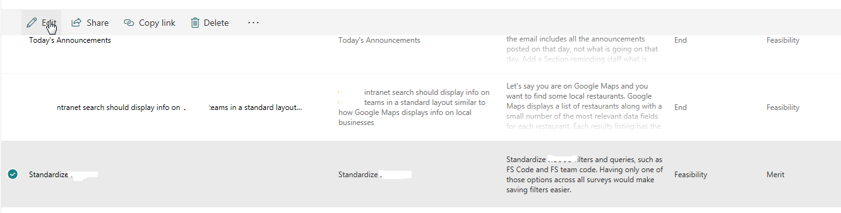

Change the “State” and “PreviousState” to reflect the new state:

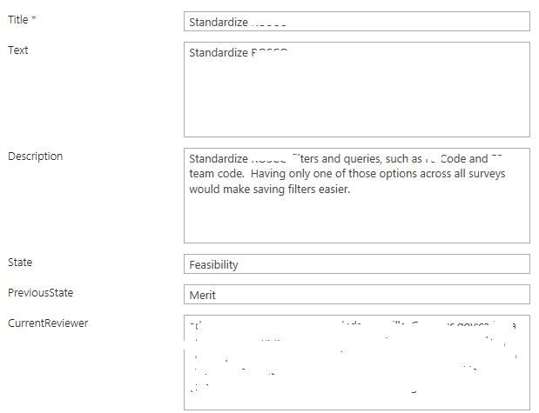

**To reset to Merit:**

**PreviousState: New**

**State: Merit**

**To reset to author (pending merit)**

**PreviousState: Merit**

**State: Author**

**To reset to author (pending feasibility)**

**PreviousState: Feasibility**

**State: Author**

**To reset to feasibility**

**PreviousState: Merit (or Admin)**

**State: Feasibility**

**The automatic process will pick these changes up nightly and fix the current reviewers, as well as, send out new email**

1. Assumptions and Dependencies

A knowledgeable SharePoint administrator that knows how to navigate SharePoint Online lists and libraries

A fully deployed Innovation Foundation solution