Vendors DMF (initial Draft)

Table of Contents

Simple End to End File Import 1

AX to AX file transfer 17

Export AX to Excel 22

# Simple End to End File Import

1. **Create Temporary Storage Directory on the SQL server**.

Assign this directory to the Shared working directory. See below.

Go to Data Import export Framework Parameters

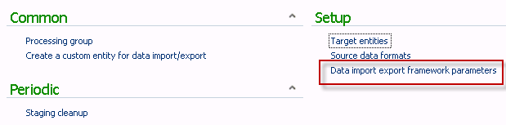

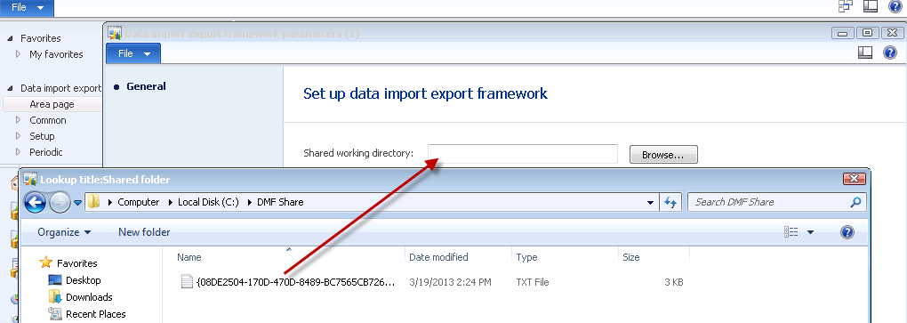

Select directory

, 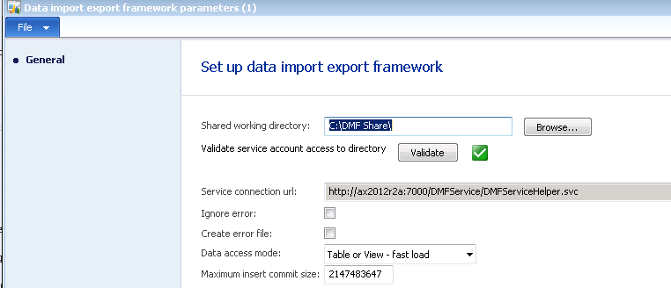

Make any other necessary changes

2. Create Source Data Form: Data import export framework -> Setup -> Source data formats.

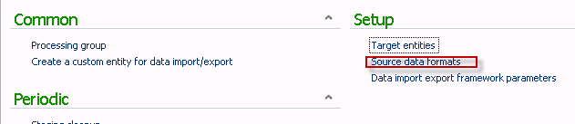

Form name: Source data formats

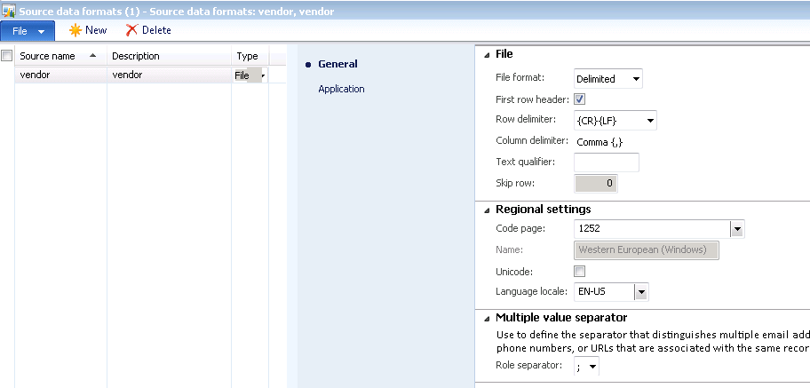

* Create Source name (Free Form)
* Optionally add a Description
* And select file type.

If the File section,

Indicate or select:

* File format
* Indicate if file has a header
* The Row Delimiter (default is {CR}-{LF})
* Column Delimiter (, in this example)
* Text Qualifier (if there is the same symbol in the data that is the same as the delimiter, enter the symbol (in this example if commas are in the file, enter a comma)
* Multiple value separator

3. Switch to the Application tab on the Source data formats form. Note: **This step may not be necessary**. Need further testing

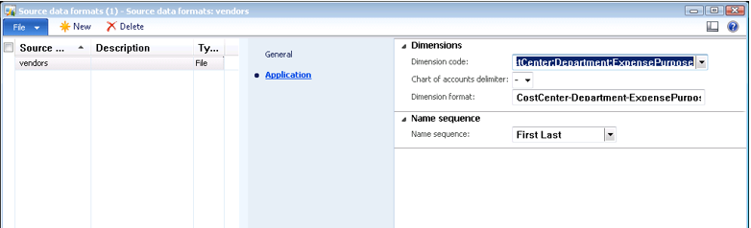

Pick valid dimensions for company (Dimension code) and separator (Delimiter)

5. Create Processing Group

Data import export framework -> Common -> Processing group.

Form name: Processing group

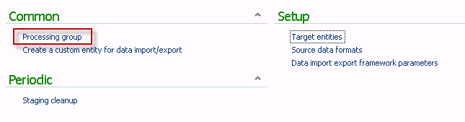

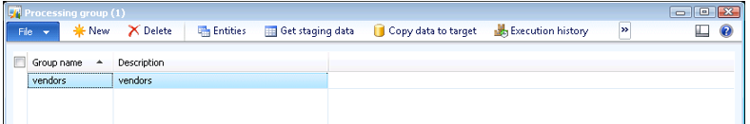

Enter group name and description. Save line. Once line is saved, Entities will be selectable.’

7. Click the Entities button.

Form name: Select entities for processing group

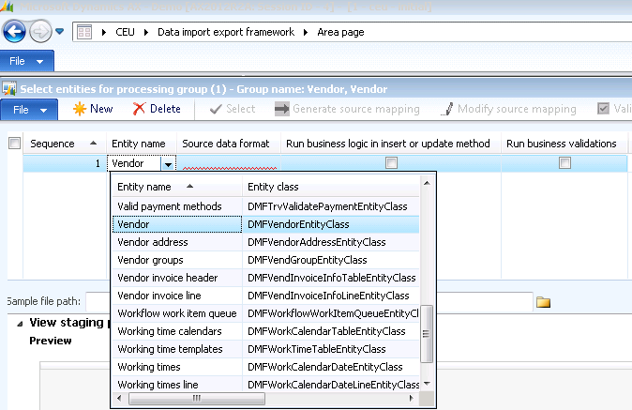

Enter Entity Name, (in the example select Vendor)

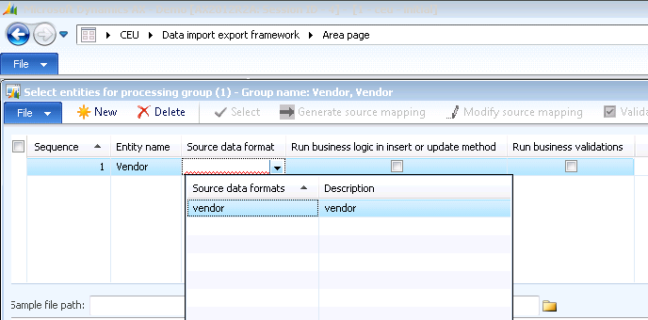 and select Source Data Format, save line,

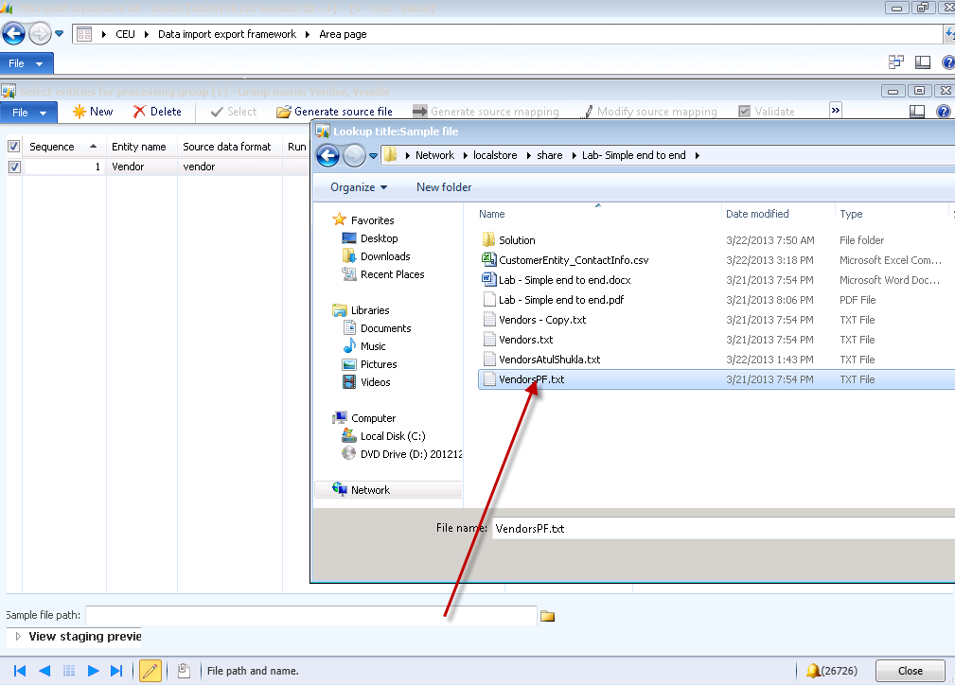

Chose path for source file

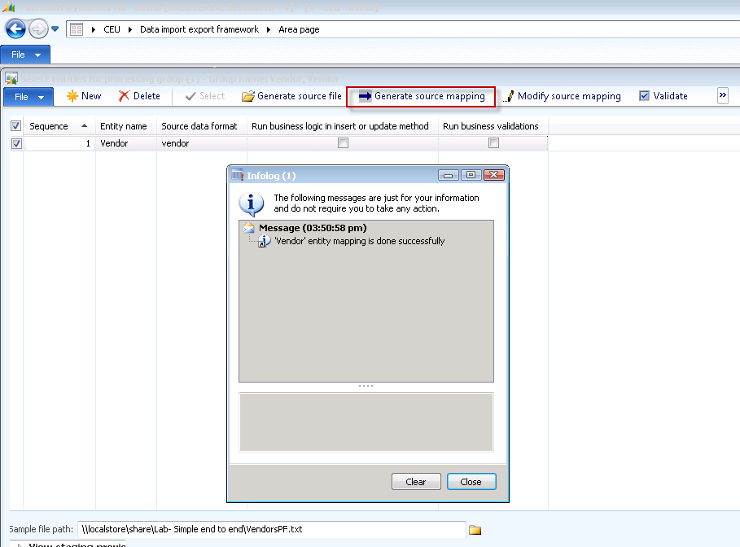

Select Generate Source mapping.

Click Yes if you receive this prompt:

“Do you want to generate the mapping from scratch (Yes) or from the modifications (No)?”

8. Click the Validate button.

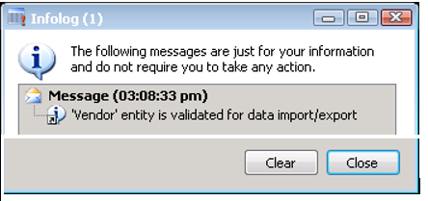

12. Click the Close button.

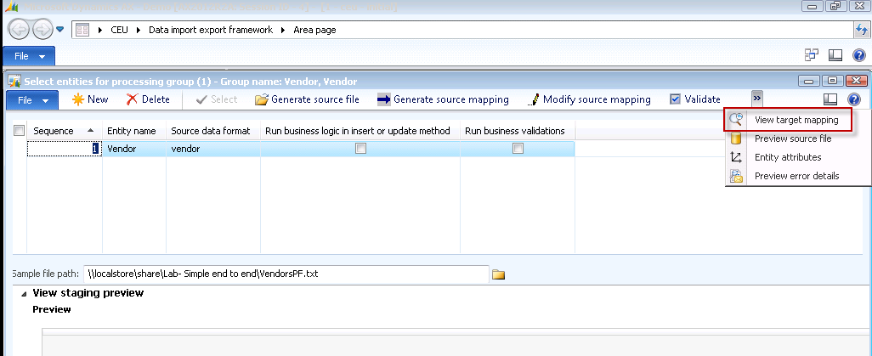

Click View Target mapping

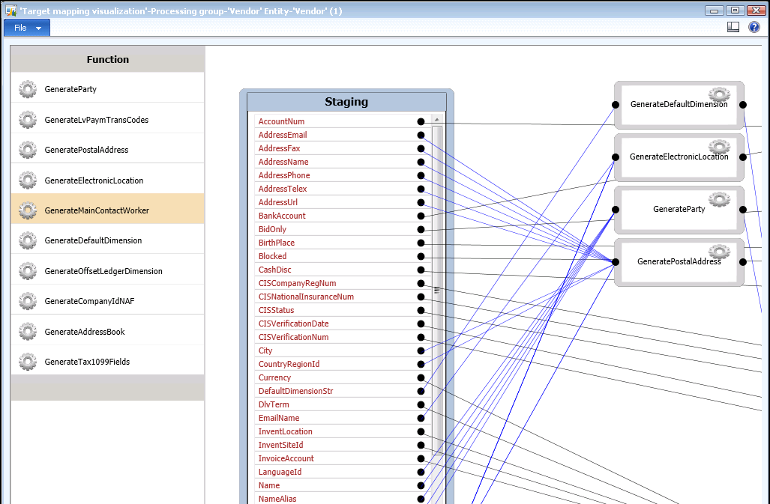

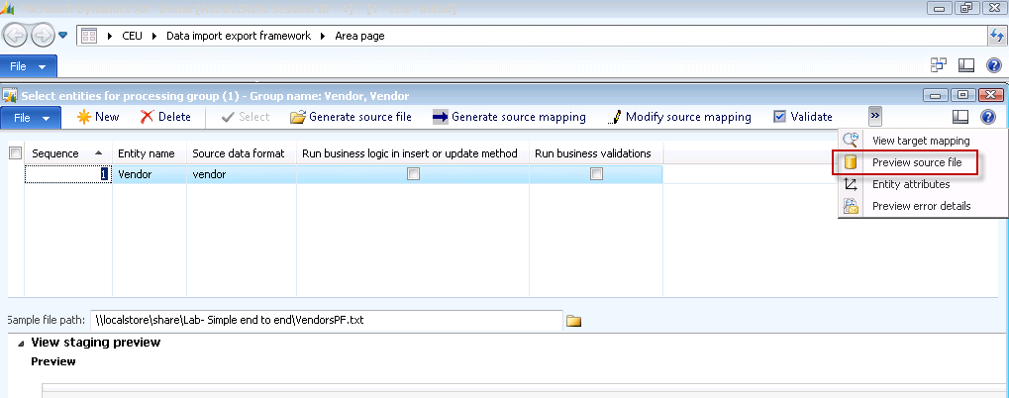

13. Click the Preview source file button.

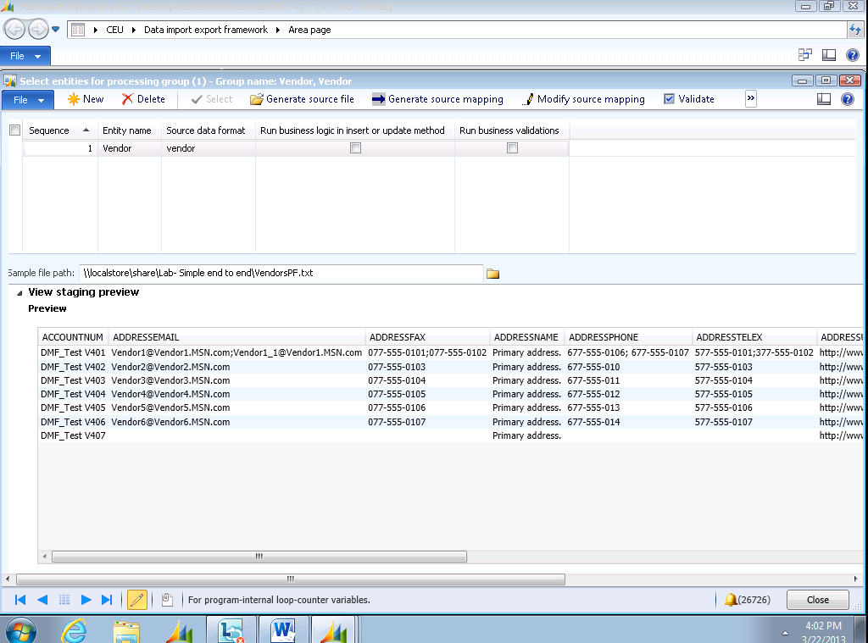

14. Click the Close toolbar button.

15. Close the Select entities for processing group form.

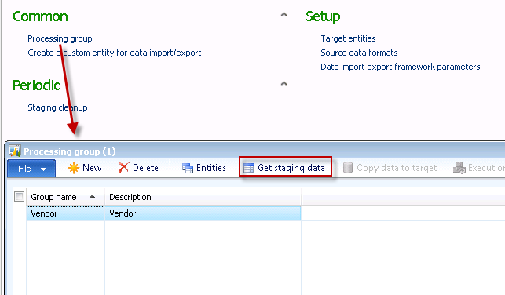

16. Click the Get staging data button.

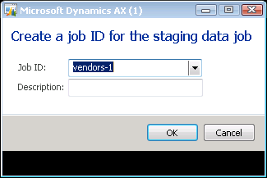

Select Job in Dropdown

17. Click the OK button.

Form name: Staging data execution

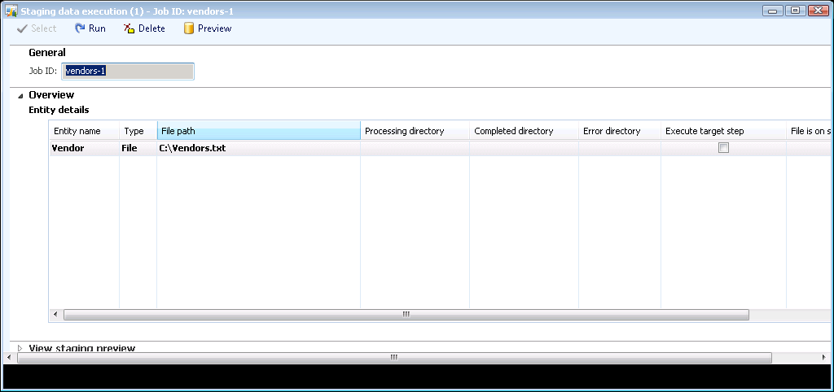

18. Click the Run button.

Form name: Microsoft Dynamics AX

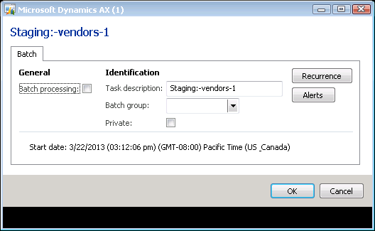

19. Click the OK button.

20. Close the Staging data execution form.

Form name: Infolog

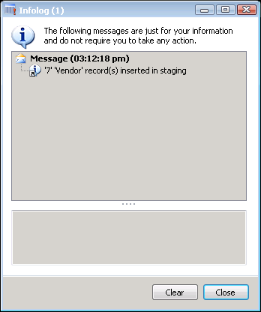

21. Click the Close button.

Move data to Target

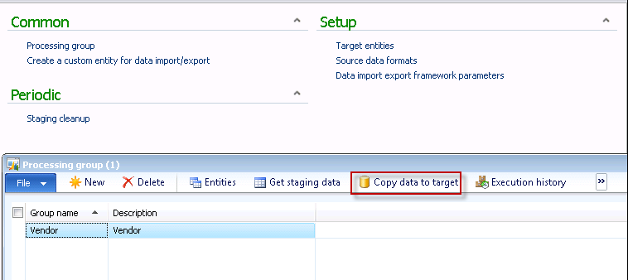

22. Click the Copy data to target button.

Form name: Microsoft Dynamics AX

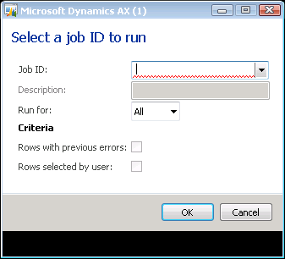

23. Select Job ID

24. Click the OK button.

Form name: Target data execution

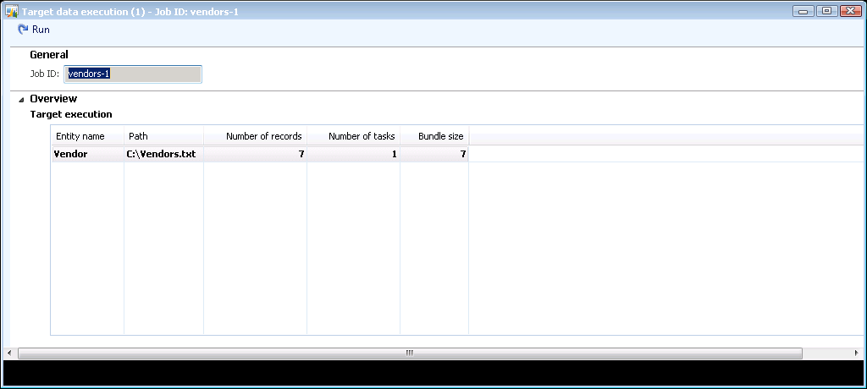

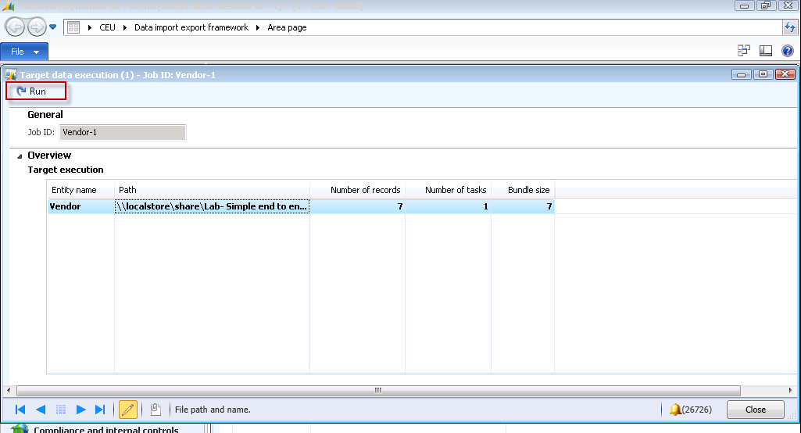

25. Click the Run button.

Form name: Microsoft Dynamics AX

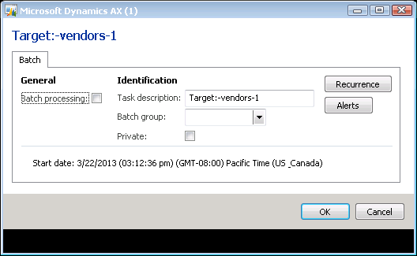

26. Click the OK button.

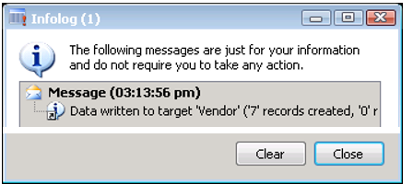

27. Click the Close button.

# AX to AX file transfer

Create source data format

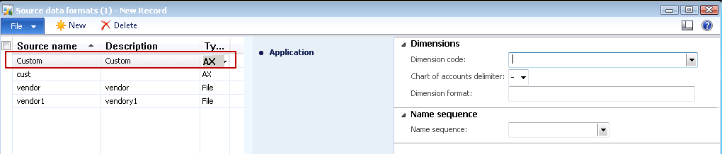

Enter source name and Description, select file type of AX

Create Processing group

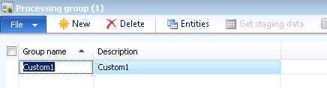

Enter Group name, and description, Refresh and select Entities

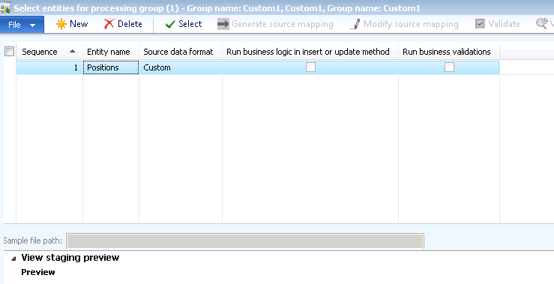

Select Entity and Source data format from Dropdowns, select 

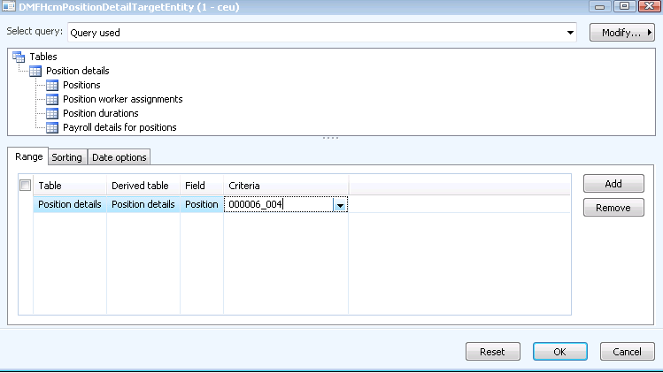

Define Criteria and select OK

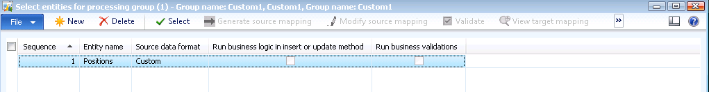

Close processing group form

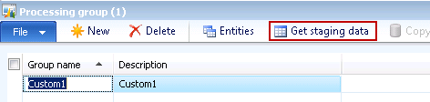

Select Get staging data

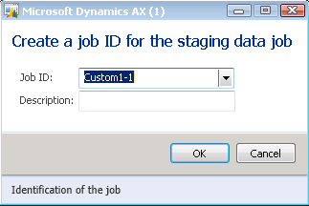

Populate the Job ID field and description if desired, Select OK

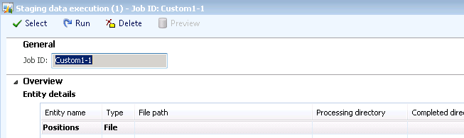

Select Run. This will copy data to Staging

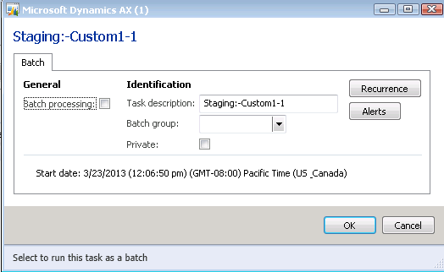

Select OK

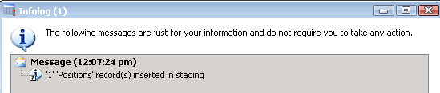

Switch companies

Go to DMF, processing group

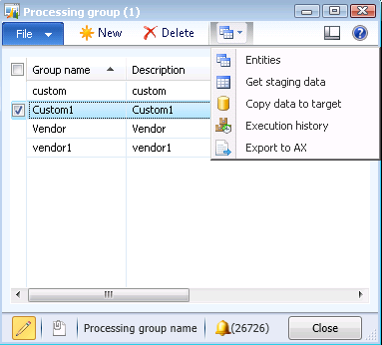

Select Group name, and Copy data to target

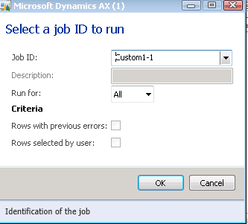

Select Job ID and OK.

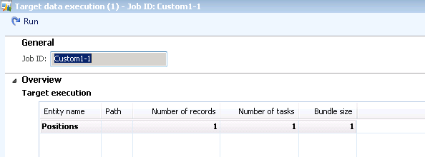

Select Run

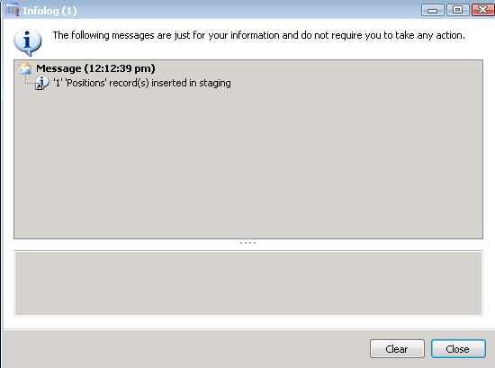

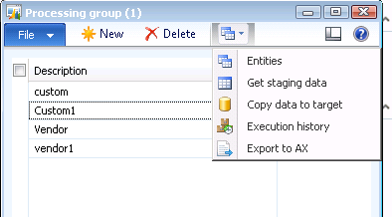

Select copy data to target

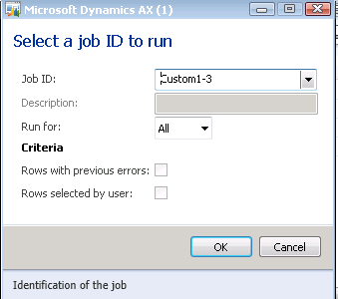

Select Job ID and OK

# Export AX to Excel

Note: There were errors in training class and will need to revisit this area and redefine exact process for selecting data to export.

Create AX source data format. Common>Processing Group

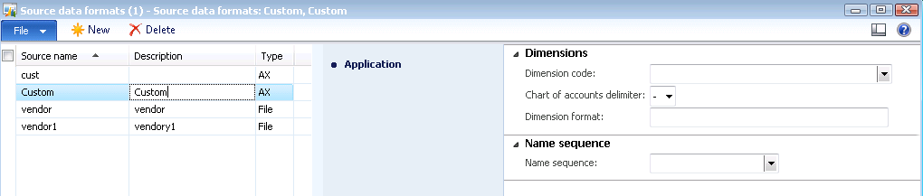

Processing Group

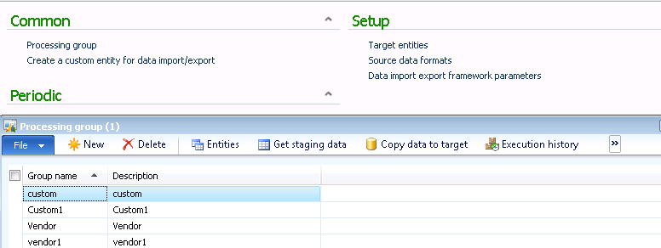

Create Processing group and select Get staging data

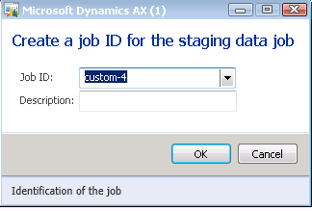

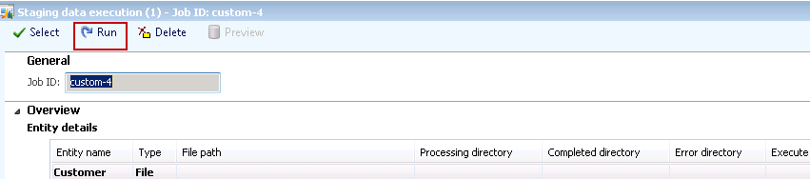

Select Run

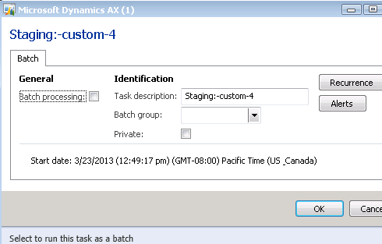

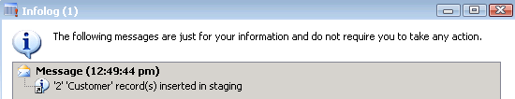

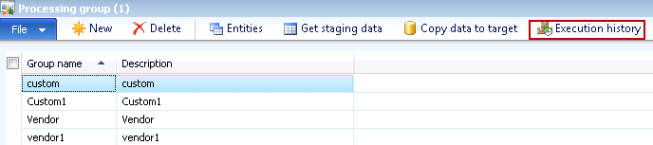

Select Execution history

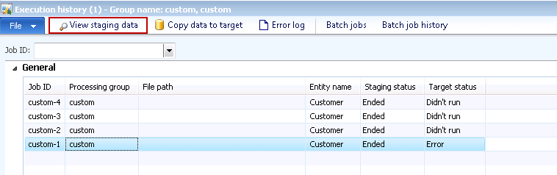

View staging data

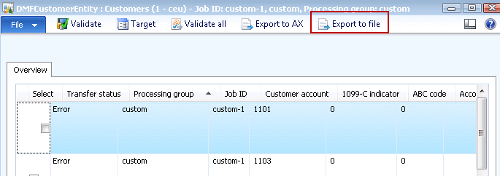

Select Export to file

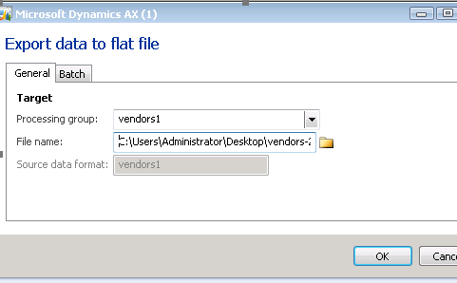

Select Processing Group

Select file location

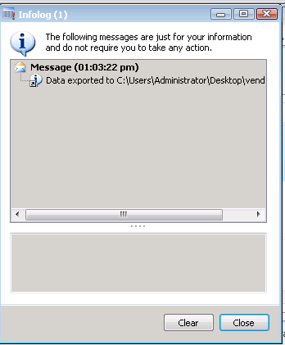

Info log will provide validation

Vendor File for import

