Engagement and Delivery Guide



System Center Configuration Management Deployment

Prepared for

[Type Customer Name Here]

February 7, 2017

Version 1 Status

Prepared by

**[Type author here]**

[Type Author Position Here]]

[Type Author Email Here]

This document contains Microsoft Confidential Information for internal use only.  Do not distribute externally.

© 2017 Microsoft Corporation. All rights reserved. Any use or distribution of these materials without express authorization of Microsoft Corp. is strictly prohibited.

Revision and sign-off sheet

Change record

Table 1: change record

|  |  |  |  |
| --- | --- | --- | --- |
| Date | Author | Version | Change reference |
|  |  |  |  |
|  |  |  |  |

Reviewers

Table 2: reviewers

|  |  |  |  |
| --- | --- | --- | --- |
| Name | Version approved | Position | Date |
|  |  |  |  |
|  |  |  |  |

Table of contents

1 Introduction 4

1.1 Purpose 4

1.2 Audience 4

1.3 Engagement Overview 4

1.4 Engagement Staffing 5

1.5 MCS Technical Skill Requirements 6

2 Sales Information 8

2.1 Typical Project Phase Durations 8

2.2 Offering Pricing 8

2.3 Pricing Guidance 8

2.3.1 Offering Constraints 8

2.3.2 Complexity Factors 9

2.4 Out of scope 10

2.5 Pre-engagement Additional Services 11

2.5.1 Premier Health Checks 11

2.5.2 Premier - PFE/DSE Offerings 11

3 Engagement Delivery 12

3.1 Engagement Process Flow 12

3.2 Technical capabilities 12

3.3 Offering IP to support delivery 13

3.4 Pre-engagement Kickoff Meeting 16

3.4.1 Pre-engagement Kickoff Meeting Prerequisites 16

3.5 Engagement Closeout 16

3.5.1 Future Work and Opportunities 16

3.5.2 Case Study Submissions 16

4 Readiness Resources 17

4.1 Offering Content Email Aliases 17

4.2 Consultant Readiness Resources 17

1. Introduction
   1. Purpose

The purpose of this document is to provide the technical and engagement delivery resource(s) with an overview of the tasks required to deliver the Microsoft Services **System Center Configuration Management Deployment** offering successfully. The offering has been developed to help customers assess, enable, and migrate to System Center Configuration Manager.

The offering material covers the following work streams:

|  |  |
| --- | --- |
| Project/Work stream | Description |
| System Center Configuration Management Deployment | System Center Configuration Manager design and implementation to support a **core infrastructure** platform that is then developed to provide:   * Application Management * Platform Delivery * Device Management (including Microsoft Intune cloud management integration, if available) * Servicing * Migration |

* 1. Audience

This document is **Microsoft Internal only** and should not be distributed to customers or vendors as part of the engagement delivery. This document should be made available for review to Microsoft program team members, Microsoft technical specialists and Microsoft engagement resources only.

* 1. Engagement Overview

The table below identifies a high-level engagement overview:

| Item | Description |
| --- | --- |
| **Timeline** | 10 Weeks |
| **Resourcing** | Fulltime MCS or MCS primary, with a partner sub-contracting if required  5% Architect time for reviews, 5% Engagement Mgr., 10% project mgmt.  See section 1.4 for details |
| **Price** | Please refer to the Project Schedule and the Statement of Work (SoW) that are provided as part of the offering content. Pricing should be determined in each region/sub based on the scope of the engagement (features selected) and the breakdown of hours provided in section 2.3 of this document. |
| **Engagement Scope** | Design and deployment of System Center Configuration Manager, and Microsoft Intune (if in scope) to 250 seats for 2-primary sites, 1 secondary site, and 1 CAS if required. |
| **Target Audience** | TDM, Desktop and Server administrators |
| **Number of Participants in Workshops** | No more than 6 customer attendees |
| **Participant prerequisites for workshops** | Participants should be technical leaders and influencers capable and responsible of executing the delivery of tasks related to assessment, designing, deploying, and migrating to the System Center Configuration Manager environment provided by this offering. |

* 1. Engagement Staffing

This diagram below gives an overview of the roles required. For detailed information on the roles represented below please see the System Center Configuration Management Deployment offering Statement of Work (SoW) document provided as part of the offering content, and the project plan for level of effort by each resource.



Engagement Manager Staffing Note:

**Best Practice**: Consider including Dedicated Support Engineers (DSEs) to transition from the design phase into operations smoothly. Have the DSEs work in tandem with MCS to facilitate this transition seamlessly with the customer. This would not be a prescriptive Premier solution offering, but rather a bespoke offering that allows DSE to offer a designated or dedicated resource to a customer for large project or major implementations.

* 1. MCS Technical Skill Requirements

The skill sets that are listed in the following table are recommended for members of the technical delivery team for them to successfully deliver the offering engagement.

| Product | Required Skills |
| --- | --- |
| System Center Configuration Manager | Design, deployment, and operations knowledge of all technology areas included in the engagement. Depending on the work streams included this can be:   * Core System Center Configuration Manager infrastructure design (hierarchies, server roles, server placement, Role Based Admin design etc.) * Client Platform Delivery (OSD) Service – including Windows 7/8/8.1/10 deployment * Application and Software Update Management design (including Windows 8/8.1/10 Side loading and App-V application deployment) * System Center Endpoint Protection implementation * Device Management and integration with Microsoft Intune and Exchange 2010/2013 * Settings Compliance Management implementation (or DCM experience) * Windows as a Service * Asset Management |
| Active Directory Certificate Services | Understanding of capabilities that require PKI design and implementation, such as features of Mobile Device Management or Secure Communication |
| Windows Operating System Deployment | Windows 7, Windows 8/8.1, and Windows 10 deployment knowledge including task sequence design, driver management strategies, image engineering strategies, User State Migration strategies and OS deployment implementation with the Microsoft Deployment Toolkit. |
| Active Directory Domain Services | Schema Extensions, Group Policies, DNS |
| File Services | System Center Configuration Manager integration for Distribution Points and State Migration Points with on-premises servers, Microsoft Intune, and Microsoft Azure |
| Internet Information Services | System Center Configuration Manager integration for Site System roles and application catalog configuration. |
| Windows Server Update Services 3.0 (or higher) | System Center Configuration Manager integration for Software Update Management |
| SQL Server 2016 | System Center Configuration Manager integration for Site Databases, WSUS and Endpoint Protection. System Center Configuration Manager integration with SQL products for object storage and replication |

1. Sales Information

This section outlines sales information as it relates to the System Center Configuration Management Deployment offering.

* 1. Typical Project Phase Durations

Please see the Project Schedule provided with offering material for details of individual tasks that make up each phase.

* 1. Offering Pricing

Please refer to the Project Schedule and the Statement of Work (SoW) that are provided as part of the offering content. Pricing should be determined in each region/sub based on the scope of the engagement (especially the features design selected).

* 1. Pricing Guidance
     1. Offering Constraints

The SoW provided with the offering is based on the information in the following table. Additional devices or sites that are placed in scope will mean that timelines/resources/costs will need to be adjusted accordingly.

|  |  |  |  |
| --- | --- | --- | --- |
| Engagement Scope | Constraints | Number of devices | Pricing Impact |
| Locations | (1) Central administration site (if required)  (2) Primary location (pilot)  (1) Secondary locations | Not Applicable  250  X | If adding more sites, please work with Pre-Sales Architect to adjust timelines. |
| Applications | * Deployment of (up to) 250 devices to System Center Configuration Manager * Deployment of up to (10) application and/or (5) Software Updates | | If adding more devices/apps, please work with Pre-Sales Architect to adjust timelines. |
| Device management | * If Device Management is part of the scope of the offering customer needs to have * Microsoft Intune subscription with Azure Active Directory ID sync is already established in customer’s production environment * Mobile device management authority is configured for Configuration Manager integration | | If additional Microsoft Intune related services like Conditional Access, Mobile Application Management or Certificate Deployment are required, please work with the Pre-Sales Architect to include the EMS Managed Mobile Productivity Pilot offer into the deal. |

* + 1. Complexity Factors

These factors should be considered when pricing engagements based on the offering - adjust timelines and costs as needed.

| Scenario | Complexity Factors | Timeline Impacts  (based on map included within offering) |
| --- | --- | --- |
| **Basic: Configuration and Inventory management** | * Type of platforms supported * thick, thin, app-v, mobile, etc. * Frequency of update | **Low (8), Medium (12), High (15)** |
| **Advanced: Application Delivery** | * Type of platforms supported * thick, thin, app-v, mobile, etc. * Frequency of update | **Low (8), Medium (12), High (15)** |
| **Advanced: Software Update Management** | * Frequency of patches * Number of platforms * Existing SUM process/skills? * Number of Windows 10 servicing rings | **Low (8), Medium (10), High (12)** |
| **Advanced: Platform Delivery** | * New or migration from XP to Windows 10 * Number of deployment processes supported (ZTI, UDI, Offline) * Complexity of ZTI automation * Complexity of UDI customization * Number of deployment types supported (New, Refresh, Replace) * Complexity of the client environment for Refresh scenario * Number of HW models included * USMT complexity (if not included in project, explicitly exclude, or include OOB USMT settings only to test the infrastructure) | **Low (8), Medium (10), High (12)** |
| **Advanced: Malware Protection** | * Number of Clients currently used that need to be replaced/re-deployed | **Low (6), Medium (8), High (10)** |
| **Advanced: Device Management** | * Number of device types that need to be managed and integration with Windows Intune for non-Windows based devices (iOS, Android etc.) | **Low (6), Medium (8), High (10)** |
| **Advanced: Device Management (PKI required) (separate section in the document and a feature that can be implemented on its own)** |  | **Low (8), Medium (10), High (12)** |
| **Migration 2007 to 2012** | * Consolidation * App migration * Groups migration * AD/Integration (groups/collections) | **Low (6), Medium (8), High (10)** |
| **Advanced: Reporting (advanced dashboards)** |  | **Not included in project plan, add scope if this will be part of engagement** |
| **Advanced: System Integration (with additional reporting/asset/ similar** |  | **Not included in project plan, add scope if this will be part of engagement** |

* 1. Out of scope

Implementation of Public Key Infrastructures and creation of any client master image are out of scope for this offering.

* Public Key Infrastructure (PKI) is required for selected Mobile Device Management capabilities and secured communications with System Center Configuration Manager. Installation of PKI is not in scope for this engagement, please reference the Security and Identity PKI offering if PKI installation is required to adjust scope, schedule, and resources.
* Creation of Enterprise reference image(s) is not in scope for this engagement, within the SoW there is support for creation of (1) basic image for testing the Platform Delivery components. If the customer wants to include image creation, please reference the Windows 10 Enterprise Pilot offering (available at aka.ms//mcs-mobility<http://mcsw-client/>) to add enterprise image creation.
* Microsoft Intune related services beside MDM are not in scope. Please review the EMS Managed Mobile Productivity Pilot offer (available at aka.ms/mmppilot<http://mcsw-client/>)
  1. Pre-engagement Additional Services

The following sections identify additional services or offerings that can be added to the System Center Configuration Management Deployment offering to develop the solution for scale or to provide pre-engagement assessment and education

* + 1. Premier Health Checks

Premier Health Checks or Risk Assessment Programs (RAPs) can be a great asset for assessing the customer environment and gaining a detail understanding of the infrastructure. The following provides suggested approaches based on the customer requirements for the engagement.

* If device management or secure communication for devices is in scope suggest that a PKI Health Check is run prior to engagement starting.
* If the customer is migrating from System Center Configuration Manager 2007 suggest that a Configuration Manager 2007 RAP is run prior to engagement starting.
* If the customer has an Active Directory environment suggest that a Premier Active Directory RAP (ADRAP) is run prior to the engagement starting.
* If the customer requires client operating system deployment, suggest that a Premier Client Health Check or RAP is run prior to the engagement starting.
  + 1. Premier - PFE/DSE Offerings

The following PFE/DES offerings are in development and planned for release at the dates indicated below. If these offerings are required, then please contact the customer’s Premier representative as part of the pre-engagement activities.

**Premier Workshops:**

* Workshop*PLUS* - System Center Configuration Manager Concepts and Administration Introduction
* Workshop*PLUS* - System Center Configuration Manager Operating System Deployment
* Workshop*PLUS* - System Center Configuration Manager Concepts and Administration Advanced
* System Center 2012: Configuration Manager Concepts and Administration Introduction
* System Center 2012:  Configuration Manager Operating System Deployment
* System Center 2012: Configuration Manager Concepts and Administration Advanced

1. Engagement Delivery

This section details the engagement delivery methodology and acts as a reference to the deliverables provided in the offering.

* 1. Engagement Process Flow

The diagram below identifies the engagement process flow and deliverables.

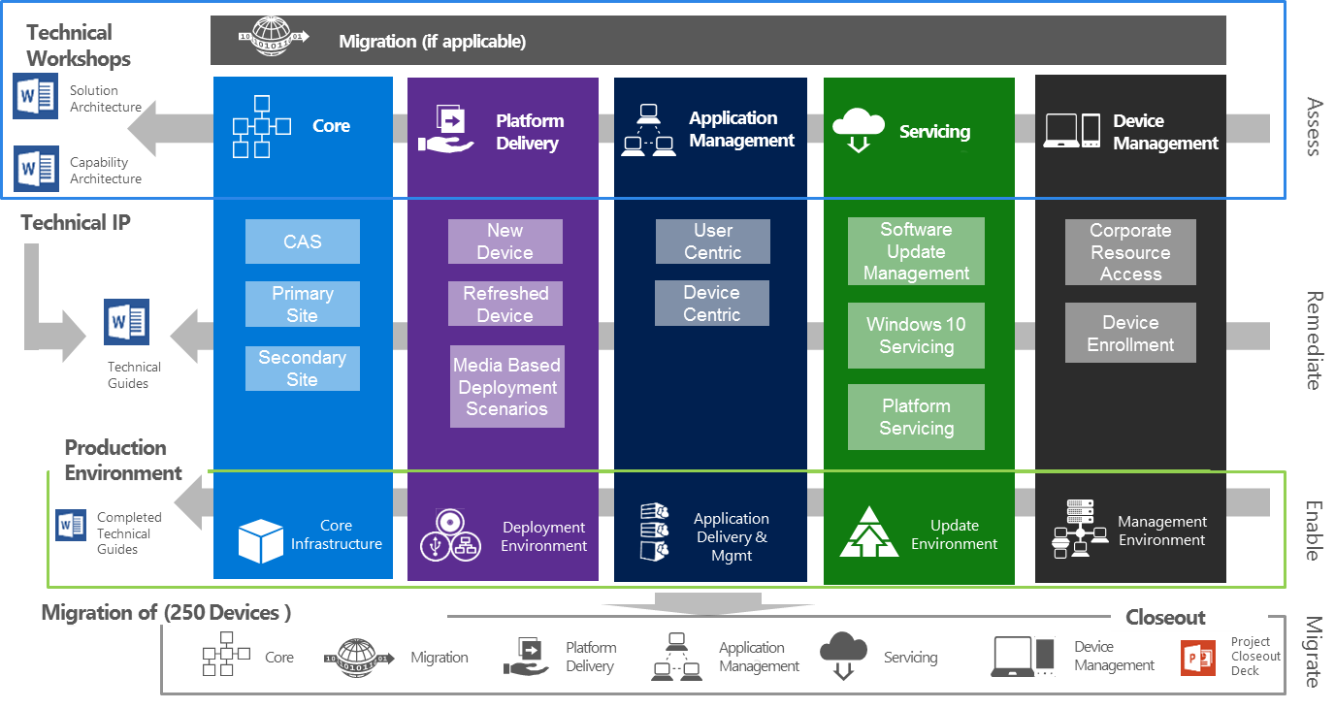

* 1. Technical capabilities

This diagram is used within the engagement Capability Architecture to help illustrate the follow and capabilities included with the engagement.

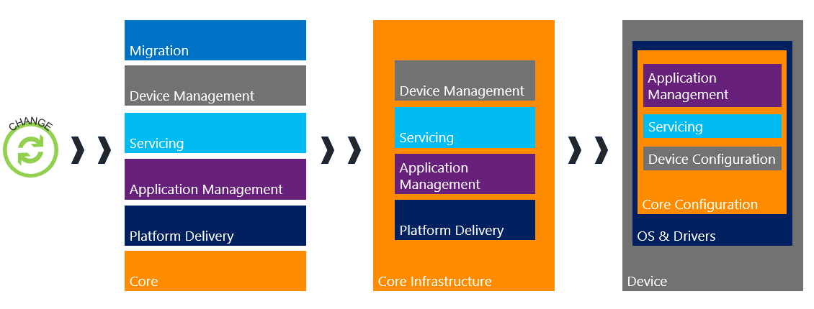

The solution provides the following benefit to the IT teams that support the environment:

* **Device Management** – Provide a common, approved and hardened baseline for all client systems that can be developed rapidly and with high-levels of automation.
* **Application Management** – Improve the ability to deliver applications dynamically to a user, where and when, thereby reducing the need for a reference image and efficiently utilizing software licenses.
* **Platform Delivery** – Automate and standardize device deployment.
* **Servicing –** Standardize and automate the approach to update and upgrade of client devices and platform infrastructure in the environment, reducing administrative effort and risk.
* **Core Infrastructure** – Lower the number of physical servers whilst providing scalability enhancements. Centralize the approach to support users and devices in the environment, and collect information to track hardware configuration and software license usage to help reduce cost and complexity.
  1. Offering IP to support delivery

The System Center Configuration Management Deployment offering includes a series of workshops decks and document templates to facilitate a discussion with the customer and to document the required solution. Use of these assets should lead to the customer requirements being gathered which in turn allow the design documents to be created and the lab and/or Pilot environment to be deployed.

The table below identifies the asset provided and a description of its use.

| Phase | Offering Asset | Description of Activities and Deliverables |
| --- | --- | --- |
| Sales | Customer Presentation | * PowerPoint Deck used to position the offer with a customer to gain buy-in for the delivery. |
| Datasheet | * 2-page customer facing document providing a short description of the offering |
| Statement of Work (SOW) | * MCS SOW for use in setting up the engagement |
| Sales Guide | * Overview of engagement, customer scenarios, and messaging copy blocks |
| Pre-engagement | Pre-Engagement Delivery Guide (this document) | * Delivery process * Engagement flow * Delivery information |
| Project Schedule | * Template high-level project plan that details the necessary phases and tasks to design and implement the proposed solution |
| Kick-off Meeting Deck | * Project kickoff presentation provides an overview of engagement and includes an Introduction of the team, timelines, logistics, and conditions of satisfaction |
| General Planning | Solution Architecture | * Documents describing the overall solution to be delivered in context to the business need   Note this is a key doc to review for context into the overall design |
| Capability Architecture | * Documents describing the capabilities, usage scenarios, and infrastructure requirements   Note this is a key doc to review for context into the overall design |
| Requirements Catalog Template xls | * Excel template for capturing the technical requirements. The template should be used in conjunction with the technical presentations included with each service capability |
| Technical Design Planning xls | * Purpose: To capture technical configuration and setting information of the customer project to support the technical guides delivered within the engagement |
| Closeout Deck | * Final customer presentation, includes a recap of capabilities deployed, open tasks, and overview of future work opportunities |
| Document Graphics | * This ppt includes all the master copies of the document graphics use within the word documents. Edit as needed then copy back to your word document |
| **03. Core** | Core Workshop | * PowerPoint deck to validate customer’s requirements output of the deck goes into the Requirements Catalog Template, Architecture documents and Technical Guide. |
| Core Technical Guide | * Technical guide to document customer functional requirements, capability design, implementation, and test cases. |
| **04. Application Management** | Application Management Workshop  Application Management Technical Guide | * See descriptions under Core delivery |
| **05.Platform Delivery** | Platform Delivery Workshop  Platform Delivery Technical Guide |
| **06.Device Management** | Device Mgmt. Workshop  Device Mgmt. Technical Guide |
| **07.Servicing** | Servicing Workshop    Servicing Technical Guide |
| **08.Migration** | Migration Workshop  Migration Technical Guide  OR  Upgrade Workshop  Upgrade Technical Guide |
| Follow on work (no template) |  | * Proposal for follow on work to deliver on the customer roadmap, and discuss next possible steps. As a recommended practice, the proposal should be conducted one or two weeks after engagement. |

* 1. Pre-engagement Kickoff Meeting

The Pre-engagement Kickoff Meeting should take place one to two weeks prior to the scheduled start of the engagement. This meeting can be in-person or delivered as an on-line meeting.

* + 1. Pre-engagement Kickoff Meeting Prerequisites

The pre-requisites for delivering the Pre-engagement Kickoff Meeting are as follows;

* The customer has returned a signed work order
  1. Engagement Closeout

Included within the offering material is a closeout deck to help facilitate the official close of the engagement. The members of the Microsoft team should be in attendance. There should be representation from the customer’s core team, customer project management and if possible the customer executive sponsor.

* + 1. Future Work and Opportunities

At the end of the System Center Configuration Management Deployment engagement additional work should be proposed to help keep the customer moving forward to complete the full deployment to all their assets. Next steps may include

* Enterprise Mobility + Security offers
* Azure Fast Starts
* Premier Ops Con support
* SA Benefits offerings that support IT training
  + 1. Case Study Submissions

To nominate a customer for a case study, go to the [Customer Evidence Engage](https://microsoft.sharepoint.com/teams/servicesportfolio/evidenceengage/Pages/FrontPage.aspx) home page, and select Nominate Customer. In addition to being able to nominate a customer from the Customer Evidence Engage site, you can find evidence and helpful resources like customer to customer calls, customer onsite visits, and customer quotes.

1. Readiness Resources

This section identifies readiness resources that are available to aid in the delivery of the System Center Configuration Management Deployment offering.

* 1. Offering Content Email Aliases

For questions about the System Center Configuration Management Deployment offering please contact:

* Comments and questions about the offering - [DAMTEAM](mailto:damteam@microsoft.com)
* Feedback and suggestions about the offering - [UserVoice](https://microsoftservices.uservoice.com/forums/321003-devices-mobility-win-10)
* For offering discussion, questions on templates or process – [DAMTALK](mailto:DAMTalk@microsoft.com)
* Technical questions: wwcomcldepm
  1. Consultant Readiness Resources

The table below identifies consultant readiness material that can be utilized.

|  |  |
| --- | --- |
| Item | Location and Format |
| System Center Configuration Manager on Microsoft Docs | [Link](https://docs.microsoft.com/en-us/sccm/) |
| Overview - Systems Center Configuration Manager | [Link](https://microsoft.sharepoint.com/sites/infopedia/Media/details/aevd-3-105147) |
| TechReady23: EMS200: What’s new in System Center Configuration Manager | [Link](https://techreadytv.com/TR23/session?sCode=EMS200) (Select Lab Type and Track to Find Exact Lab) |
| TechReady23: EMS209: What’s New in Configuration Manager for Intune Hybrid Customers in 1511 and Beyond | [Link](https://techreadytv.com/TR23/session?sCode=EMS209) (Select Lab Type and Track to Find Exact Lab) |
| TechReady23: EMS336: Getting started with Power BI and your Configuration Manager data | [Link](https://techreadytv.com/TR23/session?sCode=EMS336) (Select Lab Type and Track to Find Exact Lab) |
| TechReady23: EMS340: Deploy, provision, and keep Windows up to date with Intune and Configuration Manager | [Link](https://techreadytv.com/TR23/session?sCode=EMS340) (Select Lab Type and Track to Find Exact Lab) |
| TechReady22: CPCT203 - Office Client deployment and management with Config Mgr. | [Link](https://techreadytv.com/TR22/session?sCode=CPCT203) (Select Lab Type and Track to Find Exact Lab) |
| TechReady22: WOS327 - Endpoint security assurance with Device Health Attestation | [Link](https://techreadytv.com/TR22/session?sCode=WOS327) (Select Lab Type and Track to Find Exact Lab) |