Solution Architecture



System Center Configuration Management

Prepared for

[Type Customer Name Here]

2/7/2017

Version Draft

Prepared by

**[Type Author Here]**

Contributors

**[Type Contributors Here]**

Revision and Signoff Sheet

Change Record

|  |  |  |  |
| --- | --- | --- | --- |
| Date | Author | Version | Change Reference |
|  |  | 1 | Initial draft for review/discussion |
|  |  |  |  |
|  |  |  |  |

Reviewers

|  |  |  |  |
| --- | --- | --- | --- |
| Name | Version Approved | Position | Date |
|  |  |  |  |
|  |  |  |  |
|  |  |  |  |

Table of Contents

1 Executive Summary 3

2 Project Overview 4

2.1 Timeline 4

2.2 Scope and Approach 5

2.2.1 Assess 5

2.2.2 Remediate 6

2.2.3 Enable 6

2.2.4 Migrate 6

3 Business Impact 8

4 Architecture 9

4.1 Approach and Rationale 9

4.2 Core 9

4.2.1 High-Level Phase Activities 10

4.3 Core Upgrade 10

4.3.1 High-Level Phase Activities 10

4.4 Device Management 11

4.4.1 High-Level Phase Activities 11

4.5 Application Management 11

4.5.1 High-Level Phase Activities 11

4.6 Servicing 12

4.6.1 High-Level Phase Activities 12

4.7 Platform Delivery 12

4.7.1 High-Level Phase Activities 13

4.8 Migration 13

4.8.1 High-Level Phase Activities 13

4.9 Tradeoffs 13

5 Key Assumptions 15

5.1 Core Infrastructure 15

5.2 Hardware 15

5.3 Application Software 16

5.4 Project Team Interaction 16

6 Customers 17

7 Success Criteria 18

We are very interested in your input!  If you have comments or would like to request an update to this document, please provide your feedback to the [SDM Suggestions alias](mailto:msdmods@microsoft.com).   Attach the document and clearly describe the changes you would like and explain why the changes are needed.

**Spell/grammar check is turned ON within all SDM Word templates -** Remember to turn off spell/grammar check before sending out the document if you want to avoid showing spelling and grammar red mark-ups. To turn this feature off, do the following:

1. Click on File
2. Click on the Options on the left
3. Click on Proofing
4. Scroll to bottom and check the two boxes shown below:



**To remove all the Visible Guidance (Hot Pink text with Grey Background) all at once:**

1. Click Ctrl H to open the Find and Replace box
2. Make sure your cursor is in the ‘Find what’ box.
3. Click on the More button at the bottom left
4. Click on the Format Button at the bottom left and select Style
5. Scroll down, locate select the “Visible Guidance”
6. Make sure the ‘Replace with’ box is empty:
7. Click ‘Replace All”
8. If not empty - click on the format button in the lower left hand corner. Scroll down and chose ‘(no style)’then replace all.

**IMPORTANT – Finalize This Document**

**REMOVE** all pink text, guidance, comments, changes, and hidden text in this document before submitting it to the customer. You can do this in two ways:

* **Save as PDF** and send the PDF version to the customer.   
  ~ OR ~
* **Inspect document and remove comments, revisions, any document properties you do not want included, personal information, and hidden text.** For guidance on how to do this, see [Remove hidden data and personal information from Office documents](http://office.microsoft.com/client/helppreview.aspx?AssetID=HA100375931033&QueryID=ALdFua2no0&respos=6&rt=2&ns=WINWORD&lcid=1033&pid=CH100487501033#3).

1. Executive Summary

The System Center Configuration Manager project will design a complete infrastructure management solution and migrate up to 250 users onto the platform. The project will also include the implementation of requested System Center Configuration Manager capabilities to support the design, and provide an Operating System Deployment task sequence to support a limited number of device models, enabling the infrastructure to be validated during the project.

The users selected for the project will be located at <Site 1 Name> and <Site 2 Name> only. These users will be selected such that they can participate with minor interruption, provide constructive feedback to the project team and validate the infrastructure management platform in daily activities. If possible, users will also be selected as representative samples of Information, Deskless, Task and Mobile worker types.

With System Center Configuration Manager, organizations can enable a user centric approach to infrastructure management and simplify IT administration. When combined with Microsoft Intune, System Center Configuration Manager can provide organizations with a comprehensive, cross platform approach to deploy applications and manage users’ devices whether they are corporate-connected or cloud-based.

Once complete, the project will refine the solution and commence planning for deploying System Center Configuration Manager to the remainder of the organization.

1. Project Overview

The System Center Configuration Manager project is a structured approach to designing the complete infrastructure management solution for the production environment, and implementing the solution for up to 250 users in two sites. The project achieves this by introducing new infrastructure per the design and leveraging existing infrastructure resources, where possible, to provide a platform for new technical capabilities. Those technical capabilities can then be grouped together to provide technical solutions that deliver on business requirements in the environment. New concepts and processes are also introduced as part of the project to assist IT staff for working with new concepts specific to System Center Configuration Manager, such as user centric application delivery.

* 1. Timeline

Consultant: Once the project schedule has been updated, in the open the project plan in Microsoft Project. Click the View tab in the ribbon 🡪 Other Views 🡪 Timeline. Replace the sample timeline below with and updated timeline with correct dates.



The project will be delivered over a 10-week period commencing on <ENGAGEMENT START DATE> and ending no later than <ENGAGEMENT END DATE>. The 10-week period comprise 4 major phases as shown in Figure 1.

Figure . Engagement timeline and phases.

Each phase has a fixed duration and scope of work. A summary of each phase is discussed in Section 2.2 below.

* 1. Scope and Approach

This section provides a summary of the project scope as it relates to the phased approach. The detailed scope for the project may be found in the project Statement of Work.

The project uses a four-phase approach as shown in Figure 2.

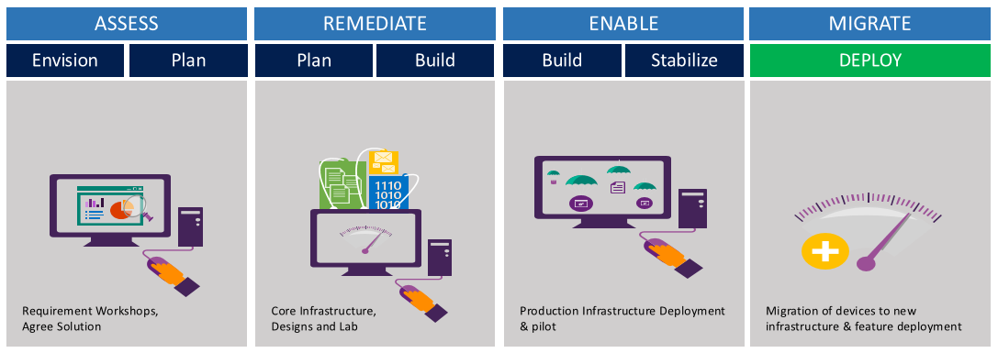

Figure . Engagement approach.

* + 1. Assess

The Assess phase will last 2 weeks. The following high-level tasks will be conducted during this phase:

* Commence project delivery
* Project schedule review
* Technical design workshops with design decisions
* Establish critical dates for required information and configuration for the next phase
* Draft Solution and Capability Architectures and technical design guides
* Validation of supporting infrastructure for development lab and pilot deployment, if required
  + 1. Remediate

The Remediate phase will last 4 weeks. The following high-level tasks will be conducted during this phase:

* Pre-production lab hardware and software installation and configuration
* Application installation media available
* Identification of users for acceptance testing
* Helpdesk briefing
* Infrastructure remediation based on solution requirements
* Pre-production lab validation of designs
* Solution briefing workshop for technical teams
* Identify and schedule 50 devices for alpha deployment
* Remediation of production systems if possible prior to the next phase
* Design review and validation
* Finalize Solution and Capability Architectures
* Update technical design guides, if needed
  + 1. Enable

The Enable phase will last 2 weeks. The following high-level tasks will be conducted during this phase:

* Implement validated design in production
* Alpha deployment of the Configuration Manager agent to 50 devices
* Alpha deployment of the Platform Delivery task sequence to up to 3 devices
* Enrollment of up to 10 mobile devices
* Support and triage of alpha deployment issues
* Design review and update based on alpha support triage
* Update and finalize design documents
* Identify and schedule remaining 75 devices for pilot deployment
* Finalize technical design guides
  + 1. Migrate

The Migrate phase will last 2 weeks. The following high-level tasks will be conducted during this phase:

* Week 9 – 75 pilot deployments of the Configuration Manager agent, up to 7 deployments of the Platform Delivery task sequence to in-scope devices
* Week 10 – 125 pilot deployments of the Configuration Manager agent
* Support and triage throughout the phase
* Pilot closeout

1. Business Impact

System Center Configuration Manager will setup a modern foundation for infrastructure management in the following ways:

* **Enable users to be more productive** – Using a self-service, user centric application model and support for corporate-connected or cloud-based device management with Microsoft Intune, users can be supported on devices of any form factor whilst complying with company standards and policies.
* **Reduce deployment duration** - System Center Configuration Manager supports the use of the new in-place upgrade deployment scenario for Windows 10, enabling users to have all their existing applications available in less time than it would take to perform a traditional wipe and load deployment.
* **Unify the IT Management Infrastructure** – Streamline operations with a unified infrastructure that integrates client management and protection across mobile, physical, and virtual environments.
* **Simplify Administration** - Administer client systems and offer improved visibility and enforcement options for maintaining system compliance.
* **Enable rapid adoption of innovation** – The transition to the System Center Configuration Manager will provide an infrastructure base that enables future updates to the Windows 10 and the infrastructure platform to be delivered in an agile fashion using the Configuration Manager servicing model, with appropriate corporate IT controls and governance.

The solution provides the following benefit to the IT teams that support the environment:

* **Core Infrastructure** – Lower the number of physical servers whilst providing scalability enhancements. Centralize the approach to support users and devices in the environment, and collect information to track hardware configuration and software license usage to help reduce cost and complexity.
* **Device Management** – Provide a common, approved and hardened baseline for all client systems that can be developed rapidly and with high-levels of automation.
* **Application Management** – Improve the ability to deliver applications dynamically to a user, where and when, thereby reducing the need for a reference image and efficiently utilizing software licenses.
* **Servicing –** Standardize and automate the approach to update and upgrade of client devices and platform infrastructure in the environment, reducing administrative effort and risk.
* **Platform Delivery** – Automated and standardize device deployment.

1. Architecture

This section discusses the technical architecture of the solution, and provides a scope summary as detailed in the Statement of Work for the project.

* 1. Approach and Rationale

The project will deliver a series of technical capabilities that, together, will enable the organization to manage their environment using the System Center Configuration Manager platform. The solution will implement the capabilities shown in Figure 3 to enable employees to work anywhere on the devices that they choose.

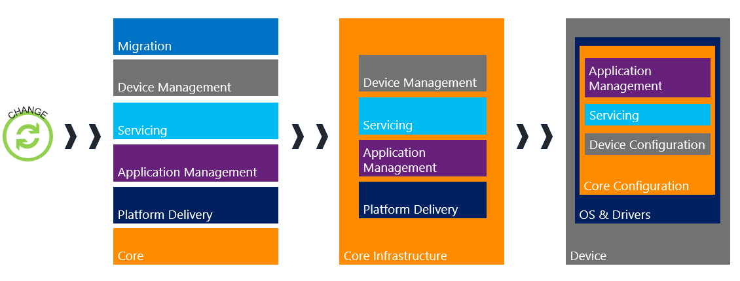

Figure . Capabilities implemented during the project.

The solution design implements 6 capabilities that may be used to affect change on the corporate environment as defined in the following sub-sections. Change may be introduced in the form of product upgrades, corporate policy changes or configuration changes.

Consultant: Update the sections below to include/exclude capabilities as decided in the workshops.

* 1. Core

The Core Infrastructure capability provides the design of the hierarchy per customer technical and business requirements, and includes changes to the core infrastructure to accommodate features and functionality required from the output of device management, platform delivery, application management and servicing workshops.

* + 1. High-Level Phase Activities
* Design workshop to determine configuration and core infrastructure requirements to support the customer environment
* Plan and design Configuration Manager infrastructure for on-premises, Azure or hybrid implementation
* Implementation of CAS and/or Primary Site and up to 1 Secondary Site (if required) in the production environment
* Migration of up to 250 devices onto Core infrastructure
* A review of the features to be implemented in the production environment
* Hardware Inventory
* Software Inventory
* Software Metering
* Asset Intelligence
* Remote Control
* Remote Assistance
* Creation of a single agreed device policy for Hardware Inventory, Software Inventory & Remote Support
* Creation of Software Metering policies for up to 5 selected applications.

Consultant: Delete activity below if out of scope

* Setup and configuration of default Configuration Manager PowerBI dashboards

Consultant: Delete Core Upgrade capability below if out of scope

* 1. Core Upgrade

The Core Upgrade capability is used to upgrade an existing System Center 2012 Configuration Manager site using existing infrastructure.

* + 1. High-Level Phase Activities
* Review the core configuration and feature capabilities implemented in the existing infrastructure management platform
* Prove the upgrade capability as part of the pilot deployment
  1. Device Management

This capability provides device management capabilities for on-premises, and optionally mobile devices if a Microsoft Intune subscription is available and prerequisites are met. Device management capabilities include corporate resource access, compliance settings, endpoint protection and power management. The design and implementation of device management features are dependent on the types of devices that are available to be managed and the supporting infrastructure available in the production customer environment.

* + 1. High-Level Phase Activities
* Design workshop to determine the supported device types to be managed
* Creation of a single on-premises policy (includes Windows Information Protection) to support client devices and non-PKI resource access policies
* Creation of a single corporate resources access profile for Email and Windows Hello for Business
* Creation of a single antimalware policy

Consultant: Delete activities below if out of scope

* Configure the core infrastructure to connect to a Microsoft Intune subscription for hybrid device management
* Create up to two hybrid device policies to support mobile devices
* Enrollment of up to 10 mobile devices
  1. Application Management

The Application Management capability is used to deploy applications to supported devices as part of the operating system deployment, or through a targeted application delivery or self-service capability. This capability ensures users can be productive on devices and receive the applications they need when the deployment of the System Center Configuration Manager agent to in-scope devices is complete.

* + 1. High-Level Phase Activities
* The delivery of up to ten supported applications or agents installed onto a device
* Device and user centric application delivery of in-scope applications are supported
* Application collections for the in-scope applications are setup to ensure re-installation of device and user targeted applications when the device is refreshed
* Support for the use of App-V applications (where App-V integration is configured and used in the production environment)
* Support for the System Center Configuration Manager Company Portal application is included for user centric application installation (when chosen as an application for deployment)
* Support for the use of the System Center Configuration Manager Application Catalog is provided for user based application installation (when Application Catalog functionality is configured and used in the production environment)

Consultant: Delete activities below if out of scope

* Integration of Windows Store for Business with the Configuration Manager infrastructure
  1. Servicing

This capability supports the update and upgrade of devices that are managed by the platform, and the ability to upgrade the platform within the product.

* + 1. High-Level Phase Activities
* Design workshop to determine product update and servicing configuration, Software Update Management & Windows as a Service approach, and core infrastructure requirements to support the capability
* Software Update Management design to support up to 5 Microsoft products, to be targeted at Pilot devices
* A Windows as a Service design with up to 6 servicing rings to support Windows 10 devices (if available in the environment)

Consultant: Delete activities below if out of scope

* Integration of Upgrade Analytics with the Configuration Manager infrastructure
  1. Platform Delivery

The Platform Delivery capability is used to deploy a customer provided reference image, selected applications, configuration, and device drivers to pilot devices in the production environment. The capability delivers a zero-touch deployment solution to enable devices to be deployed with a supported operating system in the production environment.

* + 1. High-Level Phase Activities
* The deployment of up to 10 devices (3 device models) in the production environment
* The creation of a task sequence to support deployment of a customer supplied reference image to up to three device types in the production environment
* Zero Touch Installation will be supported for the following deployment scenarios:
* New deployment scenario (Bare Metal)
* Refresh deployment scenario
* Media based deployment scenario
* In-place upgrade scenario (if Windows 10 image available and source OS is supported)

Consultant: Delete activities below if out of scope

* Microsoft BitLocker enabled and deployed to in-scope devices
  1. Migration

The Migration capability is used to automate the transfer of content and configuration from a supported version of System Center Configuration Manager 2007.

* + 1. High-Level Phase Activities
* Review the core configuration and feature capabilities implemented in the existing infrastructure management platform
* Determine what configuration and features are to be migrated
* Determine if shared infrastructure can be leveraged to support migration activities
* Prove the migration capability for each required feature as part of the pilot deployment

* 1. Tradeoffs

Consultant: Document the major tradeoffs that the customer has made during the design workshops, and the justification for the tradeoff. Examples are provided in the table below.

The following tradeoff decisions were made.

|  |  |  |
| --- | --- | --- |
| Capability | Tradeoff Decision | Justification |
| Core | Distribution Points installed on desktop devices in branch sites will be used instead of Secondary Sites | The profile of a standard branch office indicates that less than 20 devices exist at each site, and these devices don’t require a volume of content that necessitate dedicated infrastructure. |
| Device Management | Android devices will not be managed as part of the pilot implementation | iPhone and Windows 10 mobile devices will be piloted during the project, as a high percentage of users operate the devices in the environment today |
| Application Delivery | Investment in App-V packaging may not be leveraged during the pilot | Target users do not utilize App-V applications |
| Servicing | Internet connectivity will be provided to the site server(s) that hosts the Service Connection Point and Software Update point | This approach reduces administrative effort to obtain platform and product updates/upgrades that service the environment |
| Platform Delivery | User state migration is supported with out of the box functionality only. | There is no appetite within the business to invest effort in a customized user state migration approach, and supply storage to retain user data during a migration. |
| Migration | Shared Distribution Points will not be leveraged to support the implementation of the new platform | Reduction in functionality for the application management capability when shared distribution points are used during the migration phase – the benefits of the application model introduced with System Center Configuration Manager must be available to pilot users |

1. Key Assumptions

The successful delivery of the project within the prescribed 10-weeks is dependent on the assumptions in this section. These assumptions ensure that:

* Customers, business functionality and critical system are minimally impacted
* The project is delivered within the agreed scope, duration, and budget
* Depending projects can commence on time.
  1. Core Infrastructure

The core infrastructure refers to the key external dependencies of the solution. However, this may extend to other aspects of basic IT services. The following is assumed of the core infrastructure:

* Active Directory is implemented at a version supported by Microsoft
* Active Directory is operating in a healthy state and has been independently verified through an Active Directory Risk Assessment Program
* Group Policy is operating in a healthy state and has been independently verified through a Group Policy Health Check
* Basic networking services are operating in a healthy state. This includes, but is not restricted to, Domain name Service (DNS), Dynamic Host Configuration Protocol (DHCP), internet access

Consultant: Delete assumption below if not applicable

* Existing Configuration Manager infrastructure is operating in a healthy state and has been independently verified through a Configuration Manager Risk Assessment Program
  1. Hardware

Hardware refers to any hardware required for either the project development lab, production networks or client devices and associated peripherals. The following is assumed of all hardware:

* All hardware required for the project will be available no later than the end of the second week after which the project commences
* All hardware is verified for compatibility with the operating system with which it will be used.
  1. Application Software

All software required to deliver a successful project is:

* Verified for compatibility with the operating system on which it will be used
* Appropriately licensed and verified for use by the organization, group, or user(s)
* Procured timeously and installation media is made available to project staff, including any associated licenses
* Downloaded, where applicable, by the authorized organizational delegate and all download checksums are verified where applicable.
  1. Project Team Interaction

The completion of the project in the agreed 10-week period is contingent upon clear communication between the project and non-project teams. The following will be assumed of the relationship between the project team and non-project teams where dependency and delivery are required:

* Each team will assign a specific resource, and one back up resource as a point of contact for the project
* During design workshops, specified teams will nominate a subject-matter expert to participate in design workshops and timeously provide review of technical designs
* Remediation of production systems and implementation of project configurations in production will be performed by the relevant team assignee, or delegate, as appropriate.

1. Customers

Use this section to detail who the solution is being designed for (User Type, User Number, information on number of max users the solution should accommodate).

The System Center Configuration Manager solution is being designed for the entire production environment, and focused on the transformation of up to 250 users that span across the following business units:

Consultant: The first row of this table is a repeating row. Complete the first row, then click the + symbol at the bottom right of the row to add another row.

|  |  |  |  |
| --- | --- | --- | --- |
| Business Unit | Location | Number of devices | Worker Type |
| Business Unit Name | Choose an item. | # of devices | Choose an item. |

Table: In-scope users for the System Center Configuration Manager project

1. Success Criteria

Use this section to detail the success criteria of the project developed for the <CUSTOMERNAME> environment to be duplicated in the close-out deck

The table below illustrates the success criteria that must be met for the System Center Configuration Manager project to be considered a success in the production environment.

|  |  |  |
| --- | --- | --- |
| Category | Criteria | Comment |
| People | The solution supports the pilot workforce | The infrastructure management platform must be usable in the environment – meaning that relevant applications and configuration are applied to devices to ensure a positive user experience |
| People | The solution provides an opportunity for user feedback to streamline the transformation process for future accelerated deployments | Feedback on the capabilities provided by the infrastructure management platform is critical to understanding how to accelerate future deployments can be made easier for users |
| Process | The deployment of an operating system reference image should not take more than 90 minutes | Actual deployment time varies by customer and is dependent on several factors e.g. – image size, application size, network connectivity to platform delivery infrastructure, infrastructure configuration. |
| Process | Pilot applications must be certified for use on the supported operating system by the customer ahead of production deployment | Application compatibility is critical to the success of the pilot. If applications cannot be certified for use, the risk of applications not working during production deployment must be accepted |
| Technology | The solution should leverage existing customer infrastructure where possible | This approach reduces changes to the production environment and leverages existing investments made in the estate |
| Technology | Existing customer infrastructure must support platform capabilities | To ensure a successful pilot, supporting management, configuration, networking update and licensing infrastructure / tools may require changes or updates to be used or support the new infrastructure management platform in the production environment. |