Statement of Work

Modern Workplace for Spin-Off

Prepared for

Prepared by

Date: March 31, 2020

Version: 1.0

### Prepared by Microsoft Services Prepared for



Prior to the parties indicating final agreement by signing a Work Order, the information contained in this docu- ment represents the current view of Microsoft on the issues discussed as of the date of publication and is subject to change. Furthermore, prior to the signing of the Work Order, this document should not be interpreted as an invitation to contract or a commitment on the part of Microsoft. After the Work Order has been signed, changes to this document will be managed through the Change Management Process described in this document.

IF THIS DOCUMENT IS INCORPORATED BY REFERENCE INTO A WORK ORDER, ALL WARRANTIES APPLICABLE TO THE WORK ORDER APPLY TO THIS DOCUMENT. MICROSOFT MAKES NO WARRANTIES, EXPRESS OR IMPLIED, IN THIS DOCUMENT.

The descriptions of other companies’ products in this document, if any, are provided solely as a convenience to aid understanding and should not be considered authoritative or an endorsement by Microsoft. For authoritative descriptions of any non-Microsoft products described herein, please consult the products’ respective manufactur- ers. © 2020 Microsoft. All rights reserved. Any use or distribution of these materials without the express authori- zation of Microsoft is strictly prohibited.

Microsoft and Windows are either registered trademarks or trademarks of Microsoft in the United States and/or other countries.

# Table of Contents

1. INTRODUCTION 2
2. MANAGEMENT SUMMARY 4
   1. AREAS OUT OF SCOPE 5
3. TIMELINE 6
4. PROJECT GOVERNANCE 7
   1. ORGANIZATION STRUCTURE 7
   2. PROJECT GOVERNANCE APPROACH 8
      1. Steering Level 9
      2. Program Level 9
      3. Operational Level 10
      4. Offerings Dependencies 10
   3. COMMUNICATION PLAN 11
   4. EXECUTIVE STEERING COMMITTEE 12
   5. ESCALATION PROCESS 13
   6. ISSUE/RISK MANAGEMENT PROCEDURE 13
   7. CHANGE MANAGEMENT PROCESS 14
   8. PROJECT COMPLETION 15
   9. PROJECT ROLES AND RESPONSIBILITIES 15
      1. Project Roles and Responsibilities 15
      2. Microsoft Key Project Roles and Responsibilities 16
5. GENERAL CUSTOMER RESPONSIBILITIES AND OBLIGATIONS 17
6. GENERAL ASSUMPTIONS 18

List of Tables

TABLE 1: REFERENCED DOCUMENTS 3

TABLE 2: OFFERING SERVICES DESCRIPTION 4

TABLE 3: COMMUNICATION PLAN (PROPOSAL) 12

TABLE 4: MEMBERS OF THE EXECUTIVE STEERING COMMITTEE (PROPOSAL) 12

TABLE 5: ESCALATION PATH (PROPOSAL) 13

TABLE 6: KEY ROLES 15

TABLE 7: MICROSOFT KEY ROLES 16

TABLE 8: CUSTOMER SUPPLIES 17

TABLE 9: PROJECT ASSUMPTIONS 18

# List of Figures

FIGURE 1: HIGH LEVEL TIMELINE (INCLUDES RUNNING BRIDGE CONTRACT) 6

FIGURE 2: EXEMPLARY PROJECT ORGANIZATION 8

FIGURE 3: GOVERNANCE MODEL ON STEERING- PROGRAM AND PROJECT (OFFERING) LEVEL 9

# Introduction

This Statement of Work (SoW) and any exhibits, appendices, schedules, and attachments to it are made pursuant to the Work Order No. 6DEU203-287090-343321, the terms of which are incorporated herein by reference, by and between Continental AG / End Customer - (“Customer”, “”, “you”, “your”) and Microsoft Corporation (“Microsoft”, “us”, “we”, “our) or Microsoft’s affiliate, and sets forth the services to be per- formed by us related to the Cloud Readiness and Transformation Program (“Vitesco Spin- Off Modern Workplace Services”, “project”).

This SoW, together with the Work Order, represents the complete baseline for scope and ser- vices applicable to this project. All changes to this document will be managed in accordance with the Change Management Process defined below. Any terms not otherwise defined herein will assume the meanings set forth in the Work Order.

All activities described in this document are provided as services within the meaning of §§ 611 ff. German Civil Code (“Dienstleistung”). Microsoft does not owe a result or deliverable but will support the customer to achieve the project objectives described in this document.

This SoW and the associated Work Order expire 30 days after their publication date, unless signed by both parties or formally extended in writing by Microsoft.

## Referenced Documents

The following documents are related to this SoW.

Table 1: Referenced documents

|  |  |  |  |
| --- | --- | --- | --- |
| S. No. | Document title | File Name | Date / Ver- sion |
| 7 | Design and Implementation for Active Directory | 07_SOW_Design and Implementation for Ac- tive Directory | February 28, 2020/  Version 1.0 |
| 8 | Cloud Security Planning | 08_SOW_Cloud Security Planning |
| 12 | Privileged Access Workstation | 12_SOW_Privileged Access Workstation |
| 13 | Hardened Forest | 13_SOW_Hardened Forest |

# Management Summary

The services offered in-scope of this Statement of Work have been selected by Vitesco Tech- nologies for Wave 1 and are described in detail in the below Table and the respective State- ment of Work documents as referenced in this Master document.

Table 2: Offering services description

|  |  |
| --- | --- |
| **Offering** | **Services description** |
| Design and Implementation for Active Directory | Deploy a new Active Directory Domain Services (AD DS) envi- ronment for .  This will serve as a production directory service that provides authentication and authorization services across a variety of resources.  This offering has been partially provided in Bridge Contract, therefore the estimated effort for this offering has been re- duced in this proposal accordingly. |
| Cloud Security Planning | To provide a prescriptive roadmap and a set of high-level rec- ommendations that map Microsoft 365 security and Azure se- curity.  Microsoft 365 security and compliance capabilities and Cus- tomer-controlled features to ’ business and technical requirements. |
| Privileged Access Workstation | Offer addresses the need for highly secured workstations for the administration of enterprise services, data, and applica- tions.  This offering has been partially provided in Bridge Contract, therefore the estimated effort for this offering has been re- duced in this proposal accordingly. |
| Hardened Forest | This project, called Enhanced Security Administrative Environ- ment (ESAE), help confirm the root of the infrastructure is pro- tected and trusted. |

In addition, **program and project governance** as well as **quality assurance** is provided to coordinate and support the delivery of the overall program.

This document describes all general rules that apply to all services offered by Microsoft to support the overall program.

The underlying general conditions are described in chapters “Assumptions” and “Customer responsibilities” in this document as well as the respective appendix.

## Areas out of Scope

Specific topics or areas out of scope are described in the services description of each Offer- ing.

# Timeline

The timeline provided here is a high-level overview that summarizes timelines of the different Offerings. More details regarding the planning of each Offering and our basic assumptions for them is described in the respective SOW documents provided together with this master document.

|  |  |  |  |
| --- | --- | --- | --- |
| **Offerings** | **M1** **M2** **M3** **M4** | | |
| 7. Design and Implementation for AD | Provided through |  |  |
| 8. Cloud Security Planning | Bridge Contract |  |  |
| 12. Privileged Access Workstation |  |  |  |
| 13. Hardened Forest |  |  |  |

Figure 1: High Level timeline (includes running bridge contract)

# Project Governance

has the overall responsibility and ownership of the individual projects. Microsoft Project Coordinator will report into the established Program Governance Organiza- tion at and support the Program and Project Manager(s) of Vitesco Tech- nologies. Details of Microsoft’s integration into this organization will be discussed at project start.

The Microsoft team working on the project(s) will consist of a joint team, staffed by Microsoft Services and Microsoft’s implementation partners regarding the technologies used. Microsoft will also integrate Microsoft’s Global Delivery Organization to leverage the experience and capabilities Microsoft has to deliver large programs on a global scale.

In performing services under this project and the applicable Work Order, Microsoft will rely upon any instructions, authorizations or other information provided by ’ Program and/or Project Manager(s) or personnel duly designated by ’ Program and/or Project Manager(s) or other roles.

**The Program and Governance structure proposed here applies to all Offerings of this projects.**

## Organization Structure

This section describes the overall program and organization structure, reporting relationships, and key project roles. Projects are grouped into technology domains, called “Offerings,” such as ‘Design and Implementation for AD ’ or Privileged Access Workstation’.

Microsoft will work with in joint teams on the respective levels. (Steering Committee, Program Management, Project level).

The overall program will be organized as depicted in the following diagram.



Program Management

Program Manager

Program Manager

Project Coordinator

Project Manager

Lead Architect

Lead Architect

Subject Matter Experts

Subject Matter Experts

Microsoft

Vitesco

Figure 2: Exemplary Project Organization

For this project there will be joint teams, shared responsibility and active participation by technical leads. It is expected that these projects are led by a project manager from . Microsoft provides project management support with a Project Coordinator.

## Project Governance Approach

This section outlines Microsoft’s proposal to set up a Project Governance approach. The in- stantiation of the governance will be done in tight cooperation and synchronization with at the very beginning of the overall program.

For an effective and efficient delivery of Microsoft’s services it is important to implement a joint governance model that covers different levels of ’ and Microsoft’s organization.

Microsoft proposes to define a communication- and meeting structure on steering-, pro- gram- and operative level as well as to implement an escalation processes across these levels.

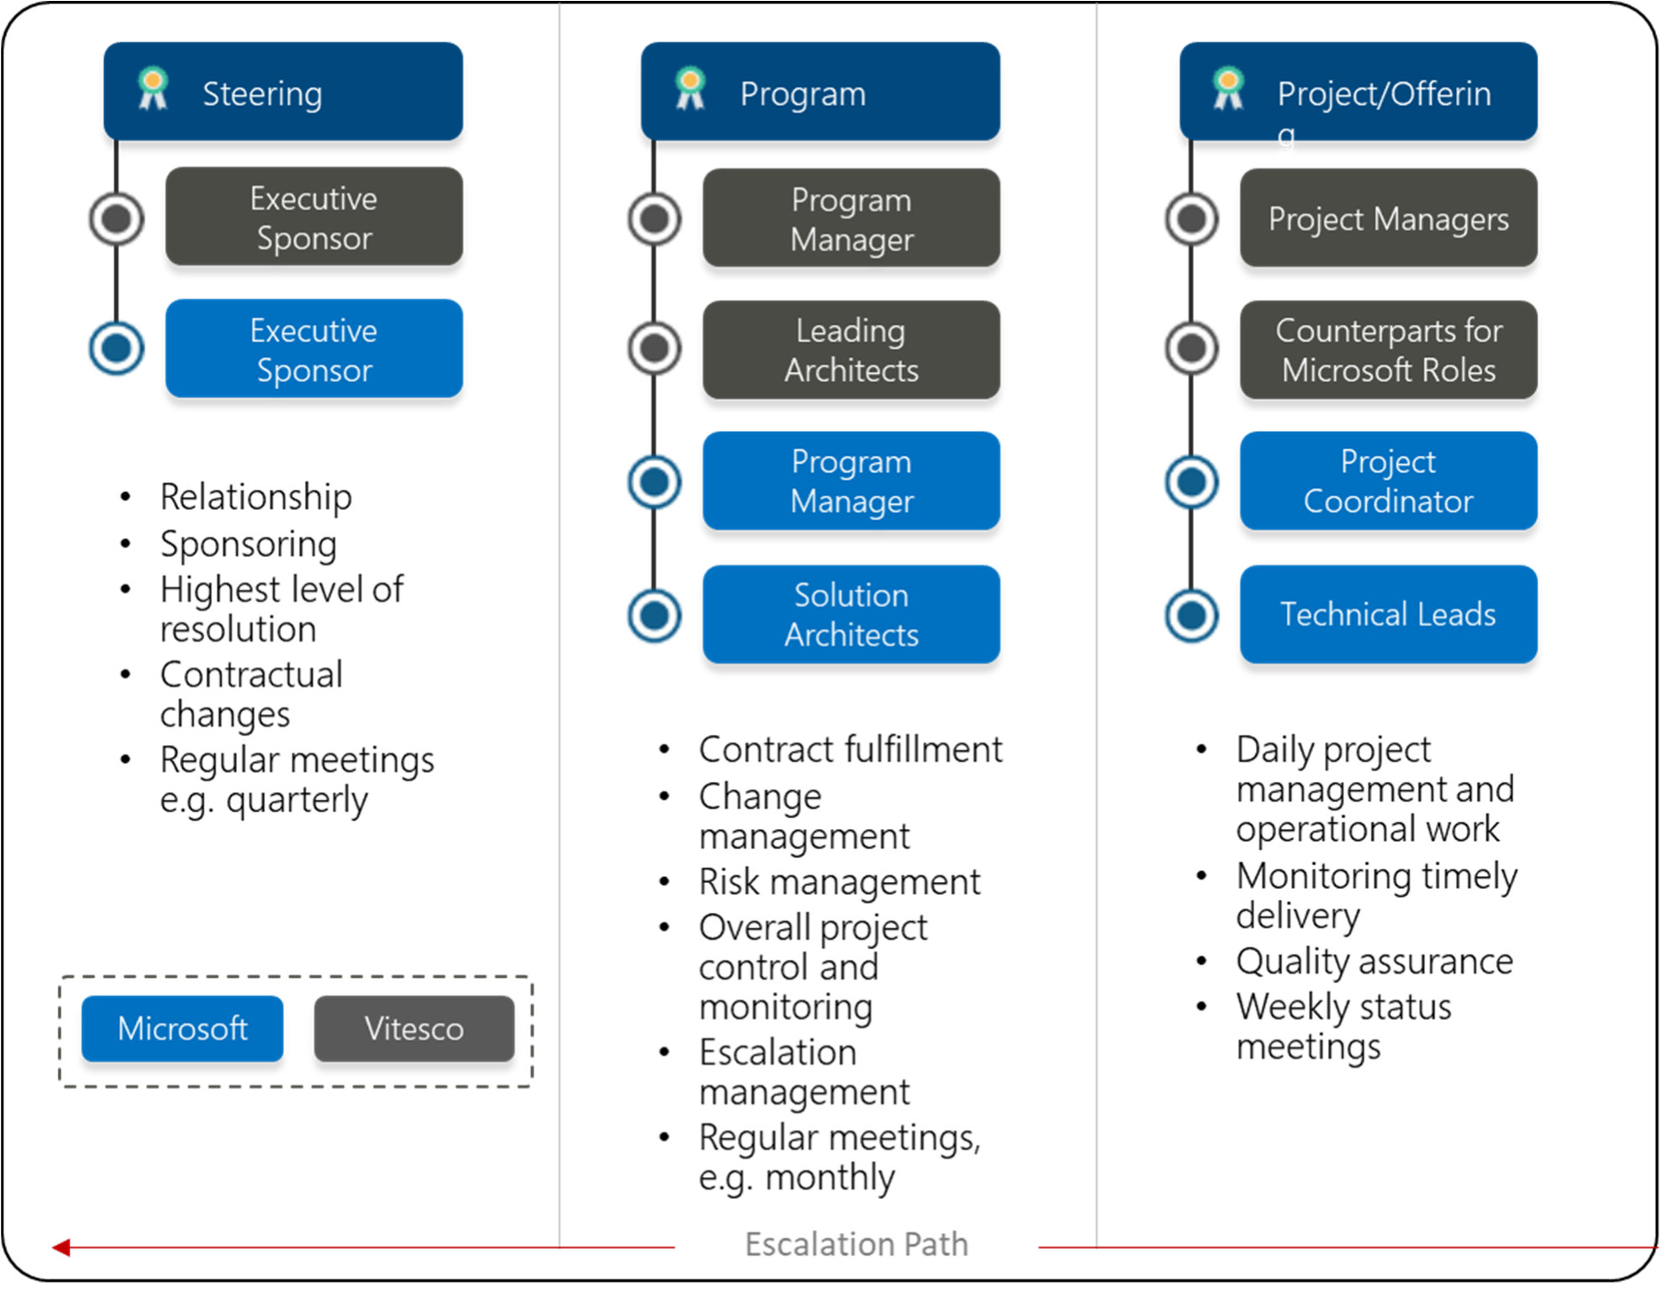Our experience shows that this also improves the partnering and integration of engaged 3rd party organizations, if any.

Figure 3: Governance Model on Steering- Program and Project (Offering) level

### Steering Level

On the Steering or “strategic” level Microsoft proposes to establish an Executive Steering Board, consisting of Management representatives and Project Sponsors of the contract part- ners.

It is proposed that this group will be informed on a regular basis, as proposed in section **Feh- ler! Verweisquelle konnte nicht gefunden werden.** or driven by specific project events.

Only the Executive steering committee is empowered to decide upon major changes in the project scope, budget or timeline.

### Program Level

* 1. The Program or “tactical” level has the complete over- sight over all activities and projects related to the Vitesco Spin-Off Modern Workplace Services program. needs to establish this organization and Microsoft will align and integrate into this organization as described in Communication Plan

.

This group will meet on a regular basis, e.g. in the Jour Fixe Meeting, and agree upon status of this project and deviations from the plan.

The tactical level monitors the delivery of the project according to the contracts.

Project members on the tactical level are empowered to decide about the implementation of minor and median changes in the project scope, budget or timeline.

Escalations received from the operative level are resolved if possible or forwarded to the stra- tegic level for final decision.

### Operational Level

The Project Coordinator from Microsoft and the project manager from cooperate on a daily basis.

Information is frequently exchanged, and this level is actively working on open issues and problems with their respective teams.

If issues cannot be solved, escalations are prepared and forwarded on demand to the pro- gram level.

The operational level is also responsible to drive the change management process for changes within the projects.

### Offerings Dependencies

Many of the offerings included in this project have dependencies on one another. A high- level overview of these dependencies is outlined in the table below. The offerings listed in the “Dependency” column, if any, must be completed in part or in their entirety before the pro- ject listed in the first column begins. The program scope, schedule or cost may be impacted if these dependencies are not satisfied.

|  |  |
| --- | --- |
| Package Name | Dependency |
| Design and Implementation for AD | No dependency |
| Cloud Security Planning | No dependency |
| Privileged Access Workstation | Design and Implementation for AD |
| Hardened Forest | Design and Implementation for AD |

## Communication Plan

To facilitate an efficient cooperation of and Microsoft’s project team members, it is necessary to establish an adequate project communication plan.

The Microsoft team will follow the communication plan that is provided by the project man- agement from . For the avoidance of doubt: This does not create any in- struction right regarding methods and approaches used or regarding working hours and place of work.

If no guidance is provided, Microsoft proposes to establish the following communication plan, which will be mutually agreed at the beginning of the project.

Table 3: Communication plan (proposal)

|  |  |  |  |
| --- | --- | --- | --- |
| Meeting | Purpose | Participants | Frequency / Duration |
| Kick-Off | Communication of general guidelines, project goals and plans  Introduction of project team members | Project team | At project start,  2 hours |
| Internal Project Meeting | Gather information about status of ac- tivities, issues and problems, escalate unresolvable problems to next level. | Project team | Weekly or on demand Max. 1 hour |
| Jour Fixe | Major instrument to monitor and man- age the project regarding   * Timeline * Budget consumption * Risks * Quality of services delivered * Resolve open issues | * Customer’s Project Management, * Microsoft Project Coordinator * On demand: Sub- ject Matter Experts | Bi-weekly |
| Executive Steering Board | * Assess overall status of the project, * Adjust priorities * Solve major issues | * Management rep- resentatives from customer and Mi- crosoft Delivery Management, * On demand: Pro- ject management, Subject Matter Ex-   perts | Monthly |

## Executive Steering Committee

Overall senior management oversight and strategic direction for this project will be provided by an Executive Steering Committee, which will consist of the following key executive busi- ness sponsors and project management representatives:

Table 4: Members of the Executive Steering Committee (proposal)

|  |  |
| --- | --- |
| Members | Microsoft Members |
| NAME TBD  Title | NAME TBD  Microsoft Delivery Manager |
| NAME TBD  Title | NAME TBD  Management Sponsor Microsoft Services |

The Executive Steering Committee will hold meetings and provide meeting minutes as de- fined in the communication plan. Customer project manager and Microsoft Project Coordina- tor will share joint responsibility for reporting to the Steering Committee.

The Executive Steering Committee is responsible for the following:

* Making decisions on project strategic direction
* Serving as the final arbiter of project issues (refer to the escalation process)
* Approving major change requests

The Executive Steering Committee has no instruction rights against Microsoft, its employees and its other vicarious agents regarding methods and approaches used or regarding working hours and place of work. Directives to help facilitate proper execution of this SOW remain un- affected.

If necessary, the steering committee members meet on demand and use other facilities to meet regularly, e.g. telephone conferences or online meetings.

## Escalation Process

The Microsoft team will follow the procedure defined by to escalate and resolve issues.

If there is no escalation process defined on the customer’s side, Microsoft proposes to estab- lish and mutually agree on the following procedure.

The escalated issue will be discussed and resolved at the next possible regular project com- munication according to the communication plan.

In urgent situations escalations can be raised on demand and resolved via phone conference or online meeting.

Table 5: Escalation path (proposal)

|  |  |  |  |
| --- | --- | --- | --- |
| Level | Escalation Manager | Organization | Name |
| Offering | Technical Lead | Microsoft | TBD |
| Project | Project Manager,  with support from Microsoft Project Coordinator |  | TBD |
| Program | Program Manager or Overall responsible person |  | TBD |
| Business | Business Lead / Stakeholder |  | TBD |

The acting persons should be identified and named during the project kickoff meeting.

## Issue/Risk Management Procedure

The following general procedure will be used to manage active project issues and risks dur- ing the project:

* **Identify:** Identify and document project issues (current problems) and risks (potential events that impact the project)
* **Analyze & Prioritize:** Assess the impact and determine the highest priority risks and issues that will be managed actively
* **Plan & Schedule:** Decide how high-priority risks are to be managed and assign re- sponsibility for risk management and issue resolution
* **Track & Report:** Monitor and report the status of risks and issues and communicate issue resolutions
* **Control:** Review the effectiveness of the risk and issue management actions
* **Active issues and risks** will be monitored and reassessed on a weekly basis. Mutually agreed upon issue escalation and risk management processes will be defined at the outset of the project.

## Change Management Process

The Microsoft team will follow the change management procedure that is provided by the project management from . For the avoidance of doubt: This does not create any instruction right regarding methods and approaches used or regarding working hours and place of work.

If no guidance is provided, Microsoft proposes to establish the following change manage- ment procedures, which will be mutually agreed at the beginning of the project.

During the project, either party may request, in writing, additions, deletions, or modifications to the services described in this SoW (“change request”).

The change management process is executed in interaction between the customer’s project manager and the Project Coordinator from Microsoft.

The impact on price, cost and schedule due to the change request will be mutually agreed by both parties.

Microsoft will document all changes in a change management log. As long as changes to the project can be done without impact to the overall effort and/or budget, this process will be solely used for documentation purposes.

If changes have an impact on required budget, Microsoft will be estimated additional efforts and make a commercial offer for the budget increase.

At Microsoft’s discretion, time required to research, and document customer originated change requests will be billed at the standard rates specified in the project Work Order.

Microsoft can apply changes due to technical improvements and technological developments without notice if these changes provide value to the customer, improve quality or efficiency of services or if it is beneficial for the delivery of Microsoft’s services.

## Project Completion

Microsoft will provide Services defined in this SOW to the extent of the fees available and the term specified in the Work Order. If additional services are required, the Change manage- ment process will be followed, and the contract modified. The project will be considered complete when at least one of the following conditions has been met:

* All fees available have been utilized for Services delivered and expenses incurred.
* The term of the project has expired.
* The Work Order has been terminated.

## Project Roles and Responsibilities

This section provides a brief description of key project roles and responsibilities.

### Project Roles and Responsibilities

Table 6: key roles

|  |  |
| --- | --- |
| Role | Responsibilities |
| Project Sponsor | * Provides strategic leadership * Clears project roadblocks |
| Steering committee member | * Make decisions regarding scope, schedules and to resolve escalated risk and issues * Approve plans and authorize deviations from plan, including the ap- proval of change request * Review program progress, benefits delivery and costs * Provide guidance and an escalation point on issues that the program has been unable to resolve |
| Program Manager | * Responsible to driving the overall program across all Offerings * Jointly working with Microsoft Program Coordinator * Gather and assemble all project management plans, project status re- ports, and project performance reports * Facilitate project governance activities and attending the Project Steer- ing Committee * Providing advice and guidance on: * Project direction and scope * Stakeholder communication issue resolution and escalation * Synchronization of Offerings * Problem resolution across Offerings |
| Project Manager | * Primary point of contact for Microsoft team * Responsible for managing and coordinating the overall project * Responsible for resource allocation, risk management, project priori- ties, and communication to executive management * Manages day-to-day activities of the project * Coordinates the activities of the team to work according to the project schedule |

|  |  |
| --- | --- |
| Role | Responsibilities |
| Offering specific roles | * All roles specific to an Offering / project are described in the respective appendix of this SoW |

The persons fulfilling the roles should be identified and named prior to the kick-off meeting.

It is assumed that customer’s team members have enough capacity, the right skills, and will be available as required to support the project and timelines.

### Microsoft Key Project Roles and Responsibilities

Table 7: Microsoft key roles

|  |  |
| --- | --- |
| Role | Responsibilities |
| Program Manager (Mi- crosoft Delivery Man- ager) | * Support Program Manager * Responsible for service quality and ’ overall satis- faction with Microsoft’s services * Single point of contact for billing issues, staffing matters, contract ex- tensions, and MCS project status * Project change management and reporting on the budget consump- tion for the dynamic scope projects * Program steering |
| Project Coordinator | * Coordinates the daily activities and services provided by the Microsoft team * Supports the Project Manager from * Attending and supporting the preparation of Jour Fixe meetings * Clarification of issues/problems/open points * Status reporting over the activities and planning the activities of Mi- crosoft and its sub-contractors |
| Offering specific roles | * All roles specific to an Offering are described in the respective appen- dix of this SoW |

# General Customer Responsibilities and Obliga- tions

Microsoft’s work on the project is dependent on the customer’s provisions in many aspects. A delayed provisioning of the obligations could lead to delays for the overall project.

If customer’s resources are limited in capacity or do not have the right skills to jointly work on the project, this may have an impact on timely delivery or quality of Microsoft’s ser-vices.

Microsoft will strive for a cooperative and proactive cooperation and expects that delays or missing obligations are notified early by the customer, as Microsoft will do.

The following table lists the dependencies and obligations for the delivery of this project, which have been identified up to this point in time.

Additional, service-specific obligations may be listed in the services descriptions

Table 8: Customer supplies

|  |  |  |  |
| --- | --- | --- | --- |
| Activity | Obligation | Description | Date |
| Overall project | Workplaces for the Microsoft team | Office workplaces onsite at the cus- tomer’s project location, including ac- cess to meeting rooms and facilities | Start of activities |
| Overall project | Provide access to IT systems | Access to all IT Systems (UID/PW) that are relevant to deliver the services as described in this SoW. | Start of activities |
| Overall project | Internet connec- tion | Broadband Internet connection for communication (email, IP telephony) and VPN access to Microsoft corporate network. | Start of activities |
| Overall project | Microsoft prod- uct licenses | Provisioning of all necessary Microsoft licenses to deliver the services as de- scribed in this SoW. | Start of activities |
| Overall project | Third-party soft- ware and li- censes | Provisioning of all necessary Third-party (non-Microsoft) software and licenses, including but not limited to :   * BitTitan MigrationWiz | Start of activities |
| Overall project | Project team share | Provision of a project file share/docu- ment repository. This includes regular file backups. | Start of activities |
| Overall project | Physical and vir- tual environ- ments | Customer will provide hardware or vir- tual machines for development, test and production in a timely manner as required and operate them. | According to pro- ject plan |

# General Assumptions

The services, fees, and delivery schedule for this project are based on the following assump- tions. If assumptions do not apply, this will be treated via the change management process.

This section describes the underlying general assumptions. Additional, detailed and service specific assumptions may be documented as part of the services description.

Table 9: Project assumptions

|  |  |
| --- | --- |
| Area | Assumption |
| Project location | The services described in this SoW will be mainly delivered in Regensburg. It is possible that the services will be partly delivered in a Microsoft office location. |
| General customer responsibilities | It is assumed that the customer will provide the obligations in a timely manner or pro-actively indicate delays or failures in contributing to the project. |
| General customer responsibilities | Customer’s team members have enough capacity and will be available as re- quired to support the project and timelines |
| Project manage- ment | It is assumed that the customer’s project management works in a timely man- ner on project tasks and decisions necessary for Microsoft’s activities |