**Generative Adversarial Networks (GANs)**

Before starting the article let us try to examine these two images. Is there any discrepancy in these images?

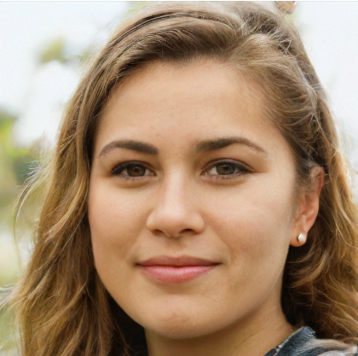 

The obvious answer is no, however you would be amazed to know that persons in these images do not exist. These images are generated by GANs.

At first, The idea of GANs was proposed by Ian Goodfellow in 2014. He is a renowned researcher in deep learning Community currently working at OpenAI. In 2014, GANs were incapable of producing such realistic images instead they were far from accurate. Through the years, improvements in algorithms have led us to the point where we may never distinguish between an image of a real person and an image generated by some GANs.

But why are these GANs so good?

So, unlike any ordinary neural network GANs consist of two neural networks working opposite of each other, each trying to be better than another one.

Think it of as a thief who once visited a gallery and saw beautiful painting worth thousands of dollars. He tries to fake it but the gallery has a genius detective who can identify fake paintings in an instant. What does the thief do?

He goes to his home and makes the painting every night improving every day to the point where the genius detective cannot recognise the difference between the original painting and fake one. Thief goes to the gallery and replaces the original one with his own painting, making a ton load of money in the process.

In GANs, the thief resembles the neural network called generator and the genius detective is called discriminator.

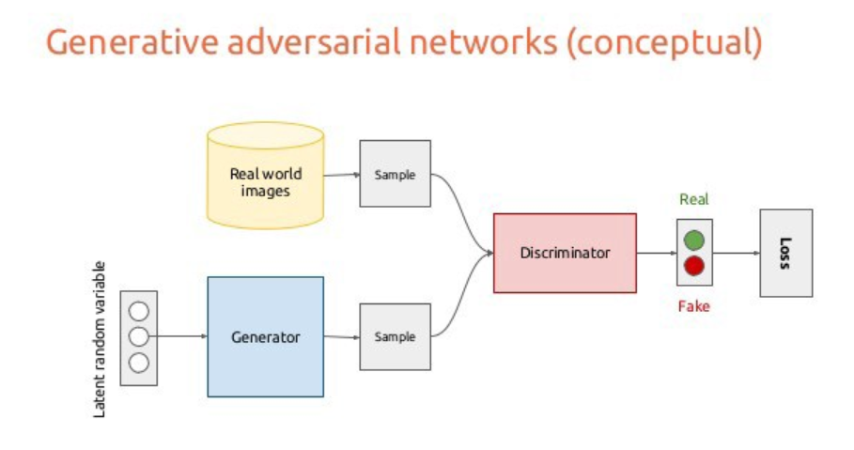

The generator is assigned with the task of designing a natural looking images, similar to the original one but different enough to fool the discriminator. The generator is given some random noises which it tries to incorporate into making new images similar to the original one. Then both original and fake images are sent to the discriminator for checking.

This article is for general understanding so we will not be getting into the equations and deeper.

But are GANs flawless yet?

Certainly not. They have improved throughout the years but still posses some problems like symmetry in faces, Background of faces may be inappropriate, distinguishable hairs etc.

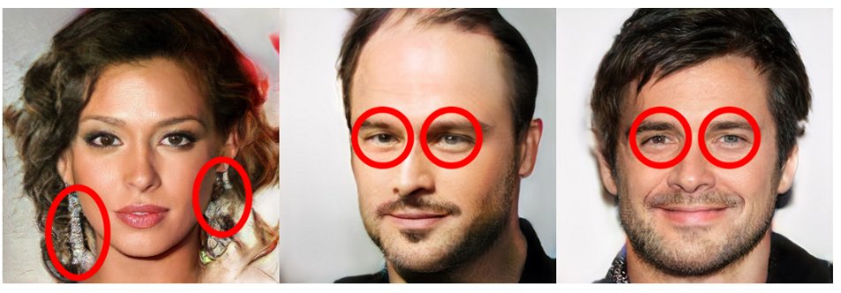

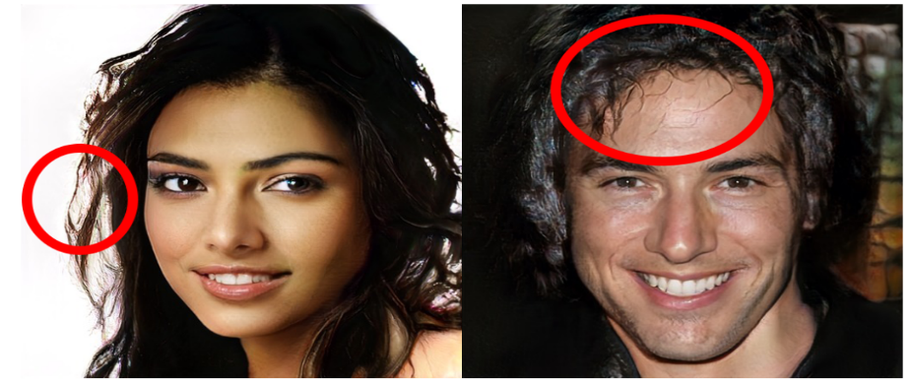

In short, GANs are better from the ones in 2014 but still, a long way lies ahead.

Sure, there are a lot of inappropriate usages of GANs. For example, Face2Face model presented at CVPR 2016 can transfer visually plausible facial expressions from a source video to a target video.

https://www.youtube.com/watch?time_continue=250&v=ohmajJTcpNk

This video shows how anyone can use footage of a country's president and completely use it for their own use.

Another one is PassGAN proposed by Briland Hitaj, Paolo Gasti, Giuseppe Ateniese and Fernando Perez-Cruz in their paper. This project was developed to crack passwords. It performed twice as well as John the ripper and had a very promising result that contemporary password cracking tools.

There are many more examples to support the statement but we are yet to see a groundbreaking result in this field.

Interested people must check out "thispersondoesnotexist.com" a small site developed by Philip Wang at Uber. It shows a different person's image every time you load the website but that person does not exist, Just an image generated by a GAN.

"https://poloclub.github.io/ganlab/" provides a playground mode for people to look at how GANs actually work and can play around with data.