**CRYPTOCURRENCY-A DECENTRALISED BUSINESS MODEL**

**HEARD OF CRYPTOCURRENCY?**

Cryptocurrency is a decentralized digital cash system that uses a peer-to-peer network . Every peer in the network needs to have a list with all transactions to check if future transactions are valid or not.

**Brief history –**

Bitcoin is the first decentralized cryptocurrency that was created in 2009 by [Satoshi Nakamoto](https://en.wikipedia.org/wiki/Satoshi_Nakamoto). It used SHA-256 cryptographic hash function.

**How Cryptocurrency Works-**

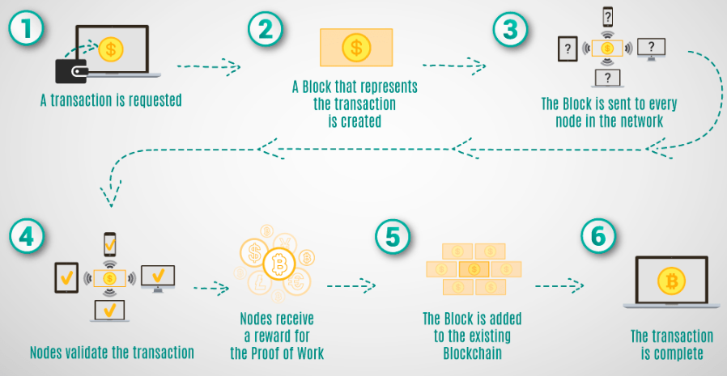

But what happens when someone creates thousands of peers and spreads forged transactions. The system would break immediately.So,here comes the **role of miners**.

Only miners can confirm transactions. They take transactions, stamp them as legit and spread them in the network. After a transaction is confirmed by a miner, every node has to add it to its database. It has become part of the blockchain.For this job, the miners get rewarded with a token of the cryptocurrency.

**How cryptocurrencies are created:**  To add a cyptocurrency such as bitcoin,miners solve a cryptographic puzzle.After finding a solution, a miner can build a block and add it to the blockchain. As an incentive, he has the right to add a so-called coinbase transaction that gives him a specific number of Bitcoins.

**Several popular cyptocurrencies(rankwise):**

1.Bitcoin-Bitcoin serves as a digital gold standard in the whole cryptocurrency-industry, is used as a global means of payment and is the de-facto currency of cyber-crime like darknet markets or ransomware.Present value of Bitcoin in indian market is 2,44,699 rupees.

2. Ethereum-Vitalik Buterian developed this cryptocurrency. Other than Bitcoin its blockchain does not only validate a set of accounts and balances but of so-called states. This means that Ethereum can not only process transactions but complex contracts and programs. Present value of Ethereum in indian market is 7516 rupees.

3. Ripple-Ripple has a native cryptocurrency – XRP.Ripple Labs created every XRP-token, the company running the Ripple network, and is distributed by them on will. For this reason, Ripple is often called pre-mined in the community and dissed as no real cryptocurrency, and XRP is not considered as a good store of value. Present value of Ripple in indian market is 22 rupees.

4.Litecoin- Litecoin was a real innovation, perfectly tailored to be the smaller brother of bitcoin. It facilitated the emerge of several other cryptocurrencies which used its codebase but made it, even more, lighter. Present value of Litecoin in indian market is 2311 rupees.

5.Monero-This algorithm was invented to add the privacy features Bitcoin is missing. If you use Bitcoin, every transaction is documented in the blockchain and the trail of transactions can be followed. With the introduction of a concept called ring-signatures, the cryptonite algorithm was able to cut through that trail.Present value of Monero in indian market is 3059 rupees.