Advanced Saline Assistance System for Remote Monitoring and Control

Chandan Thakur¹, Mayank Patil², Manthan Patil³, Omkar Joshi⁴
U. G. Students, Department of Electronics and Telecommunication, Vidyavardhinis’ College of Engineering, Vasai (W), Palghar- 401202
E-mail: ¹chandan.200471101@vcet.edu.in, ²mayank.200301105@vcet.edu.in, ³manthan.200291105@vcet.edu.in,
⁴omkar.200151101@vcet.edu.in

Abstract— One of the responsible tasks for healthcare professionals is to maintain the administration of saline solutions to critically ill or bedridden patients. Typically, medical professionals utilize their experience to hypothetically estimate and set the Intravenous (IV) fluid flow rate. This research aims to develop a regulating, monitoring, and controlling saline system with better reliability and safety measures. The flow rate is measured by the Infrared (IR) sensor placed parallel to saline bottle and mounted across the Drip chamber housing (DCH). Volume of Saline bottle is measured using Load cell sensors. A Tube Squeezing Mechanism (TSM) regulates the fluid rate and automatically cut off the infusion when required. The alerts are sent to the Nurse Alert System (NAS) with the help of communication protocols. The communication between the saline administrator and the nurse takes place via offline modes. Offline communication occurs with the help of NRF transceivers, multiple transmitters from multiple beds sends monitored data to the centralized receiver and data can be displayed over a centralized display. The data from the display is then made available on cloud and can be visualized over a web application which runs on the nurses’ portable device. As a result, systems can be remotely monitored with mobile and web applications at a very affordable cost. Along with these, vital status is being monitored with the help of heart rate sensors along with continues body temperature measurement for acquiring real-time patient health monitoring forming a paperless system in order to manage and control hospital administration and reduce the workload on the health care staff.
Keywords— Intravenous, Drip chamber housing, Tube Squeezing Mechanism, centralized receiver, hospital administration

Introduction
Healthcare professionals play a critical role in the meticulous oversight and regulation of saline solution administration, especially for patients facing critical illnesses or confined to bed rest. Through a comprehensive survey conducted across more than ten hospitals within the Vasai-Virar Municipal Corporation (VVMC), including Primary Health Centres (PHCs), the perspectives of doctors and nurses regarding the conventional Intravenous (IV) system were identified and scrutinized. The survey highlighted several significant challenges faced by these healthcare professionals. These challenges include the reliance on manual input for drop factor or determination and flow rate adjustment, the alarming issue of Reverse Blood flow, the absence of an alert system to promptly notify nurses, inconsistencies in the flow rate, the lack of real-time monitoring capabilities for IV fluid consumption, and the absence of effective control mechanisms within the administration process. When administering saline or any other intravenous (IV) fluid, two key parameters that need to be considered are the drop factor and the flow rate.
The drop rate of saline administration refers to the speed at which the saline solution is delivered to the patient through an intravenous (IV) infusion. This rate is typically measured in drops per minute (dpm) or milliliters per hour (mL/hr). The drop rate is determined by various factors, including the patient's condition, the volume of saline required, and the specific treatment protocol. Healthcare providers carefully calculate the drop rate to ensure a precise and controlled delivery of the saline solution, tailored to the patient's needs and the therapeutic goals. Regular assessment and adjustment of the drop rate are vital to maintaining the patient's fluid balance and supporting their overall treatment plan.
The flow rate refers to the speed at which the saline solution is delivered to the patient's bloodstream during intravenous (IV) therapy. It is typically measured in milliliters per hour (mL/hr) and is determined based on the prescribed infusion rate. The flow rate is a critical parameter that healthcare professionals carefully calculate and monitor to ensure the precise and controlled administration of fluids, tailored to the patient's specific needs and the therapeutic requirements of their condition. Accurate regulation of the flow rate is essential for maintaining the patient's fluid balance and supporting the overall effectiveness of the treatment plan, while minimizing the risk of complications associated with under- or over-infusion of fluids. Mathematically the flow rate of a saline administration system can be given as,
Flow rate (in gtt/min) =$\frac{(Volume to be infused (in ml)×Drop factor )}{(Total Infusion time (in minutes)}$

LITERATURE SURVEY
Several papers focused on the development of advanced systems for the management and monitoring of saline solutions in healthcare settings. The primary objective of these studies was to address the challenges associated with accurate and efficient saline administration during intravenous therapy, thereby enhancing patient safety and treatment efficacy.
The Smart Saline Management System in [1], demonstrated commendable features such as drop count measurement using the E18-D80NK IR sensor module and storage of saline bottle status in an SQL database. However, the study emphasized its limitations, particularly the system's susceptibility to inaccuracies and its dependence on a robust communication infrastructure for seamless operations. In [2] presented an Intravenous Drip Monitoring System for Smart Hospitals using IoT technology. While the system leveraged the Arduino AtMega 328 microcontroller unit and Bluetooth-based communication, its use of the NPN transistor for drip count introduced potential inaccuracies, and the complex design posed challenges in practical implementation. In the context of the study [3], the development of a Cost-Effective and Automated Saline Flow Rate Controlling System showcased promising features such as drip count adjustments based on the SEN-11574 pulse sensor and precise design considerations. However, concerns were raised regarding the potential inaccuracies associated with heightened heart rate fluctuations and the reliance on a robust communication network for effective functionality. The research paper [4] detailed the design and development of an IoT-enabled IV infusion rate monitoring and control device, integrating the ESP32 microcontroller and IR sensor for drip count measurements. Although the use of a 3D printed drip chamber provided inline drip count capabilities, the absence of a pinching mechanism and the lack of smartphone communication options were identified as key limitations. In the studies [5] and [6] both emphasized the development of smart saline level monitoring systems, utilizing advanced technologies such as the ESP32 microcontroller, MQTT-S, and multiple sensors for comprehensive data analysis. Notable features included the calculation of drip count, fluid purity, and level, along with well-designed web interfaces for data visualization. However, both studies highlighted concerns regarding the absence of a pinching mechanism and the reliance on efficient mobile applications for improved user convenience. Additionally, the [6] study underscored the complexity and cost implications associated with the presence of multiple sensors, leading to potential challenges in system scalability and practical implementation.
In summary, these research endeavors collectively underscore the significance of integrating advanced technological solutions for the precise and efficient management of saline solutions in healthcare environments. While the studies showcased innovative features and capabilities, the highlighted limitations emphasize the ongoing need for further research and development to address issues related to accuracy, adaptability, communication, and overall system complexity, thereby ensuring the seamless integration and effectiveness of smart saline management systems in clinical practice.

PROPOSED DESIGN
The proposed system encompasses two fundamental units, namely the Patient Monitoring & Control System (PMACS) and the Nurse Alert System (NAS), each designed to address specific challenges in saline solution administration and patient monitoring. Figure 1 represents the architecture of Advanced Smart Saline Assistance System.
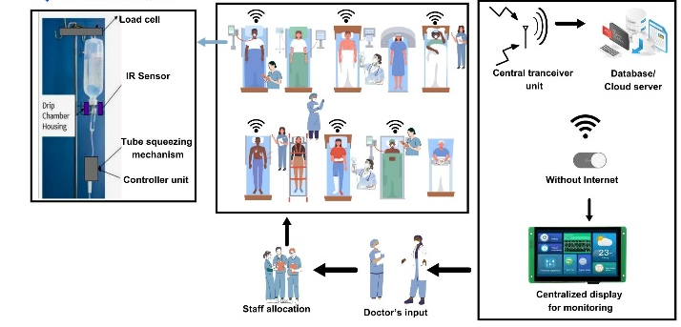
Figure 1. Architecture of the proposed System

The proposed system is operated over an offline network which is constituted over the freely available RF bandwidth 2.4 GHz with the help of NRF transceiver modules.

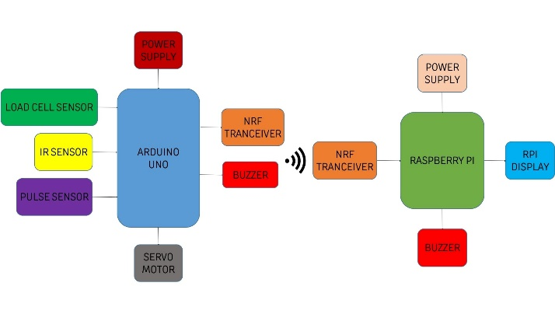
Figure 2. Block Diagram of the proposed System

IMPLEMENTATION
The approach outlined in the preceding chapter emphasizes the necessity of carefully designing and modeling both the patient and the nurse side units. This crucial step involves creating the foundational components upon which the entire system will be built. Furthermore, it underscores the importance of establishing effective communication channels between the patient and nurse entities, ensuring seamless interaction and data exchange within the infrastructure.
Design of the system components
A specialized development effort is currently underway to create a well-fitted drip chamber and an advanced tube squeezing mechanism. These components play a pivotal role in ensuring the efficient monitoring of saline consumption and facilitating effective regulation of the flow rate. The careful design and construction of the drip chamber aim to establish a secure and optimal fit within the administration setup, thereby minimizing the risk of any potential leaks or disruptions in the fluid delivery process. Simultaneously, the implementation of an innovative tube squeezing mechanism is intended to provide enhanced control over the flow rate, enabling healthcare providers to fine-tune and regulate the saline administration in accordance with specific patient requirements.

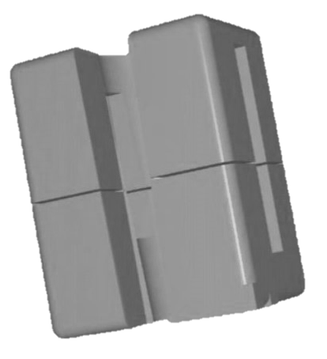
Figure 3. Isometric view of Drip Chamber Housing

In order to effectively identify the droplets as they fall within the drip chamber, an infrared (IR) sensor was strategically positioned in parallel with the chamber. This design involved the creation of a 3D model, which was then fabricated through the process of 3D printing. The resulting 3D model, as depicted in Figure 3, was meticulously tailored to accommodate a range of sizes for saline drip chambers, ensuring adaptability to diverse medical equipment configurations. Notably, the model was engineered with dynamic adjustability, allowing for real-time modifications to suit specific requirements and variations in the drip chamber's dimensions.

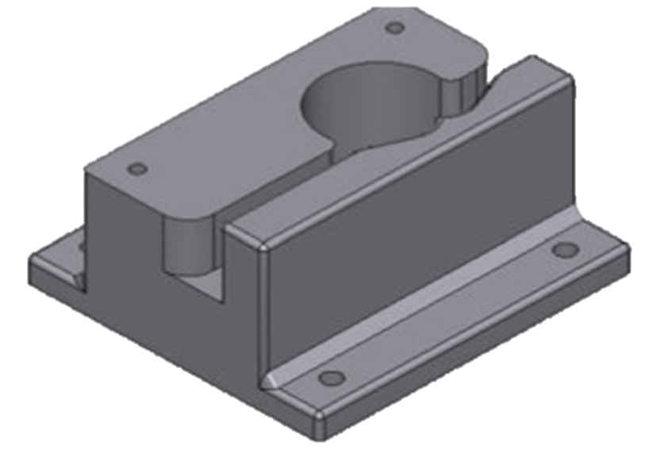
Figure 4. Isometric view of Tube Squeezing Mechanism

A tube squeezing mechanism shown in Figure 4 has been meticulously designed and subsequently fabricated using 3D printing technology. This mechanism operates on a servo motor-based methodology, specifically engineered to apply full compression to the infusion tube under specific conditions, such as when the saline bottle is nearing depletion. Moreover, it serves the crucial function of regulating the flow of droplets, intervening in instances where irregularities occur during the administration process. This is achieved through the dynamic adjustment of the motor's angle of rotation, which effectively controls the degree of tube compression.
Communication establishment
This centralized data management approach streamlines the monitoring process and enables healthcare staff to access critical information through a user-friendly web server interface or a centralized dashboard unit. The system as shown in Figure 5 enables real-time data transmission to a designated web server, allowing healthcare professionals to access critical information seamlessly. The integration of NRF24L01 transceivers at each patient bed enables swift and reliable relay of alert data to a centralized receiver, ensuring prompt actions in case of emergencies or critical situations. By integrating cloud-based storage, the system centralizes and stores data from multiple patient wards, providing an integrated and comprehensive overview of the entire healthcare facility. The real-time monitoring of the saline level, estimated time for completing the saline, drop count, flow rate, total volume of saline, drop factor, and multiple patient data contribute to a comprehensive and holistic approach to patient care management. With the aid of a pictorial saline level indicator, medical personnel can conveniently visualize the remaining fluid in the saline bottle, ensuring accurate and timely interventions.
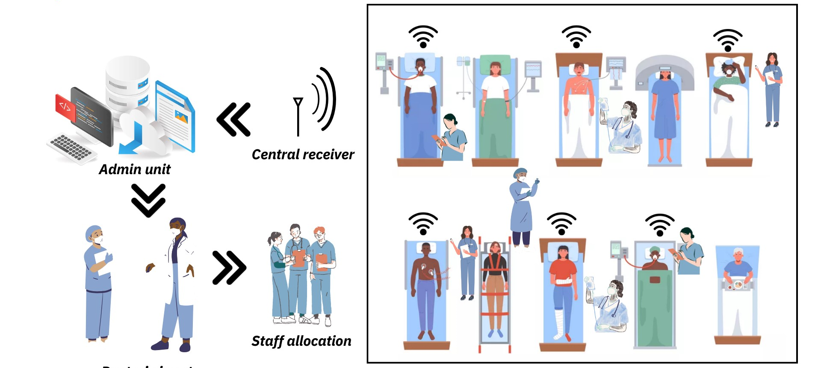
Figure 5. Centralized Server

RESULTS AND DISCUSSIONS
The proposed system offers a highly efficient solution for monitoring fluid drop counts, enabling precise calculation of flow rates with accuracy and reliability.

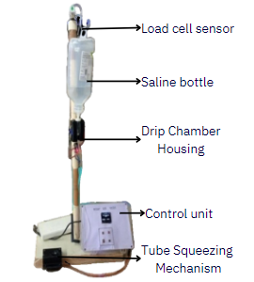
Figure 6. Proposed Setup of the system

Central to its functionality is an established and effective offline communication system facilitated by NRF transceiver modules, ensuring seamless data transmission even in environments with limited connectivity.
Complementing this communication infrastructure is an innovative drip chamber and tube squeezing mechanism design, which not only enhances the accuracy of flow control and regulation but also simplifies the overall task for users. This system's user interface is further enhanced by a responsive website that enables real-time display across diverse devices. This feature ensures seamless visualization and accessibility for authorized users, including nurses and healthcare staff, allowing them to monitor fluid flow rates and related parameters conveniently and securely.

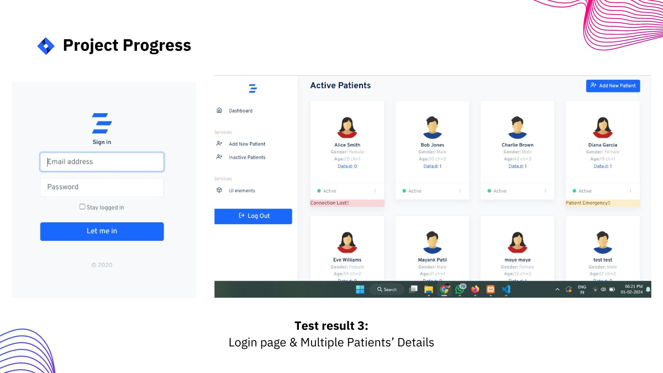
Figure 6. Login page and multiple patient registration page

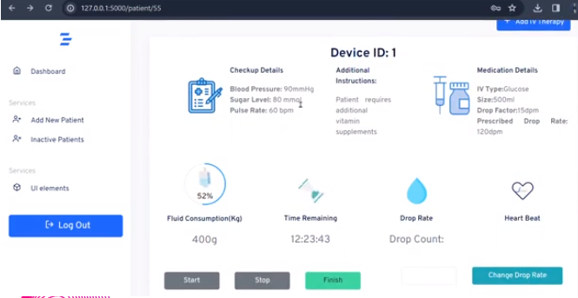
Figure 7. Individual patient dashboard

By integrating advanced technology with user-friendly design principles, this system significantly improves the efficiency and effectiveness of fluid monitoring processes in healthcare settings, ultimately enhancing patient care outcomes.

CONCLUSION
The proposed system presents a comprehensive solution for efficiently monitoring the status of multiple saline bottles, providing seamless support to healthcare staff in managing their workflow. A significant feature of the system is its capacity to automatically regulate and adjust the dosage of saline solution delivered to patients. This capability not only enhances the precision of treatment but also minimizes the potential for errors, contributing to a safer and more reliable patient care environment. Furthermore, the system's offline functionality, facilitated by a transceiver module, makes it particularly valuable in remote areas or during health camps where internet connectivity may be limited. This feature extends the benefits of the system to underserved populations, ensuring that advanced medical technologies are accessible even in resource-constrained settings. The user-friendly interface enables nurses to conveniently adjust the flow rate using their smartphones, thereby enhancing the system's flexibility and responsiveness to changing patient needs. This intuitive design optimizes the workflow within the hospital, allowing healthcare professionals to focus on delivering personalized care and managing critical medical tasks efficiently.

Acknowledgment

This project and technical paper were greatly supported by Dr. Sunayana Jadhav and Mr. Sanjay Lohar. Their expert coaching and comprehensive assistance were invaluable to us at every level of this project, and this paper would not have been possible without his contributions. We are grateful to our colleagues who contributed their knowledge and experience to the research and assisted us throughout the process.

References

- C. Amarasekara, R. Manage, C. Abeywickrama, R. Perera, R. A. S. R. Achchige and J. L. Wijekoon, "Poster Abstract: Smart Saline Management System," 2018 17th ACM/IEEE International Conference on Information Processing in Sensor Networks (IPSN), Porto, Portugal, 2018, pp. 108-109, doi: 10.1109/IPSN.2018.00017.
- S. Joseph, N. Francis, A. John, B. Farha and A. Baby, "Intravenous Drip Monitoring System for Smart Hospital Using IoT," 2019 2nd International Conference on Intelligent Computing, Instrumentation and Control Technologies (ICICICT), Kannur, India, 2019, pp. 835-839, doi: 10.1109/ICICICT46008.2019.8993241.
- R. H. Rafi, T. R. Ferdous, M. M. Islam and Z. A. Ratan, "Developing Cost Effective and Automated Saline Flow Rate Controlling System for Medical System," 2019 4th International Conference on Electrical Information and Communication Technology (EICT), Khulna, Bangladesh, 2019, pp. 1-5, doi: 10.1109/EICT48899.2019.9068824.
- M. Arfan, M. Srinivasan, A. G. Baragur and V. Naveen, "Design and Development of IOT enabled IV infusion rate monitoring and control device for precision care and portability," 2020 4th International Conference on Electronics, Communication and Aerospace Technology (ICECA), Coimbatore, India, 2020, pp. 1-7, doi: 10.1109/ICECA49313.2020.9297376.
- D. Ghosh, A. Agrawal, N. Prakash and P. Goyal, "Smart Saline Level Monitoring System Using ESP32 And MQTT-S," 2018 IEEE 20th International Conference on e-Health Networking, Applications and Services (Healthcom), Ostrava, Czech Republic, 2018, pp. 1-5, doi: 10.1109/HealthCom.2018.8531172
- S. Velmurugan, G. Shanthi, L. Raja and S. Nirmala, "Fully Automated Single Window Saline Fluid Flow Control and Automatic Container Changing System," 2021 7th International Conference on Advanced Computing and Communication Systems (ICACCS), Coimbatore, India, 2021, pp. 1259-1263, doi: 10.1109/ICACCS51430.2021.9441723.
- Dr. Sunayana Jadhav, Mr. Sanjay Lohar, Mr. Harsh Dodiya, “Smart Saline Assistance System”, in Office of the Controller General of Patents, Designs and Trademark, Govt. of India, Application no. 202321042351, Published-08th September,2023

