Delhi Technological University
(Formerly Delhi College of Engineering)
Shahbad Daulatpur, Bawana Road, Delhi-110042
DEPARTMENT OF APPLIED MATHEMATICS

Artificial Intelligence
MC-312
Practical File
Submitted to: | Submitted by:
Dr. Goonjan Jain | Mohd Mursaleen
Ms. Mamta Godara | 23/MC/206

Delhi Technological University
Vision
To be a world class university through Education, Innovation and Research for the service of humanity.
Mission
- To establish centres of excellence in emerging areas of Science, Engineering, Technology, Management and allied areas.
- To foster an ecosystem for Incubation, Product Development, Transfer of Technology and Entrepreneurship.
- To create environment of Collaboration, Experiment, Imagination and Creativity.
- To develop human potential with Analytical Abilities, Ethics and Integrity.
- To provide environment friendly, reasonable and sustainable solutions for local and global needs.
Department of Applied Mathematics
Vision
To emerge as a centre of excellence and eminence by imparting futuristic technical education with solid mathematical background in keeping with global standards, making our students technologically and mathematically competent and ethically strong so that they can readily contribute to the rapid advancement of society and mankind.
Mission
- To achieve academic excellence through innovative teaching and learning practices.
- To improve the research competence to address social needs.
- To inculcate a culture that supports and reinforces ethical, professional behaviours for a harmonious and prosperous society.
- Strive to make students to understand, appreciate and gain mathematical skills and develop logic, so that they are able to contribute intelligently in decision making which characterises our scientific and technological age.

INDEX
S. No. | Experiment | Date | Signature
01. | Write a program to solve the 8-Puzzle problem using Generate and Test Strategy. | 10-08-26
02. | Write a program to solve the 8-Puzzle problem using DFID (Depth First Iterative Deepening). | 17-08-26
03. | Write a program to solve the 3-SAT problem using Variable Neighbourhood Descent Algorithm. | 24-08-26
04. | Write a program to solve the 3-SAT problem using Stochastic Hill Climbing Algorithm. | 07-09-26
05. | Write a program to solve the 8-Puzzle problem using A* algorithm. | 14-09-26
06. | Write a program to implement AO* search algorithm on any AND OR graph. | 14-09-26
07. | Write a program in Prolog to find max of two or three numbers. | 05-10-26
08. | Write a program in Prolog to find factorial of a number. | 05-10-26
09. | Write a program in Prolog to find sum of first N numbers. | 12-10-26
10. | Write a program in Prolog to find Fibonacci sequence up to Nth term. | 12-10-26
11. | Write a program in Prolog to represent the given knowledge base (Prakash likes sweet edible food) and query it. | 02-11-26

Practical 1
Aim:
To implement the Generate and Test strategy for solving the 8-Puzzle problem, starting from the initial configuration given below and reaching the goal configuration.
Initial configuration (blank shown empty):
8 | 1 | 3
4 |  | 5
2 | 7 | 6

Goal configuration:
1 | 2 | 3
8 |  | 4
7 | 6 | 5

Theory:
Generate and Test is the simplest problem solving technique. A generator produces candidate states one after another and a tester checks every candidate against the goal condition. In this program the generator slides a tile into the blank in all legal directions and keeps generating level by level; each new board is passed to the tester. Already-seen boards are skipped so the generator is systematic and is guaranteed to reach the goal if it is reachable.
Code:
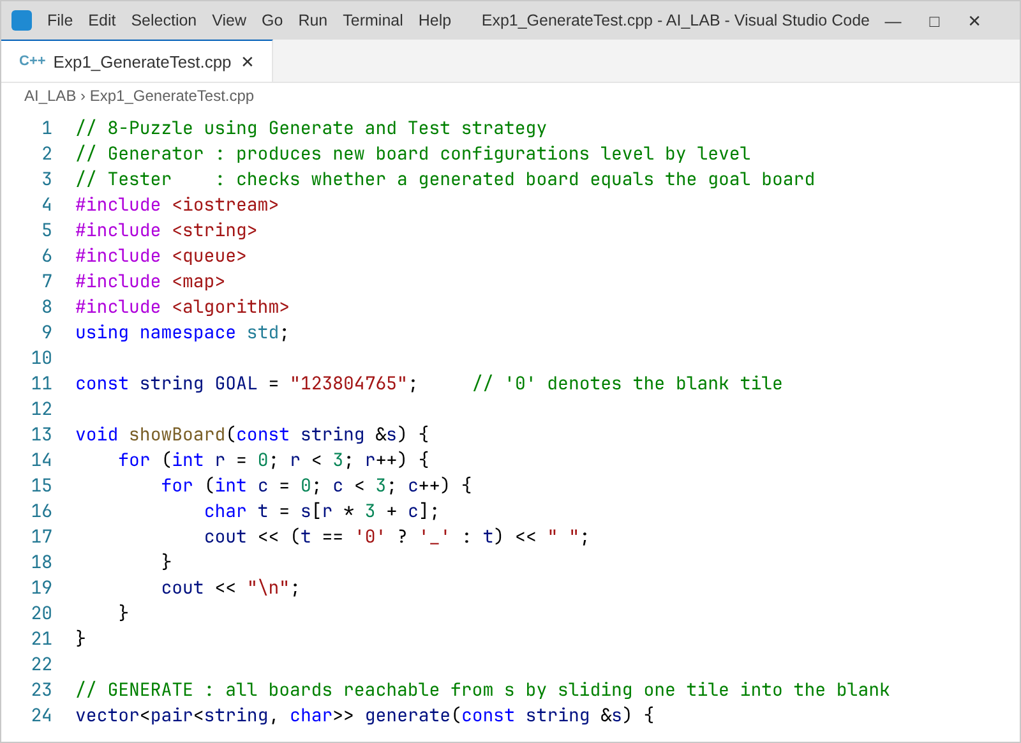
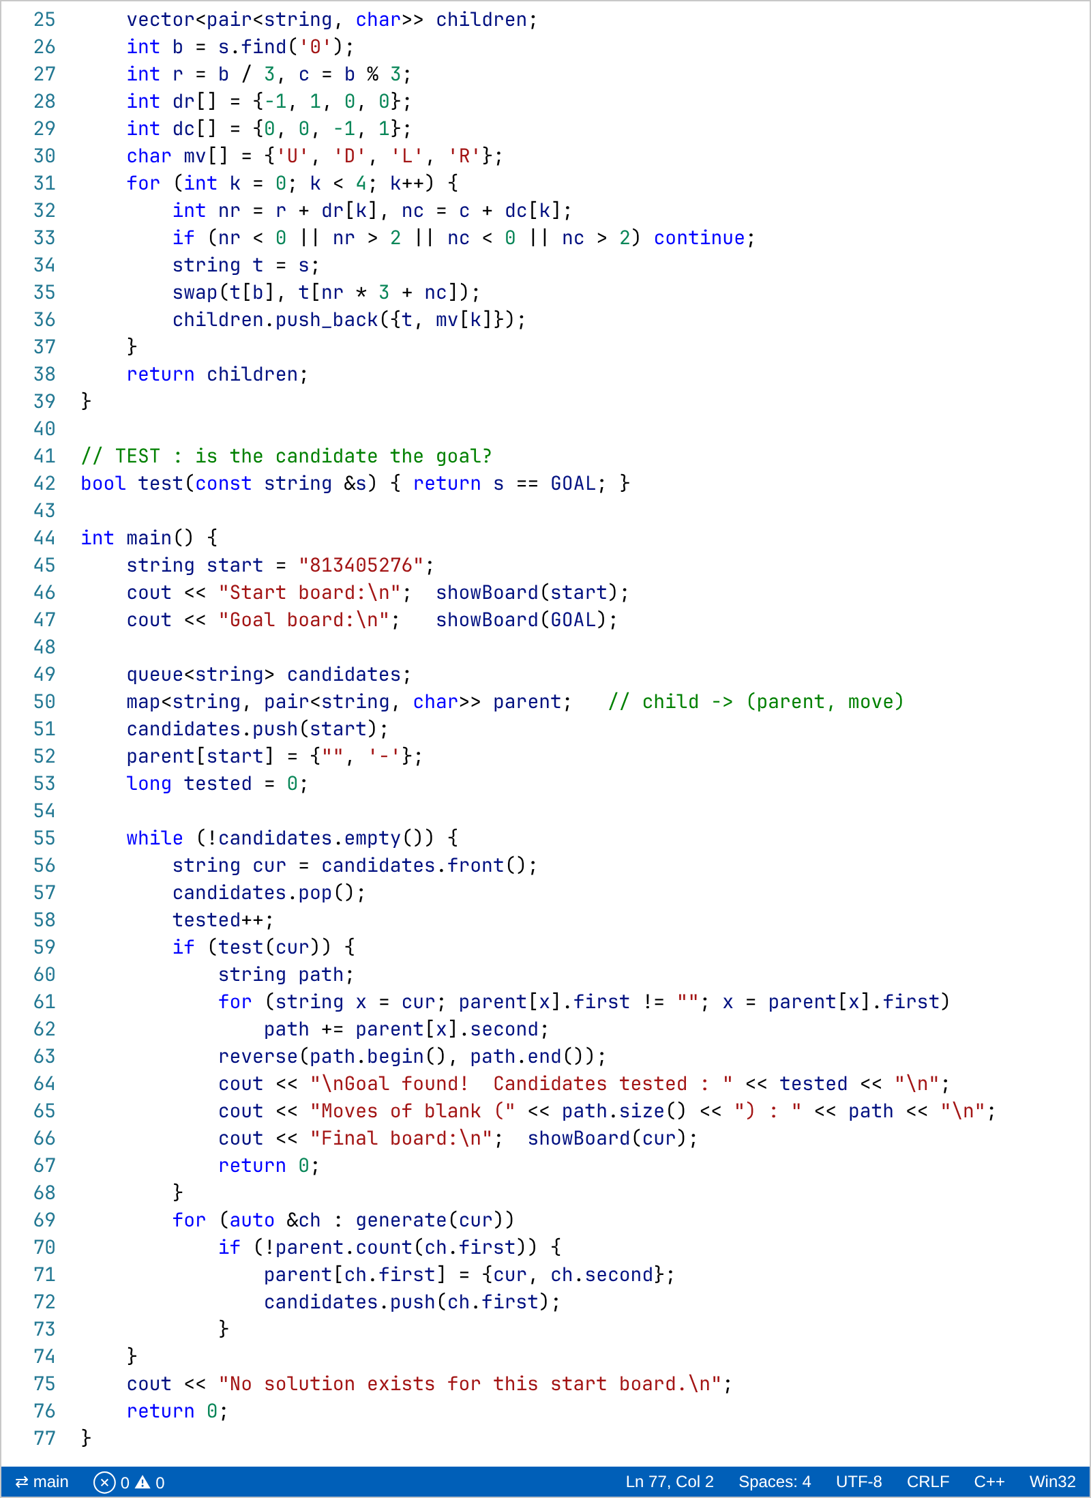
Output:
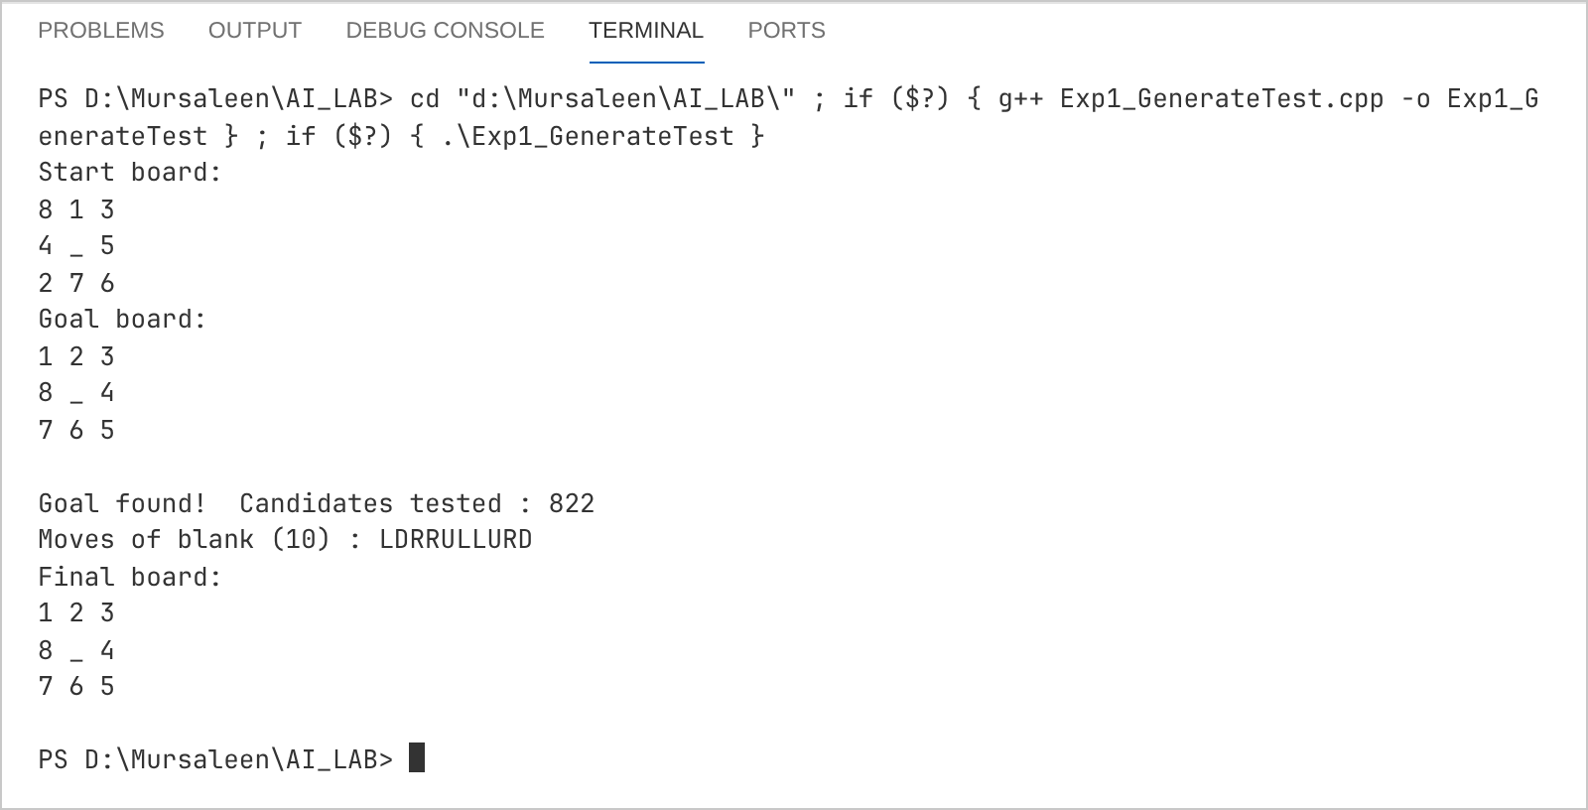
The goal configuration was found after testing 822 candidate boards and the blank tile needed 10 moves (L D R R U L L U R D).
Practical 2
Aim:
To solve the 8-Puzzle problem with the Depth First Iterative Deepening (DFID) technique for the initial and goal configurations given below.
Initial configuration (blank shown empty):
8 | 1 | 3
4 |  | 5
2 | 7 | 6

Goal configuration:
1 | 2 | 3
8 |  | 4
7 | 6 | 5

Theory:
DFID runs a depth limited depth first search repeatedly with limit 0, 1, 2, … until the goal is found. It needs only linear memory like DFS, but because the limit grows one step at a time it finds the shallowest goal like BFS. The program prints the number of nodes expanded in every iteration so the repeated work of the earlier levels can be seen. A move that directly undoes the previous move is pruned.
Code:
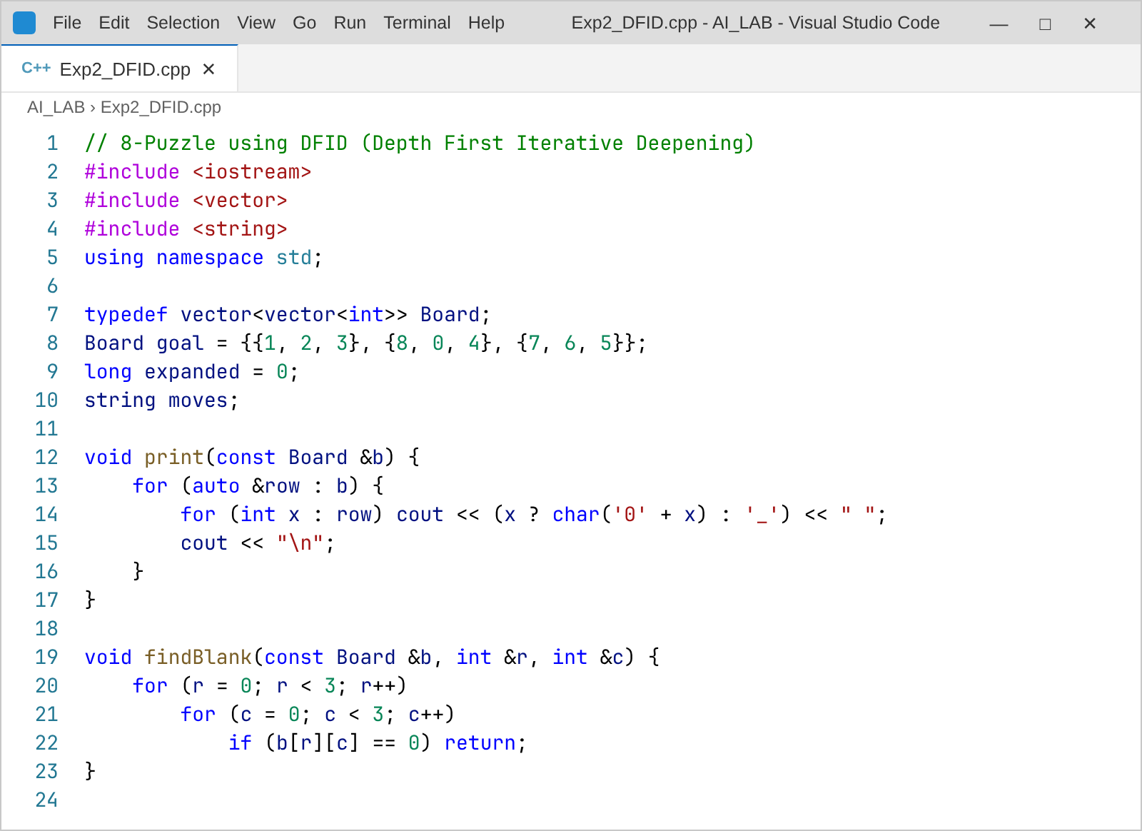
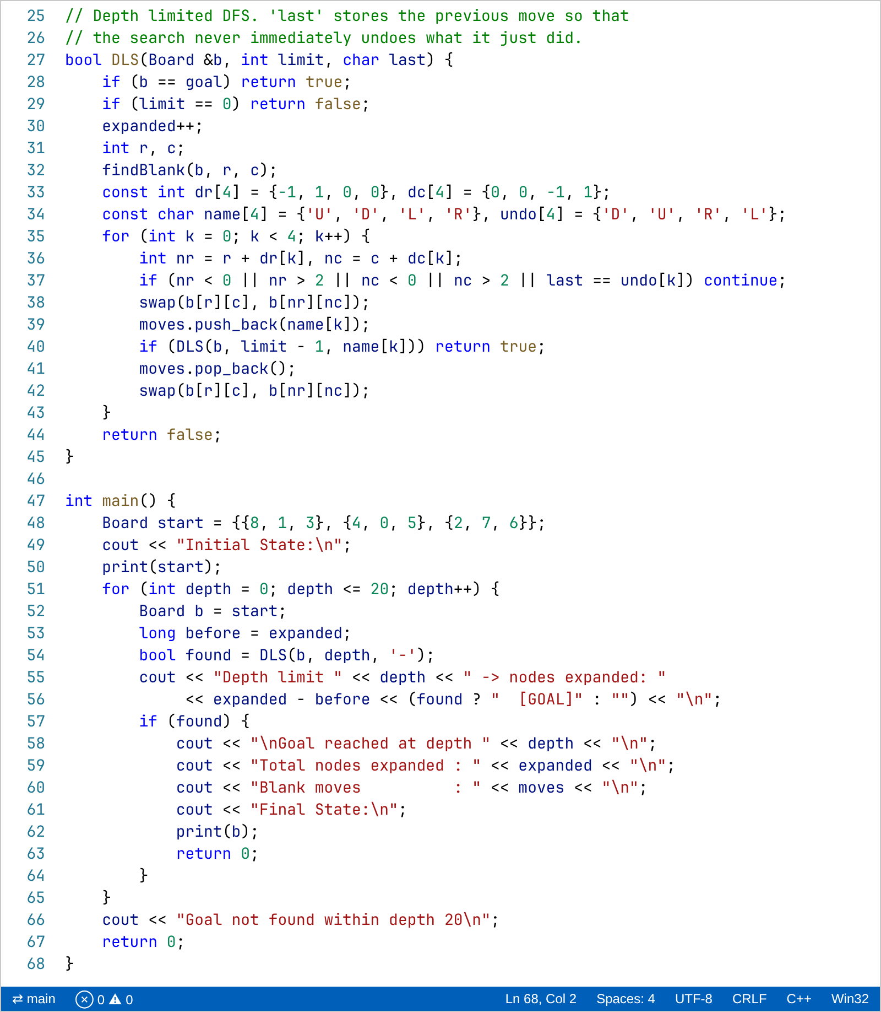
Output:
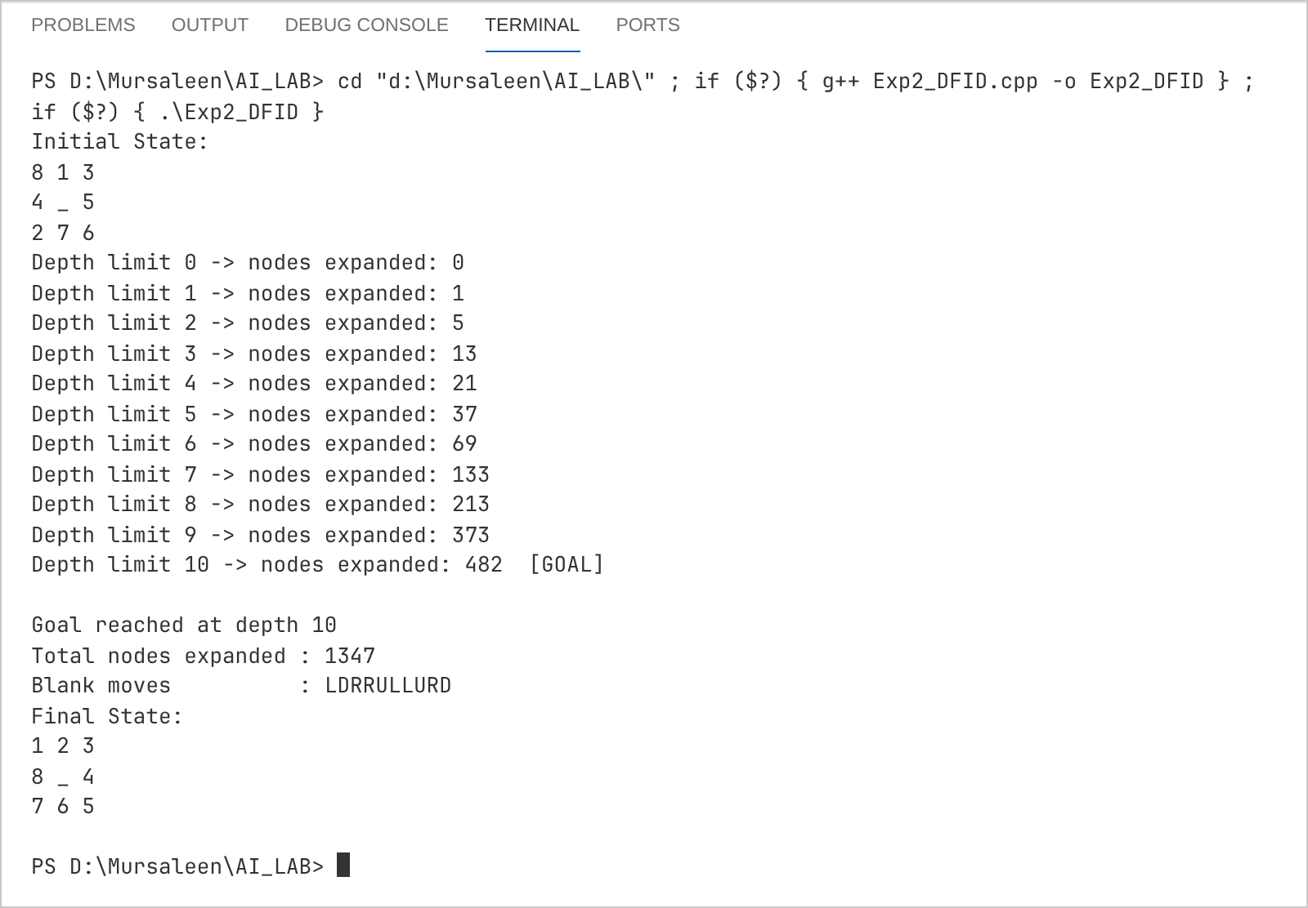
Practical 3
Aim:
To solve the following 3-SAT instance using the Variable Neighbourhood Descent (VND) algorithm, starting from the assignment {a = 1, b = 1, c = 1, d = 1, e = 1}.
F = (b ∨ ¬c) ∧ (c ∨ ¬d) ∧ (¬b) ∧ (¬a ∨ ¬e) ∧ (¬c ∨ e) ∧ (¬c ∨ ¬d)
Theory:
The heuristic h(x) is the number of clauses satisfied by an assignment x (maximum 6). VND uses a series of neighbourhoods N1, N2, …, Nk where Nk contains all assignments obtained by flipping exactly k variables. The search moves to the best neighbour of N1; when N1 offers no improvement it tries the larger neighbourhood N2, then N3, and so on. Whenever an improvement is found it returns to N1. The search stops when h = 6 (formula satisfied) or no neighbourhood improves.
Code:
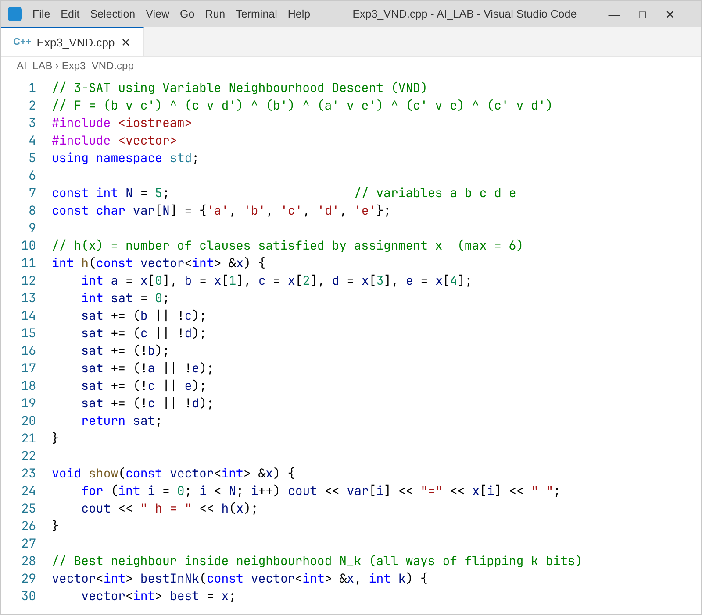
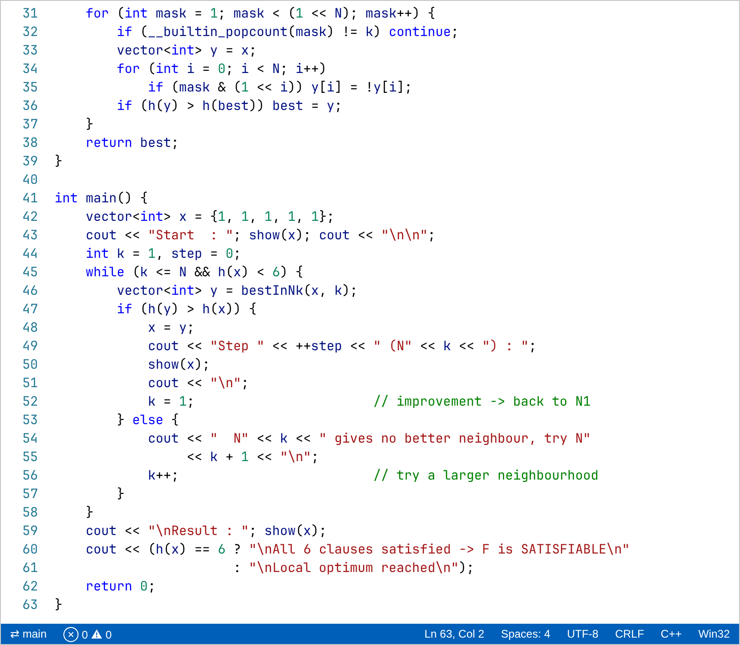
Output:
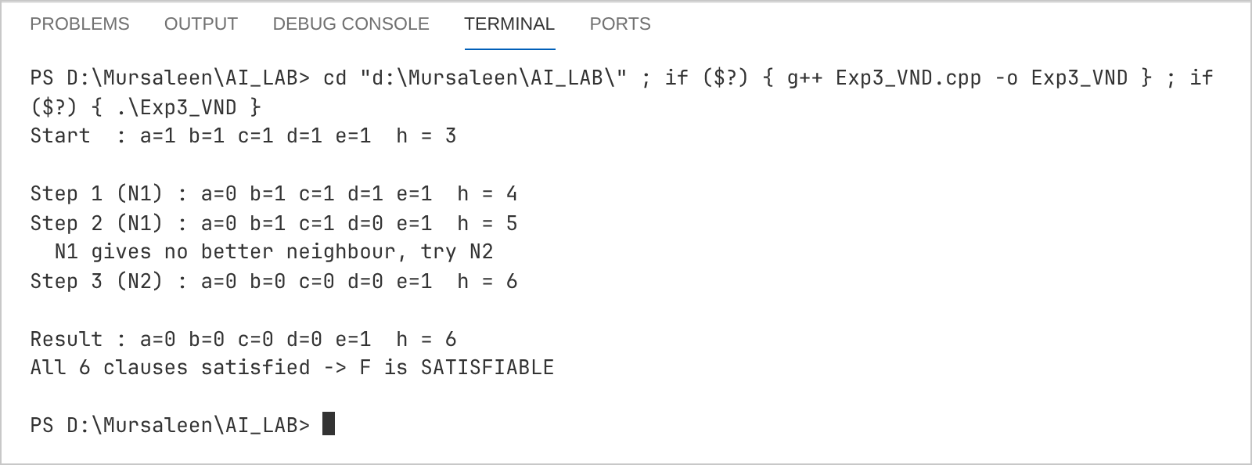
Practical 4
Aim:
To solve the following 3-SAT instance using Stochastic Hill Climbing, starting from the assignment {a = 1, b = 1, c = 1, d = 1, e = 1}.
F = (b ∨ ¬c) ∧ (c ∨ ¬d) ∧ (¬b) ∧ (¬a ∨ ¬e) ∧ (¬c ∨ e) ∧ (¬c ∨ ¬d)
Theory:
Unlike simple hill climbing, the stochastic version picks a random neighbour (one variable flipped) and moves to it with probability P = 1 / (1 + e^(−ΔE / T)), where ΔE = eval(neighbour) − eval(current) and T is a constant temperature. A better neighbour is accepted with high probability and a worse one with low probability, which helps the search escape from plateaus and local maxima. Here T = 0.8 and a fixed random seed is used so that the run can be repeated.
Code:
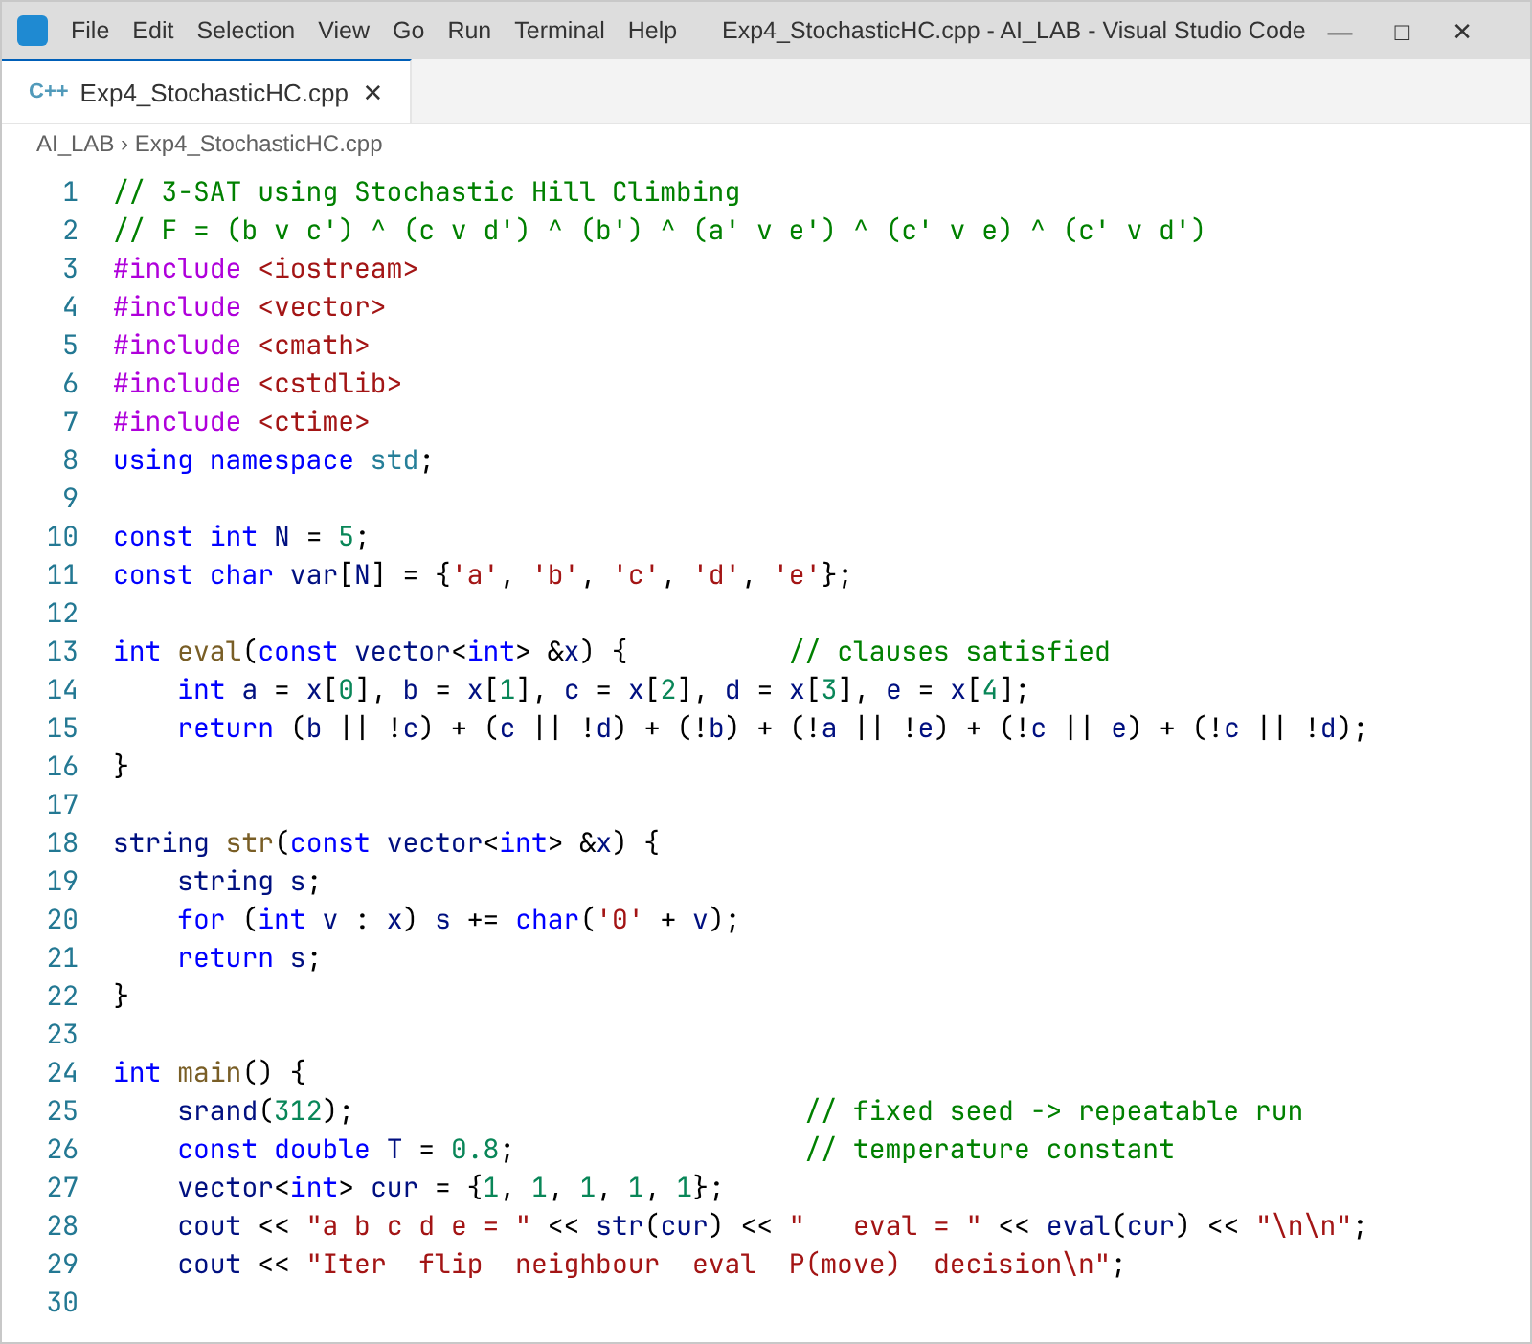
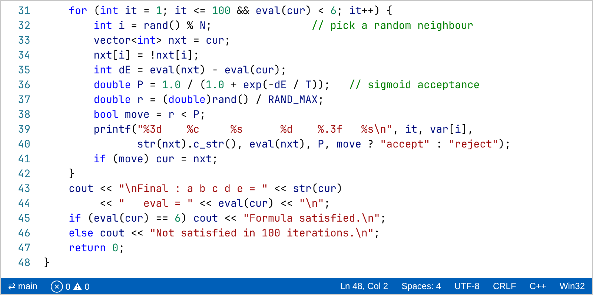
Output:
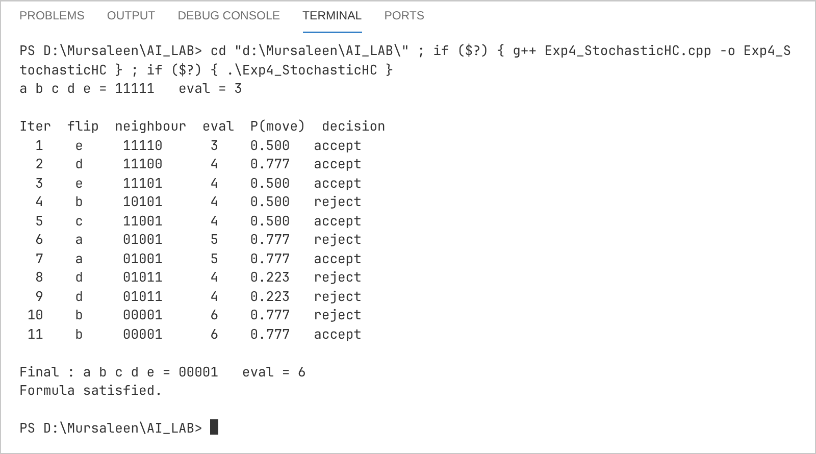
Practical 5
Aim:
To solve the 8-Puzzle problem using the A* search algorithm for the initial and goal configurations given below.
Initial configuration (blank shown empty):
2 | 8 | 3
1 | 6 | 4
7 |  | 5

Goal configuration:
1 | 2 | 3
8 |  | 4
7 | 6 | 5

Theory:
A* is a best first search which always expands the node with the lowest f(n) = g(n) + h(n), where g(n) is the number of moves from the start and h(n) is the number of misplaced tiles. Since h(n) never over-estimates the real cost it is admissible, so A* returns an optimal (shortest) solution. OPEN is a priority queue ordered on f and CLOSED stores boards already expanded.
Code:
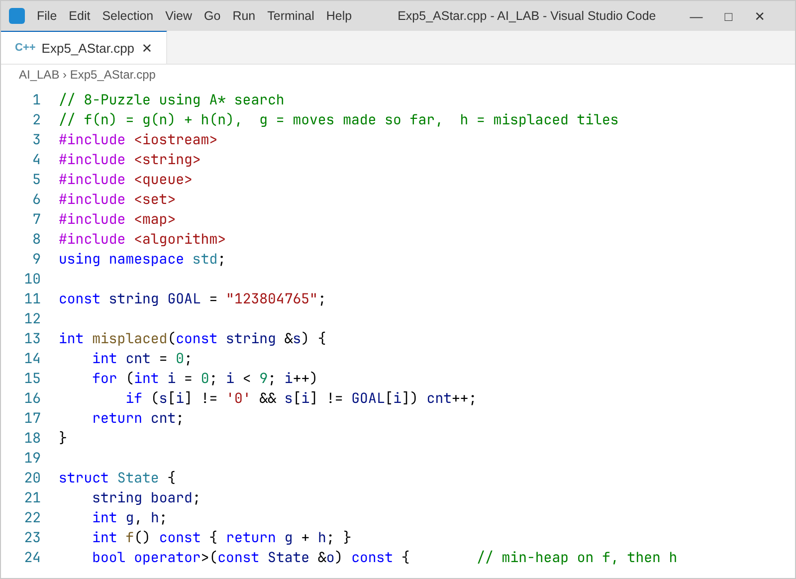
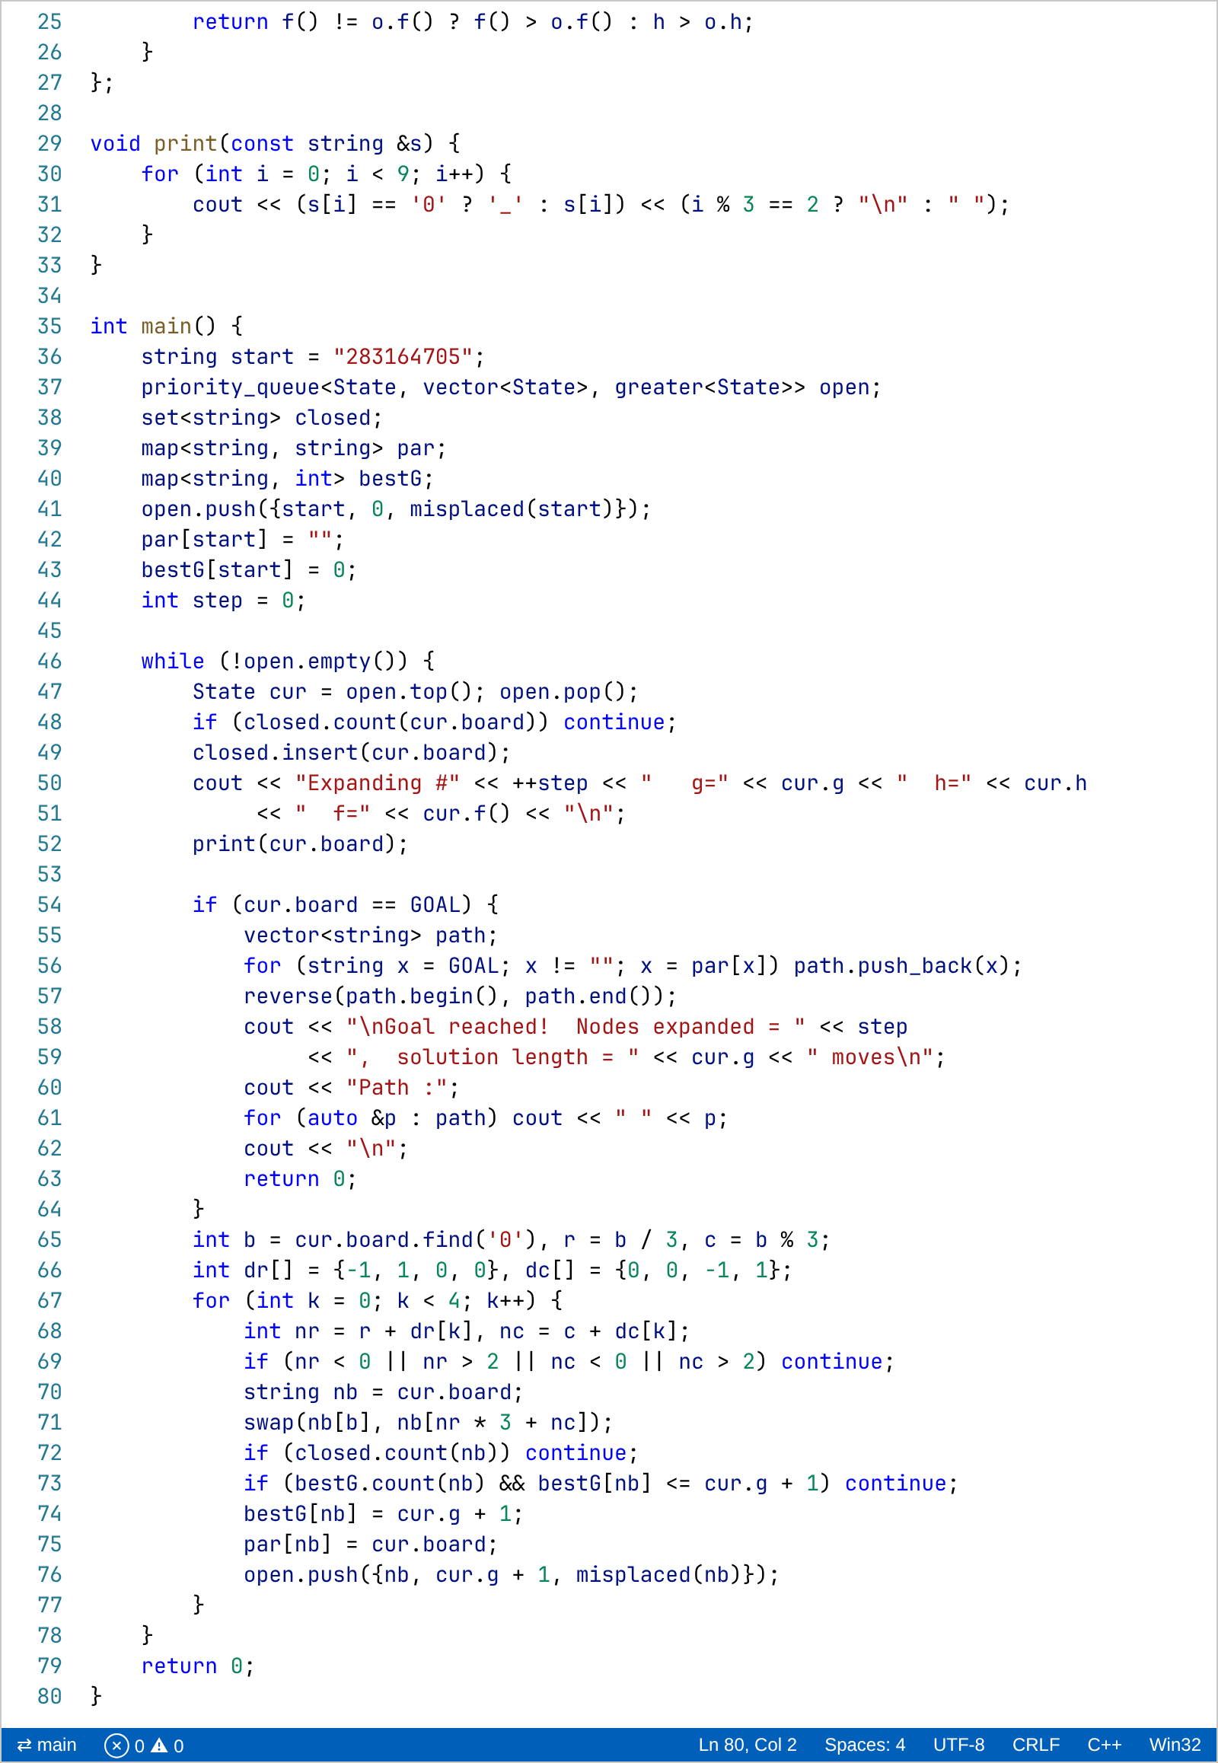
Output:
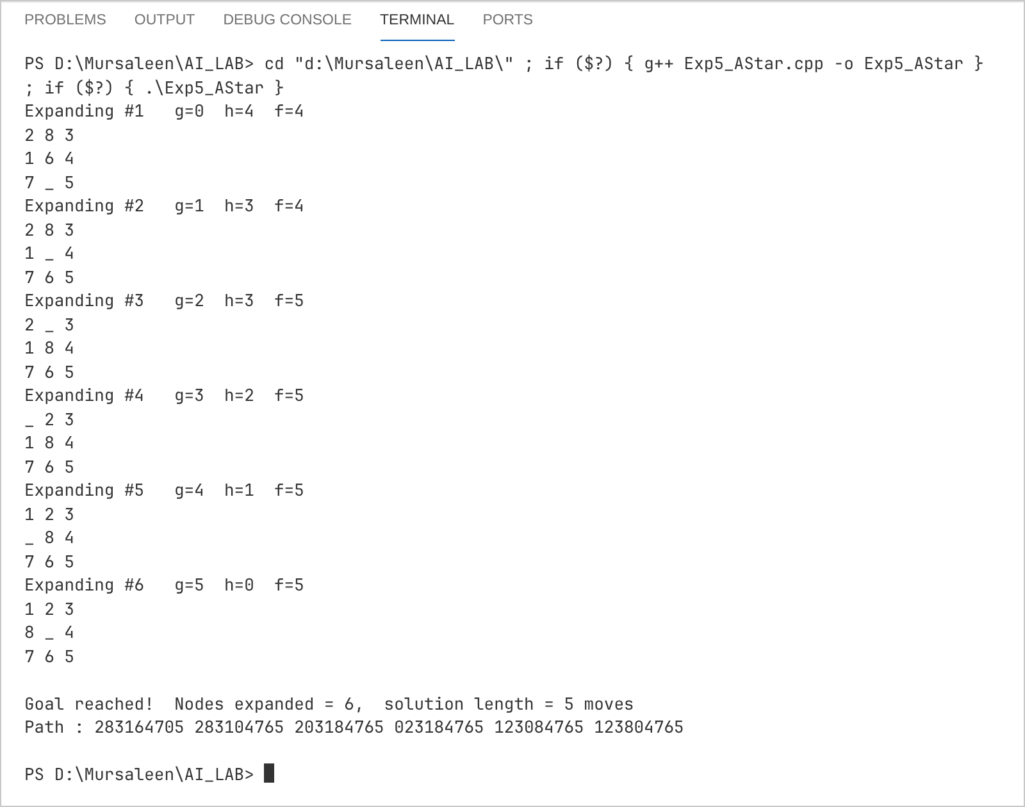
Practical 6
Aim:
To implement the AO* search algorithm on the AND-OR graph shown below. Every edge has cost 1 and the value h written beside a node is the estimated cost of solving that node. Double circled nodes are terminal (directly solvable) nodes.
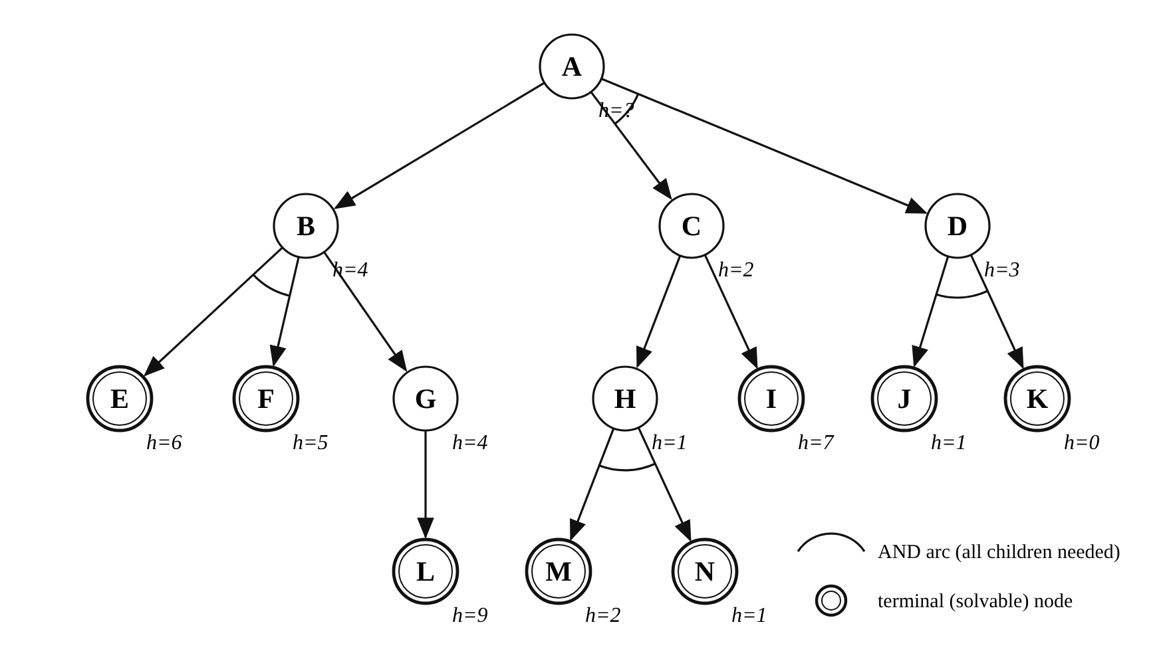
Theory:
In an AND-OR graph an OR branch means any one child is enough, while an AND arc means every child joined by the arc must be solved. AO* repeatedly follows the currently best (marked) connectors from the root, expands an unexpanded node, computes the cost of each of its connectors (sum of h of children + edge costs), marks the cheapest one and propagates the revised cost back towards the root. If a revised cost makes another connector cheaper, the marking is switched. The algorithm ends when the root is labelled SOLVED.
Code:
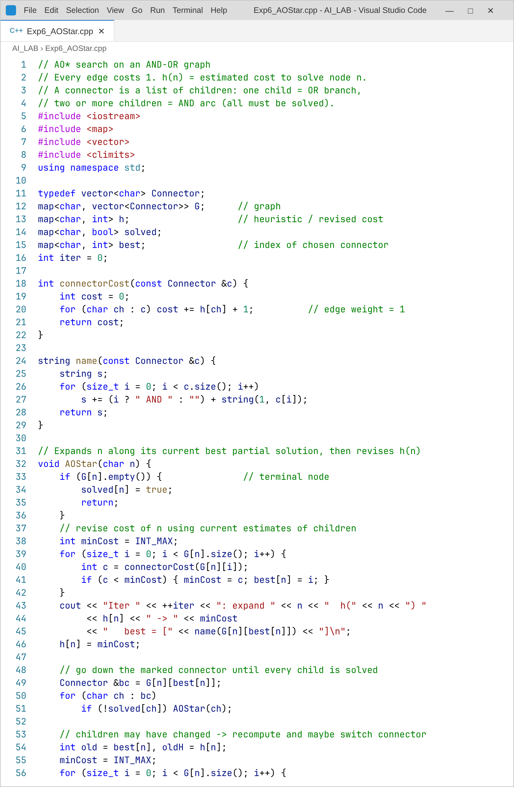
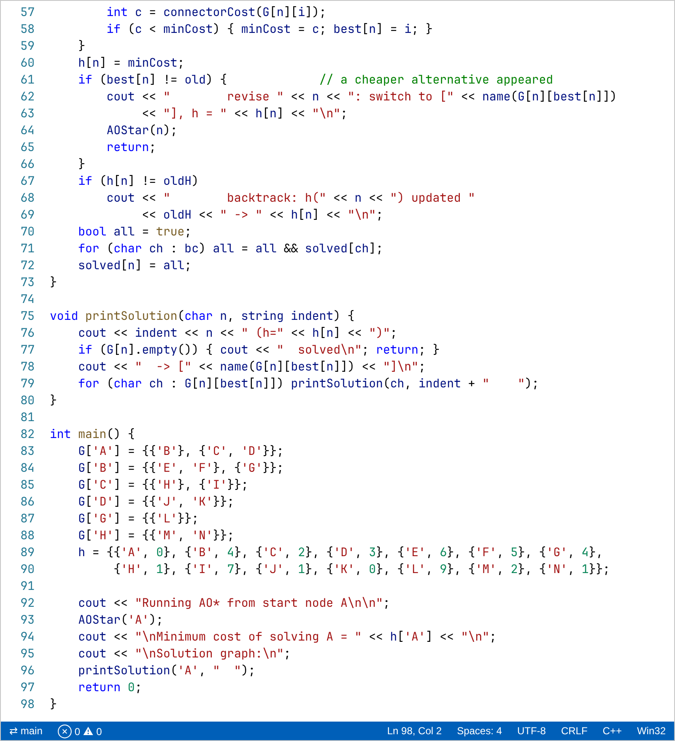
Output:
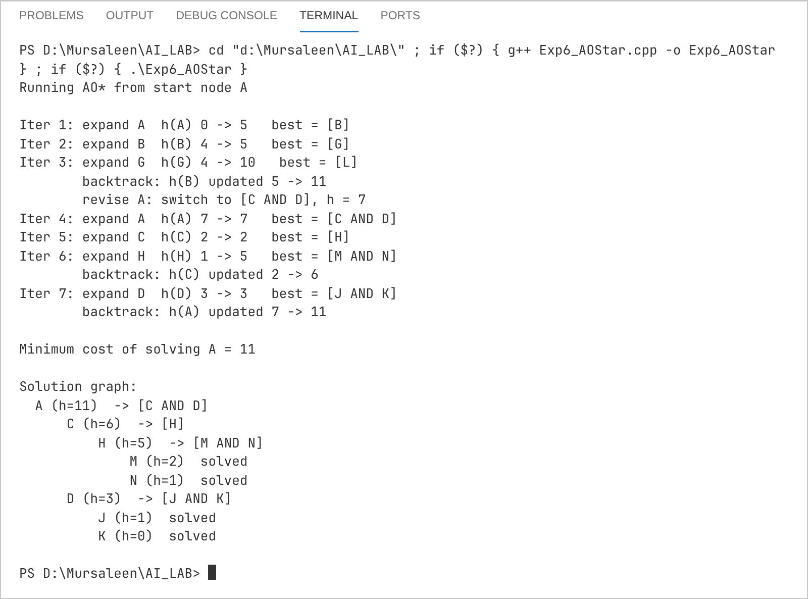
Practical 7
Aim:
To write a Prolog program that finds the maximum of two numbers and of three numbers.
Theory:
max_of_two/3 compares X and Y with the if-then-else construct ( Condition -> Then ; Else ). max_of_three/4 does not need a separate set of rules – it first finds the larger of X and Y and then compares that value with Z.
Code:
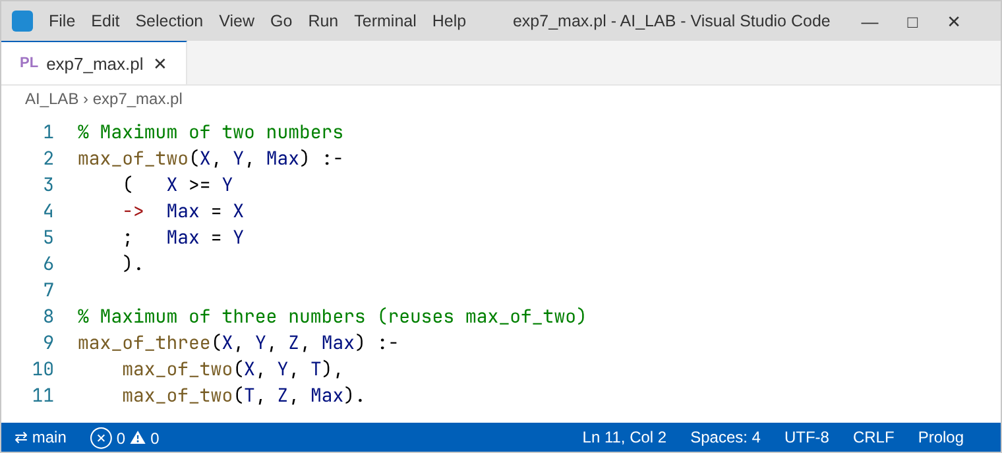
Output:
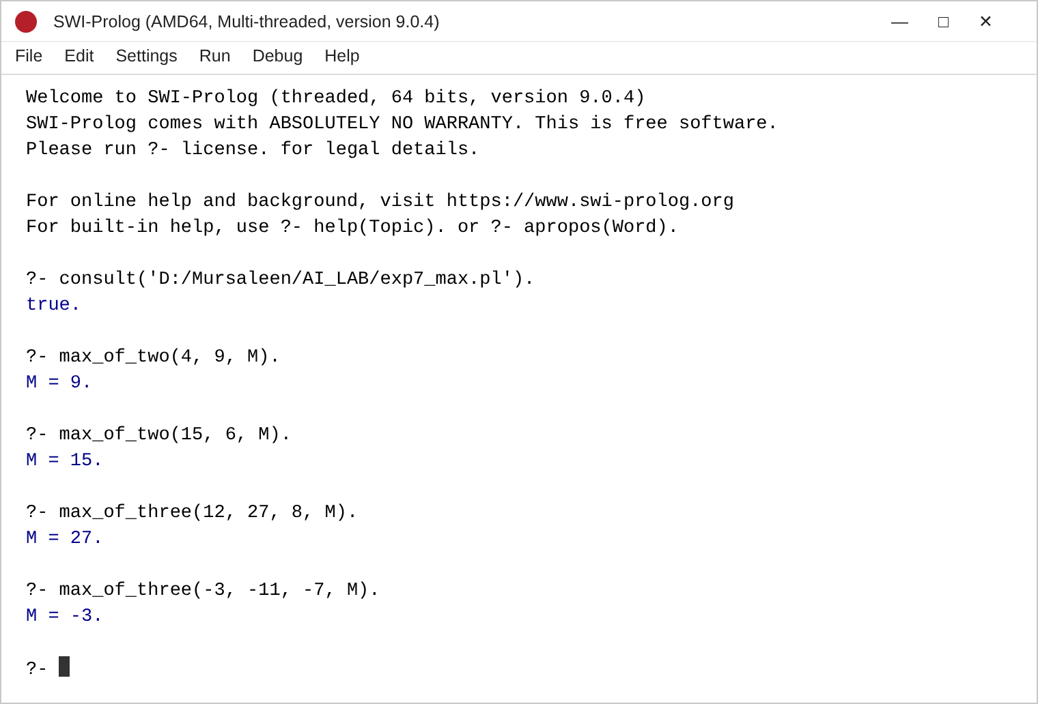
Practical 8
Aim:
To write a Prolog program to find the factorial of a given number.
Theory:
The factorial is computed with an accumulator. fact_acc(N, Acc, F) multiplies the accumulator by N and calls itself with N − 1; when N becomes 0 the accumulator holds the answer. Because the recursive call is the last goal, the program is tail recursive and works even for large values like 20!.
Code:
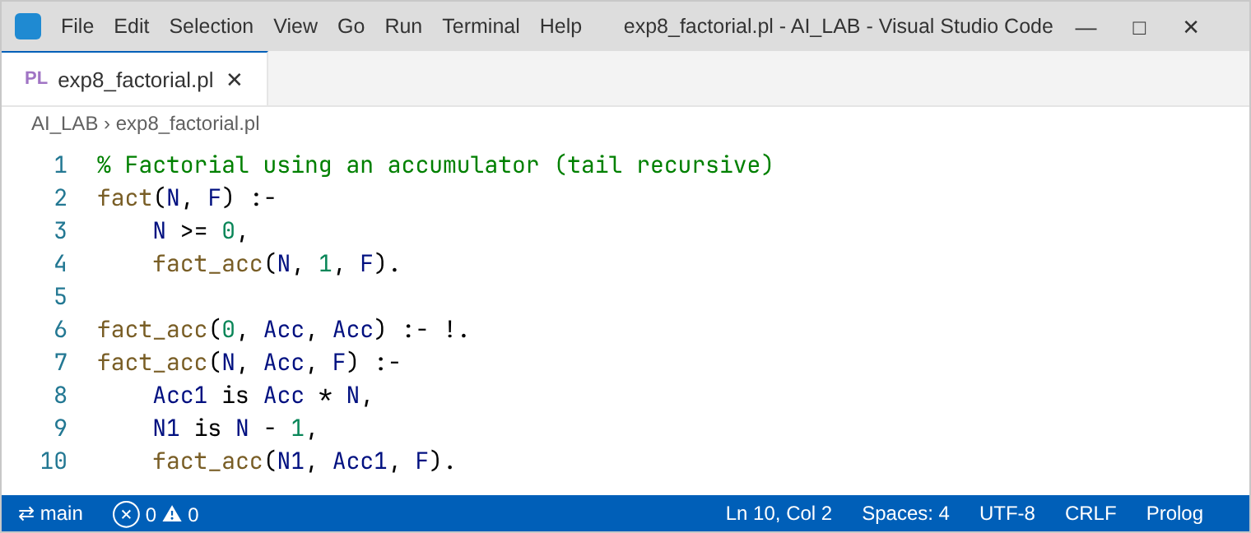
Output:
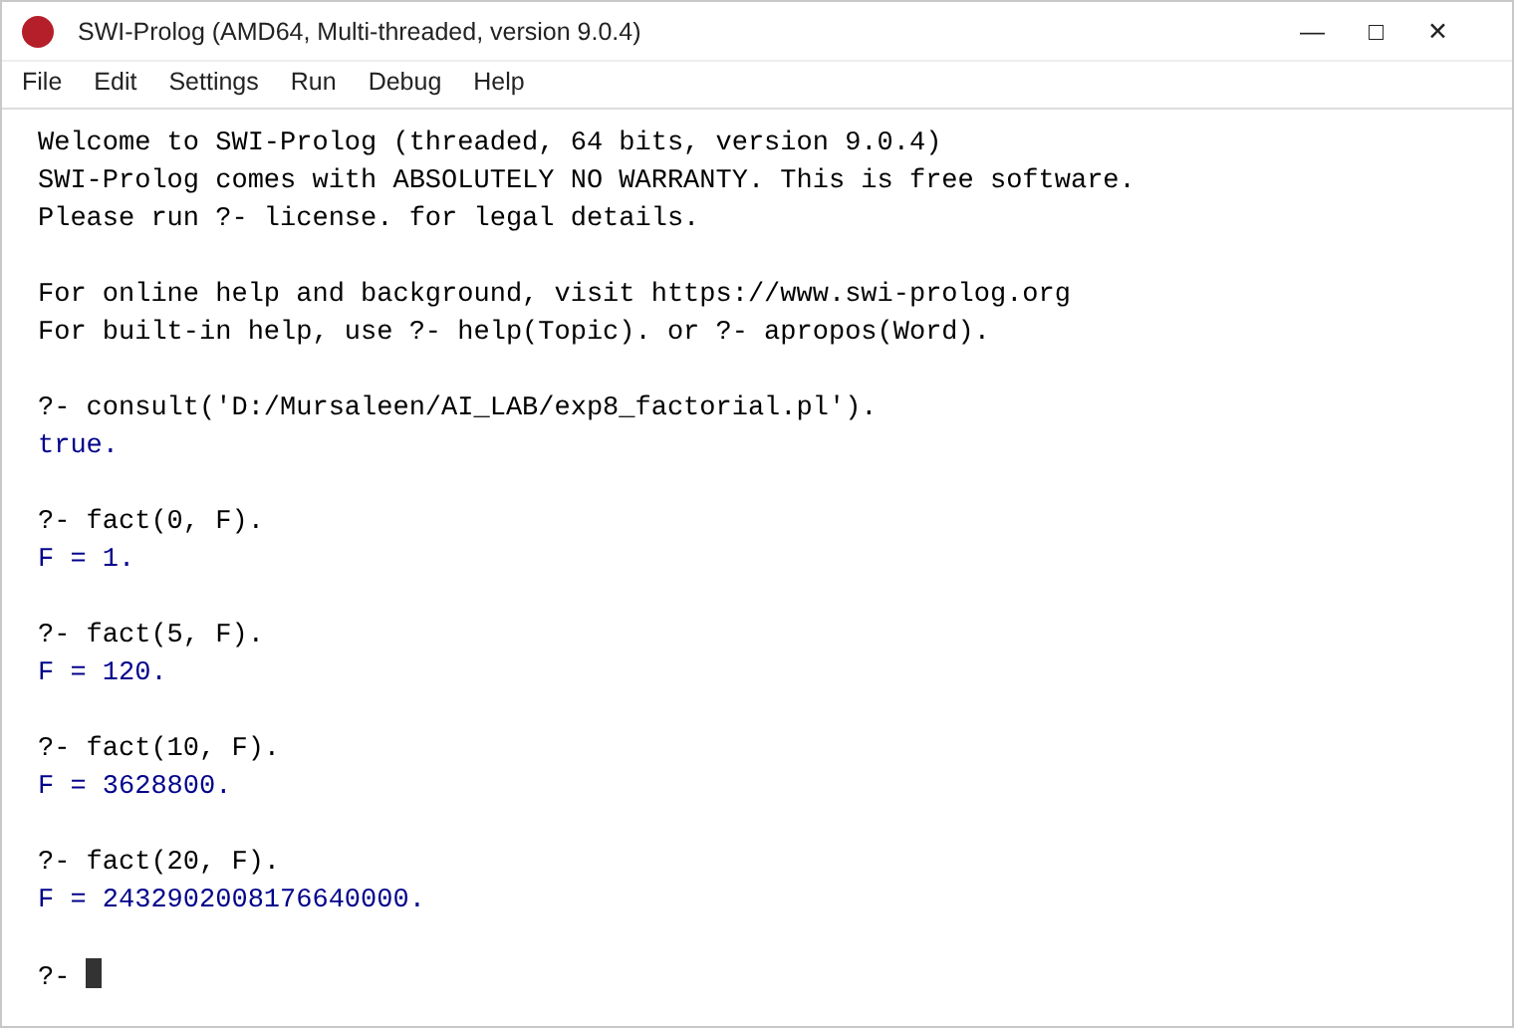
Practical 9
Aim:
To write a Prolog program to find the sum of the first N natural numbers.
Theory:
sum_n(0, 0) is the base case. For N > 0 the sum of the first N − 1 numbers is found recursively and N is added to it. The predicate verify/1 compares the result with the formula N(N + 1)/2.
Code:
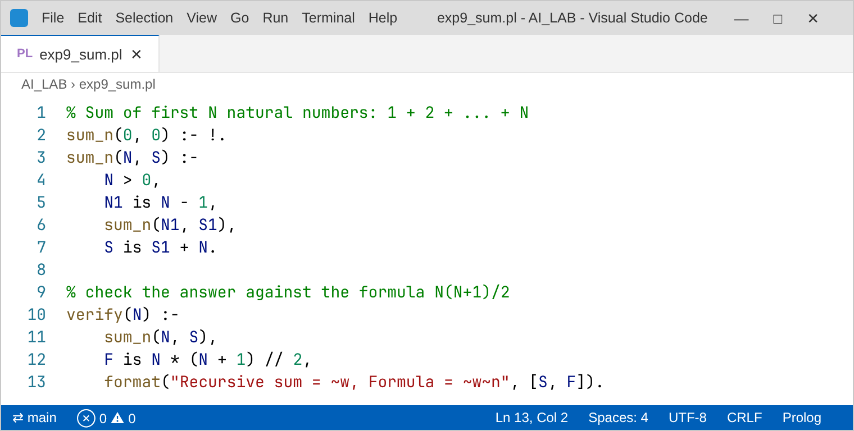
Output:
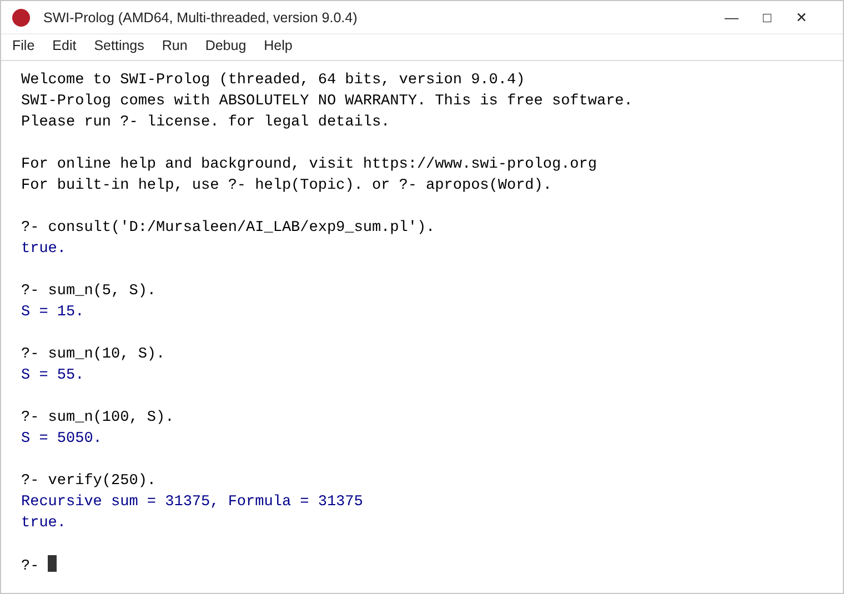
Practical 10
Aim:
To write a Prolog program to generate the Fibonacci sequence up to the Nth term (0, 1, 1, 2, 3, 5, 8, …).
Theory:
fib_build/4 carries the last two terms A and B. It puts A in the list and continues with (B, A + B) until N terms are produced. show_fib/1 prints the series and nth_fib/2 returns only the Nth term (the last element of the list).
Code:
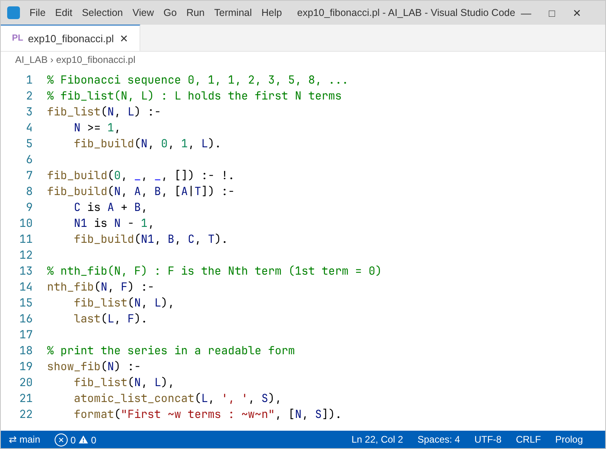
Output:
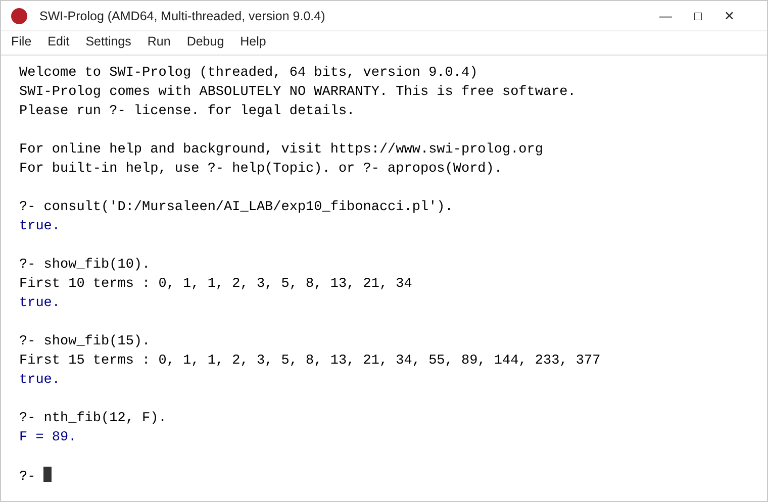
Practical 11
Aim:
To represent the following statements as a knowledge base in Prolog and then ask a query whose answers are Chocolates → Toffees → No (false).
- Prakash likes food if the food is edible and it tastes sweet.
- Chocolates taste sweet.
- Toffees taste sweet.
- Gourd tastes bitter.
- Chocolates are edible.
- Toffees are edible.
- Gourd is edible.
Theory:
The first statement becomes a rule whose body has two goals, edible(Food) and tastes(Food, sweet); the remaining statements become facts. For the query likes(prakash, X) Prolog tries every edible food and keeps those that taste sweet; pressing ; gives the next answer – chocolates, toffees, then false (gourd is bitter).
Code:
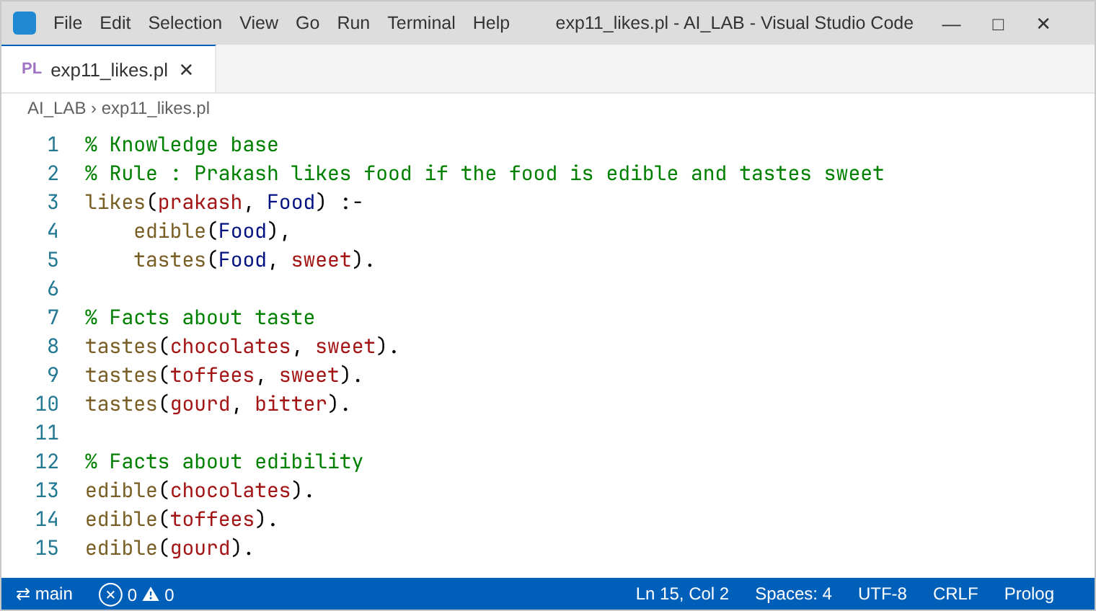
Output:


