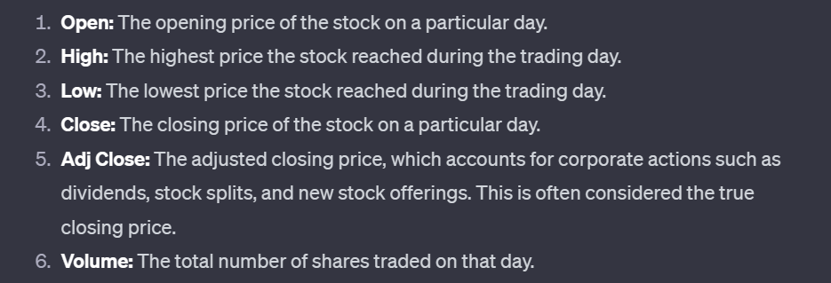

In stock trading, "volume" refers to the total number of shares of a security (such as a stock) that are traded during a specific period of time, typically a trading day. It is a measure of the market activity for a particular stock within a given timeframe.

The volume of trading is an important indicator that can provide insights into the strength and sustainability of a price movement. Here are some key points about trading volume:

1. **Liquidity:** Volume is a measure of liquidity in the market. Highly liquid stocks often have high trading volumes, making it easier for traders to buy and sell shares without significantly impacting the stock's price.
2. **Price Confirmation:** Changes in stock prices accompanied by high trading volume are often considered more significant and potentially more sustainable than price changes on low volume. For example, a price increase on high volume may indicate strong buying interest.
3. **Trends and Reversals:** Changes in trading volume can be used to identify trends or potential reversals in the market. For example, a rising price accompanied by increasing volume may indicate a strong upward trend.
4. **Confirmation of Breakouts:** Traders often look for increased volume when a stock breaks out of a trading range or a technical pattern. High volume during a breakout can confirm the validity of the move.
5. **Earnings Announcements and News:** Events like earnings announcements or significant news can lead to spikes in trading volume as investors react to new information.

In summary, trading volume is a crucial metric in technical analysis and can provide valuable insights into market dynamics. However, it's important to consider volume in conjunction with other indicators and analysis methods for a more comprehensive understanding of market behavior.