Experiment- 1

Aim: - Installation of GIMP AND BLENDER.

GIMP installation Steps

Step-1: Download the GIMP installer. To install GIMP on Windows, visit https://www.gimp.org/downloads/, and select the Microsoft Windows Platform. Consider the below image:

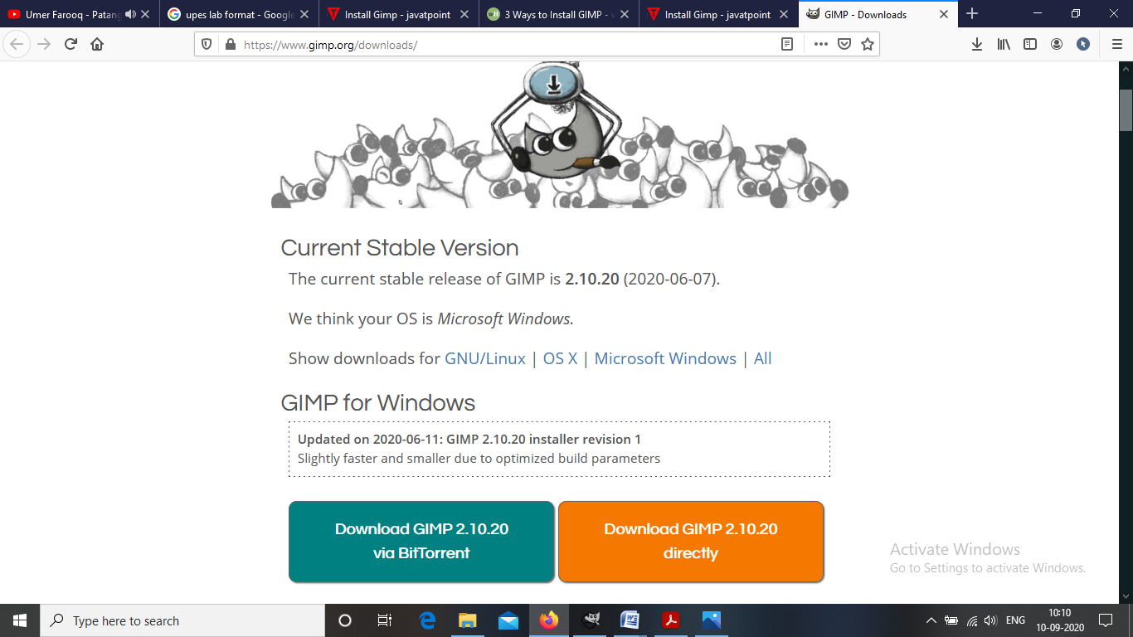

There are two download options available. Either we can download it via torrent or directly.

Step-2: Run the GIMP installer. It will be saved in your downloads section.

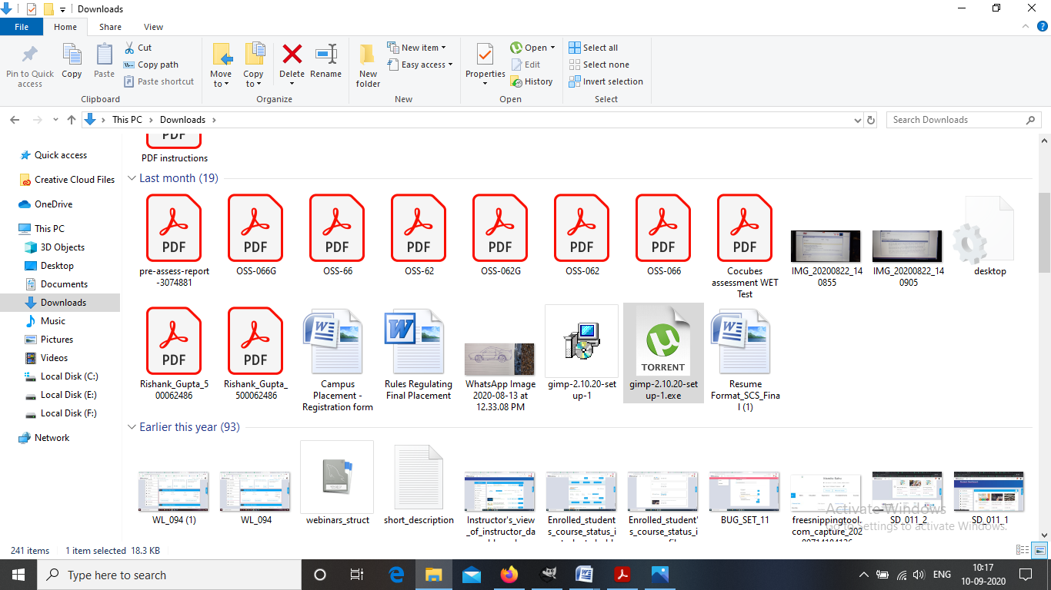

Step-3: Follow the required prompt. I leave them defaults and click on install.

Step-4: Finish the Installation. After selecting the file formats, it will take few minutes to install and then click on finish.

Step-5: Start using GIMP. Once GIMP is installed, you can start using it.

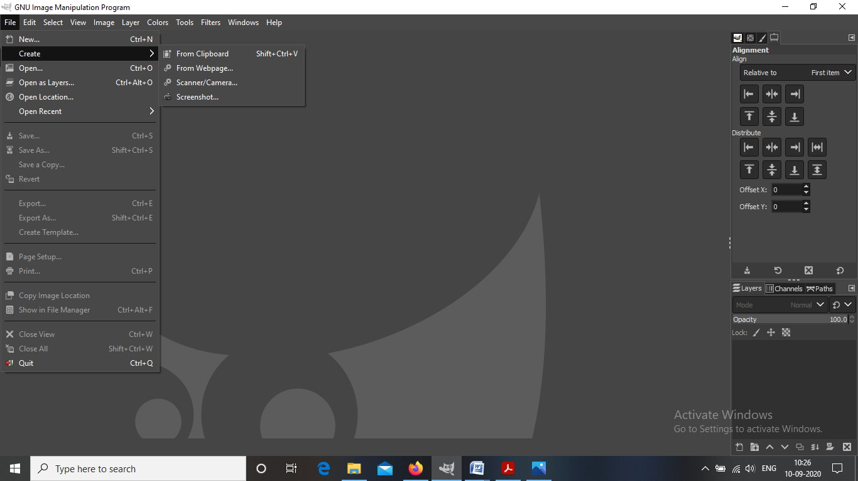

BLENDER installation Steps

Step-1: Navigate to the Blender website. www.blender.org/

Step-2: You can directly download the blender from here.

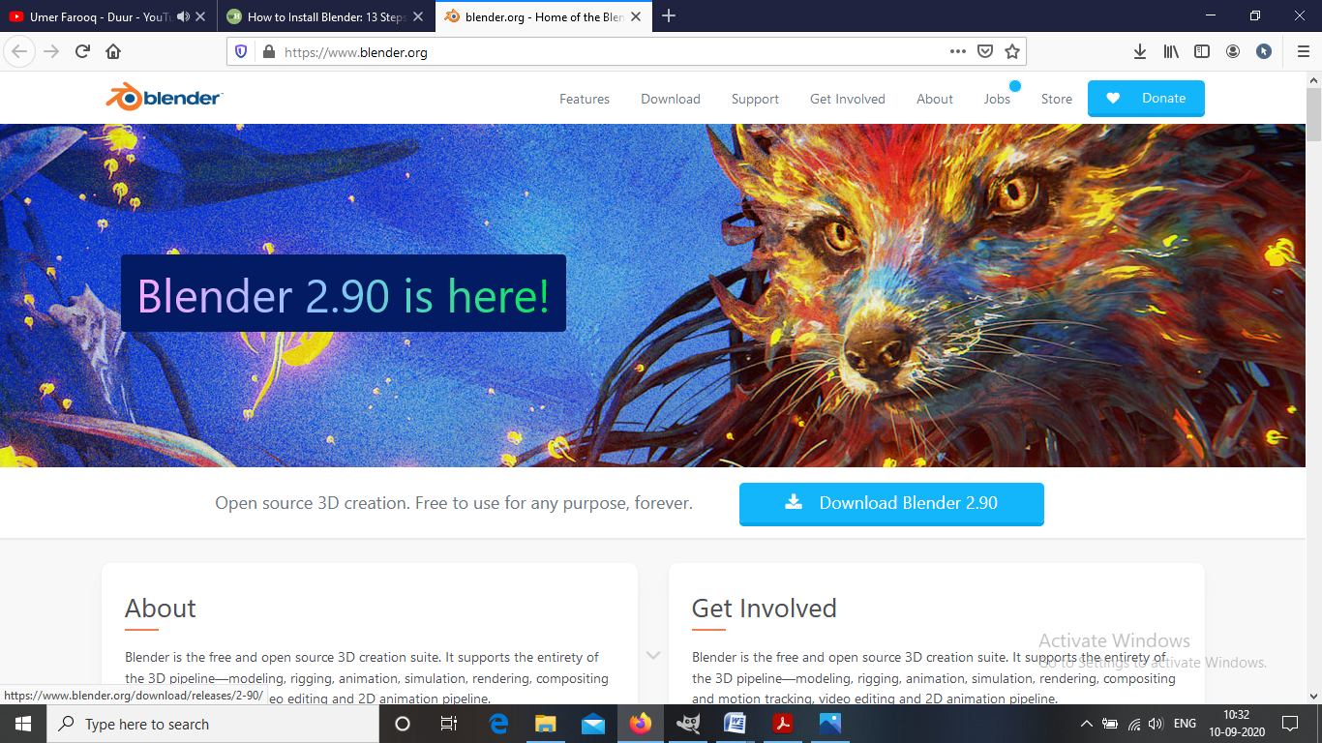

Step-3: Run the installer. It will usually be located in your download folder.

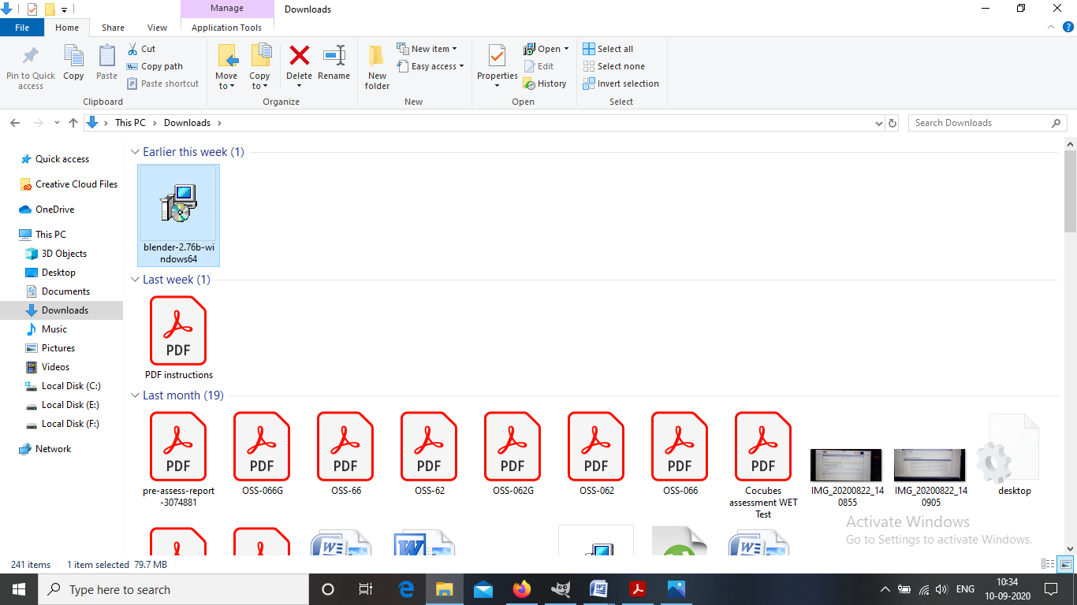

Step-4: Start the installation process. Click Next
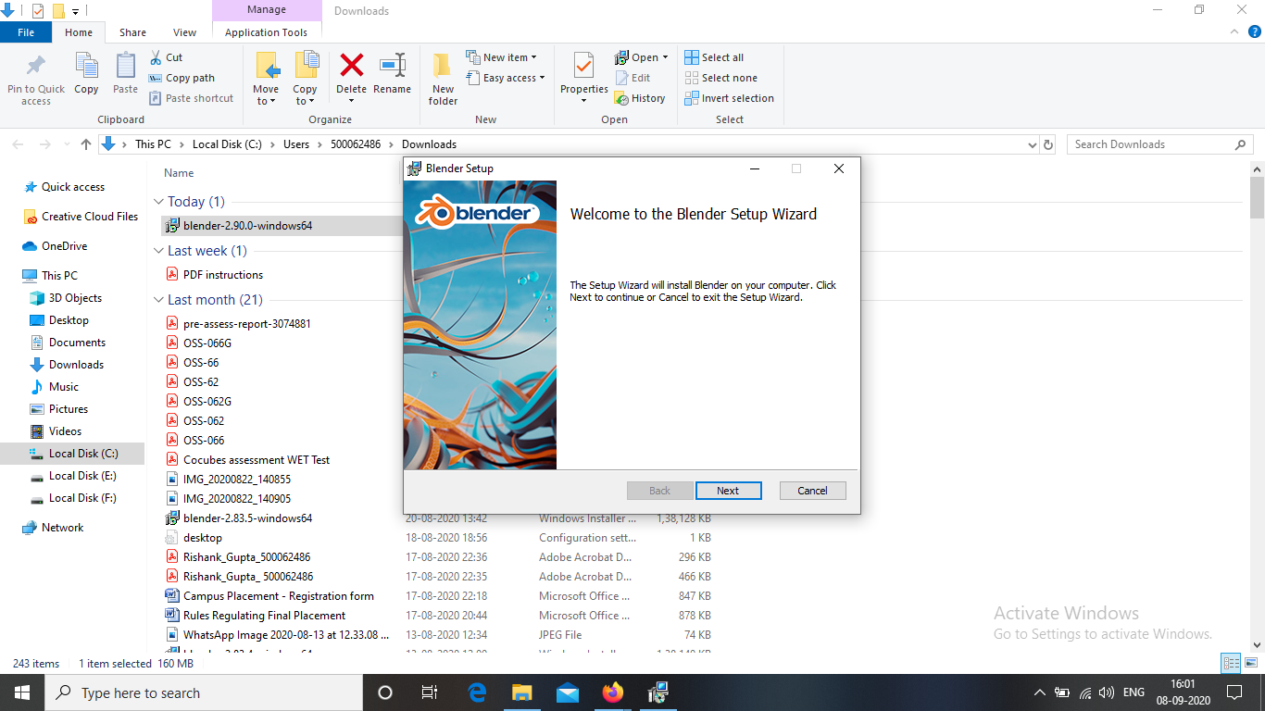

Step-5: Agree to the Terms and Conditions. When prompted, click I Agree in the installation wizard.

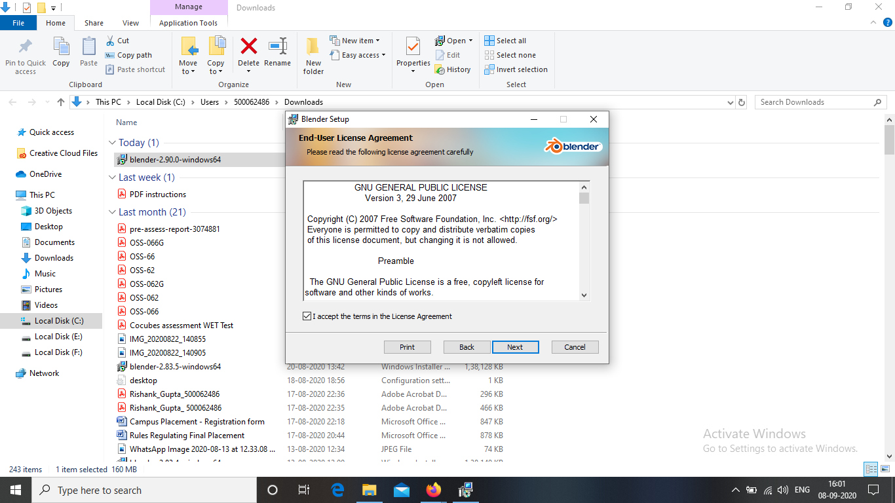

Step-6: Choose a destination folder. The default location is the Program Files folder of Drive C:\ in your computer. You may change the location of the application by clicking Browse.... Then click Install.

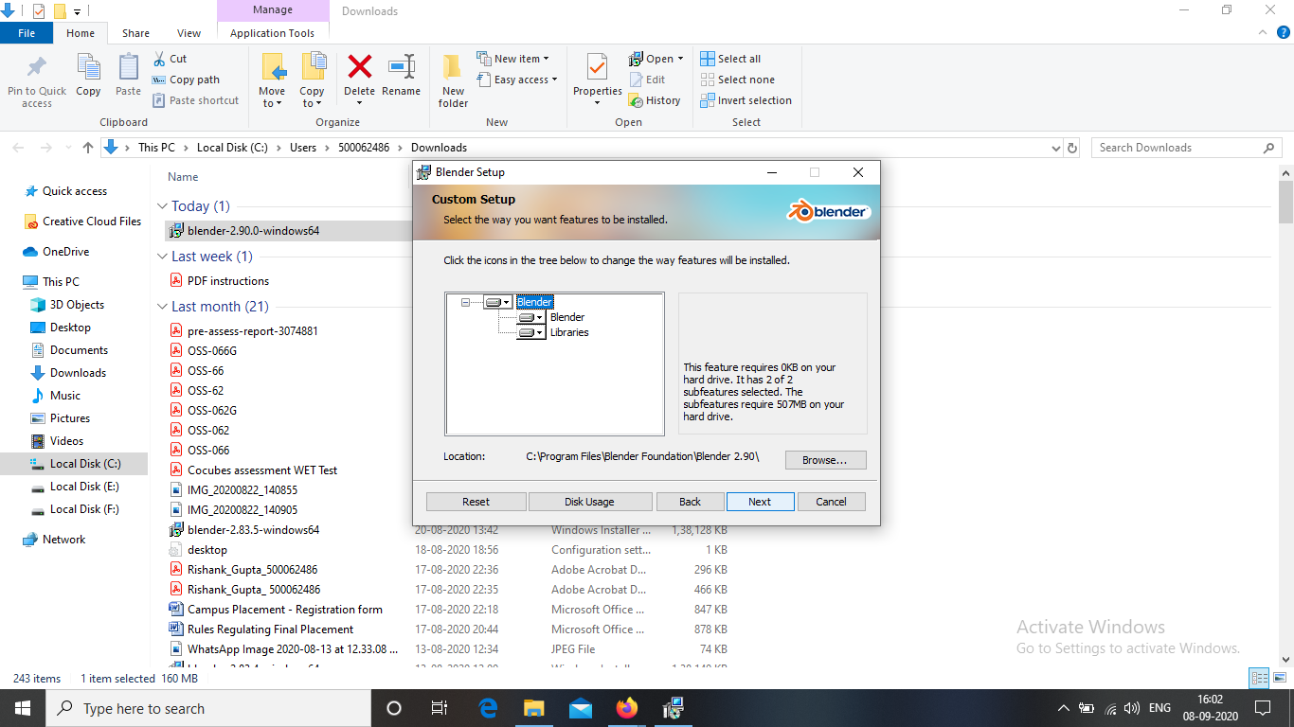

Step-7: Finish the installation. Click Finish when the installation is completed. Blender is now installed in your computer. You can start exploring the application when it starts automatically.

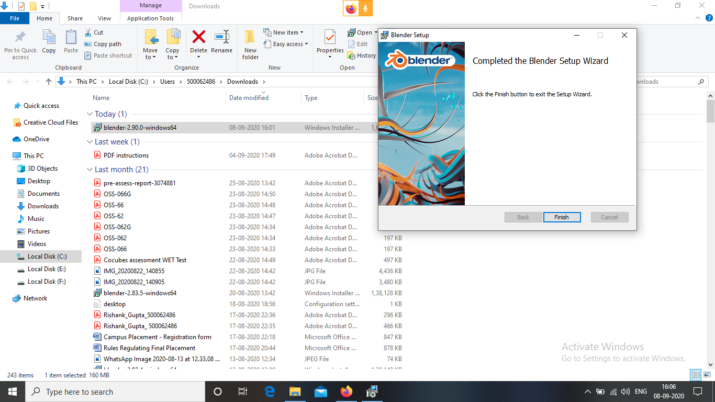

Step-8: Now start using the BLENDER.

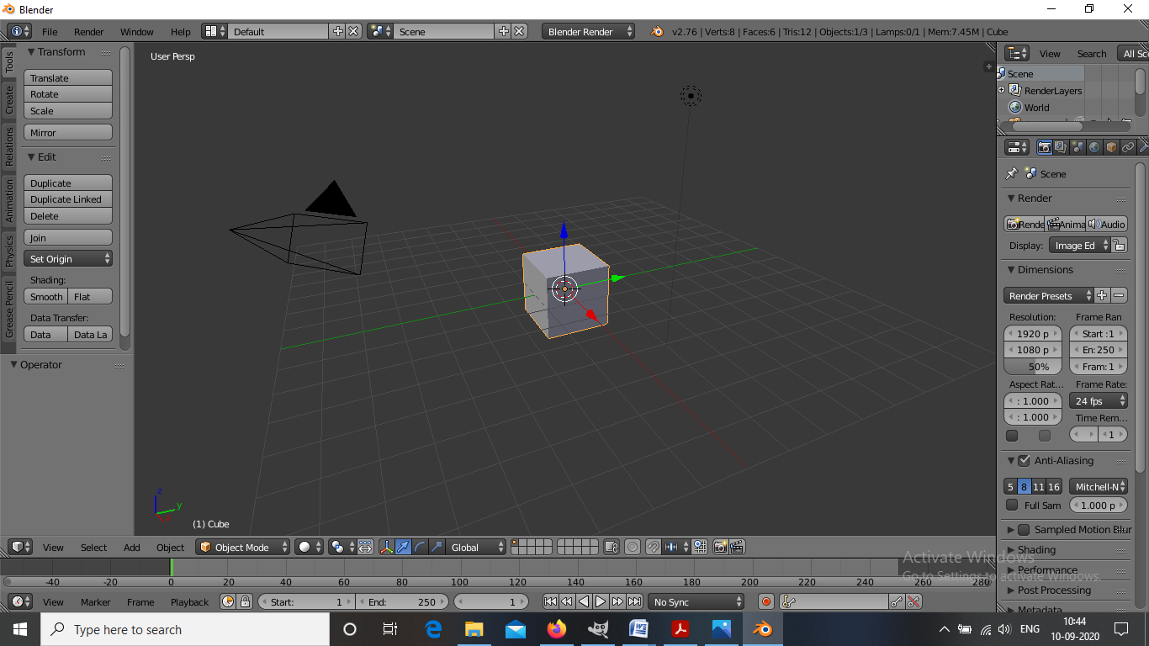

:-Mayank Shekhar
500063785
B3

