Khat : A safe mailing and messaging website

Designed and Developed by
Anshul Prasad
&
Mayank Srivastava

Website link : https://join-khat.herokuapp.com/

Github Repo Link: https://github.com/MayankShrivastava17/khat

Overview

The website Khat is designed for the purpose of having a secure message channel between 2 individuals.
It is designed such that a person can easily send a mail from in side the website to the other individual with a secure code that gives them access to a secure chat room where none of their conversations are stored. And for sending the mail with secure code also the user doesn’t have to go out as the feature of sending mail is integrated with the website.

Different Components:

The different components of the website includes:

- Homepage: This page is the face of the website.
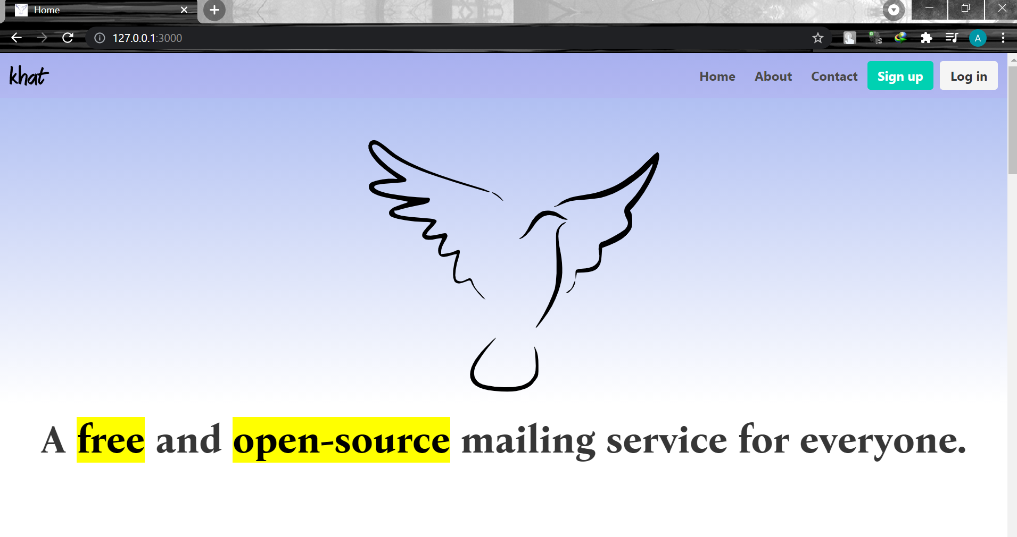
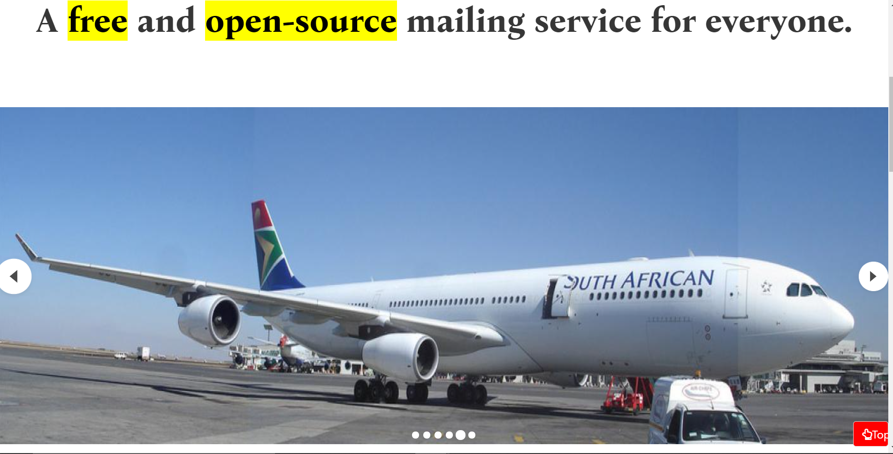

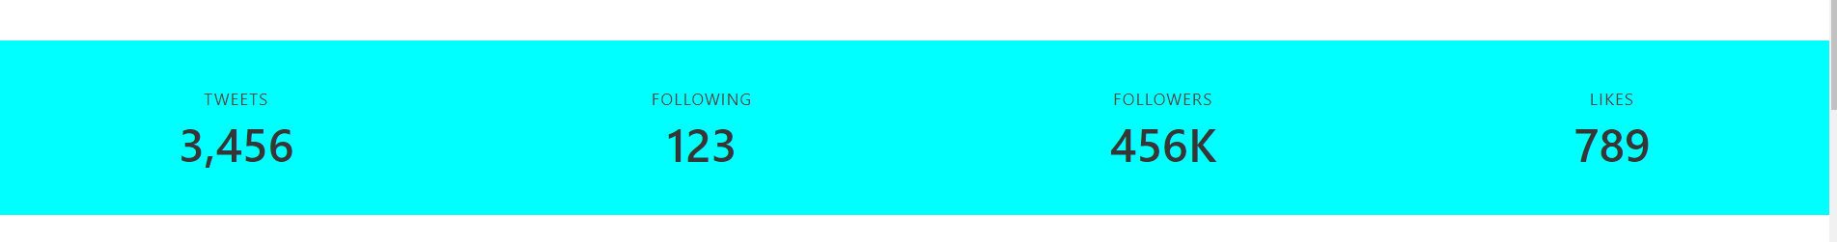
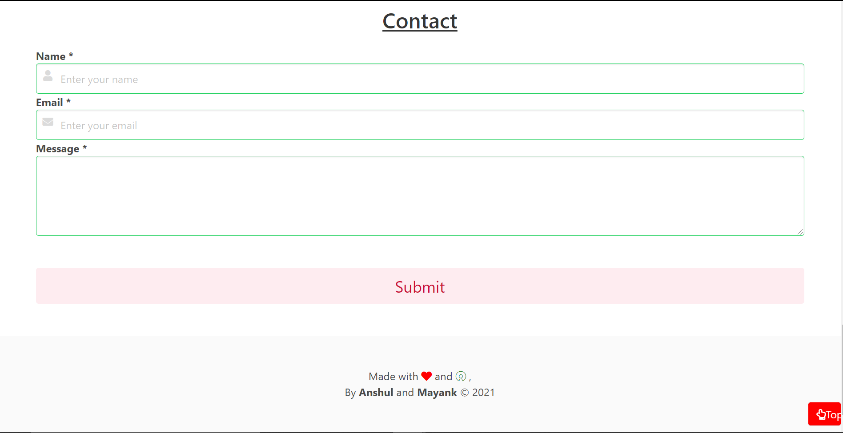

The page is having nav-bar , carousel, cards and a feedback form as its elements. There is also a top button for taking the user back to the top.

- Sign up/Login page: Sign up login pages are on full functionality and are deployed to the database with help of some javascript code for authentication and verification on firebase.

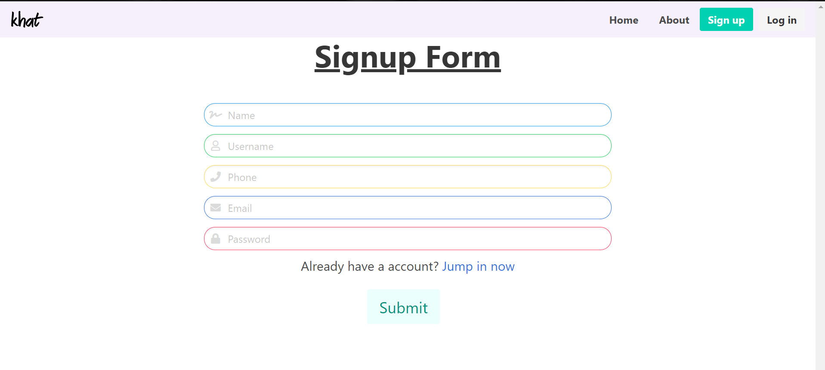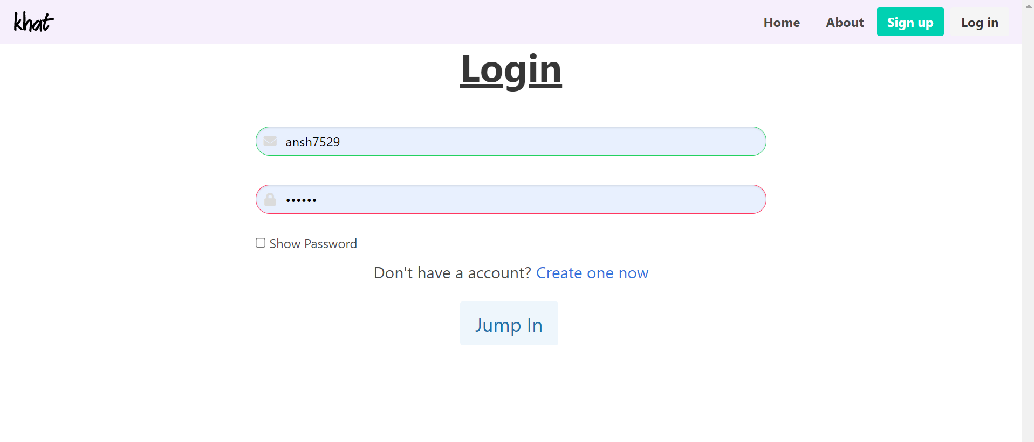

- After-Login page: This page is will only be opened after the verification and authentication of the users with the registered data. The page has a designed structure to to compose a mail and send it to a receiver. As soon as user is is on the page a 8 bit code for the secret room of the communication channel is generated. When the user sends the mail to the receiver the code is also sent with the message. Every time the page is refreshed a new code is generated automatically.
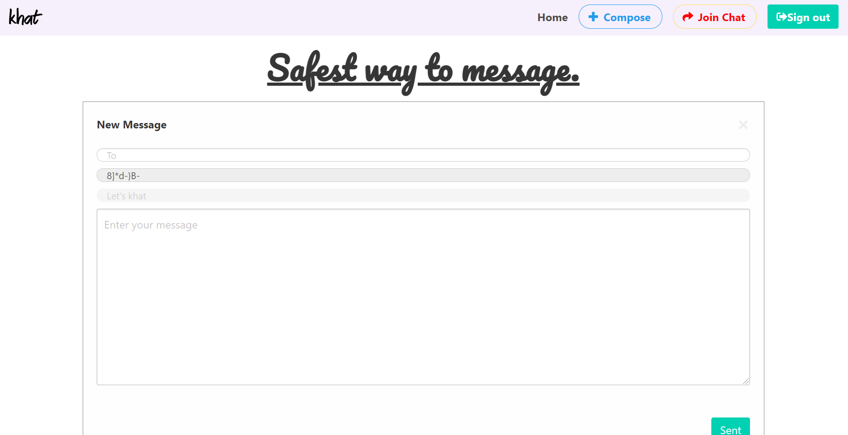

- Enter-chat-room page: This page is will ask for username and room code to enter the chatroom. User can enter any username of his/her choice. The user who has created the chat room by sending email will be having the code written in the room code field from beginning. The other user will get the code on email from where he/she needs to copy the same. 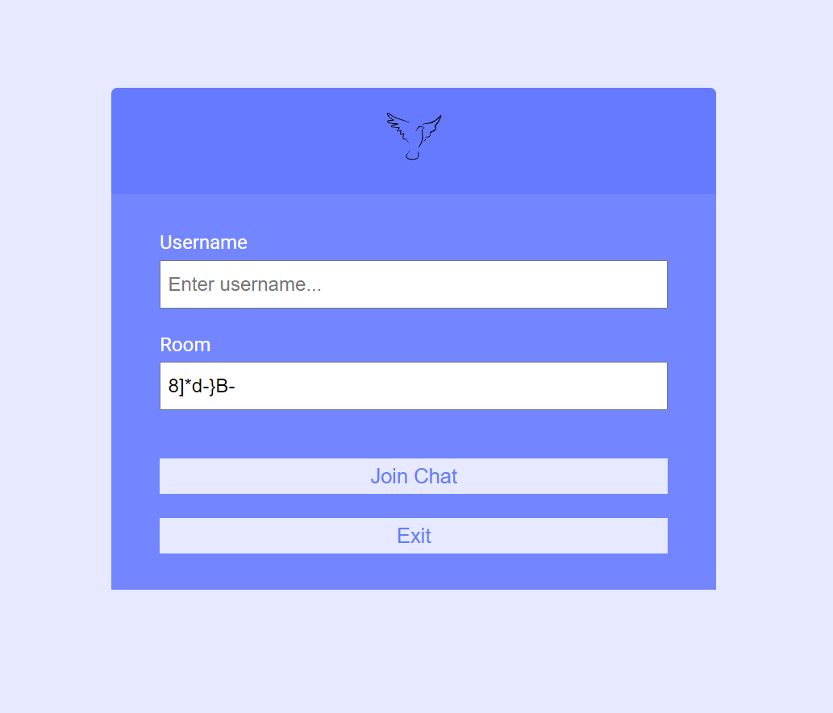
- Chat-Room: This page is the main chatting interface where the user gets the information of the other user’s username and joining time. Here, both the parties can easily chat in real-time. There is no recording of the data so it is safe as all the records gets eliminated as soon the page is refreshed.
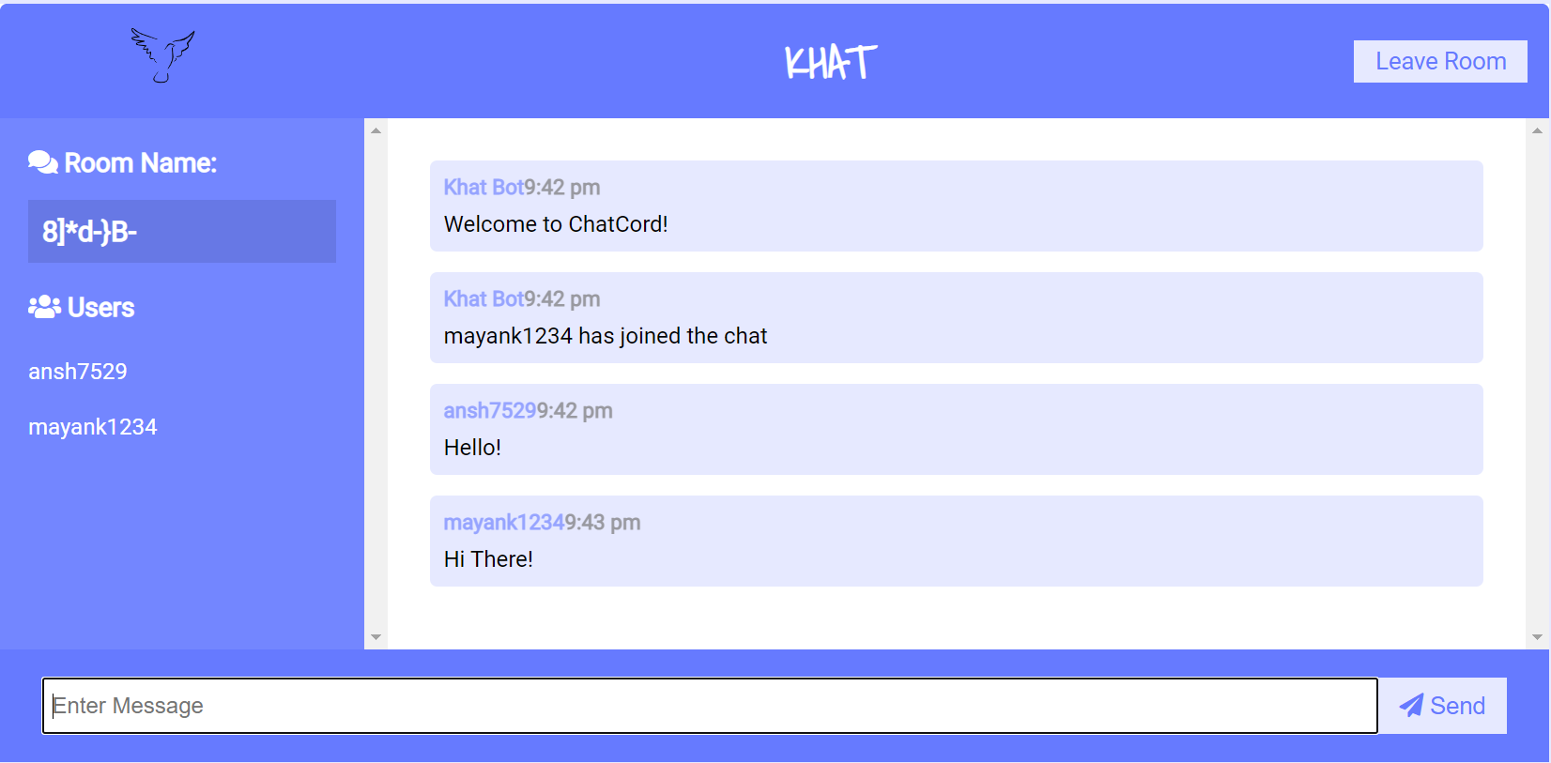

Technologies used:

- Front End:
- HTML
- CSS
- Bulma
- Back End:
- Java Script
- Database:
- Firebase
- Mongo DB
- Frameworks:
- Node.js
- Bulma-carausel
- Mongoose
- Body-Parser
- Express
- Passport
- Socket.io
- Googleapis
- Nodemailer
- APIs:
- Socket.io
- Google Apis
- Node Mailer
- Deployment:
- Heroku

Salient Features:

In the home page we are having a carousel which is rendered and is having its functionalities due to javascript.

The feedback form is connected with firebase which is live and storing data.

The whole website is responsive and adjusts itself according to every device size.

The password that is stored in the database is encrypted using passport package in node.

For sending emails from the app we have created a project on google developer’s console and used there api to establish SMT protocols to send mails.

The api is activated and the client Id and access tokens are procured from console and used to create a transport that makes the data package to send mail.

Along with this a javascript function is invoked to generate a room code to create a communication channel in messaging platform.

The chatting feature is live and doesn’t record any of the communication. It is achieved by the help of the api Socket.io.

The website is fully functional as of now and is deployed on Heroku.
Future Proposals:

Keeping in mind the limited time frame we designed and developed as much we could. But there is always the scope of improvement in any software, be it the tech giants or our projects. So, we accordingly discussed the future scopes for the same:

> Some structural and designing changes
> While creating a new account we would add an authentication feature thorough otp to verify mail ids.
> Using google button login feature
> we would try to encode the url so as to hide the username while the live chat is active.
>We will be working on having more than 2 people in chat room.
>The current chat room allows multiple users but our mailing is restricted to one ,so we would like to add cc and bcc field during mailing.
>There would be a direct entry of the creator of the chat room in the chatting section.
>A captha verified entry in chat section.

THANK YOU

