Chapter 1
Introduction
  - Project Objectives
To make the educational system online that is conducting of exams in online which results in minimum cost the examination can be done, which can prove to be very cost effective.

  - Description of the project

In the present system of the Examination conducted through franchises of the Educational institutions are carried out manually. Institutions are sending questions papers to the franchises for examination and collect the answer sheet from the franchise all these things are taking lot of time and required heavy physical strength. Institutions are frequently conducting the exams and they have to maintain the variation of questions from one exam to another exam for different times. This will take lot of time and also a very cost effective. Evaluation of answer sheets and issuing results also takes a lot of time. All sort of information pertaining to the Exams such as student information, Franchises information, Courses information, Question papers and results etc., is to be done manually. These types of procedures involve lot of paper work and it will take a lot of time. All the Examinations procedures are carried out using physical strength.

With the proposed system, with the minimum cost the examination can be done, which can prove to be very cost effective. The present system developed will give the full information about the institution courses and its exams and it is an interactive and user-friendly interface, it is flexible enough to cope up with the changing trends of the institution. The system provides the easy way of the selecting the properties from list of specifications of a particular type of exam. Thus with proposed system the user can write exam online saving time and trouble to travel all around is not faced. This system will maintain the Exams information for all the Branches of the Head Office as per the details given below.

  - Existing system

In the existing system all the work is done manually. This is chance of committing errors and it will take more time to perform any transaction. There is so many limitations in the existing system. So the existing system should be atomized. If the system is carried over manually, for every transaction it take more time. So it is difficult to take immediate decisions. It is difficult to find out where the problem is occurring
Disadvantages of the Existing System

- Existing system was not user friendly
- System was not well organized and precise
- It was time consuming
- Information was redundant and inconsistent
- It didn’t integrated all the modules Decision making was difficult
  - Proposed System
Need For Automation
- To overcome the limitations of the existing system that will provide the user the facility of choosing the exam he wants to write and saves a lot of time and money for both examiner and the examinee.
- Online Evaluator will be user friendly.
- It will maintain the information of the users who are registered and who wrote exam and what results they got.
- It will also maintain information about the questions and answers and it automates the process of evaluating the answers sheets and issuing of results.
- At the end of the exam it will display the exam summary consisting of number of questions answered, number of correct answers, number of wrong answers, number of left answers and result of the exam that is whether the user passed the exam or not.
Proposed System with Features
- To overcome the limitations of the existing system that will provide the user the facility of choosing the exam he wants to write and saves a lot of time and money for both examiner and the examinee.
- Online Evaluator will be user friendly.
- It will maintain the information of the users who are registered and who wrote exam and what results they got.
- It will also maintain information about the questions and answers and it automates the process of evaluating the answers sheets and issuing of results.
- At the end of the exam it will display the exam summary consisting of number of questions answered, number of correct answers, number of wrong answers, number of left answers and result of the exam that is whether the user passed the exam or not.
Automated Processes
Automated process is a process which is executed automatically by the system. After completion of interaction with the user, the system will perform some automated processes.
- In the user registration process, user is asked to fill a registration form. After filling the form his registration will be completed by the system with the issuing of a user id.
- After the user finishes the exam the evaluation process is done automatically by the system.
- Issuing of results is also an automated process and the database is automatically updated with marks.

Non-Automated Processes

Non-automated Process is a process, which is completely executed by the human actor. If any modifications are required to the System then the human actor will handle them.
- Admissions are to be done manually
- Institutions cannot be registered online
Sending userid and password to the Institution

Chapter 2
Software and Hardware Requirements

2.1 Hard ware Requirements

1. Intel I3 and above
2. 500MB RAM minimum (1GB RAM) recommended
3. 800*600 resolution; 16 bit color (1024*768, 24 bit is recommended)
4. For offline message audio is preferred, but no need.
15” monitor (17” monitor recommended for best results)

2.2 Software Requirements
Presentation Layer | HTML, DHTML, JavaScript, XML
Network Layer | TCP/IP
Web Server Layer | Tomcat, Servlets, RMI, JDBC,JSP
Language Specification | Java jdk 14
Databases | MySQL
Operating Systems | Windows XP,7,8,10  Chapter 3
Chapter 3
REQUIREMENTS COLLECTION

Data collection represents how the client requirement information is retrieved. This will lead to the proposed system i.e. how far the current problems in the application are overcome. To know the client requirement there are mainly 4 fact-finding techniques are used. They are frequently asked questions observation.
FAQ’S
User: User is the one who writes the exam and receives the results.
Administrator: The Administrator is the one who does the main work. He is responsible for conducting the exam, maintaining the user information and approving the registration requests of the new users, evaluating the answers sheets, issuing the results, maintaining information of question and answers in the database.
Registration: The process of creating user id and password for an intended user. This is done by filling a form.
Login: The process of registered user accessing his account through his ID and password.
Institutions: The administrator will create the institutions and this userid and password are passed on to the institutions manually. The institutions can create the questionnaires, set the test papers and view the results.

Questioners
Questionnaire method allows the collection of information from the different groups and users and from some experienced persons. The use of standardized question format can yield more reliable data than other fact-finding techniques and the wide distribution ensures greater anonymity for respondents, which can lead to more honest responses. Thus this method can be used in this project to gather information about the process of the project.
Communication Protocols
Network Protocol
TCP/IP Protocol (Transmission Control Protocol/Internet Protocol) is the Network Protocol used on the Internet. TCP/IP allows reasonably efficient and error Free transmission between different systems. Because it is a File Transfer Protocol, it can send large amount of information across networks with Great assurance that the data will arrive uncorrupted.
Layered Technology
Application

Presentation

Session

SMTP

FTP

Telnet

DNS

SNMP

Transport
TCP
UDP
Network
IP

Data Link Layer
Physical Layer

Fig 3.1 Layered Technology
Chapter 4
SYSTEM Requirement ANALYSIS
4.1 Problem Statement
In the existing system all the work is done manually. This is chance of committing errors and it will take more time to perform any transaction. There is so many limitations in the existing system. So the existing system should be atomized. If the system is carried over manually, for every transaction it take more time. So it is difficult to take immediate decisions. It is difficult to find out where the problem is occurring
4.2 Feasibility study
The feasibility report of the project holds the advantages and flexibility of the project. This is divided into three sections:
- Technical Feasibility
- Economical Feasibility
- Operational Feasibility
4.2.1 ECONOMIC FEASIBILITY
A systems financial benefit must exceed the cost of developing that system. i.e. a new system being developed should be a good investment for the organization. Economic feasibility considers the following
i. The cost to conduct a full system investigation.
ii. The cost of hardware and software for the class of application.
iii. The benefits in the form of reduced cost or fewer costly errors.
iv. The cost if nothing changes (i.e. the proposed system is not developed).
The proposed system is economically feasible because
- The system requires very less time factors.
ii. The system will provide fast and efficient automated environment instead of slow and error prone manual system, thus reducing both time and man power spent in running the system.
iii. The system will have GUI interface and very less user-training is required to learn it.
iv. The system will provide service to view various information for proper managerial decision making.

4.2.2 Technical Feasibility
Technical feasibility centers around the existing computer system ((hardware and software) whether it can support the addition of proposed system, if not, to what extent it can support and the organization’s capacity to acquire additional components.

Our proposed system is technically feasible because –
- The hardware and software required are easy to install and handle
- The necessary hardware configuration and software platform is already there
- The system supports interactivity with the user through GUI
Technical feasibility centers around the existing computer system (hardware and software) whether it can support the addition of proposed system, if not to what extend it can support the organization’s capacity to acquire required additional components.
Proposed system is technically feasible because of the following reasons:-
- It’s required less system resources.
- Expandability will be maintained in the new system. New modules can be added later on the application, if required in the future.
- The application will have User-friendly Forms and Screens, all validation checks. So the new system guarantees accuracy, reliability, ease of access and data security.
4.2.3 BEHAVIOURAL FEASIBILITY
Behavioral feasibility determines how much effort will go in the proposed information system, and in educating and training the users on the new system, along with the new ways of conducting the business. Behavioral study strives on ensuring that the equilibrium of the organization and status quo in the organization neither are nor disturbed and changes are readily accepted by the users.

The proposed system is behaviorally feasible because of the following:
The users will accept it because they are already acquainted with computers.
This system is also meant for the general user. Nowadays the Internet is almost familiar to everyone. So, it is not difficult for the user to use the system, in fact they feel comfortable in using this system.
Most of the users are familiar with the web browser and the process of booking the auditorium will be simplified for the users. The organization is definitely ready to welcome the computerized system.

4.3 System Requirements Specification (SRS)
4.3.1 Introduction
In the present system of the examination conducted through franchises of the educational institutions are carried out manually. Institutions are sending question papers to the franchises for examination and collect the answer sheet from the franchise. All these things are taking lot of time and require heavy physical strength. Institutions are frequently conducting the exams and they have to maintain the variation of questions from one exam to another exam for different times. This will take lot of time and also a very cost effective. Evaluation of answer sheets and issuing results also takes a lot of time. All sort of information pertaining to the exams such as student information, franchises information, courses information, question papers and results etc., is to be done manually. These kinds of procedures involve lot of paper work and it will take a lot of time. All the examination procedures are carried out using physical strength.

Purpose
Using Online Evaluator we can conduct the exams online that is we can conduct the exam without paper. Using this for conducting exams we can save time, money and physical strength for printing, distributing the question papers and collecting the answer papers. We are also able to issue the results quickly. We can also reduce the time and physical strength for evaluating the papers. This also provides the facility of correcting mistakes in the question papers which is difficult in manual system.

Scope
To overcome the limitations of an existing system of conducting the exam, this new system was developed. This new system will provide the users to select the exam that he wants to write and save a lot of time, money and physical strength for both examiners and examinees. This also provides the facility of issuing results immediately after the exam without much delay.

Existing System with Limitations

In the present system of conducting exams everything is done manually. In present system to conduct the exam the examination conducting authorities have to print and distribute the question papers to the exam centers and collect the answer sheets from the centers and evaluate them and issue the results. This will consume lot of time, money and physical strength. If there are any mistakes in the distributed question papers then they have to inform those mistakes to the exam centers which is a time consuming one.
4.3.2 Functional Requirements
General Constraints
There are some of the general constraints that is pre-conditions, post-conditions and business rules which we need to maintain in our system they are listed below
Pre-Conditions
- The user has to register before writing the exam.
- User has to select the exam from the given list of exams by the administrator.
Post-Conditions
- The user should finish the exam within the time specified by the administrator.
- Results should be displayed to the user immediately after finishing the exam.
Business Rules
- The non-registered users cannot take up the exams.
The user should finish the exam within the time limit

4.3.3 Performance Requirements
To achieve good performance the following requirements must be satisfied
- Scalability: The ease with which a system or component can be modified to fit the problem area.
- Portability: The ease with which a system or component can be transferred from one hardware or software environment to another.
- Security: It is the ideal state where all information can be communicated across the internet / company secure from unauthorized persons being able to read it and/or manipulate it. It is also the process of preventing and detecting unauthorized use of one’s computer.
- Maintainability: The ease with which a software system or component can be modified to correct faults, improve performance, or other attributes, or adapt to a changed environment.
- Reliability: The ability of a system or component to perform its required functions under stated conditions for a specified period of time.
- Reusability: The degree to which a software module or other work product can be used in more than one computing program or software system.

4.4 Modules
The main modules involved in the Online Evaluator are as follows:
User
Registered User
Unregistered User
Login
Today’s Topic
Personal Information
Exam Selection
Administrator
Creating New Users
Creating New Institutions
Creating New Batches
Adding New Books
Viewing Course Details
Viewing User Details
Viewing Institution Details
Viewing Batch Details
Payments
Results
Institution
Users
View Batch Users
View Batch
Upload Topic
Create Questionnaire
Set Test
View Result

4.5 Modules Description
User is one who writes the exam and receives the results. There are two kinds of users here in our system they are registered and unregistered users. The registered user can login and selects the exam of his level and writes the exam and receives the results after finishing the exam. The unregistered user can write the exam by registering himself/herself.
Administrator is the one who maintains the information of the registered users. He is the one who accepts the registration requests of new users. He also maintains the information of questions and answers in the database. He conducts the exam by giving the question paper according to the choice of the user. After the exam he will evaluate the answers given by the user against the answers already present in the answers database and then issues the results to the user. He will enter the marks in to the database.
Institutions cannot directly register into the system but indirectly they are registered by the administrator. These institutions are created by the administrator but institutions are the one, who is going to create the questionnaires, set the test papers and view the results.

User Characteristics
User to System: User gets registered with the system to login for writing the exam. By giving his details in the registration process he obtains his id and password.
System to User: System gives id and password to the user after finishing the registration process. When the user gives his id and password
to login system validates the id and password and then gives the permission to access the system. Then it will display the exams it is conducting from which the user has to select.
Administrator to System Administrator will place the list of exams he is conducting with overall description such as name of the exam, time for exam, subject of exam, etc. He gives the question paper. He receives the information from system during registration process and validates the information and sends the id and password to system which is given to user by the system.
User to Administrator User selects his level of exam which he wants to write. This request is passed to administrator.
Administrator to User: Administrator will give results to user after evaluation process.
System to Administrator System will send the details of the user to administrator during the registration process and asks for validation. It also gives the results of the exam to administrator for storing in the database.
Administrator to Institutions The administrator will create the institutions and this userid and password are passed on to the institutions manually.
Institutions to System The institutions can create the questionnaires, set the test papers and view the results.

Chapter 5
System Design
5.1 introduction

The methodology used to develop this project is object-oriented methodology is based on function and procedures. It can be said as the development of software by building self-contained modules as objects that can be easily replaced, modified and reused. In this environment software is a collection of discrete objects that encapsulate their data as well as the functionality to model real world “objects”. Each object has attribute and methods. Objects are grouped into classes. Here each object is responsible for itself.
This environment emphasizes its cooperative philosophy by allocating tasks among the objects of the applications. Instead of writing a lot of code we can create a lot of code we can create a lot of helps to take in an active role.
Object oriented methodology involves mainly
1. Analysis
2. Design
3. Prototyping and testing.

ANALYSIS
There are 5 important steps in the analysis. They are
- Identification of the users/actors.
- Development a simple business process model.
- Developing the use cases.
- Developing the interaction diagrams.
- 4Classifications.

SOFTWARE METHDOLOGY
Using JACOBSON METHDOLOGIES to develop the proposed system.

INTRODUCTION
In 1986 BOOCH developed the Object Oriented Design concept is called as BOOTCH METHOD. It covers both analysis and Design phases of the Object Oriented System, The BOOTCH METHOD consists o following diagrams:
- Class diagrams
- Object diagrams
- State transition diagram
- Module diagram
- Process diagram
- Interaction diagram

BOOTCH used the large set of symbols. Even though BOOTCH defines a lot of symbols to document almost every design decision, if we work with his method, you will notice that you never use all these symbols and diagrams; This is this main drawback of the BOOTCH METHOD.
In 1991 Jim Raumbaugh develop the OMT (Object Modeling Technique) with the help of his team It covers analysis, Design and implementation of the system.
OMT separates Modeling into three different parts:
- Object Model
Presented by the Object Model and the data dictionary.
- Dynamic model
Presented by the State diagrams and Event flow diagrams.
- Functional Model
Presented by Data flow and constraints.
There is no traceability in the different phases, both forward and back ward; this is the main disadvantage of the OMT.
In order to avoid the problems faced in the above two models JACOBSON invented the one model called as the JACOBSON METHDOLOGIES (Object Oriented Software Engineering). It will cover the entire life cycle and stress tractability between different phases, 0both forward and back ward, Additionally he invented the Use case diagrams, these diagrams are necessary to understanding system requirement. It captures the goal of the system. It is used to identify the Use cases and External users (external users are the users who interact with our system to complete the task)
THE JACOBSON ET AL. METHDOLOGIES:
JACOBSON METHDOLOGIES (Object Oriented Software Engineering) OOSE cover the Entire life cycle and stress trace ability between the different phases, both forward and backward. And Use case diagrams, these diagrams are necessary to understanding system requirement. It captures the goal of the system. It is used to identify the USE CASES and External users (external users are the users who interact with our system to complete the task)
The Use case Description must contain
- HOW and WHEN the use case begins and ends.
- The interaction between the use case and its actors, including WHEN the interaction occurs and WHAT is exchanged.
- HOW and WHEN the use case will need data stored in the system or will store data in the system.
- EXCEPTION TO THE flow of events.
- HOW and WHEN concepts of the problem domain are handled.
By using the use case model we will find the External users, External users are the users who will interact with our system to complete the task. Every single use case should describe one main flow of events. An exceptional additional flow of events could be added.

OBJECT ORIENTED SOFTEWARE ENGINEERING
Object oriented software engineering also called, as the objectory. It is build around several models:
  - USE CASE MODEL: The use-case model defines the outside (actor) and inside (use case) of the systems behavior.
  - DOMAIN OBJECT MODEL: The objects of the “real” world are mapped in to the main object model.
  - ANALYSS OBJECT MODEL: The analysis object model presents how the source code (implementation) is carried out and written.
  - IMPLIMENTATON MODEL: The implementation model represents the implementation of the system.
  - TEST MODEL: The test model constitutes the test plan, specification and reports.
JACOBSON METHDOLOGY consists of following diagrams:
- Use case Diagrams
- UML activity diagram
- UML use Case Diagram
- Sequence diagrams
- Class diagrams
- Business class diagrams

5.2 Data Flow Diagrams
Data Flow Diagrams are used to represent the flow of data from one part of the system to another part of the system. Mainly these DFDs are used to represent the existing system. We can divide the study of DFDs into 3 parts.
- Notations
- Rules
- Levels

Notations
We use four notations in Data Flow Diagrams. They are as follows.
- External Entity
It is a thing which is external to the system and uses the system, these are graphically represented using rectangle.

User

- Process
Process is an action taking place in the system. Process is represented using an ellipse.
Administration

- Data Flow
Data Flow indicates the direction of the flow of data from one part of the system to another part of the system. Data Flow is represented using a one directional arrow.

- Data Store
Data Stores are used to represent the data bases in the system. Data Stores are graphically represented using double lines.

Rules
While drawing Data Flow Diagrams we have follow some rules. The following should not be violated.
- There should not be any data flow between two external entities directly.
- There should not be any data flow between two data stores directly.
- There should not be any data flow between data store and external entity.

Context Level

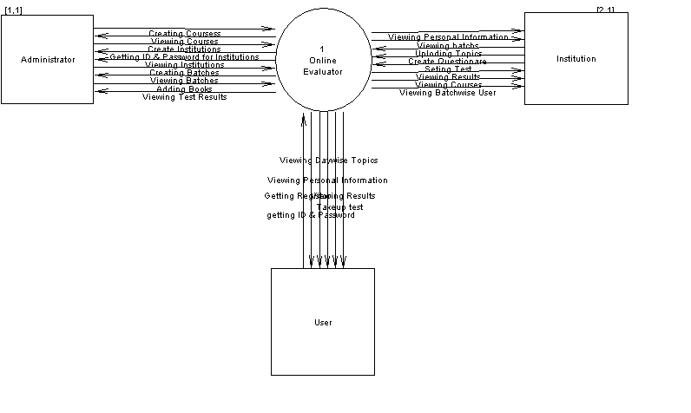
Fig 5.1 Context Level Diagram

5.3 System Flow Chart

Online Evaluator
Administrator
User
Institutions
Creating
Viewing
Course
Institution
Batch
Add Book
Course
User
Institution
Batch
Payments
Results
Personal Info
Today’s Topic
Test
Users
View Batch Users
View Batch
Upload Topic
Create Questionnaire
Set Test
View Result
Database
Fig 5.2 System Flow Chart

5.4 UML Diagrams
5.4.1 Usecase Diagram
Its purpose is to define Piece of behavior. It describes both inside (use case) and outside (actor) Behavior of the system. It describes what a system does.
These diagrams consist of:
- Use cases
- Actors
A use case is the specification of sequences of actions, including variant sequences and error sequences, which a system, subsystem or a class can perform by interacting with outside actors.
An actor may be anything that interact with the system, human, hardware device or another system etc
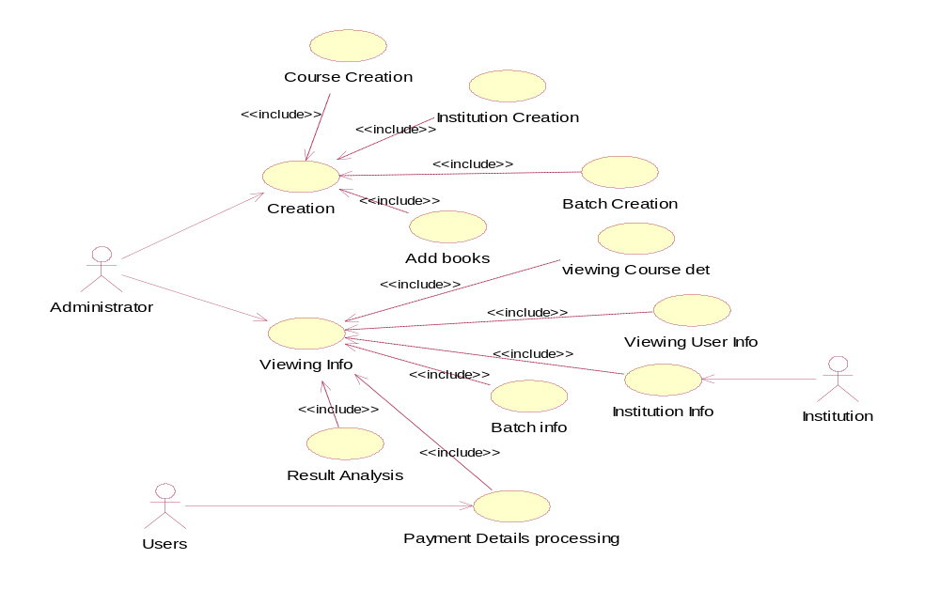
Fig5.3 Use Case Diagram of Admin login

Use Case Diagram for Institution Login
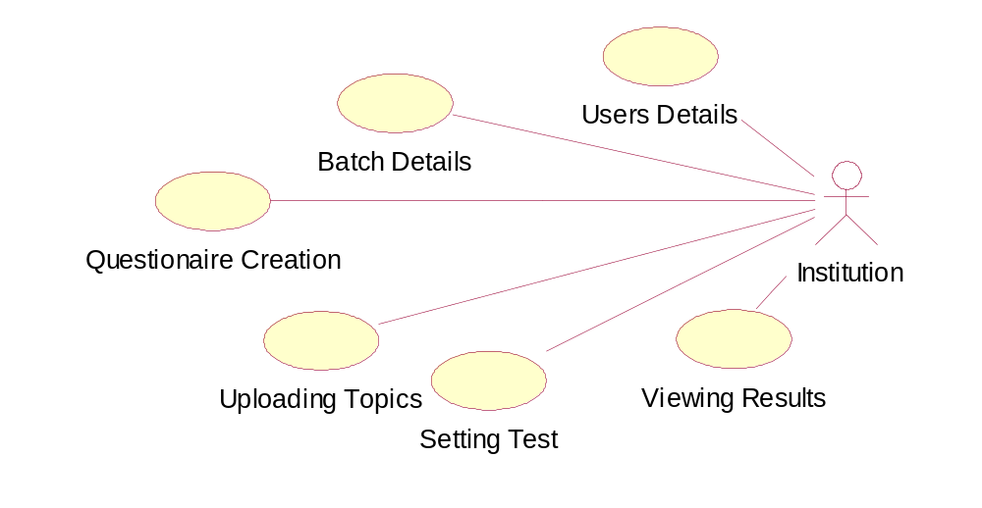
Fig 5.4 Use Case Diagram for Institution Login

Use Case Diagram for User Login
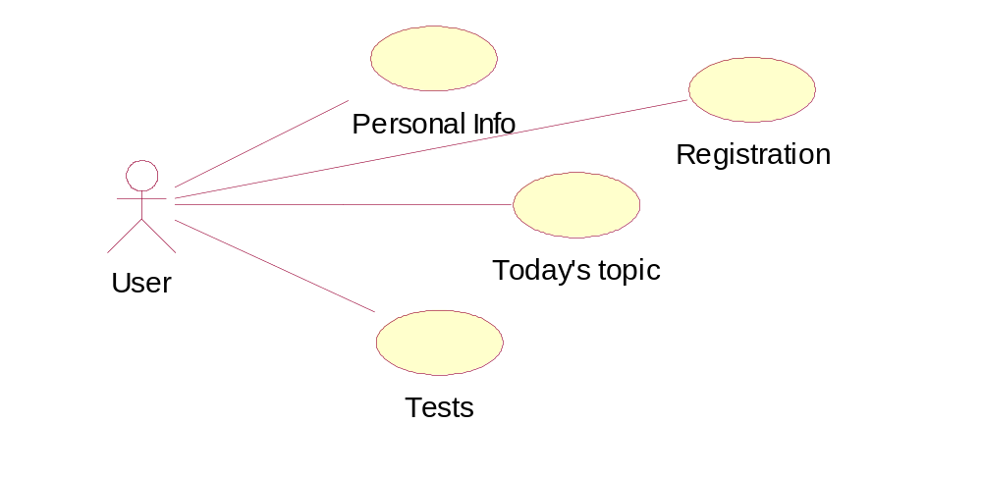
Fig5.5 Use Case Diagram for User Login

5.4.2 Class Diagram

Class diagrams are the backbone of the almost every object oriented method including UML. They describe the static structure of a system. Classes represent an abstraction of entities with common characteristics. Associations represent the relationships between classes. Illustrate classes with rectangles divided into compartments. Place the name of the class in the first partition (centered, bolded and capitalizes), list the attributes in the second partition and write operations into third.

Active classes initiate and control the flow of activity, while passive classes store data and serve other classes. Illustrate active classes with a thick border

Common contents
- Classes
- Active Classes
- Visibility
- Associations
- Multiplicity (Cardinality)
- Compositions and Aggregation
- Generalization
- Attributes List

Class Diagram
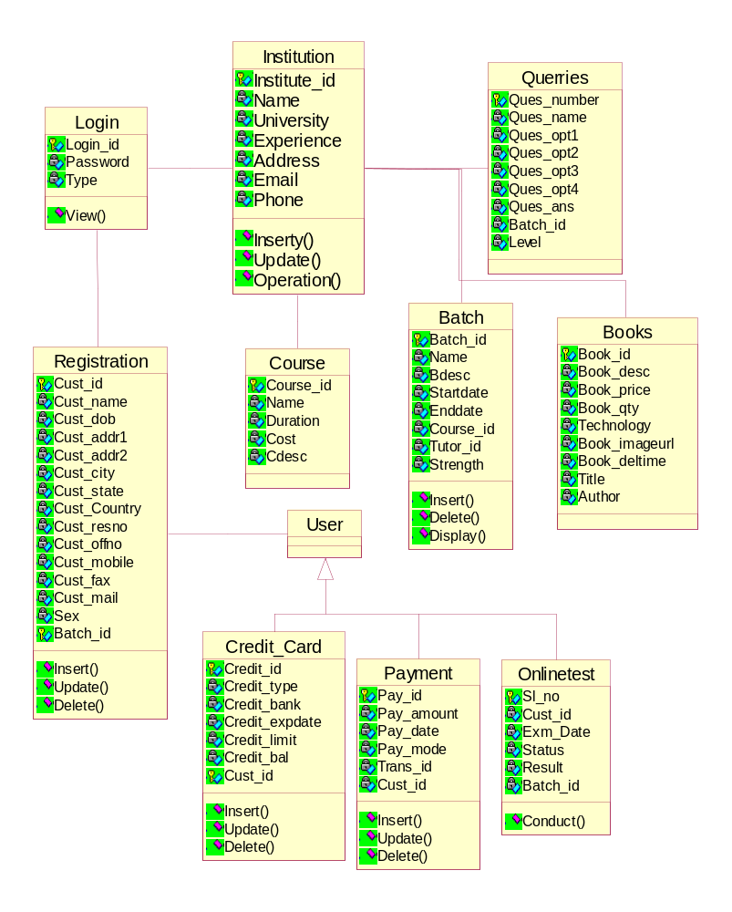
Fig5.6 Class Diagram

5.4.3 Interaction Diagram

- An interaction diagram shows an interaction, consisting of a set of objects and their relationships, including the messages that may be dispatched among them.
- A sequence diagram is an interaction diagram that emphasizes the time ordering of messages.
- Graphically, a sequence diagram is a table that shows objects arranged along x-axis and messages, ordered in increasing time, along the y-axis.

Sequence Diagram
- Sequence diagrams commonly contain the following:
    - Objects
    - Links
    - Messages
Like all other diagrams, sequence diagrams may contain notes and constrains

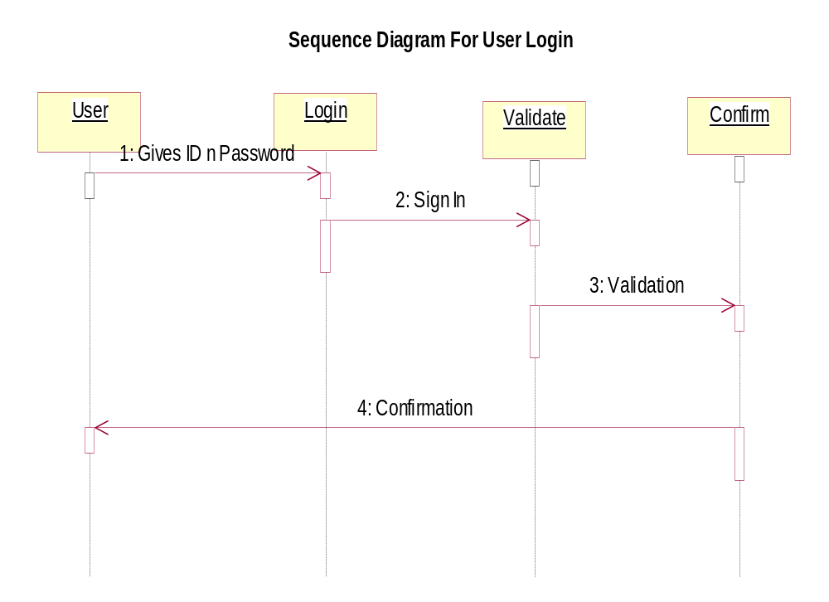

Fig5.7 Sequence Diagram for User login
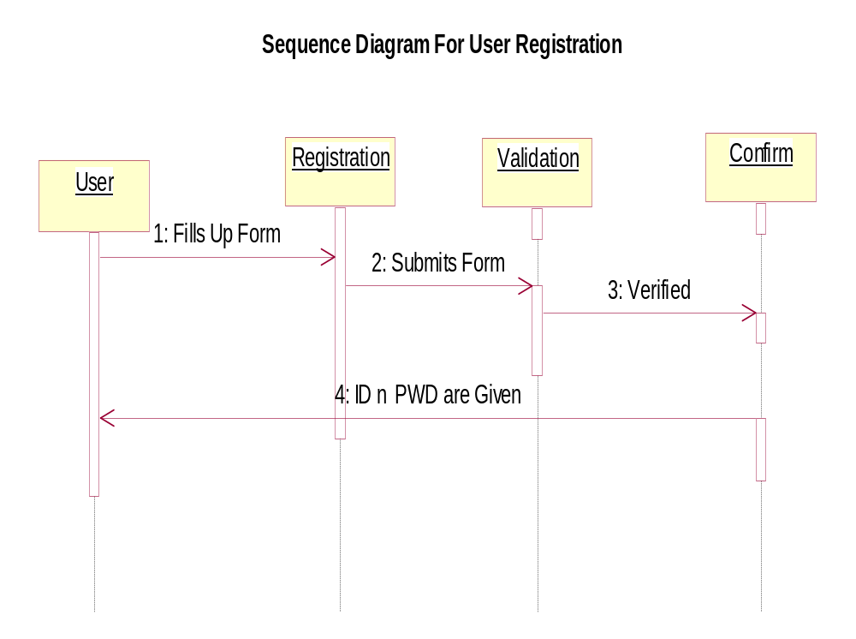
Fig5.8 Sequence Diagram for User Registration 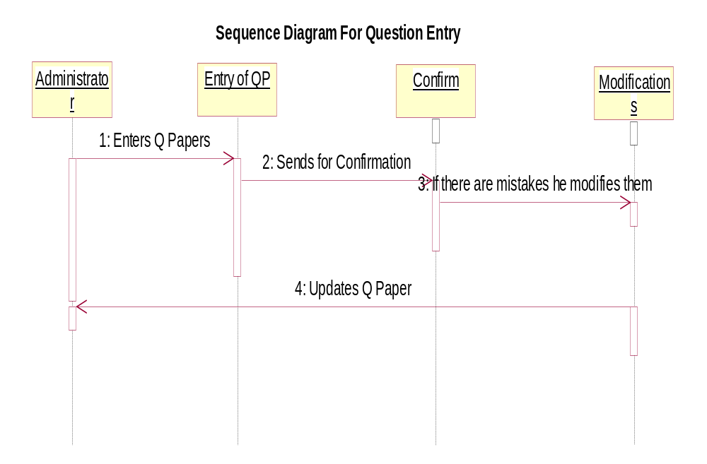
Fig5.9 Sequence Diagram for Question Entry
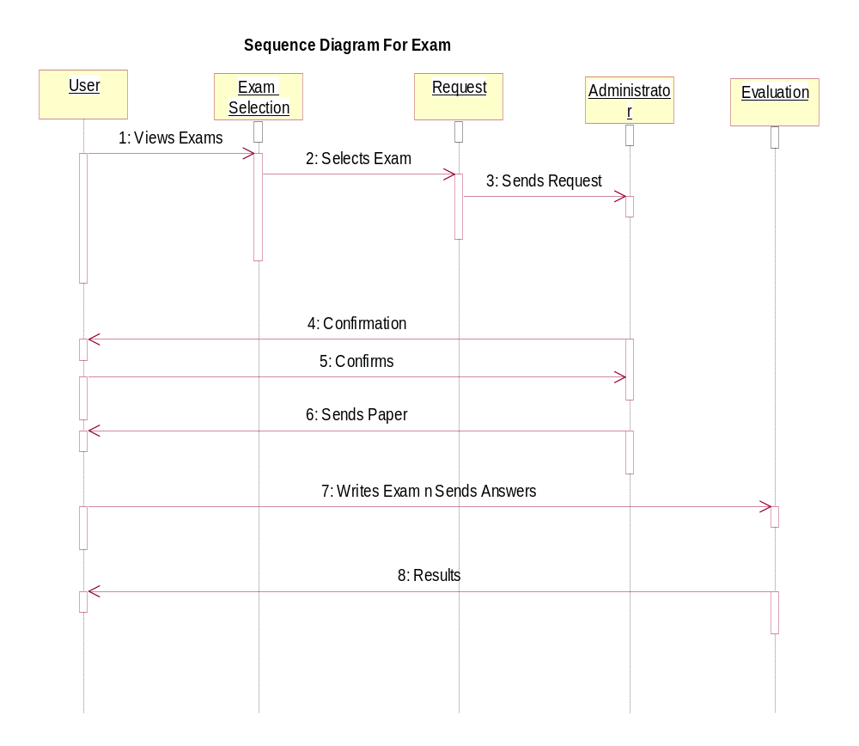

Fig5.10 Sequence Diagram for Exam

5.4.4 Collaboration Diagram
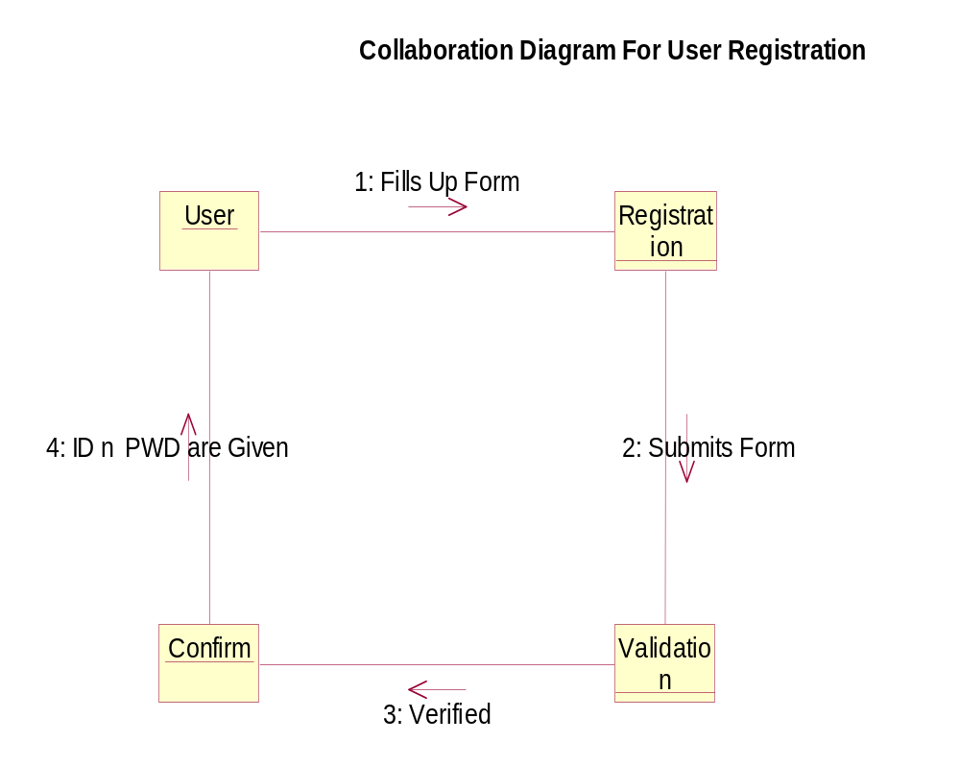
Fig5.11 Collaboration Diagram for User Registration

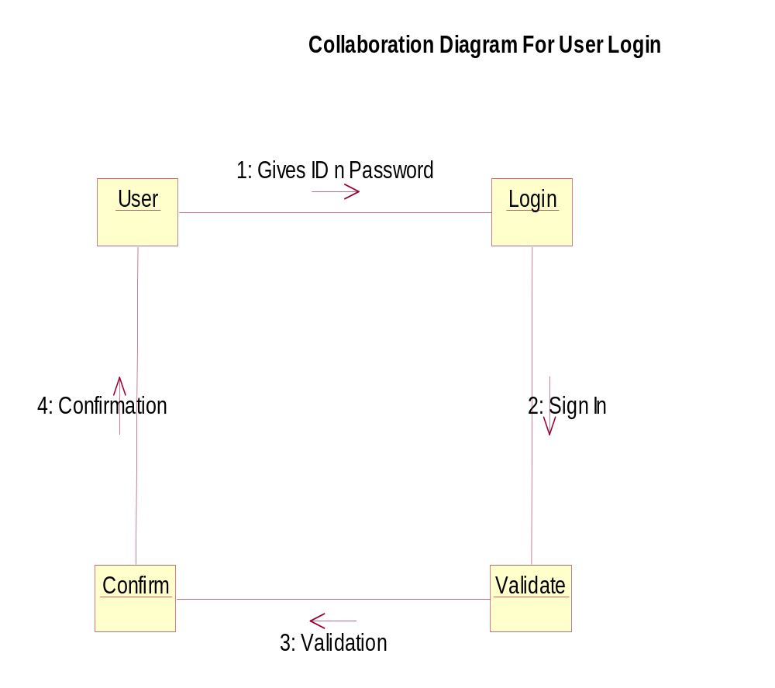

Fig5.12 Collaboration Diagram for User Login

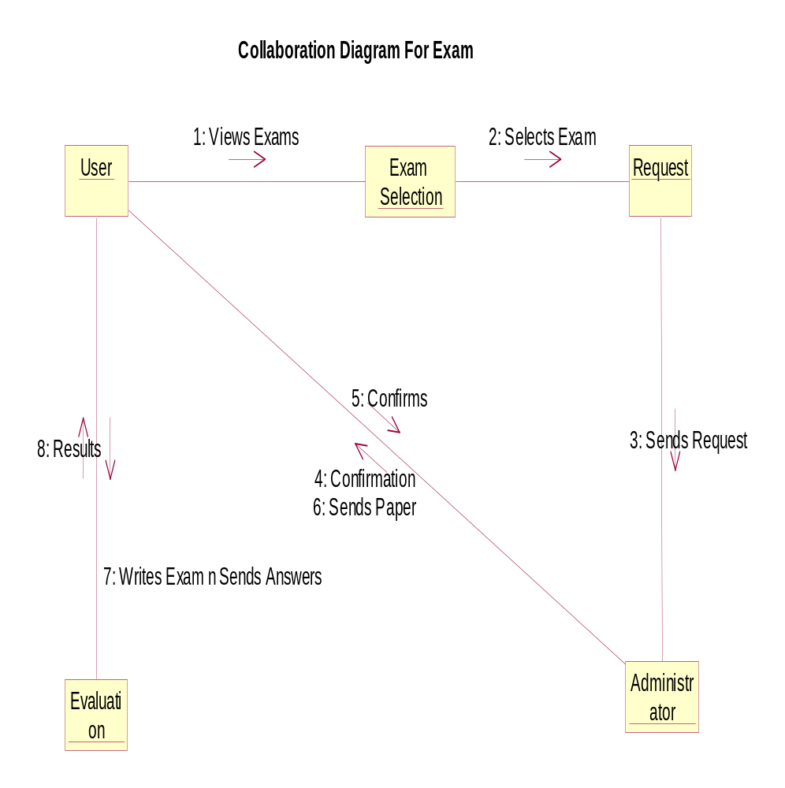

Fig5.13 Collaboration Diagram for Exam

5.4.5 Activity Diagram
Activity diagrams should be used in conjunction with other modeling techniques such as interaction diagram state diagrams. Main reason to use activity diagrams is to model the workflow behind the system being designed. Activity Diagrams are also useful for: analyzing a use case by describing what actions need to take place and when they should occur; describing a complicated sequential algorithm; and modeling applications with parallel processes. However, activity diagrams should not take the place of interaction diagram. Activity diagrams do not give detail about how objects behave or how objects collaborate. ¹
Activity diagram is a variation or special case of a state machine, in which the states are activities representing the performance of operations and the transitions are triggered by to completion of the operations. An activity diagram can be used to model an entire business process. The purpose of an activity diagram is to provide a view of flows and at is going on inside a use case or among several classes. However, activity diagram can also be used to represent a class’s method implementation.
Activity diagrams show the flow of activities through the system. Diagrams are read from top to bottom and have branches and forks to describe conditions and parallel activities. A fork is used when multiple activities are occurring at the same time.

Activity Diagram of Administrator Activities
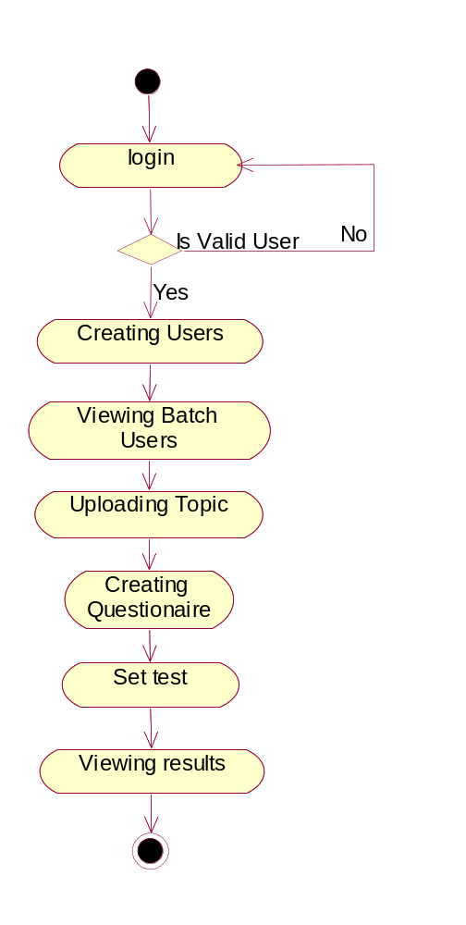
Fig5.14 Activity Diagram of Administrator Activities
Activity Diagram of Institution Activity
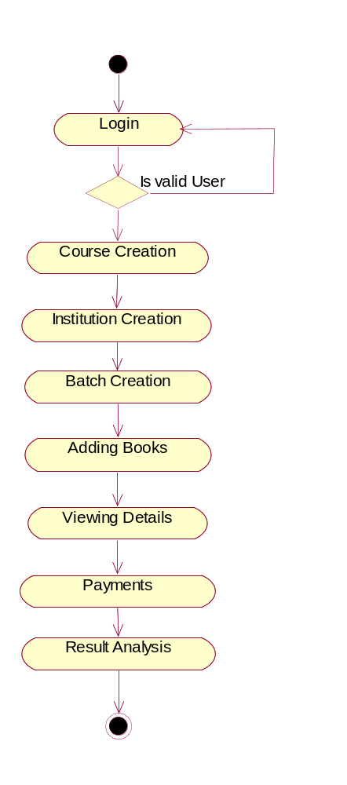
Fig5.15 Activity Diagram of Institution Activity

Activity Diagram of User Activity

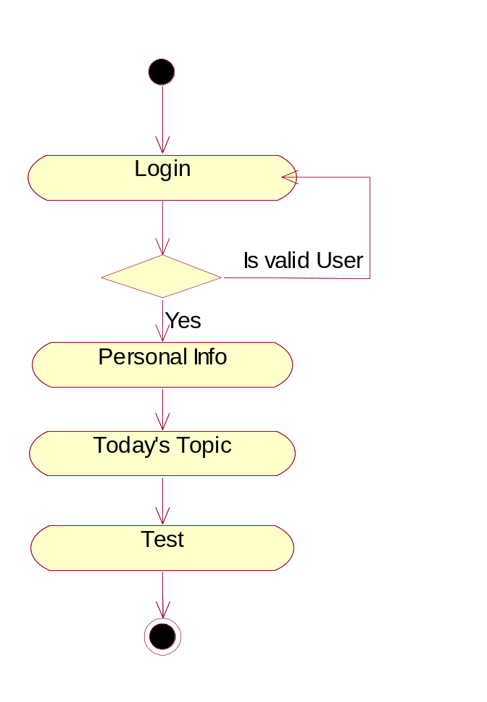

Fig5.16 Activity Diagram of User Activity

5.5 Database Design
5.5.1 Introduction
A database model is a collection of logical constructs used to represent the data in data structures and data relationships within the database. Basically, the database models may be grouped into two categories: conceptual model and implementation models. The conceptual model focuses on the logical nature of that data presentation. Therefore the conceptual model is concerned with what is representing in the database and the implementation model is concerned with how it is represented.
- Conceptual Model
The conceptual model represents data present in the entities as well the relations present is the entities. All the strong entities and weak entities are identified here and it mainly focuses on the logical nature of that data presentation.
- General Access Model

General access model is used to convert the ER model into the relation model. Here we can identify the references to the other entities and the nature of the each attribute. But, A network model’s record can have more than one parent.
- Relation Model

The relational model is represented as tables. The columns of each table are attributes that define the data or value domain for entities in that column. The rows of each table are tuples representing individual data objects being stored. A relational table should have only one primary key. A primary key is a combination of one or more attributes whose value unambiguously locates each row in the table.

5.5.2 Database Tables
Column(s) of "BAL" AttributeColumn(s) of "BAL" AttributeColumn(s) of "BAL" Attribute
Name | Is PK | Datatype
BAL | No | NUMBER(12,2)

Column(s) of "CUST_ID" AttributeColumn(s) of "CUST_ID" AttributeColumn(s) of "CUST_ID" Attribute
Name | Is PK | Datatype
CUST_ID | No | VARCHAR2(10)

Is In Index(s) of "CUST_ID" ColumnIs In Index(s) of "CUST_ID" ColumnIs In Index(s) of "CUST_ID" Column
Name | Type
XIF1CREDITCARD | IF1

Table(s) of "CREDITCARD" EntityTable(s) of "CREDITCARD" EntityTable(s) of "CREDITCARD" Entity
Name | Physical Only

Name | Is PK | Datatype
CUST_STATE | No | VARCHAR2(15)

Chapter 6
SYSTEM TESTING

TESTING
Testing Concepts
- Testing
- Testing Methodologies
- Black box Testing:
- White box Testing.
- Gray Box Testing.
- Levels of Testing
  - Unit Testing.
  - Module Testing.
  - Integration Testing.
  - System Testing.
  - User Acceptance Testing.
- Types Of Testing
  - Smoke Testing.
  - Sanitary Testing.
  - Regression Testing.
  - Re-Testing.
  - Static Testing.
  - Dynamic Testing.
  - Alpha-Testing.
  - Beta-Testing.
  - Monkey Testing.
  - Compatibility Testing.
  - Installation Testing.
  - Adhoc Testing.
  - Ext….

- TCD (Test Case Documentation)
- STLC
  - Test Planning.
  - Test Development.
  - Test Execution.
  - Result Analysis.
  - Bug-Tracing.
  - Reporting.
- Microsoft Windows – Standards
- Manual Testing
- Automation Testing (Tools)
  - Win Runner.
  - Test Director.

Testing

- The process of executing a system with the intent of finding an error.
- Testing is defined as the process in which defects are identified, isolated, subjected for rectification and ensured that product is defect free in order to produce the quality product and hence customer satisfaction.
- Quality is defined as justification of the requirements
- Defect is nothing but deviation from the requirements
- Defect is nothing but bug.
- Testing --- The presence of bugs
- Testing can demonstrate the presence of bugs, but not their absence
- Debugging and Testing is not the same thing!
- Testing is a systematic attempt to break a program or the AUT
- Debugging is the art or method of uncovering why the script /program did not execute properly.
Testing Methodologies
- Black box Testing: is the testing process in which tester can perform testing on an application without having any internal structural knowledge of application.
Usually Test Engineers are involved in the black box testing.
- White box Testing: is the testing process in which tester can perform testing on an application with having internal structural knowledge.
Usually The Developers are involved in white box testing.
- Gray Box Testing: is the process in which the combination of black box and white box techniques are used.
Levels of Testing

Module1 Module2 Module3
Units |  | Units |  | Units
i/p Integration o/p i/p Integration o/p

System Testing: Presentation + business +Databases
⓪UAT: user acceptance testing

STLC (SOFTWARE TESTING LIFE CYCLE)
Test Planning
1. TestPlan is defined as a strategic document which describes the procedure how to perform various testing on the total application in the most efficient way.
2. This document involves the scope of testing,
3. Objective of testing,
4. Areas that need to be tested,
5. Areas that should not be tested,
6. Scheduling Resource Planning,
7. Areas to be automated, various testing tools used….
Test Development: 1. Test case Development (check list)
2. Test Procedure preparation. (Description of the test cases)
Test Execution: 1. Implementation of test cases. Observing the result.

Result Analysis: 1. Expected value: is nothing but expected behavior
of application.
2. Actual value: is nothing but actual behavior of
application.
Bug Tracing: Collect all the failed cases, prepare documents.
Reporting: Prepare document (status of the application)

Types of Testing
①> Smoke Testing: is the process of initial testing in which tester looks for the availability of all the functionality of the application in order to perform detailed testing on them. (Main check is for available forms)
①> Sanity Testing: is a type of testing that is conducted on an application initially to check for the proper behavior of an application that is to check all the functionality are available before the detailed testing is conducted by on them.
①> Regression Testing: is one of the best and important testing. Regression testing is the process in which the functionality, which is already tested before, is once again tested whenever some new change is added in order to check whether the existing functionality remains same.
①>Re-Testing: is the process in which testing is performed on some functionality which is already tested before to make sure that the defects are reproducible and to rule out the environments issues if at all any defects are there.
①Static Testing: is the testing, which is performed on an application when it is not been executed.ex: GUI, Document Testing
①Dynamic Testing: is the testing which is performed on an application when it is being executed.ex: Functional testing.
①Alpha Testing: it is a type of user acceptance testing, which is conducted on an application when it is just before released to the customer.
① Beta-Testing: it is a type of UAT that is conducted on an application when it is released to the customer, when deployed in to the real time environment and being accessed by the real time users.
① Monkey Testing: is the process in which abnormal operations, beyond capacity operations are done on the application to check the stability of it in spite of the user’s abnormal behavior.
①Compatibility testing: it is the testing process in which usually the products are tested on the environments with different combinations of databases (application servers, browsers…etc) In order to check how far the product is compatible with all these environments platform combination.
①Installation Testing: it is the process of testing in which the tester try to install or try to deploy the module into the corresponding environment by following the guidelines produced in the deployment document and check whether the installation is successful or not.
①Adhoc Testing: Adhoc Testing is the process of testing in which unlike the formal testing where in test case document is used, without that test case document testing can be done of an application, to cover that testing of the future which are not covered in that test case document. Also it is intended to perform GUI testing which may involve the cosmetic issues.

TCD (Test Case Document
Test Case Document Contains
- Test Scope (or) Test objective
- Test Scenario
- Test Procedure
- Test case
This is the sample test case document for the Academic details of student project:
Test scope:
- Test coverage is provided for the screen “ Academic status entry” form of a student module of university management system application
- Areas of the application to be tested
Test Scenario:
- When the office personals use this screen for the marks entry, calculate the status details, saving the information on student’s basis and quit the form.
Test Procedure:
- The procedure for testing this screen is planned in such a way that the data entry, status calculation functionality, saving and quitting operations are tested in terms of Gui testing, Positive testing, Negative testing using the corresponding Gui test cases, Positive test cases, Negative test cases respectively
Test Cases:
- Template for Test Case

T.C.No | Description | Exp | Act | Result

Guidelines for Test Cases:
- GUI Test Cases:
- Total no of features that need to be check
- Look & Feel
- Look for Default values if at all any (date & Time, if at all any require)
- Look for spell check
Example for GUI Test cases:
T.C.No | Description | Expected value | Actual value | Result
1 | Check for all the features in the screen | The screen must contain all the features
2 | Check for the alignment of the objects as per the validations | The alignment should be in proper way

- Positive Test Cases:
- The positive flow of the functionality must be considered
- Valid inputs must be used for testing
- Must have the positive perception to verify whether the requirements are justified.
Example for Positive Test cases:

T.C.No | Description | Expected value | Actual value | Result
1 | Check for the date Time Auto Display | The date and time of the system must be displayed
2 | Enter the valid Roll no into the student roll no field | It should accept

- Negative Test Cases:
- Must have negative perception.
- Invalid inputs must be used for test.
Example for Negative Test cases:
T.C.No | Description | Expected value | Actual value | Result
1 | Try to modify The information in date and time | Modification should not be allow
2 | Enter invalid data in to the student details form, click on save | It should not accept invalid data, save should not allow

Chapter 7
Screen shots

ONLINE EVALUATOR HOME PAGE
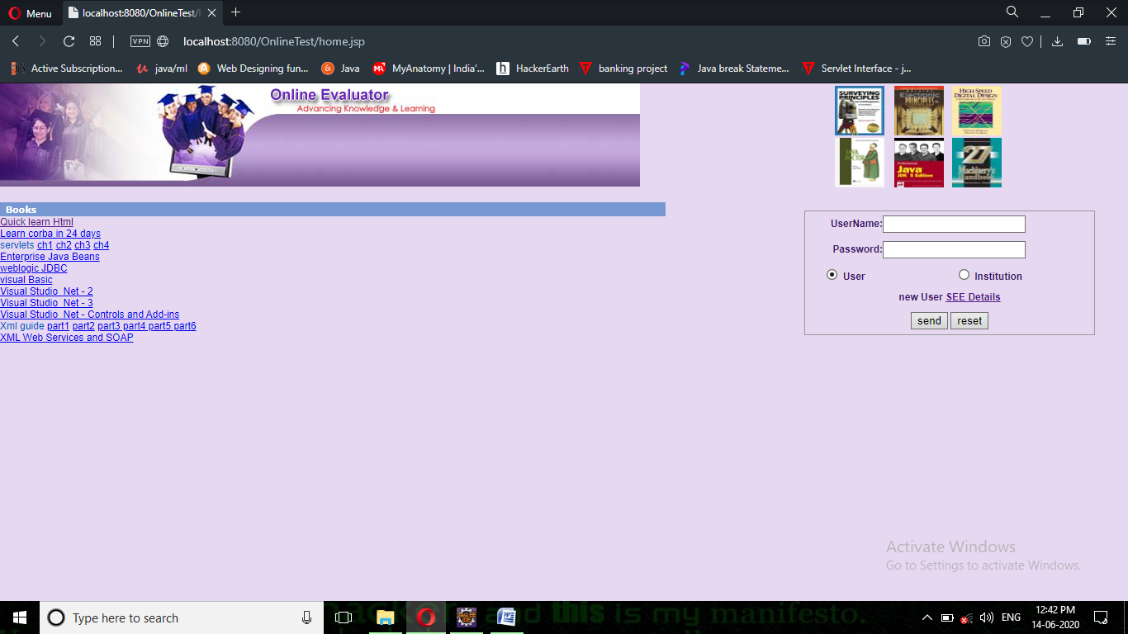
Fig7.1 ONLINE EVALUATOR HOME PAGE

ADMIN HOME PAGE

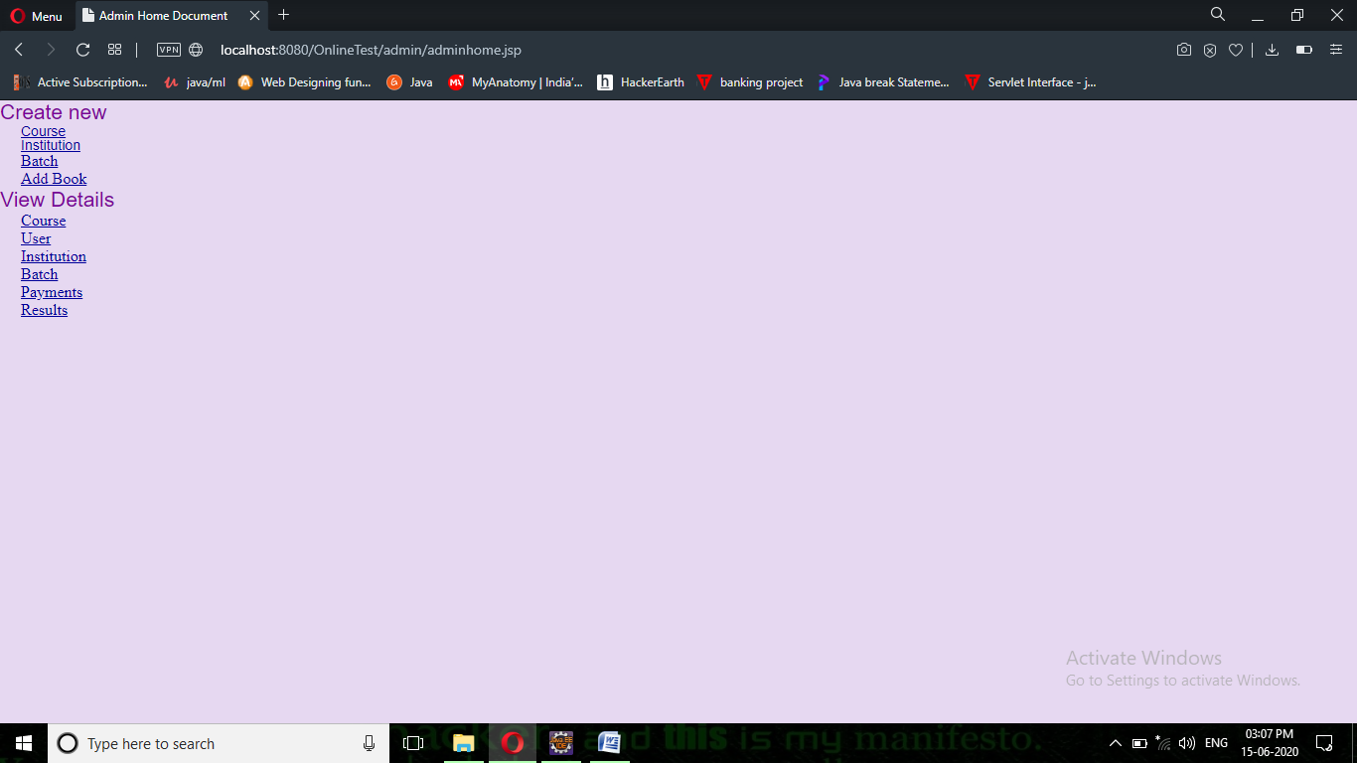

Fig7.2 ADMIN HOME PAGE

ADD NEW COURSE PAGE

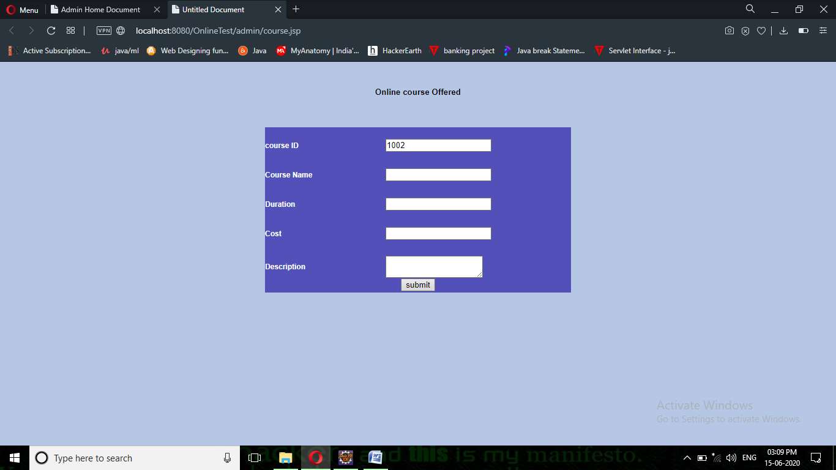

Fig7.3 ADD NEW COURSE PAGE

ADD INSTITUTION DETAILS PAGE

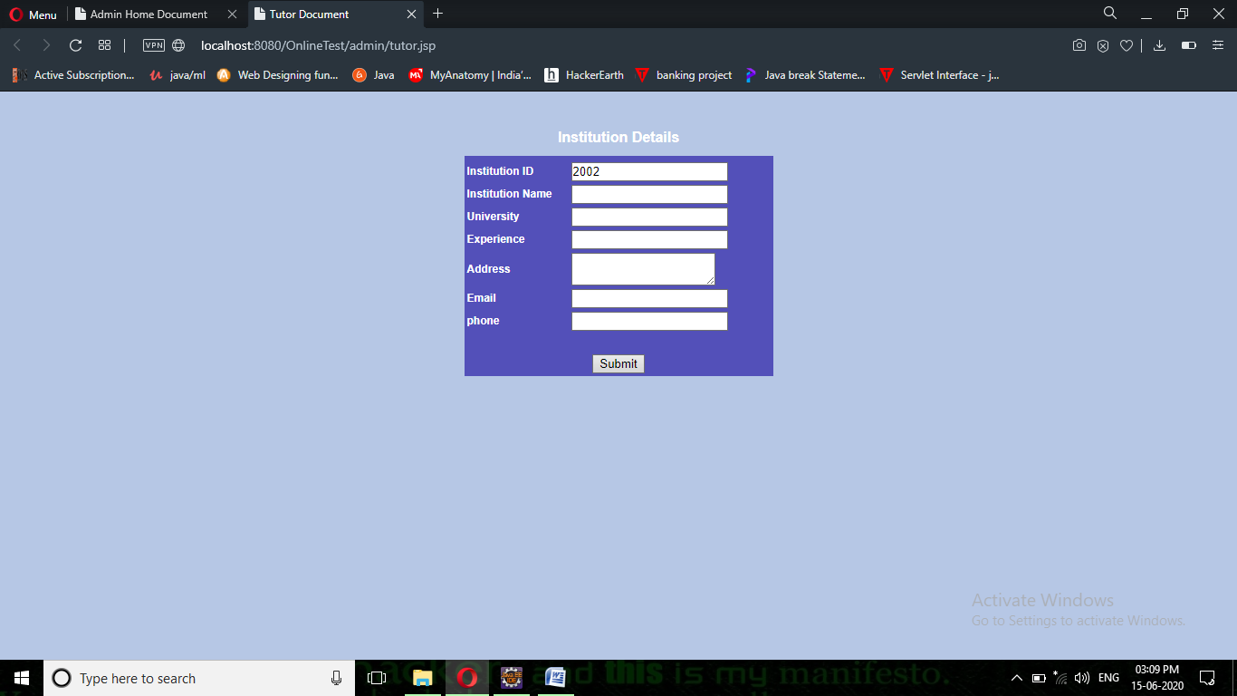
Fig7.4 ADD INSTITUTION DETAILS PAGE

ADD BATCH DETAILS PAGE

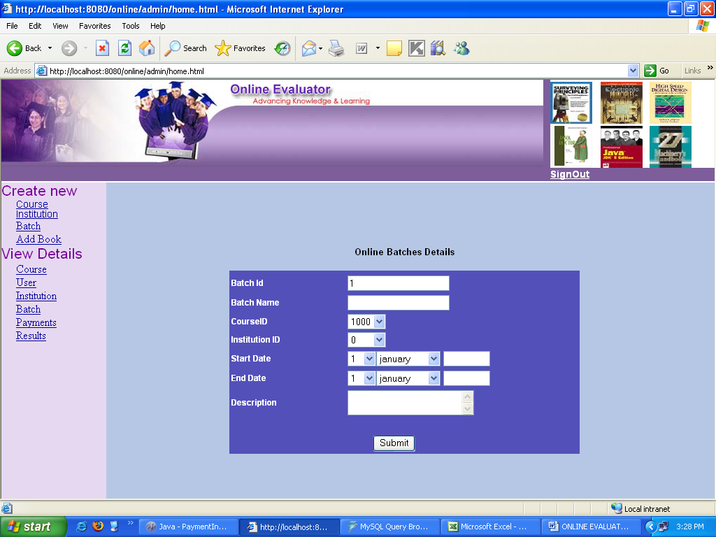

Fig7.5 ADD BATCH DETAILS PAGE

VIEW USER DETAILS PAGE

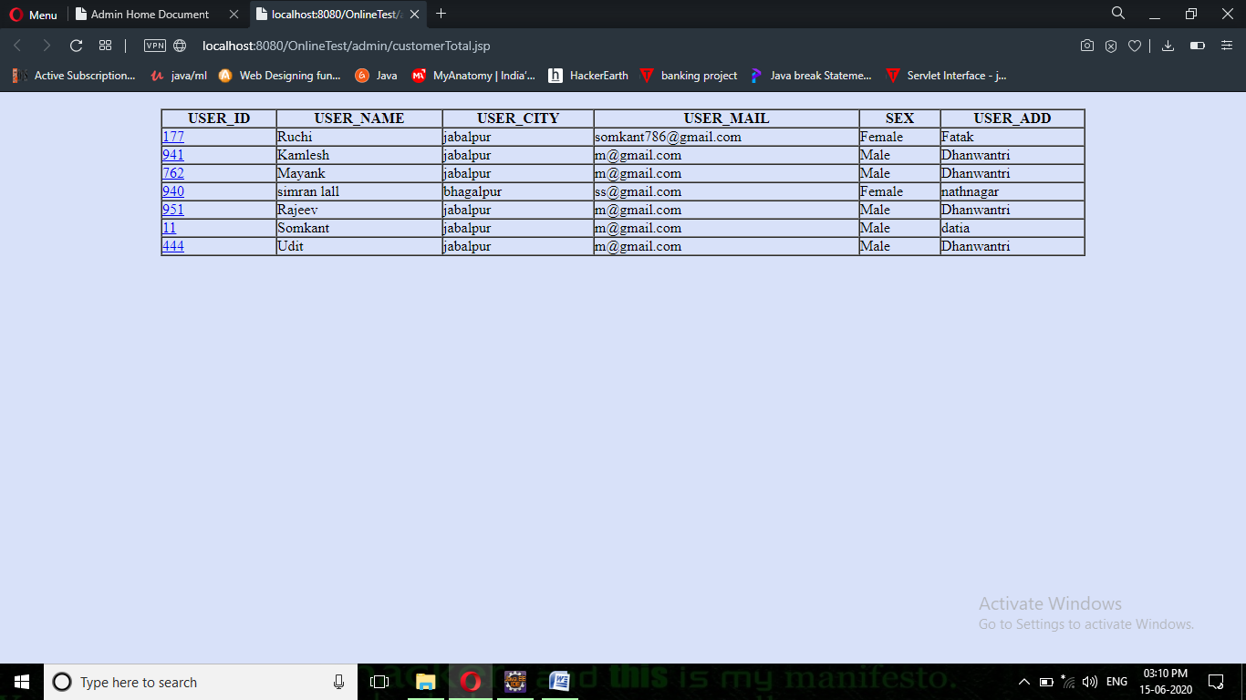

Fig7.6 VIEW USER DETAILS PAGE

VIEW INSTITUTION DETAILS PAGE

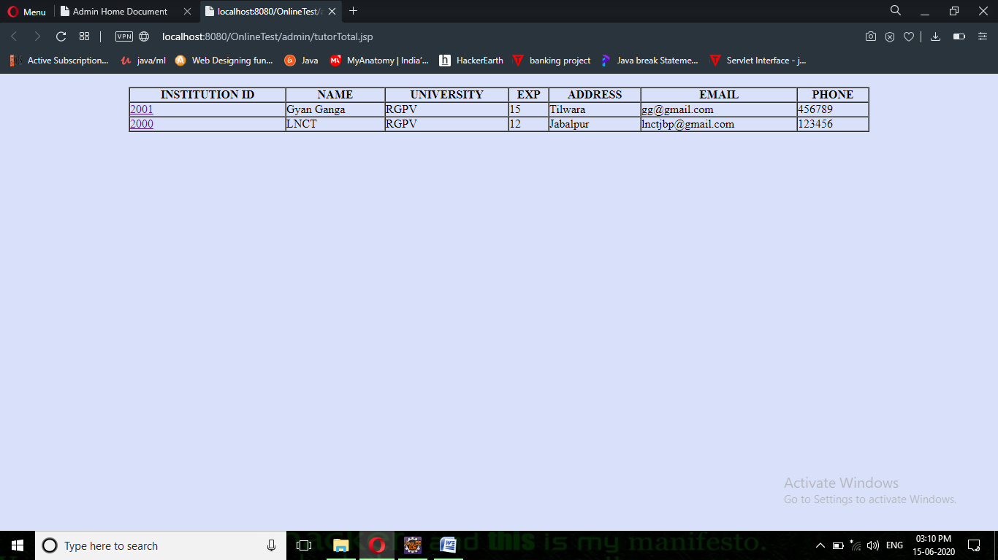

Fig7.7 VIEW INSTITUTION DETAILS PAGE

VIEW BATCH DETAILS PAGE

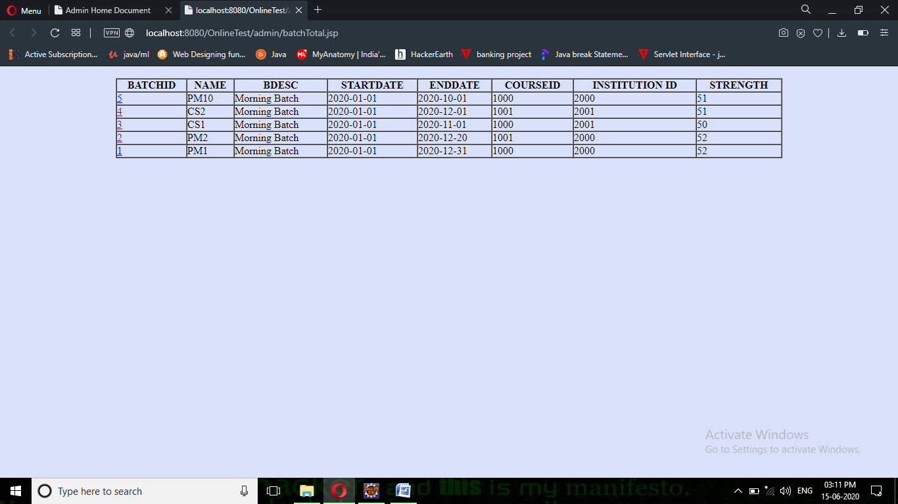
Fig7.8 VIEW BATCH DETAILS PAGE

ONLINE PAYMENT DETAILS PAGE

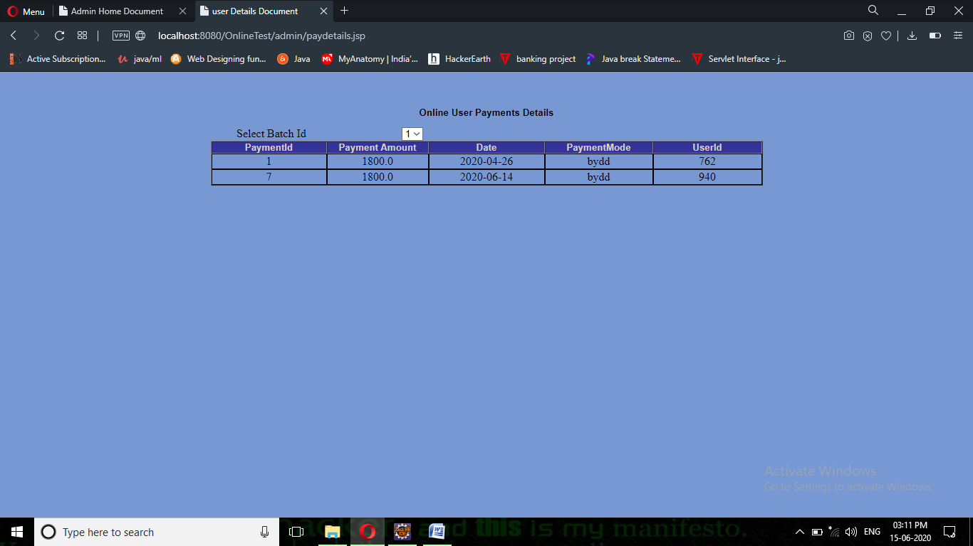
Fig7.9ONLINE PAYMENT DETAILS PAGE

USER HOME PAGE

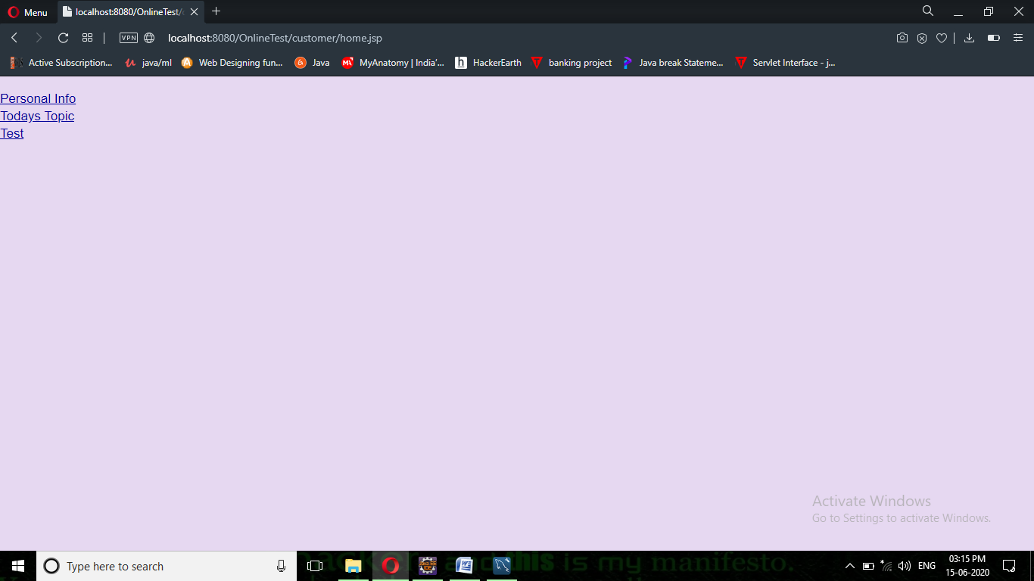
Fig7.10 USER HOME PAGE

VIEW TODAY’S TOPICS PAGE

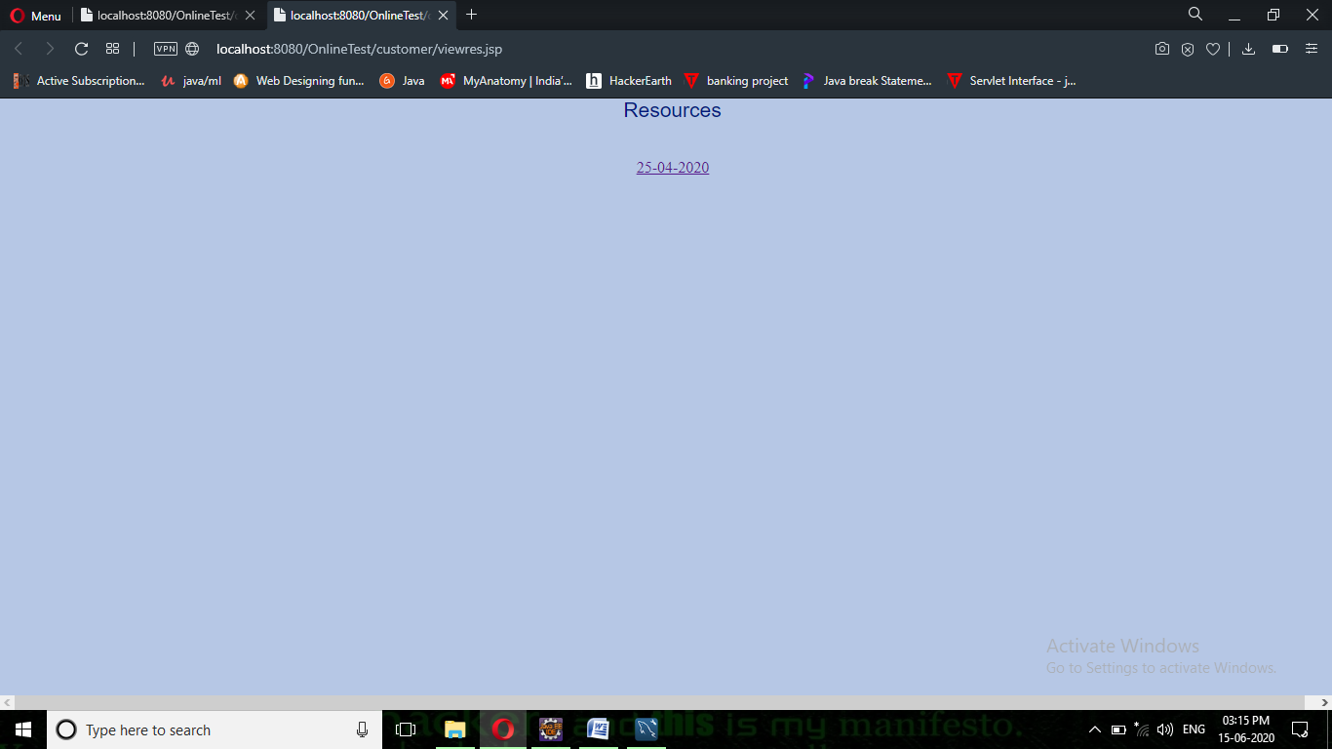
Fig7.11 VIEW TODAY’S TOPICS PAGE

TEST FORM PAGE

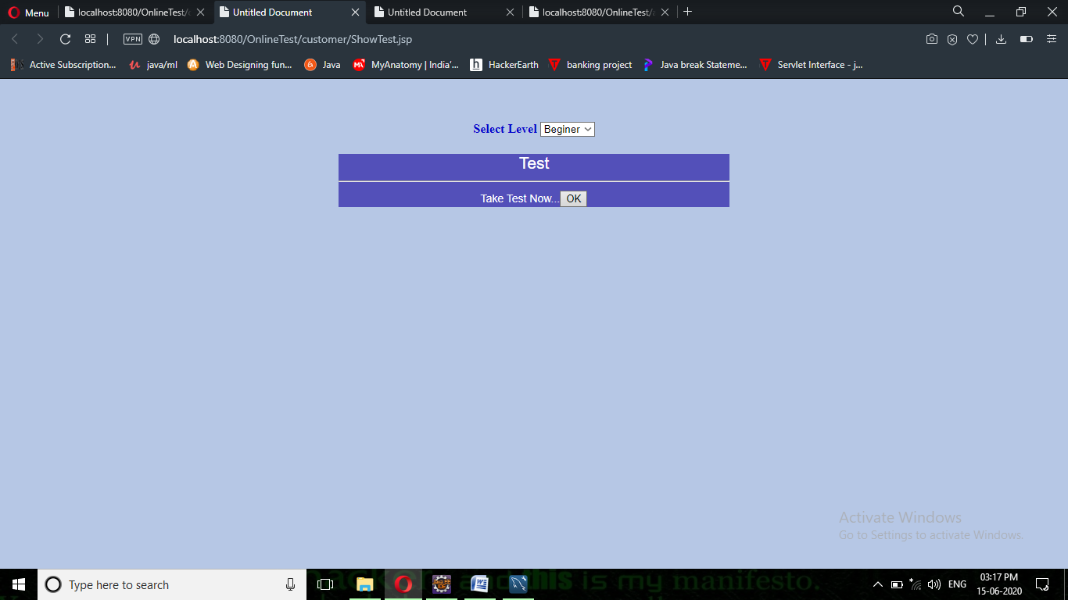
Fig7.12 TEST FORM PAGE

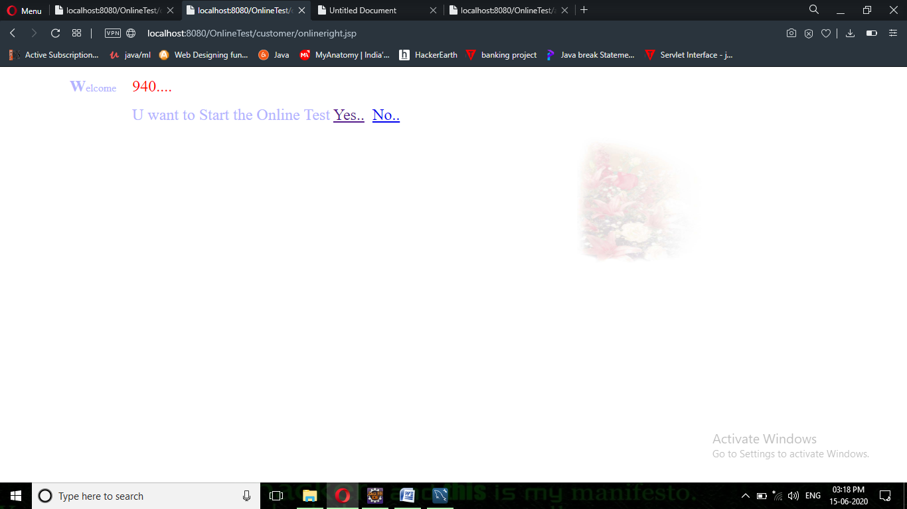

When u press Ok this page will be displayed

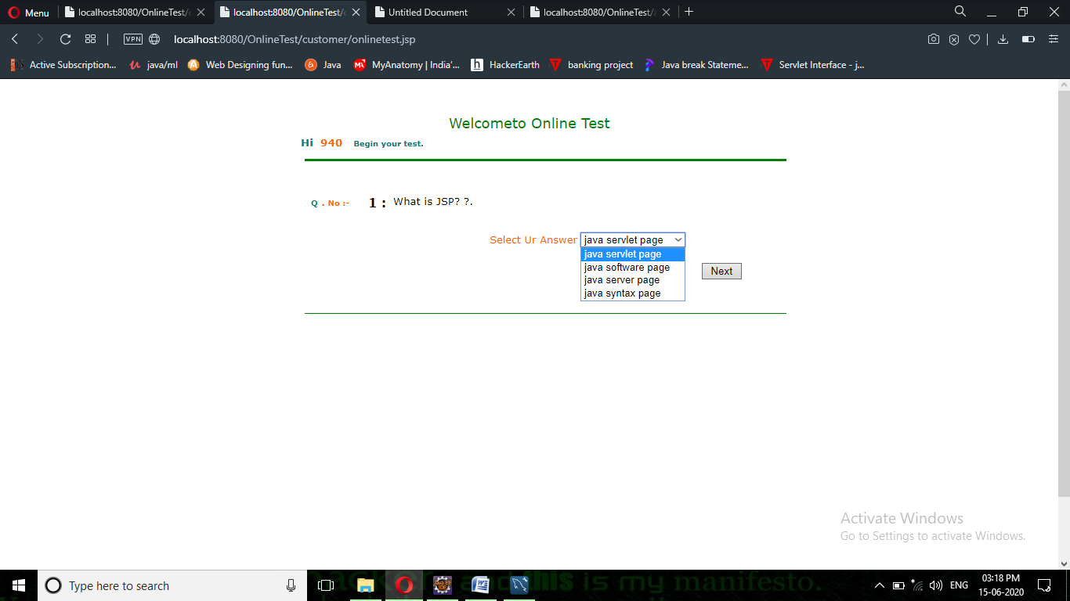

When u click on yes link test will start

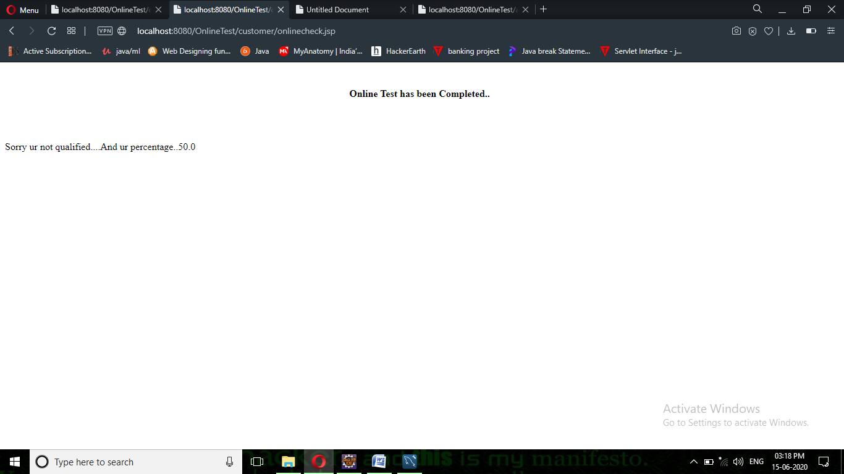

When test is over this page will be displayed with some message in it.

ADD QUESTIONS PAGE

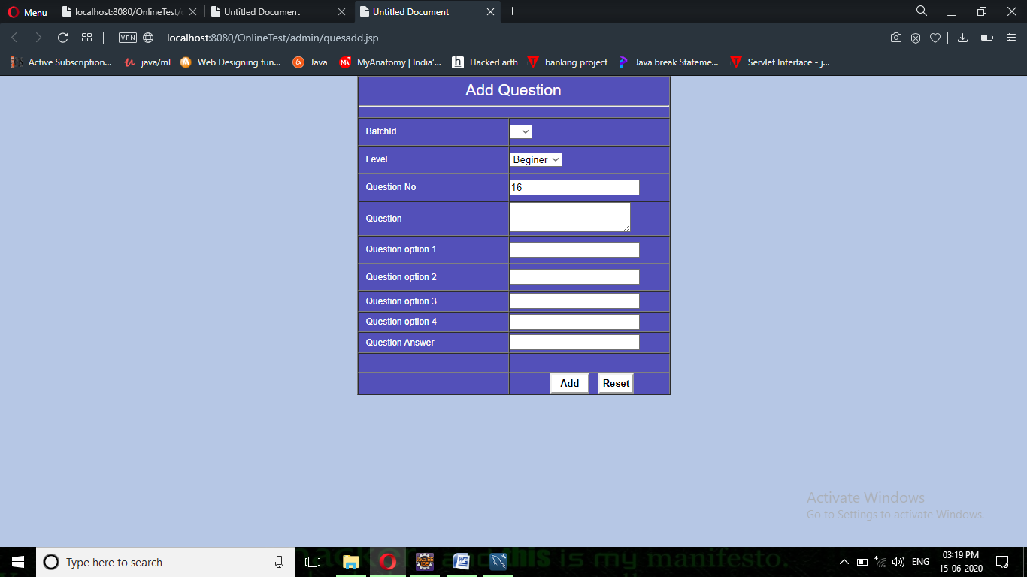

Fig7.13 ADD QUESTIONS PAGE

VIEW RESULTS PAGE

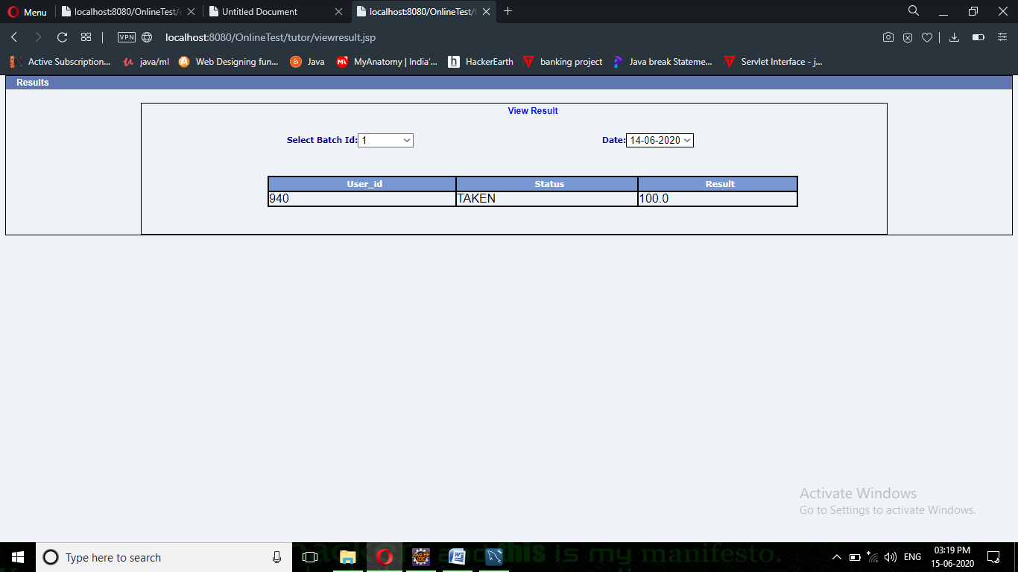

Fig7.14 VIEW RESULTS PAGE

Chapter 8

CONCLUSION
The system’s capability is to keep track of all the information and generate the reports as its main feature, which helps the management to know the current position of the organization activities by just glancing through system, generated details.
The system has been developed considering every single quality factor. Due to this reason the system is highly secure from the crash down problem. Moreover, the system is highly reliable and due to the security and integrity features, provides for the system, unauthorized users cannot access the system.

Chapter 9
FUTURE ENHANCEMENTS
1. It has to be converted into Network Based Application.
2. Student Registration from has to be created.
3. Database base has to be used for storing the exam, student, exam status, examiner details.

Chapter 10
References

These are the following links that assist me at each and every step in completing this project,wthout them I was not be able to finish this project :-

- www.javatutorialspoint.com
- www.wikipedia.com
- www.stackoverflow.com
- www.javatpoint.com
- www.geeksforgeeks.com
- www.youtube.com

