
School of Computer Applications
Master of Computer Applications (MCA)
CAP455 – Object Oriented Programming using C++
Minor Project | Session 2026–27
PROJECT REPORT – CA1
Phase 1: Design & Create
Community Book Exchange Coordinator
Item | Details
Student Name | Mayank Singh
Roll Number | RD1P2635B66
Registration Number | 12612197
Section / Group | D1P2635
Faculty (Project Guide) | Adarsh Kumar Singh
Date of Allocation | 30/10/2026
Date of Submission | 06/11/2026
Submission File Name | RD1P2635B66_CAP455_CA1_CommunityBookExchangeCoordinator
Git Repository Link | https://github.com/MayankSingh-2002/Community-Book-Exchange-Coordinator.git

Declaration and Academic Integrity Statement
I hereby declare that this report and the accompanying C++ source code titled “Community Book Exchange Coordinator” (CA1 – Design & Create) are my own individual work, submitted for the course CAP455 – Object Oriented Programming using C++ at Lovely Professional University. I am able to explain and modify every line of the submitted code.
In line with the academic-integrity policy of the Minor Project guide, I disclose that books, online documentation were used only for learning, clarification and for assistance in preparing the diagrams, test evidence and the formatting of this report. No code or text has been copied from peers or online sources.

Date: 06/11/2026 Signature: Mayank Singh
Name: Mayank Singh
Roll No.: RD1P2635B66

Table of Contents
Declaration and Academic Integrity Statement 2
1. Introduction 3
2. Problem Statement and Project Proposal 3
3. System Design 4
4. Mapping of OOP Concepts to the Code (Units I–II) 8
5. Implementation Details 9
6. Testing and Results 10
7. Build Instructions, Repository and Submission 14
8. Conclusion and Future Scope 14

1. Introduction

1.1 Background
Residents of housing societies, hostels and neighbourhoods often own books they have already read and would happily pass on, while others would like to pick up a book without buying it. A shared shelf or kiosk placed in a common area solves the physical side of this exchange, but someone still has to keep track of what has been deposited, who deposited it, where it is kept, and what condition it is in. Without a record, shelves become disorganised, duplicate donations pile up and residents cannot find the titles they want.
The Community Book Exchange Coordinator is a console application written in C++ that acts as the digital register for such a shared shelf. Every deposited book is modelled as a BookListing object with a unique listing ID, and a coordinator object manages the collection of listings.

1.2 Objectives of CA1
The first phase (CA1 – Design & Create) focuses on the design of the system and on the in-memory Create and Read operations. As defined in the Minor Project Quick Guide, CA1 must demonstrate:
- An entity class using static members, inline functions and a friend function.
- An array of objects, pointers, the this pointer and std::string handling.
- In-memory Create and Read operations with input validation and rejection of duplicate keys.
- Documentation: a proposal, data dictionary, UML diagram and flowcharts, followed by a demonstration and viva.

2. Problem Statement and Project Proposal

2.1 Problem Statement
Community shelves rely on goodwill and memory. There is no reliable way to know which books are available, who donated them, in which kiosk or shelf they are placed, and whether they are fit to be handed to the next reader. Duplicate deposits of the same title by the same person, mistyped IDs and inconsistent data make manual registers unreliable. The project provides a small, validated, object-oriented register that records each deposited book exactly once and lets volunteers and residents search it quickly.

2.2 Proposal Summary (as required by the guide)
Proposal Element | Description
Problem | Keeping an accurate, searchable register of books deposited on a community shelf or kiosk.
Entities | BookListing (a deposited book), Donor / Resident (stored as an attribute of the listing), Kiosk / Shelf location (stored as an attribute), Coordinator (the manager of all listings).
Main class | BookListing – entity class, supported by the manager class ExchangeCoordinator.
Unique key | listingId (integer, 1 to 99999). Two listings can never share the same ID.
Secondary rule | The same donor cannot deposit the same title twice (case-insensitive check).
Users | Residents / donors who deposit and look up books; the coordinator (volunteer) who runs the register.
Storage in CA1 | In-memory array of 50 BookListing objects (no files yet).

2.3 How this Project Differs from a Library System
The guide does not allow library, hospital or IPL-type systems. This project is a donation-and-pickup shelf: there is no membership, no issue / return cycle, no due dates and no fines. A book is simply deposited by a resident, tracked by listing ID, and later picked up by anyone. The data model, rules and audit logic are therefore those of a community kiosk register, not of a lending library.

2.4 Functional Requirements
ID | Requirement
FR1 | Register a new book with ID, title, author, genre, donor name, kiosk location and condition grade (1–5).
FR2 | Reject a listing whose ID already exists (duplicate primary key).
FR3 | Reject a deposit of the same title by the same donor, ignoring upper / lower case.
FR4 | Validate every input; re-prompt until the value is valid.
FR5 | Display all registered books as readable cards.
FR6 | Search a book by listing ID and run a quality audit on the match.
FR7 | Search books by full or partial title, ignoring case.
FR8 | List all books deposited by one resident.
FR9 | Show the total number of active listings using a static member.
FR10 | Refuse new registrations when the 50-book capacity is reached.

3. System Design

3.1 Architecture Overview
The program has three layers. The helper layer (free functions) performs string handling and safe input. The entity layer (BookListing) holds the data of one book and its behaviour. The manager layer (ExchangeCoordinator) owns the array of BookListing objects and implements the Create and Read use cases. main() only shows the menu and dispatches to the coordinator.

3.2 Data Dictionary
Table 3.1 describes every data member of the entity class. All members are private (encapsulation) and are reached only through member functions.
Table 3.1: Data dictionary – class BookListing
Attribute | Type | Access | Constraint / Range | Description and example
listingId | int | private | Unique key; 1 – 99999; 0 = unset | Identifies the listing. e.g. 101
title | string | private | Trimmed; min 2 characters | Book title. e.g. The Alchemist
author | string | private | Trimmed; min 1 character | Author name. e.g. Paulo Coelho
genre | string | private | Trimmed; min 1 character | Category. e.g. Fiction
donorResident | string | private | Trimmed; min 1 character | Resident who deposited the book. e.g. Rahul Sharma
dropLocation | string | private | Trimmed; min 1 character | Kiosk / shelf location. e.g. North-Wing-Shelf-A
conditionGrade | int | private | 1 – 5 (1 Poor … 5 Like New) | Physical condition. e.g. 4
isAvailable | bool | private | true after registration | Available for pickup (true) or claimed (false).
activeListingsCount | static int | private | ≥ 0; one copy for the class | Number of listings created so far; shared by all objects.

Table 3.2: Data dictionary – class ExchangeCoordinator and constants
Name | Type | Access | Description
registry | BookListing[50] | private | Array of objects; slots 0 … currentCount-1 are in use.
currentCount | int | private | Number of books stored; also the index of the next free slot (0 – 50).
MAX_CAPACITY | const int = 50 | global | Size of the array of objects.

3.3 UML Class Diagram
Figure 3.1 shows the classes, their members and the relationships. ExchangeCoordinator is composed of up to 50 BookListing objects (composition, multiplicity 0..50). The free function inspectListingIntegrity is a friend of BookListing and therefore may read its private members. Static members are underlined and inline / const functions are annotated.
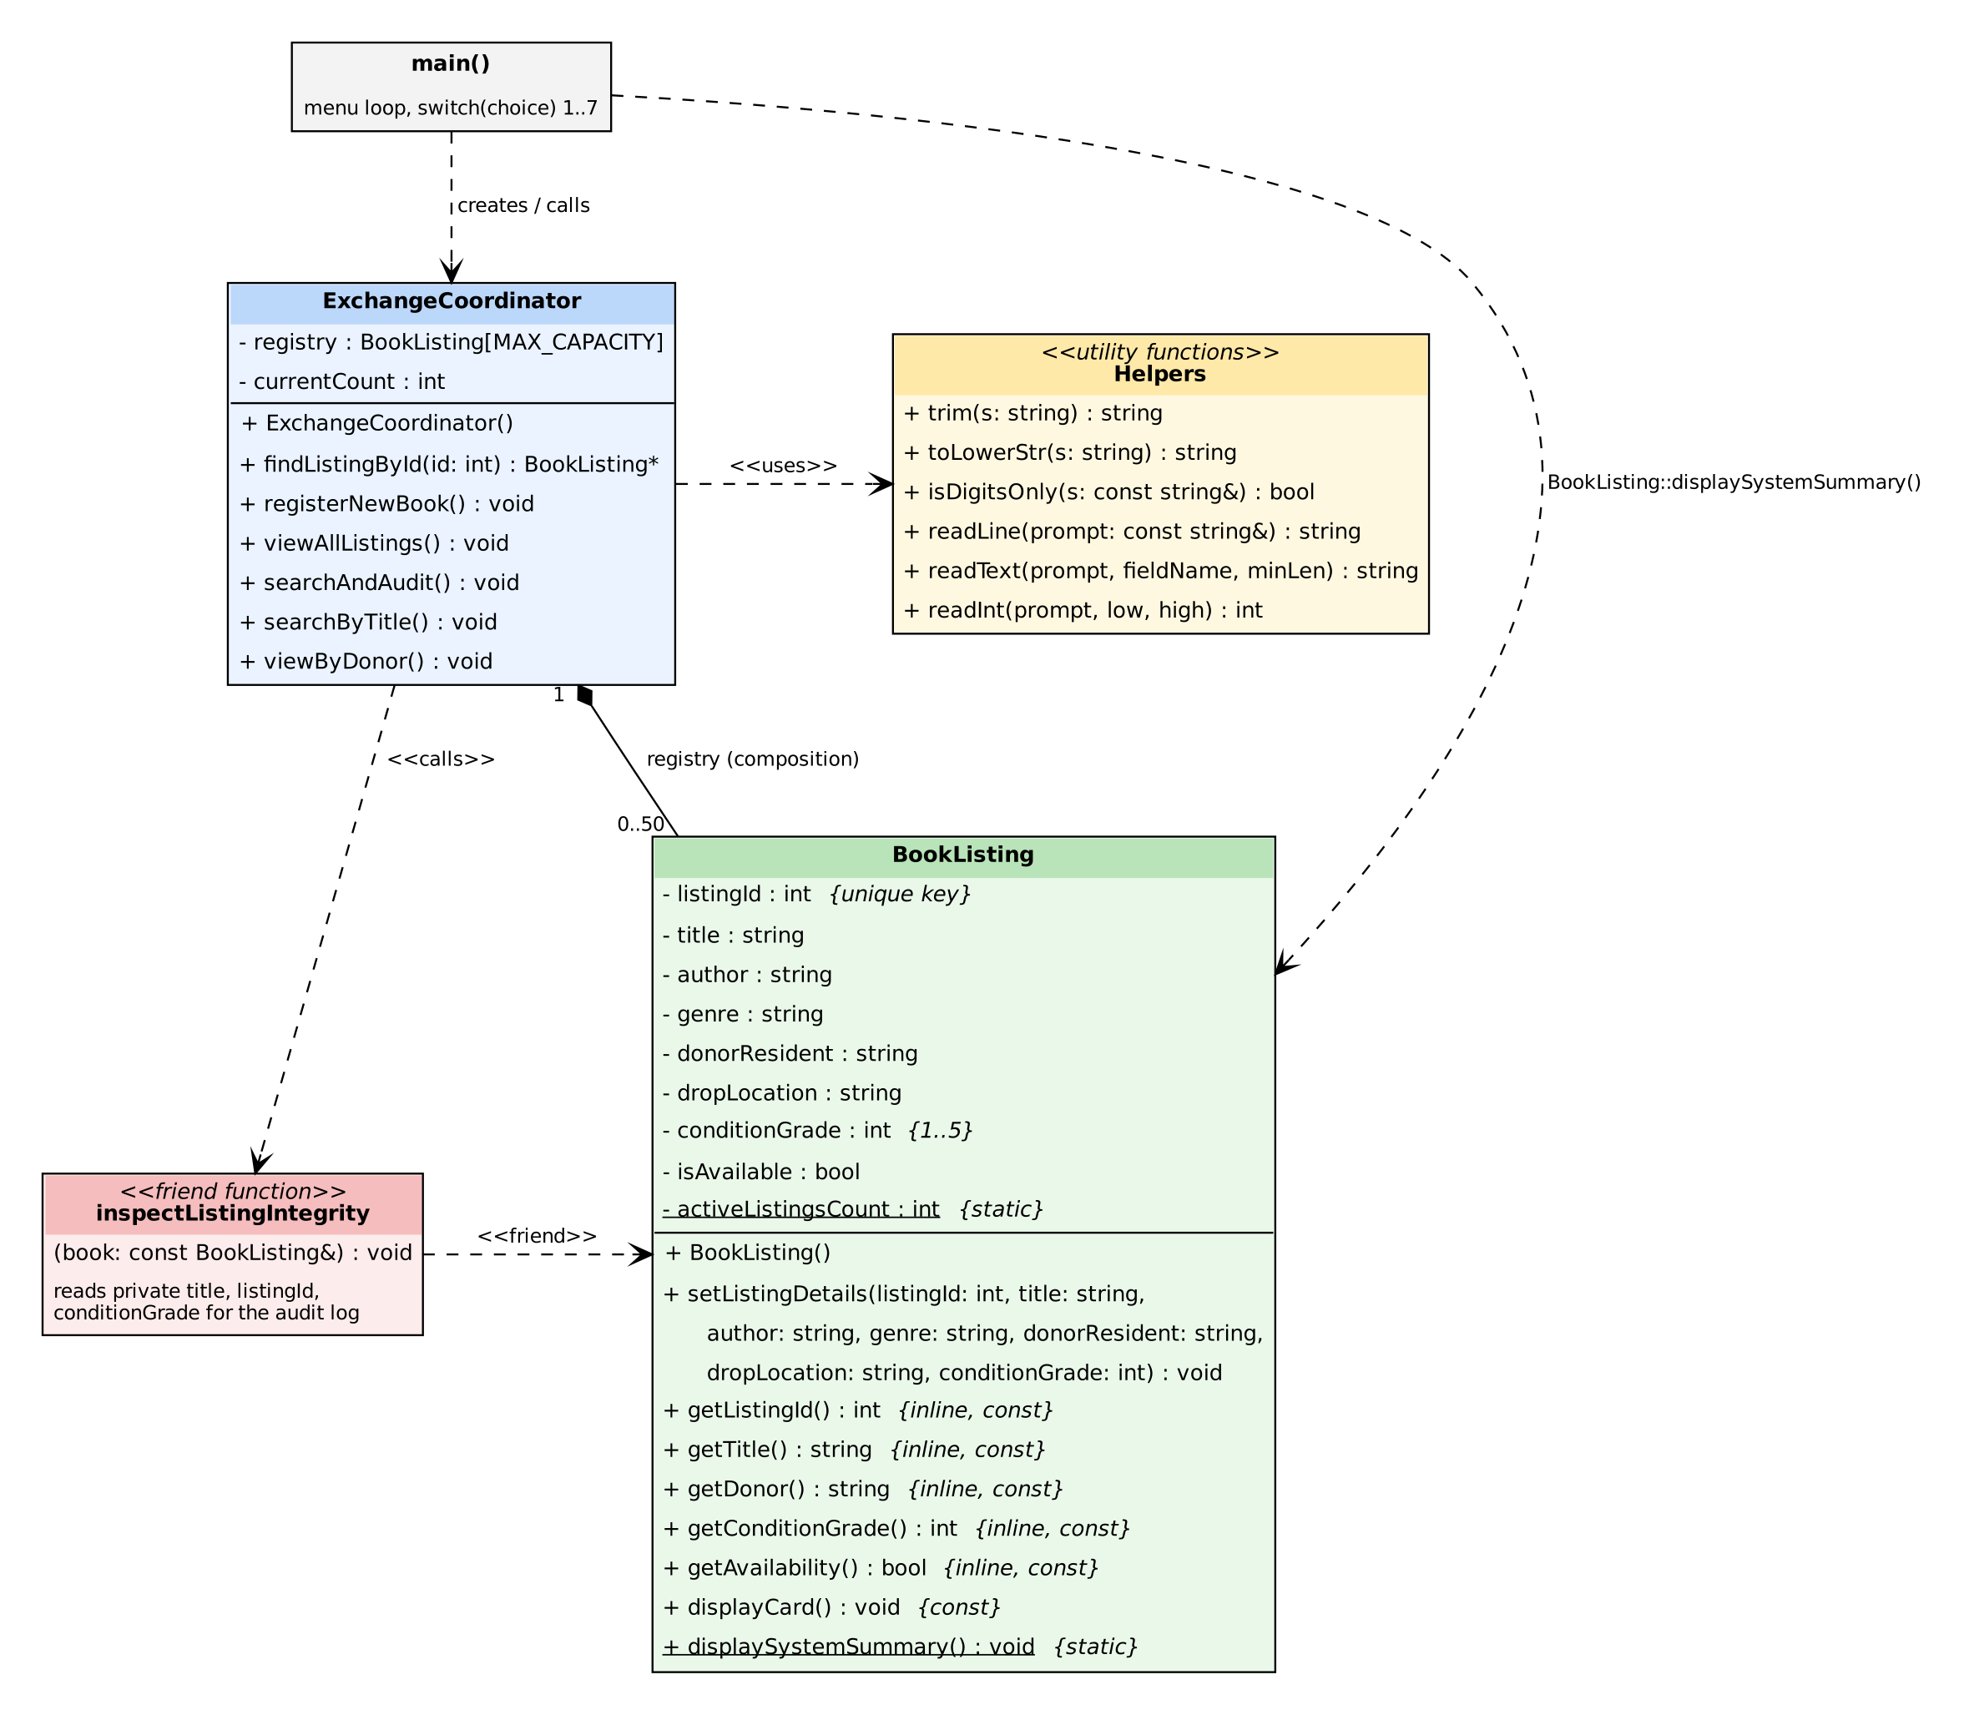
Figure 3.1: UML class diagram of the Community Book Exchange Coordinator

3.4 Use-Case Diagram
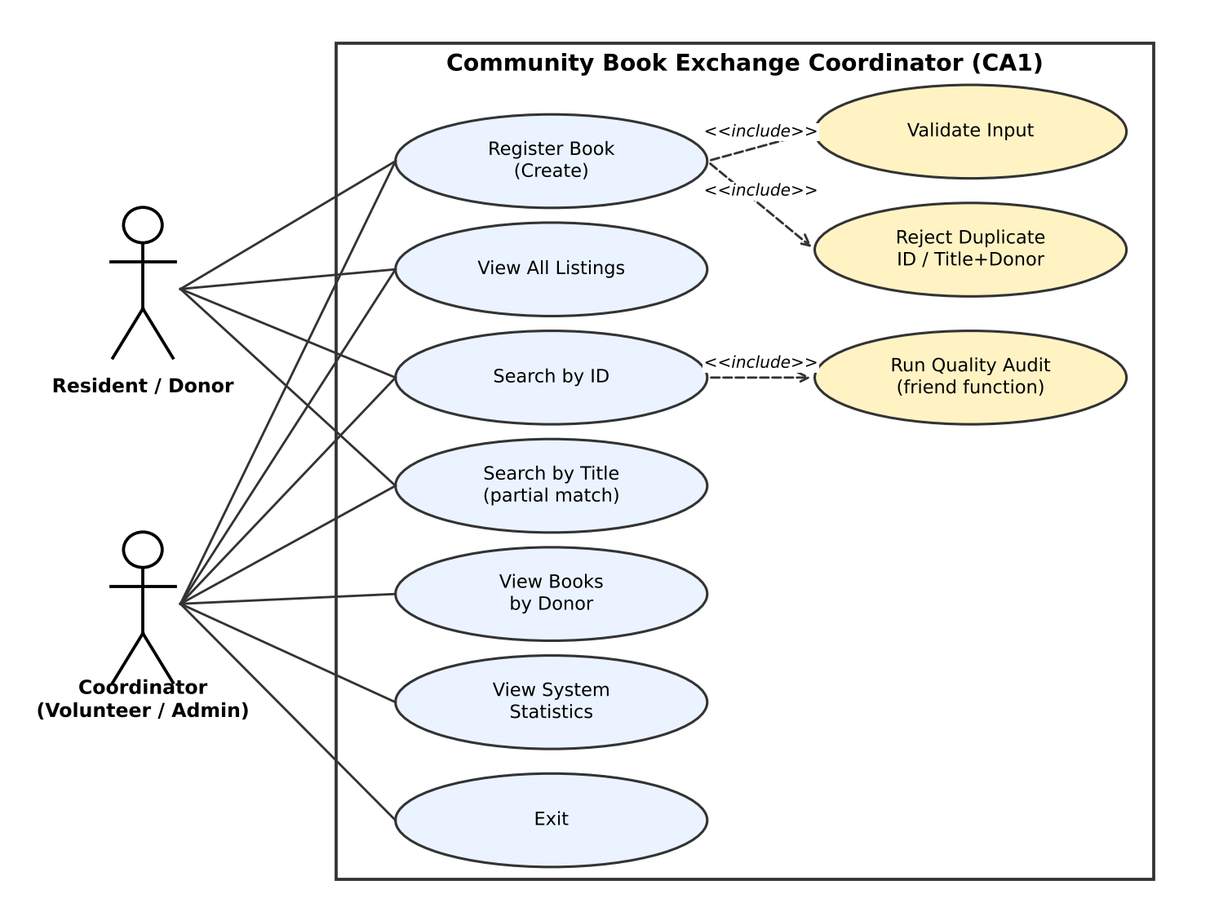
Figure 3.2: Use-case diagram

3.5 Memory Layout – Array of Objects and Pointers
The coordinator stores its listings in a fixed array. A pointer of type BookListing* is set to the start of the array and advanced with ptr++ (pointer arithmetic) in every search and display loop. The address of the next free slot is obtained with &registry[currentCount]. The static counter is stored once, outside the objects.
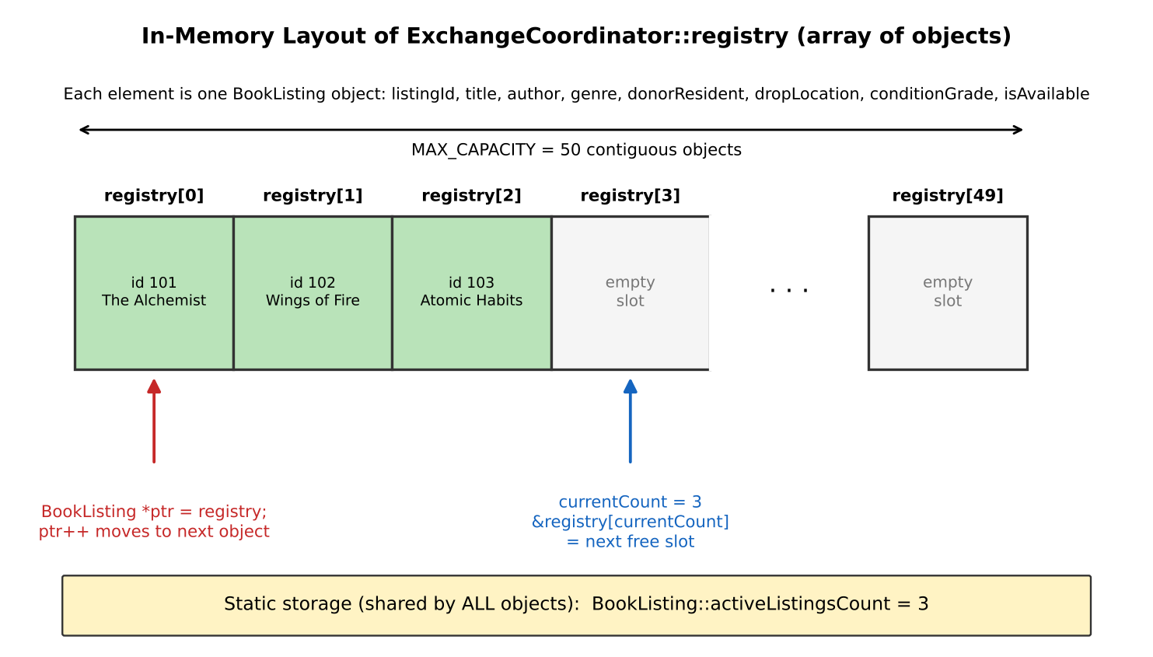
Figure 3.3: Array of objects, pointer traversal and static member

3.6 Flowcharts
Two flowcharts describe the most important algorithms: the main program loop (Figure 3.4) and the Create operation with validation and duplicate checks (Figure 3.5).
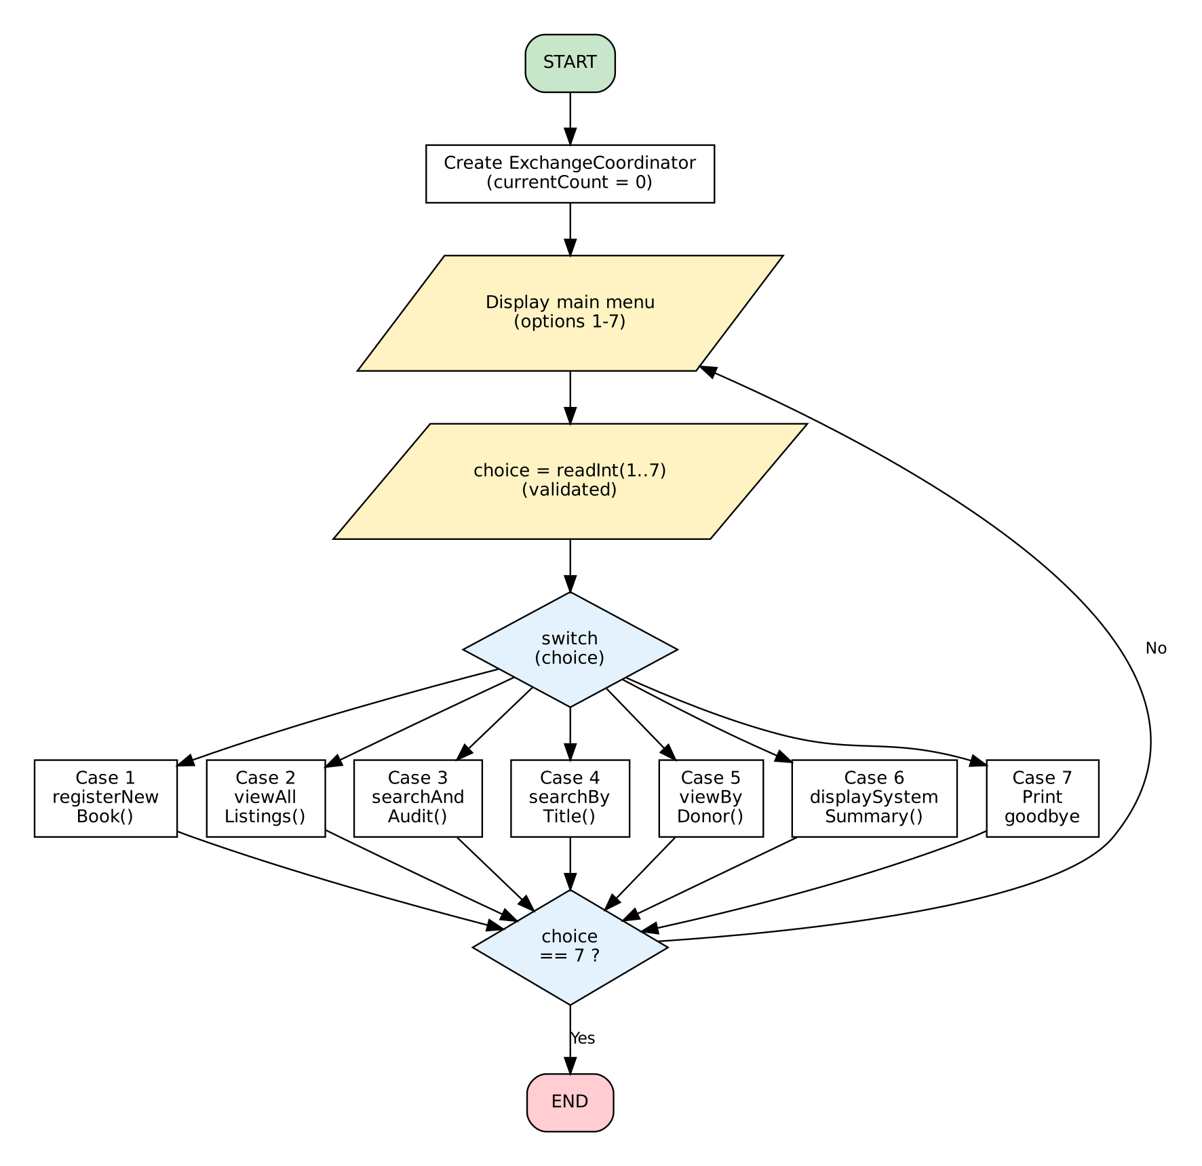
Figure 3.4: Flowchart – main program and menu loop
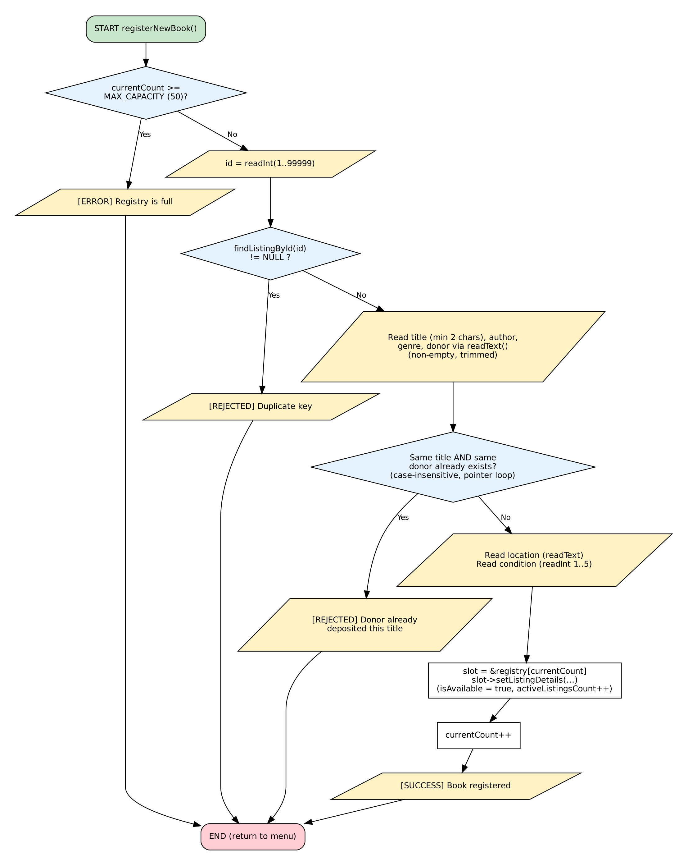
Figure 3.5: Flowchart – registerNewBook() (Create with validation and duplicate checks)

4. Mapping of OOP Concepts to the Code
The following table links each concept required by the CA1 guide to its exact location in the source code.
Concept | Where used | Purpose / Explanation
Class, object, encapsulation | class BookListing (private data, public functions) | Data is hidden; outside code can only use the public interface.
Default constructor | BookListing(); ExchangeCoordinator() | Sets every member to a safe initial value (0, "", false) and currentCount to 0.
Static data member | static int activeListingsCount | One shared counter for all objects; defined once outside the class and incremented in setListingDetails().
Static member function | BookListing::displaySystemSummary() | Called with the class name, without any object (menu option 6).
Inline functions | getListingId(), getTitle(), getDonor(), getConditionGrade(), getAvailability() | Short getters defined inside the class with the inline keyword; also const-qualified.
Friend function | inspectListingIntegrity(const BookListing&) | Non-member function allowed to read private title, listingId and conditionGrade for the audit log.
Forward declaration | class BookListing; and the friend prototype before the class | Lets the friend function be declared before the class is fully defined.
this pointer | setListingDetails(int listingId, string title, …) | Parameter names equal member names, so this->listingId = listingId removes the ambiguity.
Array of objects | BookListing registry[MAX_CAPACITY] | Fixed-size container for up to 50 listings.
Pointers and pointer arithmetic | BookListing *ptr = registry; ptr++; return NULL; &registry[currentCount] | Used in findListingById(), all display / search loops and when storing a new object.
std::string | trim, toLowerStr, searches, comparisons | Uses find, find_first_not_of, find_last_not_of, erase, length, empty, npos and ==.
const correctness | const getters, displayCard() const, const string&, const BookListing& | Prevents accidental modification and avoids copying.
Safe input handling | readLine, readText, readInt | getline-only input; no cin >> mixing, so the buffer never needs clearing; EOF handled with exit(0).

5. Implementation Details

5.1 Validation Rules
Input | Rule | Message shown on failure
Menu choice | Whole number 1 – 7 | [ERROR] Enter a whole number between 1 and 7.
Listing ID | Digits only, 1 – 99999, not already used | [ERROR] Enter a whole number between 1 and 99999. / [REJECTED] Duplicate key: Listing ID n already exists!
Title | Not empty, at least 2 characters | [ERROR] Title cannot be empty. / must be at least 2 characters.
Author, genre, donor, location | Not empty after trimming | [ERROR] <Field> cannot be empty.
Donor + title | Combination must be new (case-insensitive) | [REJECTED] <donor> has already deposited "<title>" (Listing ID n).
Condition grade | Whole number 1 – 5 | [ERROR] Enter a whole number between 1 and 5.
Capacity | currentCount < 50 | [ERROR] Registry is full. Cannot add more books.

5.2 Important Design Decisions
- getline-only input: mixing cin >> and getline() leaves a newline in the buffer. Reading every value as a line and converting it ourselves removes that problem completely.
- Order of checks in Create: the ID is checked first, so a duplicate key is rejected before the user types the remaining fields.
- Two uniqueness rules: the primary key (listingId) must be unique, and a donor may not deposit the same title twice, which prevents accidental double entry.
- Array instead of vector: CA1 requires a plain array of objects with pointers. STL containers are introduced in CA4.
- Coordinator owns the array: main() stays small, and the registry is private so it cannot be modified from outside.
- Time complexity: every search is a linear scan, O(n) with n ≤ 50, which is more than fast enough.

5.3 Known Limitations of CA1
- Data exists only in memory and is lost when the program exits (file persistence is the goal of CA2).
- Update and Delete are not available yet (planned for CA3).
- Capacity is fixed at 50 listings.
- Case conversion handles English letters A–Z only.
- activeListingsCount increases every time setListingDetails() is called; because CA1 has no delete, it always equals the number of stored books.

6. Testing and Results

6.1 Test Strategy
The final source file was compiled with g++ and tested with normal, invalid and boundary inputs. Every result in this chapter was produced by running the compiled program; the screenshots are the actual console output.

6.2 Test Case Table
ID | Category | Input / Action | Expected and actual result | Status
T01 | Normal | Register ID 101 “The Alchemist”, valid data | [SUCCESS] Book registered with ID: 101 | Pass
T02 | Normal | Register 3 books, then View all | 3 cards shown; “Total books shown: 3” | Pass
T03 | Normal | Search ID 101 | [MATCH FOUND] card + audit: Premium (grade 4) | Pass
T04 | Normal | Search title “habit” | Atomic Habits found; “Matches found: 1” (partial, case-insensitive) | Pass
T05 | Normal | View donor “rahul sharma” | Two books (101, 103); “Books deposited: 2” | Pass
T06 | Normal | System statistics after 3 books | activeListingsCount = 3 | Pass
T07 | Invalid | Menu: abc, 9, blank | [ERROR] re-prompt each time, no crash | Pass
T08 | Invalid | ID: 0, abc, 100000 | [ERROR] Enter a whole number between 1 and 99999 | Pass
T09 | Invalid | Register ID 101 again | [REJECTED] Duplicate key | Pass
T10 | Invalid | Title “X” (1 character) | [ERROR] Title must be at least 2 characters | Pass
T11 | Invalid | Empty author | [ERROR] Author cannot be empty | Pass
T12 | Invalid | Condition 6, then 0 | [ERROR] Enter a whole number between 1 and 5 | Pass
T13 | Invalid | Same title and donor in different case | [REJECTED] donor already deposited this title (Listing ID 101) | Pass
T14 | Invalid | Search ID 555 / donor “nobody” / title “zzz” | [NOT FOUND] messages | Pass
T15 | Boundary | ID 1 and ID 99999 | Both accepted and stored | Pass
T16 | Boundary | Condition 1 and 5, run audit | Grade 1: Flagged for Repair; grade 5: Premium | Pass
T17 | Boundary | Title with exactly 2 characters | Accepted | Pass
T18 | Boundary | Register 50 books, then a 51st | [ERROR] Registry is full; statistics show 50 | Pass
T19 | Empty | Options 2–5 on empty registry; statistics | [INFO] messages; statistics 0 | Pass
T20 | Input end | Ctrl+Z / Ctrl+D at a prompt | [INFO] Input ended; program exits, no infinite loop | Pass

6.3 Screenshots of Program Output
Figures 6.1 to 6.4 show selected console output covering Create, Read, audit, validation and the capacity limit. Repeated main-menu blocks are shortened to “[ ... main menu displayed again ... ]”. The complete set of screenshots for all 20 test cases is kept in the /tests folder of the repository.

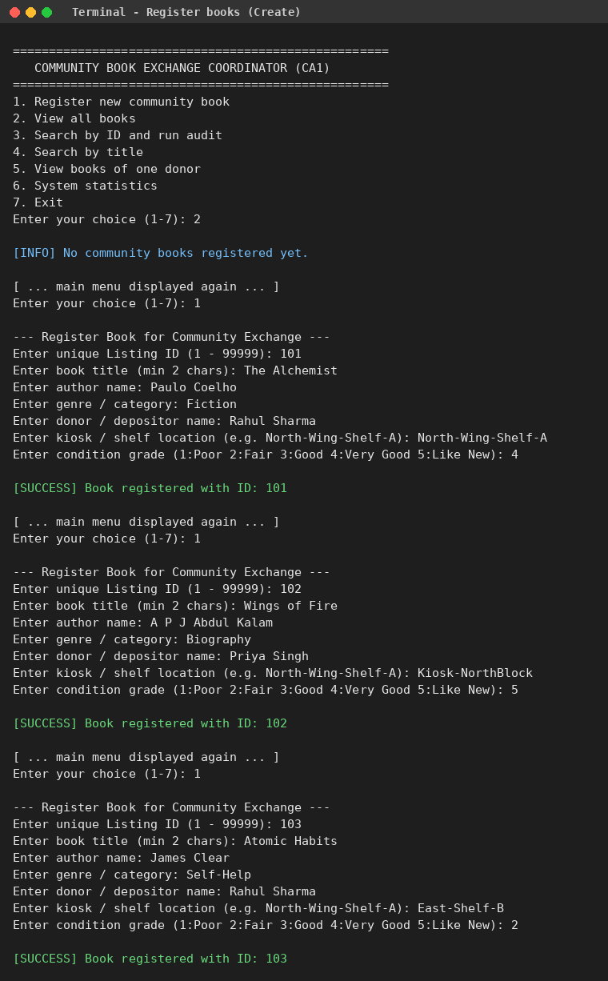
Figure 6.1: Menu and registration of books (Create) – T01, T02

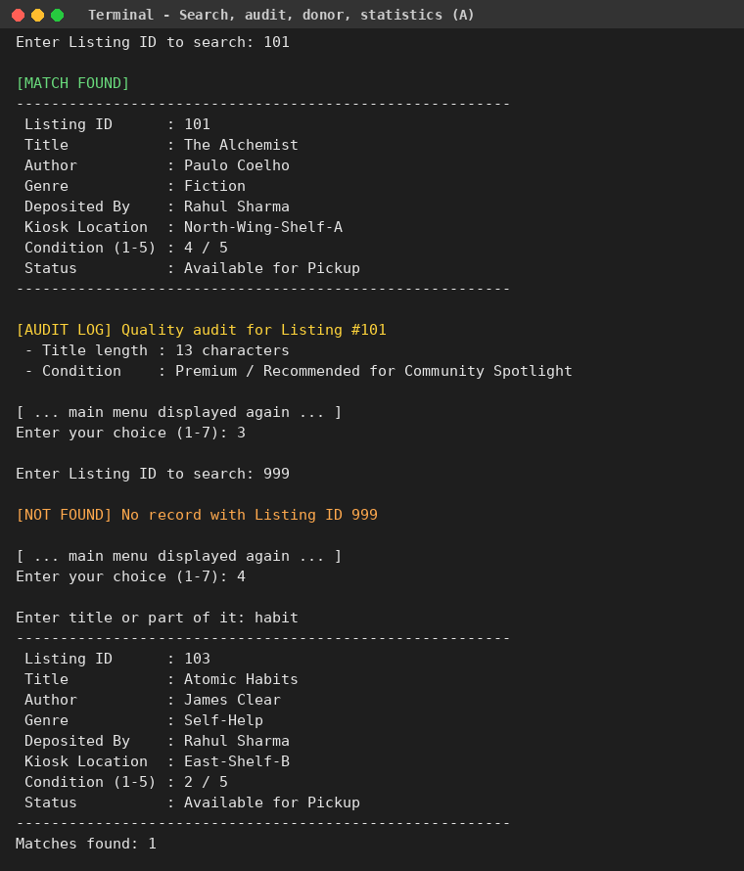
Figure 6.2: Search by ID with audit, not-found and title search – T03, T04, T14

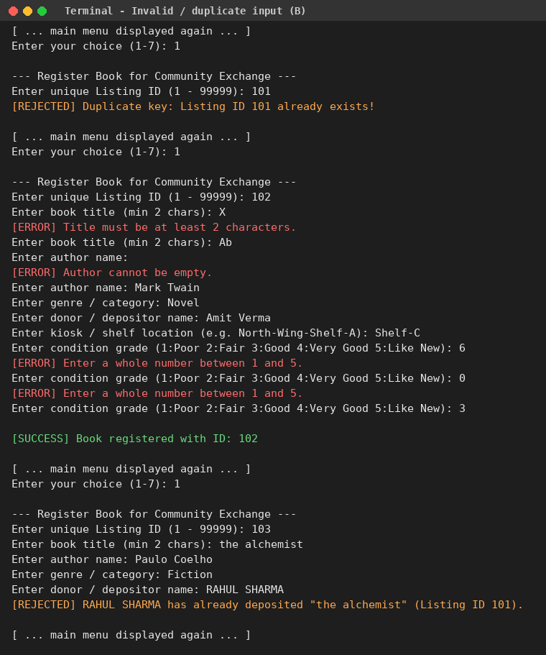
Figure 6.3: Duplicate ID, short title, empty author, bad condition, duplicate donor + title – T09 to T13
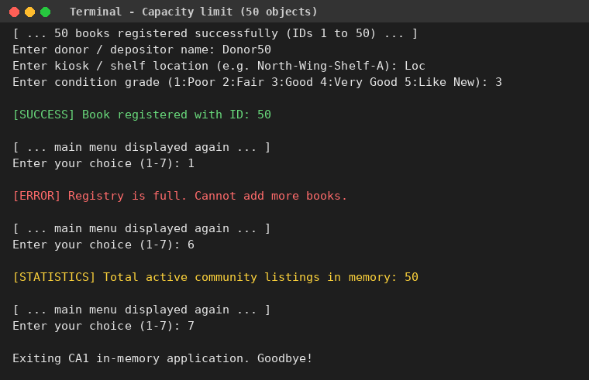
Figure 6.4: Capacity limit of 50 objects – T18

7. Build Instructions, Repository and Submission

7.1 Build and Run
The project is developed in Visual Studio Code on Windows 11 using the g++ compiler. In the PowerShell terminal, move to the src folder, compile and run:
cd "D:\Coding Journey\C++ Project\Community Book Exchange Coordinator\src"
g++ RD1P2635B66_CAP455_CA1_CommunityBookExchangeCoordinator.cpp -o RD1P2635B66_CAP455_CA1_CommunityBookExchangeCoordinator
.\RD1P2635B66_CAP455_CA1_CommunityBookExchangeCoordinator
On Linux or macOS the same source compiles with g++ <file>.cpp -o exchange and runs with ./exchange. No external library is required.
The complete source code (411 lines) is submitted as a separate file, RD1P2635B66_CAP455_CA1_CommunityBookExchangeCoordinator.cpp, and is stored in the /src folder of the repository.

7.2 Repository Layout
Folder / File | Content
/docs | Proposal, data dictionary, UML, flowcharts, this CA1 report
/src | RD1P2635B66_CAP455_CA1_CommunityBookExchangeCoordinator.cpp – complete CA1 source code (and the compiled .exe)
/data | Sample data files (none needed in CA1; used from CA2 onwards)
/tests | Test table and screenshots of normal, invalid and boundary tests
README.md | Build / run steps and features by phase

8. Future Scope and Conclusion

8.1 Plan for the Next Phases
Phase | Planned work on this project
CA2 | Add default, parameterised and copy constructors and a destructor; store BookListing records in a binary file using fixed-size records (fstream); search with seekg, update with seekp; data must survive a restart. Strings will be stored in fixed-size char arrays.
CA3 | Create a base class with at least two derived classes (for example different types of listings); overload <<, >>, ==, < and one more operator; add a type conversion; use new / delete and virtual functions with a virtual destructor; add safe Update and Delete with confirmation.
CA4 | Full CRUD menu; try / catch / throw with a custom exception class; function and class templates; STL vector / list with sort, find_if, count_if; at least one advanced feature such as backup, CSV export or an undo stack.

8.2 Conclusion
The CA1 phase of the Community Book Exchange Coordinator delivers a working, validated in-memory register of community books. The design is documented with a data dictionary, UML class diagram, use-case diagram and flowcharts. The code demonstrates all required Unit I–II concepts – an entity class with static, inline and friend members, an array of objects, pointer traversal, the this pointer and std::string handling – and handles wrong input, duplicate keys, a full registry and end-of-input safely. Twenty test cases covering normal, invalid and boundary situations passed.

