PRACTICAL 1

AIM : A multinational company, TechVault Inc., operates in both local (LAN) and global (WAN) environments. The IT team needs to establish a robust file transfer mechanism to manage sensitive data securely between branches.  
Task:  
Demonstrate and implement FTP for file transfer in the following scenarios:

* Within the same branch (LAN).
* Between two branches located in different cities (WAN).

Ensure secure file transfer practices by implementing over TLS (FTPS).

1. LAN :

OUTPUT :

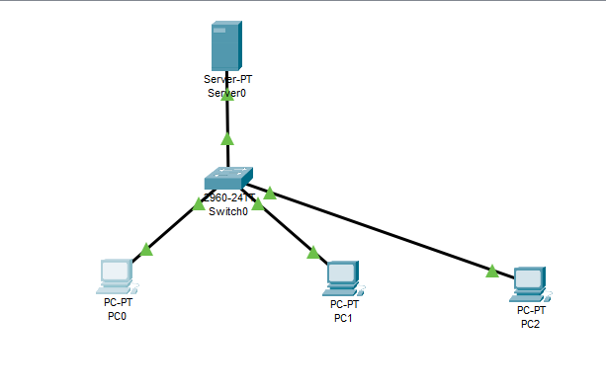

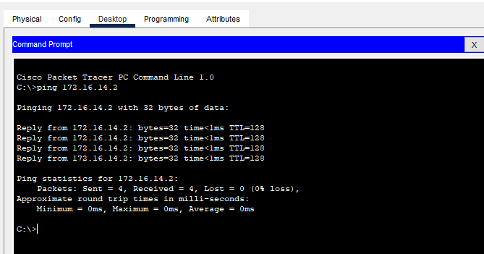

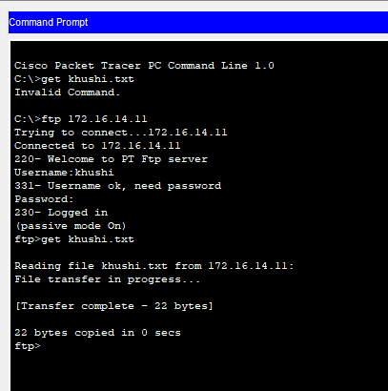

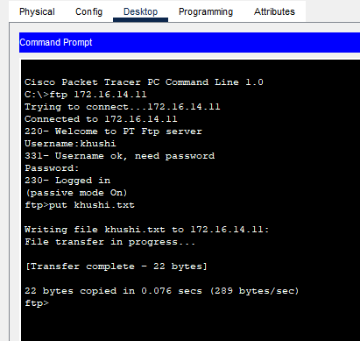

1. **WAN :**

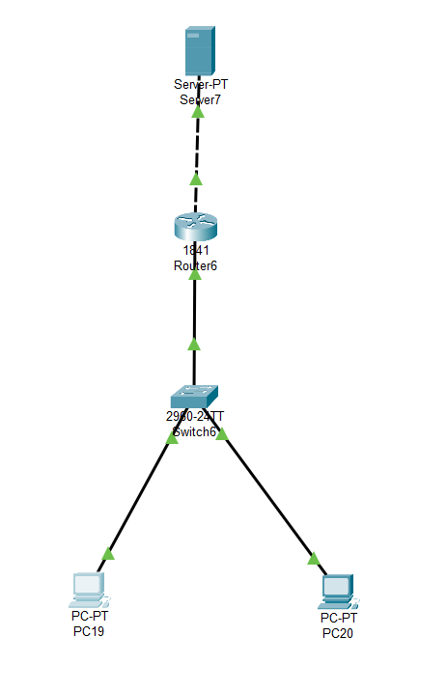

**Server config :**

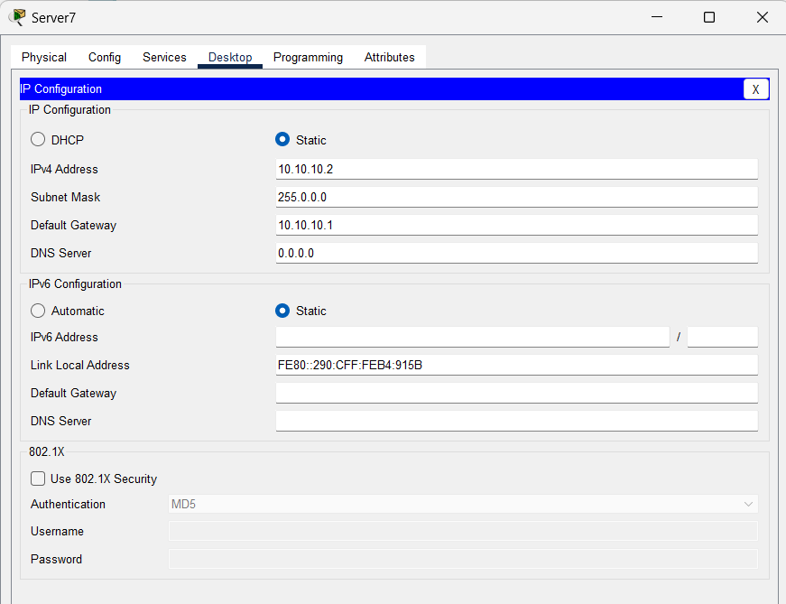

**Router config :**

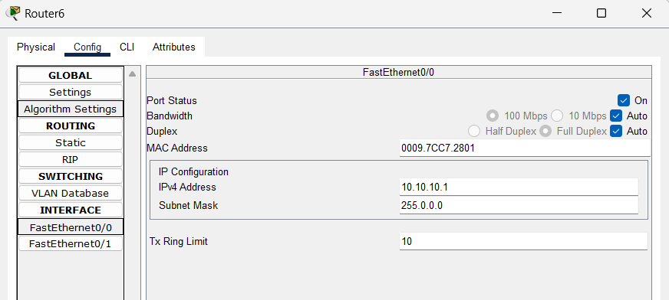

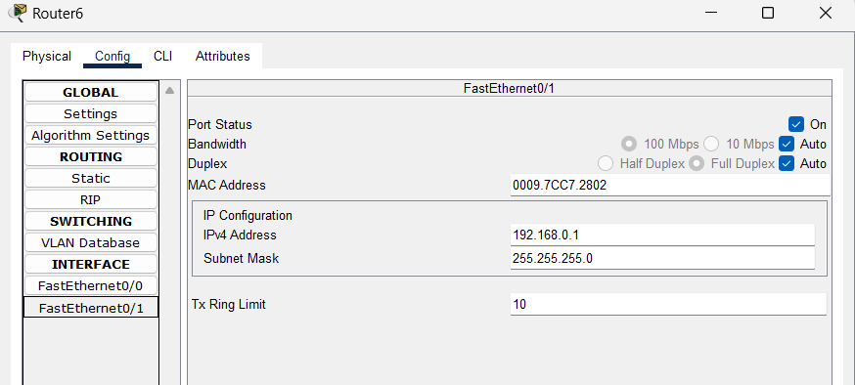

**PC CONFIG :**

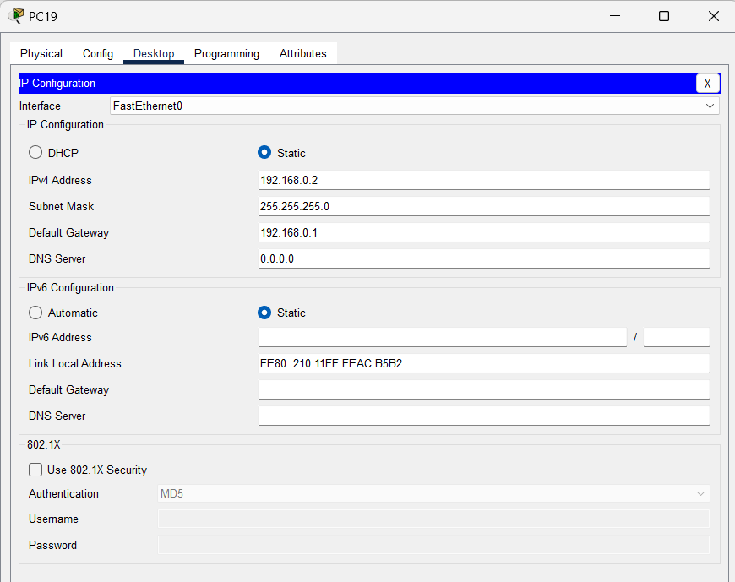

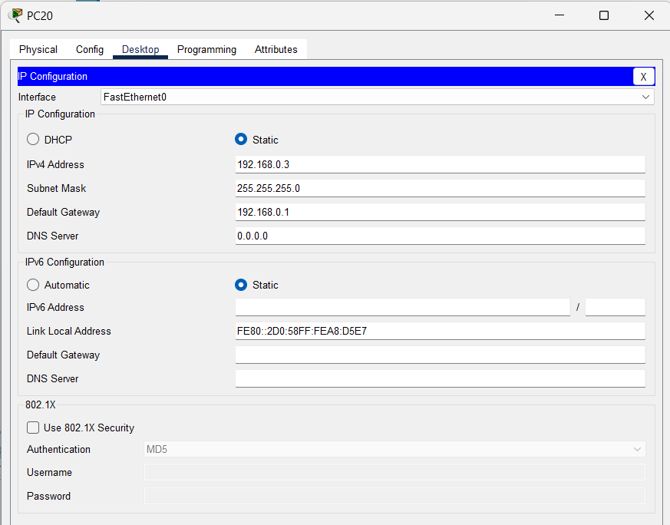

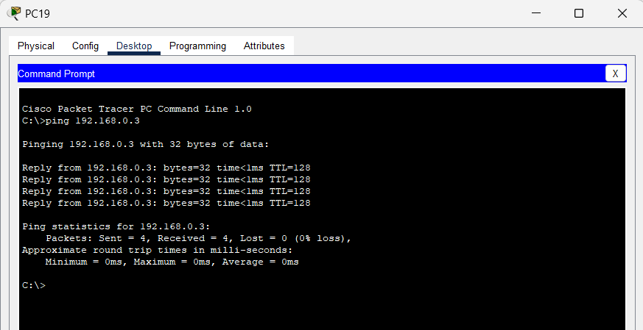

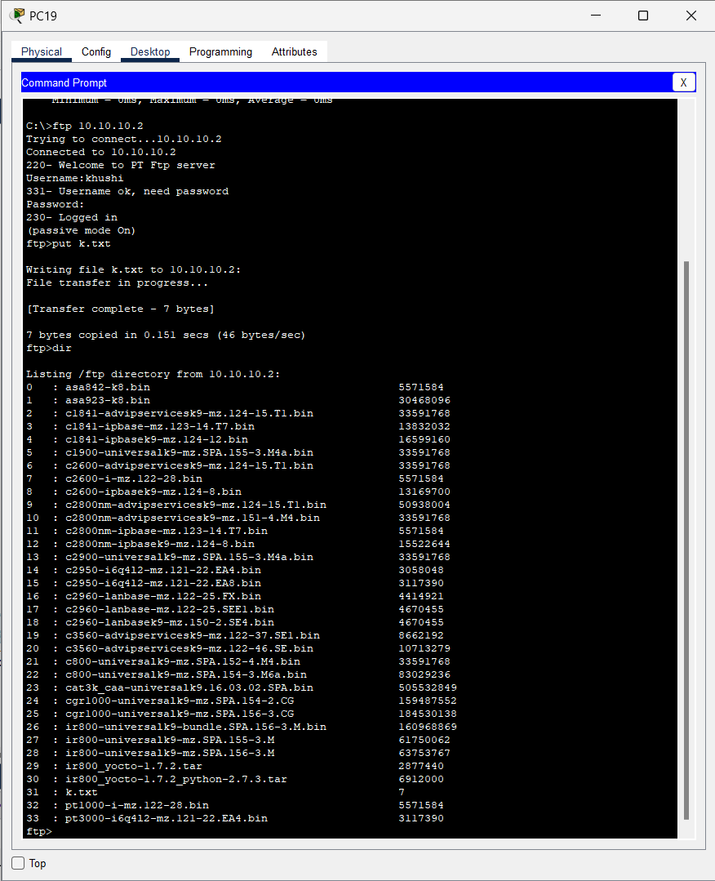

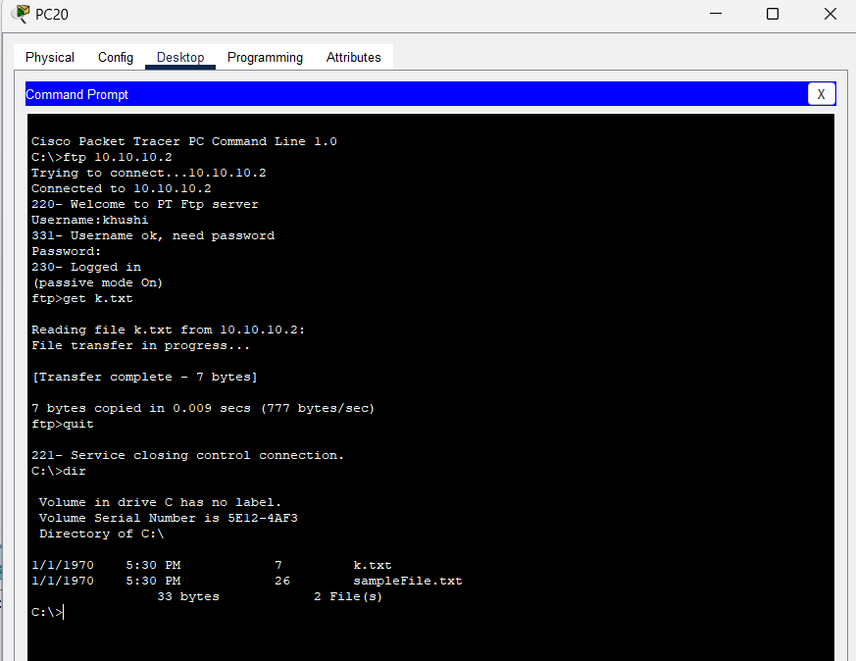

Conclusion:

1)Within LAN: FTPS enables secure and reliable file transfers within the same branch using encrypted connections, ensuring data protection on local networks.

2)Across WAN: By leveraging FTPS with TLS encryption, file transfers between branches in different cities are secure, even over public networks, with proper configurations like NAT and firewalls.

3)Secure Practices: The use of TLS, strong authentication, and restricted port ranges ensures robust security and compliance with data protection standards.

4)Efficiency: FTPS provides a scalable and secure solution for managing sensitive data transfers across both local and global environments.