- Database Table Creation Section

"This section creates the SQLite database and sets up tables to hold movie details and user reviews. It forms the data backbone for the application."

- API Request and Data Retrieval
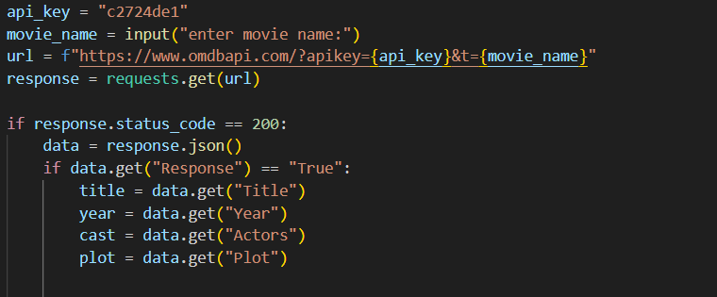

"Here, the user enters a movie name, and the code requests movie data from the OMDB API. It then extracts key information like title, year, cast, and plot."

3. Inserting Data into Database
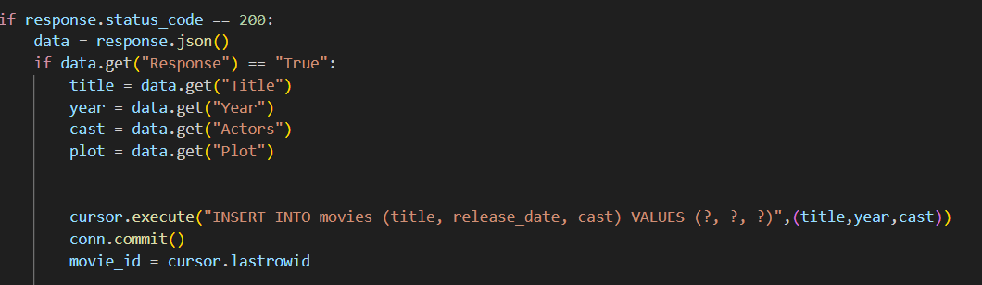

"This block takes the fetched movie details and stores them in the database. User reviews are tied to each movie entry via a foreign key relationship."

- Program Output/Review Confirmation
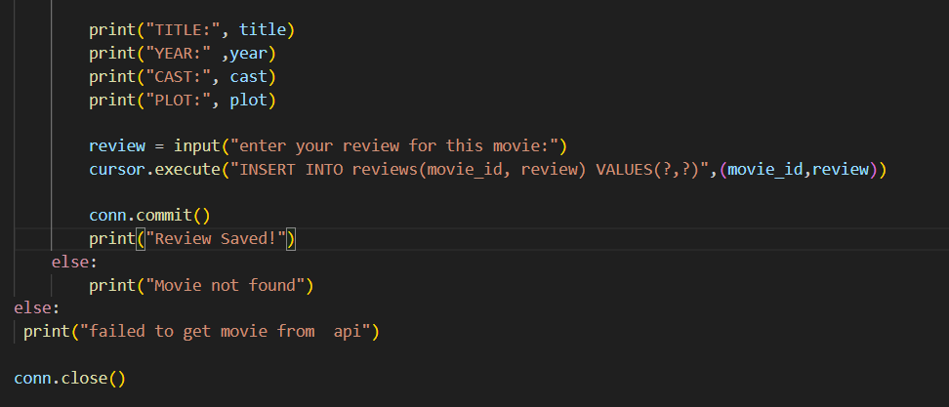
"The program displays all movie details to the user, asks for their review, and confirms when the review is saved successfully in the database."

- OUTPUT:

