# Marathwada Mitra Mandal’s

**College of Engineering, Karvenagar, PUNE - 411 052 Accredited with ‘A’ Grade by**

# NAAC, Recipient of “Best College Award 2019” by SPPU

**Department of Computer Engineering**

# ASSIGNMENT NO: 6

**AIM:** To implement a mini project.

**PROBLEM STATEMENT:** A BI report must be prepared to outline the following steps: a) Problem definition, identifying which data mining task is needed.

b) Identify and use a standard data mining dataset available for the problem.

# PREREQUISITES:

* Knowledge of preprocessing and classification .

# COURSE OUTCOME:

CO2: Use tools and techniques in the area of software development to build mini projects CO3: Design and develop applications on suitable datasets.

**Problem Statement** : Netflix Dashboard for Analyzing User Engagement and Content Performance.

**Software/ Hardware requirements:** Windows 10, Power BI Desktop

# Types of Report used:

* + Cards- Cards are a type of visualization used to display a single, key metric or value. They are typically used to highlight important information or key performance indicators (KPIs) in a report. Cards can be customized to display data in various formats, including numbers, percentages, and currencies. They are versatile and can be used in combination with other visualizations to create informative and interactive reports.
* 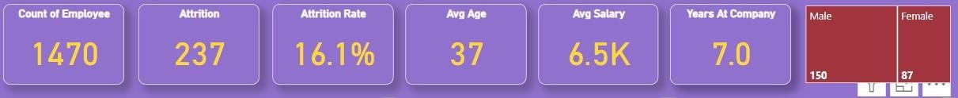Top of Form



* Donut Charts- Doughnut chart is a circular chart with a hole in the center, similar to a pie chart but with a blank center. Doughnut charts are used to show the proportions of different categories within a dataset. Each category is represented by a segment of the doughnut, and the size of each segment corresponds to the proportion of that category relative to the total.

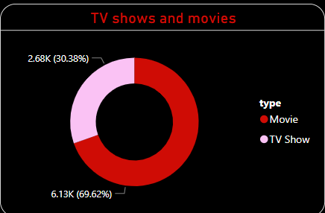

* Stacked Bar chart- A stacked bar chart is a visualization that displays data in rectangular bars where the length of each bar represents the value of a category, and the bars are stacked on top of each other to show the total value. Stacked bar charts are useful for comparing the total values across categories and also for comparing the proportions of each category within a total.

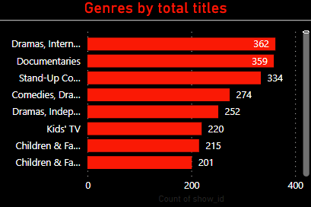

* Area Chart – An area chart is a visualization that displays data as a series of data points connected by line segments and the area between the line and the x-axis is filled with color. Area charts are useful for showing trends over time or for comparing the contributions of different categories to a total.

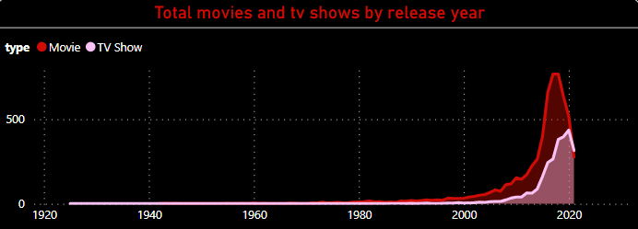

# Dashboard Layout:

The purpose of creating a Netflix dashboard is to provide actionable insights into viewer behavior and content performance. This dashboard can help Netflix make data-driven decisions to enhance the user experience, improve content offerings, and increase viewer engagement.

* Primary KPI - Total Number of Subscribers and Total Churn Rate for the Netflix Platform.
* Primary KPIs - Average Age and Average Subscription Fee of Netflix Users.
* Secondary KPIs - Total Churn Rate with respect to Viewing Habits and Subscription Plan of Netflix Users.
* Secondary KPIs - Total Churn Rate with respect to Average Subscription Tenure of Netflix Users.
* Role of Content Genre in Ratings.
* Detailed Churn rate Information based on the Content Category.

# STAKEHOLDERS

* + - **Executives**

# Content Managers

* + - **Marketing Teams**

# Product Managers

* + - **Data Analysts**

# Investors

The Netflix dashboard project using Power BI aims to provide stakeholders with a comprehensive view of key metrics and insights related to the streaming platform's performance. The dashboard will include visualizations for subscriber growth, content popularity, viewer demographics, and engagement metrics. This dashboard enables executives to make informed decisions regarding content acquisition, production, and marketing strategies.

# Dataset used:

The dataset used is collected from a freely available data repository (Kaggle). Dataset contains following columns: Show Id, Type, Title, Director, Cast, Country, Date Added, Release year, Rating , Duration, Listed_in, Description etc.

# Screenshots :

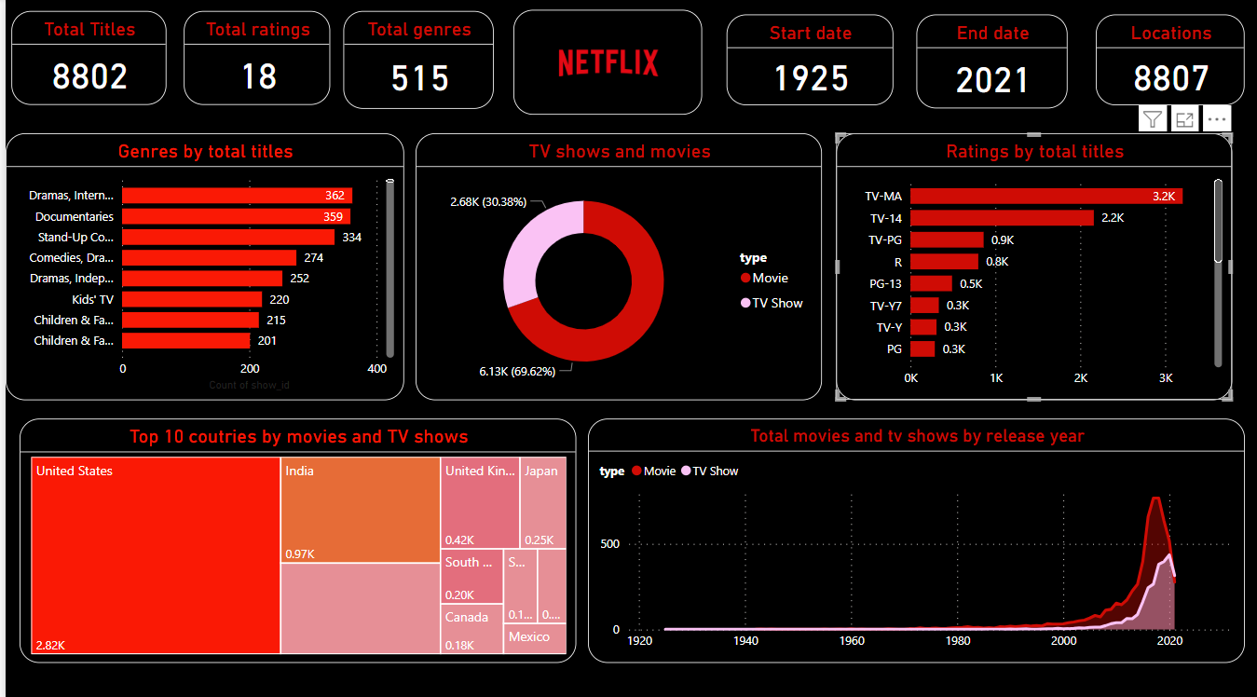

Fig1. Report View

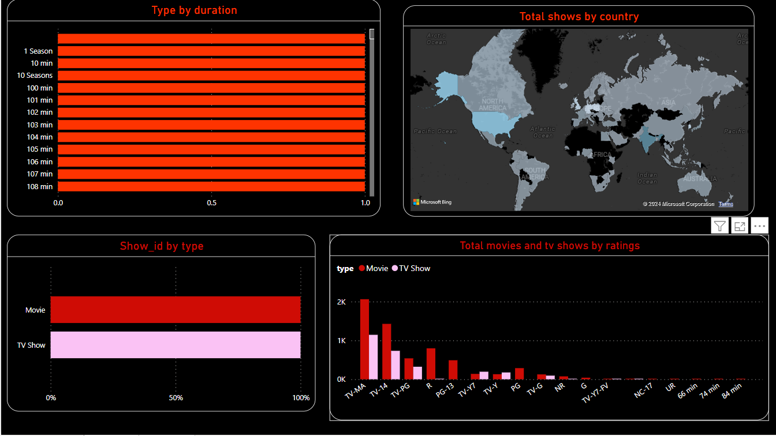

Fig2. Report View

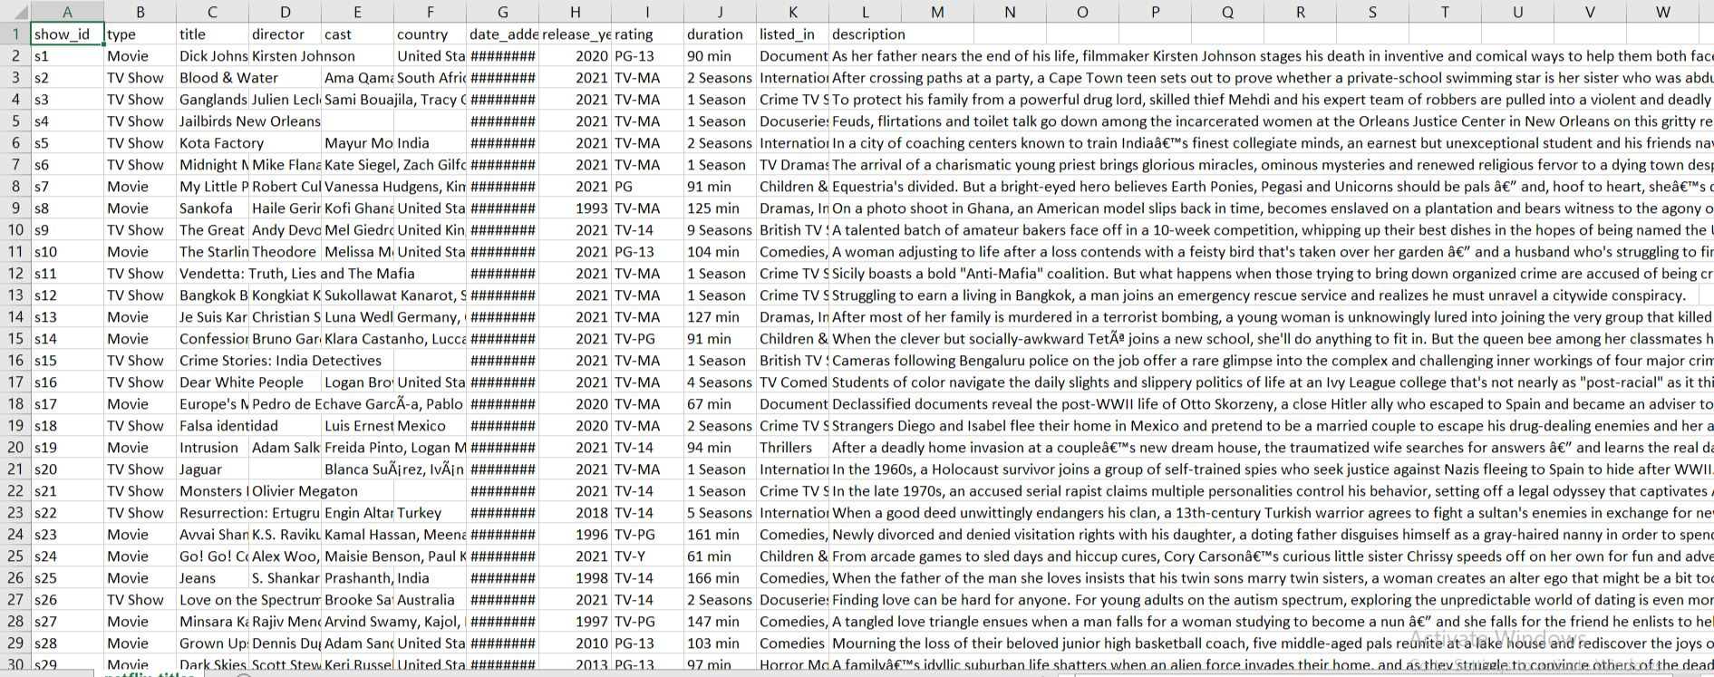

Fig. Data View

Conclusion:

The Netflix dashboard provides stakeholders with valuable insights into user behavior, content performance, and platform engagement. The dashboard's interactive visualizations and user-friendly interface have facilitated easy data interpretation and decision-making.

**Conclusion:** An interactive dashboard is created using Power BI through which Human Recruiters team can come up with optimal solutions for better decisions and can able decreases the attrition rate of employee.