Azad Kishori
Add AK:
- After clicking on “Add AK”, a blank screen appears initially. The form fields only load after a hard refresh. It should not be like this. Ensure that all fields load properly on the first click without requiring a refresh.
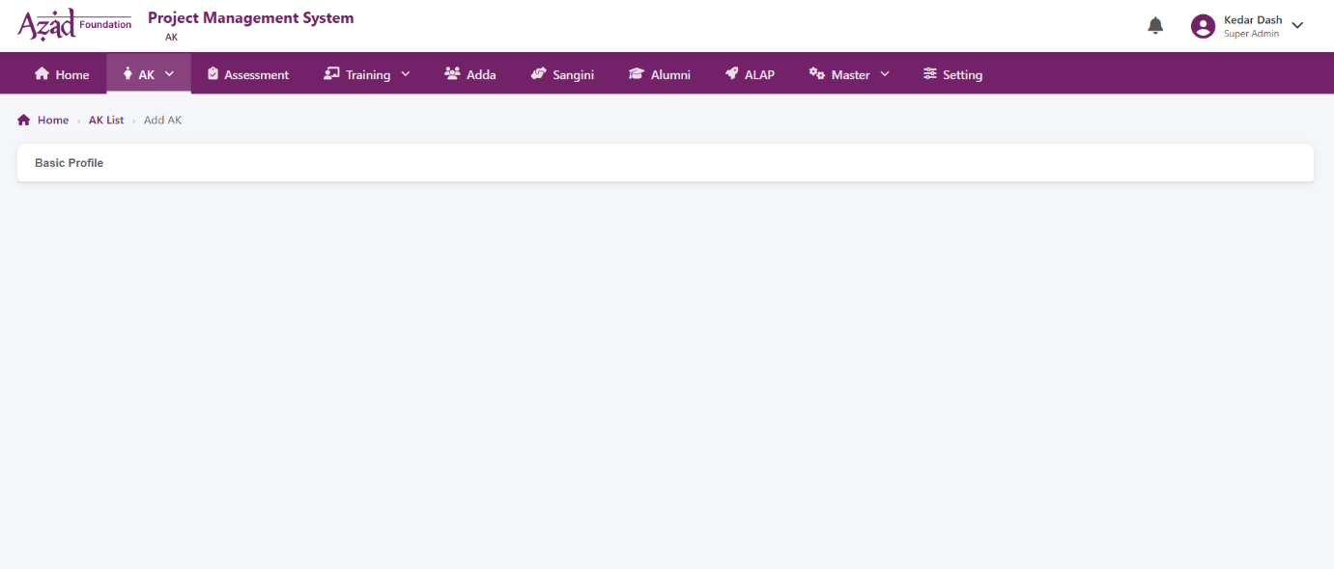
- State dropdown is not fetching the data properly, sometimes it is showing the data and sometimes the list of state is not showing. It should fetch list of states properly.
- Per Capita Income is not generated immediately after entering number of family members, it should must be auto calculated immediately after entering number of family members.
- Change “Click to Upload” to “Click to upload picture”.
- Address, Current education, Family Monthly Income, Number of family members should be mandatory fields.
- DOB should not take any future dates and years.
- Remove (*) symbol from “Stream chosen in +2” field.

