YUVA INTERN – WEEK 6 FINAL REPORT
Final Report Synthesis and Presentation | Virtual Data Science with Python Intern
Data Science for Digital Governance and Public Digital Services
Intern: Mayank
YUVA Intern
Project Theme: Data-driven improvement of e-Governance and digital public services
Internship Period: 06 September 2026 – 18 October 2026
Final Task: Week 6 – Final Report Synthesis and Presentation
Submission-ready DOCX | Demonstration datasets are clearly identified as synthetic/illustrative.

1. Executive Summary
This final report synthesizes the complete six-week learning journey completed during the YUVA Virtual Data Science with Python internship. The work was organized around a practical digital-governance problem: how data science can help public institutions understand service performance, identify operational bottlenecks, prioritize citizen complaints, and evaluate possible improvements to digital public services. The project began with problem framing and exploratory analysis, moved through data collection and cleaning, progressed to feature engineering and visualization, then developed and evaluated a machine-learning model, and finally connected technical findings to policy-oriented simulation. The result is a unified analytical workflow rather than a collection of isolated weekly exercises.
Week 1 established the e-governance context and defined the problem around service workload, disposal performance, resolution time, and digital-service capability. Week 2 converted that problem into a disciplined data strategy covering data sources, variables, quality checks, missing values, duplicates, anomalies, standardization, privacy, and reproducibility. Week 3 demonstrated how raw operational fields can be transformed into useful indicators such as resolution rate, requests per staff member, and an exploratory service-efficiency score. Week 4 developed a Random Forest classification workflow for prioritizing citizen complaints into Low, Medium, and High categories. On the synthetic test data, the model produced accuracy of 0.685, weighted precision of 0.684, weighted recall of 0.685, and weighted F1 of 0.681. Week 5 extended the work from prediction to policy analysis by simulating how response time and service reliability could influence digital-service engagement.
A central conclusion across the internship is that technology alone does not guarantee better public services. Reliable data, clear definitions, quality controls, responsible modelling, interpretability, privacy protection, human oversight, and measurable policy objectives are equally important. The final recommendations therefore focus on improving data quality, service monitoring, complaint prioritization, digital-service reliability, citizen usability, model governance, and continuous evaluation. All numerical results based on synthetic or illustrative datasets are presented as educational demonstrations and should not be interpreted as official government statistics.

2. Problem Context, Research Questions and Objectives
Digital public services are increasingly important because citizens use online channels to obtain information, submit applications, register for services, make payments, submit grievances, and track the progress of requests. However, digital availability does not automatically mean that a service is accessible, reliable, fast, or satisfactory. A citizen may encounter slow processing, repeated failures, limited awareness, connectivity constraints, confusing interfaces, language barriers, low digital literacy, or uncertainty about how a complaint will be handled. From a governance perspective, these challenges create a need for evidence rather than assumptions. Data science can help convert operational records and service indicators into measurable information for decision-making.
The internship therefore framed a broad problem: public-service organizations may collect or generate large amounts of service data, but decision-makers need structured methods to identify delays, workload pressure, service-performance differences, complaint priorities, and possible improvement strategies. The project was designed as an educational analytical framework rather than an operational government system. The main research questions were: Which service indicators can reveal operational bottlenecks? How can data be cleaned and transformed into reliable analytical variables? Can a machine-learning model support complaint prioritization? How can model results be interpreted responsibly? How might technical improvements such as faster response and higher reliability influence citizen engagement under different policy scenarios?
The main objectives were to establish a measurable digital-governance problem; design a responsible data collection and cleaning process; create useful engineered features; visualize important patterns; develop and evaluate a predictive classification model; simulate policy scenarios; interpret findings in governance terms; identify limitations and risks; and formulate practical recommendations. A further objective was reproducibility. The work used Python-oriented tools and documented workflows so that another learner or evaluator can understand the logic, assumptions, data structures, and limitations. This objective is important because analytical credibility depends not only on producing an output but also on explaining how that output was created and how it should or should not be used.

3. Overall Methodology and End-to-End Workflow
The methodology followed an end-to-end data-science lifecycle. The first stage was problem framing, where the digital-governance context was translated into measurable service and citizen-experience questions. Instead of starting with an algorithm, the project first identified the decision problem, possible variables, scope, assumptions, feasibility, and expected governance value. This ensured that later analysis remained connected to a practical public-service objective.
The second stage was data planning and quality management. The Week 2 workflow defined possible secondary sources and a privacy-conscious primary-data option. It documented variables such as geographic context, service access, internet availability, usage, satisfaction, processing information, and service outcomes. Data quality checks included schema inspection, missing-value assessment, duplicate detection, category standardization, numeric-range validation, date validation, anomaly review, and post-cleaning verification. The workflow separated raw and processed data and emphasized documentation of source metadata and assumptions. Personally identifiable information was deliberately minimized because it was not necessary for the analytical objective.
The third stage was analytical transformation. In Week 3, raw service-level information was converted into indicators that are easier to interpret. Resolution rate measured the share of requests completed, requests per staff member represented workload pressure, and a combined efficiency score was used as an exploratory comparison indicator. Matplotlib visualizations were used to communicate distributions and relationships.
The fourth stage was predictive modelling. Week 4 used a reproducible preprocessing pipeline with one-hot encoding for categorical complaint type and a Random Forest Classifier. The data was split into training and testing subsets using an 80/20 approach with a fixed random state and stratification. Accuracy, precision, recall, F1 score, a confusion matrix, and feature-importance analysis were used to evaluate the model.
The fifth stage was policy simulation. Week 5 compared baseline, improved-response, improved-reliability, and combined-improvement scenarios using synthetic users. The simulation was designed to demonstrate scenario reasoning, not to produce official forecasts. Finally, all stages were integrated into recommendations that emphasize evidence, transparency, responsible AI, and continuous monitoring.

4. Integration of Week 1 to Week 5 Work
The strength of the final project comes from connecting the weekly tasks into one logical pipeline. Week 1 supplied the foundation by defining the e-governance problem and explaining why service workload, disposal performance, resolution time, and digital-service capability matter. This stage prevented the later technical work from becoming disconnected coding exercises. It also introduced the importance of authoritative data sources, responsible interpretation, privacy, and the difference between an illustrative dataset and official statistics.
Week 2 converted the Week 1 problem into a data-management plan. The report identified the need for consistent variable definitions, source documentation, missing-value treatment, duplicate checks, anomaly handling, standardization, and reproducibility. This stage established an important principle: a sophisticated model cannot compensate for poor-quality data. It also highlighted that rural digital-service analysis may require contextual information about connectivity, awareness, device access, digital literacy, and usability.
Week 3 then demonstrated how cleaned data can be transformed into meaningful analytical features. Resolution rate, requests per staff member, and service efficiency were used to connect raw operational data with service performance. Visualization made these relationships easier to communicate to both technical and non-technical audiences. This stage created the bridge between descriptive analysis and predictive modelling.
Week 4 built on those foundations by showing how machine learning can support a specific decision problem. The complaint-priority model classified cases into Low, Medium, or High priority using structured complaint attributes. Its evaluation showed moderate performance on synthetic test data and also reinforced the importance of limitations, fairness, interpretability, auditability, and human review.
Week 5 extended the project from “what may happen?” to “what could happen under a proposed improvement?” Scenario simulation compared response-time and reliability interventions. Together, the five stages form a coherent sequence: define the problem, prepare trustworthy data, engineer useful information, model a decision-support task, simulate policy choices, and convert the evidence into recommendations. This integration directly addresses the Week 6 requirement to synthesize previous tasks into a single narrative.

5. Data Strategy, Quality, Ethics and Reproducibility
Data quality was treated as a core part of the project rather than a preliminary technical detail. The internship workflow recognized that digital-governance data can come from multiple sources with different definitions, time periods, formats, update schedules, and levels of completeness. Therefore, the project proposed a disciplined sequence: preserve raw inputs, inspect the schema, define each variable, check missingness, identify duplicates, standardize categories, validate numeric ranges, verify dates, investigate anomalies, and re-run quality checks after transformation. Every transformation should be documented so that an evaluator can understand why a value was changed, retained, flagged, or treated as missing.
The project also emphasized the difference between synthetic demonstration data and real public-sector data. The Week 4 model used a synthetic dataset containing 1,000 records, while Week 5 used simulated users and assumptions. These data were useful for demonstrating Python, modelling, evaluation, and scenario analysis, but they cannot establish real citizen behaviour or actual government performance. This distinction is essential for ethical communication. Presenting simulated values as real statistics could mislead decision-makers and undermine trust.
Privacy was another important consideration. A digital-governance analytics system may process complaint descriptions, service information, demographic attributes, contact details, or other potentially sensitive information. The analytical objective should therefore determine the minimum data required. Identifiers should be removed or protected when they are not necessary, access should be restricted, and public repositories should not expose personal information. If real administrative data were used in a production project, governance approval, lawful processing, security controls, retention rules, and audit mechanisms would be required.
Reproducibility was supported through documented Python workflows, requirements, README files, structured folders, and clearly stated assumptions. Fixed random seeds and documented train-test settings make educational experiments easier to reproduce. In a real deployment, reproducibility would also require versioned datasets, model versions, configuration records, experiment logs, and monitoring. The final recommendation is therefore to treat data governance as a continuous lifecycle involving collection, cleaning, analysis, modelling, publication, monitoring, and responsible retirement of outdated datasets or models.

6. Feature Engineering, Visualization and Analytical Findings
Feature engineering was an important bridge between raw operational records and decision-support information. Raw fields such as total requests, resolved requests, processing time, satisfaction, digital adoption, and staff count do not always answer a management question directly. The project therefore created derived indicators. Resolution rate percentage was calculated from resolved requests divided by total requests, providing a direct measure of service completion. Requests per staff member represented workload pressure and can help identify services where capacity may be constrained. An exploratory service-efficiency score combined resolution, satisfaction, adoption, and processing time to support comparative analysis. Because composite scores can hide important assumptions, the report treated this score as an exploratory indicator rather than a final policy measure.
Visualization was used to make patterns easier to understand. A histogram of processing time helps reveal the typical range and possible concentration of delays. A scatter plot comparing digital adoption with citizen satisfaction can support exploration of whether the two variables move together, while also reminding analysts that correlation does not establish causation. A service-level resolution-rate bar chart allows managers to compare outcomes and identify services that may require deeper investigation. These visual tools are valuable because they can communicate findings to stakeholders who may not understand statistical or machine-learning terminology.
The analytical findings should be interpreted as demonstrations of the workflow. The project indicates that processing time is an important performance variable, resolution rate provides a clear completion indicator, and workload per staff member can reveal capacity differences. It also suggests that citizen satisfaction should be considered alongside operational measures rather than treated as an unrelated outcome. Importantly, visualization can expose data-quality issues as well as substantive patterns. Unexpected values, extreme processing times, impossible percentages, or inconsistent service labels may become visible before modelling.
The overall lesson is that feature engineering should be driven by the decision problem. A derived feature is useful when its definition is clear, its data inputs are reliable, its assumptions are documented, and its interpretation is meaningful to the intended user. Before a feature is used in a production model or policy dashboard, it should be validated for stability, fairness, sensitivity to missing values, and possible unintended consequences.
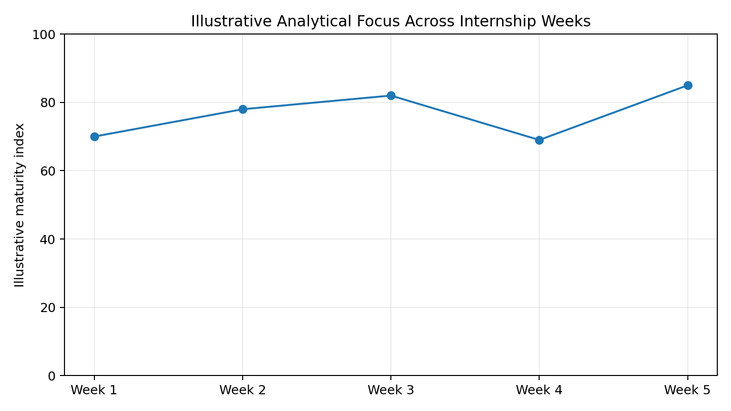
Figure 1. Illustrative progression of analytical focus across the internship weeks; this is a presentation aid, not an official score.

7. Machine-Learning Model Development and Evaluation
Week 4 implemented a machine-learning workflow for e-governance complaint prioritization. The decision-support problem was to classify complaints into Low, Medium, or High priority using structured attributes such as complaint category, severity, pending days, previous complaints, essential-service indicators, and repeat-issue information. The dataset was synthetic and contained 1,000 records. A preprocessing pipeline handled categorical information through one-hot encoding, after which a Random Forest Classifier was trained. The dataset was divided into 80% training and 20% testing subsets, with stratification and a fixed random state to make the educational experiment reproducible.
The model achieved an accuracy of 0.685, weighted precision of 0.684, weighted recall of 0.685, and weighted F1 score of 0.681 on the synthetic test set. These numbers describe the behaviour of the model on the demonstration data only. They should not be interpreted as the expected accuracy of a real government complaint system. The confusion matrix was used to understand correct and incorrect class predictions, while metric comparison and permutation feature-importance visualizations were included to improve interpretability.
From a governance perspective, the model should be treated as decision support rather than an automatic authority. A predicted priority level should help an authorized officer focus attention, but it should not automatically determine whether a citizen receives a benefit, service, appeal outcome, or other public entitlement. Human reviewers should be able to inspect relevant information, understand the reason for a recommendation, and override it where necessary. Audit logs should record model versions, input conditions, outputs, and human decisions.
A production model would require a representative historical dataset, reliable labels, fairness testing, subgroup evaluation, data-drift monitoring, security controls, privacy safeguards, and periodic revalidation. It would also be important to examine false negatives because a high-priority complaint incorrectly classified as low priority may have greater consequences than some other errors. The main learning outcome from Week 4 is therefore not simply the numerical score. It is the ability to connect preprocessing, model training, evaluation, interpretation, limitations, and responsible deployment into one accountable workflow.
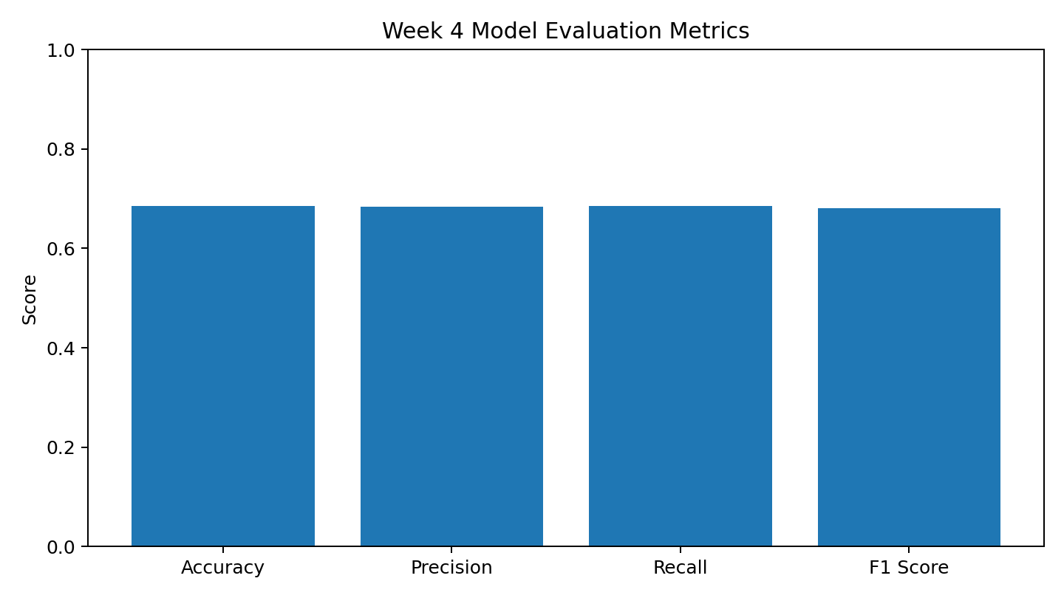
Figure 2. Week 4 Random Forest evaluation metrics on the synthetic test set.
Metric | Week 4 result | Meaning
Accuracy | 0.685 | Overall proportion of correct predictions on the test set.
Weighted Precision | 0.684 | Precision weighted by the number of examples in each class.
Weighted Recall | 0.685 | Recall weighted by class support.
Weighted F1 | 0.681 | Balance of precision and recall across classes.

8. Policy Impact Analysis and Simulation
Week 5 connected data science to policy reasoning through a scenario-based simulation of digital-service efficiency. The policy issue selected was the effect of service response time and reliability on citizen engagement. Four scenarios were considered: a baseline service with a 60-minute response time and 80% reliability; improved response with a 30-minute response time and 80% reliability; improved reliability with a 60-minute response time and 95% reliability; and combined improvement with a 30-minute response time and 95% reliability. Each scenario represented 1,000 simulated users.
The simulation framework used assumptions that faster response and higher reliability increase the probability that a citizen successfully engages with a digital service. An illustrative run can produce engagement rates such as 58%, 68%, 67%, and 77% for the four scenarios. These values are included here only as a presentation example of the scenario logic; they are not official measurements and should not be treated as predictions of real citizens. The important analytical idea is the comparison between alternatives, not the exact simulated percentage.
Scenario analysis can support policy decisions by showing how different interventions might change an outcome before an expensive full-scale implementation. If response-time improvements produce stronger engagement gains, policymakers could investigate server capacity, workflow automation, queue management, process simplification, and faster backend processing. If reliability produces stronger gains, investment may be directed toward uptime, infrastructure, testing, monitoring, backup systems, and technical support. A combined intervention may be preferred when the expected benefit justifies the additional cost.
The simulation also demonstrates why assumptions must be explicit. Real citizen behaviour depends on internet access, digital literacy, language, accessibility, trust, age, location, service complexity, and previous experiences. A simple model cannot capture all of these factors. A stronger real-world analysis would use observed administrative and user-experience data, confidence intervals, cost information, subgroup analysis, sensitivity testing, and validation against historical outcomes. The policy lesson is therefore that simulation is a decision-support tool for comparing plausible scenarios, not a replacement for evidence. It is most useful when assumptions are transparent, alternatives are measurable, and the results are combined with real-world monitoring.
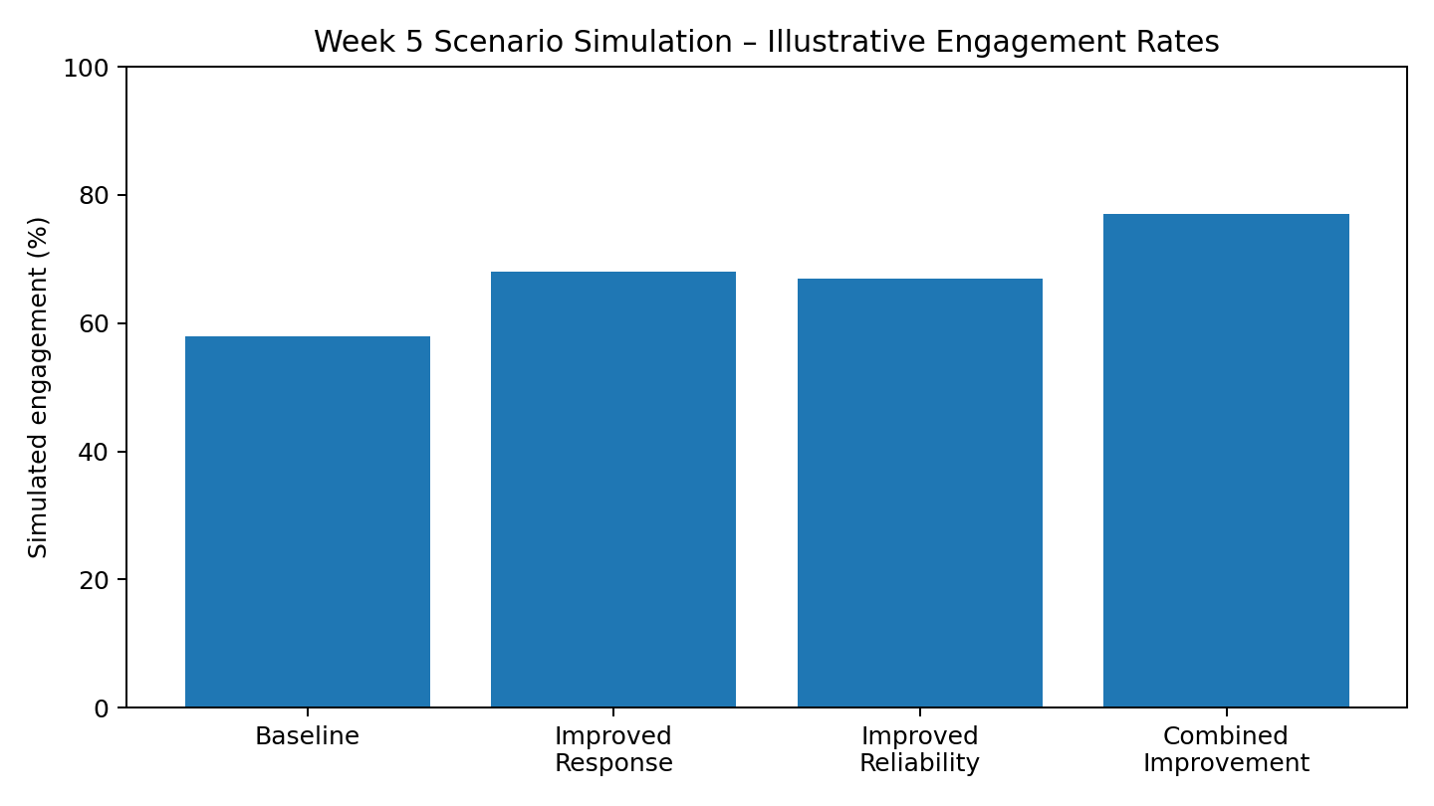
Figure 3. Illustrative Week 5 scenario comparison. Values are simulated for demonstration and are not government statistics.

9. Discussion: What the Combined Results Mean for Digital Governance
When the findings from all five weeks are considered together, the project supports a broader conclusion: effective digital governance requires a chain of evidence from problem definition to operational action. A dashboard without reliable data can mislead. A clean dataset without meaningful features may not answer a management question. A machine-learning model without appropriate validation may produce unreliable recommendations. A simulation without realistic assumptions may create false confidence. The value of data science comes from connecting these stages responsibly.
The Week 1 and Week 2 work shows that service performance should be measured through multiple dimensions. Volume alone does not indicate whether a service is performing well. Disposal rate, pending workload, processing time, satisfaction, adoption, reliability, and complaint characteristics can provide complementary perspectives. Week 3 demonstrates how these dimensions can be converted into actionable indicators. This is important for public administrators because a useful indicator should point toward a possible decision, such as investigating a high workload, improving a slow workflow, or examining a service with low completion.
Week 4 demonstrates that machine learning can add another layer by prioritizing cases or identifying patterns. However, the moderate synthetic performance reinforces the need for caution. In a real system, model quality should be evaluated not only through overall metrics but also through class-specific performance, fairness, error costs, calibration, drift, and human review. The most important governance principle is that a model should remain accountable to institutional rules and citizen rights.
Week 5 adds the policy dimension. Once an organization understands its service weaknesses, it can compare potential interventions rather than making decisions based only on intuition. Scenario analysis can help estimate direction and relative impact, but implementation should be followed by measurement. A policy should have a baseline, target indicators, monitoring frequency, cost assumptions, and a process for revising the intervention if results differ from expectations.
The combined project therefore suggests a continuous improvement loop: collect trustworthy data, measure service performance, identify bottlenecks, test analytical explanations, prioritize actions, simulate or pilot interventions, monitor outcomes, and revise decisions. This approach makes data science a practical component of governance rather than a standalone technical exercise.

10. Challenges Encountered, Limitations and Lessons Learned
The project involved several challenges that are important to document because Week 6 specifically requires reflection. The first challenge was the gap between a broad governance problem and measurable variables. Digital-service quality is multidimensional, so the project had to narrow the scope to indicators that could be represented in structured data. This required balancing ambition with feasibility. The second challenge was data quality. Public-service datasets can contain missing values, inconsistent labels, duplicate records, changing definitions, and different reporting periods. The Week 2 workflow showed that cleaning decisions must be documented rather than performed silently.
A third challenge was the limitation of synthetic data. Synthetic datasets are useful for learning because they avoid exposing real citizen information and make controlled experiments possible. However, they do not capture the full complexity of real administrative systems. The Week 4 model results therefore cannot be generalized to real complaints, and the Week 5 simulation cannot be used as an official estimate of citizen engagement. This limitation is not a weakness of the educational exercise itself, but it must be communicated clearly.
A fourth challenge was model interpretation. Machine-learning outputs can appear authoritative because they are expressed as numerical scores. The project learned that accuracy alone is insufficient. Analysts must understand which errors matter most, whether performance differs between groups, whether features are appropriate, and whether humans can review the output. A fifth challenge was connecting technical results to policy. A technical improvement is valuable only when it addresses a real service problem and can be implemented within organizational, financial, legal, and operational constraints.
The most important lessons learned were therefore methodological and professional. First, define the problem before selecting a tool. Second, treat data quality as part of analysis. Third, use visualization to communicate rather than decorate. Fourth, evaluate models with multiple measures and explain limitations. Fifth, never present synthetic or simulated numbers as real-world facts. Sixth, connect every recommendation to a measurable outcome. Finally, responsible data science requires continuous learning, documentation, transparency, and human judgment. These lessons can be applied beyond this internship to future software, data-science, and AI projects.

11. Final Recommendations and Proposed Implementation Roadmap
Based on the integrated internship work, the first recommendation is to establish a standardized digital-service data framework. Each service should have clearly defined variables, units, reporting periods, ownership, and quality rules. A data dictionary should be maintained so that terms such as resolved request, pending request, processing time, complaint priority, reliability, and satisfaction have consistent meanings. This will improve comparability across departments and over time.
The second recommendation is to create a service-performance monitoring layer. A dashboard can combine request volume, resolution rate, pending workload, processing time, satisfaction, digital adoption, and reliability. Filters for service type, geography, and period can help administrators move from a general overview to a specific operational issue. Alerts can be considered for unusual delays or sudden increases in unresolved workload, provided that alert thresholds are carefully validated.
The third recommendation is to use machine learning only where it creates measurable decision value. Complaint-priority prediction can assist triage, but it should remain under human oversight. Before production use, the model should be tested on representative historical data, evaluated for subgroup fairness, monitored for drift, and governed through model versioning and audit logs. The model should never independently determine citizen eligibility or rights.
The fourth recommendation is to prioritize digital-service reliability and response-time improvement through evidence. The Week 5 simulation suggests that both dimensions can be evaluated as policy levers. Real implementation should measure baseline response time, failure rate, abandonment, successful completion, and citizen satisfaction before and after an intervention. Small pilots can be used before large-scale investment.
A practical roadmap is: Phase 1, validate real data sources and establish governance; Phase 2, build cleaning and quality pipelines; Phase 3, deploy descriptive dashboards; Phase 4, test predictive models in a controlled environment; Phase 5, conduct policy pilots and measure outcomes; Phase 6, establish continuous monitoring and periodic model/service review. Across all phases, privacy, accessibility, security, transparency, and human oversight should be treated as design requirements rather than afterthoughts. The overall goal should be better citizen outcomes, not simply higher model accuracy or more sophisticated technology.

12. Conclusion
This final report brings together the complete analytical journey of the YUVA Virtual Data Science with Python internship. The project began by framing a practical challenge in digital governance: public digital services generate valuable operational information, but institutions need reliable methods to understand performance, prioritize problems, and evaluate improvement strategies. The work then progressed through data collection planning, cleaning, feature engineering, visualization, machine learning, policy simulation, and final recommendation.
The main technical outcome is an end-to-end demonstration of how Python-based data science can support public-service analysis. Week 1 established the problem and governance context. Week 2 created a responsible data-quality and reproducibility framework. Week 3 transformed raw operational information into meaningful indicators and visualizations. Week 4 developed a Random Forest complaint-priority model and evaluated it with multiple metrics. Week 5 used scenario simulation to connect technical service improvements with possible engagement outcomes. Week 6 integrates these stages into a single narrative focused on decision support.
The most important conclusion is that data science should be used as part of a broader governance system. Better algorithms cannot compensate for poor data definitions, incomplete records, weak processes, or unclear accountability. Similarly, a strong analytical result has limited value if decision-makers cannot understand it or if citizens cannot trust the system. Responsible deployment therefore requires data quality, privacy protection, fairness, interpretability, auditability, human oversight, and continuous evaluation.
The project also demonstrates the value of transparency. Synthetic and simulated datasets were used for educational purposes and are explicitly identified as such. Their results should not be presented as official government statistics or direct forecasts of citizen behaviour. In a real implementation, the same workflow could be applied to approved administrative and public datasets, with stronger validation and governance controls.
Overall, the internship developed a practical understanding of the journey from problem identification to policy-oriented data analysis. The final framework can serve as a foundation for future work involving dashboards, real public datasets, predictive analytics, responsible AI, and digital-service improvement. The ultimate measure of success should be whether data-driven decisions make public services more accessible, reliable, timely, transparent, and citizen-centred.

13. References and Responsible-Use Note
The project was developed using the conceptual guidance and analytical themes documented across the internship tasks, including e-governance and digital-government literature, public-data practices, Python data-analysis methods, machine-learning evaluation principles, and policy-simulation concepts. The Week 1 work identified major public-sector reference areas such as the United Nations E-Government Survey, World Bank GovTech research, OECD digital-government work, India’s Open Government Data ecosystem, and public grievance/service-delivery resources. These sources provide context for understanding digital government, open data, service delivery, and evidence-based administration.
The analytical implementation was based on standard Python-oriented data-science practices. Pandas was used conceptually for tabular data handling, NumPy for numerical operations and reproducible demonstration data, Matplotlib for visualizations, and scikit-learn for the machine-learning workflow. The Random Forest model and evaluation measures were selected for educational demonstration of a structured classification problem.
Responsible-use principles are a core part of this report. All synthetic datasets, illustrative charts, and simulation values must be understood as educational demonstrations. They should not be represented as official government data, verified citizen statistics, or production-level model performance. Any future use with real public-service data should verify source authority, data licensing, privacy requirements, data quality, representativeness, and relevant institutional approvals.
For a production implementation, references should be expanded with the exact dataset titles, source URLs, download dates, version information, applicable laws or policies, and model documentation. The final report should also be accompanied by the corresponding source code and dataset documentation when those materials are permitted to be shared publicly. This approach supports transparency and makes it easier for an evaluator, developer, administrator, or researcher to reproduce and critically assess the work.

14. Appendix: Final Submission Checklist and Project Inventory
The following checklist is designed to make the Week 6 submission complete and easy to evaluate. The primary required deliverable is the final Word document containing the executive summary, methodology, integrated weekly work, analytical results, discussion, recommendations, reflections, and visual aids. The document should be uploaded in .doc or .docx format as requested by the YUVA Intern portal. This generated report is formatted as a submission-ready .docx and includes tables and charts.
The technical-project requirement should also be addressed. The portal message states that for a technical or software-related internship, sharing a GitHub project URL is compulsory for certificate issuance. Therefore, the final submission should contain a valid GitHub URL that points to the project repository. If the previously prepared Week 4 or Week 5 repository is the project being evaluated, its URL can be used provided that it contains the relevant code, documentation, and project files. If a single consolidated repository is preferred, the GitHub-ready package accompanying this report can be uploaded to a new repository.
The portal also asks for a minimum 200-word description. A separate 200+ word description is included in the submission package so that it can be copied into the portal without shortening the report. Before pressing Submit, verify that the selected file opens correctly, the GitHub URL is public or otherwise accessible to the evaluator, the description is pasted completely, and the final report does not contain unintended placeholder text.
Final checklist: (1) Open the DOCX and review the cover page; (2) verify your name and internship details; (3) check all charts and tables; (4) confirm that synthetic/illustrative labels remain visible; (5) upload the DOCX; (6) paste the GitHub repository URL; (7) paste the 200+ word description; (8) review the form once; and (9) submit only after all fields are correct. This checklist reduces avoidable submission errors and ensures that the final report communicates both technical learning and responsible data-science practice.

Appendix A – 200+ Word Portal Submission Description
This final report presents the complete six-week journey of my YUVA Virtual Data Science with Python internship, focused on data-driven improvement of digital governance and public digital services. The project began with problem identification and exploratory analysis of e-governance service performance, including workload, disposal, processing time, digital-service capability, and citizen experience. I then developed a structured data collection and cleaning strategy covering data sources, variable definitions, missing values, duplicates, anomalies, standardization, privacy, and reproducibility.
In Week 3, I applied feature engineering and visualization using Python, Pandas, NumPy, and Matplotlib. Important derived indicators included resolution rate, requests per staff member, and an exploratory service-efficiency score. Visualizations such as processing-time distributions, digital-adoption versus satisfaction analysis, and service-level resolution comparisons were used to communicate patterns clearly.
In Week 4, I developed a Random Forest classification model for e-governance complaint prioritization. The model classified complaints into Low, Medium, and High priority using structured features. The synthetic demonstration dataset contained 1,000 records, and the model achieved 0.685 accuracy, 0.684 weighted precision, 0.685 weighted recall, and 0.681 weighted F1 score on the test set. I also created evaluation visualizations and considered privacy, fairness, interpretability, auditability, and human oversight.
In Week 5, I connected data science with policy analysis through a scenario-based simulation of digital-service response time and reliability. Four scenarios were compared to understand how service improvements could influence simulated engagement. The final report integrates all these stages into a unified data-science workflow and provides recommendations for data quality, service monitoring, responsible machine learning, digital-service reliability, and evidence-based policy decisions. All synthetic and simulated values are clearly identified as educational demonstrations and should not be treated as official government statistics.

Appendix B – Suggested GitHub Repository Information
Suggested repository name: yuva-intern-week6-final-report
Suggested repository description: Final YUVA Virtual Data Science internship project covering e-governance problem framing, data cleaning, feature engineering, machine learning, policy simulation, and recommendations.
Folder/File | Purpose
README.md | Project overview, workflow, setup and responsible-use notes
Week_6_Final_Report_Mayank.docx | Main final report for internship submission
portal_description.txt | 200+ word YUVA portal description
charts/ | Final report visualization files
docs/ | Optional weekly reports and supporting documentation
data/ | Only synthetic/publicly shareable datasets
src/ | Optional Python analysis, modelling and simulation scripts
requirements.txt | Python package requirements where applicable

