Dataset Description

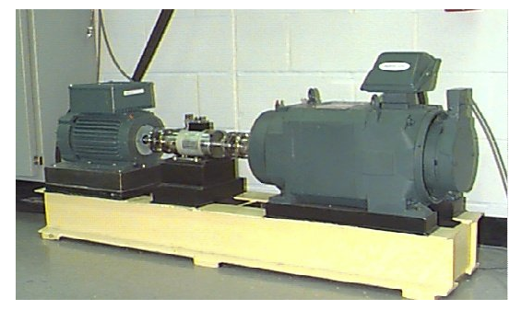

As shown in **Figure 1** above, the test stand consists of a 2 hp motor (left), a torque transducer/encoder (center), a dynamometer (right), and control electronics (not shown). The test bearings support the motor shaft. Single point faults were introduced to the test bearings using electro-discharge machining with fault diameters of 7 mils and, 28mils (1 mil=0.001 inches). The fault specification are as follows:

|  |  |  |  |  |
| --- | --- | --- | --- | --- |
| **Bearing** | **Fault Location** | **Fault Diameter** | **Bearing Manufacturer** | **Datalink** |
| Drive End | NO Fault (healthy) | NA | SKF |  |
| Drive End | Inner Raceway | .007 | SKF |  |
| Drive End | Inner Raceway | 0.028 | SKF |  |
| Drive End | Ball | 0.007 | SKF |  |
| Drive End | Ball | 0.028 | SKF |  |

Digital data was collected at 12,000 samples per second, using accelerometer sensors. The file name are as follows:A_X.csv which means A represents the type of fault while X represents the diameter of the fault. Each csv file contain data under the two operating conditions mentioned below.

Operating conditions:

1. 0kw load and 1797 RPM
2. 3kw load and 1730 RPM

Reference:

https://engineering.case.edu/bearingdatacenter