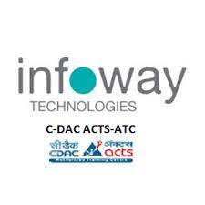

**Project Name** :- **ScarpYard**

**Project Members**:-

**Ms. Swati Sonaje 210943120102**

**Ms. Dhanashri Deore 210943120027**

**Mr. Pratik Varute 210943120074**

**Mr. Mayank Namdev 210943120051**

1. **Introduction** 
   1. **Problem Definition**:-

Since last few years, we have seen and observed that many of the factories, Industries are using solid waste as a raw material to increase their productions and to get a large amount of raw material as in solid waste form.

The major problem that we have observed related to landfilling due to the dumping of solid waste. Which is causing so many problems such as pollution, shortage of land, health related issues and many more. But now many of the researchers and entrepreneur invented and came up with so many ideas to reuse, recycle and reduce waste such as plastic, paper, iron, oil, etc.

In India as our Road transportation and highways minister Mr. Nitin Gadkari proposed a rule related to construction of road is to be done by the mixing of shredded plastic into it for so many good reasons. Now as a survey says if you try to make all the roads in India constructed with the help of plastic then till now the plastic waste that we generated will not be enough….!

So the problem that we observed is that the link between the Scrap Dealers who are collecting the waste across the city, town they collect the waste and sell it to the factories, industries but they are restricted to a particular area. Same with the Industrialists they are facing problem related to the regular supply of the raw material is there.

**1.2. Objective of Project**

Our main objective behind developing this project is that to establish a direct link between the scrap dealers with the industrialist and the traders (importers, exporters).

So the Scrap dealers can sell their product across the country and the industrialist can get enough of raw material for continuous production at a fair price.

As we know internet is everywhere and it is the easiest way to find people for our own benefits. So here we design a system, a B2B (business to business) model like an e-commerce website for mainly selling the scarp.

1. **Feasibility Study**
2. **Analysis**

**3.1. Existing System**

* The current system that are available in the market are not a separate body for particular scrap or waste.
* Their designed model is not so user friendly.
* And currently the main design of our designed model is not available in the current market.
* Many times due to monopoly of the scrap dealers the industrialist have to suffer.

**3.2 Proposed System**

* This system is particularly designed for the waste and scrap dealing.
* This system increase the network of sell for the dealers as well as industrialists and traders.
* This system provides the continuity and regular flow of the goods and product.

**3.3 Software Requirement Specification**

**3.3.1 Hardware**

* Intel i3 processor 3 rd generation or later / AMD Ryzen 200 2 nd generation or later
* 2 GB ddr3 ram.
* Windows 7 Home edition or later.
* 200 GB Sata HDD Space
* Data Connection 200 kbps

**3.3.2 Software**

* SpringToolSuit
* MySQL 5.7 with Workbench 8.0
* Google Chrome version 79.0
* Visual Studio

1. **Design**
   1. **UML Diagram**

**Flow diagram**

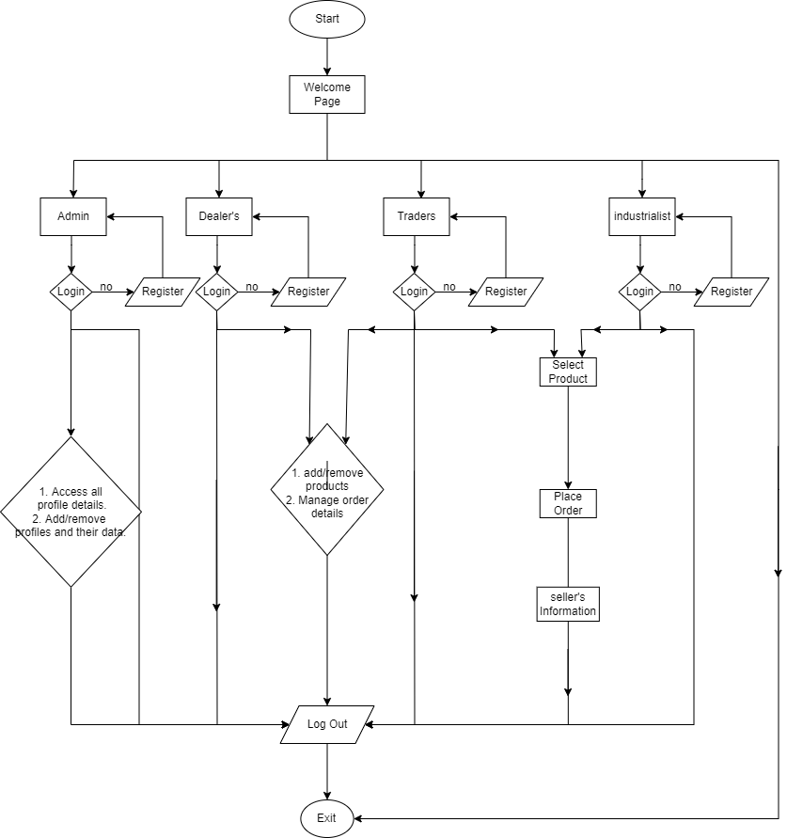

**Entity relation diagram**

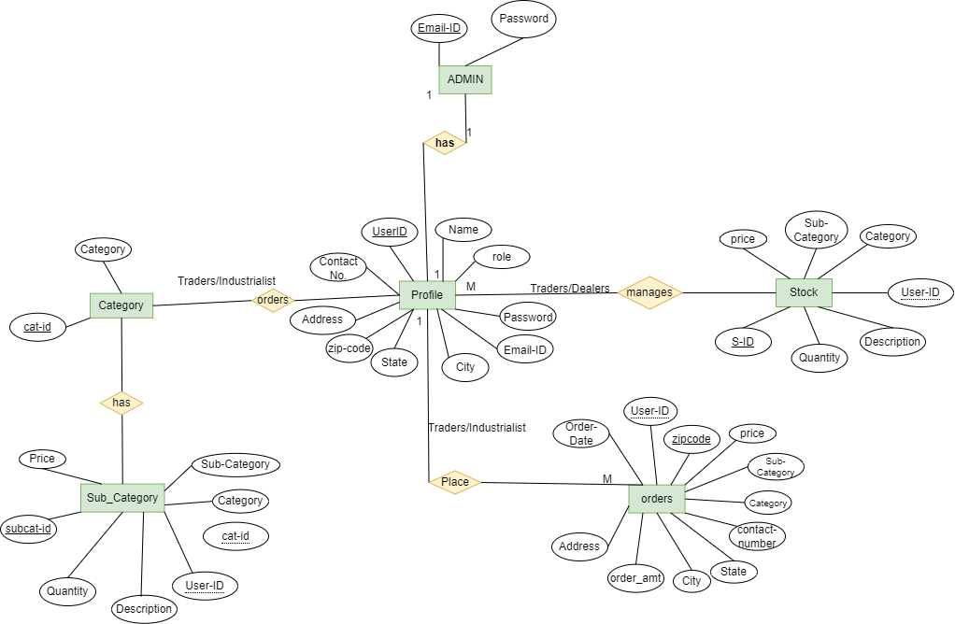

**5 Implementation**

**5.1 Modules**

1. Admin Module

2. User Module

**5.2 Module Discription**

**1. Admin Module**

1. Admin will login as Admin from the ‘Admin login’ page

2. After login Dashboard page will be displayed to him which will display the list of all users such as dealer, importer/exporter and trader.

If admin finds any malware practice of any user of the user he has right to delete him and remove him as a part of our application.

**2. Users**

i. User will login as user from the ‘User login’ page to the portal or will have to register if he is not a registered user.

ii. After registration User will login and Dashboard page will be displayed as per his role .According to his role the features and responsibilities will be displayed to him.

1) Trader-

i) Trader is an importer/exporter of our application can click on sell product button to add and sell new products into our application .also his personal stock will get decremented for the corresponding category and subcategory of the product.

He can click on view stock button to view his reflected stock.

ii) He can click on buy new products button to buy the products for himself and that purchased product details will get added to order table.

iii) He will be able to see the seller's information of that purchased product and can contact him in future.

iv) He can view his orders by clicking on view your orders option.

v) He can add his personal stock for the category, stock, quantity and subcategory of the products for selling purpose.

vi) If that stock quantity gets changes from his end he can update that quantity.

vii) Trader can view his stock by clicking view stock.

viii) Trader can logout

2)Industrialist-

i) Industrialist-Industrialist is a buyer of our application.

ii)He can click on buy new products button to buy the products for himself and that purchased product details will get added to order table.

iii)He will be able to see the seller's information of that purchased product and can contact him in future.

iv) He can view his orders by clicking on view your orders option.

v) Industrialist can logout

3)Dealer-

i) Dealer is a seller of our application.

ii) Dealer is seller of our application can click on sell product button to add and sell new products into our application,

also his personal stock will get decremented for the corresponding category and subcategory of the product.

iii) He can click on view stock button to view his reflected stock.

iv) He can add his personal stock for the category and subcategory of the products for selling purpose.

v) Dealer can view that stock by clicking view stock.

vi) Dealer can logout

**5.3 Technologies’ Used**

**1. Spring Framework:**

Spring Framework is a Java platform that provides comprehensive infrastructure support for developing Java applications. Spring handles the infrastructure so you can focus on your application.

Spring enables you to build applications from “plain old Java objects” (POJOs) and to apply enterprise services non-invasively to POJOs. This capability applies to the Java SE programming model and to full and partial Java EE.

**1.1 Features of Spring Framework:**

**1. Lightweight**

Spring is modular lightweight framework which allows you to selectively use any of its modules on the top of Spring Core.

**2. Inversion of Control (IOC)**

This is another top feature of Spring framework where application dependencies are satisfied by the framework itself. Framework creates the object in runtime and satisfies application dependencies.

**3. Aspect Oriented Programming (AOP)**

Aspect Oriented Programming (AOP) is very popular in programming world and in Spring it is well implemented. Developer can use Aspect Oriented Programming (AOP feature of Spring to develop application in which business logic is separated from system services.

**4. Container**

Spring provides their own container for managing the bean lifecycle.

**5. MVC Framework**

Spring MVC Framework is used for developing MVC based web applications.

**6. Transaction Management**

Spring framework provides generic Transaction Management layer which can be used with or without J2EE(JEE) environment.

**7. JDBC Exception Handling**

Spring provides their own abstraction of JDBC exception which further simplifies the exception handling in program.

**1.2 Advantages of Spring Framework:**

**1. Solving difficulties of Enterprise application development**

Spring is solving the difficulties of development of complex applications, it provides Spring Core, Spring IoC and Spring AOP for integrating various components of business applications.

**2. Support Enterprise application development through POJOs**

Spring supports development of Enterprise application development using the POJO classes which removes the need of importing heavy Enterprise container during development. This makes application testing much easier.

**3. Easy integration other frameworks**

Spring designed to be used with all other frameworks of Java, you can use ORM, Struts, Hibernate and other frameworks of Java together. Spring framework do not impose any restriction on the frameworks to be used together.

**4. Application Testing**

Spring Container can be used to develop and run test cases outside enterprise container which makes testing much easier.

**5. Modularity**

Spring framework is modular framework and it comes with many modules such as Spring MVC, Spring ORM, Spring JDBC, Spring Transactions etc. which can used as per application requirement in modular fashion.

**6. Spring Transaction Management**

Spring Transaction Management interface is very flexible it can configure to use local transactions in small application which can be scaled to JTA for global transactions.

**2.MySQL**

**Features of MySQL:**

* **MySQL is a database management system.**

A database is a structured collection of data. It may be anything from a simple shopping list to a picture gallery or the vast amounts of information in a corporate network. To add, access, and process data stored in a computer database, you need a database management system such as MySQL Server. Since computers are very good at handling large amounts of data, database management systems play a central role in computing, as standalone utilities, or as parts of other applications.

* **MySQL databases are relational.**

A relational database stores data in separate tables rather than putting all the data in one big storeroom. The database structures are organized into physical files optimized for speed. The logical model, with objects such as databases, tables, views, rows, and columns, offers a flexible programming environment.

* **MySQL software is Open Source.**

Open Source means that it is possible for anyone to use and modify the software. Anybody can download the MySQL software from the Internet and use it without paying anything.

* **The MySQL Database Server is very fast, reliable, scalable, and easy to use.**

MySQL Server was originally developed to handle large databases much faster than existing solutions and has been successfully used in highly demanding production environments for several years. Although under constant development, MySQL Server today offers a rich and useful set of functions. Its connectivity, speed, and security make MySQL Server highly suited for accessing databases on the Internet.

* **MySQL Server works in client/server or embedded systems.**

The MySQL Database Software is a client/server system that consists of a multithreaded SQL server that supports different back ends, several different client programs and libraries, administrative tools, and a wide range of application programming interfaces (APIs).

**3. React**

React is a JavaScript library for building user interfaces.

React is used to build single-page applications.

React allows us to create reusable UI components.

**6. Test Cases**

**Registered User Login Test Cases:**



**7. Screenshots of Web Pages**

HOME PAGE

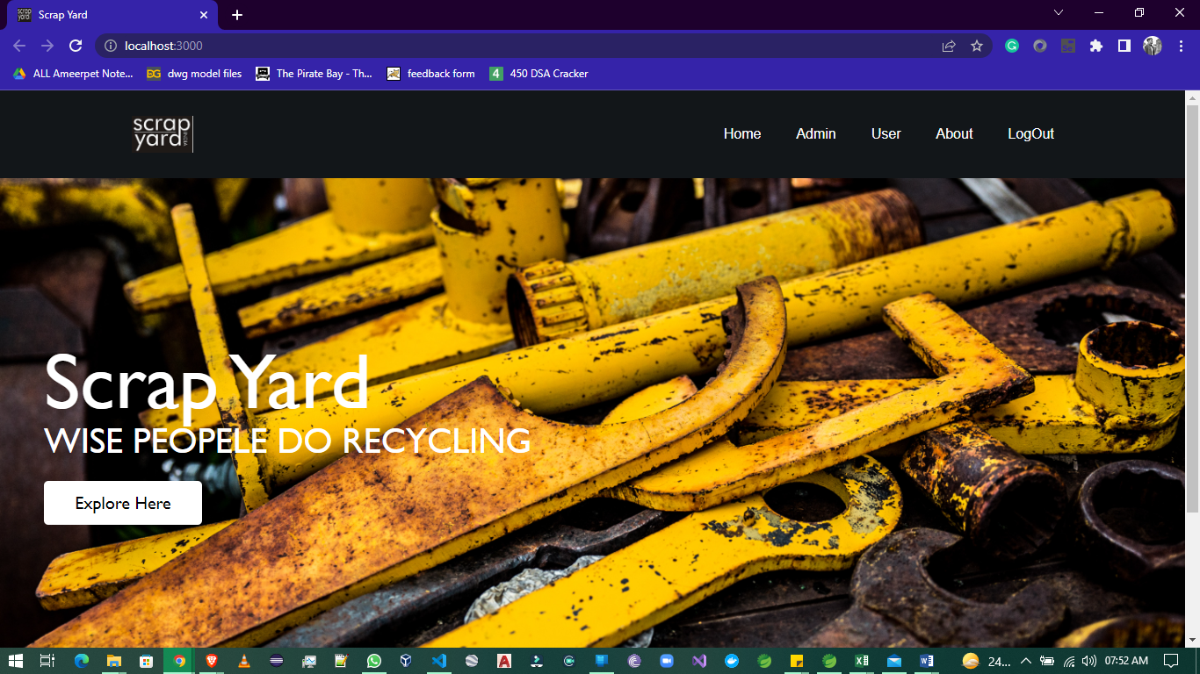

ADMIN LOGIN

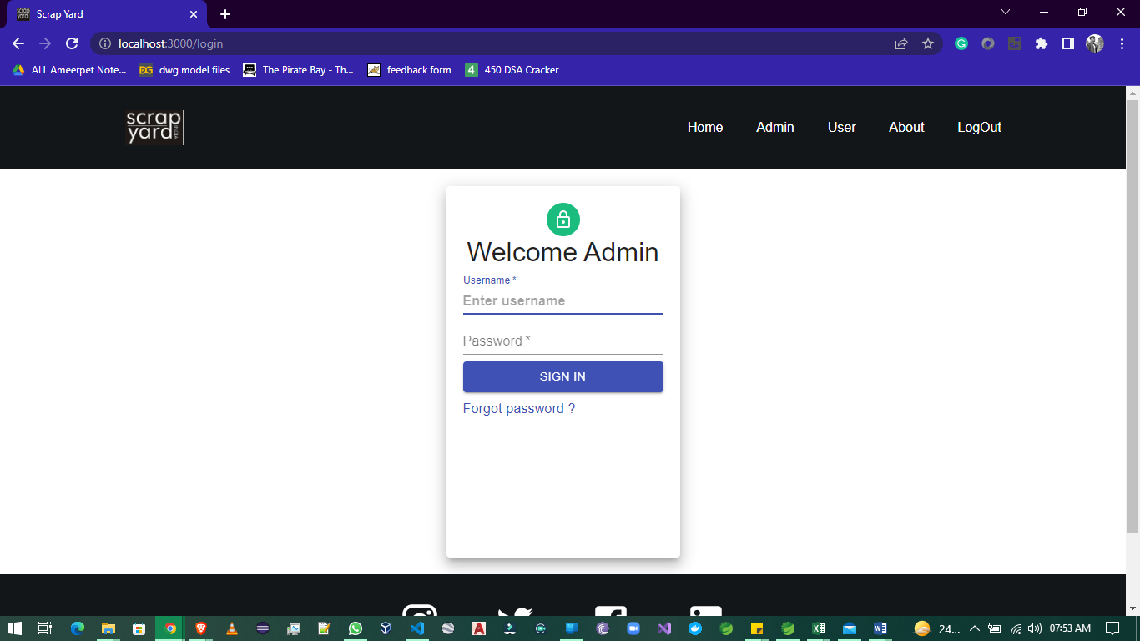

**ADMIN DASHBOARD**

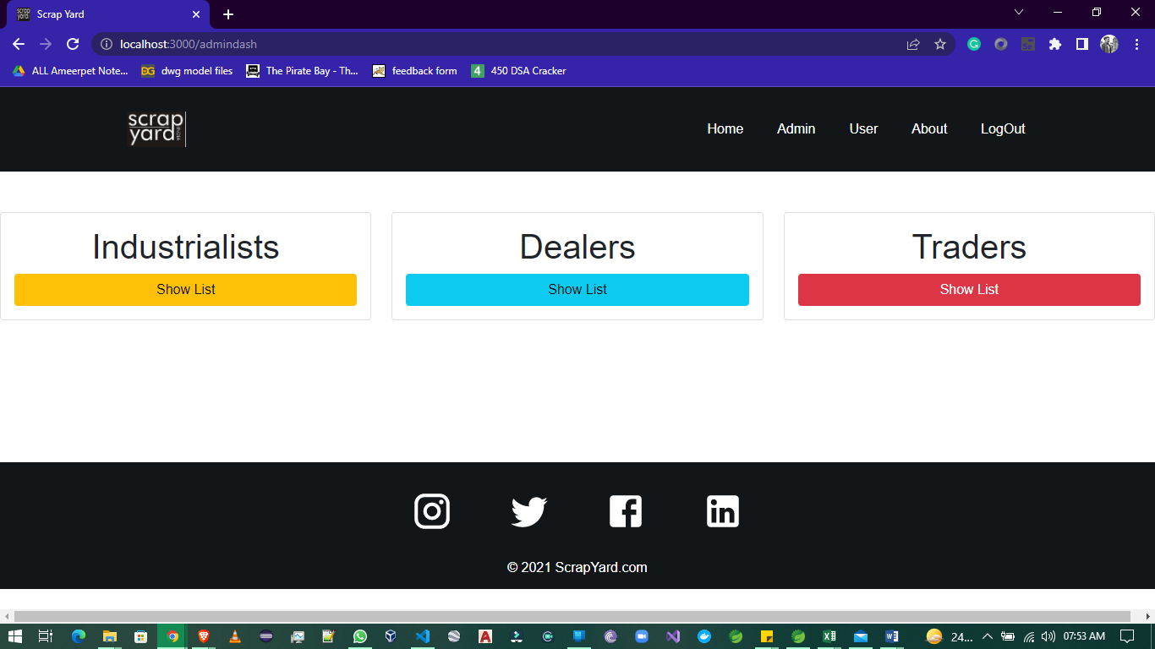

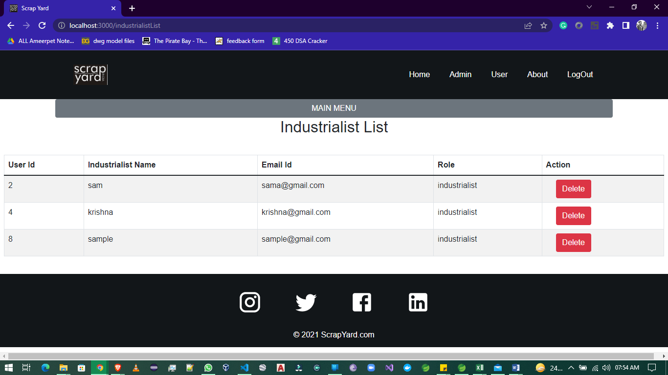

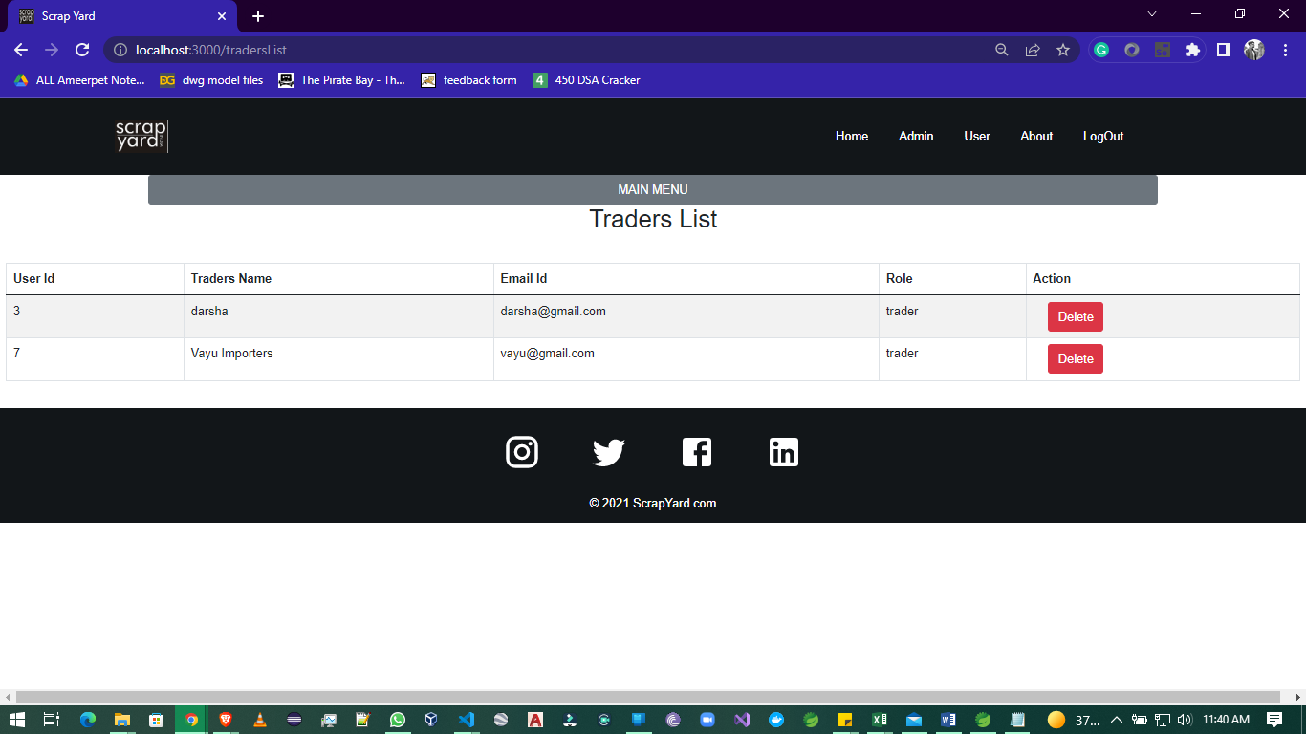

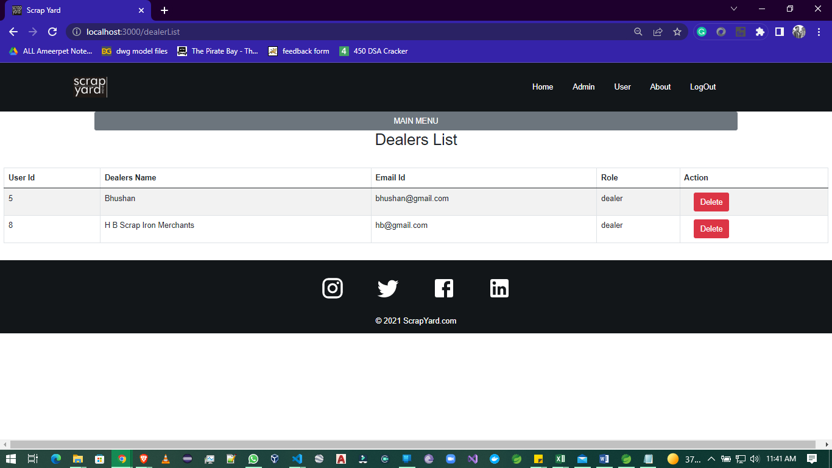

**USER LOGIN**

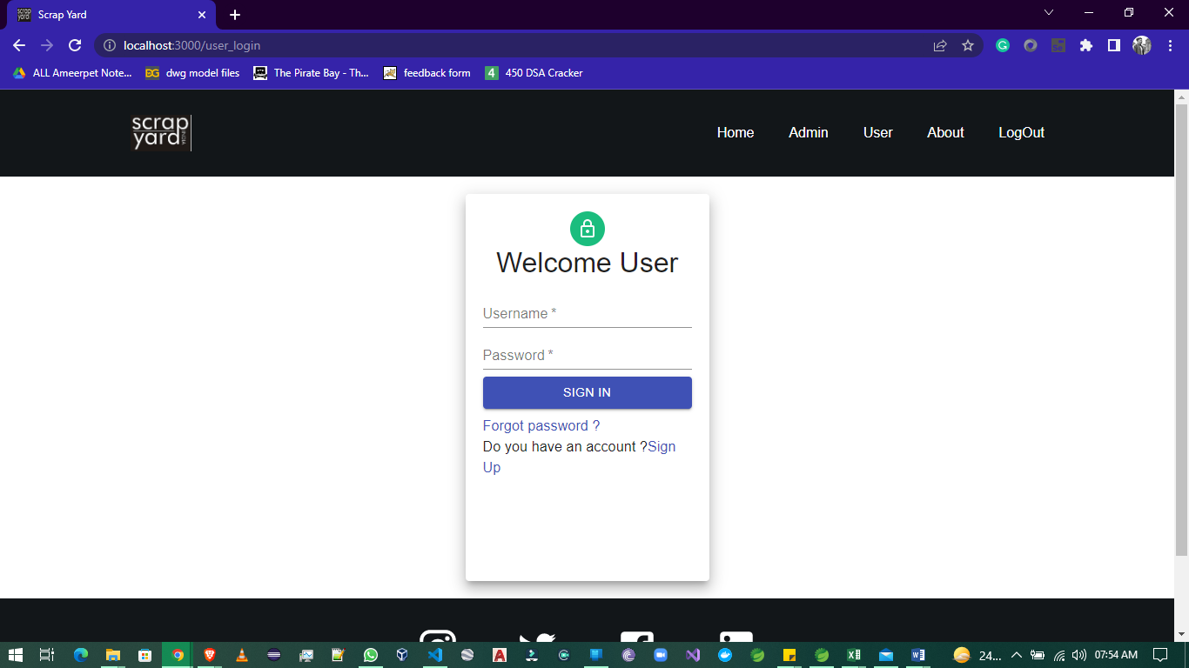

**INDUSTRIALIST DASHBOARD**

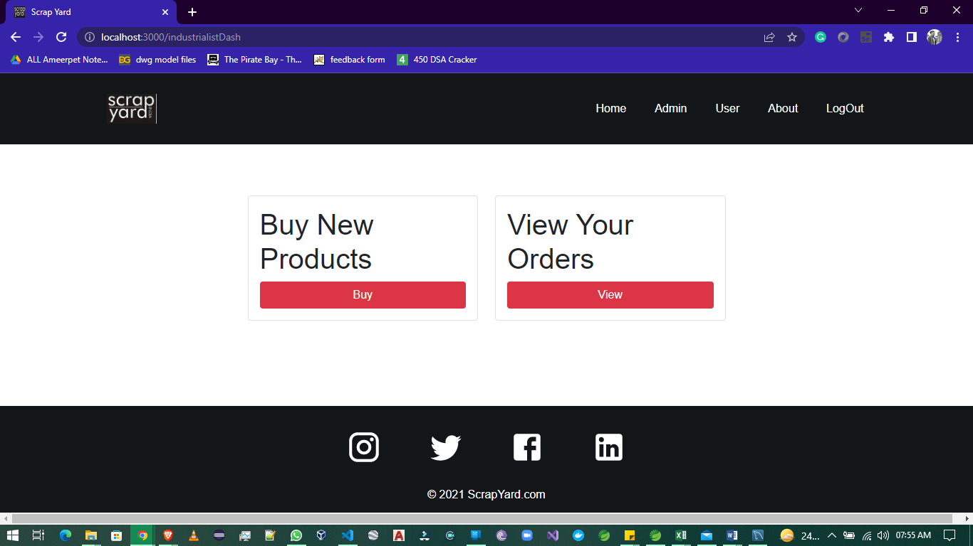

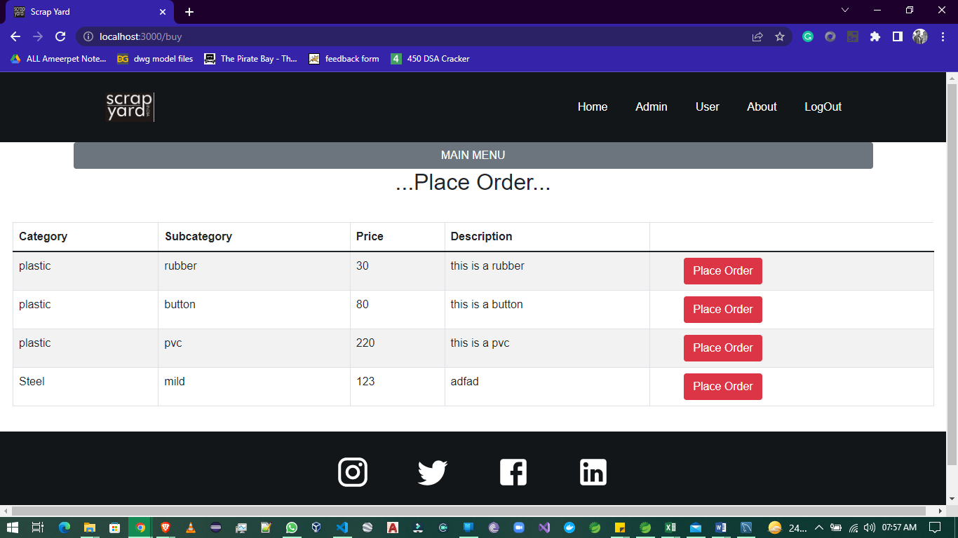

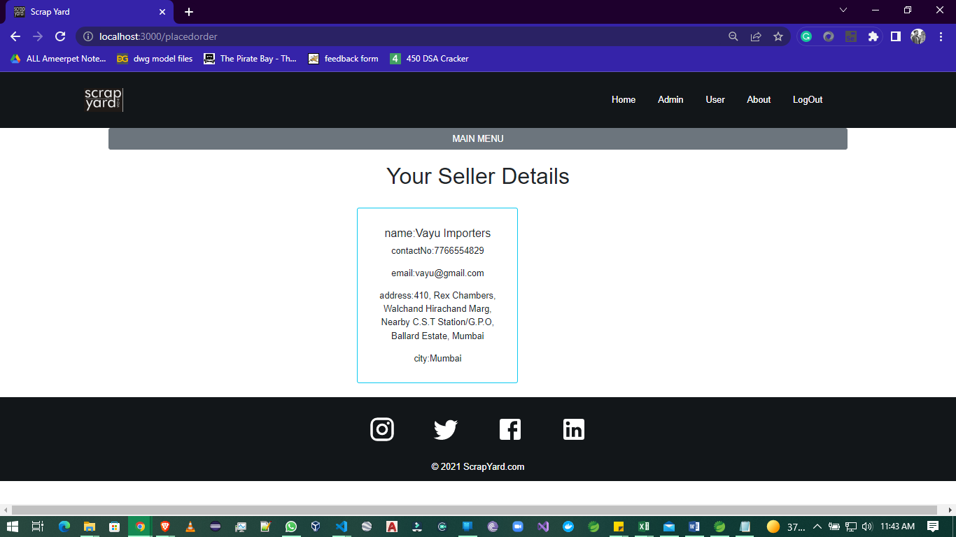

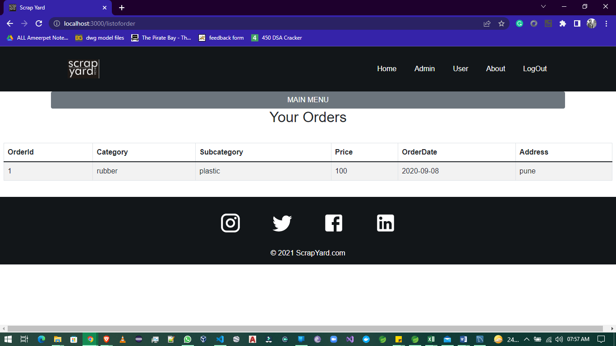

**TRADERS DASHBOARD**

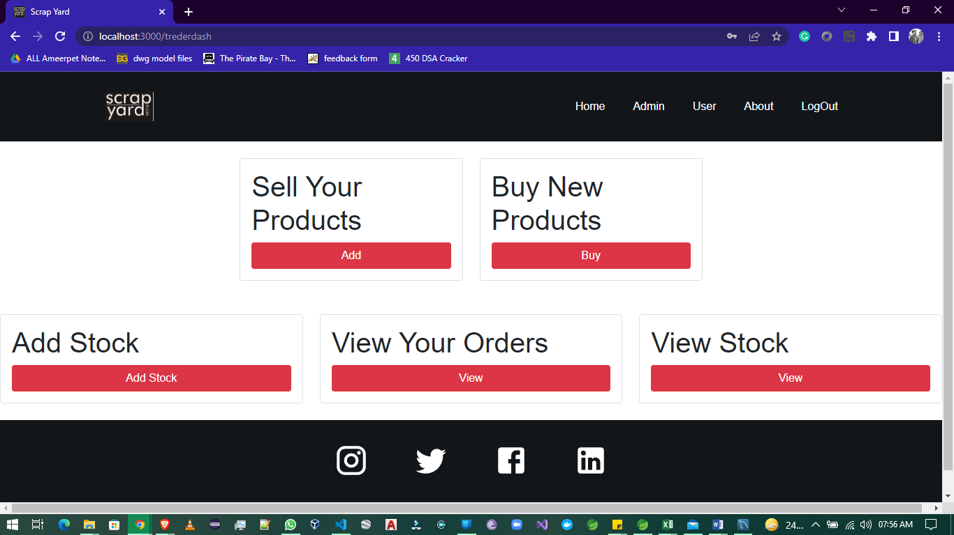

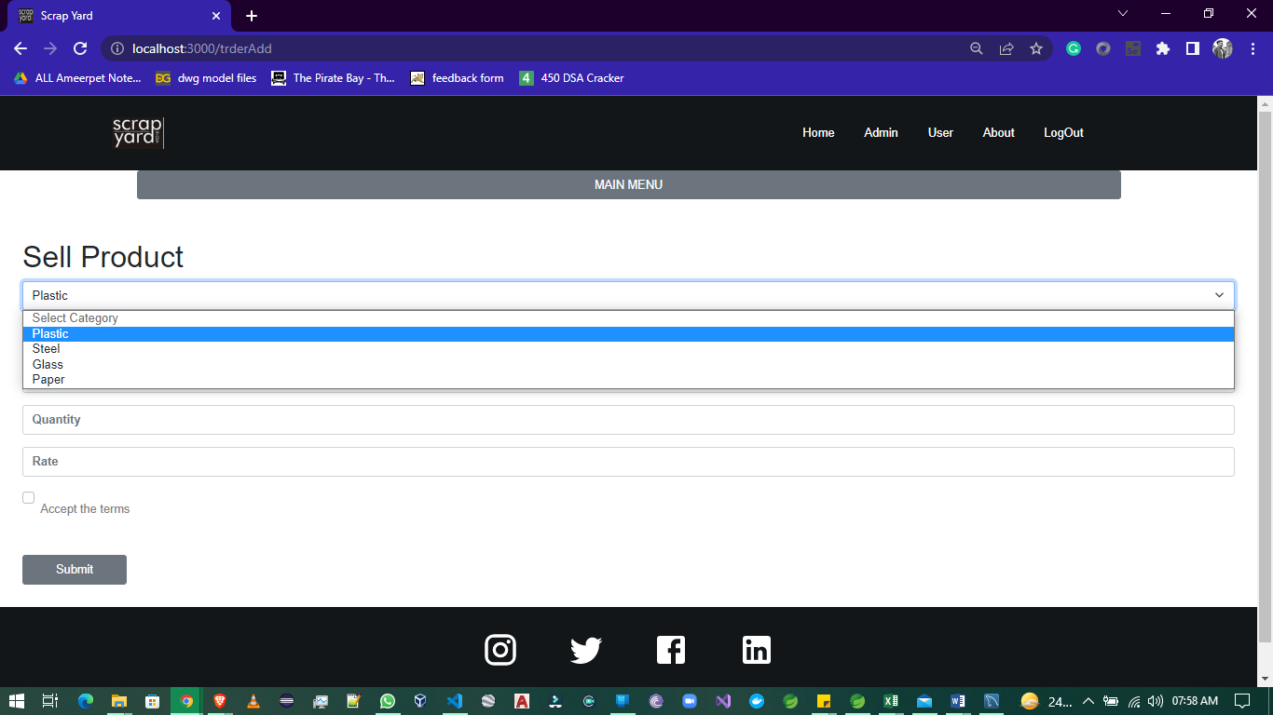

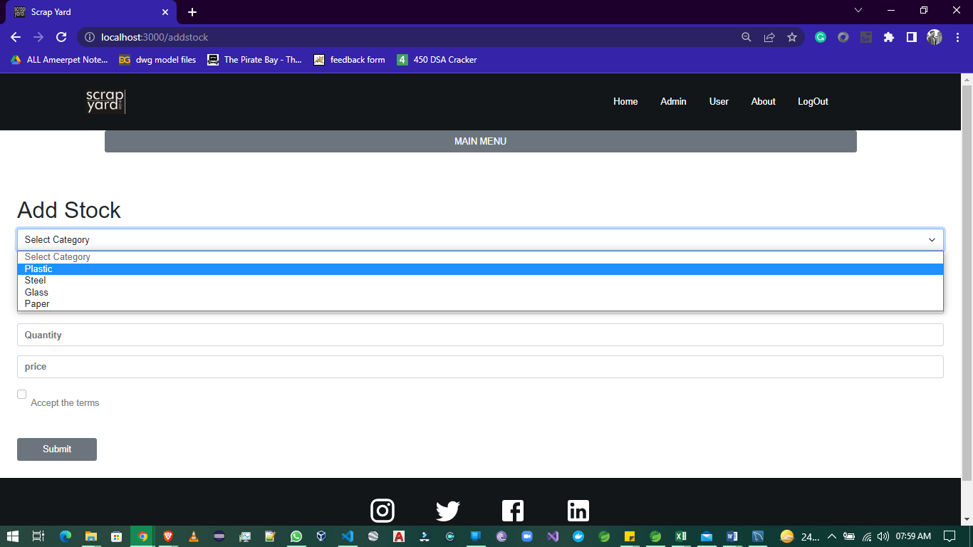

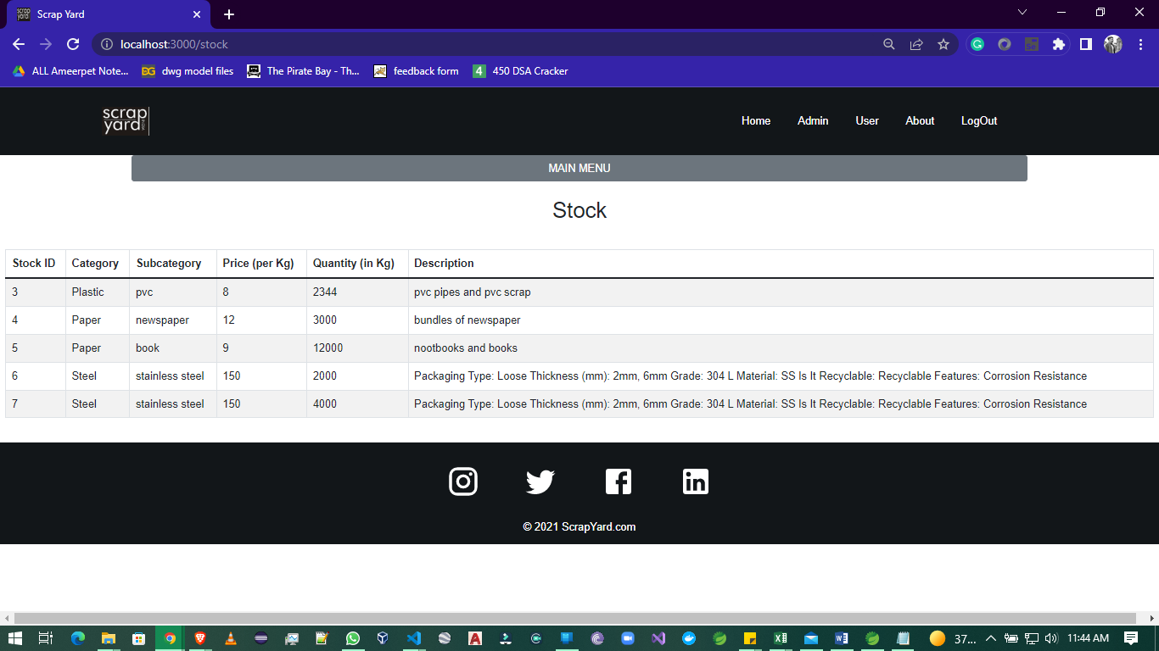

**DEALERS DASHBOARD**

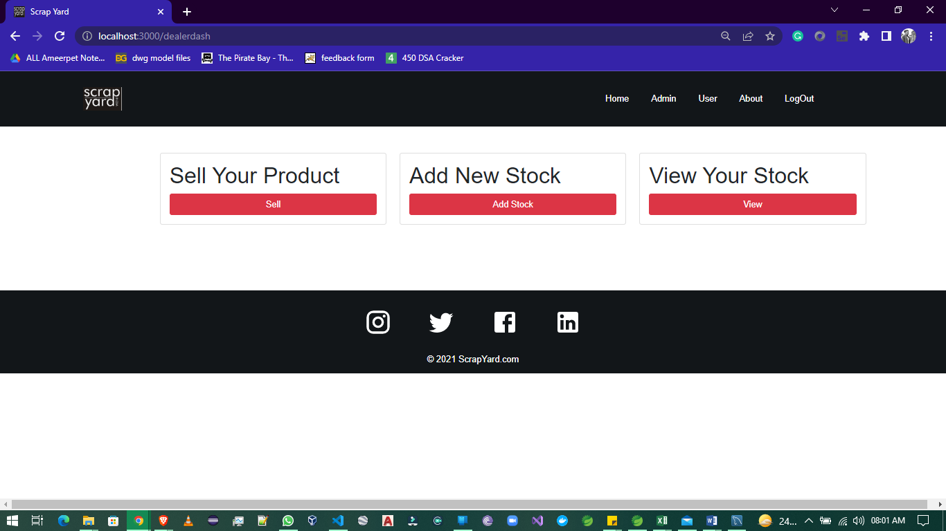

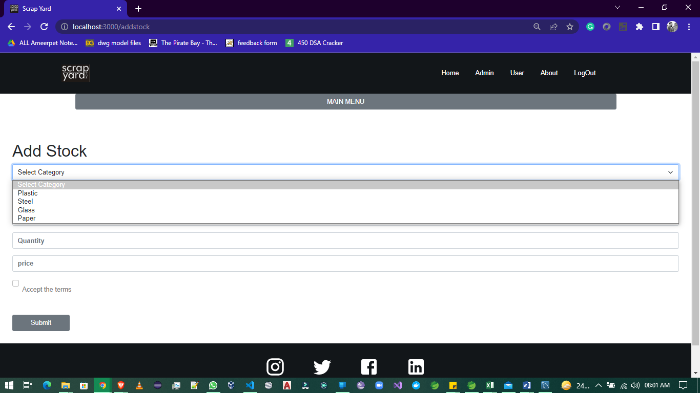

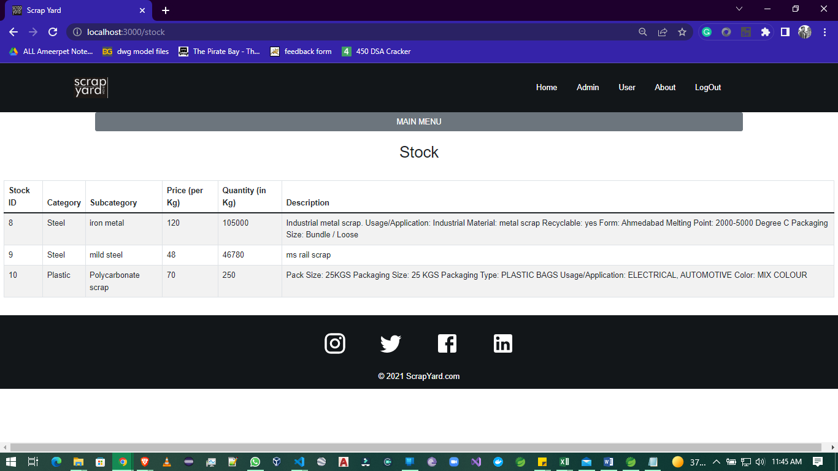

**8. Conclusion**

So thus we have successfully developed a smart website through which a user can sell all type of scarp and buyers can purchase those scrap. In a single application admin can also manages all the admin work.

**9. Future Enhancement**

* We will generate auction system.
* We will connect international clients for business expansion.
* We will provide tracking and delivery system.
* We will provide services that helps for tax benefits.
* Industrialist can also sell his raw waste material.
* This platform not only sell the scrap but also the used and old factory machineries and parts

**10. Bibliography**

1. <https://www.w3schools.com/>

2. <https://start.spring.io/>

3. <https://react-bootstrap.github.io/>

4. <https://stackoverflow.com/>

5. https://www.javatpoint.com/