Quality-Aware Multi-Patch Remote Photoplethysmography for Contactless Atrial Fibrillation Screening from Facial Video
BCSE417L – Machine Vision
Final Project Report
Team Members
Mayank, Vyomesh Pandita
23BAI0158, 23BAI0151

School of Computer Science and Engineering
Vellore Institute of Technology
Vellore
Fall Semester 2025-26

Abstract
1. Motivation, aim and objective. Atrial fibrillation (AF) is the most common sustained heart-rhythm disorder; it is often silent, it raises the risk of stroke about five-fold, and it is treatable once found (Wolf et al., 1991; US Preventive Services Task Force, 2018). Remote photoplethysmography (rPPG) recovers the pulse from tiny, heartbeat-driven colour changes of the skin in an ordinary video, so a contactless rhythm check is possible in principle (Yan et al., 2018). The obstacle is that anything that disturbs beat timing makes a normal rhythm look irregular, which is what AF looks like, so poor signals produce false AF alarms. The aim was a machine-vision system that screens for AF from facial RGB video with few false alarms, flags slow, fast and extra (premature) heartbeats, and says when it cannot be trusted.
2. About methodology. MediaPipe FaceLandmarker gives 478 3D face landmarks and the head pose in every frame. The forehead and cheeks are divided into up to 25 mesh-based patches, and the POS algorithm turns each patch's colour trace into a pulse. Every second, each patch is trusted by four checks that do not assume a regular rhythm (orientation, brightness, consistency with the other patches, beat agreement); trusted patches are fused, head motion is regressed out, and a rhythm-independent confidence is computed. Beats are located with sub-frame precision. A random forest on five beat-interval irregularity features, trained on MIMIC PERform AF with camera-like timing noise, screens 30 s windows for AF after isolated extra beats are removed by a timing rule tuned on MIT-BIH Arrhythmia.
3. Outcome. The system outputs heart rate, a rhythm result (“regular rhythm”, “possible AF – see a doctor” or “signal unreliable”), the number of extra beats, slow or fast heart-rate flags, RMSSD and a confidence, and runs live on a webcam with the patch trust map drawn on the face. Breathing rate was built and evaluated but is not shown, because it proved unreliable. Only part of UBFC-rPPG could be downloaded and the AF face-video dataset (OBF) was not available, so the face-video evaluation uses 12 normal-rhythm videos, and AF detection is evaluated on contact pulse signals.
4. Efficiency attained. On MIMIC PERform AF (35 patients, leave-one-subject-out) the AF classifier reached an AUC of 0.96 on camera-like pulses, detecting all 19 AF patients and clearing 14 of 16 non-AF patients; confidence gating raised the AUC to 0.99 while keeping 96% of AF windows, whereas a spectral-sharpness gate would have discarded 94–100% of them. On the 12 healthy face videos, AF false alarms fell from 11 (GREEN) and 2 (CHROM) to 1 (POS on one region) and 0 (the proposed method). Heart-rate error on the face videos was 0.2 BPM, beat-interval error 21 ms, extra-beat removal nearly halved AF false alarms caused by premature beats on MIT-BIH, the slow/fast flag agreed with the ECG in 95% of segments, and processing takes about 10 ms per frame on a laptop CPU.
Keywords: remote photoplethysmography; atrial fibrillation screening; multi-patch signal fusion; signal quality assessment; premature beats; machine vision

Introduction

1. Overall idea about the project
The project turns an ordinary camera into a contactless heart-rhythm screening tool. Every heartbeat pushes a little more blood into the facial skin, which changes how much light the skin absorbs; the change is far too small to see, but a camera records it and machine-vision processing can recover it as a pulse wave. From the pulse wave the system finds individual beats, measures the time between them, and checks whether the rhythm is regular or chaotic, as in atrial fibrillation.
The project's own contribution is how it decides which parts of the face to believe. Instead of averaging one large skin region, the face is split into up to 25 small patches that move with the face mesh. Each patch is trusted only when it faces the camera, is neither in shadow nor saturated, and shows the same pulse and the same beats as the other patches; none of these checks assumes a regular heartbeat, so a genuinely irregular rhythm is not mistaken for noise. Head motion is removed using the 3D head pose, and every result carries a confidence, so the rhythm is judged only when the signal can be trusted.

2. Background of the project
Photoplethysmography (PPG) measures blood-volume changes optically and is the principle behind pulse oximeters and smartwatches. Verkruysse et al. (2008) showed that the same signal can be recorded remotely with a consumer camera under ambient light, which started the field of rPPG. Later methods made rPPG robust to lighting and motion using colour-space projections such as CHROM and POS (de Haan & Jeanne, 2013; Wang et al., 2017), and deep networks such as DeepPhys, PhysNet and PhysFormer learn the pulse directly from video (Chen & McDuff, 2018; Yu et al., 2019; Yu et al., 2022).
Atrial fibrillation is a rhythm disorder in which the upper chambers of the heart quiver instead of contracting, so ventricular beats arrive at irregular intervals. Blood can pool and clot in the quivering chamber; if a clot reaches the brain it causes a stroke. AF is diagnosed with an electrocardiogram (ECG), but because it is frequently silent, many people are only diagnosed after a stroke (US Preventive Services Task Force, 2018). Irregularity of the beat-to-beat intervals is the basis of automatic AF detection from ECG and from pulse signals (Tateno & Glass, 2001; Dash et al., 2009), and smartphone and face-video studies showed that the pulse alone is enough to screen for AF (McManus et al., 2013; Yan et al., 2018).
Slow (below 50 beats per minute) and fast (above 100 beats per minute) resting heart rates and premature beats are secondary findings that come from the same beat timings. A slow rate can be normal in fit people or during sleep but can also signal sinus-node or conduction disease (Kusumoto et al., 2019); a fast rate can be normal during exercise or after caffeine but can also indicate an arrhythmia. Premature beats are usually harmless but must be told apart from AF (Chong et al., 2015).

3. Statistics related to the methods used
1. Burden of AF: AF raises stroke risk nearly five-fold (Wolf et al., 1991). Its prevalence is about 2–3% at ages 65–69 and about 10% over 85, and about 20% of AF-related strokes occur in people whose AF is first found at the time of the stroke (US Preventive Services Task Force, 2018).
2. AF detection from beat intervals: comparing the distribution of successive RR-interval differences with AF templates reached 94.4% sensitivity and 97.2% specificity on the MIT-BIH AF database (Tateno & Glass, 2001); combining RMSSD, Shannon entropy and turning-point ratio reached 94.4% sensitivity and 95.1% specificity (Dash et al., 2009).
3. AF detection from camera pulses: a smartphone camera on the fingertip with RMSSD and Shannon entropy reported 96.2% sensitivity and 97.5% specificity (McManus et al., 2013); a smartphone camera filming the face detected AF with 95% sensitivity and 96% specificity against a 12-lead ECG (Yan et al., 2018), and learning systolic peaks from face video reached 96.0% accuracy for AF versus healthy subjects and 95.2% for AF versus sinus rhythm (Sun et al., 2022).
4. Heart-rate accuracy of rPPG: with the rPPG-Toolbox implementations (Liu et al., 2023), the training-free methods CHROM and POS reach 3.98 and 4.00 BPM mean absolute error on UBFC-rPPG, against 14.70 BPM for ICA and 19.82 BPM for GREEN (Paruchuri et al., 2024).
5. Normal heart-rate variability: a review of 44 studies with 21,438 healthy adults found that short-term HRV values vary widely between studies and are lower than the 1996 Task Force norms (Nunan et al., 2010), so rhythm screening should rely on irregularity features rather than fixed HRV thresholds.

4. Advantages and disadvantages of the various methods and of the project
Table 1: Advantages and disadvantages of rPPG method families and of this project
Approach | Advantages | Disadvantages
Classical, single region (GREEN, ICA, CHROM, POS) | No training; fast on a CPU; interpretable equations | One region mixes good and bad skin; sensitive to motion, shadows and shine
Deep learning (DeepPhys, PhysNet, TS-CAN, PhysFormer) | Lowest heart-rate error on benchmark datasets | Needs labelled training data and often a GPU; weaker across datasets; opaque
Multi-region weighting (DistancePPG, random patches, SAMC) | Uses the best skin regions; more robust to local noise | Designed and evaluated for heart rate, not for preserving irregular beat timing
Rhythm screening from pulse intervals (Dash, McManus, Yan) | Simple, explainable features; high accuracy on clean signals | Motion and missed beats look like AF, creating false alarms
This project | One ordinary camera; per-patch trust without a regular-rhythm assumption; motion removal; confidence-gated decisions; real-time on a CPU | Accuracy still depends on lighting and camera; gated decisions reduce coverage; a screening aid, not a diagnosis; no AF face videos were available for testing

Literature Survey / Related Works

1. Remote plethysmographic imaging using ambient light
Citation: (Verkruysse et al., 2008)
Verkruysse et al. showed that a plethysmographic signal can be recorded from the face at more than 1 m with a simple consumer digital camera under ordinary ambient light, without any dedicated illumination. They found that the green channel carries the strongest pulse signal because haemoglobin absorbs green light strongly, and that heart and respiration rates can be read from the signal's spectrum. The work established the principle of rPPG but used manually selected regions and stationary subjects, leaving robustness to motion and lighting open.

2. Non-contact, automated cardiac pulse measurements using video imaging and blind source separation
Citation: (Poh et al., 2010)
Poh et al. automated webcam pulse measurement with face tracking and independent component analysis (ICA), which separates the pulse from other colour variations in the RGB traces. Pulse rates from webcam video agreed closely with an FDA-approved finger blood-volume-pulse sensor, and the method tolerated slight motion and could measure several people at once. The study showed that low-cost webcams can measure heart rate, but its blind source separation offers limited robustness to stronger motion.

3. Robust pulse rate from chrominance-based rPPG
Citation: (de Haan & Jeanne, 2013)
De Haan and Jeanne proposed CHROM, which builds two chrominance signals from normalised RGB under a standardised skin-tone assumption and combines them with a ratio that cancels motion-induced specular changes. On 117 stationary subjects it agreed with contact PPG in 92% of cases with half the RMSE of blind-source-separation methods, and on a fitness bike correct pulse-rate detection rose from 79% to 98%. It remains a standard classical baseline, although it still processes one skin region as a whole.

4. Improved motion robustness of remote-PPG by using the blood volume pulse signature
Citation: (de Haan & van Leest, 2014)
De Haan and van Leest introduced the PBV method, which uses the known colour signature of the blood-volume pulse across the R, G and B channels to project the signal. Because the pulse direction in colour space is fixed, distortions in other directions are suppressed; in a gym study the correct pulse rate was obtained in 68% of measurements against 60% for the best earlier method. The method depends on an accurate signature, which can vary with camera and skin tone.

5. Algorithmic principles of remote PPG
Citation: (Wang et al., 2017)
Wang et al. derived a mathematical model of skin reflection that explains classical rPPG methods as different projections of the RGB signal. From it they proposed POS, which projects temporally normalised RGB onto a plane orthogonal to the skin tone and combines the two projections with an alpha-tuning step. POS needs no training and is among the most accurate training-free methods in later benchmarks (Paruchuri et al., 2024), which is why it is the per-patch pulse extractor in this project.

6. Exploiting spatial redundancy of image sensor for motion robust rPPG
Citation: (Wang et al., 2015)
Wang, Stuijk and de Haan treated every tracked skin pixel as an independent rPPG sensor and combined these many pulse signals. With motion-compensated pixel tracking, spatial pruning and temporal filtering, the SNR on 36 challenging videos rose from 3.34 dB to 6.76 dB over the previous best method. The work motivates measuring many small skin regions, as done with the 25 patches here, but it was evaluated on pulse rate, not on irregular rhythms.

7. DistancePPG: Robust non-contact vital signs monitoring using a camera
Citation: (Kumar et al., 2015)
Kumar et al. divided the face into small regions, tracked them over time and combined their signals with a weighted average whose weights, estimated from the video itself, reflect local blood perfusion and incident light. Across 12 subjects the weighting improved SNR by about 4.1 dB over face averaging, with larger gains for darker skin tones, and reduced heart-rate bias. It is the closest prior work to our patch fusion, but it was designed and evaluated for heart rate, not for rhythm analysis.

8. Robust heart rate measurement from video using select random patches
Citation: (Lam & Kuno, 2015)
Lam and Kuno selected local facial patches, treated their signals as a blind source separation problem, and combined many per-patch estimates by majority voting. The method needed no controlled setup and coped with motion and illumination changes on a large database of challenging videos. Its output is a heart rate rather than beat timing, so it cannot support rhythm analysis directly.

9. Self-adaptive matrix completion for heart rate estimation from face videos under realistic conditions
Citation: (Tulyakov et al., 2016)
Tulyakov et al. dynamically selected the face regions useful for heart-rate estimation using matrix completion, estimating the heart rate and the regions to use jointly. The approach significantly outperformed earlier methods on public benchmarks recorded under naturalistic conditions. It shows that region selection matters under realistic conditions, though its optimisation is heavier than simple weighting.

10. Unsupervised skin tissue segmentation for remote photoplethysmography
Citation: (Bobbia et al., 2019)
Bobbia et al. avoided face and skin detection altogether by dividing the video into temporal superpixels, extracting a pulse from each and weighting them by their pulsatility. The method outperformed the state of the art at the time. The paper also introduced a new public dataset for comparing rPPG algorithms, UBFC-rPPG, which is one of the evaluation datasets of this project.

11. Detecting pulse from head motions in video
Citation: (Balakrishnan et al., 2013)
Balakrishnan et al. showed that the head moves very slightly with each heartbeat, as a reaction to the influx of blood, and recovered the pulse by tracking head feature points and applying principal component analysis; on 18 subjects the heart rates were nearly identical to an ECG. For this project the finding is a caution: head-pose signals can contain the pulse, so regressing the pulse on small head movements can remove real pulse, which our motion-removal design guards against.

12. Orientation-conditioned facial texture mapping for video-based facial remote photoplethysmography estimation
Citation: (Cantrill et al., 2024)
Cantrill et al. used a 3D face mesh to map facial texture into a pose-independent space and conditioned the network on facial orientation. Trained on PURE and tested on MMPD it improved on the PhysNet baseline by 18.2%, and by up to 29.6% in the motion scenarios. It supports the use of 3D orientation in this project, where patch orientation is used explicitly as a trust check rather than inside a network.

13. DeepPhys: Video-based physiological measurement using convolutional attention networks
Citation: (Chen & McDuff, 2018)
Chen and McDuff proposed DeepPhys, an end-to-end convolutional network for heart and breathing rate that uses normalised frame differences as a motion representation and an appearance branch that produces attention masks over skin. It significantly outperformed earlier methods on both RGB and infrared video datasets. As a supervised model it requires labelled training data and may generalise poorly to new conditions.

14. Remote photoplethysmograph signal measurement from facial videos using spatio-temporal networks
Citation: (Yu et al., 2019)
Yu, Li and Zhao proposed PhysNet, a 3D convolutional network that recovers the rPPG waveform from facial video end to end, using spatio-temporal features. Trained on OBF and tested across datasets on MAHNOB-HCI, it recovered the waveform well enough for heart-rate variability analysis and gave promising results for AF detection. Deep models like this are used in this project only as comparison baselines.

15. Multi-task temporal shift attention networks for on-device contactless vitals measurement
Citation: (Liu et al., 2020)
Liu et al. proposed TS-CAN, which uses temporal shift modules to model time without 3D convolutions and estimates pulse and respiration jointly. The design runs at more than 150 frames per second on a mobile ARM CPU with state-of-the-art accuracy at the time. It shows that efficiency matters for deployment, a requirement that our CPU-only pipeline also meets.

16. PhysFormer: Facial video-based physiological measurement with temporal difference transformer
Citation: (Yu et al., 2022)
Yu et al. introduced PhysFormer, a video transformer with temporal-difference attention that captures long-range spatio-temporal relations in facial video. With label-distribution learning and a curriculum-style frequency constraint it achieved state-of-the-art results on several datasets without large-scale pre-training. Its computational cost and reliance on training data contrast with the training-free signal-level method of this project.

17. rPPG-Toolbox: Deep remote PPG toolbox
Citation: (Liu et al., 2023)
Liu et al. released an open-source toolbox that implements unsupervised methods (GREEN, ICA, CHROM, POS and others) and supervised networks with standardised preprocessing and evaluation. With these implementations, CHROM and POS reach about 4 BPM error on UBFC-rPPG (Paruchuri et al., 2024). Its GREEN and CHROM implementations are the reference for the baselines re-implemented in this project.

18. Contact-free screening of atrial fibrillation by a smartphone using facial pulsatile photoplethysmographic signals
Citation: (Yan et al., 2018)
Yan et al. used a smartphone application (Cardiio Rhythm) to record facial videos of patients and classify the facial pulse as AF or sinus rhythm. Against a 12-lead ECG it reached 95% sensitivity and 96% specificity, with positive and negative predictive values of 92% and 97%. The study proved that face-video AF screening is feasible; how such screening behaves when people move or the lighting changes, where false alarms arise, is the question this project focuses on.

19. High-throughput, contact-free detection of atrial fibrillation from video with deep learning
Citation: (Yan et al., 2020)
Yan et al. extended their work to detect AF from one-minute videos containing several people at once, using a pretrained deep convolutional neural network on the facial PPG signals. The study showed that video-based AF screening can scale from one person to several people in the same video. It relies on a trained deep model.

20. The OBF database: A large face video database for remote physiological signal measurement and atrial fibrillation detection
Citation: (Li et al., 2018)
Li et al. collected the OBF database of face videos with synchronised reference physiological signals from healthy volunteers and from patients with AF, and reported baseline heart-rate, HRV and respiration accuracy together with promising AF detection from video-derived HRV features. It is one of the few resources for testing AF detection on face video. Access is granted on request, which makes it the dataset this project depends on most for its strongest result.

21. Non-contact atrial fibrillation detection from face videos by learning systolic peaks
Citation: (Sun et al., 2022)
Sun et al. trained a 3D convolutional network with a loss based on systolic-peak timing, then classified AF from HRV features of the resulting beat intervals with a support vector machine. On OBF with subject-independent cross-validation it reached 96.0% accuracy for AF versus healthy subjects and 95.2% for AF versus sinus rhythm. It uses deep learning for peak finding, whereas this project improves the signal before peak finding with patch trust and motion removal.

22. Automatic detection of atrial fibrillation using the coefficient of variation and density histograms of RR and ΔRR intervals
Citation: (Tateno & Glass, 2001)
Tateno and Glass compared the distribution of successive RR-interval differences in a segment with reference distributions from AF using a Kolmogorov-Smirnov test. On the MIT-BIH AF database this test reached 94.4% sensitivity and 97.2% specificity. It established that the randomness of beat intervals alone is a strong AF marker.

23. Automatic real time detection of atrial fibrillation
Citation: (Dash et al., 2009)
Dash et al. combined three beat-interval statistics, RMSSD for variability, Shannon entropy for complexity and the turning-point ratio for randomness, with thresholds chosen by ROC analysis. On the MIT-BIH AF database the detector reached 94.4% sensitivity and 95.1% specificity. These features form the core of the AF feature set used in this project.

24. A novel application for the detection of an irregular pulse using an iPhone 4S in patients with atrial fibrillation
Citation: (McManus et al., 2013)
McManus et al. recorded fingertip pulse videos with an iPhone 4S camera from 76 adults with persistent AF before and after cardioversion. Normalised RMSSD and Shannon entropy were higher in AF, and their combination reached 96.2% sensitivity and 97.5% specificity against a 12-lead ECG for an irregular pulse. The study shows that camera pulses carry enough timing information for AF screening.

25. Arrhythmia discrimination using a smart phone
Citation: (Chong et al., 2015)
Chong et al. extended smartphone AF detection to distinguish AF from premature atrial and ventricular contractions. They combined RMSSD and Shannon entropy with Poincaré-plot or turning-point features and pulse rise and fall times, separating premature ventricular and atrial contractions from AF with sensitivities of 96.8% and 97.8% in 99 subjects. The work shows that premature beats are a key confounder of AF detection, which motivates removing extra beats before the AF check in this project.

26. Signal-quality indices for the electrocardiogram and photoplethysmogram: Derivation and applications to wireless monitoring
Citation: (Orphanidou et al., 2015)
Orphanidou et al. derived beat-level signal-quality indices for ECG and PPG for wireless patient monitoring. For the PPG, the index identified usable signals with 91% sensitivity and 95% specificity, and was used to save power and to reduce the error of respiratory-rate estimates. It supports the idea, used in our confidence, of judging quality from individual beats rather than from the spectrum.

27. Multiparameter respiratory rate estimation from the photoplethysmogram
Citation: (Karlen et al., 2013)
Karlen et al. estimated breathing rate from the PPG using three respiratory modulations: of intensity, amplitude and frequency. Their Smart Fusion method combines the three estimates and discards those that disagree, and it has become a widely used benchmark for PPG-derived breathing rate. The breathing-rate block of this project follows this approach; on intensive-care data it proved too unreliable to be shown as an output.

28. Detecting beats in the photoplethysmogram: Benchmarking open-source algorithms
Citation: (Charlton et al., 2022)
Charlton et al. benchmarked 15 open-source PPG beat detectors on 8 datasets; the best reached F1 scores of 92–97% in AF against 99–100% in sinus rhythm. They released the MIMIC PERform datasets, among them MIMIC PERform AF with 20-minute recordings from 19 AF and 16 non-AF critically ill adults. This dataset is used in this project to train and validate the AF classifier on real AF pulse data.
Table 2: Comparative analysis of the surveyed articles
No. | Authors, year | Method / focus | Data / setting | Key result | Limitation
1 | Verkruysse et al., 2008 | Ambient-light camera PPG, green channel | Volunteers, still | PPG and rates from a consumer camera | Manual region; no motion handling
2 | Poh et al., 2010 | ICA on facial RGB | Webcam vs finger BVP sensor | Close agreement; several people at once | Limited robustness to strong motion
3 | de Haan & Jeanne, 2013 | CHROM chrominance projection | 117 still subjects; fitness | 92% agreement; half the RMSE of BSS | Single region
4 | de Haan & van Leest, 2014 | PBV pulse-signature projection | Gym and still subjects | 68% vs 60% correct in gym | Needs accurate signature
5 | Wang et al., 2017 | POS projection, skin model | Benchmark recordings | Unifying model; strong training-free method | Single region
6 | Wang et al., 2015 | Pixel-level rPPG sensors | 36 challenging videos | SNR 3.34 to 6.76 dB | Pulse rate only
7 | Kumar et al., 2015 | Region tracking + weighted average | 12 subjects, 3 skin tones | About 4.1 dB SNR gain | Heart rate only
8 | Lam & Kuno, 2015 | Local patches + BSS + voting | Challenging video database | Robust to motion and lighting | No beat timing
9 | Tulyakov et al., 2016 | Matrix completion over regions | Naturalistic benchmarks | Beat earlier methods | Heavy optimisation
10 | Bobbia et al., 2019 | Temporal superpixels by pulsatility | UBFC-rPPG (new) | No face/skin detection needed | Not motion-specific
11 | Balakrishnan et al., 2013 | Pulse from head motion | 18 subjects vs ECG | Head moves with each beat | Sensitive to other motion
12 | Cantrill et al., 2024 | Orientation-conditioned texture maps | PURE to MMPD | 18.2% better than PhysNet | Needs training
13 | Chen & McDuff, 2018 | DeepPhys attention CNN | RGB and infrared datasets | Beat earlier methods | Needs labels
14 | Yu et al., 2019 | PhysNet 3D CNN | OBF; MAHNOB-HCI (cross) | HRV-grade waveform; AF promising | Needs labels and GPU
15 | Liu et al., 2020 | TS-CAN temporal shift | Benchmark datasets | >150 fps on mobile CPU | Needs labels
16 | Yu et al., 2022 | PhysFormer transformer | Several datasets | State of the art | Heavy computation
17 | Liu et al., 2023 | rPPG-Toolbox | UBFC-rPPG, PURE, MMPD … | POS/CHROM about 4 BPM MAE | Cross-dataset drops
18 | Yan et al., 2018 | Smartphone face video, AF classifier | Patients vs 12-lead ECG | 95% sens., 96% spec. | Motion false alarms not studied
19 | Yan et al., 2020 | Deep CNN, several people at once | One-minute group videos | Multi-person AF screening | Deep model
20 | Li et al., 2018 | OBF database | Healthy + AF patients | Public AF face-video data | Access on request
21 | Sun et al., 2022 | Systolic-peak loss + HRV + SVM | OBF | 96.0% / 95.2% accuracy | Deep peak detector
22 | Tateno & Glass, 2001 | ΔRR density histograms | MIT-BIH AF (ECG) | 94.4% sens., 97.2% spec. | ECG intervals
23 | Dash et al., 2009 | RMSSD + entropy + TPR | MIT-BIH AF (ECG) | 94.4% sens., 95.1% spec. | ECG intervals
24 | McManus et al., 2013 | nRMSSD + Shannon entropy | 76 AF patients, iPhone | 96.2% sens., 97.5% spec. | Fingertip contact
25 | Chong et al., 2015 | AF vs premature beats | 99 subjects, smartphone | 96.8% / 97.8% sens. for PVC/PAC | Fingertip contact
26 | Orphanidou et al., 2015 | Beat-level quality indices | Wireless monitoring | PPG: 91% sens., 95% spec. | Contact signals
27 | Karlen et al., 2013 | Smart Fusion of PPG modulations | Clinical PPG | Benchmark breathing-rate method | Discards disagreeing estimates
28 | Charlton et al., 2022 | 15 beat detectors, 8 datasets | MIMIC PERform AF and others | F1 92–97% in AF | ICU population

Interpretation of the comparison
The surveyed work falls into three lines. The first (articles 1–6, 13–17) made rPPG accurate for heart rate, moving from a single averaged region with handcrafted projections to deep networks trained on labelled video. The second (articles 6–12) showed that measuring many small regions and weighting them by quality improves robustness, and that 3D head orientation matters. The third (articles 18–28) showed that beat-interval irregularity reliably separates AF from normal rhythm, first on ECG and then on camera pulses, and supplied the datasets and quality indices needed to do so.
The gap is where these lines meet. Region-weighting methods were designed and evaluated for heart rate, not for preserving irregular beat timing, and common spectral quality measures such as the SNR of de Haan and Jeanne (2013) reward a sharp spectral peak, which is exactly what AF removes. Face-video AF studies, in turn, report detection accuracy rather than how motion and lighting create false alarms. To our knowledge, no published method combines per-patch trust that is independent of rhythm, head-pose motion removal and confidence-gated rhythm decisions to reduce false AF alarms from face video. This project addresses that gap.

Overall Architecture

1. Representation of the overall architecture
Figure 1 (next page) shows the complete proposed architecture. Thin-bordered blocks process the video and face geometry, thick-bordered blocks are the project's own trust, fusion and analysis stages, and double-bordered blocks are the input and output.

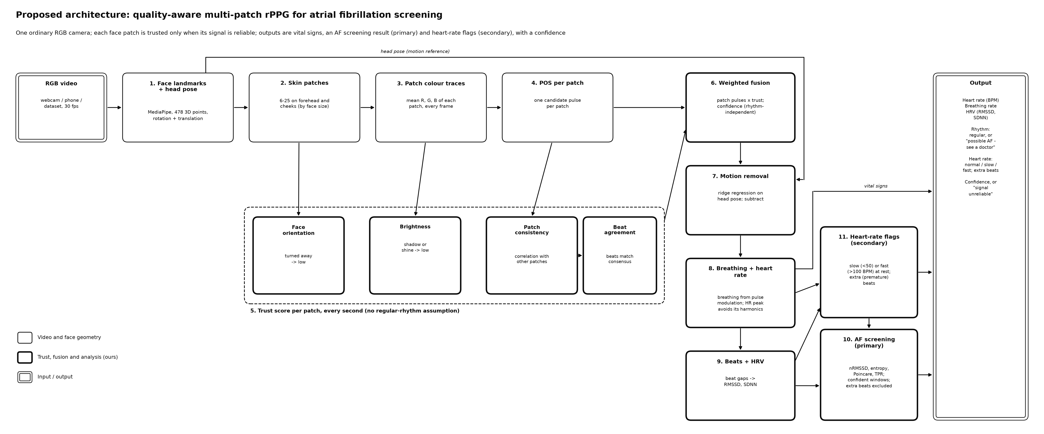
Figure 1: Overall architecture of the proposed system (detailed)

2. Flow of the architecture
A video enters at the top left. Every frame passes through face tracking (block 1), patch extraction (block 2) and colour measurement (block 3), producing one colour trace per patch; these traces are cached because they are the slow, per-frame part. Block 4 converts every patch's trace into a pulse. From then on the system works in overlapping 8-second windows advanced every second: block 5 scores every patch, block 6 fuses the patches with those scores, and block 7 removes the part of the signal that follows the head movement measured in block 1. The cleaned pulse flows down the right-hand column to rates (block 8) and beats (block 9); the beat timings feed both analyses, heart-rate flags (block 11) and AF screening (block 10), and extra beats found by block 11 are removed before the AF check. Everything is collected in the output panel together with the confidence.

3. Explanation of each block
1. RGB video (input): any colour video of a face at about 30 frames per second from a webcam, phone or dataset. No special camera, light or contact sensor is needed.
2. Block 1 – Face landmarks and head pose: MediaPipe FaceLandmarker finds 478 landmarks with relative depth in every frame and returns a facial transformation matrix, from which the head's yaw, pitch and roll angles and its position are computed. The landmarks define the patches; the pose is the reference for motion removal.
3. Block 2 – Skin patches: the forehead and both cheeks are covered by 25 patches, each a group of 2–4 triangles of the face mesh, so the patches move and deform with the face. When the face is small in the frame, neighbouring patches are merged into 12 or 6 so that each keeps enough pixels.
4. Block 3 – Patch colour traces: for every frame the mean red, green and blue values of every patch are measured, together with its pixel count and its orientation to the camera.
5. Block 4 – POS per patch: the POS algorithm turns each patch's colour trace into a candidate pulse signal, which is then detrended and band-pass filtered to the 30–200 BPM range.
6. Block 5 – Trust score per patch: four checks give each patch a weight in each window: face orientation (patches turned away count less), brightness (shadowed or saturated patches count less), patch consistency (correlation with the pulse of all other patches) and beat agreement (whether the patch's beats line up with the consensus beats).
7. Block 6 – Weighted fusion: the patch pulses are averaged with their trust weights. A confidence between 0 and 1 is computed from patch consistency, beat-shape consistency, head motion and the number of trusted patches.
8. Block 7 – Motion removal: the part of the signal that a ridge regression on the head-pose signals can explain is subtracted, first from every patch's colour trace and then from the fused pulse, but only for pose channels that clearly move.
9. Block 8 – Breathing and heart rate: heart rate is read from the strongest spectral peak, or from the mean beat interval when the rhythm is irregular. Breathing rate from the pulse's respiratory modulation was built and evaluated but is not shown, because it proved unreliable.
10. Block 9 – Beats and HRV: systolic peaks are detected with sub-frame precision, giving the inter-beat intervals, RMSSD and SDNN.
11. Block 10 – AF screening (primary): beat-interval irregularity features (normalised RMSSD, entropy, Poincaré plot, turning-point ratio) are classified as regular or possible AF, in confident windows only.
12. Block 11 – Heart-rate flags (secondary): a resting rate below 50 or above 100 BPM for at least 2 minutes is flagged as slow or fast, and an early beat followed by a long pause is flagged as an extra (premature) beat.
13. Output: heart rate, RMSSD, the rhythm result with the number of extra beats, the heart-rate flags and the confidence; when the confidence is too low, “signal unreliable” is shown instead of a result.
All blocks are implemented and evaluated (Results). Breathing rate is computed but not shown, and extra beats found by block 11 are removed before the AF check only when they are isolated.

Proposed Methodology

1. Overall architecture of the project
Figure 2 (next page) is a simplified view of the same architecture with the steps grouped into seven blocks. It is used below to explain the methods.

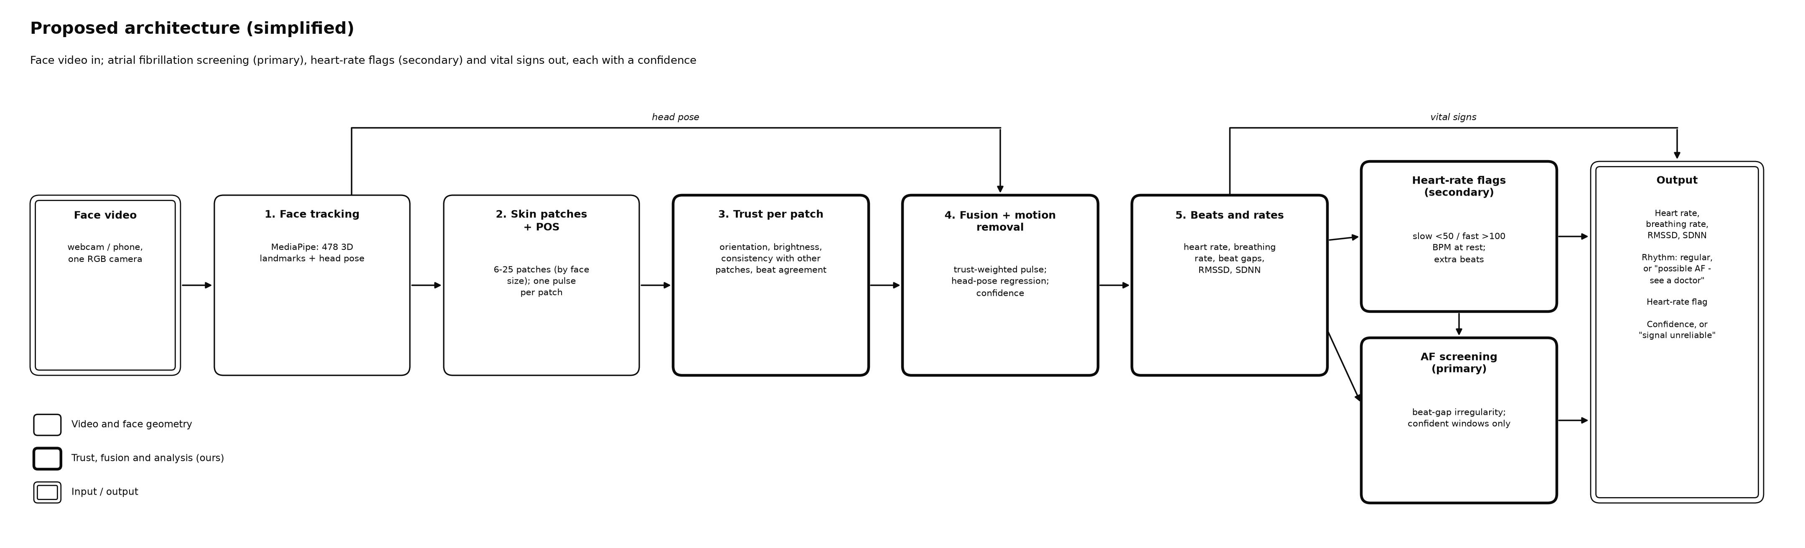
Figure 2: Simplified architecture of the proposed method

2. Flow of the architecture
1. Per frame: track the face, measure the 25 fine patches (colour, pixel count, orientation) and record the head pose. These measurements are saved, so later stages can be re-run and compared without re-processing the video.
2. Per video: choose the patch level from the face size, merge the fine measurements to that level, remove head motion from the colour traces where the head moves, and run POS on every patch.
3. Per window (8 s, every 1 s): compute the four trust checks, fuse the patches, remove the remaining motion, and compute the confidence. Windows are blended with a Hann window, so the fused pulse is continuous.
4. Per recording: detect beats on the fused pulse, compute heart rate and beat intervals, and run AF screening (after removing isolated extra beats) and the heart-rate flags on confident windows.

3. Detailed explanation of the methods used

3.1 Face tracking and head pose
MediaPipe FaceLandmarker (Kartynnik et al., 2019; Lugaresi et al., 2019) runs in video mode, which tracks the face between frames. Each landmark has x and y in pixels and a relative depth z, which is scaled to pixels so the landmarks form a 3D surface. The 4×4 facial transformation matrix is decomposed into a rotation (yaw, pitch and roll in degrees) and a translation (x, y and z in centimetres), giving six head-pose signals per frame.

3.2 Skin patches and their measurement
Patch definitions are generated once from a frontal reference face. Mesh triangles whose centre lies inside the forehead or a cheek polygon are clustered by position with k-means into 9 forehead and 8 + 8 cheek patches. Coarser levels are unions of these: 4 patches per region (12 in total) and 2 per region (6), shown in Figure 3. Because patches are lists of mesh triangles, they follow the face in every video.
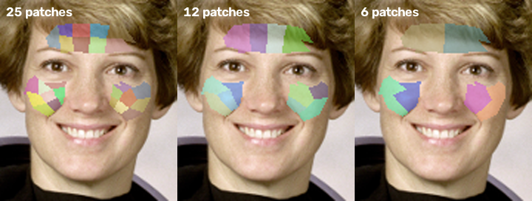
Figure 3: The three patch levels on a reference face: 25, 12 and 6 patches
In each frame the triangles are filled into a label image, and the mean colour and pixel count of every patch are computed in one pass. The orientation of a patch is the area-weighted cosine between its triangles' surface normals and the camera axis:
n = (b − a) × (c − a), facing = |n_z| / |n|
where a, b and c are the 3D corners of a triangle. The level used for a video is the finest one whose typical patch has at least 350 pixels, because averaging over pixels is what cancels camera noise and the pulse changes skin brightness by well under 1%.

3.3 Pulse extraction with POS
For every patch, in sliding windows of 1.6 s, the RGB trace is divided by its mean (Cn) and projected onto two axes orthogonal to the skin tone (Wang et al., 2017):
S1 = Gn − Bn, S2 = −2Rn + Gn + Bn, h = S1 + (σ(S1) / σ(S2)) · S2
The window outputs are overlap-added. The pulse is then detrended with the smoothness-priors method (Tarvainen et al., 2002) and band-passed with a zero-phase Butterworth filter from 0.5 to 3.3 Hz (30–200 BPM). The band is wider than the usual 42–180 BPM so that slow and fast heart rates can be measured.

3.4 Trust checks
Within each 8-second window every patch pulse p_k is scaled to unit variance and four weights are computed:
1. Face orientation: w_f = facing if facing ≥ 0.3, else 0. A tilted surface reflects less light towards the camera (Lambert's law), so patches turned more than about 72° are ignored.
2. Brightness: luma Y = 0.299R + 0.587G + 0.114B. The weight ramps from 0 to 1 between Y = 20 and 45 (shadow) and back to 0 between Y = 220 and 245 (shine or saturation, which clips the pulse).
3. Patch consistency: c_k = max(0, corr(p_k, Σ_{j≠k} w_j p_j)), the correlation with the weighted pulse of all other patches (leave-one-out). In AF all patches still show the same irregular beats, so consistency stays high; noise differs from patch to patch, so it drops. The weight is c_k².
4. Beat agreement: a_k = 2 M_k / (N_k + N_k′), where N_k beats are detected in the patch, N_k′ beats in the leave-one-out consensus, and M_k beats match within 100 ms.
t_k = w_f,k · w_b,k · c_k² · a_k, normalised so that Σ t_k = 1

3.5 Weighted fusion and confidence
The fused pulse is the trust-weighted sum of the patch pulses, f = Σ t_k p_k. The confidence of each window is the geometric mean of four components, each between 0 and 1:
confidence = (C_cons · C_shape · C_motion · C_patch)^(1/4)
- C_cons = Σ t_k c_k, the trust-weighted patch consistency.
- C_shape: beat-shape consistency, the mean correlation of each beat (from 35% of the median interval before its peak to 65% after it, resampled to 32 points) with the average beat of the window. Like the beat-level quality indices of Orphanidou et al. (2015), it judges quality from individual beats. AF changes the timing of beats, not their shape, so a clean AF pulse still scores high.
- C_motion = 1 / (1 + (v / 5)²), where v is the mean head-rotation speed in degrees per second.
- C_patch = min(1, N_eff / (0.3 P)), where N_eff = 1 / Σ t_k² is the effective number of trusted patches out of P.
A spectral-sharpness confidence, the share of power in the strongest frequency peak, was deliberately not used. An irregular rhythm has no single frequency, so such a score would reject exactly the AF windows the system must keep (Figure 7).

3.6 Motion removal
The six head-pose signals and their rates of change form up to 12 regressors, band-passed like the pulse. In each window the part of a signal y explained by the regressors X is estimated with ridge regression and subtracted:
β = (XᵀX + λ n I)⁻¹ Xᵀ y, y_clean = y − X β, λ = 0.1
This is done twice. First it is applied to every patch's normalised colour trace before POS, where the artifact is still linear in the motion. Then it is applied to the fused pulse, for the part that POS's per-window tuning made non-linear. Only pose channels that clearly move in the window are used (rotation of at least 1° RMS or translation of at least 0.5 cm RMS). During development, MediaPipe's pose estimate was found to fluctuate in step with the pulse, with correlations up to 0.36 on still synthetic videos, so regressing on small pose changes would remove real pulse (see also Balakrishnan et al., 2013).

3.7 Heart rate and beat detection
Heart rate is read from the highest peak of a zero-padded periodogram (2^15 points) of the cleaned pulse. Beats are the systolic peaks, found with a minimum distance of half the dominant period and a prominence of 0.25 standard deviations, and refined to sub-frame precision with a parabola through each peak and its neighbours. Without this refinement, beat intervals are quantised to 33 ms at 30 fps, which alone adds irregularity that resembles AF. The beat-based heart rate, 60 / mean interval, is used when the rhythm is irregular, because an irregular rhythm has no single spectral peak.

3.8 AF screening
Rhythm features are computed from the inter-beat intervals (IBI) of non-overlapping 30 s windows, after implausible intervals (outside 0.3–2.0 s) and isolated extra beats (Section 3.9) are removed. Figure 4 shows why they work: a regular rhythm changes its beat gaps smoothly and slightly, while AF changes them randomly and strongly.
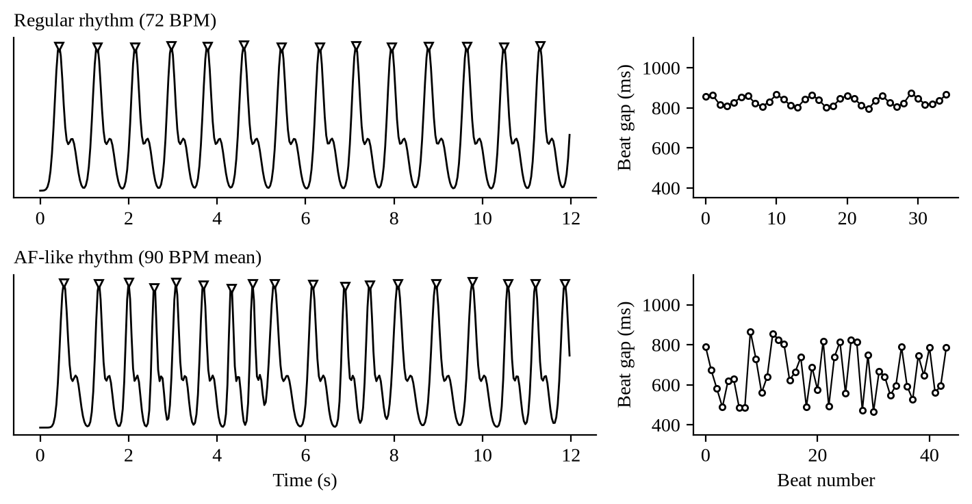
Figure 4: Synthetic pulse waves with detected beats (left) and their beat gaps (right): regular rhythm (top) and AF-like rhythm (bottom)
RMSSD = √( mean( (IBI_{i+1} − IBI_i)² ) ), nRMSSD = RMSSD / mean(IBI)
- Normalised RMSSD: beat-to-beat change independent of heart rate.
- Shannon entropy of the IBI histogram (16 bins, after dropping the 8 shortest and 8 longest intervals, as in Dash et al., 2009) and sample entropy (m = 2, r = 0.2 SD; Richman & Moorman, 2000) measure unpredictability.
- Poincaré SD1/SD2: short- against long-term variability; near 1 for AF, small for a normal rhythm.
- Turning-point ratio: the share of intervals that are a local maximum or minimum; about 2/3 for random intervals.
Classifier. A random forest (Breiman, 2001) of 200 trees (minimum 5 windows per leaf, balanced class weights; scikit-learn, Pedregosa et al., 2011) was chosen over logistic regression after subject-independent cross-validation. It is trained on MIMIC PERform AF (Charlton et al., 2022) after resampling the 125 Hz finger PPG to 30 fps and adding 16 ms of random timing noise to every beat, the beat-timing error measured on the UBFC face videos. Without this, camera timing noise alone made healthy faces look like AF. Only timing features are used, so the model transfers from contact to camera pulses.
Gating and decision. A window is judged only when its beat-shape consistency is at least 0.8; otherwise the output is “signal unreliable”. A video or live window is called “possible AF” when the mean AF probability of its reliable windows is at least 0.5.

3.9 Extra beats and heart-rate flags
A beat is flagged as premature when the interval before it is more than 8% shorter than the local median (8 intervals on each side, leaving out the two around the beat) and the interval after it is longer than 1.05 times that median:
IBI_before < 0.92 · median, IBI_after > 1.05 · median
The two thresholds were chosen by grid search on half of MIT-BIH Arrhythmia (DS1 of de Chazal et al., 2004) with 16 ms timing noise, and tested on the other half (DS2). Before the AF check, an extra beat and its two intervals are removed only if it is isolated, that is, if the intervals just outside its short-long pair are within 20% of the local median and at most 20% of the window's beats are flagged. This follows the definition of an extra beat inside an otherwise regular rhythm (Chong et al., 2015) and stops the rule from “cleaning” real AF, whose neighbouring intervals are irregular too. The setting was chosen on DS1 as the one with the fewest false alarms that loses at most 2 points of AF sensitivity.
A slow or fast flag is raised when the median heart rate over at least 2 minutes of confident windows is below 50 BPM (bradycardia; Kusumoto et al., 2019) or above 100 BPM, and is shown with context (“can be normal for fit people”).

3.10 Breathing rate, heart rate in irregular rhythms and HRV
Breathing modulates the pulse in amplitude (RIAV), beat intervals (RIFV) and intensity (RIIV). Each beat-by-beat series is resampled to 4 Hz, band-passed to 6–36 breaths/min and its spectral peak taken; the estimates are averaged when their standard deviation is at most 4 breaths/min and discarded otherwise (Smart Fusion; Karlen et al., 2013). RIFV is dropped in irregular windows. Because POS removes changes slower than its 1.6 s window, RIIV is taken from a separate trust-weighted, inverted green-channel pulse that keeps slow changes.
Heart rate is the spectral peak of the last 8 s in a regular rhythm and 60 / mean IBI when the rhythm is irregular (normalised RMSSD above 0.1), because an irregular rhythm has no single spectral peak. A breathing-aware variant that skips spectral peaks at the breathing rate and its 2nd and 3rd harmonics was also evaluated. RMSSD and SDNN are computed from the cleaned IBIs.

3.11 Comparison variants and baselines
To measure what each ingredient contributes, the method runs as seven variants, each adding one ingredient: single (one skin region, plain POS), patch_mean (patches with equal weights), +facing, +brightness, +consistency, +beats and full (adding motion removal, the proposed method). Two further baselines replace POS with GREEN (the inverted, normalised green channel; Verkruysse et al., 2008) or CHROM (de Haan & Jeanne, 2013) on one skin region. Every variant feeds the same beat detector and the same AF classifier, so differences come from pulse extraction and fusion alone.

3.12 Evaluation against a contact sensor
A finger or ear sensor sees each beat at a different time than the face (pulse transit time), and the camera pulse is inverted relative to a contact PPG (more blood means less reflected light, while oximeters plot more blood upwards). Neither affects heart rate or beat intervals, but both break beat-time matching. Before beats are matched, the reference is therefore shifted by the delay (within ±1 s) and sign that maximise its correlation with the face pulse. The fitted delays were 0.10–0.21 s on every video, and the beat F1 rose from 0.72 to 0.98.

3.13 Live demo
The live demo processes a webcam (or a video file played as if live). Each frame's landmarks and patch colours enter a rolling 32 s buffer with their real timestamps, which is resampled to 30 fps. Once a second, a background thread runs the full method on a snapshot of the buffer, so the video keeps its frame rate, and the screen shows the trust map, heart rate, confidence, rhythm status with the number of extra beats, RMSSD and, after 2 minutes of confident readings, the slow/fast flag, always with the note “screening aid, not a diagnosis”.

4. Advantages and disadvantages of the methods used
Table 3: Advantages and disadvantages of the methods used
Method | Advantages | Disadvantages
MediaPipe FaceLandmarker | 478 3D landmarks and head pose in real time on a CPU; no training | Pose estimate jitters with the pulse; can lose very small or strongly turned faces
Mesh-based patches (25/12/6) | Follow the face; localise shadows, shine and noise; adapt to face size | Small patches are noisy; forehead patches can touch the hairline
POS per patch | Training-free, well-founded, cancels intensity changes and one distortion direction | Cannot cancel several colour distortions at once; makes motion artifacts non-linear
Rhythm-independent trust checks | Keep real AF while rejecting noise; each check is interpretable | Need several patches; beat agreement adds computation
Ridge regression on head pose | Removes motion artifacts linked to pose; cheap | Can remove pulse if the pose carries it (handled by channel gating)
Confidence gating | Avoids decisions on poor windows, reducing false alarms | Some windows get no answer (lower coverage)
Beat-interval features and simple classifier | Explainable; proven on ECG and contact PPG | Trained on contact PPG; must transfer to camera pulses
Random forest on IBI features, trained with camera-like timing noise | Explainable features; transfers from contact PPG; robust to camera timing jitter | Trained on 35 ICU patients; contact PPG, not face video
Extra-beat rule with neighbour check | Removes isolated premature beats without erasing AF | Finds ventricular beats well, but most atrial premature beats are too slightly early
Breathing from pulse modulations (Smart Fusion) | No extra sensor; standard method | Unreliable on ICU data and in AF; not shown as an output

5. Justification for choosing these methods
1. Why not a new deep network? Existing networks such as PhysNet and PhysFormer are trained on large labelled datasets that a course project cannot match, and they still give a single pulse with no indication of which skin to trust. Improving the signal with explicit, testable checks is a contribution that can be validated with the available data.
2. Why POS? It rests on an explicit skin-reflection model (Wang et al., 2017), needs no training, runs per patch in real time, and is among the most accurate training-free methods (4.00 BPM MAE on UBFC-rPPG, against 14.70 for ICA and 19.82 for GREEN; Paruchuri et al., 2024).
3. Why patches with trust? Shadows, shine, a turned cheek or local motion affect only part of the face; patches localise these problems so they can be down-weighted instead of contaminating the whole signal (Kumar et al., 2015; Lam & Kuno, 2015).
4. Why rhythm-independent quality? The target condition, AF, is defined by an irregular rhythm. Quality measures that reward a sharp spectral peak would reject it, as Figure 7 shows, so consistency across patches and beat shape are used instead.
5. Why beat-interval features for AF? They are simple, explainable and among the best-validated AF markers on ECG and camera pulses (Dash et al., 2009; McManus et al., 2013), and they transfer from contact PPG training data better than waveform shape.

Implementation Details

1. Hardware / Software
Table 4: Hardware and software used
Item | Details
Development and experiments | Windows 11 laptop, Intel CPU (20 threads), no GPU; earlier phases in a Linux cloud container (4 cores)
Camera | Any RGB webcam or phone camera at about 30 fps; phone videos in H.264
Language | Python 3.12 (3.11–3.13 supported)
Face tracking | MediaPipe 1.0.1, FaceLandmarker task (float16 model, 3.7 MB)
Numerical and signal processing | NumPy 2.4.6, SciPy 1.17.1
Video and image processing | OpenCV 5.0 (headless)
Machine learning | scikit-learn 1.9.1 (k-means for patches; random-forest AF classifier)
Data handling and plots | pandas 3.0.6, Matplotlib 3.11.2
ECG tools | wfdb 4.3.1 (MIT-BIH reading; XQRS R-peak detector for the MIMIC ECG references)
Testing | pytest 9.1.1 (72 tests)
Version control | Git and GitHub (repository mayankoff/vision)
Development assistant | An AI coding assistant, see Prompt Engineering

2. Any other

2.1 Code organisation
Table 5: Modules of the implementation (package afscreen)
Module | Role
config.py | All settings in one place (band, windows, thresholds), so experiments stay comparable
face/tracker.py, face/patches.py | MediaPipe landmarks and head pose; patch definitions, measurement, merging to 12/6/1 patches, level choice
traces.py | Runs tracking and measurement over a video and caches the patch traces
signal/pos.py, baselines.py | POS (vectorised); GREEN and CHROM baselines
signal/beats.py, quality.py, spectrum.py | Beats with sub-frame refinement, beat-shape consistency, spectrum, plain and breathing-aware FFT heart rate
signal/resp.py, hrv.py | Breathing rate from pulse modulations; RMSSD and SDNN
core/trust.py, core/fusion.py | Trust checks, weighted fusion, motion removal, confidence
pipeline.py | One call per video and variant; the seven variants and two baselines
af/features.py, af/experiment.py, af/screen.py | IBI features; training and cross-validation on MIMIC; AF screening of face videos with gating
flags/ectopy.py, flags/experiment.py | Extra-beat rule and its removal; MIT-BIH experiments; slow/fast flags
vitals.py, eval/* | Phase 2 experiments; metrics, reference alignment, benchmarks, Phase 5 comparisons
live.py | Live demo (webcam or file), background analysis, on-screen display
io/datasets.py, af/mimic.py, flags/mitbih.py | Readers for UBFC-rPPG (both sets), PURE, synthetic videos, MIMIC PERform and MIT-BIH, straight from the zips
cli.py, scripts/ | Command line (run, extract, evaluate, af-train, af-screen, extra-beats, hr-flags, vitals, compare, live); figures, report, synthetic data, Windows setup

2.2 Synthetic data with known beat times
Real datasets give a reference pulse from a contact sensor, but not the exact time of every beat. A synthetic generator therefore produces regular, AF-like, slow, fast and extra-beat rhythms beat by beat, and turns them into per-patch colour traces (with optional noisy, shadowed, turned-away patches and tinted-light head motion) or into pulsing face videos made from a still photo (with optional small faces and side-to-side sway). It is used for the stress tests in Section Results 1.2 and for end-to-end tests of the live demo.

2.3 Testing
The implementation has 72 automatic tests (plus 2 optional end-to-end tests that run MediaPipe on synthetic face videos). They cover filtering, POS and its vectorised form, the baselines, beat detection and refinement, patches, each trust check, motion removal, the AF features and classifier, the extra-beat rule, breathing, the dataset readers, reference alignment and the live monitor. All of them pass, in about 25 s.

2.4 Datasets and access
Table 6: Datasets: planned and used
Dataset | Contents | Use | Status
UBFC-rPPG DATASET_2 and DATASET_1 | Face videos + finger PPG, normal rhythm | Heart rate, beat timing, AF false alarms | Partly downloaded: 12 videos, 7 with a reference
MIMIC PERform AF | PPG + ECG, 19 AF and 16 non-AF ICU patients, 20 min | Train and validate the AF classifier | Used (complete)
MIMIC PERform Testing (adults) | PPG + ECG + impedance respiration, 100 ICU adults, 10 min | Breathing rate, heart rate | Used
MIT-BIH Arrhythmia | ECG with every beat labelled, 48 records | Extra-beat rule; second AF test | Used (44 non-paced records)
Synthetic videos and traces | Known beat times | Stress tests, demo checks | Generated
PURE, OBF, COHFACE, UBFC-Phys | Head motion; AF face videos; breathing belt; talking | Motion removal; AF on faces; breathing | Not used (access on request or not obtained in time)

2.5 How to run
- Install with scripts\windows\setup.ps1 (or pip), which also downloads the face model and runs the tests.
- afscreen live starts the webcam demo; afscreen run video.mp4 --debug-video trust.mp4 analyses one video.
- python scripts/extract_from_zips.py datasets/UBFC caches the face videos; afscreen evaluate, af-train, af-screen, extra-beats, hr-flags, vitals and compare reproduce every result in this report (see the repository README).
- python scripts/synthetic_stress.py, scripts/report_figures.py and scripts/build_final_report.py regenerate the stress tests, the figures and this document.

Results

1. Results obtained
All numbers below were produced by the project code from the datasets in Table 6 and can be regenerated with the commands in Implementation Details 2.5. The face-video set is small (12 videos, 7 with a reference), so differences of one video or one window should not be over-read.

1.1 Evaluation data and protocol
- Face videos: UBFC-rPPG subjects 25 and 26 (DATASET_2) and 5, 8, 10, 11 and 12 (DATASET_1) have a finger-PPG reference; five more DATASET_2 videos (1, 4, 5, 27, 48) have none. Every UBFC subject has a normal rhythm, so any AF result on them is a false alarm.
- AF classifier: MIMIC PERform AF, 30 s windows, leave-one-subject-out cross-validation: every patient is tested by a model that never saw them.
- Extra beats: MIT-BIH Arrhythmia beat annotations, tuned on DS1 and tested on DS2, scored outside AF episodes; paced records excluded.
- Breathing and heart rate: MIMIC PERform Testing adults and the AF set, PPG resampled to 30 fps, against impedance respiration and ECG R-peaks.

1.2 Synthetic stress tests: what the trust checks and motion removal do
The UBFC videos are still and evenly lit, so the trust checks have nothing to correct there. Six simulated scenarios of 40 s with 25 patches show what they do when part of the face is bad (mean of three random seeds).
Table 7: Beat-interval error (ms) of each variant on synthetic patch traces; lower is better
Scenario | single | patch mean | +facing | +bright-ness | +consis-tency | +beats | full
Clean, regular 72 BPM | 7.8 | 4.0 | 4.0 | 4.0 | 4.0 | 4.1 | 4.1
8 noisy patches | 45.3 | 8.9 | 8.9 | 8.9 | 4.9 | 4.9 | 4.9
Shadowed and turned patches | 41.1 | 7.5 | 6.8 | 4.6 | 4.6 | 4.6 | 4.6
Head motion artifact | 77.3 | 76.1 | 76.1 | 76.1 | 76.2 | 76.2 | 8.2
AF, clean | 8.6 | 5.9 | 5.9 | 5.9 | 6.0 | 5.9 | 5.9
AF, 8 noisy patches | 48.8 | 10.6 | 10.6 | 10.6 | 6.3 | 6.3 | 6.3

Table 8: Effect of motion removal on a regular 72 BPM rhythm with head motion (beat-interval error, ms)
Motion frequency | Artifact (x pulse) | Without motion removal | With motion removal
0.8 Hz | 10 | 63.6 | 7.1
1.0 Hz | 3 | 76.2 | 8.2
1.0 Hz | 10 | 90.9 | 14.2
1.3 Hz | 7 | 241.1 | 14.5

1.3 Heart rate and beat timing on the UBFC face videos
Table 9: Baselines and ablation on the 7 UBFC videos with a reference
Variant | HR MAE (BPM) | Window HR MAE (BPM) | IBI error (ms) | Beat F1 | RMSSD error (ms)
GREEN, one region | 0.58 | 2.33 | 55.4 | 0.84 | 157.0
CHROM, one region | 0.23 | 1.17 | 43.5 | 0.94 | 89.3
POS, one region (single) | 0.22 | 0.43 | 21.1 | 0.98 | 31.4
+ patches, equal weights | 0.22 | 0.48 | 22.2 | 0.98 | 39.4
+ facing | 0.23 | 0.47 | 21.3 | 0.98 | 41.6
+ brightness | 0.23 | 0.46 | 21.3 | 0.98 | 41.5
+ consistency | 0.23 | 0.46 | 21.1 | 0.98 | 38.5
+ beat agreement | 0.23 | 0.46 | 21.8 | 0.99 | 39.2
+ motion removal (full) | 0.23 | 0.46 | 21.8 | 0.99 | 39.2

1.4 AF classifier on MIMIC PERform AF
Table 10: AF classifier, leave-one-subject-out (35 patients; 1,399–1,400 windows of 30 s)
Signal | Model | AUC | Window sens. | Window spec. | AF patients found | Non-AF patients cleared
Contact PPG, 125 Hz | Random forest | 0.94 | 0.95 | 0.86 | 19 / 19 | 14 / 16
Resampled to 30 fps | Random forest | 0.96 | 0.94 | 0.88 | 19 / 19 | 14 / 16
30 fps + 16 ms timing noise | Logistic regression | 0.91 | 0.87 | 0.83 | 18 / 19 | 14 / 16
30 fps + 16 ms timing noise (final) | Random forest | 0.96 | 0.93 | 0.89 | 19 / 19 | 14 / 16
Same, gated (beat shape ≥ 0.8) | Random forest | 0.99 | 0.96 | 0.95 | 19 / 19 | 14 / 16

Table 11: Share of windows kept by a quality gate (MIMIC, 30 fps + 16 ms noise)
Gate | Threshold | AF windows kept | Non-AF windows kept
Beat-shape consistency (used) | 0.7 | 0.99 | 0.96
Beat-shape consistency (used) | 0.8 | 0.96 | 0.91
Beat-shape consistency (used) | 0.9 | 0.76 | 0.85
Spectral peak sharpness | 0.5 | 0.06 | 0.86
Spectral peak sharpness | 0.7 | 0.00 | 0.67

1.5 AF false alarms on the face videos
Table 12: AF screening of the 12 normal-rhythm UBFC videos (same classifier, extra beats removed, gated)
Variant | Windows called AF | Videos called AF
GREEN, one region | 14 / 17 | 11 / 12
CHROM, one region | 4 / 20 | 2 / 12
POS, one region | 2 / 20 | 1 / 12
POS + patches, equal weights | 1 / 20 | 0 / 12
+ facing, + brightness, + consistency | 0 / 20 | 0 / 12
+ beat agreement, full method | 1 / 20 | 0 / 12
Full method without extra-beat removal | 2 / 20 | 1 / 12
Full method, classifier trained without timing noise | 2 / 20 | 2 / 12

1.6 Extra beats on MIT-BIH Arrhythmia
Table 13: Extra-beat rule on DS2 (test half), outside AF episodes
Beat-timing noise | Sensitivity | Precision | F1 | Ventricular found | Atrial found | False flags per 1000 normal beats
0 ms (exact) | 0.54 | 0.92 | 0.68 | 0.82 | 0.14 | 5.5
16 ms (measured on faces) | 0.54 | 0.86 | 0.66 | 0.81 | 0.15 | 10.7
33 ms (one frame at 30 fps) | 0.54 | 0.61 | 0.57 | 0.77 | 0.20 | 43.1

Table 14: MIMIC-trained AF classifier on MIT-BIH 30 s windows (16 ms noise): share called AF
Windows | Split | Number | No removal | Plain removal | Removal of isolated extra beats
AF (sensitivity) | DS1 | 59 | 0.97 | 0.92 | 0.98
AF (sensitivity) | DS2 | 170 | 0.90 | 0.71 | 0.82
Normal rhythm with extra beats | DS1 | 602 | 0.13 | 0.06 | 0.07
Normal rhythm with extra beats | DS2 | 443 | 0.22 | 0.09 | 0.12
Normal rhythm without extra beats | DS1 | 630 | 0.002 | 0.002 | 0.002
Normal rhythm without extra beats | DS2 | 644 | 0.003 | 0.003 | 0.005

1.7 Slow and fast heart-rate flags
Table 15: Flag from camera-like PPG beats versus flag from the ECG (MIMIC, 2-minute segments)
Reference \ prediction | Slow | Normal | Fast
Slow (< 50 BPM) | 3 | 0 | 0
Normal | 0 | 223 | 2
Fast (> 100 BPM) | 0 | 15 | 90

333 of 350 segments (95%) were scored; agreement was 0.95, Cohen's kappa 0.88 and the heart-rate error 2.8 BPM. Fifteen of the 17 disagreements are AF patients whose ECG rate is fast but whose pulse rate reads normal.

1.8 Breathing rate and heart rate in irregular rhythms
Table 16: Breathing rate (64 s windows, wide-band pulse, three modulations, Smart Fusion) against impedance respiration; “constant guess” always predicts the median rate (17.9 /min)
Group | Windows | Coverage | MAE (/min) | Within 2 /min | Constant guess: MAE / within 2
ICU non-AF | 179 | 0.80 | 3.8 | 0.43 | 3.3 / 0.21
ICU adults (Testing) | 573 | 0.79 | 5.5 | 0.39 | 4.1 / 0.26
ICU AF | 142 | 0.82 | 9.8 | 0.07 | 5.7 / 0.24

Table 17: Heart-rate error per 30 s window against the ECG (BPM; share of windows off by more than 10 BPM)
Group | Windows | FFT peak | Breathing-aware FFT | From beats | Combined
ICU AF | 760 | 12.5 (35%) | 12.0 (35%) | 7.4 (19%) | 7.4 (19%)
ICU non-AF | 602 | 2.2 (6%) | 2.4 (6%) | 2.6 (6%) | 2.6 (6%)
ICU adults (Testing) | 1989 | 8.5 (15%) | 8.5 (16%) | 8.8 (16%) | 9.0 (17%)

1.9 Beat timing and heart-rate variability on the face videos
Table 18: Placement of beats between frames (single region, 7 UBFC videos of about 1 minute)
Beats placed | IBI error (ms) | RMSSD error (ms) | SDNN error (ms) | RMSSD camera / reference
Whole frames | 25.4 | 36.6 | 18.6 | 75.6 / 39.0
Parabola through each peak (used) | 21.0 | 31.3 | 16.8 | 70.3 / 39.0
Cubic spline | 21.1 | 31.6 | 16.9 | 70.6 / 39.0

1.10 Patch count and face size
Table 19: Full method with a fixed or adaptive number of patches, on the 7 videos re-processed at smaller frame sizes (HR MAE in BPM / IBI error in ms)
Frame size | Skin pixels | 6 patches | 12 patches | 25 patches | Adaptive (chose)
640 x 480 | 4696 | 0.23 / 21.5 | 0.23 / 20.6 | 0.22 / 20.3 | 0.23 / 21.8 (6 or 12)
320 x 240 | 1243 | 0.23 / 22.4 | 0.22 / 22.0 | 0.21 / 22.6 | 0.23 / 22.4 (6)
160 x 120 | 350 | 0.23 / 22.2 | 0.22 / 22.6 | 0.21 / 21.8 | 0.23 / 22.2 (6)

1.11 Live demo and processing speed
Table 20: Live demo on files played as if live (status after 35 s)
Input | Truth | Shown
UBFC DATASET_1 subject 5 (real video) | Oximeter 75–84 BPM, rising | 74–86 BPM, follows the rise; confidence 0.93–0.96; regular rhythm
Synthetic, regular 72 BPM | Regular | 72 BPM; regular rhythm; 0 extra beats
Synthetic, AF about 86 BPM | AF | 83–87 BPM from beats; possible AF
Synthetic, regular with extra beats | Regular, about 4 extra beats per 30 s | 70 BPM; regular rhythm; 4 extra beats

Table 21: Processing time on the laptop CPU (300 frames of a UBFC video)
Frame size | Landmarks | Patches | Fusion and the rest | Total | Max. frame rate
640 x 480 | 9.0 ms | 0.7 ms | 0.7 ms | 10.4 ms | 96 fps
320 x 240 | 8.5 ms | 0.5 ms | 0.4 ms | 9.4 ms | 107 fps

In the live demo the full analysis of the 32 s buffer takes 0.2–0.4 s once a second in a background thread; POS was vectorised for this (identical output, 14 times faster).

2. Interpretation of the obtained results
1. Beat timing, not heart rate, decides AF false alarms. All pulse extractors give heart rates within 0.6 BPM on these videos, yet GREEN raises a false AF alarm on 11 of 12 healthy people, CHROM on 2 and POS on 1, in the same order as their beat-interval errors (55, 43 and 21 ms). Patches remove the last false alarm.
2. The trust checks matter when part of the face is bad. On the clean UBFC videos the weights stay nearly equal and the checks change nothing. In the stress tests they cut the beat-interval error from 41–49 ms (single region) to 4.6–6.3 ms, each check acting on its own problem, and motion removal cuts 64–241 ms to 7–15 ms.
3. Rhythm-independent quality keeps AF. A spectral-sharpness gate would discard 94–100% of AF windows; the beat-shape gate keeps 96% and raises the AUC from 0.96 to 0.99.
4. The classifier transfers. Trained on contact PPG, it detects 90–97% of AF windows on MIT-BIH ECG beat timing and flags only 0.2–0.3% of clean normal windows; training with the measured camera timing noise costs nothing on MIMIC and lowers false alarms on faces.
5. Extra beats are the main remaining cause of false alarms, raising the AF call rate from 0.3% to 13–22% on MIT-BIH. Removing isolated extra beats nearly halves this at a cost of 8 points of AF sensitivity on DS2; removal without the neighbour check would have cost 19 points.
6. Beat-based heart rate is needed in AF, where it halves large heart-rate errors; breathing-aware selection is a coin flip because the breathing estimate itself is unreliable.
7. The camera overestimates RMSSD about twofold, because about 20 ms of timing noise per beat, shared by all patches, adds beat-to-beat variation that is not there. Heart rate, AF and the flags are robust to it; RMSSD is not.
8. Face size and patch count did not matter on these clean, lightly compressed videos, down to about 14 pixels per patch.

Analysis

1. Analysis of the results obtained
The results support the central idea of the project: for rhythm screening the quality of beat timing matters more than the accuracy of heart rate, and quality must be judged without assuming a regular rhythm. Beat timing separated the pulse extractors where heart rate could not, the beat-shape gate kept AF where a spectral gate would have removed it, and training the classifier with the camera's measured timing noise and removing isolated extra beats each lowered false alarms.
The results also show what could not be shown. The trust checks and motion removal help strongly in simulation, but the available real videos have no shadows, shine, turned faces or real head motion, so their real-world benefit is not demonstrated; without PURE, motion removal never activated on a real video. AF detection was validated on contact pulses (MIMIC) and ECG timing (MIT-BIH) with camera-like noise, not on face videos of AF patients, because OBF was not available. Breathing rate from the pulse failed on intensive-care data, and camera RMSSD is biased upwards.
Three findings changed the design during the project: the camera pulse is inverted and delayed relative to a finger sensor (evaluation had to align them); camera timing noise alone makes healthy faces look like AF (the classifier is now trained with it); and removing every extra beat also removes AF (only isolated ones are removed now).

2. Comparison with existing results
Table 22: Published results and the results of this project
Work | Task and data | Reported result
POS / CHROM with rPPG-Toolbox (Paruchuri et al., 2024) | Heart rate, UBFC-rPPG (42 videos) | 4.00 / 3.98 BPM MAE
This project: POS, one region / full method | Heart rate, 7 UBFC videos | 0.22 / 0.23 BPM MAE (an easier subset)
Dash et al. (2009) | AF from ECG intervals, MIT-BIH AF | 94.4% sensitivity, 95.1% specificity
McManus et al. (2013) | AF from fingertip camera pulse, 76 patients | 96.2% sensitivity, 97.5% specificity
Yan et al. (2018) | AF from face video vs 12-lead ECG | 95% sensitivity, 96% specificity
Sun et al. (2022) | AF from face video (OBF) | 96.0% accuracy (AF vs healthy)
This project: AF classifier | MIMIC PERform AF, camera-like PPG, per patient | 100% sensitivity (19/19), 88% specificity (14/16); window AUC 0.96 (0.99 gated)
This project: AF screening on faces | 12 normal-rhythm UBFC videos | 0 / 12 false alarms (GREEN 11, CHROM 2, POS 1)
de Chazal et al. (2004) | Beat classification from ECG shape and timing, MIT-BIH DS2 | Sensitivity 75.9% (supraventricular), 77.7% (ventricular)
This project: extra-beat rule | Beat timing only, MIT-BIH DS2, 16 ms noise | Sensitivity 15% (atrial), 81% (ventricular); precision 86%

The comparison is not like-for-like: the published AF results come from face or fingertip videos of real AF patients, while ours come from contact pulses with simulated camera noise, and our UBFC subset is smaller and easier than the full dataset. The extra-beat rule uses timing only, which a camera can provide, whereas de Chazal et al. also use the ECG waveform shape; this explains its weak result for atrial premature beats, which are often only slightly early.

3. Efficiency obtained and metrics used
Table 23: Metrics used in the project
Metric | Meaning | Better
MAE, window MAE (BPM) | Heart-rate error against the reference, whole video and per 8 s window | Lower
Beat-interval error (ms), beat F1 | Error of matched inter-beat intervals; beats found without missing or inventing any | Lower; higher
RMSSD, SDNN error (ms) | Heart-rate-variability error against the reference | Lower
AUC, sensitivity, specificity | AF detection per window and per patient | Higher
False-alarm rate, coverage | AF calls on normal rhythm; share of windows with an answer | Lower; higher
Sensitivity, precision | Extra-beat detection | Higher
Agreement, Cohen's kappa | Slow/fast flag against the flag from the ECG | Higher
Breathing MAE, within 2 /min | Breathing-rate error against impedance respiration | Lower; higher
Processing time (ms per frame) | Computational efficiency | Lower

Efficiency obtained: AF AUC 0.96 (0.99 gated) with every AF patient detected; no AF false alarm on the healthy face videos; heart-rate error 0.2 BPM and beat-interval error 21 ms on face videos; extra-beat precision 86%; slow/fast agreement 95%; and about 10 ms per frame (96 fps) on a laptop CPU, three times faster than real time.

4. Results represented in graphs with interpretation
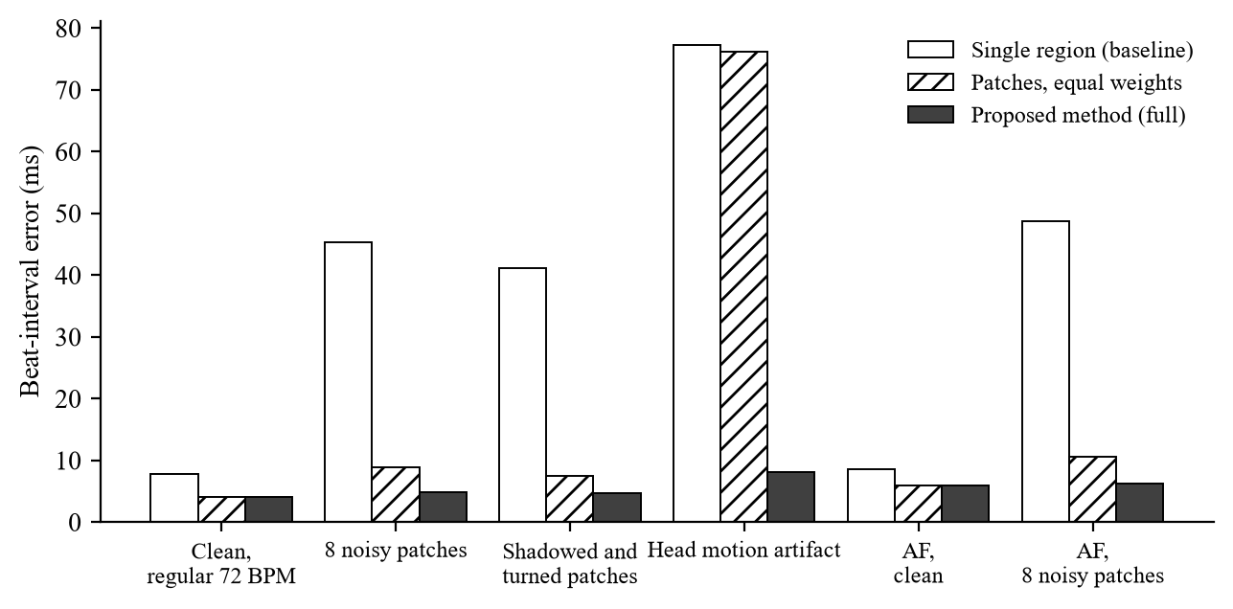
Figure 5: Beat-interval error of the baseline, equal-weight patches and the proposed method in six simulated scenarios
Figure 5: the single region (white) fails whenever part of the face is bad or the head moves; equal-weight patches (hatched) help except under motion, and the proposed method (dark) stays at 4–8 ms in every scenario, including AF.
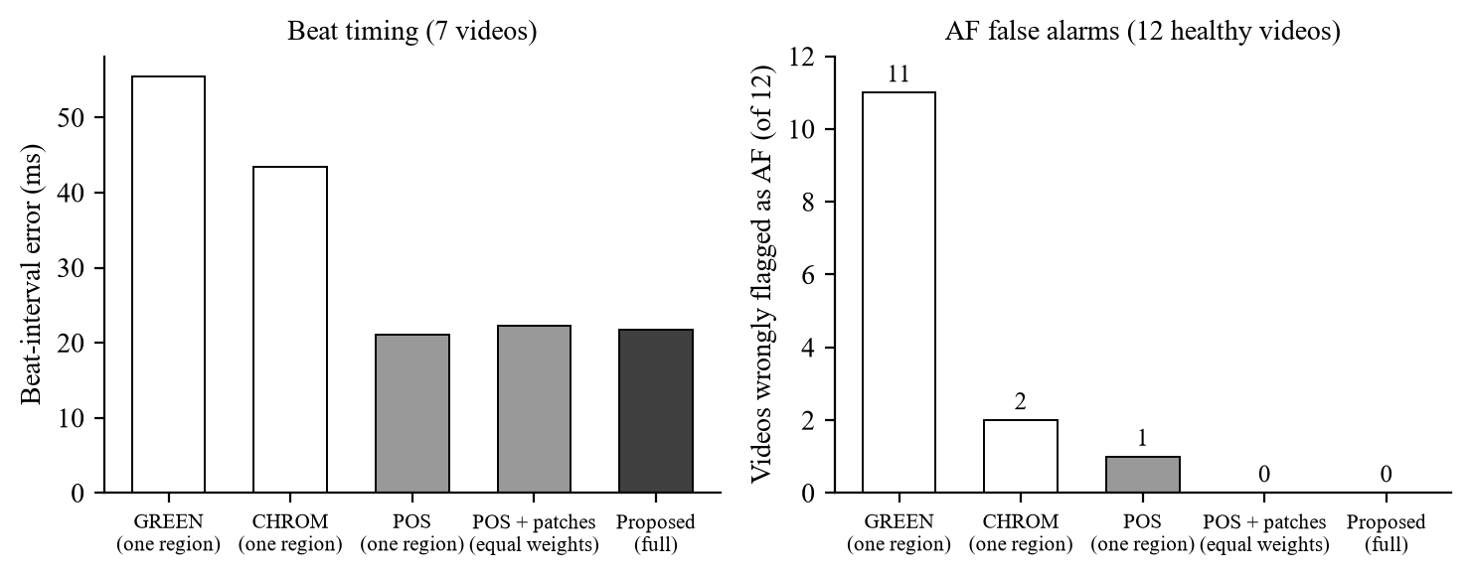
Figure 6: Beat-interval error and AF false alarms of the baselines and the proposed method on the UBFC face videos
Figure 6: the ranking of false alarms (11, 2, 1, 0, 0) follows the ranking of beat-timing errors; heart-rate error, which is 0.2–0.6 BPM for all, would hide these differences.
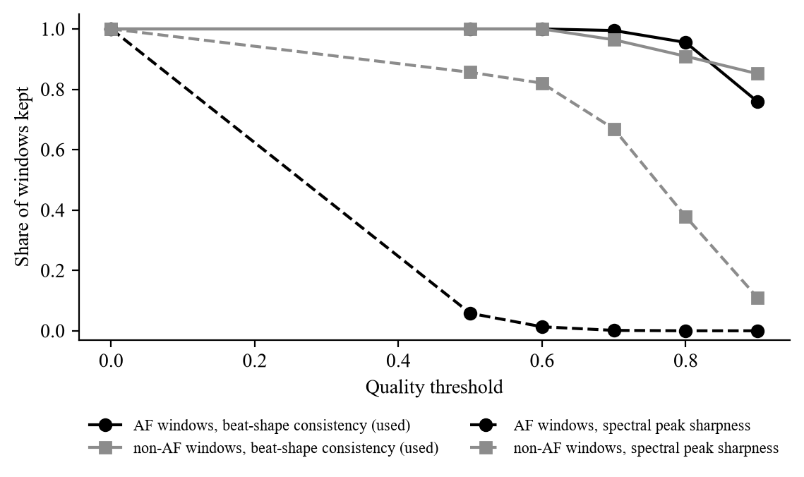
Figure 7: Share of AF and non-AF windows kept by the beat-shape gate and by a spectral sharpness gate (MIMIC PERform AF)
Figure 7: the beat-shape gate (solid) keeps AF and normal windows alike, while the spectral gate (dashed) removes nearly all AF windows already at 0.5, which would make AF undetectable.
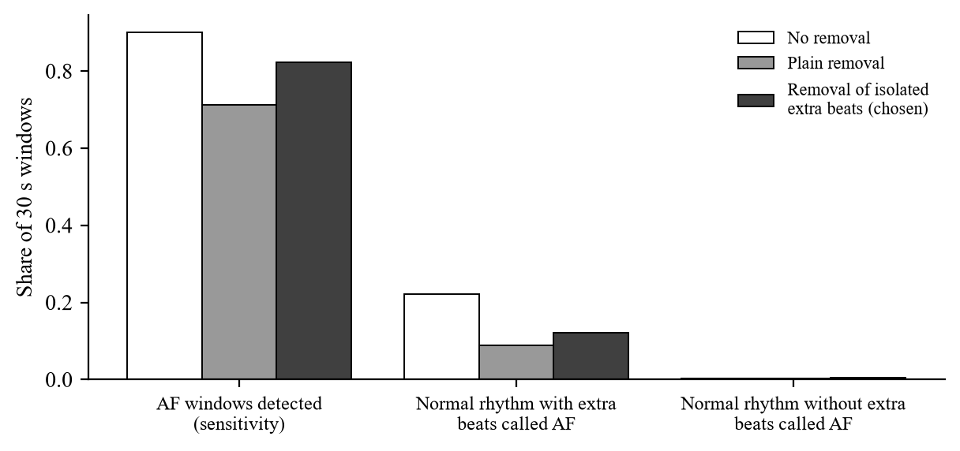
Figure 8: Effect of extra-beat removal on the AF classifier on MIT-BIH DS2
Figure 8: plain removal lowers false alarms on extra beats but also erases AF; removing only isolated extra beats keeps most AF windows while nearly halving the false alarms.
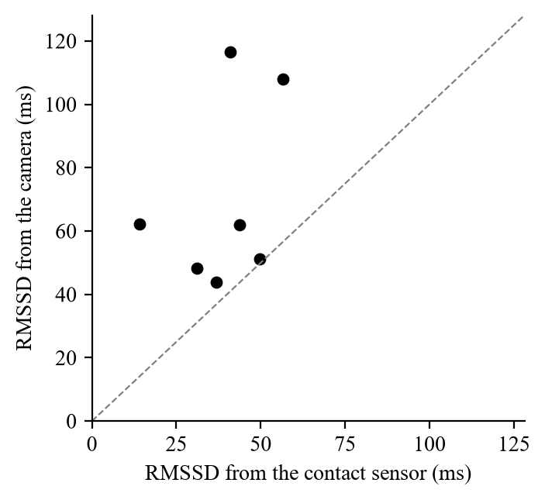
Figure 9: RMSSD from the camera against RMSSD from the finger sensor (7 UBFC videos)
Figure 9: every point lies above the identity line: camera timing noise roughly doubles RMSSD, so camera RMSSD is shown with a warning, and the AF classifier is trained to tolerate the same noise.
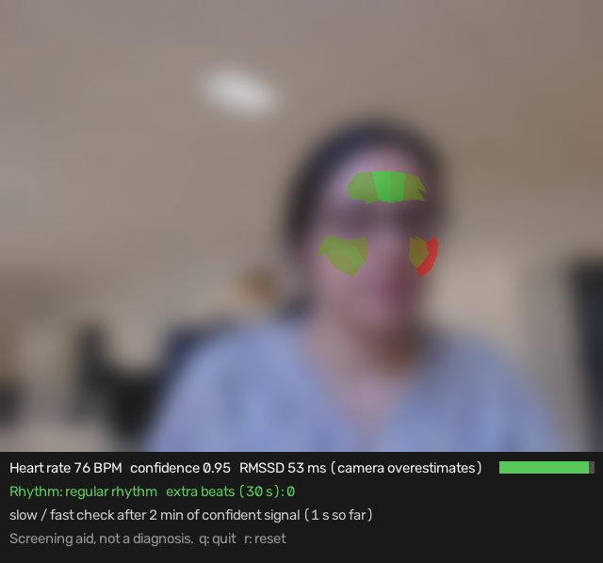
Figure 10: Live demo on a UBFC video played as if live (face blurred for privacy)
Figure 10: the trust map shows the forehead and left cheek trusted (green) and the turned right cheek less trusted (red); the panel shows heart rate, confidence, rhythm, extra beats and RMSSD.

Conclusion and Future Work

1. Significance of the project
Atrial fibrillation is common, often silent and a major cause of stroke, and finding it early allows stroke-preventing treatment. A screening check that needs only the camera already present in phones, laptops and kiosks could reach people who would never wear a monitor. The project contributes a way to make such a check trustworthy: it measures the pulse in many small skin patches, trusts them by rules that do not assume a regular heartbeat, removes head motion and decides only when the signal is reliable, to reduce the false AF alarms that motion and lighting otherwise cause.

2. Results and efficiency obtained
The complete system was built: face tracking, 25 mesh-based patches, rhythm-independent trust, fusion, motion removal, confidence, beat detection, an AF classifier, extra-beat and slow/fast flags, and a live webcam demo running at about 10 ms per frame on a CPU. Trained on MIMIC PERform AF with camera-like timing noise, the classifier found all 19 AF patients with a window AUC of 0.96 (0.99 with confidence gating) and transferred to MIT-BIH ECG timing. On the healthy UBFC face videos it raised no false alarm with the proposed method, against 11 with GREEN and 2 with CHROM. The project's main lesson is that beat timing, not heart rate, determines whether a camera can screen rhythm, and that quality measures must not assume a regular rhythm.

3. Difficulties faced in performing this project
1. Data access: OBF (AF face videos), PURE (head motion) and COHFACE (breathing) need access requests that could not be completed in time, and the UBFC-rPPG download failed part-way, leaving 12 videos, 7 with a reference. Two videos had lost their folder names and were identified by heart rate and duration.
2. Camera versus contact pulse: the camera pulse is inverted and delayed relative to the finger sensor, which at first made beat matching look poor (F1 0.72) until the reference was aligned.
3. Camera timing noise looks like AF: the first classifier flagged healthy faces; training with the measured timing noise fixed it without losing AF.
4. Extra-beat removal also removed AF: solved by removing only isolated extra beats, chosen on a separate data split.
5. Breathing from the pulse: the estimator was correct on synthetic signals but unreliable on intensive-care patients, so it was dropped as an output.
6. Speed of the live demo: the analysis grew with the buffer and exceeded 1 s; POS was vectorised and the buffer limited to 32 s.
7. Practical issues: limited disk space (videos were processed straight from the zip files), Windows setup, and phone videos in HEVC that OpenCV cannot read.

4. Future work
1. Test AF screening on face videos of AF patients (OBF), and on talking and moving people (PURE, UBFC-Phys), to measure real sensitivity and the real benefit of trust and motion removal.
2. Reduce beat-timing noise, for example with a higher frame rate or a better beat fiducial, to make camera RMSSD usable and lower AF false alarms further.
3. Use beat shape as well as timing to recognise atrial premature beats, which timing alone misses.
4. Validate breathing rate on resting, healthy people (COHFACE) before showing it.
5. Compare with pretrained deep networks (PhysNet, PhysFormer) through rPPG-Toolbox, and test across skin tones, lighting and phone cameras.
6. Run a prospective study with clinicians against a 12-lead ECG before any real-world use; the system is a screening aid, not a diagnosis.

Prompt Engineering

1. Prompt source
The prompts were written by the team and given to an AI coding assistant (an agent that can read the repository, run code and search the web): first in the cloud (prompts 1–35) and then in the desktop app on the team's laptop with the datasets (prompts 36–45). It was used to plan the phases, explain concepts, research the literature, draw the architecture diagrams, write and test the code, run the experiments and draft the reports. The team made the project decisions (scope, outputs, which datasets to use, what to keep or drop), and every result was produced by running the project code.

2. Prompts utilized
The prompts below are listed in the order they were used. Their wording has been edited for clarity and grammar, and closely related follow-up questions are combined; the content of each request is unchanged.
1. Adapt the setup and scripts for Windows, run and demonstrate what has been built, and proceed with Phase 2.
2. The rPPG-Toolbox environment is now working. What is the next step?
3. We have not recorded our own face video yet. What can be done in the meantime?
4. Suggest an addition that would make the project more original, since it currently relies only on existing classical and deep-learning methods.
5. Are the deep-learning models already trained, so that only the datasets are needed to measure their accuracy? The question is meant in general terms.
6. Explain the proposed new method in simple language.
7. Clarify the following: (1) What is the MMPD dataset? (2) What does the rhythm used in the trust score refer to? (3) Can MediaPipe identify shadowed regions so that they receive a low trust score? (4) How is the pulse produced in the proposed method, compared with POS, CHROM or PhysNet followed by an FFT?
8. Confirm my understanding: the project compares two existing approaches with one new method built from existing techniques.
9. Provide a block diagram of the system.
10. Could we train our own neural network on the available datasets to replace POS, so that the core model is our own work?
11. Are existing deep networks such as PhysNet built on forehead and cheek regions, and on which datasets were they trained?
12. Since existing networks are large and difficult to outperform, we will keep the planned method of applying POS to about 25 facial patches. Do not implement it yet; this is a design discussion only.
13. Keep the agreement check, add it to the diagram, and write a context paragraph that can be used to generate the block diagram with an AI tool.
14. Show the handcrafted equations that classical methods use to obtain the pulse signal, and explain how they differ between methods.
15. Explain how deep-learning models generate the pulse signal.
16. Provide content for a presentation of at most five slides based on the finalised architecture diagram.
17. Revise the plan without implementing it: show only the proposed architecture in the diagram; add a research-backed, real-world output derived from the predicted heart rate; and research whether thermal imaging could make the method more precise and more novel.
18. Summarise the proposal in a short paragraph.
19. Would users of the application need a separate thermal camera in addition to a normal camera?
20. Remove the thermal component from the project.
21. Suggest a more clinically useful output than the stress level.
22. Update the plan with atrial fibrillation screening as the primary output and stress as a secondary output.
23. Generate the updated implementation plan.
24. Create a black-and-white architecture diagram and a prompt for generating it with an AI tool.
25. Explain how the model detects atrial fibrillation or estimates stress from the heart rate.
26. What are heart-rate variability and the LF/HF ratio, and how are they measured?
27. What is the normal range of heart-rate variability, and how was it established?
28. Explain atrial fibrillation in simple terms, how the model detects it, and what happens after it is detected.
29. Are the beat-interval values used in the explanation supported by research?
30. Can other medical conditions be detected from the predicted heartbeat?
31. What do abnormally slow or fast heartbeats indicate?
32. Make abnormal heart-rate flags the secondary output, keep atrial fibrillation as the primary output, and assess the feasibility.
33. Explain the architecture in one paragraph, defining every technical term.
34. Answer the following design questions: (1) Can the face realistically be divided into 25 patches, or should the number be reduced? (2) How is the confidence of the weighted fusion computed? (3) How are the trust-score features computed? (4) How is motion removal performed? (5) Which of RMSSD, SDNN and LF/HF is most important for the project?
35. Update the implementation plan and create a simplified architecture diagram.
36. This is the repository of my project, built with an AI coding assistant in the cloud. Pull it into this folder and understand everything about the project.
37. I am downloading UBFC-rPPG DATASET_2 and then MIMIC; PURE needs an access request that I have no time for. Check whether using only these, or other public datasets, will cause problems.
38. Both datasets are now in the datasets folder as zip files; part of DATASET_2 failed to download. Is this enough to train the model, or is the complete dataset needed?
39. I cannot download the rest of the dataset. Do what is possible with the existing data.
40. I have added the MIT-BIH dataset to the same folder. Start Phase 4.
41. Commit this and start Phase 2.
42. Try again (after a failing test of the breathing-aware heart rate).
43. Commit this and start Phase 5.
44. Commit this and start Phase 6.
45. Commit this and start Phase 7: the final project report in the course format (no slides for now).

3. Relevant search keywords
The following keywords were used to search the literature, datasets and guidelines:
- remote photoplethysmography (rPPG); contactless heart rate from facial video
- POS, CHROM, PBV and ICA rPPG methods; rPPG-Toolbox benchmark
- multi-region and patch-based rPPG; region weighting; DistancePPG; skin segmentation
- rPPG head motion; face orientation; ballistocardiographic head motion
- deep learning rPPG: DeepPhys, PhysNet, TS-CAN, PhysFormer
- atrial fibrillation detection from facial video; smartphone photoplethysmography atrial fibrillation
- atrial fibrillation RR-interval irregularity: RMSSD, Shannon entropy, turning-point ratio, Poincaré plot
- premature atrial and ventricular contractions versus atrial fibrillation in PPG
- PPG signal-quality index; PPG beat detection benchmark
- respiratory rate from the photoplethysmogram
- OBF database; MIMIC PERform AF; UBFC-rPPG; PURE; UBFC-Phys; COHFACE; MMPD; MIT-BIH Arrhythmia Database
- atrial fibrillation prevalence, stroke risk and screening (USPSTF); bradycardia guideline
- normal values of short-term heart-rate variability
- RGB and thermal imaging for stress detection (explored and not adopted)
- MIMIC PERform datasets; impedance pneumography; PPG-derived respiratory rate Smart Fusion
- inter-patient heartbeat classification; de Chazal DS1/DS2 split; premature beat detection from RR intervals
- sample entropy; random forest; scikit-learn
- pulse transit time between face and finger; rPPG polarity

4. Any other
- Verification: every numerical result in this report was produced by running the project code. Every published fact and number was checked against the paper's abstract, publisher record or an indexed summary, and statements that could not be confirmed were removed.
- Iteration: design questions (patch count, confidence, trust features, motion removal, which HRV measure to keep) were asked explicitly, and the answers were turned into changes to the implementation plan before any code was written.
- Limitations: an AI assistant can make mistakes in citations and code; the team checked the code by running the tests and experiments, and should check the references before final submission.

References

1. Journals
Bobbia, S., Macwan, R., Benezeth, Y., Mansouri, A., & Dubois, J. (2019). Unsupervised skin tissue segmentation for remote photoplethysmography. Pattern Recognition Letters, 124, 82–90. https://doi.org/10.1016/j.patrec.2017.10.017
Breiman, L. (2001). Random forests. Machine Learning, 45(1), 5–32. https://doi.org/10.1023/A:1010933404324
Charlton, P. H., Kotzen, K., Mejía-Mejía, E., Aston, P. J., Budidha, K., Mant, J., Pettit, C., Behar, J. A., & Kyriacou, P. A. (2022). Detecting beats in the photoplethysmogram: Benchmarking open-source algorithms. Physiological Measurement, 43(8), 085007. https://doi.org/10.1088/1361-6579/ac826d
Chong, J. W., Esa, N., McManus, D. D., & Chon, K. H. (2015). Arrhythmia discrimination using a smart phone. IEEE Journal of Biomedical and Health Informatics, 19(3), 815–824. https://doi.org/10.1109/JBHI.2015.2418195
Dash, S., Chon, K. H., Lu, S., & Raeder, E. A. (2009). Automatic real time detection of atrial fibrillation. Annals of Biomedical Engineering, 37(9), 1701–1709. https://doi.org/10.1007/s10439-009-9740-z
de Chazal, P., O'Dwyer, M., & Reilly, R. B. (2004). Automatic classification of heartbeats using ECG morphology and heartbeat interval features. IEEE Transactions on Biomedical Engineering, 51(7), 1196–1206. https://doi.org/10.1109/TBME.2004.827359
de Haan, G., & Jeanne, V. (2013). Robust pulse rate from chrominance-based rPPG. IEEE Transactions on Biomedical Engineering, 60(10), 2878–2886. https://doi.org/10.1109/TBME.2013.2266196
de Haan, G., & van Leest, A. (2014). Improved motion robustness of remote-PPG by using the blood volume pulse signature. Physiological Measurement, 35(9), 1913–1926. https://doi.org/10.1088/0967-3334/35/9/1913
Karlen, W., Raman, S., Ansermino, J. M., & Dumont, G. A. (2013). Multiparameter respiratory rate estimation from the photoplethysmogram. IEEE Transactions on Biomedical Engineering, 60(7), 1946–1953. https://doi.org/10.1109/TBME.2013.2246160
Kumar, M., Veeraraghavan, A., & Sabharwal, A. (2015). DistancePPG: Robust non-contact vital signs monitoring using a camera. Biomedical Optics Express, 6(5), 1565–1588. https://doi.org/10.1364/BOE.6.001565
Kusumoto, F. M., Schoenfeld, M. H., Barrett, C., et al. (2019). 2018 ACC/AHA/HRS guideline on the evaluation and management of patients with bradycardia and cardiac conduction delay. Circulation, 140(8), e382–e482. https://doi.org/10.1161/CIR.0000000000000628
McManus, D. D., Lee, J., Maitas, O., Esa, N., Pidikiti, R., Carlucci, A., Harrington, J., Mick, E., & Chon, K. H. (2013). A novel application for the detection of an irregular pulse using an iPhone 4S in patients with atrial fibrillation. Heart Rhythm, 10(3), 315–319. https://doi.org/10.1016/j.hrthm.2012.12.001
Moody, G. B., & Mark, R. G. (2001). The impact of the MIT-BIH Arrhythmia Database. IEEE Engineering in Medicine and Biology Magazine, 20(3), 45–50. https://doi.org/10.1109/51.932724
Nunan, D., Sandercock, G. R. H., & Brodie, D. A. (2010). A quantitative systematic review of normal values for short-term heart rate variability in healthy adults. Pacing and Clinical Electrophysiology, 33(11), 1407–1417. https://doi.org/10.1111/j.1540-8159.2010.02841.x
Orphanidou, C., Bonnici, T., Charlton, P., Clifton, D., Vallance, D., & Tarassenko, L. (2015). Signal-quality indices for the electrocardiogram and photoplethysmogram: Derivation and applications to wireless monitoring. IEEE Journal of Biomedical and Health Informatics, 19(3), 832–838. https://doi.org/10.1109/JBHI.2014.2338351
Pedregosa, F., Varoquaux, G., Gramfort, A., Michel, V., Thirion, B., Grisel, O., et al. (2011). Scikit-learn: Machine learning in Python. Journal of Machine Learning Research, 12, 2825–2830. https://jmlr.org/papers/v12/pedregosa11a.html
Poh, M.-Z., McDuff, D. J., & Picard, R. W. (2010). Non-contact, automated cardiac pulse measurements using video imaging and blind source separation. Optics Express, 18(10), 10762–10774. https://doi.org/10.1364/OE.18.010762
Richman, J. S., & Moorman, J. R. (2000). Physiological time-series analysis using approximate entropy and sample entropy. American Journal of Physiology – Heart and Circulatory Physiology, 278(6), H2039–H2049. https://doi.org/10.1152/ajpheart.2000.278.6.H2039
Sun, Z., Junttila, J., Tulppo, M., Seppänen, T., & Li, X. (2022). Non-contact atrial fibrillation detection from face videos by learning systolic peaks. IEEE Journal of Biomedical and Health Informatics, 26(9), 4587–4598. https://doi.org/10.1109/JBHI.2022.3193117
Tarvainen, M. P., Ranta-aho, P. O., & Karjalainen, P. A. (2002). An advanced detrending method with application to HRV analysis. IEEE Transactions on Biomedical Engineering, 49(2), 172–175. https://doi.org/10.1109/10.979357
Tateno, K., & Glass, L. (2001). Automatic detection of atrial fibrillation using the coefficient of variation and density histograms of RR and ΔRR intervals. Medical & Biological Engineering & Computing, 39(6), 664–671. https://doi.org/10.1007/BF02345439
US Preventive Services Task Force; Curry, S. J., Krist, A. H., Owens, D. K., et al. (2018). Screening for atrial fibrillation with electrocardiography: US Preventive Services Task Force recommendation statement. JAMA, 320(5), 478–484. https://doi.org/10.1001/jama.2018.10321
Verkruysse, W., Svaasand, L. O., & Nelson, J. S. (2008). Remote plethysmographic imaging using ambient light. Optics Express, 16(26), 21434–21445. https://doi.org/10.1364/OE.16.021434
Wang, W., den Brinker, A. C., Stuijk, S., & de Haan, G. (2017). Algorithmic principles of remote PPG. IEEE Transactions on Biomedical Engineering, 64(7), 1479–1491. https://doi.org/10.1109/TBME.2016.2609282
Wang, W., Stuijk, S., & de Haan, G. (2015). Exploiting spatial redundancy of image sensor for motion robust rPPG. IEEE Transactions on Biomedical Engineering, 62(2), 415–425. https://doi.org/10.1109/TBME.2014.2356291
Wolf, P. A., Abbott, R. D., & Kannel, W. B. (1991). Atrial fibrillation as an independent risk factor for stroke: The Framingham Study. Stroke, 22(8), 983–988. https://doi.org/10.1161/01.STR.22.8.983
Yan, B. P., Lai, W. H. S., Chan, C. K. Y., et al. (2018). Contact-free screening of atrial fibrillation by a smartphone using facial pulsatile photoplethysmographic signals. Journal of the American Heart Association, 7(8), e008585. https://doi.org/10.1161/JAHA.118.008585
Yan, B. P., Lai, W. H. S., Chan, C. K. Y., Au, A. C. K., Freedman, B., Poh, Y. C., & Poh, M.-Z. (2020). High-throughput, contact-free detection of atrial fibrillation from video with deep learning. JAMA Cardiology, 5(1), 105–107. https://doi.org/10.1001/jamacardio.2019.4004

2. Conferences
Balakrishnan, G., Durand, F., & Guttag, J. (2013). Detecting pulse from head motions in video. Proceedings of the IEEE Conference on Computer Vision and Pattern Recognition, 3430–3437. https://doi.org/10.1109/CVPR.2013.440
Cantrill, S., Ahmedt-Aristizabal, D., Petersson, L., Suominen, H., & Armin, M. A. (2024). Orientation-conditioned facial texture mapping for video-based facial remote photoplethysmography estimation. Proceedings of the IEEE/CVF Conference on Computer Vision and Pattern Recognition Workshops, 354–363. https://doi.org/10.1109/CVPRW63382.2024.00040
Chen, W., & McDuff, D. (2018). DeepPhys: Video-based physiological measurement using convolutional attention networks. Proceedings of the European Conference on Computer Vision (ECCV). https://arxiv.org/abs/1805.07888
Kartynnik, Y., Ablavatski, A., Grishchenko, I., & Grundmann, M. (2019). Real-time facial surface geometry from monocular video on mobile GPUs. CVPR Workshop on Computer Vision for Augmented and Virtual Reality. arXiv:1907.06724. https://arxiv.org/abs/1907.06724
Lam, A., & Kuno, Y. (2015). Robust heart rate measurement from video using select random patches. Proceedings of the IEEE International Conference on Computer Vision (ICCV), 3640–3648. https://doi.org/10.1109/ICCV.2015.415
Li, X., Alikhani, I., Shi, J., Seppänen, T., Junttila, J., Majamaa-Voltti, K., Tulppo, M., & Zhao, G. (2018). The OBF database: A large face video database for remote physiological signal measurement and atrial fibrillation detection. 13th IEEE International Conference on Automatic Face & Gesture Recognition (FG 2018), 242–249. https://doi.org/10.1109/FG.2018.00043
Liu, X., Fromm, J., Patel, S., & McDuff, D. (2020). Multi-task temporal shift attention networks for on-device contactless vitals measurement. Advances in Neural Information Processing Systems, 33. https://arxiv.org/abs/2006.03790
Liu, X., Narayanswamy, G., Paruchuri, A., Zhang, X., Tang, J., Zhang, Y., Sengupta, R., Patel, S., Wang, Y., & McDuff, D. (2023). rPPG-Toolbox: Deep remote PPG toolbox. Advances in Neural Information Processing Systems, 36 (Datasets and Benchmarks Track). https://arxiv.org/abs/2210.00716
Paruchuri, A., Liu, X., Pan, Y., Patel, S., McDuff, D., & Sengupta, S. (2024). Motion matters: Neural motion transfer for better camera physiological measurement. Proceedings of the IEEE/CVF Winter Conference on Applications of Computer Vision (WACV), 5933–5942. https://arxiv.org/abs/2303.12059
Lugaresi, C., Tang, J., Nash, H., McClanahan, C., Uboweja, E., Hays, M., Zhang, F., Chang, C.-L., Yong, M. G., Lee, J., Chang, W.-T., Hua, W., Georg, M., & Grundmann, M. (2019). MediaPipe: A framework for building perception pipelines. arXiv:1906.08172. https://arxiv.org/abs/1906.08172
Tulyakov, S., Alameda-Pineda, X., Ricci, E., Yin, L., Cohn, J. F., & Sebe, N. (2016). Self-adaptive matrix completion for heart rate estimation from face videos under realistic conditions. Proceedings of the IEEE Conference on Computer Vision and Pattern Recognition, 2396–2404. https://doi.org/10.1109/CVPR.2016.263
Yu, Z., Li, X., & Zhao, G. (2019). Remote photoplethysmograph signal measurement from facial videos using spatio-temporal networks. Proceedings of the British Machine Vision Conference (BMVC). arXiv:1905.02419. https://arxiv.org/abs/1905.02419
Yu, Z., Shen, Y., Shi, J., Zhao, H., Torr, P. H. S., & Zhao, G. (2022). PhysFormer: Facial video-based physiological measurement with temporal difference transformer. Proceedings of the IEEE/CVF Conference on Computer Vision and Pattern Recognition, 4176–4186. https://doi.org/10.1109/CVPR52688.2022.00415

3. Book Chapters | Websites
Google AI Edge. (n.d.). Face landmark detection guide (MediaPipe Face Landmarker). https://ai.google.dev/edge/mediapipe/solutions/vision/face_landmarker
PhysioNet. (n.d.). MIT-BIH Arrhythmia Database, version 1.0.0. https://physionet.org/content/mitdb/1.0.0/
Charlton, P. H. (n.d.). MIMIC PERform AF dataset (ppg-beats documentation). https://ppg-beats.readthedocs.io/en/latest/datasets/mimic_perform_af/
Charlton, P. H. (2022). MIMIC PERform datasets [Data set]. Zenodo. https://zenodo.org/record/6950488
Benezeth, Y. (n.d.). UBFC-rPPG dataset. https://sites.google.com/view/ybenezeth/ubfcrppg
Ubicomp Lab, University of Washington. (n.d.). rPPG-Toolbox [Source code]. GitHub. https://github.com/ubicomplab/rPPG-Toolbox

