
School of Computer Science and Engineering
Vellore Institute of Technology
Vellore
Fall Semester 2025-26
Quality-Aware Multi-Patch Remote Photoplethysmography for Contactless Atrial Fibrillation Screening from Facial Video
BCSE417L – Machine Vision
Digital Assignment 3
Team Members
Mayank, Vyomesh Pandita
23BAI0158, 23BAI0151

Abstract
1. Motivation, aim and objective. Atrial fibrillation (AF) is the most common sustained heart-rhythm disorder; it is often silent, it raises the risk of stroke about five-fold, and it is treatable once found (Wolf et al., 1991; US Preventive Services Task Force, 2018). Remote photoplethysmography (rPPG) recovers the pulse from tiny, heartbeat-driven colour changes of the skin in an ordinary video, so a contactless rhythm check during a video call or at a kiosk is possible in principle (Yan et al., 2018). The obstacle is that head motion, shadows and lighting changes distort beat timing, and irregular beat timing is exactly what AF looks like, so motion produces false AF alarms. The aim of this project is a machine-vision system that screens for AF from facial RGB video with few false alarms and also flags slow, fast and extra (premature) heartbeats. The objectives are to (a) measure the pulse separately in up to 25 skin patches on the face mesh, (b) score each patch with trust checks that do not assume a regular rhythm, (c) fuse the trusted patches, remove head-motion artifacts and attach a confidence value, and (d) judge the rhythm only in confident windows.
2. About methodology. MediaPipe FaceLandmarker gives 478 three-dimensional face landmarks and the head pose in every frame. The forehead and cheeks are divided into 25 mesh-based patches (merged to 12 or 6 when the face is small), and the mean colour of each patch is tracked. The Plane-Orthogonal-to-Skin (POS) algorithm turns each patch's colour trace into a candidate pulse. Every second, over an 8-second window, each patch receives a trust score from four checks: face orientation, brightness, consistency with the other patches and beat agreement. Trusted patches are fused, head-motion artifacts are removed by a ridge regression on the head pose, and a rhythm-independent confidence is computed. Beats are detected with sub-frame precision, and beat-interval irregularity features (normalised RMSSD, entropy, Poincaré plot, turning-point ratio) feed an AF classifier; slow, fast and extra beats are flagged from the same beat timings.
3. Expected outcome. The system outputs heart rate, breathing rate, heart-rate variability (RMSSD, SDNN), a rhythm result (“regular” or “possible AF – see a doctor”), heart-rate flags and a confidence, and says “signal unreliable” instead of guessing when the video is poor. The AF classifier will be trained on MIMIC PERform AF and tested on face videos (OBF, UBFC-rPPG, PURE, UBFC-Phys), reporting sensitivity, specificity, false-alarm rate and coverage against single-region POS and published methods. It is a screening aid, not a diagnosis.
4. Efficiency attained. Phases 0 and 1 of the plan (face tracking, patches, trust, fusion, motion removal, confidence, beats) are implemented and verified on synthetic data with known beat times; real-dataset evaluation and the AF classifier are the next phases. On synthetic patch traces with noisy, shadowed or turned-away patches and head motion, the beat-interval error fell from 33.8–93.9 ms for single-region POS to 4.9–9.7 ms for the proposed method. On nine synthetic face videos processed end to end with MediaPipe, every face was tracked, the beat-detection F1 score was 0.99–1.00, the beat-based heart-rate error was 0.12 BPM, and clean AF pulses kept a confidence of 0.97. Processing takes about 12 ms per frame on a 4-core laptop-class CPU, faster than real time at 30 frames per second.
Keywords: remote photoplethysmography; atrial fibrillation screening; multi-patch signal fusion; signal quality assessment; head-motion compensation; machine vision

Introduction

1. Overall idea about the project
The project turns an ordinary camera into a contactless heart-rhythm screening tool. Every heartbeat pushes a little more blood into the facial skin, which changes how much light the skin absorbs; the change is far too small to see, but a camera records it and machine-vision processing can recover it as a pulse wave. From the pulse wave the system finds individual beats, measures the time between them, and checks whether the rhythm is regular or chaotic, as in atrial fibrillation.
The project's own contribution is how it decides which parts of the face to believe. Instead of averaging one large skin region, the face is split into up to 25 small patches that move with the face mesh. Each patch is trusted only when it faces the camera, is neither in shadow nor saturated, and shows the same pulse and the same beats as the other patches; none of these checks assumes a regular heartbeat, so a genuinely irregular rhythm is not mistaken for noise. Head motion is removed using the 3D head pose, and every result carries a confidence, so the rhythm is judged only when the signal can be trusted.

2. Background of the project
Photoplethysmography (PPG) measures blood-volume changes optically and is the principle behind pulse oximeters and smartwatches. Verkruysse et al. (2008) showed that the same signal can be recorded remotely with a consumer camera under ambient light, which started the field of rPPG. Later methods made rPPG robust to lighting and motion using colour-space projections such as CHROM and POS (de Haan & Jeanne, 2013; Wang et al., 2017), and deep networks such as DeepPhys, PhysNet and PhysFormer learn the pulse directly from video (Chen & McDuff, 2018; Yu et al., 2019; Yu et al., 2022).
Atrial fibrillation is a rhythm disorder in which the upper chambers of the heart quiver instead of contracting, so ventricular beats arrive at irregular intervals. Blood can pool and clot in the quivering chamber; if a clot reaches the brain it causes a stroke. AF is diagnosed with an electrocardiogram (ECG), but because it is frequently silent, many people are only diagnosed after a stroke (US Preventive Services Task Force, 2018). Irregularity of the beat-to-beat intervals is the basis of automatic AF detection from ECG and from pulse signals (Tateno & Glass, 2001; Dash et al., 2009), and smartphone and face-video studies showed that the pulse alone is enough to screen for AF (McManus et al., 2013; Yan et al., 2018).
Slow (below 50 beats per minute) and fast (above 100 beats per minute) resting heart rates and premature beats are secondary findings that come from the same beat timings. A slow rate can be normal in fit people or during sleep but can also signal sinus-node or conduction disease (Kusumoto et al., 2019); a fast rate can be normal during exercise or after caffeine but can also indicate an arrhythmia. Premature beats are usually harmless but must be told apart from AF (Chong et al., 2015).

3. Statistics related to the methods used
1. Burden of AF: AF raises stroke risk nearly five-fold (Wolf et al., 1991). Its prevalence is about 2–3% at ages 65–69 and about 10% over 85, and about 20% of AF-related strokes occur in people whose AF is first found at the time of the stroke (US Preventive Services Task Force, 2018).
2. AF detection from beat intervals: comparing the distribution of successive RR-interval differences with AF templates reached 94.4% sensitivity and 97.2% specificity on the MIT-BIH AF database (Tateno & Glass, 2001); combining RMSSD, Shannon entropy and turning-point ratio reached 94.4% sensitivity and 95.1% specificity (Dash et al., 2009).
3. AF detection from camera pulses: a smartphone camera on the fingertip with RMSSD and Shannon entropy reported 96.2% sensitivity and 97.5% specificity (McManus et al., 2013); a smartphone camera filming the face detected AF with 95% sensitivity and 96% specificity against a 12-lead ECG (Yan et al., 2018), and learning systolic peaks from face video reached 96.0% accuracy for AF versus healthy subjects and 95.2% for AF versus sinus rhythm (Sun et al., 2022).
4. Heart-rate accuracy of rPPG: with the rPPG-Toolbox implementations (Liu et al., 2023), the training-free methods CHROM and POS reach 3.98 and 4.00 BPM mean absolute error on UBFC-rPPG, against 14.70 BPM for ICA and 19.82 BPM for GREEN (Paruchuri et al., 2024).
5. Normal heart-rate variability: a review of 44 studies with 21,438 healthy adults found that short-term HRV values vary widely between studies and are lower than the 1996 Task Force norms (Nunan et al., 2010), so rhythm screening should rely on irregularity features rather than fixed HRV thresholds.

4. Advantages and disadvantages of the various methods and of the project
Table 1: Advantages and disadvantages of rPPG method families and of this project
Approach | Advantages | Disadvantages
Classical, single region (GREEN, ICA, CHROM, POS) | No training; fast on a CPU; interpretable equations | One region mixes good and bad skin; sensitive to motion, shadows and shine
Deep learning (DeepPhys, PhysNet, TS-CAN, PhysFormer) | Lowest heart-rate error on benchmark datasets | Needs labelled training data and often a GPU; weaker across datasets; opaque
Multi-region weighting (DistancePPG, random patches, SAMC) | Uses the best skin regions; more robust to local noise | Designed and evaluated for heart rate, not for preserving irregular beat timing
Rhythm screening from pulse intervals (Dash, McManus, Yan) | Simple, explainable features; high accuracy on clean signals | Motion and missed beats look like AF, creating false alarms
This project | One ordinary camera; per-patch trust without a regular-rhythm assumption; motion removal; confidence-gated decisions; real-time on a CPU | Accuracy still depends on lighting and camera; gated decisions reduce coverage; a screening aid, not a diagnosis; real-dataset validation still pending

Literature Survey / Related Works

1. Remote plethysmographic imaging using ambient light
Citation: (Verkruysse et al., 2008)
Verkruysse et al. showed that a plethysmographic signal can be recorded from the face at more than 1 m with a simple consumer digital camera under ordinary ambient light, without any dedicated illumination. They found that the green channel carries the strongest pulse signal because haemoglobin absorbs green light strongly, and that heart and respiration rates can be read from the signal's spectrum. The work established the principle of rPPG but used manually selected regions and stationary subjects, leaving robustness to motion and lighting open.

2. Non-contact, automated cardiac pulse measurements using video imaging and blind source separation
Citation: (Poh et al., 2010)
Poh et al. automated webcam pulse measurement with face tracking and independent component analysis (ICA), which separates the pulse from other colour variations in the RGB traces. Pulse rates from webcam video agreed closely with an FDA-approved finger blood-volume-pulse sensor, and the method tolerated slight motion and could measure several people at once. The study showed that low-cost webcams can measure heart rate, but its blind source separation offers limited robustness to stronger motion.

3. Robust pulse rate from chrominance-based rPPG
Citation: (de Haan & Jeanne, 2013)
De Haan and Jeanne proposed CHROM, which builds two chrominance signals from normalised RGB under a standardised skin-tone assumption and combines them with a ratio that cancels motion-induced specular changes. On 117 stationary subjects it agreed with contact PPG in 92% of cases with half the RMSE of blind-source-separation methods, and on a fitness bike correct pulse-rate detection rose from 79% to 98%. It remains a standard classical baseline, although it still processes one skin region as a whole.

4. Improved motion robustness of remote-PPG by using the blood volume pulse signature
Citation: (de Haan & van Leest, 2014)
De Haan and van Leest introduced the PBV method, which uses the known colour signature of the blood-volume pulse across the R, G and B channels to project the signal. Because the pulse direction in colour space is fixed, distortions in other directions are suppressed; in a gym study the correct pulse rate was obtained in 68% of measurements against 60% for the best earlier method. The method depends on an accurate signature, which can vary with camera and skin tone.

5. Algorithmic principles of remote PPG
Citation: (Wang et al., 2017)
Wang et al. derived a mathematical model of skin reflection that explains classical rPPG methods as different projections of the RGB signal. From it they proposed POS, which projects temporally normalised RGB onto a plane orthogonal to the skin tone and combines the two projections with an alpha-tuning step. POS needs no training and is among the most accurate training-free methods in later benchmarks (Paruchuri et al., 2024), which is why it is the per-patch pulse extractor in this project.

6. Exploiting spatial redundancy of image sensor for motion robust rPPG
Citation: (Wang et al., 2015)
Wang, Stuijk and de Haan treated every tracked skin pixel as an independent rPPG sensor and combined these many pulse signals. With motion-compensated pixel tracking, spatial pruning and temporal filtering, the SNR on 36 challenging videos rose from 3.34 dB to 6.76 dB over the previous best method. The work motivates measuring many small skin regions, as done with the 25 patches here, but it was evaluated on pulse rate, not on irregular rhythms.

7. DistancePPG: Robust non-contact vital signs monitoring using a camera
Citation: (Kumar et al., 2015)
Kumar et al. divided the face into small regions, tracked them over time and combined their signals with a weighted average whose weights, estimated from the video itself, reflect local blood perfusion and incident light. Across 12 subjects the weighting improved SNR by about 4.1 dB over face averaging, with larger gains for darker skin tones, and reduced heart-rate bias. It is the closest prior work to our patch fusion, but it was designed and evaluated for heart rate, not for rhythm analysis.

8. Robust heart rate measurement from video using select random patches
Citation: (Lam & Kuno, 2015)
Lam and Kuno selected local facial patches, treated their signals as a blind source separation problem, and combined many per-patch estimates by majority voting. The method needed no controlled setup and coped with motion and illumination changes on a large database of challenging videos. Its output is a heart rate rather than beat timing, so it cannot support rhythm analysis directly.

9. Self-adaptive matrix completion for heart rate estimation from face videos under realistic conditions
Citation: (Tulyakov et al., 2016)
Tulyakov et al. dynamically selected the face regions useful for heart-rate estimation using matrix completion, estimating the heart rate and the regions to use jointly. The approach significantly outperformed earlier methods on public benchmarks recorded under naturalistic conditions. It shows that region selection matters under realistic conditions, though its optimisation is heavier than simple weighting.

10. Unsupervised skin tissue segmentation for remote photoplethysmography
Citation: (Bobbia et al., 2019)
Bobbia et al. avoided face and skin detection altogether by dividing the video into temporal superpixels, extracting a pulse from each and weighting them by their pulsatility. The method outperformed the state of the art at the time. The paper also introduced a new public dataset for comparing rPPG algorithms, UBFC-rPPG, which is one of the evaluation datasets of this project.

11. Detecting pulse from head motions in video
Citation: (Balakrishnan et al., 2013)
Balakrishnan et al. showed that the head moves very slightly with each heartbeat, as a reaction to the influx of blood, and recovered the pulse by tracking head feature points and applying principal component analysis; on 18 subjects the heart rates were nearly identical to an ECG. For this project the finding is a caution: head-pose signals can contain the pulse, so regressing the pulse on small head movements can remove real pulse, which our motion-removal design guards against.

12. Orientation-conditioned facial texture mapping for video-based facial remote photoplethysmography estimation
Citation: (Cantrill et al., 2024)
Cantrill et al. used a 3D face mesh to map facial texture into a pose-independent space and conditioned the network on facial orientation. Trained on PURE and tested on MMPD it improved on the PhysNet baseline by 18.2%, and by up to 29.6% in the motion scenarios. It supports the use of 3D orientation in this project, where patch orientation is used explicitly as a trust check rather than inside a network.

13. DeepPhys: Video-based physiological measurement using convolutional attention networks
Citation: (Chen & McDuff, 2018)
Chen and McDuff proposed DeepPhys, an end-to-end convolutional network for heart and breathing rate that uses normalised frame differences as a motion representation and an appearance branch that produces attention masks over skin. It significantly outperformed earlier methods on both RGB and infrared video datasets. As a supervised model it requires labelled training data and may generalise poorly to new conditions.

14. Remote photoplethysmograph signal measurement from facial videos using spatio-temporal networks
Citation: (Yu et al., 2019)
Yu, Li and Zhao proposed PhysNet, a 3D convolutional network that recovers the rPPG waveform from facial video end to end, using spatio-temporal features. Trained on OBF and tested across datasets on MAHNOB-HCI, it recovered the waveform well enough for heart-rate variability analysis and gave promising results for AF detection. Deep models like this are used in this project only as comparison baselines.

15. Multi-task temporal shift attention networks for on-device contactless vitals measurement
Citation: (Liu et al., 2020)
Liu et al. proposed TS-CAN, which uses temporal shift modules to model time without 3D convolutions and estimates pulse and respiration jointly. The design runs at more than 150 frames per second on a mobile ARM CPU with state-of-the-art accuracy at the time. It shows that efficiency matters for deployment, a requirement that our CPU-only pipeline also meets.

16. PhysFormer: Facial video-based physiological measurement with temporal difference transformer
Citation: (Yu et al., 2022)
Yu et al. introduced PhysFormer, a video transformer with temporal-difference attention that captures long-range spatio-temporal relations in facial video. With label-distribution learning and a curriculum-style frequency constraint it achieved state-of-the-art results on several datasets without large-scale pre-training. Its computational cost and reliance on training data contrast with the training-free signal-level method of this project.

17. rPPG-Toolbox: Deep remote PPG toolbox
Citation: (Liu et al., 2023)
Liu et al. released an open-source toolbox that implements unsupervised methods (GREEN, ICA, CHROM, POS and others) and supervised networks with standardised preprocessing and evaluation. With these implementations, CHROM and POS reach about 4 BPM error on UBFC-rPPG (Paruchuri et al., 2024). It provides the baselines against which this project is compared.

18. Contact-free screening of atrial fibrillation by a smartphone using facial pulsatile photoplethysmographic signals
Citation: (Yan et al., 2018)
Yan et al. used a smartphone application (Cardiio Rhythm) to record facial videos of patients and classify the facial pulse as AF or sinus rhythm. Against a 12-lead ECG it reached 95% sensitivity and 96% specificity, with positive and negative predictive values of 92% and 97%. The study proved that face-video AF screening is feasible; how such screening behaves when people move or the lighting changes, where false alarms arise, is the question this project focuses on.

19. High-throughput, contact-free detection of atrial fibrillation from video with deep learning
Citation: (Yan et al., 2020)
Yan et al. extended their work to detect AF from one-minute videos containing several people at once, using a pretrained deep convolutional neural network on the facial PPG signals. The study showed that video-based AF screening can scale from one person to several people in the same video. It relies on a trained deep model.

20. The OBF database: A large face video database for remote physiological signal measurement and atrial fibrillation detection
Citation: (Li et al., 2018)
Li et al. collected the OBF database of face videos with synchronised reference physiological signals from healthy volunteers and from patients with AF, and reported baseline heart-rate, HRV and respiration accuracy together with promising AF detection from video-derived HRV features. It is one of the few resources for testing AF detection on face video. Access is granted on request, which makes it the dataset this project depends on most for its strongest result.

21. Non-contact atrial fibrillation detection from face videos by learning systolic peaks
Citation: (Sun et al., 2022)
Sun et al. trained a 3D convolutional network with a loss based on systolic-peak timing, then classified AF from HRV features of the resulting beat intervals with a support vector machine. On OBF with subject-independent cross-validation it reached 96.0% accuracy for AF versus healthy subjects and 95.2% for AF versus sinus rhythm. It uses deep learning for peak finding, whereas this project improves the signal before peak finding with patch trust and motion removal.

22. Automatic detection of atrial fibrillation using the coefficient of variation and density histograms of RR and ΔRR intervals
Citation: (Tateno & Glass, 2001)
Tateno and Glass compared the distribution of successive RR-interval differences in a segment with reference distributions from AF using a Kolmogorov-Smirnov test. On the MIT-BIH AF database this test reached 94.4% sensitivity and 97.2% specificity. It established that the randomness of beat intervals alone is a strong AF marker.

23. Automatic real time detection of atrial fibrillation
Citation: (Dash et al., 2009)
Dash et al. combined three beat-interval statistics, RMSSD for variability, Shannon entropy for complexity and the turning-point ratio for randomness, with thresholds chosen by ROC analysis. On the MIT-BIH AF database the detector reached 94.4% sensitivity and 95.1% specificity. These features form the core of the AF feature set planned in this project.

24. A novel application for the detection of an irregular pulse using an iPhone 4S in patients with atrial fibrillation
Citation: (McManus et al., 2013)
McManus et al. recorded fingertip pulse videos with an iPhone 4S camera from 76 adults with persistent AF before and after cardioversion. Normalised RMSSD and Shannon entropy were higher in AF, and their combination reached 96.2% sensitivity and 97.5% specificity against a 12-lead ECG for an irregular pulse. The study shows that camera pulses carry enough timing information for AF screening.

25. Arrhythmia discrimination using a smart phone
Citation: (Chong et al., 2015)
Chong et al. extended smartphone AF detection to distinguish AF from premature atrial and ventricular contractions. They combined RMSSD and Shannon entropy with Poincaré-plot or turning-point features and pulse rise and fall times, separating premature ventricular and atrial contractions from AF with sensitivities of 96.8% and 97.8% in 99 subjects. The work shows that premature beats are a key confounder of AF detection, which motivates removing extra beats before the AF check in this project.

26. Signal-quality indices for the electrocardiogram and photoplethysmogram: Derivation and applications to wireless monitoring
Citation: (Orphanidou et al., 2015)
Orphanidou et al. derived beat-level signal-quality indices for ECG and PPG for wireless patient monitoring. For the PPG, the index identified usable signals with 91% sensitivity and 95% specificity, and was used to save power and to reduce the error of respiratory-rate estimates. It supports the idea, used in our confidence, of judging quality from individual beats rather than from the spectrum.

27. Multiparameter respiratory rate estimation from the photoplethysmogram
Citation: (Karlen et al., 2013)
Karlen et al. estimated breathing rate from the PPG using three respiratory modulations: of intensity, amplitude and frequency. Their Smart Fusion method combines the three estimates and discards those that disagree, and it has become a widely used benchmark for PPG-derived breathing rate. The planned breathing-rate block of this project and its breathing-aware heart-rate selection follow this approach.

28. Detecting beats in the photoplethysmogram: Benchmarking open-source algorithms
Citation: (Charlton et al., 2022)
Charlton et al. benchmarked 15 open-source PPG beat detectors on 8 datasets; the best reached F1 scores of 92–97% in AF against 99–100% in sinus rhythm. They released the MIMIC PERform datasets, among them MIMIC PERform AF with 20-minute recordings from 19 AF and 16 non-AF critically ill adults. This dataset is used in this project to train and validate the AF classifier on real AF pulse data.
Table 2: Comparative analysis of the surveyed articles
No. | Authors, year | Method / focus | Data / setting | Key result | Limitation
1 | Verkruysse et al., 2008 | Ambient-light camera PPG, green channel | Volunteers, still | PPG and rates from a consumer camera | Manual region; no motion handling
2 | Poh et al., 2010 | ICA on facial RGB | Webcam vs finger BVP sensor | Close agreement; several people at once | Limited robustness to strong motion
3 | de Haan & Jeanne, 2013 | CHROM chrominance projection | 117 still subjects; fitness | 92% agreement; half the RMSE of BSS | Single region
4 | de Haan & van Leest, 2014 | PBV pulse-signature projection | Gym and still subjects | 68% vs 60% correct in gym | Needs accurate signature
5 | Wang et al., 2017 | POS projection, skin model | Benchmark recordings | Unifying model; strong training-free method | Single region
6 | Wang et al., 2015 | Pixel-level rPPG sensors | 36 challenging videos | SNR 3.34 to 6.76 dB | Pulse rate only
7 | Kumar et al., 2015 | Region tracking + weighted average | 12 subjects, 3 skin tones | About 4.1 dB SNR gain | Heart rate only
8 | Lam & Kuno, 2015 | Local patches + BSS + voting | Challenging video database | Robust to motion and lighting | No beat timing
9 | Tulyakov et al., 2016 | Matrix completion over regions | Naturalistic benchmarks | Beat earlier methods | Heavy optimisation
10 | Bobbia et al., 2019 | Temporal superpixels by pulsatility | UBFC-rPPG (new) | No face/skin detection needed | Not motion-specific
11 | Balakrishnan et al., 2013 | Pulse from head motion | 18 subjects vs ECG | Head moves with each beat | Sensitive to other motion
12 | Cantrill et al., 2024 | Orientation-conditioned texture maps | PURE to MMPD | 18.2% better than PhysNet | Needs training
13 | Chen & McDuff, 2018 | DeepPhys attention CNN | RGB and infrared datasets | Beat earlier methods | Needs labels
14 | Yu et al., 2019 | PhysNet 3D CNN | OBF; MAHNOB-HCI (cross) | HRV-grade waveform; AF promising | Needs labels and GPU
15 | Liu et al., 2020 | TS-CAN temporal shift | Benchmark datasets | >150 fps on mobile CPU | Needs labels
16 | Yu et al., 2022 | PhysFormer transformer | Several datasets | State of the art | Heavy computation
17 | Liu et al., 2023 | rPPG-Toolbox | UBFC-rPPG, PURE, MMPD … | POS/CHROM about 4 BPM MAE | Cross-dataset drops
18 | Yan et al., 2018 | Smartphone face video, AF classifier | Patients vs 12-lead ECG | 95% sens., 96% spec. | Motion false alarms not studied
19 | Yan et al., 2020 | Deep CNN, several people at once | One-minute group videos | Multi-person AF screening | Deep model
20 | Li et al., 2018 | OBF database | Healthy + AF patients | Public AF face-video data | Access on request
21 | Sun et al., 2022 | Systolic-peak loss + HRV + SVM | OBF | 96.0% / 95.2% accuracy | Deep peak detector
22 | Tateno & Glass, 2001 | ΔRR density histograms | MIT-BIH AF (ECG) | 94.4% sens., 97.2% spec. | ECG intervals
23 | Dash et al., 2009 | RMSSD + entropy + TPR | MIT-BIH AF (ECG) | 94.4% sens., 95.1% spec. | ECG intervals
24 | McManus et al., 2013 | nRMSSD + Shannon entropy | 76 AF patients, iPhone | 96.2% sens., 97.5% spec. | Fingertip contact
25 | Chong et al., 2015 | AF vs premature beats | 99 subjects, smartphone | 96.8% / 97.8% sens. for PVC/PAC | Fingertip contact
26 | Orphanidou et al., 2015 | Beat-level quality indices | Wireless monitoring | PPG: 91% sens., 95% spec. | Contact signals
27 | Karlen et al., 2013 | Smart Fusion of PPG modulations | Clinical PPG | Benchmark breathing-rate method | Discards disagreeing estimates
28 | Charlton et al., 2022 | 15 beat detectors, 8 datasets | MIMIC PERform AF and others | F1 92–97% in AF | ICU population

Interpretation of the comparison
The surveyed work falls into three lines. The first (articles 1–6, 13–17) made rPPG accurate for heart rate, moving from a single averaged region with handcrafted projections to deep networks trained on labelled video. The second (articles 6–12) showed that measuring many small regions and weighting them by quality improves robustness, and that 3D head orientation matters. The third (articles 18–28) showed that beat-interval irregularity reliably separates AF from normal rhythm, first on ECG and then on camera pulses, and supplied the datasets and quality indices needed to do so.
The gap is where these lines meet. Region-weighting methods were designed and evaluated for heart rate, not for preserving irregular beat timing, and common spectral quality measures such as the SNR of de Haan and Jeanne (2013) reward a sharp spectral peak, which is exactly what AF removes. Face-video AF studies, in turn, report detection accuracy rather than how motion and lighting create false alarms. To our knowledge, no published method combines per-patch trust that is independent of rhythm, head-pose motion removal and confidence-gated rhythm decisions to reduce false AF alarms from face video. This project addresses that gap.

Overall Architecture

1. Representation of the overall architecture
Figure 1 (next page) shows the complete proposed architecture. Thin-bordered blocks process the video and face geometry, thick-bordered blocks are the project's own trust, fusion and analysis stages, and double-bordered blocks are the input and output.

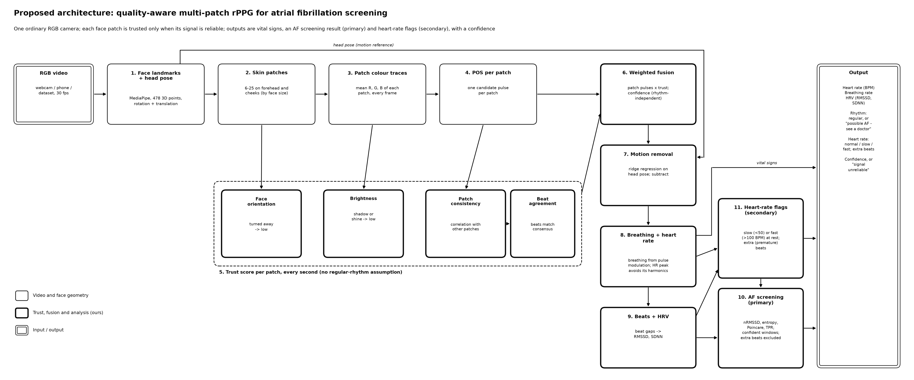
Figure 1: Overall architecture of the proposed system (detailed)

2. Flow of the architecture
A video enters at the top left. Every frame passes through face tracking (block 1), patch extraction (block 2) and colour measurement (block 3), producing one colour trace per patch; these traces are cached because they are the slow, per-frame part. Block 4 converts every patch's trace into a pulse. From then on the system works in overlapping 8-second windows advanced every second: block 5 scores every patch, block 6 fuses the patches with those scores, and block 7 removes the part of the signal that follows the head movement measured in block 1. The cleaned pulse flows down the right-hand column to rates (block 8) and beats (block 9); the beat timings feed both analyses, heart-rate flags (block 11) and AF screening (block 10), and extra beats found by block 11 are removed before the AF check. Everything is collected in the output panel together with the confidence.

3. Explanation of each block
1. RGB video (input): any colour video of a face at about 30 frames per second from a webcam, phone or dataset. No special camera, light or contact sensor is needed.
2. Block 1 – Face landmarks and head pose: MediaPipe FaceLandmarker finds 478 landmarks with relative depth in every frame and returns a facial transformation matrix, from which the head's yaw, pitch and roll angles and its position are computed. The landmarks define the patches; the pose is the reference for motion removal.
3. Block 2 – Skin patches: the forehead and both cheeks are covered by 25 patches, each a group of 2–4 triangles of the face mesh, so the patches move and deform with the face. When the face is small in the frame, neighbouring patches are merged into 12 or 6 so that each keeps enough pixels.
4. Block 3 – Patch colour traces: for every frame the mean red, green and blue values of every patch are measured, together with its pixel count and its orientation to the camera.
5. Block 4 – POS per patch: the POS algorithm turns each patch's colour trace into a candidate pulse signal, which is then detrended and band-pass filtered to the 30–200 BPM range.
6. Block 5 – Trust score per patch: four checks give each patch a weight in each window: face orientation (patches turned away count less), brightness (shadowed or saturated patches count less), patch consistency (correlation with the pulse of all other patches) and beat agreement (whether the patch's beats line up with the consensus beats).
7. Block 6 – Weighted fusion: the patch pulses are averaged with their trust weights. A confidence between 0 and 1 is computed from patch consistency, beat-shape consistency, head motion and the number of trusted patches.
8. Block 7 – Motion removal: the part of the signal that a ridge regression on the head-pose signals can explain is subtracted, first from every patch's colour trace and then from the fused pulse, but only for pose channels that clearly move.
9. Block 8 – Breathing and heart rate: heart rate is read from the strongest spectral peak, or from the mean beat interval when the rhythm is irregular. Breathing rate from the pulse's respiratory modulation is planned for the next phase.
10. Block 9 – Beats and HRV: systolic peaks are detected with sub-frame precision, giving the inter-beat intervals, RMSSD and SDNN.
11. Block 10 – AF screening (primary): beat-interval irregularity features (normalised RMSSD, entropy, Poincaré plot, turning-point ratio) are classified as regular or possible AF, in confident windows only.
12. Block 11 – Heart-rate flags (secondary): a resting rate below 50 or above 100 BPM for at least 2 minutes is flagged as slow or fast, and an early beat followed by a long pause is flagged as an extra (premature) beat.
13. Output: heart rate, breathing rate, RMSSD and SDNN, the rhythm result, the heart-rate flags and the confidence; when the confidence is too low, “signal unreliable” is shown instead of a result.
Blocks 1–7, heart rate and beat detection (blocks 8–9) are implemented and tested; breathing rate, the AF classifier (block 10) and the heart-rate flags (block 11) are designed and scheduled for the next phases of the plan.

Proposed Methodology

1. Overall architecture of the project
Figure 2 (next page) is a simplified view of the same architecture with the steps grouped into seven blocks. It is used below to explain the methods.

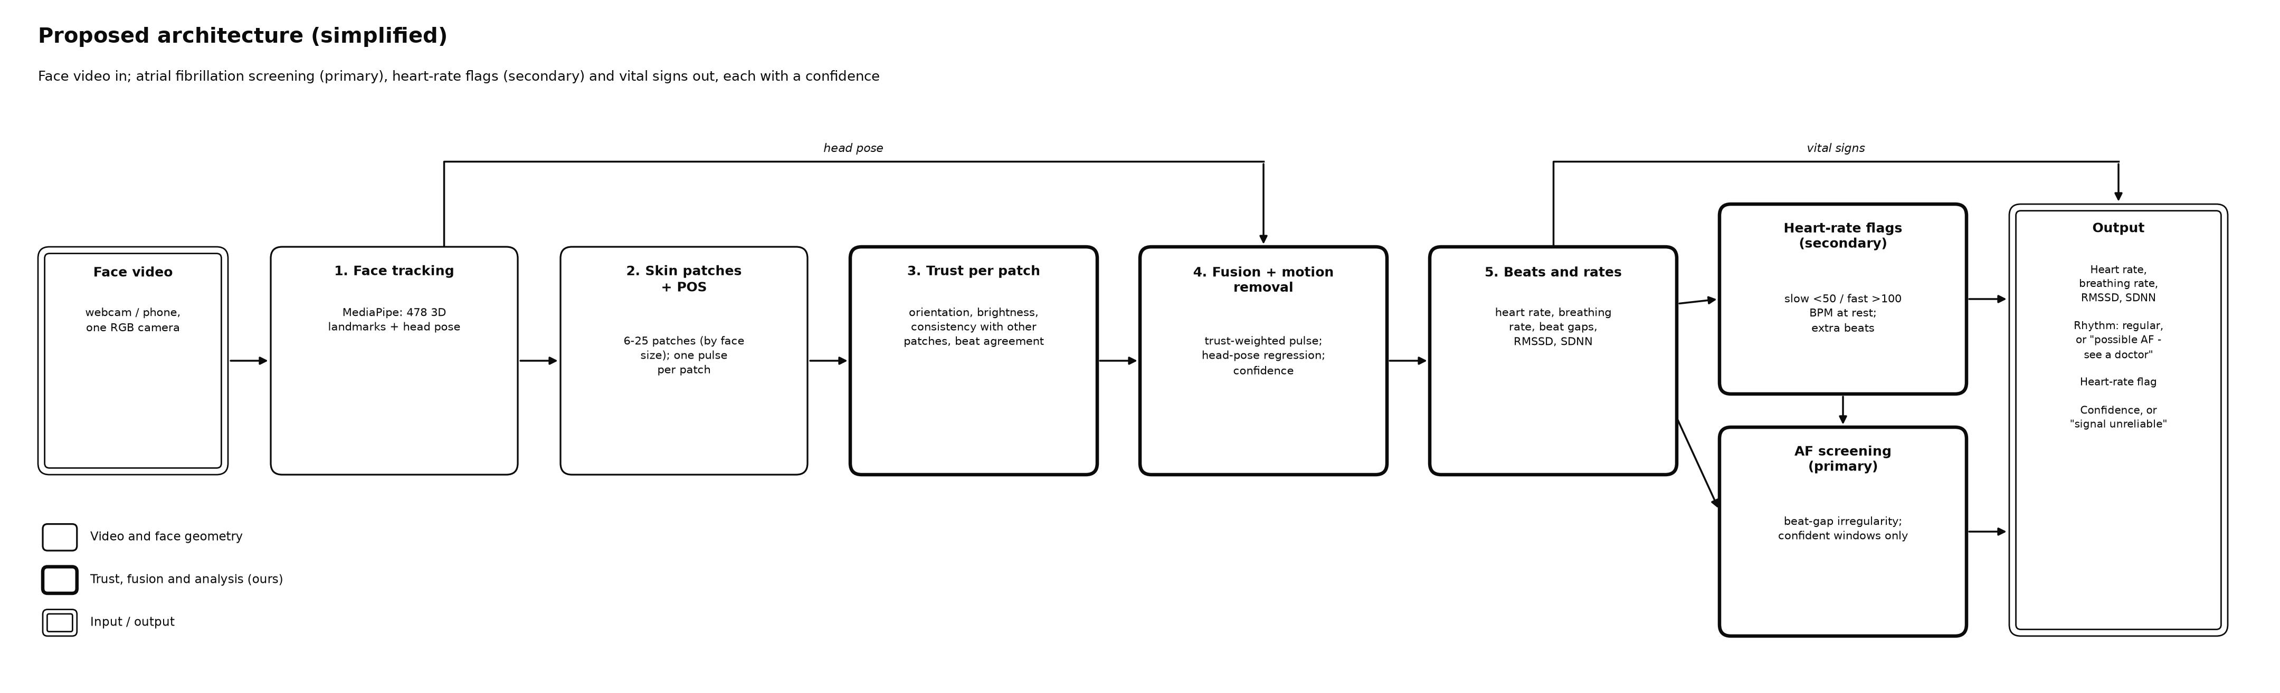
Figure 2: Simplified architecture of the proposed method

2. Flow of the architecture
1. Per frame: track the face, measure the 25 fine patches (colour, pixel count, orientation) and record the head pose. These measurements are saved, so later stages can be re-run and compared without re-processing the video.
2. Per video: choose the patch level from the face size, merge the fine measurements to that level, remove head motion from the colour traces where the head moves, and run POS on every patch.
3. Per window (8 s, every 1 s): compute the four trust checks, fuse the patches, remove the remaining motion, and compute the confidence. Windows are blended with a Hann window, so the fused pulse is continuous.
4. Per recording: detect beats on the fused pulse, compute heart rate and beat intervals, and, in the next phases, run AF screening and the heart-rate flags on confident windows.

3. Detailed explanation of the methods used

3.1 Face tracking and head pose
MediaPipe FaceLandmarker (Kartynnik et al., 2019; Lugaresi et al., 2019) runs in video mode, which tracks the face between frames. Each landmark has x and y in pixels and a relative depth z, which is scaled to pixels so the landmarks form a 3D surface. The 4×4 facial transformation matrix is decomposed into a rotation (yaw, pitch and roll in degrees) and a translation (x, y and z in centimetres), giving six head-pose signals per frame.

3.2 Skin patches and their measurement
Patch definitions are generated once from a frontal reference face. Mesh triangles whose centre lies inside the forehead or a cheek polygon are clustered by position with k-means into 9 forehead and 8 + 8 cheek patches. Coarser levels are unions of these: 4 patches per region (12 in total) and 2 per region (6), shown in Figure 3. Because patches are lists of mesh triangles, they follow the face in every video.
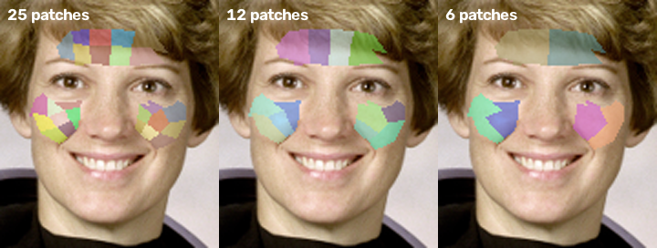
Figure 3: The three patch levels on a reference face: 25, 12 and 6 patches
In each frame the triangles are filled into a label image, and the mean colour and pixel count of every patch are computed in one pass. The orientation of a patch is the area-weighted cosine between its triangles' surface normals and the camera axis:
n = (b − a) × (c − a), facing = |n_z| / |n|
where a, b and c are the 3D corners of a triangle. The level used for a video is the finest one whose typical patch has at least 350 pixels, because averaging over pixels is what cancels camera noise and the pulse changes skin brightness by well under 1%.

3.3 Pulse extraction with POS
For every patch, in sliding windows of 1.6 s, the RGB trace is divided by its mean (Cn) and projected onto two axes orthogonal to the skin tone (Wang et al., 2017):
S1 = Gn − Bn, S2 = −2Rn + Gn + Bn, h = S1 + (σ(S1) / σ(S2)) · S2
The window outputs are overlap-added. The pulse is then detrended with the smoothness-priors method (Tarvainen et al., 2002) and band-passed with a zero-phase Butterworth filter from 0.5 to 3.3 Hz (30–200 BPM). The band is wider than the usual 42–180 BPM so that slow and fast heart rates can be measured.

3.4 Trust checks
Within each 8-second window every patch pulse p_k is scaled to unit variance and four weights are computed:
1. Face orientation: w_f = facing if facing ≥ 0.3, else 0. A tilted surface reflects less light towards the camera (Lambert's law), so patches turned more than about 72° are ignored.
2. Brightness: luma Y = 0.299R + 0.587G + 0.114B. The weight ramps from 0 to 1 between Y = 20 and 45 (shadow) and back to 0 between Y = 220 and 245 (shine or saturation, which clips the pulse).
3. Patch consistency: c_k = max(0, corr(p_k, Σ_{j≠k} w_j p_j)), the correlation with the weighted pulse of all other patches (leave-one-out). In AF all patches still show the same irregular beats, so consistency stays high; noise differs from patch to patch, so it drops. The weight is c_k².
4. Beat agreement: a_k = 2 M_k / (N_k + N_k′), where N_k beats are detected in the patch, N_k′ beats in the leave-one-out consensus, and M_k beats match within 100 ms.
t_k = w_f,k · w_b,k · c_k² · a_k, normalised so that Σ t_k = 1

3.5 Weighted fusion and confidence
The fused pulse is the trust-weighted sum of the patch pulses, f = Σ t_k p_k. The confidence of each window is the geometric mean of four components, each between 0 and 1:
confidence = (C_cons · C_shape · C_motion · C_patch)^(1/4)
- C_cons = Σ t_k c_k, the trust-weighted patch consistency.
- C_shape: beat-shape consistency, the mean correlation of each beat (from 35% of the median interval before its peak to 65% after it, resampled to 32 points) with the average beat of the window. Like the beat-level quality indices of Orphanidou et al. (2015), it judges quality from individual beats. AF changes the timing of beats, not their shape, so a clean AF pulse still scores high.
- C_motion = 1 / (1 + (v / 5)²), where v is the mean head-rotation speed in degrees per second.
- C_patch = min(1, N_eff / (0.3 P)), where N_eff = 1 / Σ t_k² is the effective number of trusted patches out of P.
A spectral-sharpness confidence, the share of power in the strongest frequency peak, was deliberately not used. An irregular rhythm has no single frequency, so such a score would reject exactly the AF windows the system must keep (Figure 7).

3.6 Motion removal
The six head-pose signals and their rates of change form up to 12 regressors, band-passed like the pulse. In each window the part of a signal y explained by the regressors X is estimated with ridge regression and subtracted:
β = (XᵀX + λ n I)⁻¹ Xᵀ y, y_clean = y − X β, λ = 0.1
This is done twice. First it is applied to every patch's normalised colour trace before POS, where the artifact is still linear in the motion. Then it is applied to the fused pulse, for the part that POS's per-window tuning made non-linear. Only pose channels that clearly move in the window are used (rotation of at least 1° RMS or translation of at least 0.5 cm RMS). During development, MediaPipe's pose estimate was found to fluctuate in step with the pulse, with correlations up to 0.36 on still synthetic videos, so regressing on small pose changes would remove real pulse (see also Balakrishnan et al., 2013).

3.7 Heart rate and beat detection
Heart rate is read from the highest peak of a zero-padded periodogram (2^15 points) of the cleaned pulse. Beats are the systolic peaks, found with a minimum distance of half the dominant period and a prominence of 0.25 standard deviations, and refined to sub-frame precision with a parabola through each peak and its neighbours. Without this refinement, beat intervals are quantised to 33 ms at 30 fps, which alone adds irregularity that resembles AF. The beat-based heart rate, 60 / mean interval, is used when the rhythm is irregular, because an irregular rhythm has no single spectral peak.

3.8 AF screening features (next phase)
Rhythm features are computed from the inter-beat intervals (IBI) of confident 30–60 s windows, after removing isolated extra beats. Figure 4 shows why they work: a regular rhythm changes its beat gaps smoothly and slightly, while AF changes them randomly and strongly.
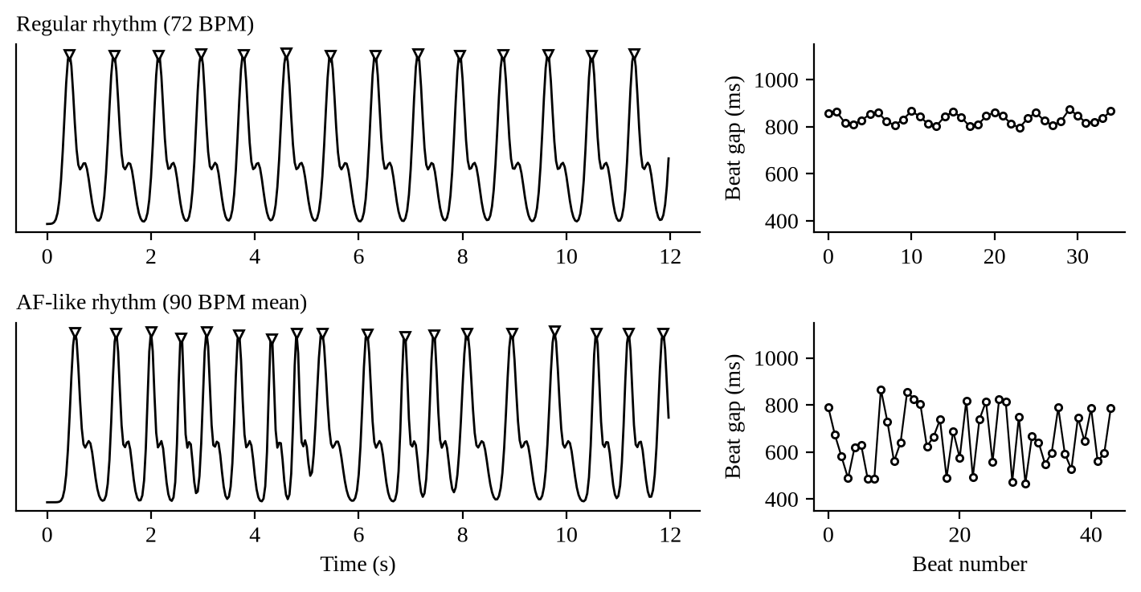
Figure 4: Synthetic pulse waves with detected beats (left) and their beat gaps (right): regular rhythm (top) and AF-like rhythm (bottom)
RMSSD = √( mean( (IBI_{i+1} − IBI_i)² ) ), nRMSSD = RMSSD / mean(IBI)
- Shannon entropy of the IBI histogram (16 bins) and sample entropy measure unpredictability.
- Poincaré plot: each IBI plotted against the next one. SD1 (spread across the identity line) and SD2 (spread along it) describe the cluster; normal rhythm forms a tight cluster and AF a scattered cloud.
- Turning-point ratio: the share of intervals that are a local maximum or minimum; a random series gives about 2/3.
- Classifier: logistic regression or random forest, trained on MIMIC PERform AF (Charlton et al., 2022) with subject-independent cross-validation; thresholds come from the ROC curve, as in Dash et al. (2009).

3.9 Heart-rate flags (next phase)
A slow or fast flag is raised when the median resting heart rate over at least 2 minutes of confident windows is below 50 BPM (bradycardia; Kusumoto et al., 2019) or above 100 BPM (tachycardia). An extra beat is an interval clearly shorter than the local median followed by a longer one. The extra-beat rule is built and tested on MIT-BIH Arrhythmia beat timings (Moody & Mark, 2001) with camera-like timing noise added.

3.10 Comparison variants
To measure what each ingredient contributes, the method can run as seven variants, each adding one ingredient: single (one skin region, plain POS, the baseline), patch_mean (patches with equal weights), +facing, +brightness, +consistency, +beats and full (adding motion removal, the proposed method).

4. Advantages and disadvantages of the methods used
Table 3: Advantages and disadvantages of the methods used
Method | Advantages | Disadvantages
MediaPipe FaceLandmarker | 478 3D landmarks and head pose in real time on a CPU; no training | Pose estimate jitters with the pulse; can lose very small or strongly turned faces
Mesh-based patches (25/12/6) | Follow the face; localise shadows, shine and noise; adapt to face size | Small patches are noisy; forehead patches can touch the hairline
POS per patch | Training-free, well-founded, cancels intensity changes and one distortion direction | Cannot cancel several colour distortions at once; makes motion artifacts non-linear
Rhythm-independent trust checks | Keep real AF while rejecting noise; each check is interpretable | Need several patches; beat agreement adds computation
Ridge regression on head pose | Removes motion artifacts linked to pose; cheap | Can remove pulse if the pose carries it (handled by channel gating)
Confidence gating | Avoids decisions on poor windows, reducing false alarms | Some windows get no answer (lower coverage)
Beat-interval features and simple classifier | Explainable; proven on ECG and contact PPG | Trained on contact PPG; must transfer to camera pulses

5. Justification for choosing these methods
1. Why not a new deep network? Existing networks such as PhysNet and PhysFormer are trained on large labelled datasets that a course project cannot match, and they still give a single pulse with no indication of which skin to trust. Improving the signal with explicit, testable checks is a contribution that can be validated with the available data.
2. Why POS? It rests on an explicit skin-reflection model (Wang et al., 2017), needs no training, runs per patch in real time, and is among the most accurate training-free methods (4.00 BPM MAE on UBFC-rPPG, against 14.70 for ICA and 19.82 for GREEN; Paruchuri et al., 2024).
3. Why patches with trust? Shadows, shine, a turned cheek or local motion affect only part of the face; patches localise these problems so they can be down-weighted instead of contaminating the whole signal (Kumar et al., 2015; Lam & Kuno, 2015).
4. Why rhythm-independent quality? The target condition, AF, is defined by an irregular rhythm. Quality measures that reward a sharp spectral peak would reject it, as Figure 7 shows, so consistency across patches and beat shape are used instead.
5. Why beat-interval features for AF? They are simple, explainable and among the best-validated AF markers on ECG and camera pulses (Dash et al., 2009; McManus et al., 2013), and they transfer from contact PPG training data better than waveform shape.

Implementation Details

1. Hardware / Software
Table 4: Hardware and software used
Item | Details
Development machine | Linux cloud container, Intel Xeon processor at 2.1 GHz, 4 cores, no GPU
Team machine | Windows laptop (CPU only); setup and run scripts provided for PowerShell
Camera | Any RGB webcam or phone camera at about 30 fps; phone videos in H.264
Language | Python 3.11 (3.11–3.13 supported)
Face tracking | MediaPipe 1.0.1, FaceLandmarker task (float16 model, 3.7 MB)
Numerical and signal processing | NumPy 2.4.6, SciPy 1.17.1
Video and image processing | OpenCV 5.0 (headless)
Machine learning | scikit-learn 1.9.1 (k-means for patches; AF classifier in the next phase)
Data handling and plots | pandas 3.0.6, Matplotlib 3.11.2
ECG data access | wfdb 4.3.1 (MIT-BIH Arrhythmia from PhysioNet)
Testing | pytest 9.1.1
Version control | Git and GitHub (repository mayankoff/vision)

2. Any other

2.1 Code organisation
Table 5: Modules of the implementation (package afscreen)
Module | Role
config.py | All settings in one place (band, windows, thresholds), so experiments stay comparable
face/tracker.py | MediaPipe landmarks with depth, and head pose from the transformation matrix
face/patches.py, patches_def.py | Patch definitions, per-frame measurement, merging to 12/6/1 patches, level choice
traces.py | Runs tracking and measurement over a video and caches the patch traces
signal/pos.py, filters.py, spectrum.py | POS, detrending, band-pass filtering, spectrum and FFT heart rate
signal/beats.py, quality.py | Beat detection with sub-frame refinement, beat matching, beat-shape consistency
core/trust.py, core/fusion.py | Trust checks, weighted fusion, motion removal, confidence
pipeline.py | One call per video and variant; the seven comparison variants
io/datasets.py, eval/* | Dataset loaders (UBFC-rPPG, PURE, synthetic), reference values, metrics, benchmark tables
synth.py, scripts/ | Synthetic rhythms and face videos; patch generation; data download; diagrams; Windows scripts

2.2 Synthetic data with known beat times
Real datasets give a reference pulse from a contact sensor, but not the exact time of every beat, and AF face videos are scarce. A synthetic generator was therefore written. It produces beat sequences for regular rhythm (with breathing-linked variation), AF-like rhythm (random intervals), slow and fast rates and extra beats, and turns them into a pulse wave beat by beat. The pulse drives either per-patch colour traces, with optional noisy, shadowed or turned-away patches and tinted-light head motion, or a pulsing face video made from a still photo, with optional small faces and side-to-side sway. Because every beat time is known, beat-timing errors can be measured exactly.

2.3 Testing
The implementation has 37 automatic unit tests and 2 end-to-end tests that run real MediaPipe on synthetic face videos. They cover filtering, POS across 38–150 BPM, beat detection on regular and AF rhythms, patch geometry and merging, each trust check, motion removal, the pulse-locked pose case, AF confidence, data loaders and the evaluation tables. All of them pass.

2.4 Datasets and access
Table 6: Datasets used in the plan
Dataset | Contents | Use | Access
UBFC-rPPG | Face videos + contact PPG | Heart rate and beat timing | Public download
PURE | Face videos with controlled head motion + PPG | Motion removal, beat timing | On request
MIMIC PERform AF | Contact PPG + ECG, 19 AF and 16 non-AF ICU patients | Train/validate AF classifier | Public
MIT-BIH Arrhythmia | ECG with every beat labelled | Extra-beat detector | Public (PhysioNet)
OBF | Face videos, healthy subjects and AF patients | AF on real face videos | On request
UBFC-Phys | Face videos while talking and under stress tasks | False AF alarms on normal rhythm | IEEE DataPort
COHFACE | Face videos + PPG + respiration belt | Breathing rate | On request

2.5 How to run
- Install with the setup script (Windows) or pip, which also downloads the face model and runs the tests.
- afscreen run video.mp4 --debug-video trust.mp4 analyses one video and writes a video with each patch coloured by its trust.
- afscreen extract ubfc data/UBFC-rPPG caches the patch traces of a dataset; afscreen evaluate cache/traces/ubfc scores all seven variants against the reference.

Results

1. Results obtained
Phases 0 and 1 of the plan are complete. The results below come from that implementation and are measured on synthetic data with known beat times. The public face-video datasets (UBFC-rPPG, PURE) and the AF datasets (MIMIC PERform AF, OBF) were not available in the development environment, so real-dataset results, the AF classifier and the heart-rate flags are not reported yet. All numbers were produced by the project code and can be regenerated.

1.1 Contribution of each ingredient (synthetic patch traces)
Six scenarios of 40 s each were simulated with 25 patches: a clean regular rhythm; eight noisy patches; three shadowed and three turned-away patches (all six also noisy); a head-motion artifact in two colour directions; a clean AF-like rhythm; and AF with eight noisy patches. Table 7 gives the beat-interval error of every variant, and Table 8 compares the baseline and the full method.
Table 7: Beat-interval error (ms) of each variant; lower is better
Scenario | single | patch mean | +facing | +bright-ness | +consis-tency | +beats | full
Clean, regular 72 BPM | 6.7 | 3.6 | 3.6 | 3.6 | 3.6 | 3.6 | 3.6
8 noisy patches | 47.8 | 10.8 | 10.8 | 10.8 | 6.5 | 6.3 | 6.3
Shadowed and turned patches | 33.8 | 9.6 | 8.0 | 4.9 | 4.9 | 4.9 | 4.9
Head motion artifact | 93.9 | 93.4 | 93.4 | 93.4 | 93.4 | 93.4 | 9.7
AF, clean | 8.6 | 6.1 | 6.1 | 6.1 | 6.1 | 6.1 | 6.1
AF, 8 noisy patches | 51.3 | 12.0 | 12.0 | 12.0 | 7.5 | 7.4 | 7.4

Table 8: Baseline (single region) versus proposed method (full)
Scenario | True HR (BPM) | HR error single | HR error full | Beat F1 single | Beat F1 full | Conf. single | Conf. full
Clean, regular 72 BPM | 72.1 | 0.02 | 0.03 | 1.00 | 1.00 | 1.00 | 0.98
8 noisy patches | 66.0 | 13.40 | 0.05 | 0.85 | 1.00 | 0.93 | 0.98
Shadowed and turned patches | 80.0 | 9.24 | 0.05 | 0.94 | 0.99 | 0.95 | 0.98
Head motion artifact | 72.1 | 10.29 | 6.90 | 0.41 | 0.93 | 0.48 | 0.46
AF, clean | 90.2 | 0.08 | 0.05 | 1.00 | 1.00 | 0.98 | 0.97
AF, 8 noisy patches | 90.1 | 18.45 | 0.01 | 0.88 | 1.00 | 0.94 | 0.96

1.2 Motion removal
Table 9: Effect of motion removal on a regular 72 BPM rhythm with head motion (artifact strength relative to the pulse)
Motion frequency | Artifact | Beat error without (ms) | Beat error with (ms) | HR error without (BPM) | HR error with (BPM)
0.8 Hz | 10× | 74.9 | 7.6 | 6.4 | 0.06
1 Hz | 3× | 84.6 | 7.7 | 10.1 | 0.01
1 Hz | 10× | 97.5 | 13.1 | 10.1 | 0.01
1.3 Hz | 7× | 230.3 | 18.4 | 34.7 | 0.10

1.3 Quality measures on regular and AF pulses
Table 10: Spectral peak sharpness versus beat-shape consistency (60 s clean pulses)
Signal | Spectral peak sharpness | Beat-shape consistency (used)
Regular pulse, 75 BPM | 0.79 | 1.00
AF-like pulse, 90 BPM mean | 0.33 | 0.95
Band-passed noise only | 0.14 | 0.74

1.4 End-to-end synthetic face videos with real MediaPipe tracking
Nine 30-second synthetic face videos (480 × 480 pixels, 30 fps) were processed by the full pipeline: regular rhythms at 42, 64 (small face), 72, 76 (head sway) and 128 BPM, AF-like rhythms at about 89 (with and without sway) and 109 BPM, and a regular rhythm with extra beats. The face was found in 100% of frames in every video, and the 6-patch level was chosen automatically because the faces are small.
Table 11: End-to-end results on synthetic face videos (full method unless stated)
Video | Rhythm | True HR | Spectral HR | Beat HR | Beat error single (ms) | Beat error full (ms) | Beat F1 | Conf.
af 110 | AF-like | 109.3 | 106.8 | 108.8 | 5.4 | 4.8 | 0.99 | 0.82
af 88 | AF-like | 89.3 | 94.0 | 89.3 | 5.4 | 4.6 | 1.00 | 0.83
af 92 sway | AF-like | 89.3 | 74.6 | 89.3 | 5.4 | 8.2 | 1.00 | 0.79
extra beats 70 | extra beats | 70.3 | 70.5 | 70.4 | 5.1 | 4.6 | 1.00 | 0.81
fast 128 | regular | 128.0 | 128.5 | 128.1 | 2.9 | 2.0 | 0.99 | 0.83
regular 64 small | regular | 64.0 | 64.1 | 64.1 | 6.4 | 3.9 | 1.00 | 0.75
regular 72 | regular | 71.9 | 72.1 | 72.0 | 3.8 | 2.8 | 1.00 | 0.83
regular 76 sway | regular | 76.0 | 76.0 | 76.0 | 2.8 | 2.4 | 1.00 | 0.81
slow 42 | regular | 42.1 | 42.1 | 42.2 | 5.9 | 5.1 | 1.00 | 0.82

1.5 Head pose carries the pulse
Table 12: Largest correlation between a head-pose regressor and the true pulse on still and swaying synthetic videos
Video | Max. |correlation|
regular 72 (still) | 0.32
slow 42 (still) | 0.23
AF 88 (still) | 0.23
regular 76 (sway) | 0.36

1.6 Processing speed
Table 13: Processing time on a 4-core 2.1 GHz CPU (single process)
Stage | Time
MediaPipe face tracking (480 × 480 frame) | 10.5 ms per frame
Patch measurement (25 patches) | 0.9 ms per frame
POS, trust, fusion, motion removal, beats (full method) | 0.54 ms per frame (0.49 s per 30 s video)
Total | about 12 ms per frame, about 80 frames per second

2. Interpretation of the obtained results
1. Patches beat one region whenever part of the face is bad. With noisy, shadowed or turned patches, the single-region baseline mixes bad skin into the signal, producing beat errors of 47.8 ms and 33.8 ms and missing or inventing beats (F1 0.85 and 0.94). Equal-weight patches already help; the trust checks then cut the error to 6.3 ms and 4.9 ms with every beat found.
2. Each check acts on its own problem. Orientation and brightness reduce the error only in the shadowed/turned scenario, and consistency and beat agreement act most when patches are noisy. On clean data all variants agree, so the checks cost nothing when nothing is wrong.
3. Motion removal is essential under head motion. Without it, the motion artifact dominates (beat errors of 74.9–230.3 ms and heart-rate errors up to 34.7 BPM); with it, beat errors fall to 7.6–18.4 ms and the heart rate is within 0.1 BPM.
4. AF is kept, not rejected. A clean AF pulse keeps beat-shape consistency 0.95 and confidence 0.97, while its spectral peak sharpness drops to 0.33 (regular: 0.79). A spectral confidence would have treated real AF almost like noise (0.14).
5. Beat timing is accurate end to end. On the nine synthetic videos, beat errors are 2–8 ms with F1 0.99–1.00, and the beat-based heart rate is within 0.12 BPM of the truth on average. The spectral heart rate fails on AF (for example 74.6 BPM against a true 89.3 BPM in the AF video with sway), which confirms that irregular rhythms need the beat-based rate.
6. The trust checks show no gain on the synthetic videos because the still photo gives every patch the same quality. Their effect must be shown on real videos, where shadows, shine and motion are uneven.
7. MediaPipe's head pose follows the pulse (correlations 0.23–0.36). An earlier version of motion removal therefore removed real pulse and raised the beat error on still videos about tenfold. Using only clearly moving pose channels fixed this. A small cost remains in one swaying AF video (8.2 ms against 5.4 ms for the baseline), which will be checked on PURE.

Analysis

1. Analysis of the results obtained
The results support the two design ideas of the project. First, judging skin patch by patch, and combining them by trust, protects beat timing against local problems that a single averaged region cannot avoid; the error reductions are largest exactly where a part of the face is bad. Second, quality measures must not assume a regular rhythm: the measures used here keep clean AF pulses at high confidence, while the spectral measure common in earlier region-weighting methods would discard them.
Two findings came from building the system and changed the design. POS cancels one colour-distortion direction by itself but makes motion artifacts non-linear in the fused pulse, so motion is removed from the colour traces before POS as well as afterwards. MediaPipe's pose estimate contains the pulse, so only clearly moving pose channels are used. Both are now covered by automatic tests.
The limits of the evidence are clear. Synthetic data cannot reproduce real skin optics, compression, lighting changes or physiology, and the AF classifier and heart-rate flags are not yet implemented. The results show that the machinery works as designed. They do not yet show how accurate the system is on people.

2. Comparison with existing results
Table 14: Published results and the status of this project
Work | Task and data | Reported result
POS / CHROM with rPPG-Toolbox (Paruchuri et al., 2024) | Heart rate, UBFC-rPPG | 4.00 / 3.98 BPM MAE
Tateno & Glass (2001) | AF from ECG intervals, MIT-BIH AF | 94.4% sensitivity, 97.2% specificity
Dash et al. (2009) | AF from ECG intervals, MIT-BIH AF | 94.4% sensitivity, 95.1% specificity
McManus et al. (2013) | AF from fingertip camera pulse, 76 patients | 96.2% sensitivity, 97.5% specificity
Yan et al. (2018) | AF from face video vs 12-lead ECG | 95% sensitivity, 96% specificity
Sun et al. (2022) | AF from face video (OBF) | 96.0% accuracy (AF vs healthy); 95.2% (AF vs sinus rhythm)
This project (so far) | Beat timing and heart rate, synthetic face videos | Beat error 2–8 ms, beat F1 0.99–1.00, beat-based HR error 0.12 BPM; real-dataset and AF results pending

The published numbers come from real recordings and are not directly comparable with synthetic results. The planned comparison will run POS on one region (the published baseline), the proposed method and, through rPPG-Toolbox, pretrained deep networks on UBFC-rPPG and PURE with the same metrics. All of them will feed the same AF classifier, so the comparison isolates the quality of pulse extraction. The AF results will be reported against Yan et al. (2018) and Sun et al. (2022) on OBF if access is granted, and as false-alarm rates on normal-rhythm videos in any case.

3. Efficiency obtained and metrics used
Table 15: Metrics used in the project
Metric | Meaning | Better
MAE, RMSE, MAPE (BPM, %) | Heart-rate error against the reference | Lower
Pearson r | Agreement of predicted and reference heart rate | Higher
SNR (dB) | Pulse power near the reference heart rate versus the rest of the band | Higher
Beat-interval error (ms) | Mean absolute error of matched inter-beat intervals | Lower
Beat F1 | Share of beats found without missing or inventing beats | Higher
Confidence | Rhythm-independent signal quality, 0–1 | Higher on good signals
Sensitivity, specificity, AUC | AF detection quality (next phase) | Higher
False-alarm rate, coverage | AF alarms on normal rhythm; share of windows with an answer (next phase) | Lower; higher
Processing time (ms per frame) | Computational efficiency | Lower

Efficiency obtained: beat-interval errors of 4.9–9.7 ms under simulated problems (against 33.8–93.9 ms for the baseline), beat F1 of 0.99–1.00 and a 0.12 BPM beat-based heart-rate error on synthetic face videos, and a processing speed of about 12 ms per frame (about 80 frames per second) on a 4-core CPU without a GPU, which is real time for 30 fps video.

4. Results represented in graphs with interpretation
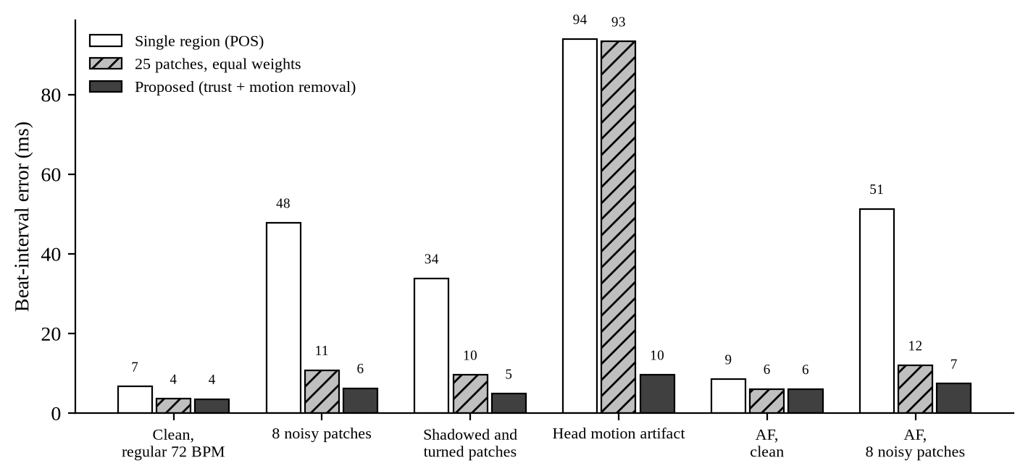
Figure 5: Beat-interval error of the baseline, equal-weight patches and the proposed method in six simulated scenarios
Figure 5: the white bars (single region) rise sharply whenever part of the face is bad or the head moves, while the dark bars (proposed method) stay between about 4 and 10 ms. The hatched bars (equal-weight patches) show that splitting the face helps by itself, and the gap between hatched and dark bars is the contribution of trust and motion removal. The motion case is the clearest: only the proposed method, which removes motion, avoids the artifact.
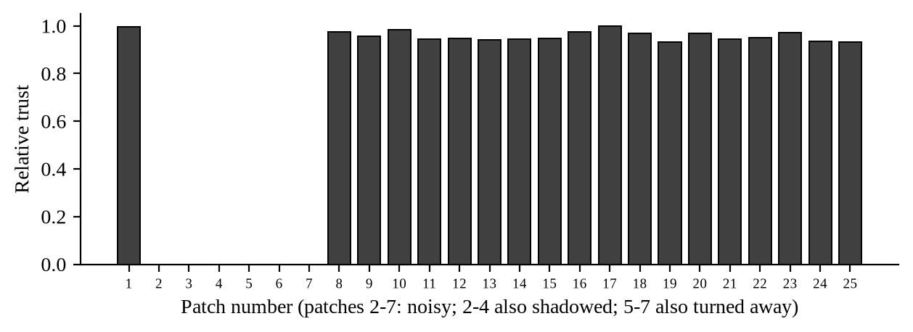
Figure 6: Average trust of each patch when patches 2–7 are noisy and, in addition, shadowed (2–4) or turned away (5–7)
Figure 6: the six problem patches receive practically zero trust and the 19 good patches share the weight almost equally, so the fused pulse is built only from good skin. This is what the trust map in the debug video shows on the face.
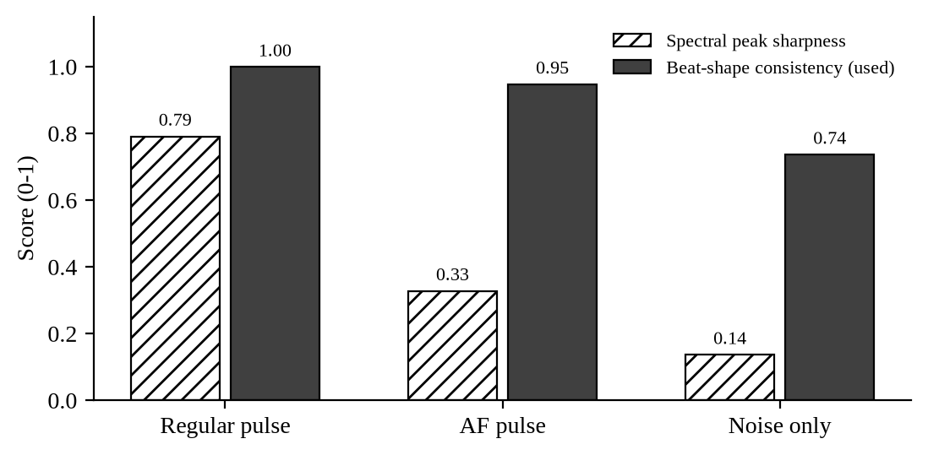
Figure 7: Spectral peak sharpness and beat-shape consistency for a regular pulse, an AF pulse and noise
Figure 7: spectral peak sharpness falls from 0.79 for a regular pulse to 0.33 for AF, much closer to noise (0.14), so it cannot tell AF from a bad signal. Beat-shape consistency stays high for AF (0.95) and drops for noise (0.74). This is why the confidence uses beat shape and cross-patch consistency.
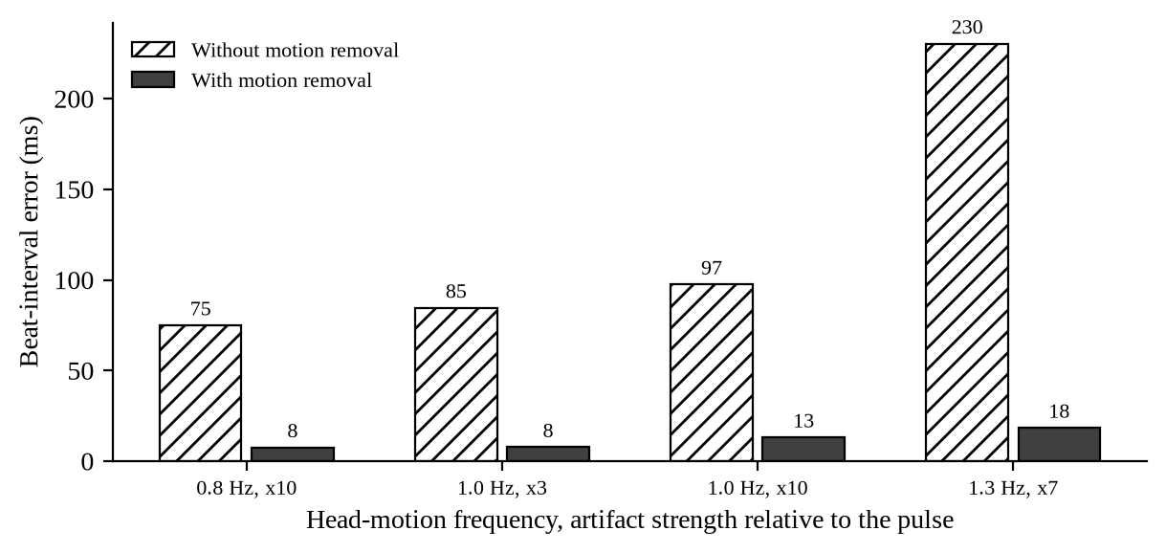
Figure 8: Beat-interval error with and without motion removal under head motion of different frequencies and strengths
Figure 8: without motion removal, errors of 75–230 ms make beat timing useless for rhythm analysis, and they grow when the motion frequency is close to the heart rate (1.3 Hz against 1.2 Hz). With motion removal the errors stay at 8–18 ms in every case.

Conclusion and Future Work

1. Significance of the project
Atrial fibrillation is common, often silent and a major cause of stroke, and finding it early allows stroke-preventing treatment. A screening check that needs only the camera already present in phones, laptops and kiosks could reach people who would never wear a monitor. The project contributes a way to make such a check trustworthy: it measures the pulse in many small skin patches, trusts them by rules that do not assume a regular heartbeat, removes head motion and decides only when the signal is reliable, to reduce the false AF alarms that motion and lighting otherwise cause.

2. Results and efficiency obtained
The face tracking, patch, trust, fusion, motion-removal, confidence and beat-detection stages are implemented, tested by 39 automatic tests, and run at about 12 ms per frame on a CPU. On synthetic data with known beats they cut beat-timing errors from 34–94 ms to 5–10 ms in the presence of bad patches and head motion. They keep clean AF pulses at high confidence and find every beat on synthetic face videos. Real-dataset accuracy and AF screening performance are the next results to be obtained.

3. Difficulties faced in performing this project
1. Data access: the most important datasets (OBF for AF face videos, PURE, COHFACE) are available only on request, and the development environment could not download the public ones, so validation so far relies on synthetic data.
2. Unexpected coupling of head pose and pulse: MediaPipe's pose estimate moves with each heartbeat, so the first motion-removal design removed real pulse; this had to be diagnosed and solved by using only clearly moving pose channels.
3. Non-linearity introduced by POS: removing motion only after POS barely helped, because POS's per-window tuning distorts the artifact; motion removal had to be moved before POS as well.
4. Irregular rhythms break common tools: spectral quality measures and the FFT heart rate both fail on AF, so rhythm-independent quality measures and a beat-based heart rate were needed.
5. Changes of scope: the project moved from a benchmark of existing methods to a new method, and its output moved from stress (and a briefly considered thermal camera, dropped because it needs extra hardware) to AF screening with heart-rate flags, which required re-planning.
6. Practical issues: Windows-specific setup problems with the earlier toolbox environment, and phone videos in HEVC format that OpenCV cannot read.

4. Future work
1. Run the Phase 1 check on UBFC-rPPG and PURE: the proposed method against single-region POS, and the ablation of every ingredient on real faces.
2. Add breathing rate and breathing-aware heart-rate selection, and validate breathing on COHFACE (Phase 2).
3. Build the AF classifier on MIMIC PERform AF and test it on face videos: sensitivity and specificity on OBF if granted, and false-alarm rate and coverage with and without confidence gating on normal-rhythm videos (Phase 3).
4. Implement the slow, fast and extra-beat flags and test the extra-beat rule on MIT-BIH Arrhythmia (Phase 4).
5. Compare with pretrained deep networks through rPPG-Toolbox, measure robustness across skin tones and lighting, and build a live webcam demo with the trust map on the face (Phases 5–6).
6. Longer term, the method can be improved by learning the trust weights from data, adding near-infrared cameras for low light, and validating with clinicians on people with confirmed AF.

Prompt Engineering

1. Prompt source
The prompts were written by the team and given to Claude, Anthropic's AI assistant, through Claude Code (a coding agent that can read the repository, run code and search the web). It was used to plan the phases, explain concepts, research the literature, draw the architecture diagrams, write and test the code, and draft this report. The team made the project decisions (changes of direction, scope, primary and secondary outputs), and the assistant's code was verified by running the automatic tests and the synthetic experiments reported above.

2. Prompts utilized
The prompts below are listed in the order they were used. Their wording has been edited for clarity and grammar, and closely related follow-up questions are combined; the content of each request is unchanged.
1. Adapt the setup and scripts for Windows, run and demonstrate what has been built, and proceed with Phase 2.
2. The rPPG-Toolbox environment is now working. What is the next step?
3. We have not recorded our own face video yet. What can be done in the meantime?
4. Suggest an addition that would make the project more original, since it currently relies only on existing classical and deep-learning methods.
5. Are the deep-learning models already trained, so that only the datasets are needed to measure their accuracy? The question is meant in general terms.
6. Explain the proposed new method in simple language.
7. Clarify the following: (1) What is the MMPD dataset? (2) What does the rhythm used in the trust score refer to? (3) Can MediaPipe identify shadowed regions so that they receive a low trust score? (4) How is the pulse produced in the proposed method, compared with POS, CHROM or PhysNet followed by an FFT?
8. Confirm my understanding: the project compares two existing approaches with one new method built from existing techniques.
9. Provide a block diagram of the system.
10. Could we train our own neural network on the available datasets to replace POS, so that the core model is our own work?
11. Are existing deep networks such as PhysNet built on forehead and cheek regions, and on which datasets were they trained?
12. Since existing networks are large and difficult to outperform, we will keep the planned method of applying POS to about 25 facial patches. Do not implement it yet; this is a design discussion only.
13. Keep the agreement check, add it to the diagram, and write a context paragraph that can be used to generate the block diagram with an AI tool.
14. Show the handcrafted equations that classical methods use to obtain the pulse signal, and explain how they differ between methods.
15. Explain how deep-learning models generate the pulse signal.
16. Provide content for a presentation of at most five slides based on the finalised architecture diagram.
17. Revise the plan without implementing it: show only the proposed architecture in the diagram; add a research-backed, real-world output derived from the predicted heart rate; and research whether thermal imaging could make the method more precise and more novel.
18. Summarise the proposal in a short paragraph.
19. Would users of the application need a separate thermal camera in addition to a normal camera?
20. Remove the thermal component from the project.
21. Suggest a more clinically useful output than the stress level.
22. Update the plan with atrial fibrillation screening as the primary output and stress as a secondary output.
23. Generate the updated implementation plan.
24. Create a black-and-white architecture diagram and a prompt for generating it with an AI tool.
25. Explain how the model detects atrial fibrillation or estimates stress from the heart rate.
26. What are heart-rate variability and the LF/HF ratio, and how are they measured?
27. What is the normal range of heart-rate variability, and how was it established?
28. Explain atrial fibrillation in simple terms, how the model detects it, and what happens after it is detected.
29. Are the beat-interval values used in the explanation supported by research?
30. Can other medical conditions be detected from the predicted heartbeat?
31. What do abnormally slow or fast heartbeats indicate?
32. Make abnormal heart-rate flags the secondary output, keep atrial fibrillation as the primary output, and assess the feasibility.
33. Explain the architecture in one paragraph, defining every technical term.
34. Answer the following design questions: (1) Can the face realistically be divided into 25 patches, or should the number be reduced? (2) How is the confidence of the weighted fusion computed? (3) How are the trust-score features computed? (4) How is motion removal performed? (5) Which of RMSSD, SDNN and LF/HF is most important for the project?
35. Update the implementation plan and create a simplified architecture diagram.

3. Relevant search keywords
The following keywords were used to search the literature, datasets and guidelines:
- remote photoplethysmography (rPPG); contactless heart rate from facial video
- POS, CHROM, PBV and ICA rPPG methods; rPPG-Toolbox benchmark
- multi-region and patch-based rPPG; region weighting; DistancePPG; skin segmentation
- rPPG head motion; face orientation; ballistocardiographic head motion
- deep learning rPPG: DeepPhys, PhysNet, TS-CAN, PhysFormer
- atrial fibrillation detection from facial video; smartphone photoplethysmography atrial fibrillation
- atrial fibrillation RR-interval irregularity: RMSSD, Shannon entropy, turning-point ratio, Poincaré plot
- premature atrial and ventricular contractions versus atrial fibrillation in PPG
- PPG signal-quality index; PPG beat detection benchmark
- respiratory rate from the photoplethysmogram
- OBF database; MIMIC PERform AF; UBFC-rPPG; PURE; UBFC-Phys; COHFACE; MMPD; MIT-BIH Arrhythmia Database
- atrial fibrillation prevalence, stroke risk and screening (USPSTF); bradycardia guideline
- normal values of short-term heart-rate variability
- RGB and thermal imaging for stress detection (explored and not adopted)

4. Any other
- Verification: every numerical result in this report was produced by running the project code. Every published fact and number was checked against the paper's abstract, publisher record or an indexed summary, and statements that could not be confirmed were removed.
- Iteration: design questions (patch count, confidence, trust features, motion removal, which HRV measure to keep) were asked explicitly, and the answers were turned into changes to the implementation plan before any code was written.
- Limitations: an AI assistant can make mistakes in citations and code; the team should check the references and the code before final submission.

References

1. Journals
Bobbia, S., Macwan, R., Benezeth, Y., Mansouri, A., & Dubois, J. (2019). Unsupervised skin tissue segmentation for remote photoplethysmography. Pattern Recognition Letters, 124, 82–90. https://doi.org/10.1016/j.patrec.2017.10.017
Charlton, P. H., Kotzen, K., Mejía-Mejía, E., Aston, P. J., Budidha, K., Mant, J., Pettit, C., Behar, J. A., & Kyriacou, P. A. (2022). Detecting beats in the photoplethysmogram: Benchmarking open-source algorithms. Physiological Measurement, 43(8), 085007. https://doi.org/10.1088/1361-6579/ac826d
Chong, J. W., Esa, N., McManus, D. D., & Chon, K. H. (2015). Arrhythmia discrimination using a smart phone. IEEE Journal of Biomedical and Health Informatics, 19(3), 815–824. https://doi.org/10.1109/JBHI.2015.2418195
Dash, S., Chon, K. H., Lu, S., & Raeder, E. A. (2009). Automatic real time detection of atrial fibrillation. Annals of Biomedical Engineering, 37(9), 1701–1709. https://doi.org/10.1007/s10439-009-9740-z
de Haan, G., & Jeanne, V. (2013). Robust pulse rate from chrominance-based rPPG. IEEE Transactions on Biomedical Engineering, 60(10), 2878–2886. https://doi.org/10.1109/TBME.2013.2266196
de Haan, G., & van Leest, A. (2014). Improved motion robustness of remote-PPG by using the blood volume pulse signature. Physiological Measurement, 35(9), 1913–1926. https://doi.org/10.1088/0967-3334/35/9/1913
Karlen, W., Raman, S., Ansermino, J. M., & Dumont, G. A. (2013). Multiparameter respiratory rate estimation from the photoplethysmogram. IEEE Transactions on Biomedical Engineering, 60(7), 1946–1953. https://doi.org/10.1109/TBME.2013.2246160
Kumar, M., Veeraraghavan, A., & Sabharwal, A. (2015). DistancePPG: Robust non-contact vital signs monitoring using a camera. Biomedical Optics Express, 6(5), 1565–1588. https://doi.org/10.1364/BOE.6.001565
Kusumoto, F. M., Schoenfeld, M. H., Barrett, C., et al. (2019). 2018 ACC/AHA/HRS guideline on the evaluation and management of patients with bradycardia and cardiac conduction delay. Circulation, 140(8), e382–e482. https://doi.org/10.1161/CIR.0000000000000628
McManus, D. D., Lee, J., Maitas, O., Esa, N., Pidikiti, R., Carlucci, A., Harrington, J., Mick, E., & Chon, K. H. (2013). A novel application for the detection of an irregular pulse using an iPhone 4S in patients with atrial fibrillation. Heart Rhythm, 10(3), 315–319. https://doi.org/10.1016/j.hrthm.2012.12.001
Moody, G. B., & Mark, R. G. (2001). The impact of the MIT-BIH Arrhythmia Database. IEEE Engineering in Medicine and Biology Magazine, 20(3), 45–50. https://doi.org/10.1109/51.932724
Nunan, D., Sandercock, G. R. H., & Brodie, D. A. (2010). A quantitative systematic review of normal values for short-term heart rate variability in healthy adults. Pacing and Clinical Electrophysiology, 33(11), 1407–1417. https://doi.org/10.1111/j.1540-8159.2010.02841.x
Orphanidou, C., Bonnici, T., Charlton, P., Clifton, D., Vallance, D., & Tarassenko, L. (2015). Signal-quality indices for the electrocardiogram and photoplethysmogram: Derivation and applications to wireless monitoring. IEEE Journal of Biomedical and Health Informatics, 19(3), 832–838. https://doi.org/10.1109/JBHI.2014.2338351
Poh, M.-Z., McDuff, D. J., & Picard, R. W. (2010). Non-contact, automated cardiac pulse measurements using video imaging and blind source separation. Optics Express, 18(10), 10762–10774. https://doi.org/10.1364/OE.18.010762
Sun, Z., Junttila, J., Tulppo, M., Seppänen, T., & Li, X. (2022). Non-contact atrial fibrillation detection from face videos by learning systolic peaks. IEEE Journal of Biomedical and Health Informatics, 26(9), 4587–4598. https://doi.org/10.1109/JBHI.2022.3193117
Tarvainen, M. P., Ranta-aho, P. O., & Karjalainen, P. A. (2002). An advanced detrending method with application to HRV analysis. IEEE Transactions on Biomedical Engineering, 49(2), 172–175. https://doi.org/10.1109/10.979357
Tateno, K., & Glass, L. (2001). Automatic detection of atrial fibrillation using the coefficient of variation and density histograms of RR and ΔRR intervals. Medical & Biological Engineering & Computing, 39(6), 664–671. https://doi.org/10.1007/BF02345439
US Preventive Services Task Force; Curry, S. J., Krist, A. H., Owens, D. K., et al. (2018). Screening for atrial fibrillation with electrocardiography: US Preventive Services Task Force recommendation statement. JAMA, 320(5), 478–484. https://doi.org/10.1001/jama.2018.10321
Verkruysse, W., Svaasand, L. O., & Nelson, J. S. (2008). Remote plethysmographic imaging using ambient light. Optics Express, 16(26), 21434–21445. https://doi.org/10.1364/OE.16.021434
Wang, W., den Brinker, A. C., Stuijk, S., & de Haan, G. (2017). Algorithmic principles of remote PPG. IEEE Transactions on Biomedical Engineering, 64(7), 1479–1491. https://doi.org/10.1109/TBME.2016.2609282
Wang, W., Stuijk, S., & de Haan, G. (2015). Exploiting spatial redundancy of image sensor for motion robust rPPG. IEEE Transactions on Biomedical Engineering, 62(2), 415–425. https://doi.org/10.1109/TBME.2014.2356291
Wolf, P. A., Abbott, R. D., & Kannel, W. B. (1991). Atrial fibrillation as an independent risk factor for stroke: The Framingham Study. Stroke, 22(8), 983–988. https://doi.org/10.1161/01.STR.22.8.983
Yan, B. P., Lai, W. H. S., Chan, C. K. Y., et al. (2018). Contact-free screening of atrial fibrillation by a smartphone using facial pulsatile photoplethysmographic signals. Journal of the American Heart Association, 7(8), e008585. https://doi.org/10.1161/JAHA.118.008585
Yan, B. P., Lai, W. H. S., Chan, C. K. Y., Au, A. C. K., Freedman, B., Poh, Y. C., & Poh, M.-Z. (2020). High-throughput, contact-free detection of atrial fibrillation from video with deep learning. JAMA Cardiology, 5(1), 105–107. https://doi.org/10.1001/jamacardio.2019.4004

2. Conferences
Balakrishnan, G., Durand, F., & Guttag, J. (2013). Detecting pulse from head motions in video. Proceedings of the IEEE Conference on Computer Vision and Pattern Recognition, 3430–3437. https://doi.org/10.1109/CVPR.2013.440
Cantrill, S., Ahmedt-Aristizabal, D., Petersson, L., Suominen, H., & Armin, M. A. (2024). Orientation-conditioned facial texture mapping for video-based facial remote photoplethysmography estimation. Proceedings of the IEEE/CVF Conference on Computer Vision and Pattern Recognition Workshops, 354–363. https://doi.org/10.1109/CVPRW63382.2024.00040
Chen, W., & McDuff, D. (2018). DeepPhys: Video-based physiological measurement using convolutional attention networks. Proceedings of the European Conference on Computer Vision (ECCV). https://arxiv.org/abs/1805.07888
Kartynnik, Y., Ablavatski, A., Grishchenko, I., & Grundmann, M. (2019). Real-time facial surface geometry from monocular video on mobile GPUs. CVPR Workshop on Computer Vision for Augmented and Virtual Reality. arXiv:1907.06724. https://arxiv.org/abs/1907.06724
Lam, A., & Kuno, Y. (2015). Robust heart rate measurement from video using select random patches. Proceedings of the IEEE International Conference on Computer Vision (ICCV), 3640–3648. https://doi.org/10.1109/ICCV.2015.415
Li, X., Alikhani, I., Shi, J., Seppänen, T., Junttila, J., Majamaa-Voltti, K., Tulppo, M., & Zhao, G. (2018). The OBF database: A large face video database for remote physiological signal measurement and atrial fibrillation detection. 13th IEEE International Conference on Automatic Face & Gesture Recognition (FG 2018), 242–249. https://doi.org/10.1109/FG.2018.00043
Liu, X., Fromm, J., Patel, S., & McDuff, D. (2020). Multi-task temporal shift attention networks for on-device contactless vitals measurement. Advances in Neural Information Processing Systems, 33. https://arxiv.org/abs/2006.03790
Liu, X., Narayanswamy, G., Paruchuri, A., Zhang, X., Tang, J., Zhang, Y., Sengupta, R., Patel, S., Wang, Y., & McDuff, D. (2023). rPPG-Toolbox: Deep remote PPG toolbox. Advances in Neural Information Processing Systems, 36 (Datasets and Benchmarks Track). https://arxiv.org/abs/2210.00716
Paruchuri, A., Liu, X., Pan, Y., Patel, S., McDuff, D., & Sengupta, S. (2024). Motion matters: Neural motion transfer for better camera physiological measurement. Proceedings of the IEEE/CVF Winter Conference on Applications of Computer Vision (WACV), 5933–5942. https://arxiv.org/abs/2303.12059
Lugaresi, C., Tang, J., Nash, H., McClanahan, C., Uboweja, E., Hays, M., Zhang, F., Chang, C.-L., Yong, M. G., Lee, J., Chang, W.-T., Hua, W., Georg, M., & Grundmann, M. (2019). MediaPipe: A framework for building perception pipelines. arXiv:1906.08172. https://arxiv.org/abs/1906.08172
Tulyakov, S., Alameda-Pineda, X., Ricci, E., Yin, L., Cohn, J. F., & Sebe, N. (2016). Self-adaptive matrix completion for heart rate estimation from face videos under realistic conditions. Proceedings of the IEEE Conference on Computer Vision and Pattern Recognition, 2396–2404. https://doi.org/10.1109/CVPR.2016.263
Yu, Z., Li, X., & Zhao, G. (2019). Remote photoplethysmograph signal measurement from facial videos using spatio-temporal networks. Proceedings of the British Machine Vision Conference (BMVC). arXiv:1905.02419. https://arxiv.org/abs/1905.02419
Yu, Z., Shen, Y., Shi, J., Zhao, H., Torr, P. H. S., & Zhao, G. (2022). PhysFormer: Facial video-based physiological measurement with temporal difference transformer. Proceedings of the IEEE/CVF Conference on Computer Vision and Pattern Recognition, 4176–4186. https://doi.org/10.1109/CVPR52688.2022.00415

3. Book Chapters | Websites
Google AI Edge. (n.d.). Face landmark detection guide (MediaPipe Face Landmarker). https://ai.google.dev/edge/mediapipe/solutions/vision/face_landmarker
PhysioNet. (n.d.). MIT-BIH Arrhythmia Database, version 1.0.0. https://physionet.org/content/mitdb/1.0.0/
Charlton, P. H. (n.d.). MIMIC PERform AF dataset (ppg-beats documentation). https://ppg-beats.readthedocs.io/en/latest/datasets/mimic_perform_af/
Benezeth, Y. (n.d.). UBFC-rPPG dataset. https://sites.google.com/view/ybenezeth/ubfcrppg
Ubicomp Lab, University of Washington. (n.d.). rPPG-Toolbox [Source code]. GitHub. https://github.com/ubicomplab/rPPG-Toolbox
Mayank, & Pandita, V. (2026). vision: Quality-aware multi-patch rPPG for atrial fibrillation screening [Source code]. GitHub. https://github.com/mayankoff/vision

