

C.V. Raman Global University Bhubaneshwar, Odisha ESTD-2020

ABSTRACT

Prediction of winner of FIFA World Cup football matches using the historical statistics. The prediction should be for 2022 and 2026 World Cups

Course Instructor: Asst. Prof. Dilip Rout

TEAM MEMBERS

|  |  |  |
| --- | --- | --- |
| **SO.NO** | **REG.NO.** | **NAME** |
| 1 | 2201020462 | MASIRA JAINAB |
| 2 | 2201020479 | SUGYANI RANI PANDA |
| 3 | 2201020485 | VIJIT KUMAR |
| 4 | 2201020607 | KHUSHI KUMARI |
| 5 | 2201020754 | PRINCE KUMAR |
| 6 | 2201020886 | MAYANK RAJ |

**INTRODUCTION**

This project aims to develop a predictive model that uses historical statistics to forecast the winner of FIFA World Cup matches for the 2022 and 2026 tournaments. The model will be trained on a dataset of historical FIFA World Cup match data from 1930 to 2014, including team and player statistics, match outcomes, and tournament-specific factors. By analysing these statistics, the model will identify patterns and trends that can be used to predict the winner of each match. The project will employ advanced machine learning algorithms such as logistic regression and decision trees etc. to develop the predictive model. The model's performance will be evaluated using metrics such as accuracy, precision, and recall. The final model will be used to predict the winner of each match for the 2022 and 2026 FIFA World Cup tournaments, providing valuable insights for football fans, analysts, and teams. The project's outcome will be a robust and reliable predictive model that can be used to make informed predictions about the outcome of FIFA World Cup matches.

### Real-life Situation and Usages

1. **Sports Betting and Fantasy Leagues**: Accurate predictions of World Cup match outcomes can be used by sports bettors and fantasy league participants to make informed decisions,

potentially increasing their chances of success.

1. **Team Strategy Development**: Football teams and coaches can use predictive models to analyze opponents, anticipate match outcomes, and develop strategies to enhance their chances of winning.
2. **Broadcasting and Media Coverage**: Media outlets can use predictive insights to enhance

their coverage, offering viewers data-driven analyses and predictions that engage and inform audiences.

1. **Sponsorship and Marketing**: Brands and sponsors can leverage predictions to time their marketing efforts, associating with teams or matches that are likely to draw significant attention and success.
2. **Fan Engagement**: Sports organizations and clubs can use prediction models to create

interactive content for fans, such as polls or prediction games, enhancing fan engagement and loyalty during tournaments.

**PROBLEM STATEMENT**

The FIFA World Cup, a premier international football tournament, is plagued by numerous uncertainties and complexities that make it challenging to predict the outcome of individual matches and the overall tournament winner. The performance of each team is influenced by a multitude of factors, including team dynamics, player skills, coaching strategies, weather conditions, and external pressures, which interact with each other in complex ways. Furthermore, the tournament format, with its group stages and knockout rounds, introduces additional layers of uncertainty, making it difficult to develop a reliable predictive model. As a result, fans, pundits, and bookmakers alike struggle to accurately forecast the outcome of the tournament, leading to widespread speculation and debate.

**Objectives:**

The primary objective of this study is to develop a comprehensive predictive model that can accurately forecast the outcome of the 2022 FIFA World Cup tournament, considering the numerous variables and uncertainties that influence team performance. Specifically, the objectives of this study are to:

* Identify the key factors that influence team performance in the FIFA World Cup.
* Develop a theoretical framework that can account for the complex interactions between these factors.
* Evaluate the effectiveness of the predictive model using historical data and statistical analysis.

By achieving these objectives, this study aims to provide a reliable and accurate predictive model that can inform decision-making and enhance the overall experience of the FIFA World Cup for fans, teams, and stakeholders alike.

**AIM AND OBJECTIVES**

### Aim:

The aim of this project is to develop a predictive model to accurately forecast the winners of FIFA World Cup football matches for the years 2022 and 2026. This model will be based on a

comprehensive analysis of historical statistics and data related to team performance, player rankings, and match outcomes. The goal is to provide valuable insights and predictions that can be used by fans, analysts, and sports betting enthusiasts alike.

### Objectives:

1. **Develop a robust predictive model:** Create a machine learning model capable of accurately predicting the outcomes of FIFA World Cup matches based on historical data.
2. **Identify key factors influencing match outcomes:** Determine the most significant factors that contribute to team performance and match results, such as player rankings, team chemistry, home field advantage, and historical trends.
3. **Evaluate model performance:** Assess the accuracy and reliability of the predictive model using appropriate evaluation metrics, such as classification accuracy, precision, recall, and F1-score.
4. **Incorporate real-time data:** Explore the potential of incorporating real-time data, such as player injuries, team morale, and current form, to enhance the model's predictive capabilities.
5. **Provide actionable insights:** Offer valuable insights and recommendations to stakeholders, including fans, analysts, and sports betting enthusiasts, based on the model's predictions and identified key factors

**Inputs :**

The success of project relies heavily on the availability and accuracy of relevant data. To achieve the objectives of this study, the following inputs will be required:

* Historical data on team performance, player statistics, and match outcomes from previous FIFA World Cup tournaments
* Data on team dynamics, coaching strategies, and external pressures (e.g., from news articles, social media, and expert opinions)
* Weather data for the tournament venues
* Expert opinions and predictions from football analysts and pundits
* Access to relevant literature and research on predictive modelling and football analytics

**PROPOSED METHEDOLOGY**

### Data Collection and Preparation

* 1. **Gather historical data:** Collect relevant data from previous FIFA World Cups, including:
     + Match results
     + Team statistics (e.g., goals scored, goals conceded, possession, shots on target)
     + Player statistics (e.g., goals, assists, yellow cards, red cards)
     + Team rankings (e.g., FIFA rankings)
     + Historical head-to-head records
     + External factors (e.g., weather conditions, home field advantage)

### Clean and preprocess data:

* + - Handle missing values (e.g., imputation, deletion)
    - Normalize numerical features (e.g., standardization, min-max scaling)
    - Convert categorical features (e.g., one-hot encoding, label encoding)

### Data Segmentation and Arrangement

1. **Train-test split:** Divide the dataset into training and testing sets to evaluate model performance.
2. **Stratified sampling:** Ensure that the distribution of classes (win, loss, draw) is balanced in both sets.

### KEY FACTORS DEFINING THE WINNER

**Objective :**

Identify and analyze significant factors influencing match outcomes.

**Detailed Points:**

* Team Strength: Evaluate indicators such as recent form, player quality, team chemistry, and FIFA rankings.
* Match Conditions: Assess the impact of home field advantage, weather conditions, and even the referee’s influence.
* Historical Data: Consider the significance of past head-to-head records and tournament history.
* Real-time Factors: Incorporate dynamic elements like player injuries, team morale, and current form that can fluctuate leading up to a match.

**VISUALIZATION**

**Objective:**

Use visual tools to highlight key trends and patterns in the data.

**Detailed Points:**

* + - **Participation Trends:** Visualize the number of teams participating from each continent across different World Cups, showcasing regional trends.
    - **Performance Trends:** Graphical representation of team performance over multiple tournaments, highlighting consistent performers and emerging nations.
    - **Correlation Charts:** Visual tools to show the relationship between different factors (e.g., FIFA rankings vs. match outcomes)
    - **Heatmaps:** Highlight the intensity of certain factors, such as how frequently certain teams advance to the later stages of the tournament.

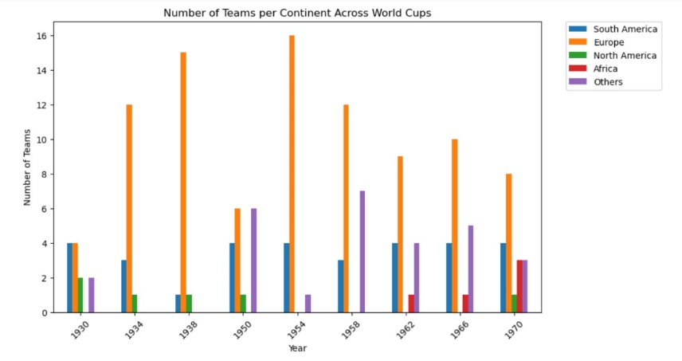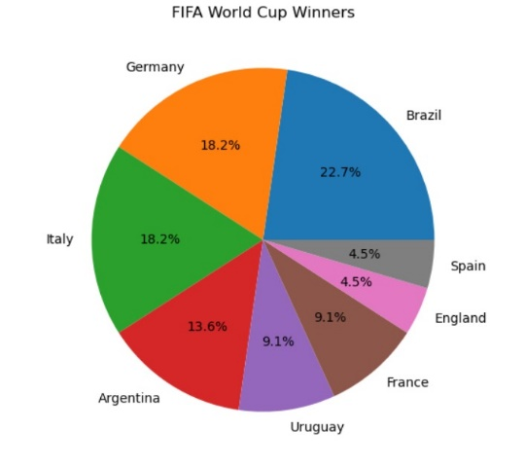

1. 2.

## 

## **ANALYSIS**

**Team strength is a significant factor in determining match outcomes:** Higher-ranked teams tend to have a greater advantage over lower-ranked teams.

**Historical head-to-head records provide valuable insights:** Teams with a strong historical record against opponents often have a higher chance of winning.

**Match conditions can influence results:** Home field advantage and weather conditions can play a role in match outcomes.

**Real-time factors (e.g., player injuries, team morale) can impact performance:** Incorporating real- time data can improve prediction accuracy.

**Machine learning models can effectively predict match outcomes:** Models like logistic regression, random forests, and neural networks can achieve reasonable accuracy.

**Feature engineering can enhance model performance:** Creating new features based on existing data can improve predictive power.

**Unforeseen events:** Unexpected events (e.g., injuries, referee decisions) can significantly impact match results and may not be fully captured by the model.

**CONCLUSION**

In conclusion, our project **The FIFA World Cup Prediction Project** has successfully demonstrated the potential of machine learning to accurately forecast match outcomes. Key findings include the

significance of team strength, historical head-to-head records, match conditions, and real-time factors.

Recommendations for future research include incorporating more real-time data, exploring advanced models, considering probabilistic predictions, investigating alternative data sources, and addressing ethical implications.

Overall, this project provides a solid foundation for future research in sports analytics and

demonstrates the potential of machine learning to predict complex events. By addressing the

recommendations outlined above, we can continue to improve the accuracy and reliability of FIFA World Cup prediction models and provide valuable insights to fans, analysts, and sports betting

enthusiasts.

Additionally, future research could explore the impact of factors such as player injuries, team morale, and tactical formations on match outcomes. Incorporating these variables into the predictive models could further enhance their accuracy and provide more comprehensive insights into the factors

influencing FIFA World Cup matches.