* *Creating Collection Sales in SalesData Database*

*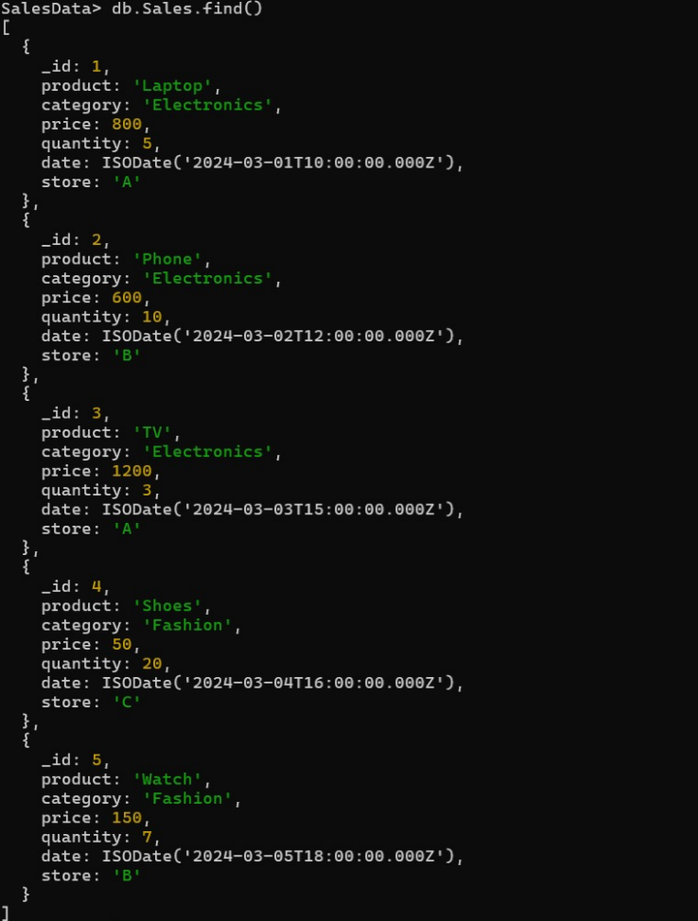*

* *Total sales per product.*

*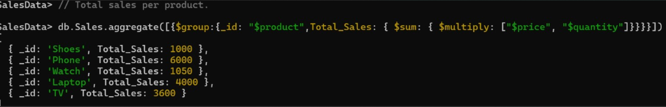*

* *Total revenue per product.*

*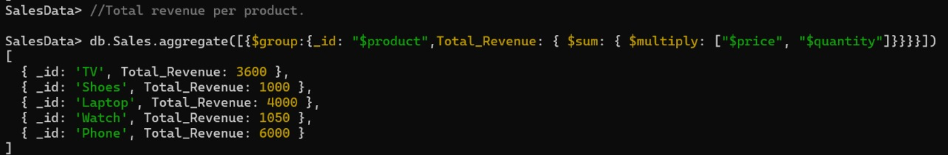*

* *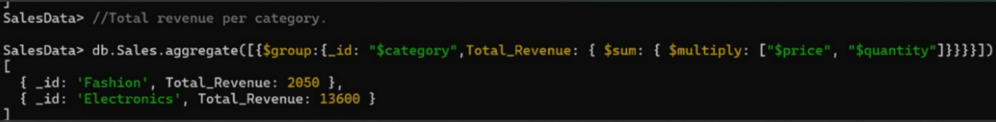Total revenue per category.*

* *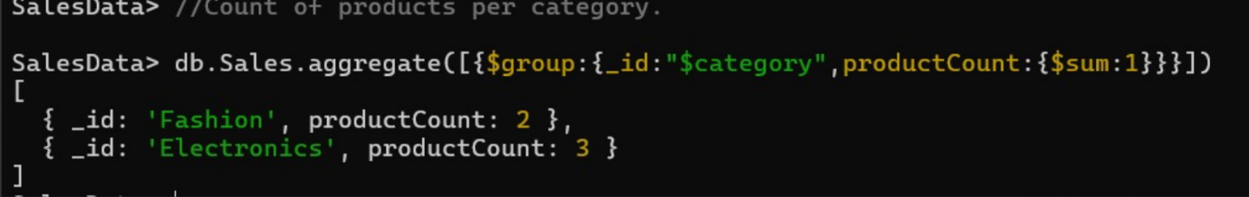 Count of products per category.*

* *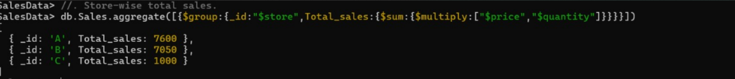Store-wise total sales.*

* *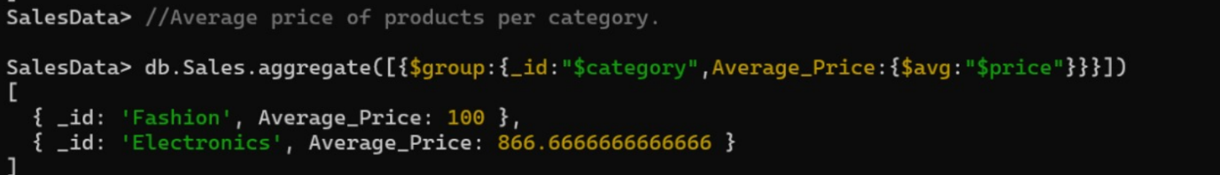Average price of products per category.*
* *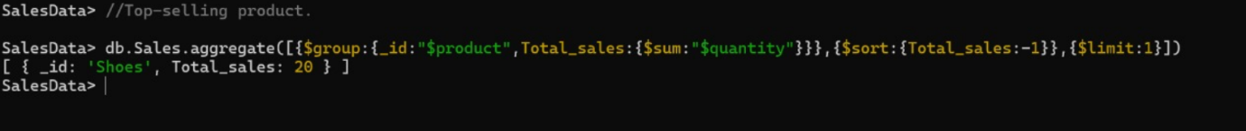Top-selling product.*

* *Total sales for Electronics category.*

* *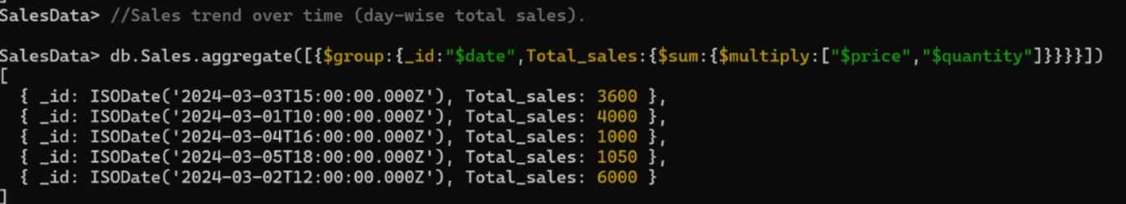Sales trend over time (day-wise total sales).*

* *Highest revenue-generating product.*
* *Average revenue per sale.*

* *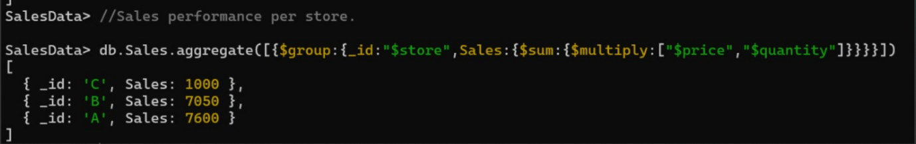Sales performance per store.*
* *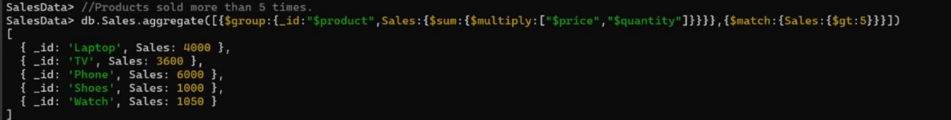Products sold more than 5 times.*
* *Least sold product.*

* *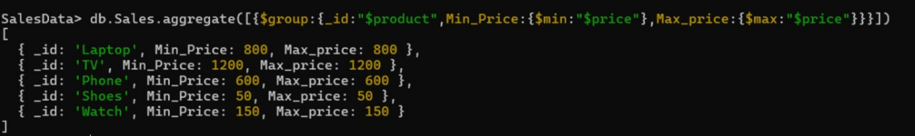Maximum and minimum priced product.*

* *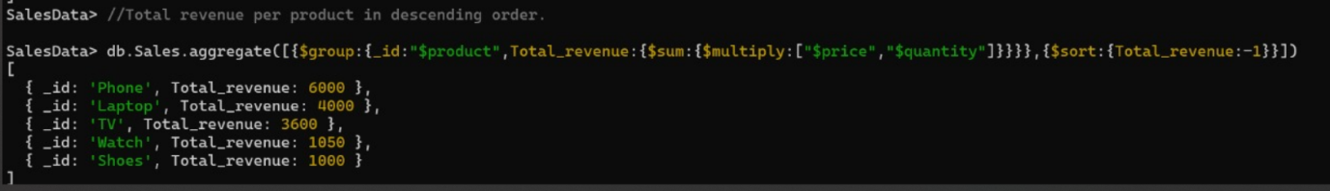Total revenue per product in descending order.*

* *Revenue generated per store per category.*

* *Products contributing more than 50% revenue.*

****