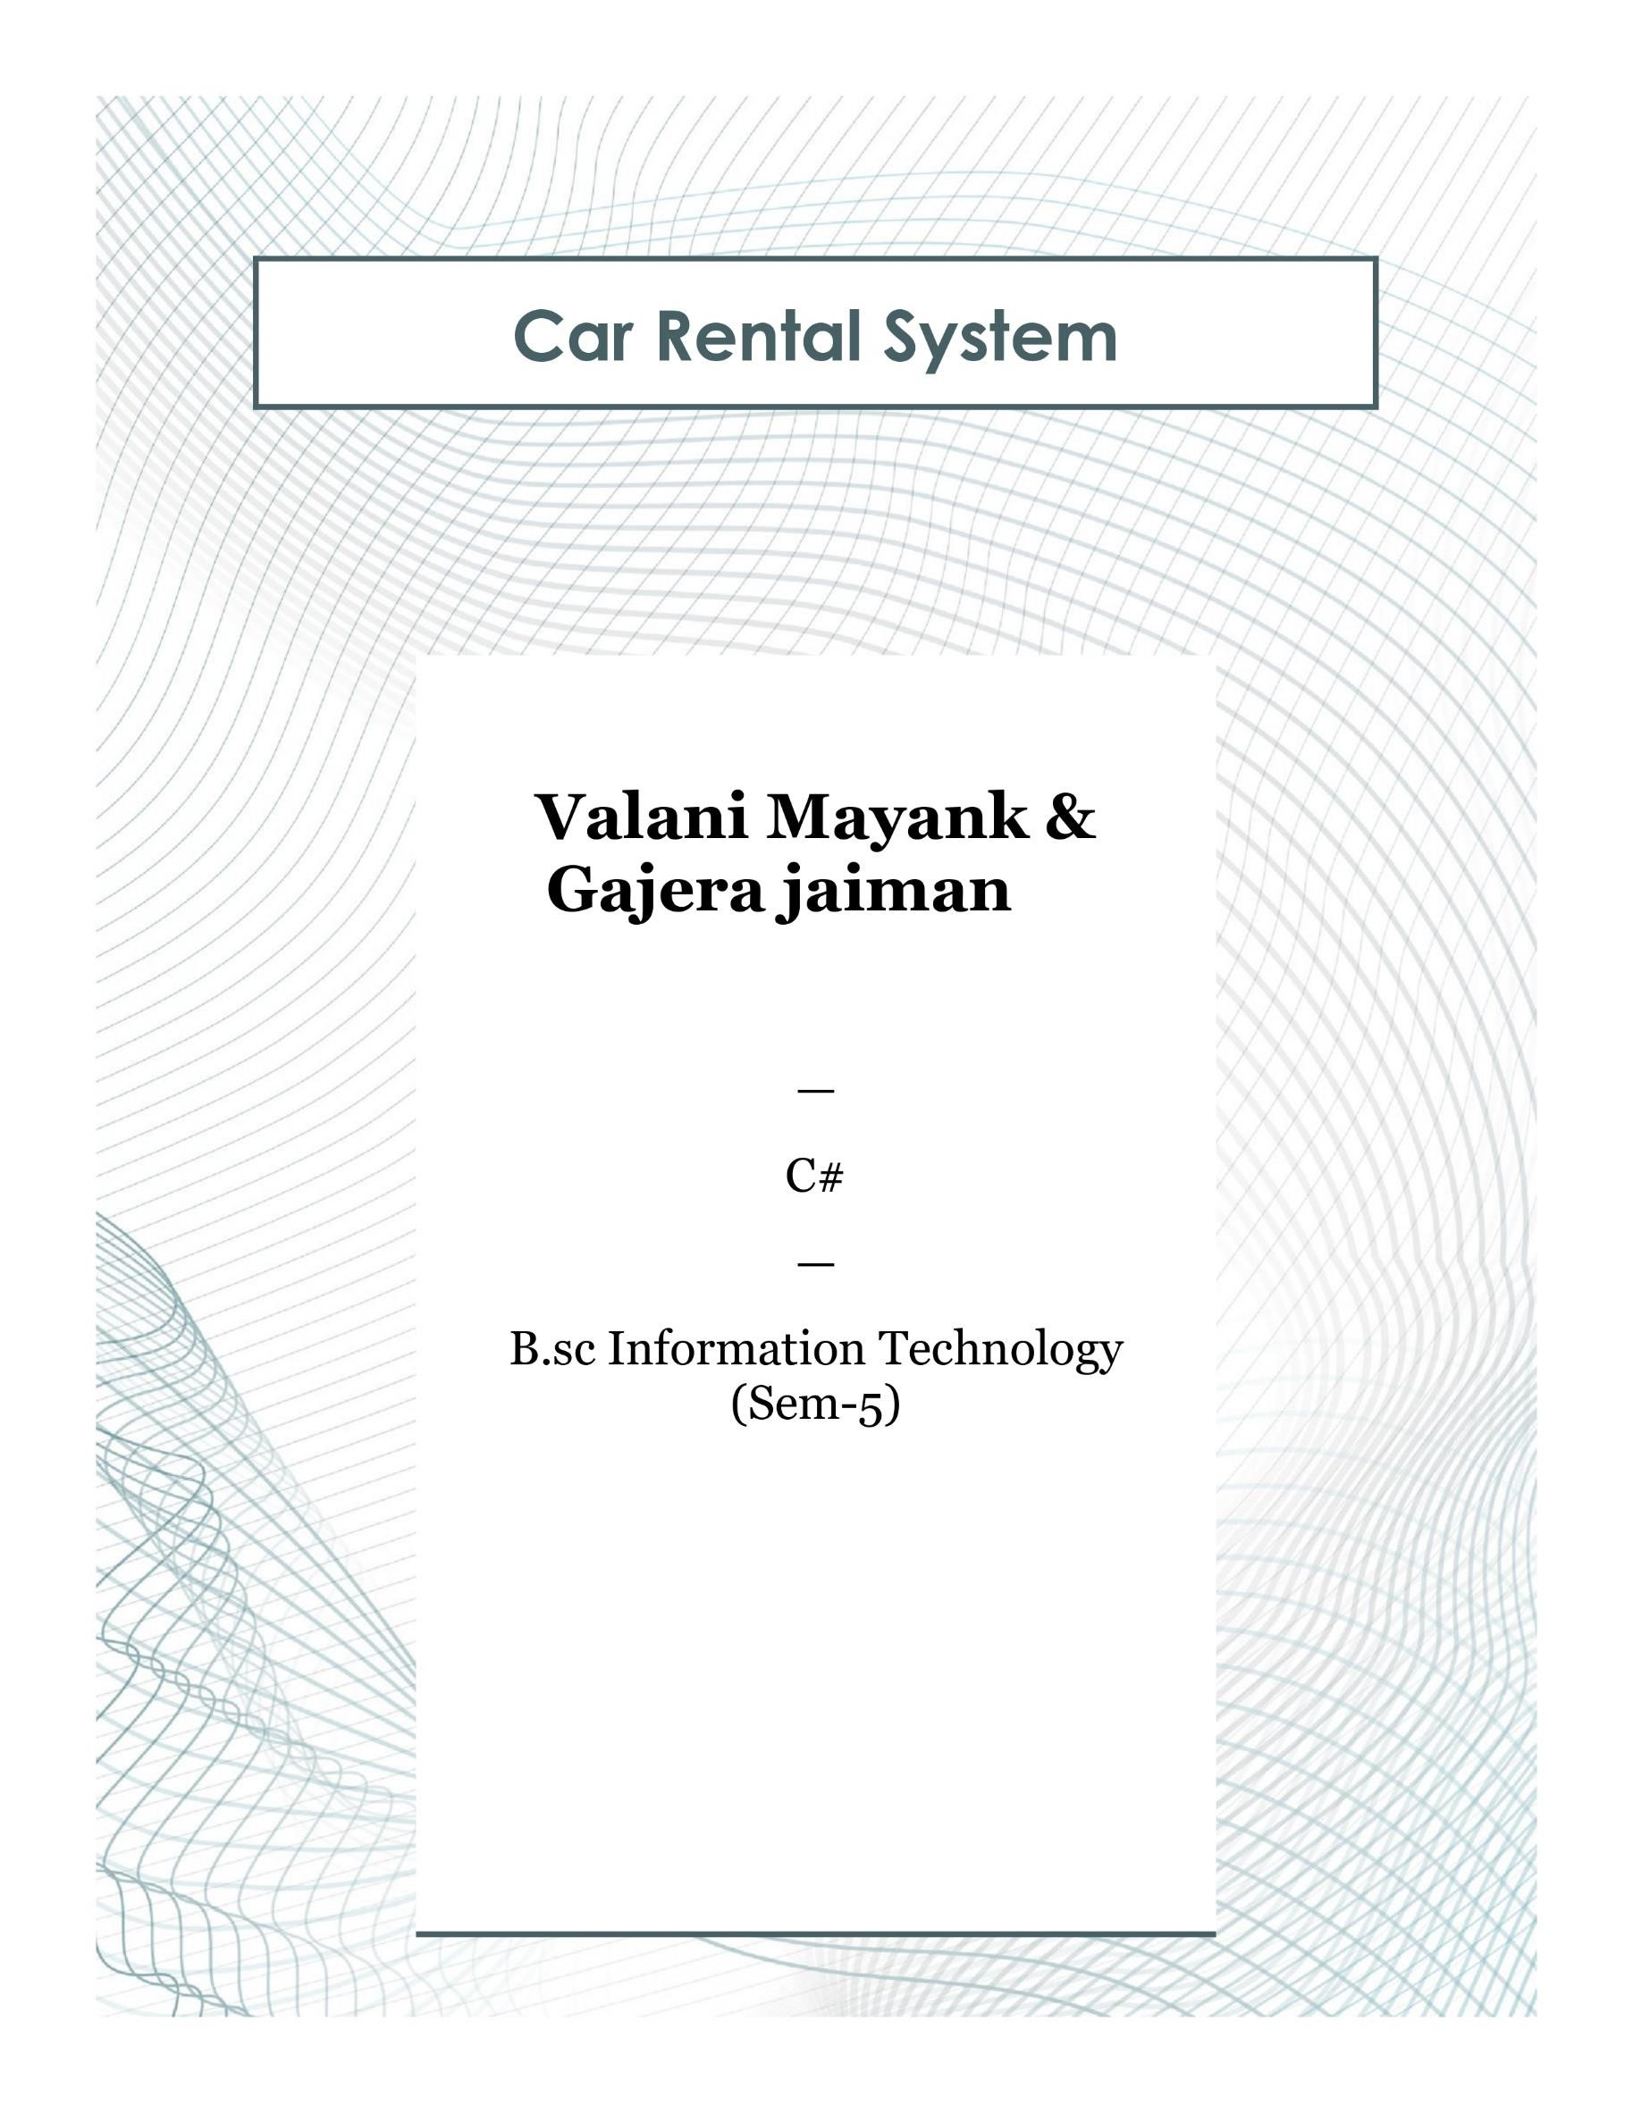

**System Requirements (Hardware and Software)**

**Hardware Requirements:**

* Processor: Intel Core i3 or higher
* RAM: 4GB or higher
* Hard Disk: 500GB or higher
* Monitor: 15" or larger
* Keyboard and Mouse

**Software Requirements:**

* Operating System: Windows 10 or higher
* .NET Framework 4.7 or higher
* Integrated Development Environment (IDE): Visual Studio 2022 or higher
* Database: SQL Server Managemnet
* Additional Libraries: Entity Framework

**Description**

**About Project**

**Project Description:**

The Grocery Shop Management System automates key tasks such as inventory management, order processing, customer handling, and sales reporting, aiming to improve operational efficiency and customer service. It allows employees to manage products, track stock levels, process orders, and generate reports. The system also includes user authentication for secure access based on roles.

**Key Features:**

* Product Inventory Management
* Customer Management
* Order and Sales Management
* Reporting and Analytics
* User Authentication and Authorization

The project uses C# for both backend and frontend, leveraging ASP.NET to create a scalable, user-friendly web application with an interactive UI.

**Database Description**

The database for the Grocery Shop Management System consists of multiple tables that store information related to products, customers, orders, inventory, and transactions. The primary database used is SQL Server, ensuring reliable and scalable data management.

**Tables and Their Descriptions:**

1. **Product Tbl:**

* **Table Name:**
* **Fields**

