My Pets Store

Database class project 2020/2021

|  |  |  |  |  |
| --- | --- | --- | --- | --- |
| Student Name in English | Student Name in Arabic | Student ID | Section | Work percentage |
| Nora al sadder | نورا الصدر | 11924246 | 8-9.5 | 50% |
| Mayar imad | ميار عماد | 11924955 | 8-9.5 | 50% |
|  |  |  |  |  |

Date/time

---------------------------------------------This section is intended for the Instructor---------------------------------------

|  |  |
| --- | --- |
| **Topic** | **Mark** |
| Project Requirements and Modeling |  |
| Correctness of Database mapping |  |
| Functional Dependency and Normalization |  |
| Project Tools |  |
| Project Discussion |  |
| Project Completeness |  |
| Project Output Results or reporting (JasperReport, charts, graphs, etc.) |  |
| Project Administration and Management |  |
| Project Report |  |
| Project Idea |  |
| Project Complexity |  |
| Team work |  |
|  |  |
|  |  |
|  |  |

* Abstract:

Starting from our love and care for animals, I and my friend decided to choose My pets store as our project in the database course, we are familiar with this kind of work since both of us takes care of pets in our houses, our store provides many products like dog, cat and the necessary item related to them, we focused to make our project as real as it in customer's, employee's hands.

* Table Of Content :

|  |  |
| --- | --- |
| Page number | Content |
| 1 | Cover page |
| 2 | abstract |
| 3 | Table content |
| 4 | introduction |
| 5 | Project requirements |
| 6 | Functional dependency |
| 7 | UML |
| 8 | Normalization |
| 9+10 | BCNF |
| 11 | Tools |
| 12-28 | Discussion |
| 29+30 | Jasper Report |
| 31 | conclusion |
| 31 | references |

* Introduction :

The structure includes a JavaFX development with a Database management system, which can work integrally, a GUI design is supported to enables three kinds of users to deal with our pets store, the customers, employees, and admin, our JavaFX application provide the customers the ability to see, add to cart, order products, and tracking them, the employees could manage the store by adding, deleting, searching updating products, inserting the suppliers who provide our products, tracking and packaging orders, admin could hire new employee, update their information, our application also provides generating reports of the sales/month which the admin can see only, a lot of work done to make the application practical in the real world, with modern interfaces for users.

* Project requirements :

**Project Name: My pets store**

**Project Description: creating data base for animal store**

**Description: Entity Attributes Relationship Relational attributes Generalization**

**Requirements:**

* in our application the **user that can interact with it is either a customer or an employee**, each **user** has a **userID** which is a unique value, **composite name**, **gender**, **address**, **phone** **number**, **email** and **birth date**.
* **our store get product from multiple suppliers, in the other hand one supplier could supply us a multiple products**, the **supplier** has **phone**, and a **name**, while the **product** has a **price** and **remaining quantity**, the supplier could supply us a **one or more product with different price** for each product.
* **Each product is managed by one or more employee**, each **employee** has a **salary**, **the product could be a pet or accessories**,

The **pet** has a category describes if he is dog or cat, **pet type**, **gender**

and **birth date**, **medical Situation** and **description** for both pets and

**accessories**.

* **the customer could order multiple orders**, the **orders** shows the tracking of an order (**processing, on the way**, **delivered**),total price and order date.
* **Each customer have a temporary cart**, and each **cart** contains one or more product, we store **the total price and the quantity** for ever single product, when the user order what is in the cart a new cart will be given to the customer, and the product in the cart will be stored as an order to start tracking.
* 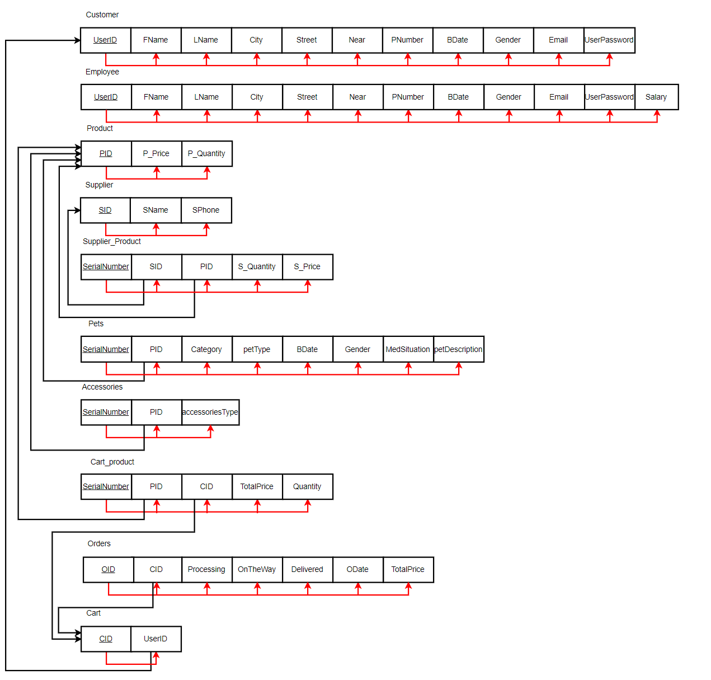Functional dependencies :

Figure 1

* 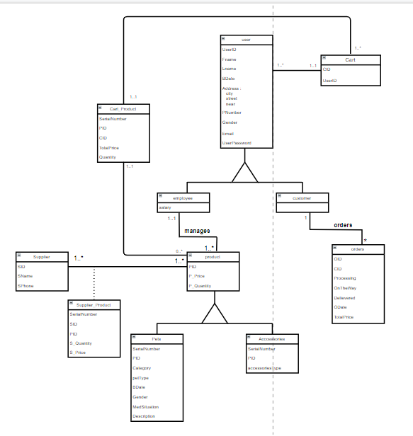UML :
* Normalization :
* First normal form(1NF):

A table in which the intersection of every column and record contains only one value.

* All our columns are simple **√**
* Second normal form (2NF):

A table that is in 1NF and in which the values of each non-primary key column can be worked out from the values in all the columns that make up the primary key.

* Our primary keys are single column **√**
* Third normal form (3NF):

A table that is in 1NF and 2NF and in which no non-primary-key column is transitively dependent on the primary-key.

* No transitively dependent you can check that from Figure 1 **√**
* BCNF:

A relation is BCNF if and only if every determinant is a candidate key, in our tables all the determinants are candidate key:

1. Customer table:

UserID🡪FName,LName,City,Stret,Near,PNumber,BDate,Gender , Email, UserPassword

1. Employee table:

UserID🡪FName,LName,City,Stret,Near,PNumber,BDate,Gender , Email, UserPassword , Salary

1. Product table:

PID 🡪 P_Price , P_Quantity

1. Supplier table:

SID 🡪 SName , SPhone

1. Supplier_product table:

SerialNumber 🡪 SID , PID , S_Quantity , S_Price

1. Pets table:

SerialNumber 🡪 PID , category , petType , BDate , Gender , MedSituation , petDescription .

1. Accessories table:

SerialNumber 🡪 PID , accessoriesType

1. Cart_product table :

SerialNumber 🡪 CID , PID , TotalPrice , Quantity

1. Cart table:

CID 🡪 UserID

1. Orders table:

OID 🡪 CID , Processing , OnTheWay , Delivered ,ODate,TotalPrice

* Tools:

1. Programs:

|  |  |  |
| --- | --- | --- |
| Pic | Name | Notes |
|  | IntelliJ | To write the javafx code |
|  | Scene builder | To design the GUI |
|  | MySQL | The DBMS nora used |
|  | SQLDeveloper | The DBMS mayar used |
|  | Jaspersoft Studio | To make Reports |

1. Libraries:

|  |  |
| --- | --- |
| Name | Notes |
| jfoenix-9.0.10 | Additional library to help us with the GUI |
| javafx-sdk-16 | To run intejij |
| jdk-15.0.1 | To run intejij |
| mysql-connector-java-8.0.26 | The database connector of mysql program |
| Ojdbc8 | The database connector of sqldeveloper program |

* Discussion:

Log in interface:

If the user already has an account, he can log in by entering his email and password

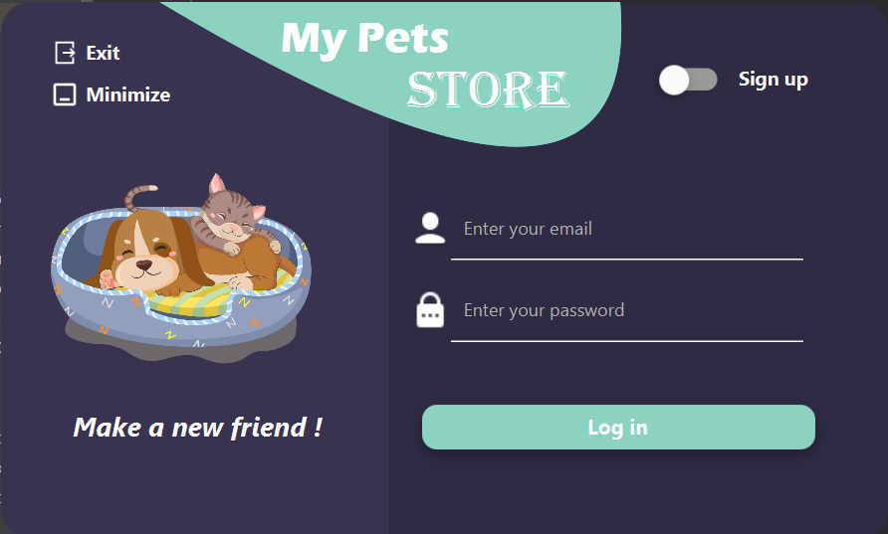

If the user entered non existing email this alert appears:

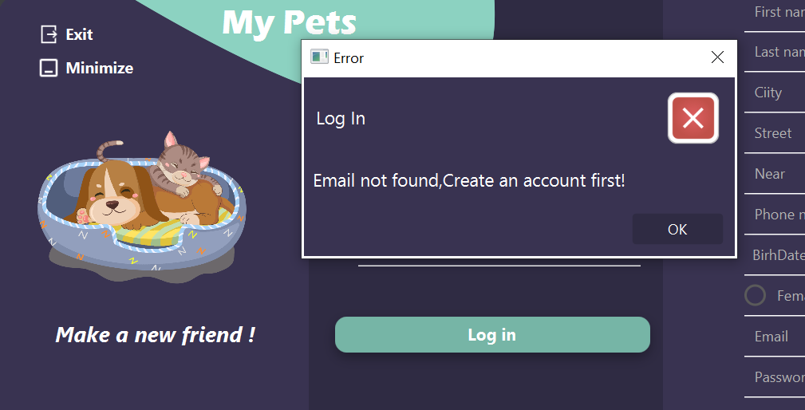

If the user entered incorrect password this alert appears:

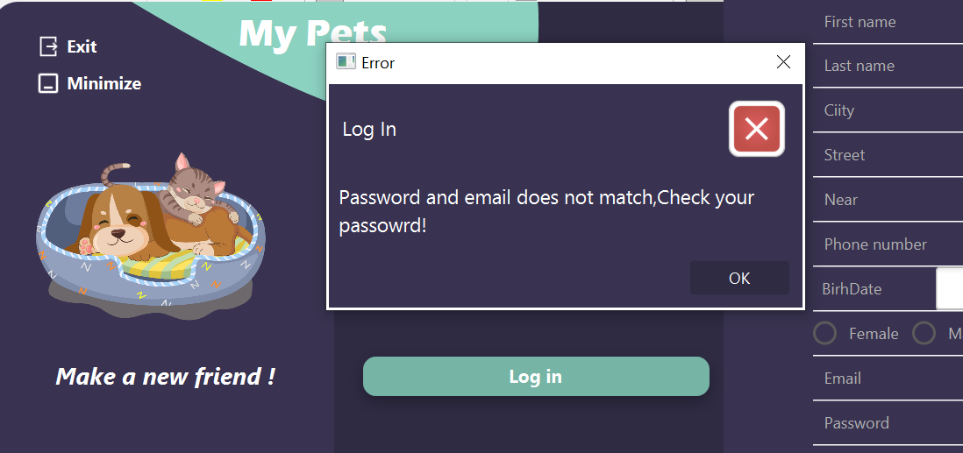

If the user doesn’t have an account he can create one by sliding the sign up slider and the following window will appear , he must enter his information and then click on sign up button .

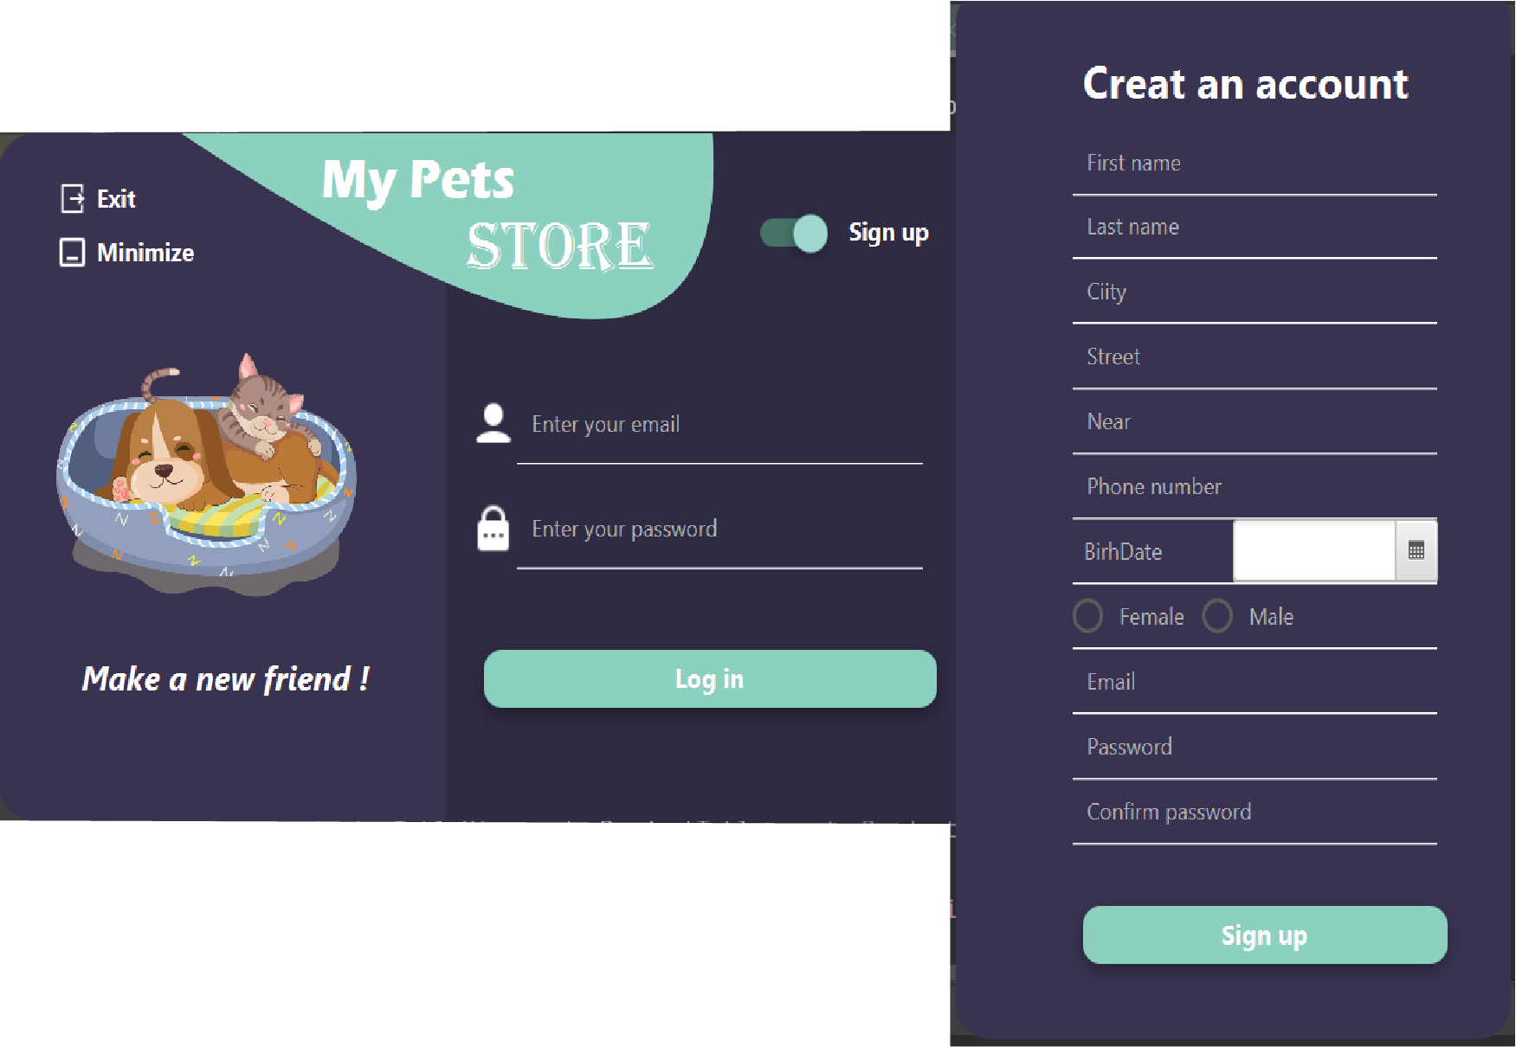

Customer interface:

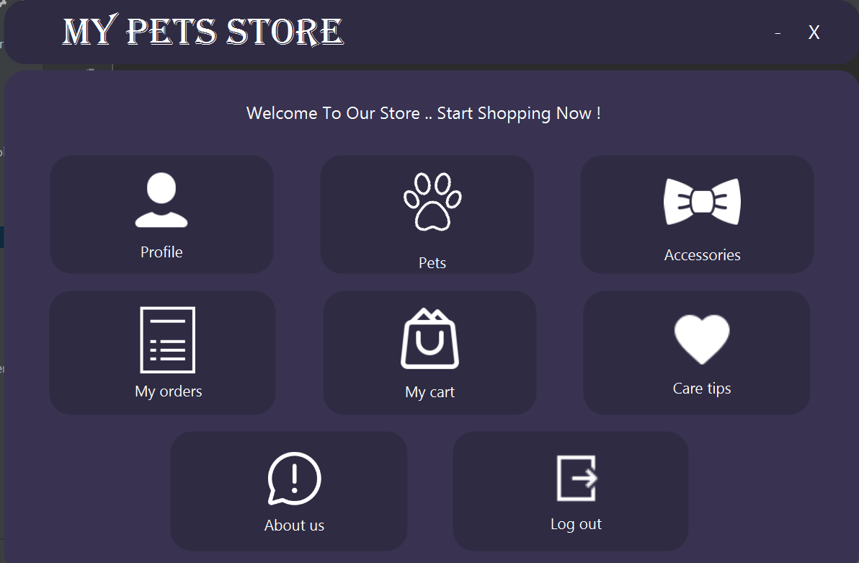When the user is logged in, if the entered email was a customer email the home page of the customer will appear:

If the user want to see his information or edit them he can go to profile page by clicking on the profile button, and the following page will open:

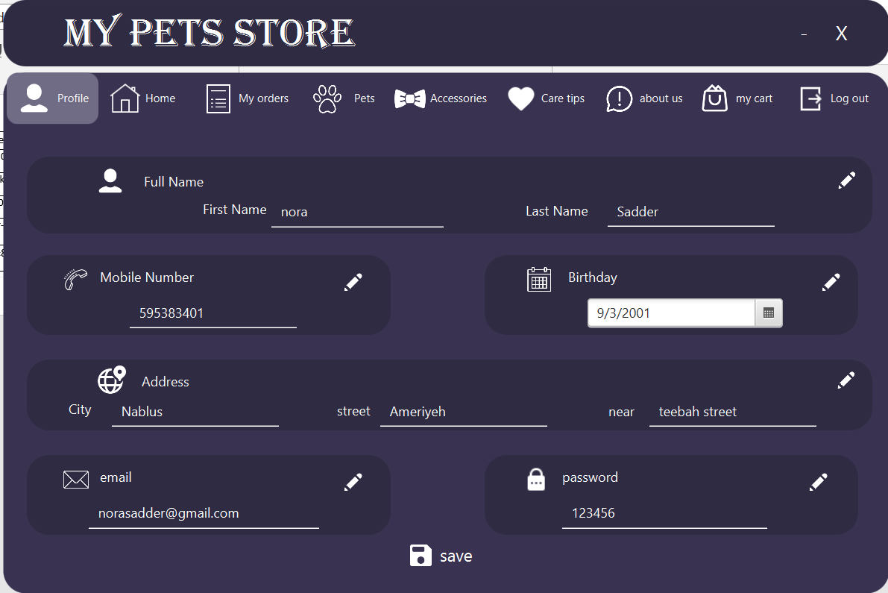

All the text fields of the user information are noneditable by default, if he wants to edit his information he can click on the edit button and the text fields of the clicked button pane will become editable, then when he finishes editing he have to click on save button and then his information will be updated.

And if he left one of the fields empty the following error will appear:

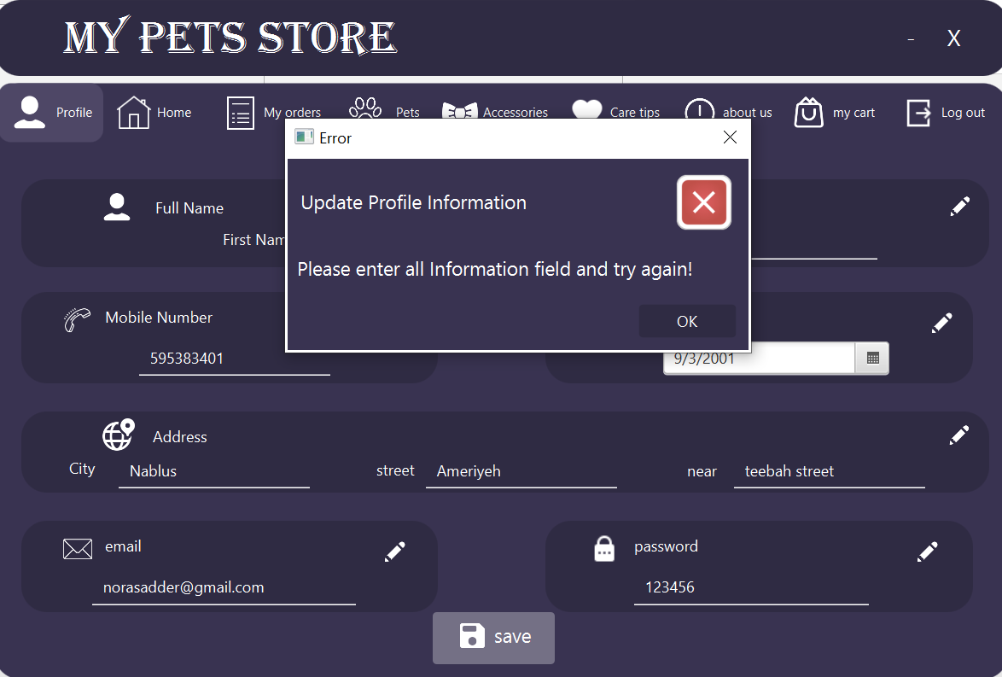

The user can switch to any page he wants by clicking on the desired button above.

The products of the store are shown in 2 pages: page for pets and page for accessories :

Pets Page :

When the customer opens the page all the available pets in the store will appear in the table like this :

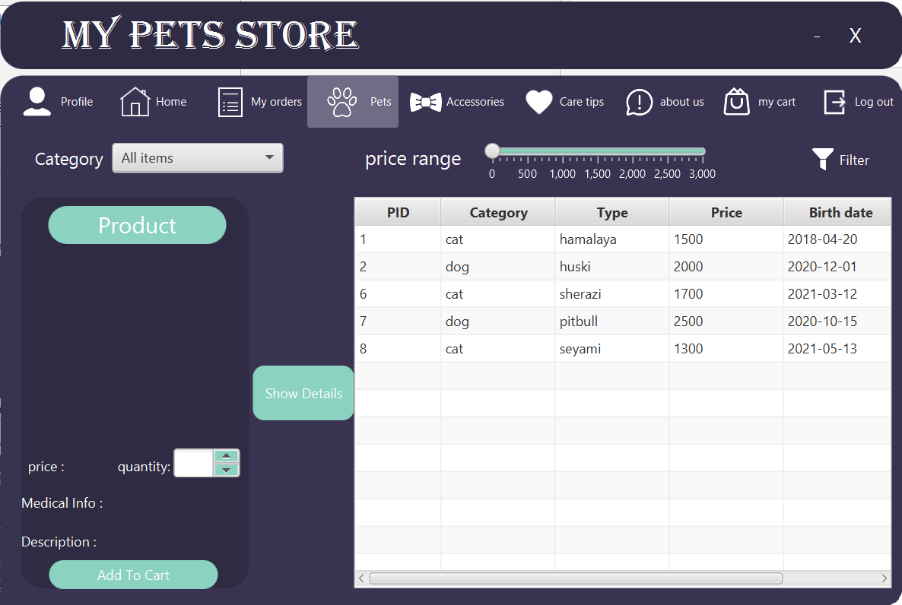

If the customer wants to know more details about a certain pets he can click on the row of the desired pet and then click on show details button and the pets details will appear in the left of the screen as shown :

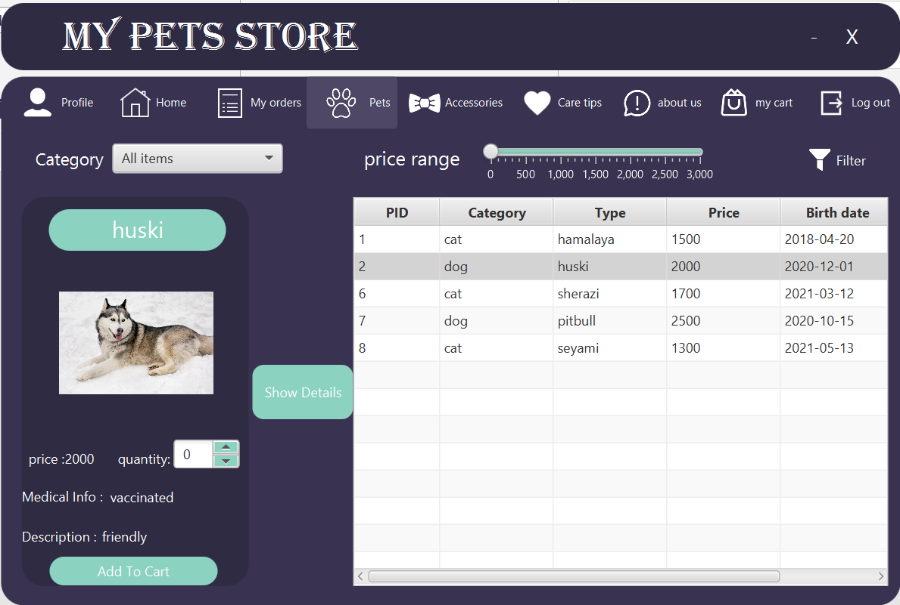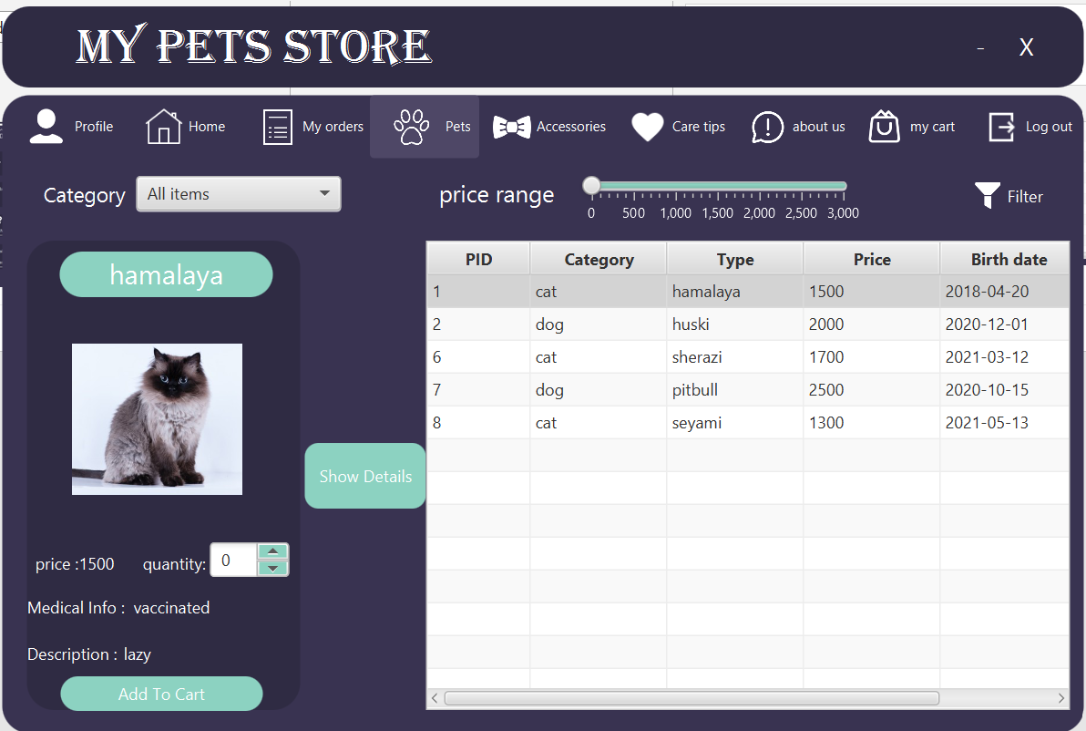

The page is provided with 2 filters: one to choose the desired category (cat, dog, all items) and the other to choose the price range he wants, after choosing the price range or/and pet category he have to click on filter button to filter the pets result:

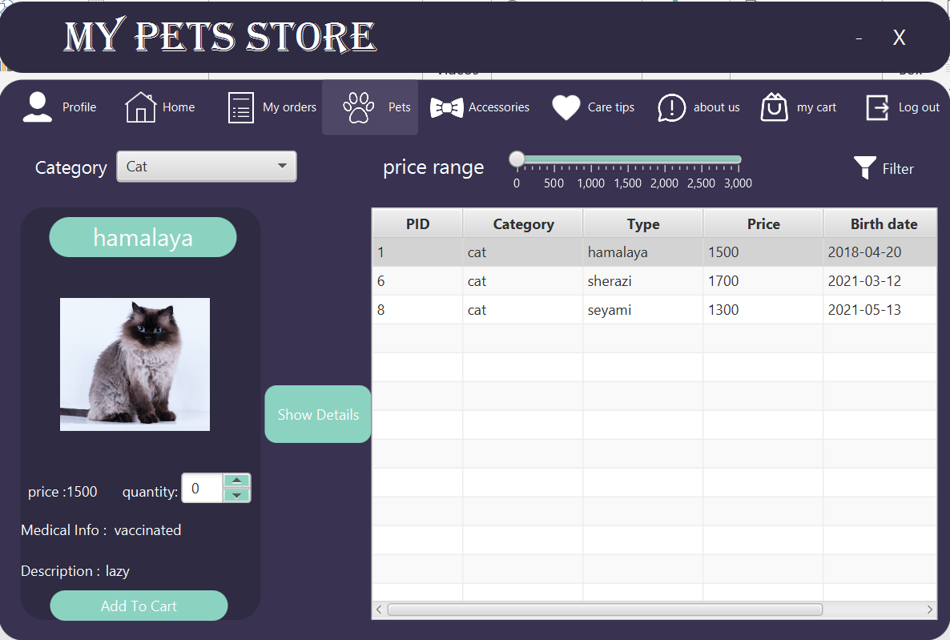 Pet category is chosen:

Dog category is chosen:

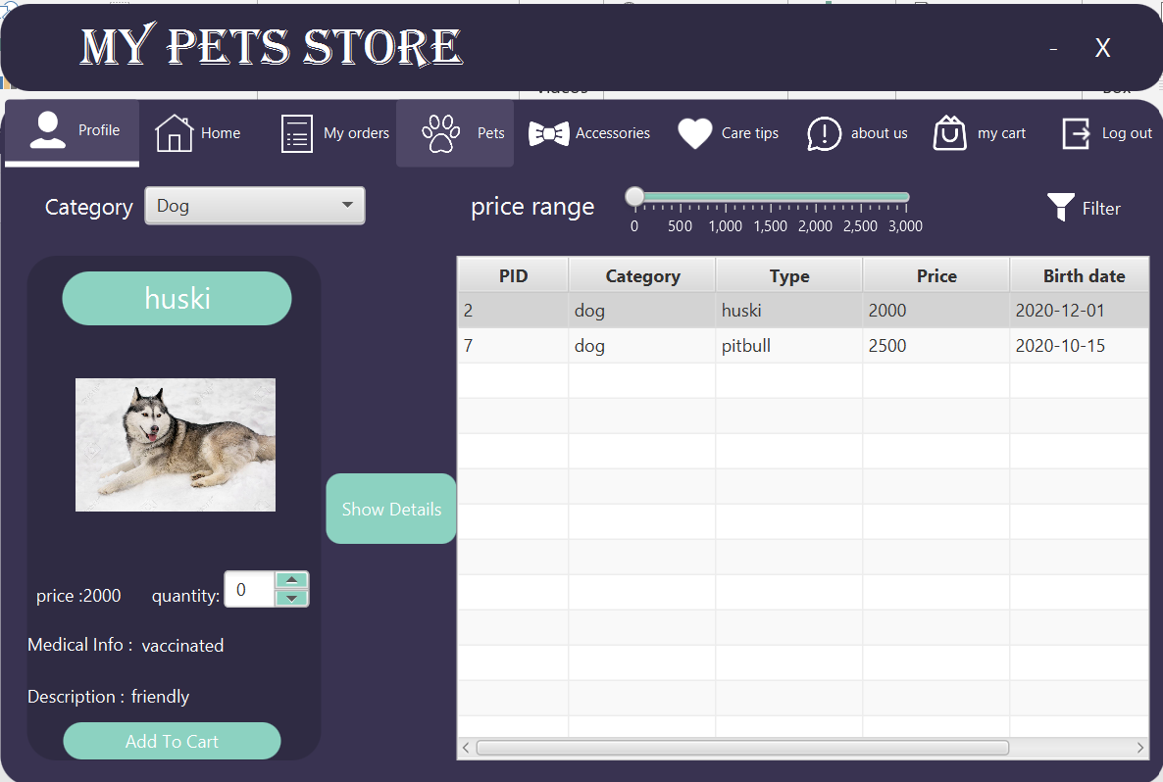

Cat category & price less or equal 1500:

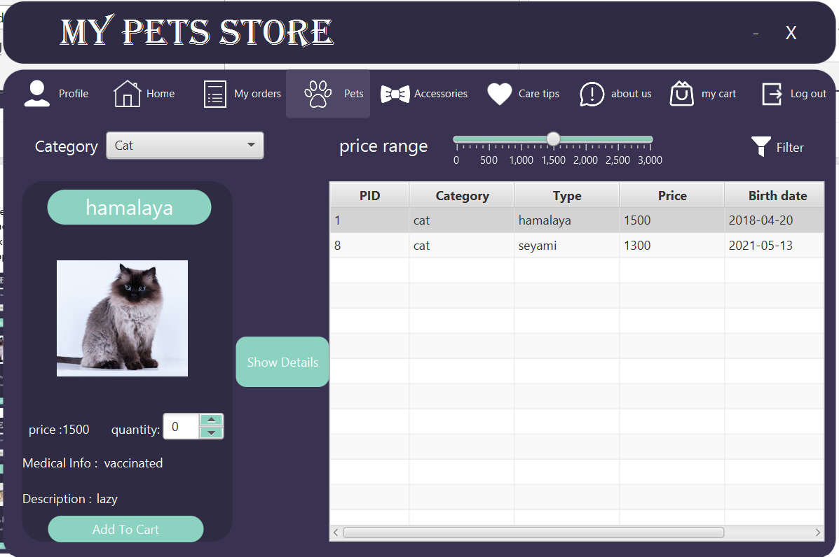

dog category & price less or equal 2200:

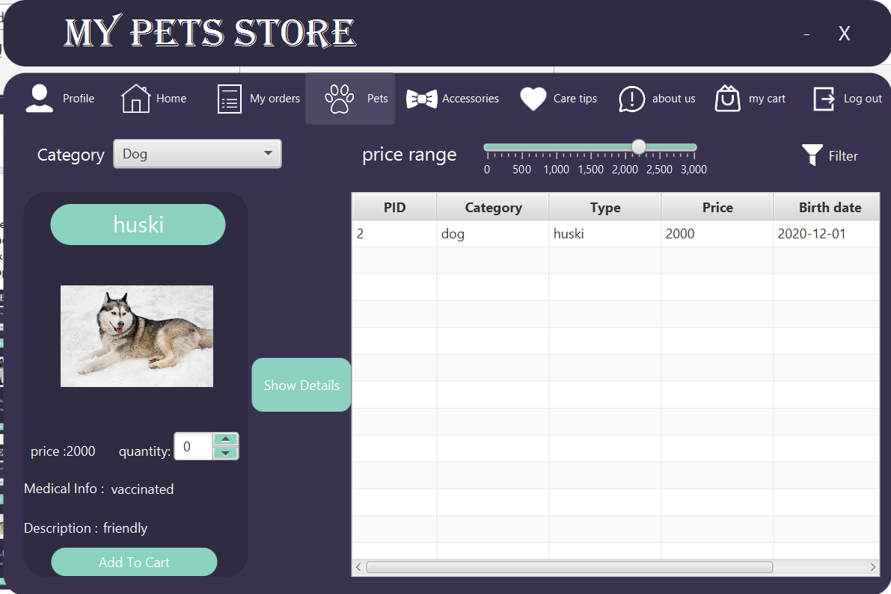

The same procedure is applied on the accessories page:

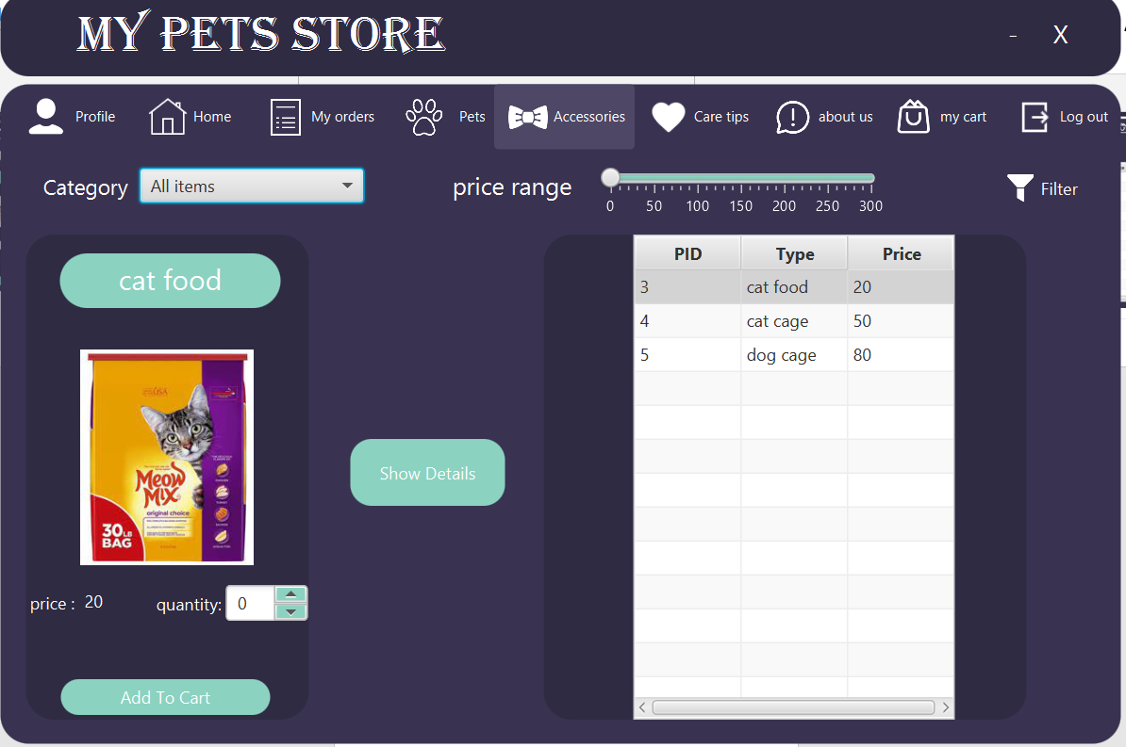

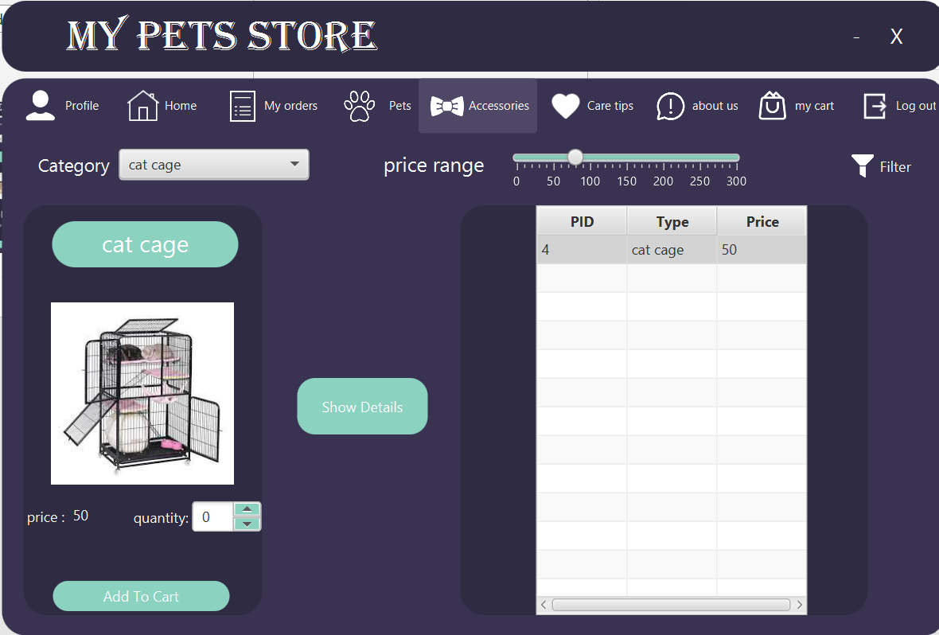the category is chosen cat cage and the price is less than 80:

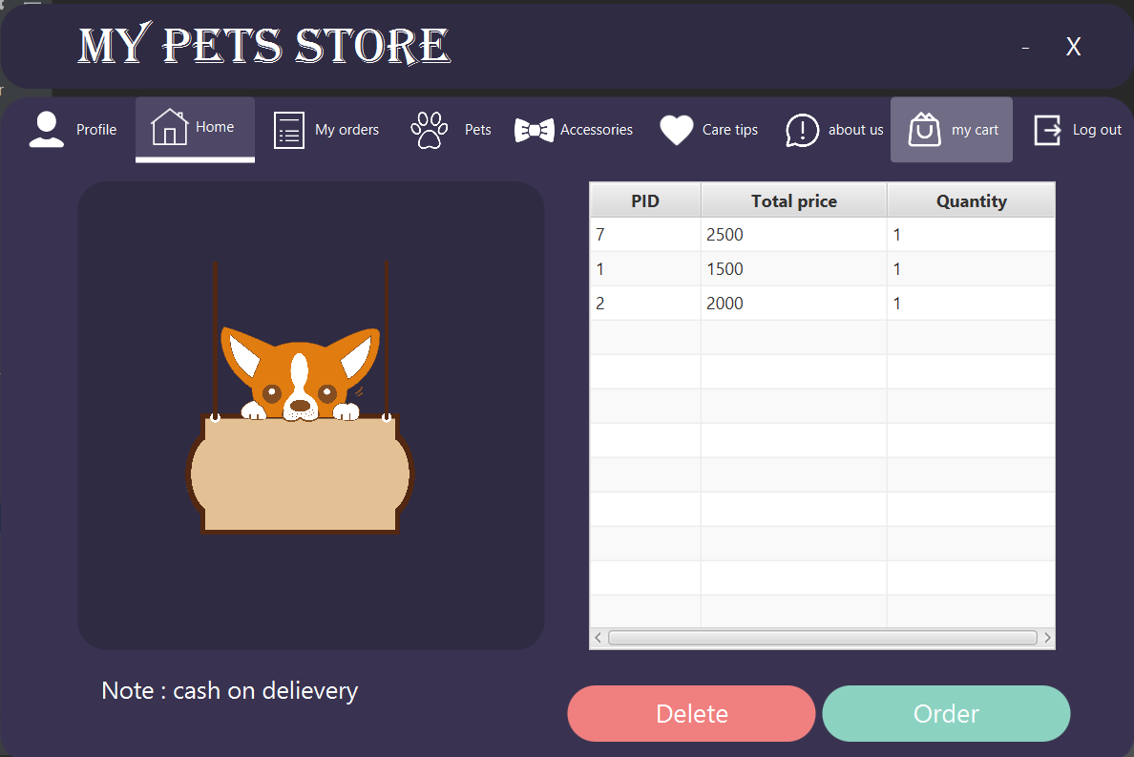In the accessories and pets page there is a button named “Add to Cart” , when the user selects an item and then clicks add to cart the selected item will move to his cart , and all the products he added to his cart will appear like this :

If he wants to delete an item from his cart he can select the item and then click on delete button , and if he want to order the items in his cart he can click on order button

When the customer click order button all the items in his cart will be deleted and an order will be processed for him, and will appear in my orders page .

The orders of the customer will appear in the table as bellow:

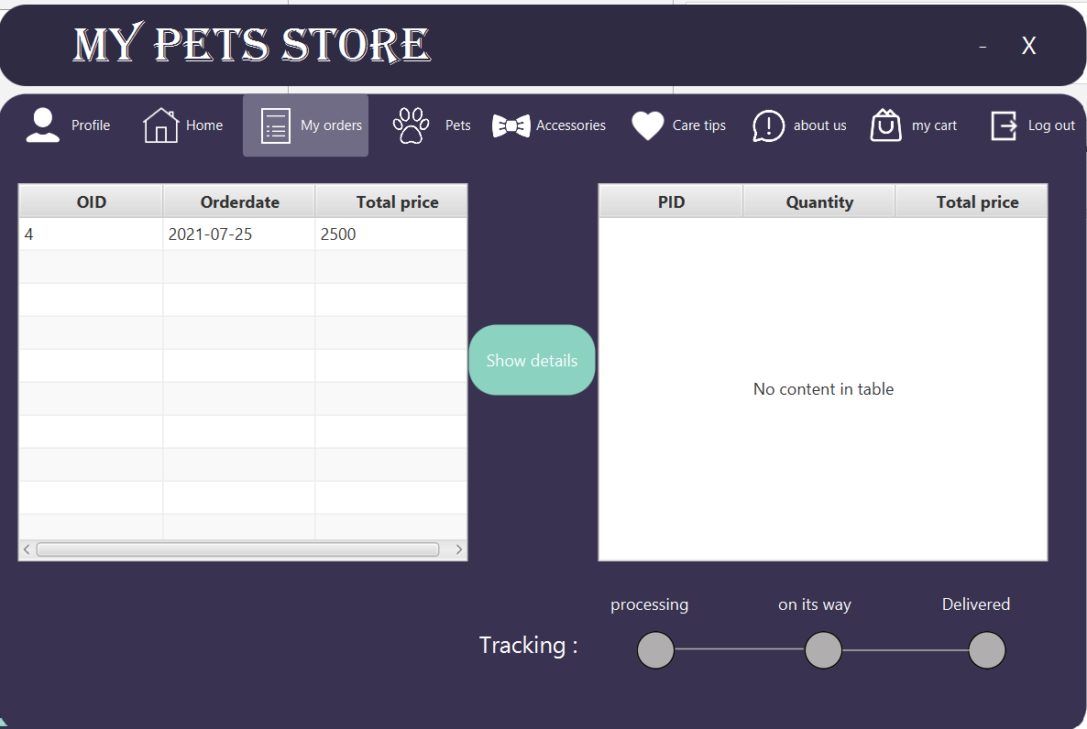

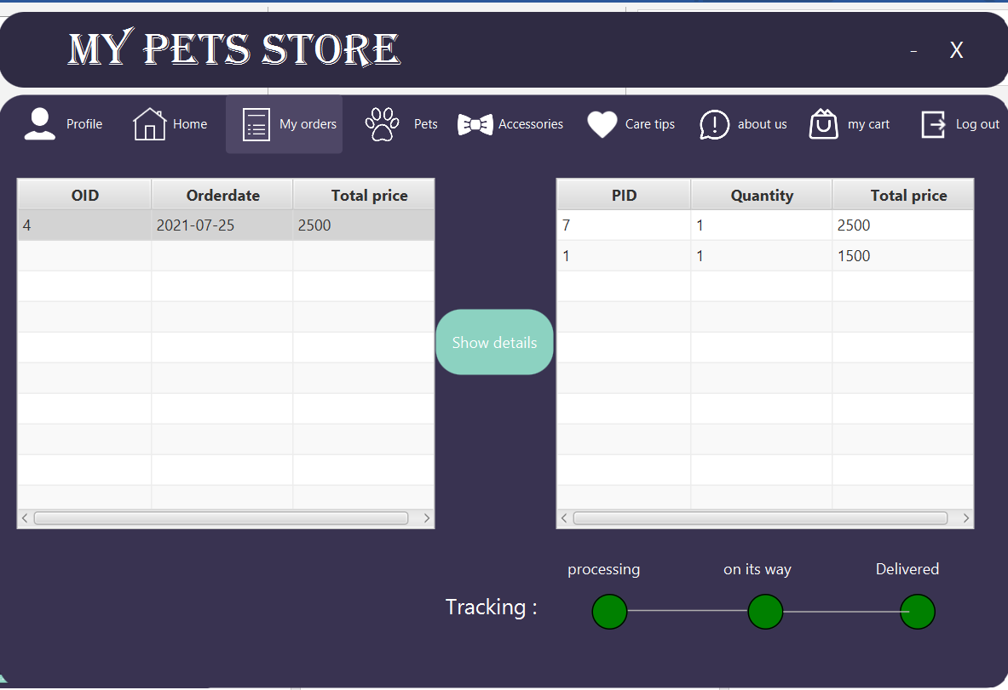And if he wants to see the details of the order he has to click on the order and then click on show details button

Also we provided the application with a page called care tips to provide the customer with some tips to know how to deal with his pet:

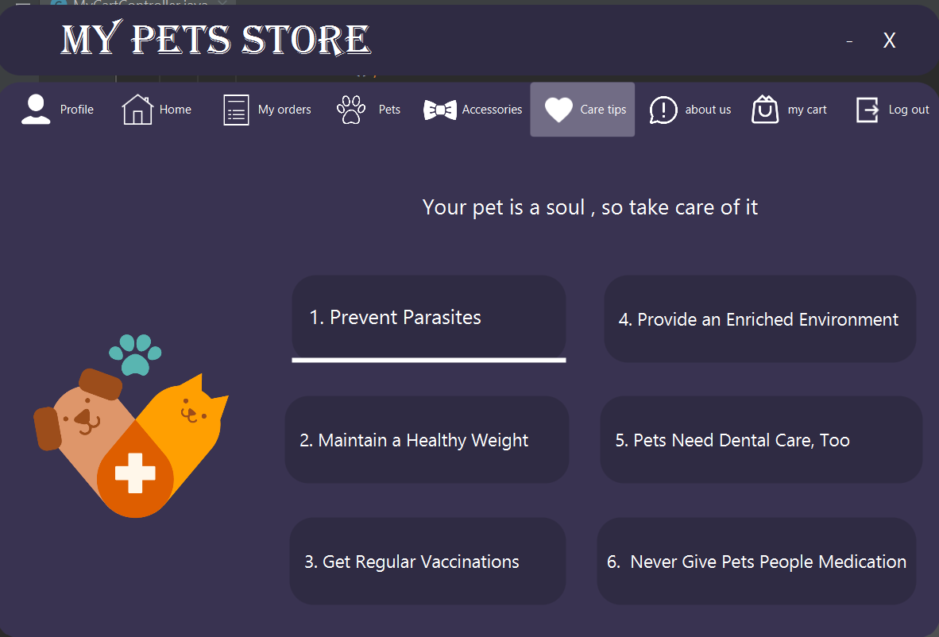

and a page to give the customer information about our store so he can contact us if needed:

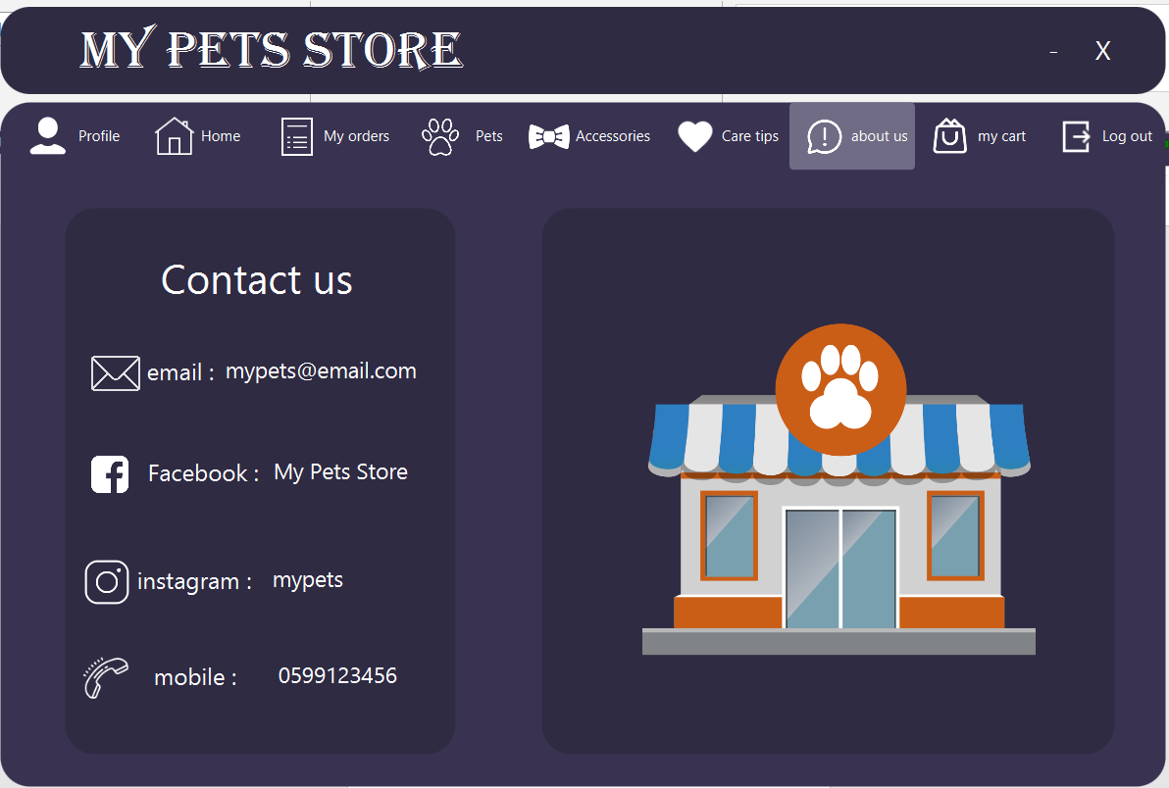

Employee interfaces:

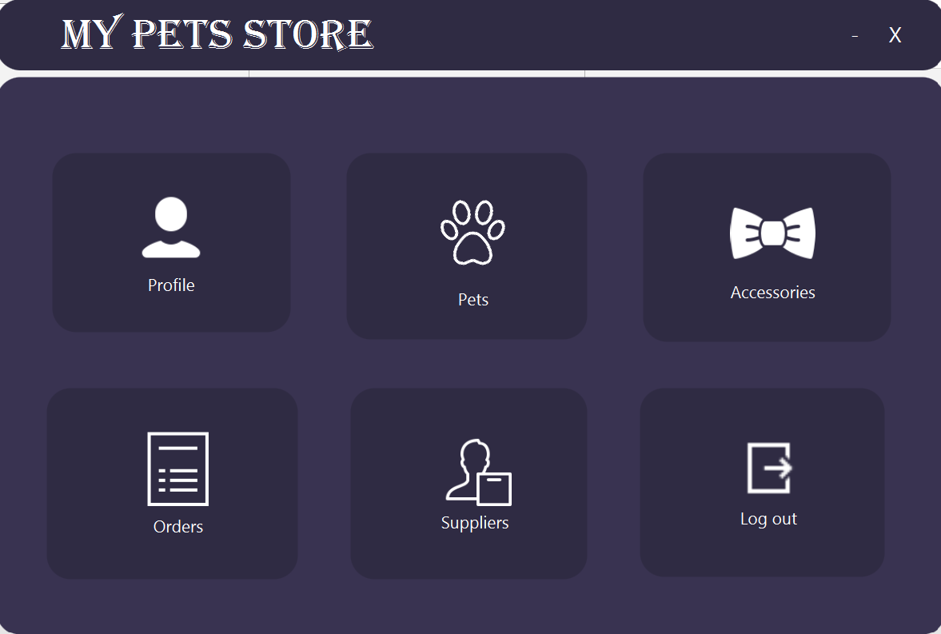If the entered email was belonging to an employee the home page of the employee will appear:

The employee can see or edit his information by clicking on profile button which will take him to profile page:

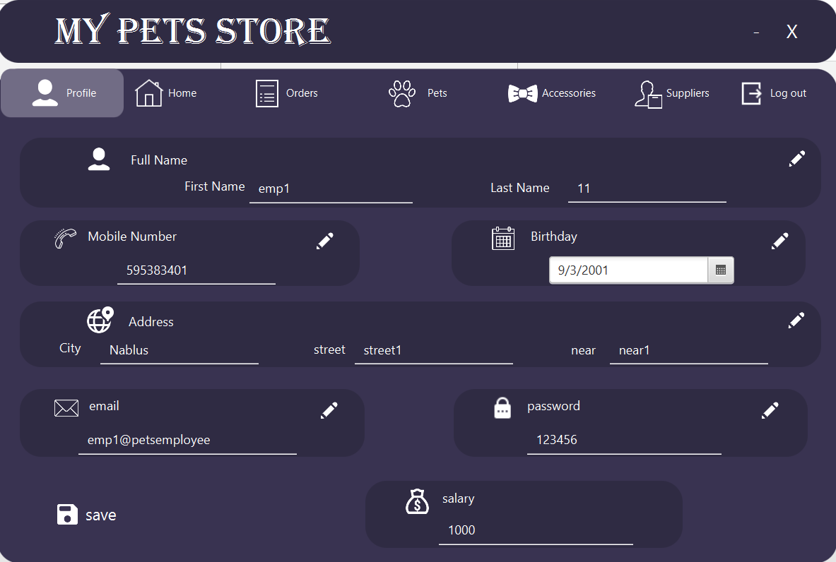

The employee can edit his information in the same procedure of how the customer can edit them.

The employee can see the orders the customer’s order so he can prepare them.

Also, he can set the tracking of each order using the three check boxes on the right of the screen

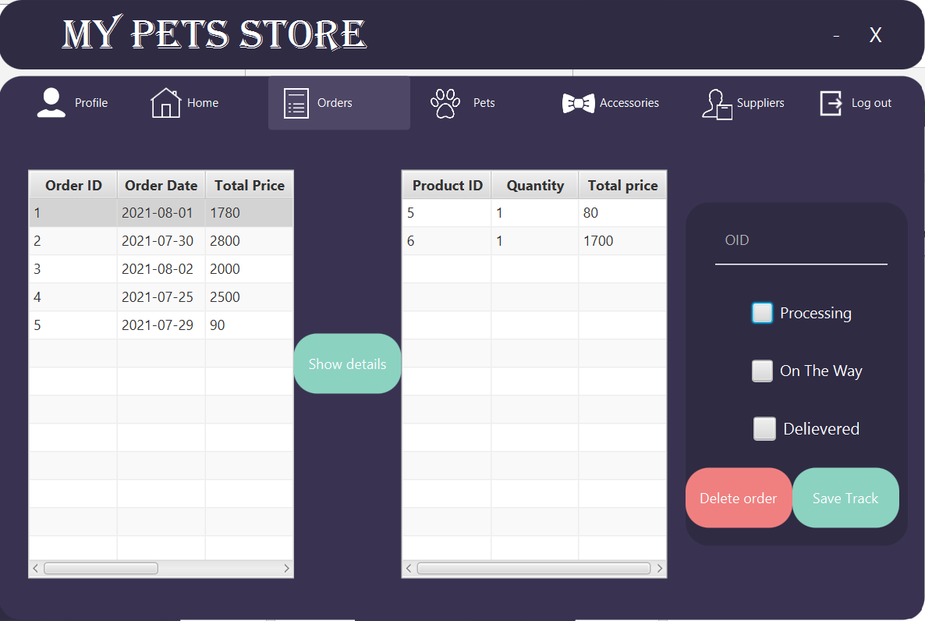He can also delete an order if required “for example it was returned”.

The employee also can add/delete/search/update products using pets and accessories page:

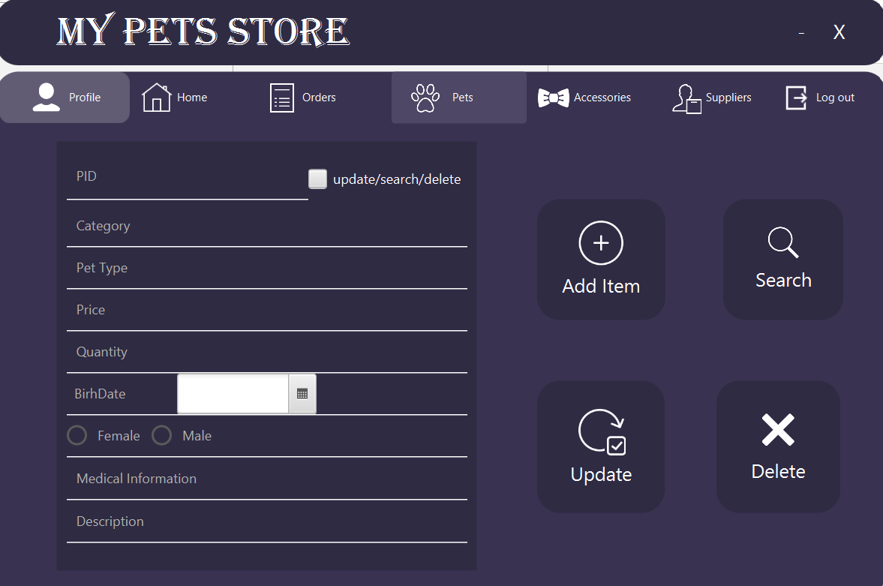

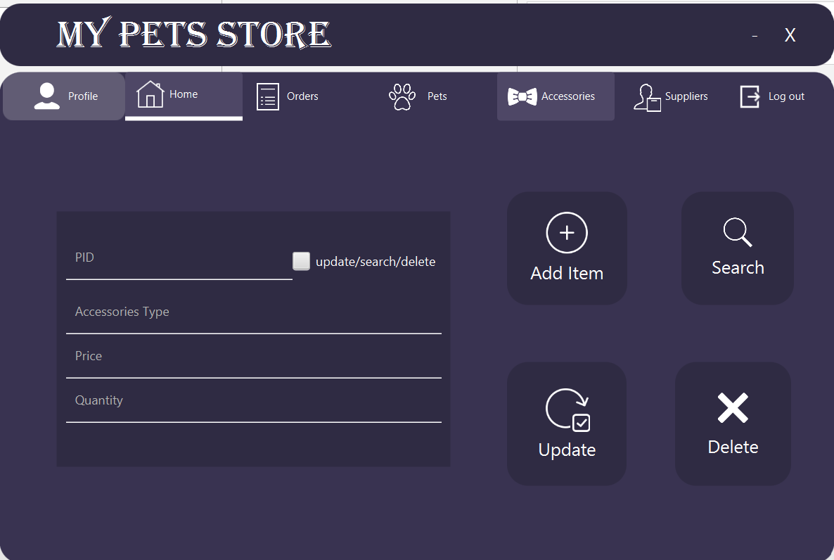

The employee can also add/search/delete/update suppliers by going to supplier page:

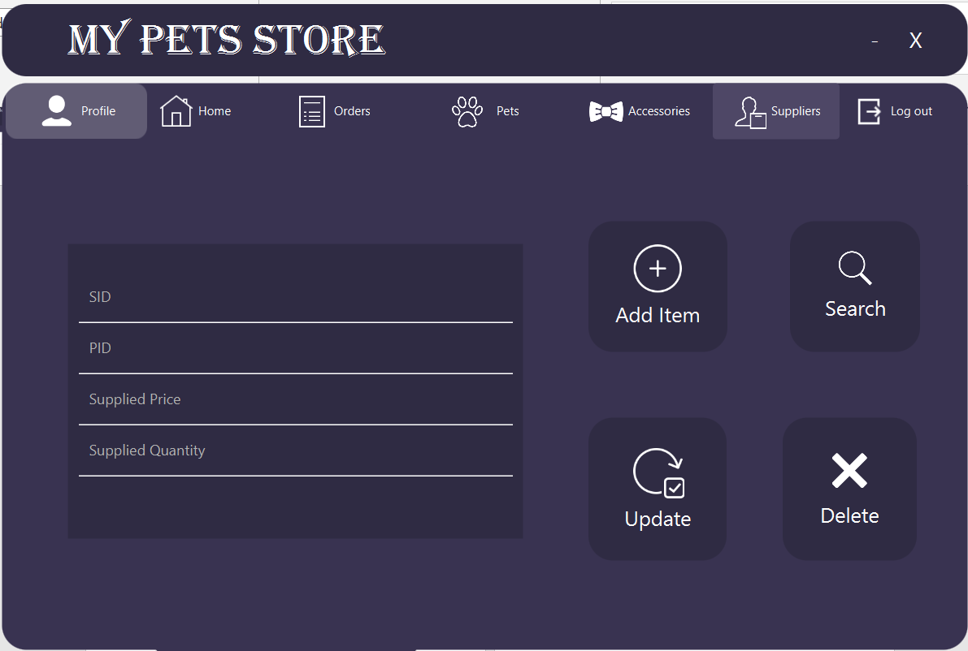and at the end Log out button returns the user to log in page.

Admin interface :

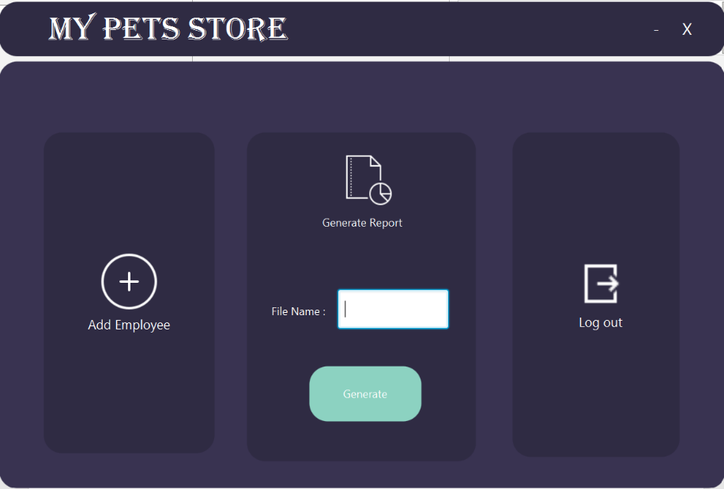If the entered email was “admin@petsstore” and the password was “admin@123” then the following home page will appear:

The admin can generate a pdf with the name he enters in the text field which gives the total sales of required product in a certain month.

He can also add employees in the add employees page:

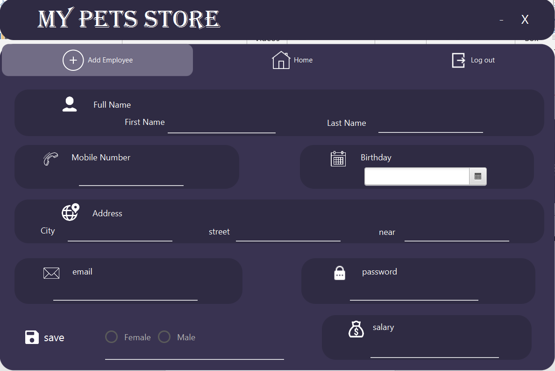

* Jasper Report:

The following report shows the total sales in each month:

In our database the orders that were delivered and got their money is only the order who have CID = 4 :

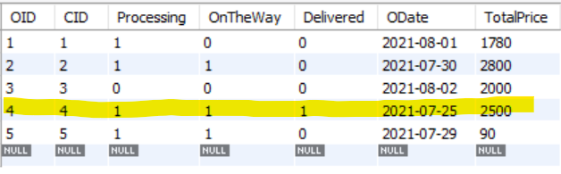

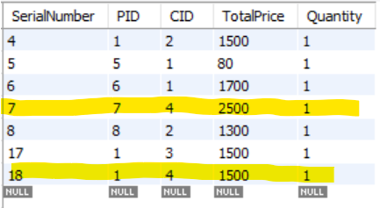And the CID = 4 contains these 2 products , with a total Price of 4000 :

The SQL code to generate the report is :

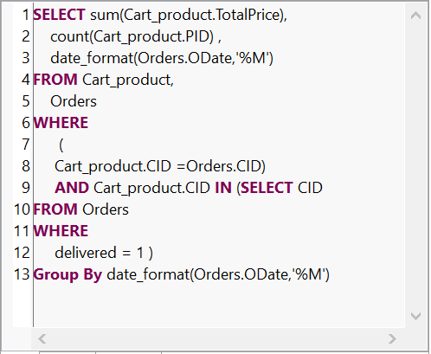

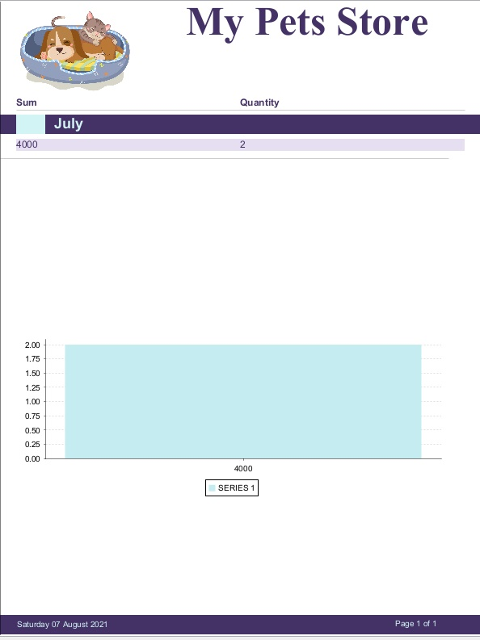So, the final result of the report was like this:

* Conclusion:

This database application can be used by 3 type of users:

1. Customer who can order products (pets and accessories of pets) and he have the ability to track his order .
2. Employee who can add products , add suppliers and manage the tracking of the orders and prepare them
3. Admin who can add employee and generate a sales report.

* References:

1. Database course by Dr.Sufyan Samara
2. YouTube course to learn javaFX : <https://www.youtube.com/watch?v=9XJicRt_FaI&t=9082s>
3. Oracle website: <https://www.oracle.com/index.html>
4. MySQL website: <https://www.mysql.com/>
5. Google.