Change IP to 192.168.1.15\26 With getaway 192.168.1.1 and DNS 8.8.8.8

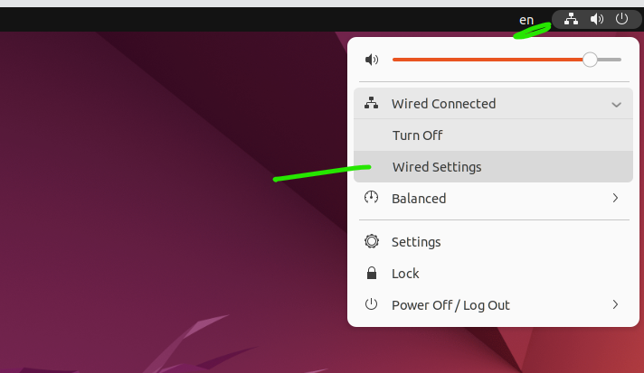

Show date and time for now

Install stopwatch

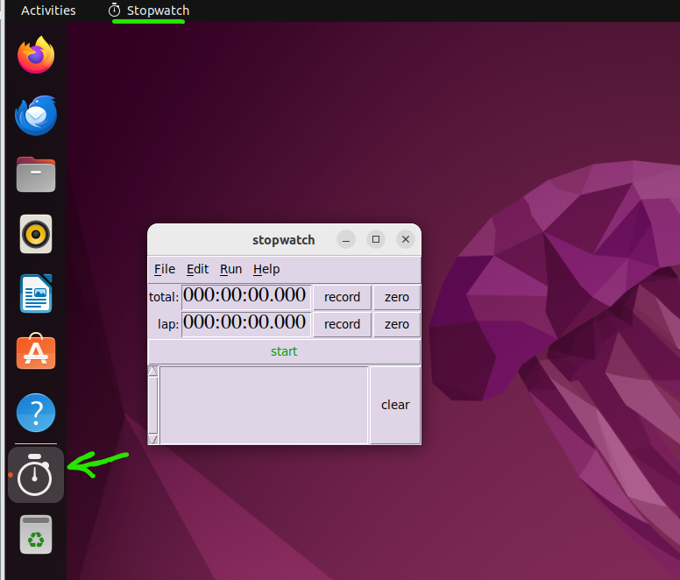

Show the directory (dire , ls , ls-s)

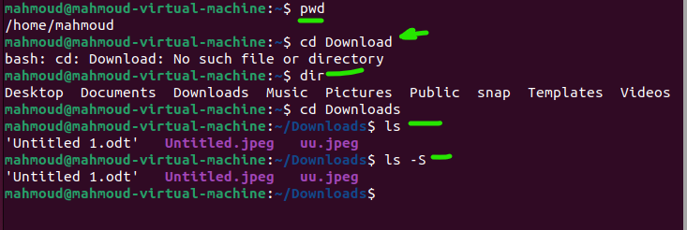

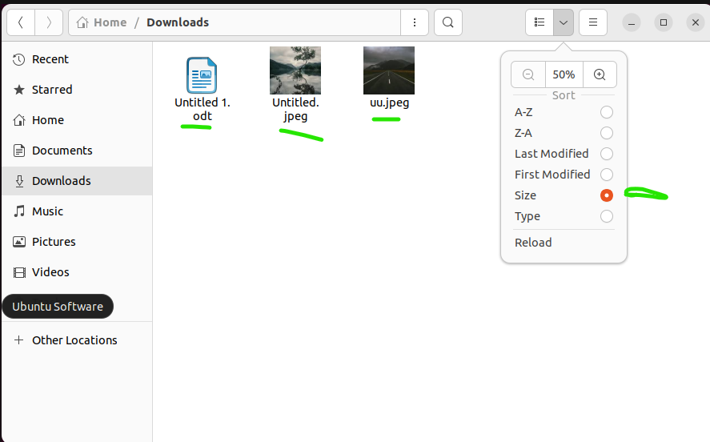

Where am I ?

How can I know the options in command (LS)

How to list files by size

How to list files in txt file

How to list files with extension jpeg

How to list files with any extension

How to list hidden files

How to list hidden files with details

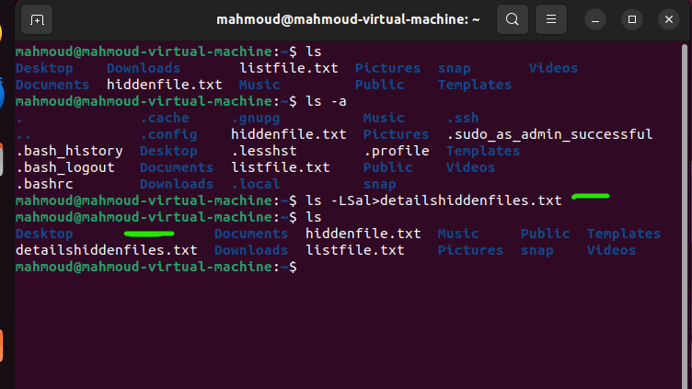

How to list hidden files with details by size

How to convert from console to another ?

Control + alt + F