* Show date and time for now

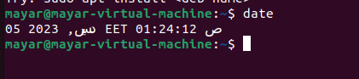

* Install stopwatch

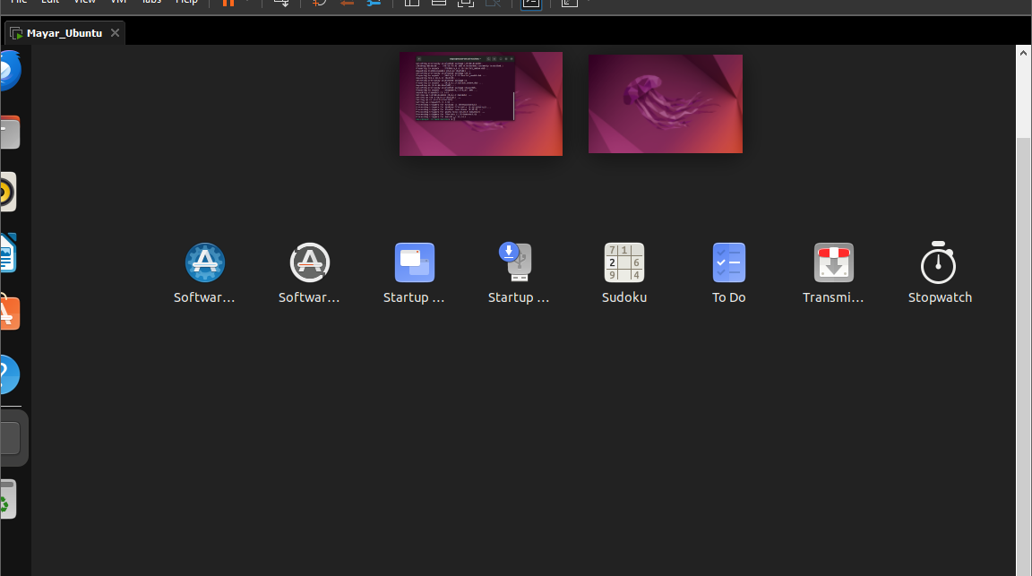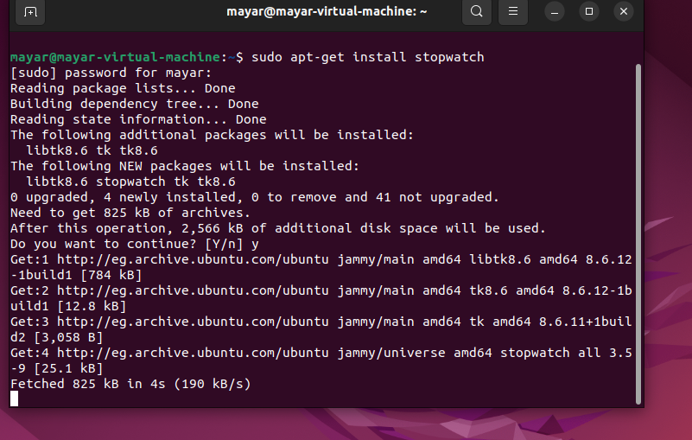

* Show the directory (dir , ls , ls-s)

DIR

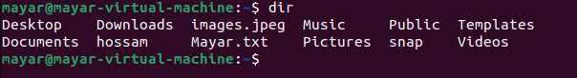

ls

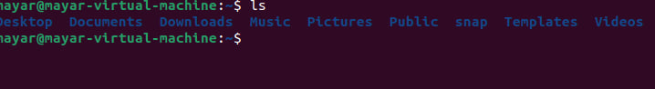

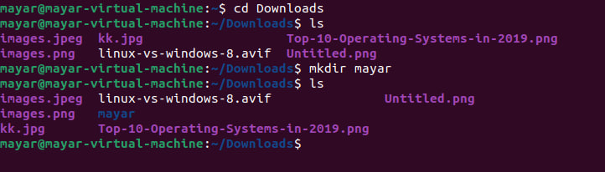

**ls -s**

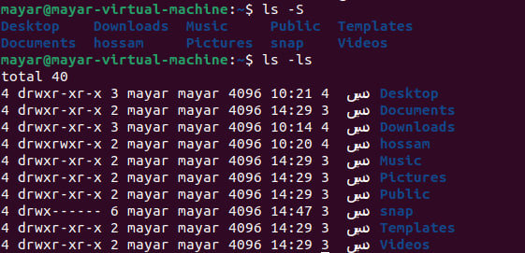

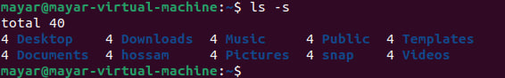

* Where am I ?

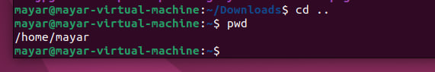

* How can I know the options in command (LS) >>> Man ls

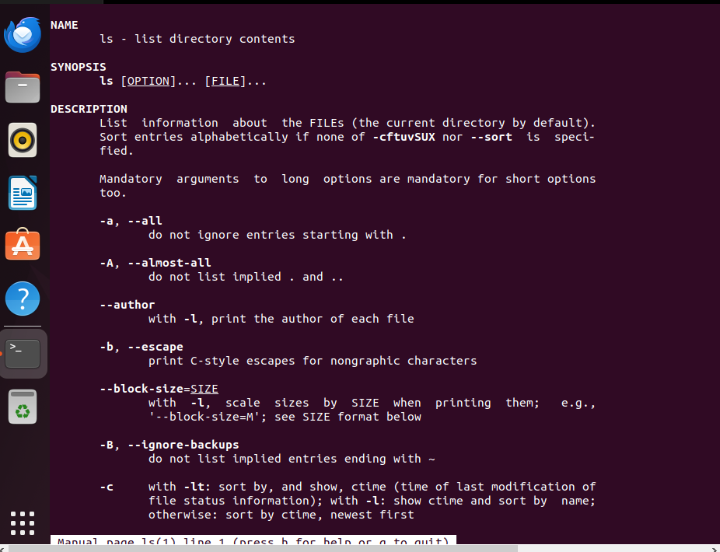

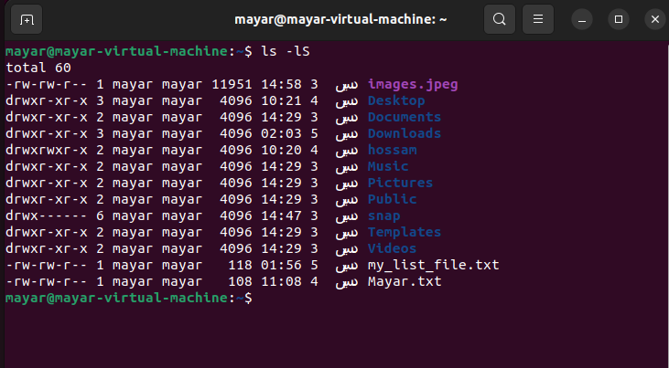

* How to list files by size
* How to list files in txt file

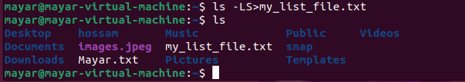

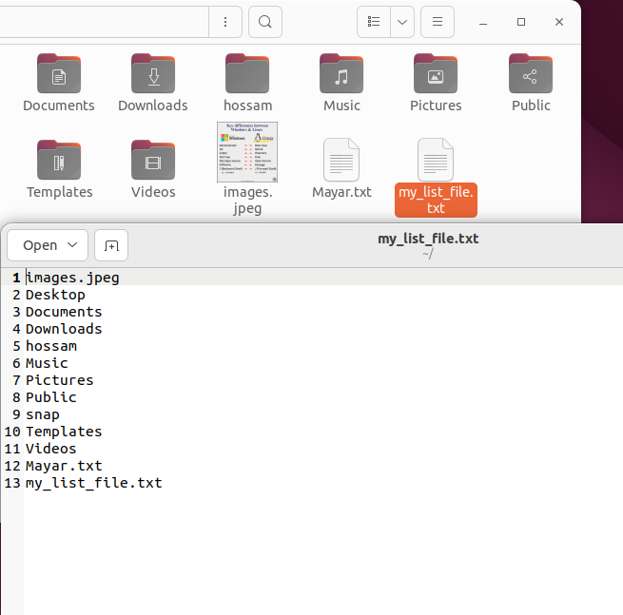

* How to list files with extension jpeg

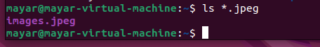

* How to list files with any extension

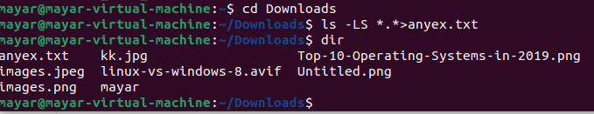

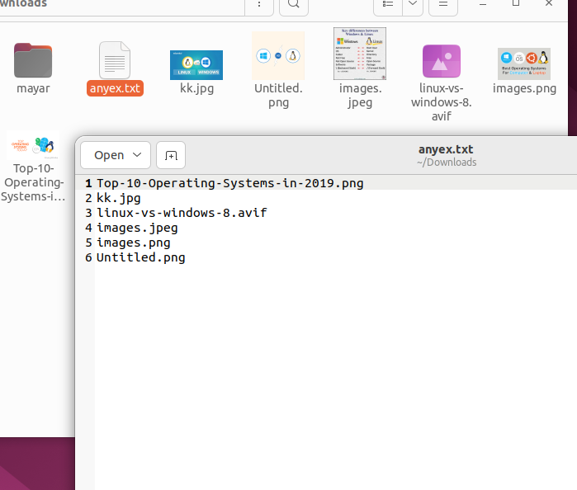

* How to list hidden files

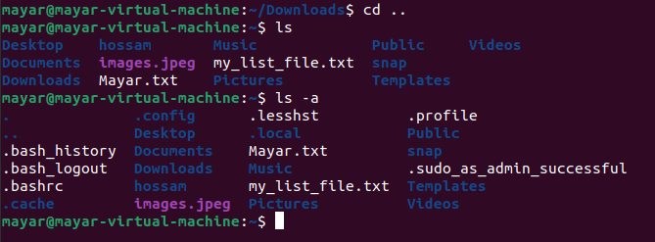

* How to list hidden files with details

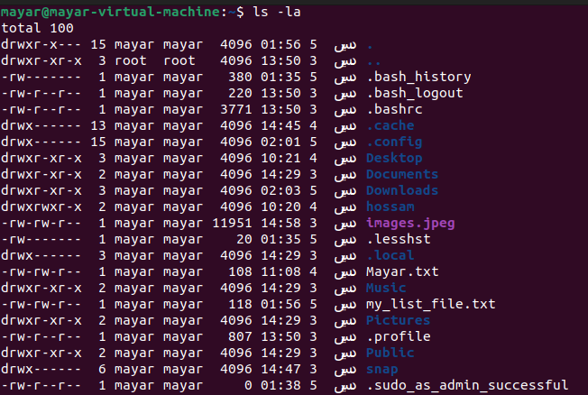

* How to list hidden files with details by size

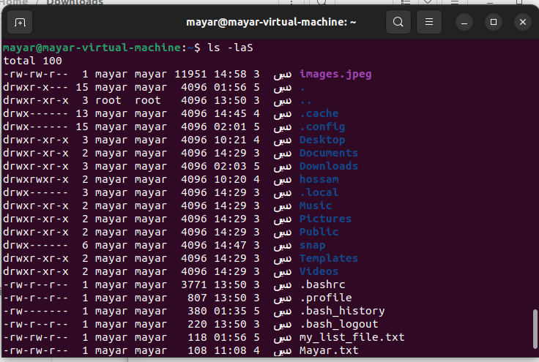

* How to convert How
* to convert from console to another ? Ctrl + Alt +F

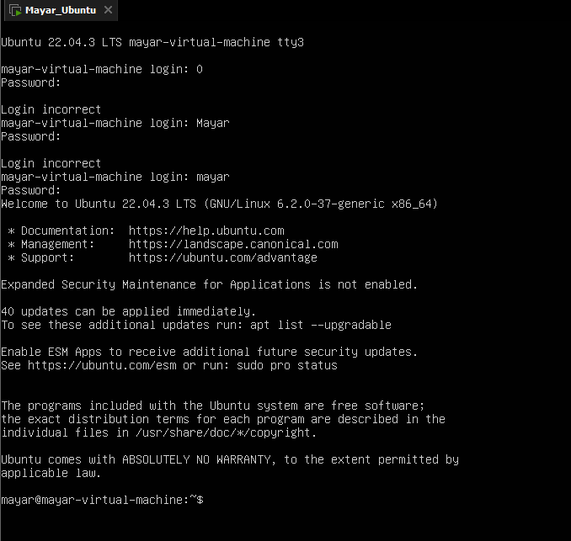

Thanks to Eng. Ramy