Scalable URL Shortener
Project 1

Objective
- What a URL shortener is 
- How creating a short URL works
- How redirecting works
- What happens behind the scenes
- What makes a URL shortener scalable
- What problems a real-world URL shortener needs to solve

What URL shorteners actually do?
The main idea is to shorten a long URL by mapping the long URL to a number code and store it in database so that when user uses the short URL, our application looks into the database to find original URL and redirects user to that URL.
How do we make a URL-shortening service that can handle a large number of users and redirects quickly and reliably? This is the question we are trying to answer.
Why use it?
It is more readable and easier to track. Better to paste for character limits in social media or websites you want to share link to.

How the basic redirect process works?
The basic redirect process relies on a standard HTTP handshake between your web browser and the URL shortener's server.
There are two ways in using this URL shortener:
- User enters a short URL → redirected to the original URL
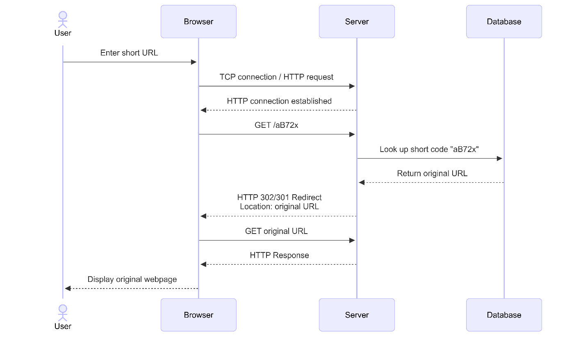

  - Initiation: The User inputs the shortened URL into the Browser.
  - Handshake: The Browser establishes a TCP/HTTP connection with the Shortener Server.
  - Resolution: The Browser issues a GET request for the unique token (/aB72x), prompting the Server to query the Database for the matching long URL destination.
  - Redirection: The Server issues an HTTP 301/302 response containing the destination address in the Location header.
  - Final Load: The Browser seamlessly processes the redirect and loads the target webpage for the User.
- User submits a long URL → server generates a short URL
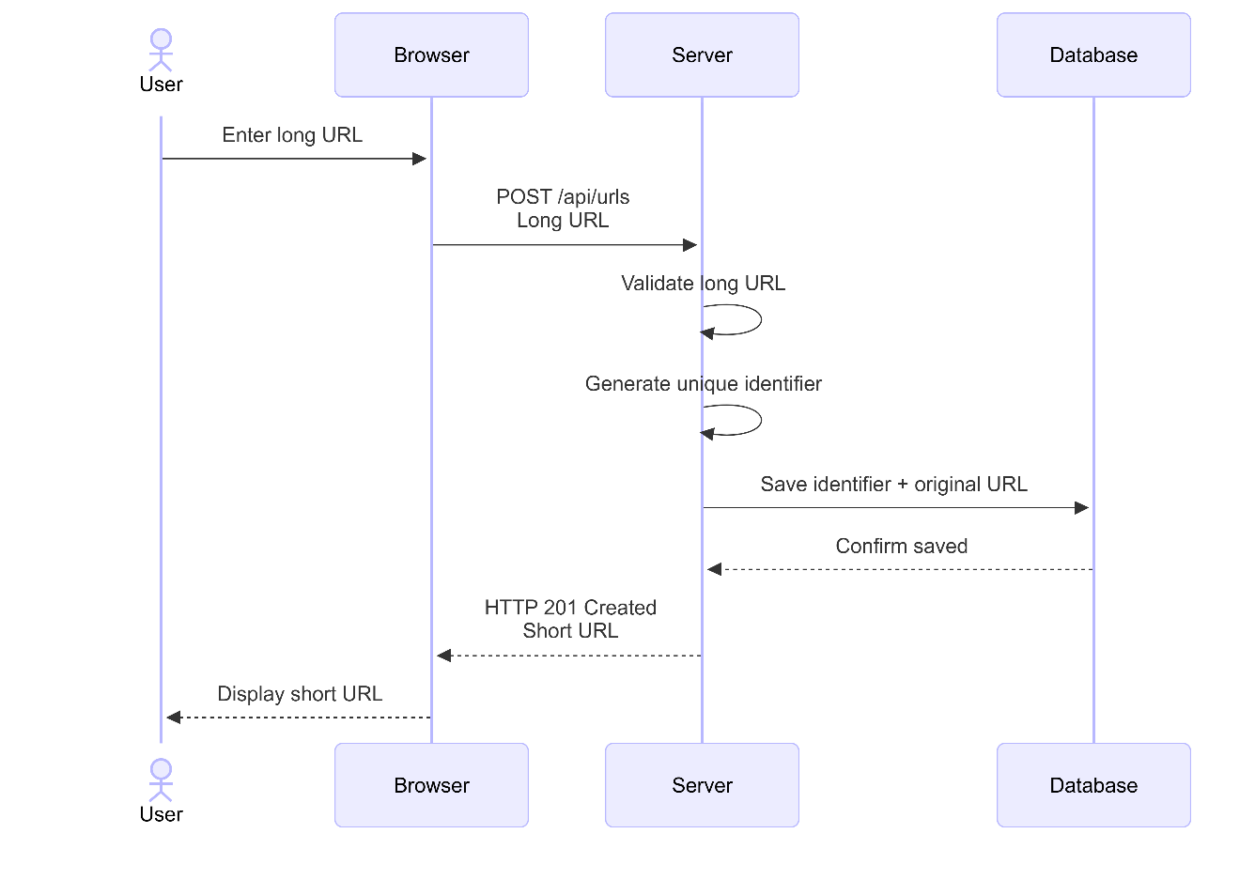

  - Submission: The User inputs the target long URL into the client interface, prompting the Browser to issue an HTTP POST request payload to the application gateway.
  - Validation & Generation: The Server intercepts the request, runs input validation checks to confirm the URL is well-formed, and executes a key-generation algorithm (e.g. Base62 encoding) to output a token.
  - Persistence: The Server issues a write command to commit the unique identifier and original long URL mapping to the Database.
  - Confirmation: Upon receiving a write confirmation from the Database, the Server transmits an HTTP 201 Created status code containing the shortened URL asset back to the client application.
  - Rendering: The Browser processes the server response and surfaces the generated shortened link to the User.
Examples of real URL-shortening services
- Bitly — probably the most recognizable example. It creates short links and also provides click analytics, QR codes, branded/custom domains, and link management.
- TinyURL — one of the older and simpler URL-shortening services. It's useful for quickly turning a long URL into a short one.
- Rebrandly — focuses heavily on branded links, custom domains, analytics, QR codes, and managing links at scale.
- Short.io — provides short links, custom domains, analytics, APIs, QR codes, and link-management features.

What makes a URL shortener scalable
What does "scalable" mean?
A system is scalable if we can increase the amount of traffic it handles without the system becoming unusably slow or failing.
- Multiple backend servers (The load balancer distributes incoming requests between servers).
- Keep the backend stateless (backend servers should not depend on locally stored client/session state. Shared data should be stored in external systems such as the database or cache, allowing requests to be handled by any backend server).
- Database optimization (use indexes in databases).
- Caching with Redis
- Handle huge numbers of requests, we should think about:
- Latency — How quickly does a request finish?
- Throughput — How many requests can we handle?
- Concurrency — What happens when thousands of requests arrive simultaneously?
- Availability — Does the system stay usable if something fails?
- Rate limiting (How many requests a user can send in a minute?).
- Reliability and failure handling
Common challenges with URL shorteners
- Generating unique short codes
- Handling a huge number of URLs in DB
- Handling a huge number of redirects
- High availability
- Database failure
- Cache consistency
- Security and abuse
- Rate limiting
- Expiration and deletion (when URL should no longer work, what happens to the corresponding database/cache data.
- Analytics (Every redirect can generate analytics data such as timestamp, IP/location information, device/browser information, referrer, and click count. Collecting this data without significantly slowing down redirects is a design challenge.)
- Concurrent requests (Imagine two users create URLs at exactly the same time. We need to make sure concurrent operations don't produce incorrect or duplicate data. This introduces concepts like race conditions, atomicity, and concurrency control).
- Short-code length
