Day 2 : Research
- Short-code generation
how URL shorteners generate the identifier part of the short URL
Method 1: Sequential ID + Base-62 Encoding
When a user submits a long URL, the database assigns the next sequential integer. The system converts this base-10 number into a Base-62 string. Base-62 uses lowercase letters (a-z), uppercase letters (A-Z), and numbers (0-9), avoiding special characters so the link remains safe in web browsers and text messages. The number 11,157 becomes a compact string like 2tx.
- Pros: Guaranteed unique, zero collision risks, and short, predictable lengths.
- Cons: Sequential numbers can make it easy for competitors to guess total link volume or scrape neighboring URLs. Systems often add random padding or shuffle characters to prevent this. (Security)
Method 2: Hashing the Long URL
This approach derives the identifier directly from the original long URL using a cryptographic hash function like MD5 or SHA-256. The system inputs the long URL into a hashing algorithm to produce a long alphanumeric string (e.g., a 128-bit MD5 hash). Truncate: It takes a small slice of that hash—usually the first 6 to 8 characters (e.g., 9b324g).
Handle Collisions: Because different URLs might produce the same starting characters (a hash collision), the system must check the database. If that short code already exists, it appends a counter/salt to the original URL and re-hashes it until it finds an unused identifier.
- Pros: Completely deterministic (the same long URL always yields the same short code if generated by the same user/timestamp rules).
- Cons: Requires extra database lookup steps to handle occasional collisions.
Method 3: Random Unique Strings (e.g., NanoID)
Some modern applications generate a completely random string of fixed length using secure random generators. The system uses a lightweight library (like NanoID) to pick random alphanumeric characters. It checks the database to confirm the random string (xs19F) isn't already taken, then saves it.
- Pros: Highly secure and unpredictable; impossible to guess neighboring links.
- Cons: Requires a quick uniqueness check against the database before final saving.

- Database storage
URL shorteners handle a massive volume of read requests (redirects) compared to write requests (generating short links). To achieve low latency—often under 20 milliseconds—and maintain data integrity, a URL shortener must split its data storage strategy into a persistent data layer and a high-speed caching layer.

- Persistent Storage (The Source of Truth)
- NoSQL Key-Value / Wide-Column Stores (Mongodb, JSON)
Because a URL shortener operates fundamentally as a simple lookup engine, NoSQL databases like Cassandra or DynamoDB are perfectly optimized for this workload. The Short Code serves as the primary/partition key, and the Original URL is the value.
Strengths: Massive linear scalability—adding more nodes allows the system to easily handle billions of rows. No complex relational operations (like JOINs) are needed, keeping raw read/write times predictable and incredibly low.
- Relational Databases (SQL)
For smaller-scale systems, standard relational databases like PostgreSQL or MySQL work well. A simple two-column table maps short_code (VARCHAR, Indexed) to original_url (VARCHAR).
Strength: High data consistency, ACID compliance, and easy auto-incrementing ID generation for Base-62 mapping.
Weakness: Scaling horizontally requires complex database sharding (splitting rows across multiple servers based on the first letter of the short code, for example).

- High-Speed Caching Layer (The Performance Engine)
Relying purely on a persistent database for every click would quickly crash a popular system. URL shorteners intercept almost all read requests using an in-memory database like Redis or Memcached.
The Setup: When a user clicks a short link, the system checks the fast memory cache first. If the mapping is found (Cache Hit), the user is redirected instantly. If it isn't (Cache Miss), the system fetches it from the database, sends it to the user, and writes it to the cache for the next visitor.
Eviction Policies (LRU): Because memory is expensive, the cache cannot hold every link ever created. Systems apply a Least Recently Used (LRU) eviction policy. When the cache fills up, the links that haven't been clicked recently are deleted from memory, making room for viral links.
- Quick Comparison: SQL vs. NoSQL Storage

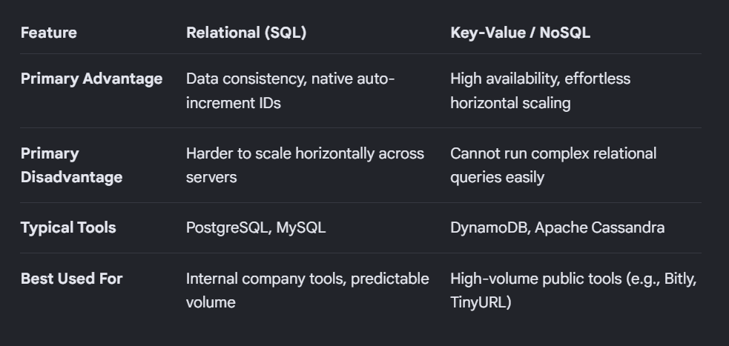

- Estimating Storage Size
URL mappings consume very little space per row. We can estimate the physical data requirements for a mid-sized service using a standard projection model:
    - Short Code Size: ~7 bytes
    - Original URL Size: ~100 bytes
    - Metadata (Created Date, Expiration): ~13 bytes
    - Total per link: ~120 bytes
If a platform generates 100 million new links per month, the absolute storage growth curve remains highly manageable for modern infrastructure over a five-year period.

- Redirects
Real-world URL shorteners handle the redirect process using a highly optimized workflow designed to maximize speed, minimize database load, and collect analytics. When a user clicks a short link, the system executes the following steps in a matter of milliseconds.
The HTTP Status Code Selection
To redirect the browser, the shortener's web server responds with specific HTTP 3xx status codes. The choice between these codes dramatically impacts network traffic and analytics precision:
- HTTP 301 (Moved Permanently): The browser is told that the link will never change. The browser aggressively caches the mapping locally. The next time the user clicks that same short link, the browser redirects them instantly without contacting the URL shortener's servers again.
- HTTP 302 (Found / Found Temporarily) or 307 (Temporary Redirect): The browser is told that this redirect is valid only for this specific request. The browser is forced to contact the URL shortener server every single time the link is clicked.
The Core Request Workflow

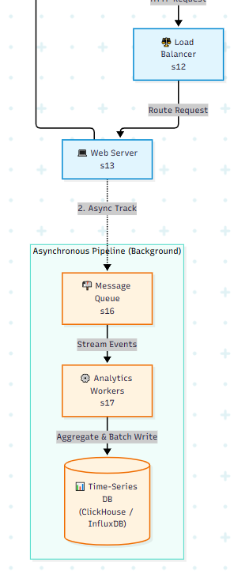
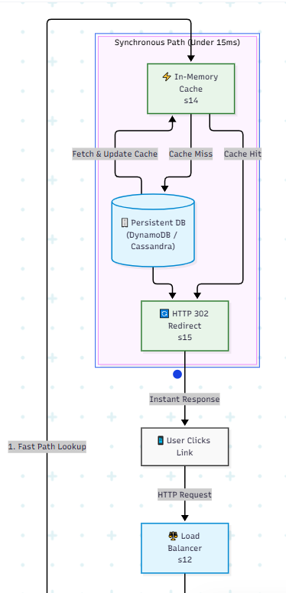

Step 1: Parsing and Cache Lookup
  - The request hits a Load Balancer (like NGINX or AWS ALB), which routes it to an available lightweight web application server.
  - The application server extracts the short code (e.g., 2tx from bit.ly/2tx).
  - The server checks an in-memory cache system like Redis. Since memory lookups take under 2 milliseconds, a cache hit immediately allows the server to issue the HTTP 302 response with the long URL in the Location header.
Step 2: Database Fallback (Cache Miss)
If the link is old or viral status has cooled down, it won't be in the cache. The system queries the persistent NoSQL or sharded relational database, updates the cache for future visitors, and returns the redirect.
Asynchronous Analytics Tracking
Tracking data (IP address, country, user-agent/device type, and timestamp) is a critical business feature for shorteners. However, writing this data directly to a database during the user's request would cause massive delays.
To maintain ultra-low latency, real-world systems decouple analytics from the redirect using a Message Queue / Stream:
  - As soon as the web server finds the destination URL, it immediately fires a raw log event into a streaming platform like Apache Kafka or AWS Kinesis.
  - Instant Delivery: The server returns the 302 redirect to the user immediately, completing the transaction in under 15ms.
  - Background Processing: Independent analytics worker threads consume events from the message queue asynchronously. They process, aggregate, and store the metrics into a time-series database (like InfluxDB or ClickHouse) completely in the background without affecting the user's experience.

- Caching
URL shorteners handle a highly asymmetric workload, where 90% to 99% of all traffic consists of read requests (redirects) rather than write requests (creating new links). In this environment, relying solely on a persistent database introduces major architectural vulnerabilities.
A URL shortener utilizes an in-memory caching layer (like Redis or Memcached) for several critical technical and financial reasons.

- Analytics
Research what information real URL-shortening services may collect when a short URL is visited.
When a user clicks a short URL, the shortening service intercepts the request before redirecting the browser to the final destination. Because this transition happens on the service's web servers, the platform can capture metadata directly from the HTTP request headers, the network packet, or URL structures.
Number of clicks, Time of access, Referrer, Device, Location, Browser
The User-Agent String: This text block informs the server about the hardware and software making the request. From this, the shortener extracts:
  - Device Type: (e.g., Mobile, Desktop, Tablet, Smart TV).
  - Operating System: (e.g., iOS, Android, Windows, macOS).
  - Web Browser: (e.g., Chrome, Safari, Firefox, Edge).
Networking and Temporal Data: IP address and timestamp.
Intentional Campaign Tracking Data (UTM Parameters)
- Expiration
URL expiration allows platforms to manage storage costs, recycle premium short codes, and enforce temporal link limits (such as a 15-minute password reset link or a 30-day promotional campaign).
Here is how production systems store, check, handle, and clean up expired URL mappings.
How Expiration is Stored
To enforce an expiration date, the data model must track precisely when a link ceases to be valid.
  - The Database Schema: A nullable timestamp column, typically named expires_at or expiration_time (stored in UTC ISO-8601 format or as a Unix epoch integer), is appended to the link mapping record.
  - Default vs. Custom Expiration: Systems usually implement a tier-based default lifecycle (e.g., anonymous users get 30 days, free registered accounts get 1 year, and enterprise tiers get infinite/custom durations). If a link is set to never expire, the field is left as NULL.
  - Cache Strategy: In the high-speed caching layer (like Redis), the system sets an explicit TTL (Time-To-Live) on the key that mirrors the database expiration. If a link expires in 4 hours, the Redis key is set to automatically delete itself in exactly 4 hours.
How the System Checks for Expiration
When a user clicks a short link, the system evaluates validity sequentially to minimize heavy database reads:
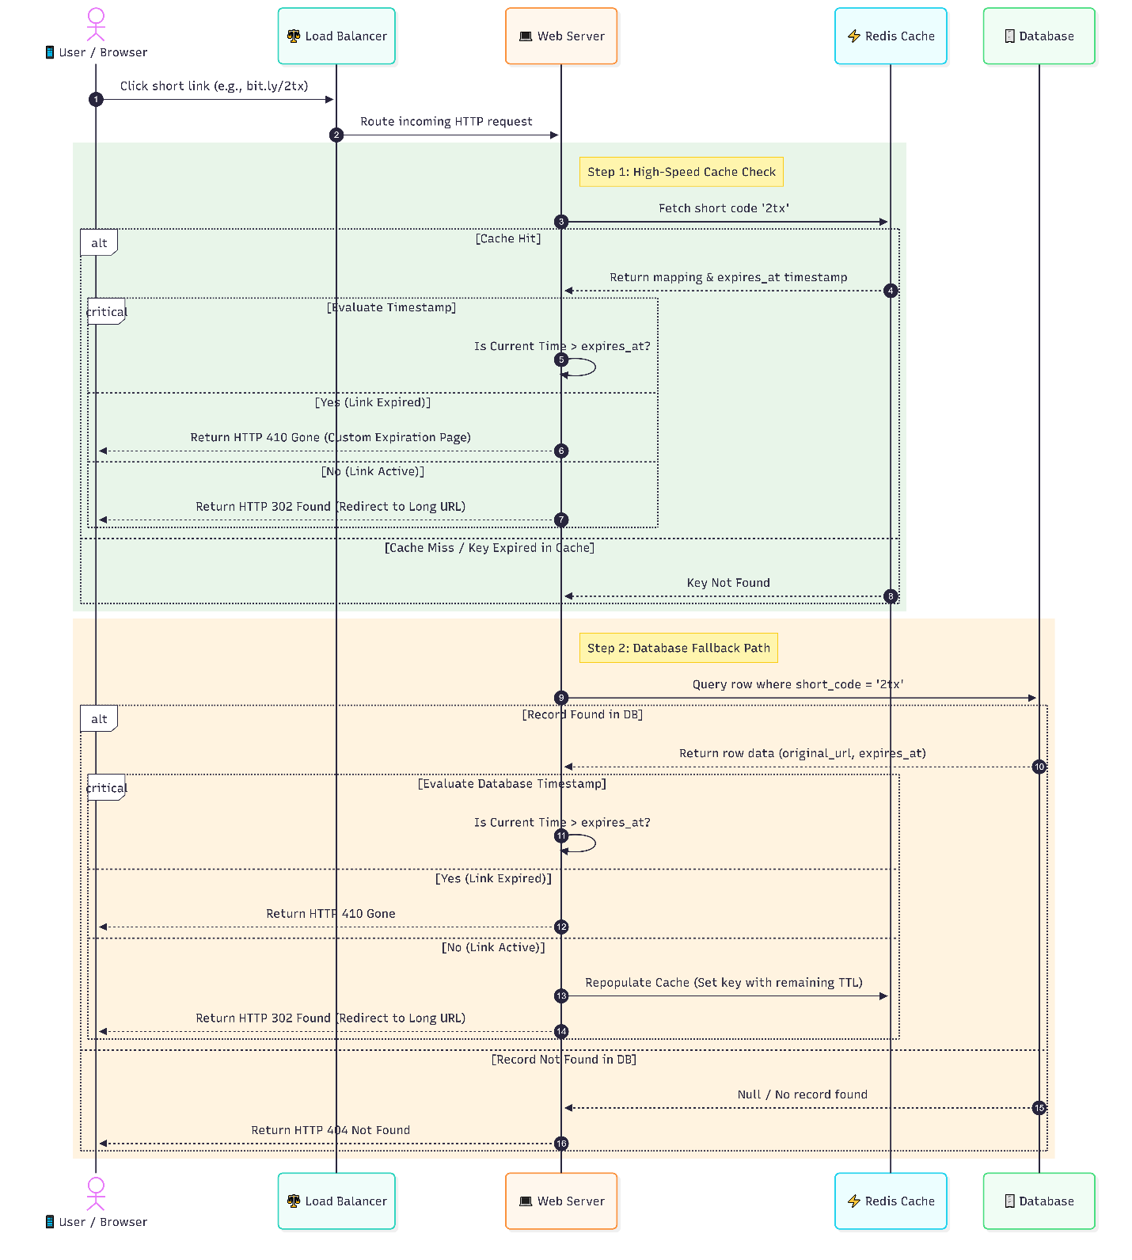

What Happens to Expired URLs
When an expiration threshold is crossed, a real-world system avoids throwing a generic error. It responds using semantic HTTP codes to inform search engines and clients of the link's status:
  - HTTP Status 410 Gone: This is the most accurate industry response. Unlike a generic 404 Not Found, a 410 Gone explicitly tells search engine crawlers and browsers that the resource used to exist but has been intentionally removed and will not return. This instructs search engines to instantly scrub the dead link from their indexes.
  - The Custom Landing Page: Instead of a raw browser error, the shortener renders a polished interface explaining that the link has expired, often providing a call-to-action to visit the platform's main homepage or contact the link creator.
Should Expired Data Eventually Be Deleted?
Yes. Retaining billions of dead links indefinitely creates technical debt, inflates infrastructure costs, and slows down index performance. However, systems do not delete data the exact second it expires.
The Deletion Strategy: Two-Stage Purging
  - Stage 1: Logical (Soft) Expiration: The link remains in the database, but its status flag changes or its timestamp marks it dead. It is inaccessible to users, ensuring no traffic strains downstream services.
  - Stage 2: Asynchronous Hard Deletion (The Janitor Cron): A low-priority background worker task runs during low-traffic windows (e.g., 2:00 AM UTC). It batches delete operations to prevent locking production database tables.

- Rate limiting
Rate limiting is a foundational security and operational control used by high-throughput web applications to control the rate of traffic sent or received by a network interface or user session. For a URL shortener, which processes massive numbers of requests simultaneously, rate limiting acts as a critical shield.
What Rate Limiting Is
Rate limiting is the practice of restricting the number of times a user, IP address, or API token can interact with an application within a specific timeframe (e.g., maximum 5 link creations per minute for anonymous users, or 10,000 API calls per hour for enterprise developers).
When a client breaches this threshold, the server rejects the request immediately, responding with an HTTP Status 429 (Too Many Requests) instead of processing the payload.

Why It Protects the Service (and What Happens Without It)
Without robust rate limiting, a public URL shortener faces catastrophic vulnerabilities across its infrastructure:
  - Preventing Infrastructure Exhaustion (DDoS Protection): A single malicious actor could orchestrate an automated script to request millions of short link redirects simultaneously. Without a rate limiter, this brute-force traffic floods the web servers and the fallback database, triggering a complete system outage for legitimate users.
  - Controlling Storage Explosion: Because creating a short URL writes a permanent row to the database, a bot script left unchecked could generate billions of dummy links in hours. This artificially inflates cloud storage costs and bloats database indexes, slowing down lookups globally.
  - Stopping Fraud, Phishing, and Spam: Bad actors frequently use public URL shorteners to obscure malicious destination links (like phishing sites or malware downloads) to bypass email spam filters. Rate limiting blocks automated spammers from mass-producing these deceptive links.
  - Preventing Cache Stampedes: Serving thousands of concurrent requests for a single expired or cold link can force the system to bomb the backend database for answers all at once. Rate limiting keeps traffic throughput predictable.
What Targets are Rate-Limited in Production?
Real-world URL shorteners implement layered rate-limiting tiers tailored to specific application entry points:
- URL Creation (Write Path)
The Focus: Protecting the primary database from rapid, automated writes and storage inflation.
Implementation: Tracks traffic based on the client's IP Address or logged-in User ID. Anonymous tiers are restricted aggressively (e.g., 5 links per minute), while logged-in free tiers get slightly more breathing room (e.g., 60 links per hour).
- Redirect Requests (Read Path)
The Focus: Preventing malicious scraping, enumeration attacks (brute-forcing short codes sequentially to discover private links), and denial-of-service traffic.
Implementation: Tracks traffic based on the combination of the Client IP and the specific Short Code identifier. If a script aggressively calls bit.ly/A8b9X thousands of times a second, the rate limiter drops that specific IP's access to that short code while keeping the rest of the site functional.
- Developer API Requests
The Focus: Managing resource consumption on programmatic endpoints where external software generates or fetches link metadata in bulk.
Implementation: Tracks traffic directly via the user's API Key / Bearer Token. This easily maps to monetization layers: free developer keys are capped tightly (e.g., 1,000 requests/day), while enterprise paid tokens scale to millions of monthly allocations with tiered overage pricing.

How the Infrastructure Handles a Rate Limit
To prevent the rate limiter itself from becoming a performance bottleneck, production systems implement algorithms like Token Bucket or Sliding Window Log directly inside high-speed memory stores like Redis.
When a request passes through, the rate-limiting algorithm evaluates it instantly. The table below details how standard systems signal these boundary limits back to the client via HTTP response headers:
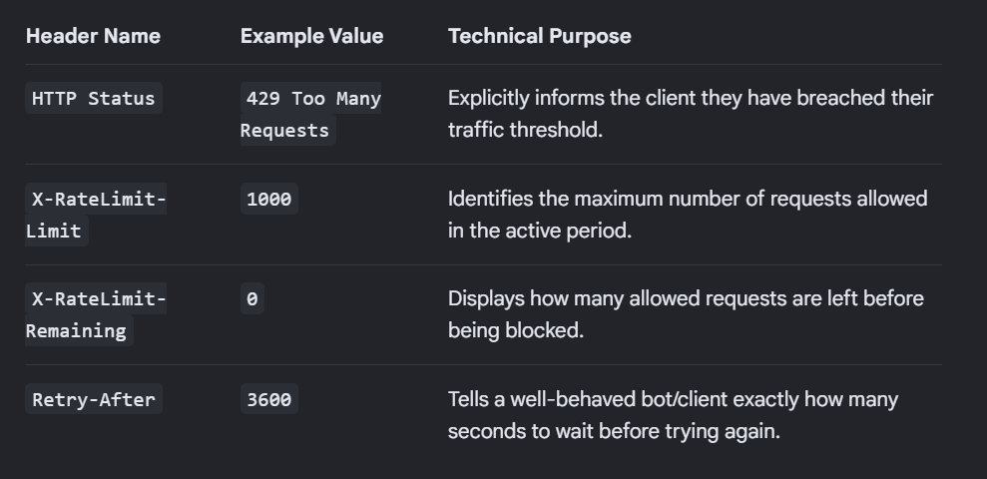

- Scaling architecture
Horizontal Scaling vs. Vertical Scaling
Scaling is the process of upgrading a system to handle increased traffic or data loads.
  - Vertical Scaling (Scaling Up): Adding more power (CPU, RAM, SSD space) to a single existing server.
    - The Catch: It has a hard hardware ceiling and creates a single point of failure.
  - Horizontal Scaling (Scaling Out): Adding more physical or virtual servers to the pool instead of making one server bigger.
    - Why it's used: It provides infinite scaling potential. If traffic doubles, you simply spin up more identical, low-cost server instances to share the load.
Multiple Backend Instances
Instead of deploying an entire application on one machine, modern systems run identical copies (instances) of the application code simultaneously across several servers.
  - Redundancy: If one backend server crashes due to a software crash or hardware failure, the remaining instances continue running without interrupting service to users.
  - Parallel Processing: Traffic is distributed across these multiple nodes, preventing any single machine's CPU or memory from becoming overwhelmed
Load Balancing
A Load Balancer acts as a traffic cop sitting directly between the incoming internet users and your multiple backend instances.
  - Traffic Distribution: It intercepts all incoming HTTP requests and distributes them evenly across your backend instances using algorithms like Round Robin (cycling through servers sequentially) or Least Connections (sending traffic to the least busy server).
  - Health Checks: It constantly tests the backend servers. If an instance stops responding, the load balancer automatically drops it from the rotation and routes traffic only to healthy servers.
Stateless Servers
To allow a load balancer to distribute requests freely across multiple backend instances, the application servers must be completely stateless.
  - What it means: A backend server does not store local user session files, uploaded images, or stateful data on its own local hard drive.
  - Why it's critical: If a user logs in on Server A, their next click might be routed to Server B. If the servers are stateless, Server B doesn't need local memory of the login; instead, session data is stored centrally in a shared database or a lightweight cookie token (like a JWT), making all backend instances perfectly interchangeable.
Database Bottlenecks
While web servers can scale horizontally effortlessly, the central database often becomes the ultimate system bottleneck because it handles hard disk reads/writes and maintains strict data consistency.
  - The Cause: As thousands of backend instances try to read and write data simultaneously, the database runs out of available connection pools, disk I/O bandwidth, or CPU cycles to process complex queries.
  - The Mitigations: Engineers resolve this bottleneck by implementing database replication (Read Replicas), sharding (splitting data across separate databases), or adding a fast caching layer.
Caching
A cache is a high-speed data storage layer that holds a subset of transient data, allowing requests to be fulfilled much faster than accessing the primary storage disk.
  - In-Memory Speed: Tools like Redis or Memcached store data in RAM. Reading from RAM takes less than a millisecond, compared to the tens of milliseconds it takes to query a traditional database disk.
  - Database Shield: By serving highly requested, static, or viral data (such as a popular short URL mapping) directly out of memory, the cache intercepts up to 90%+ of read traffic, preventing database bottlenecks entirely.
