


Cairo University – Faculty of Engineering
Credit Hours System –Fall 2025
Prepared By: Mayar Ayman
ID:1210085

1. Medical Device Explanation
1.1 What is an Incubator?
A medical incubator is a life-support device commonly used in neonatal care units (NICU) to provide a controlled environment for newborns, especially premature infants.
It maintains stable temperature, humidity, oxygen, and airflow, which are critical for infant survival and development.

1.2 Purpose of the Incubator Simulator
The developed Incubator Simulator emulates the behavior of a real neonatal incubator to:
- Demonstrate how environmental parameters are monitored
- Show alarm generation when values exceed safe limits
- Allow manual overrides for testing abnormal conditions
- Log sensor data for analysis and reporting
This simulator helps understand:
- Medical device monitoring logic
- Safety thresholds
- Alarm management
- User interface design for clinical systems
  - Simulated Parameters
The simulator continuously monitors and displays:
Parameter | Description
Temperature (°C) | Maintains infant body heat
Humidity (%) | Prevents dehydration and skin damage
Oxygen (O₂ %) | Supports respiratory needs
Carbon Dioxide (CO₂ %) | Indicates air quality
Fan Speed (%) | Ensures air circulation

1.4 Alarm System
- Triggers when any parameter exceeds safe limits
- Visual alarms displayed in red
- Alarm can be paused/resumed
- All alarms are logged with timestamps

2. User Interface (UI) Steps
2.1 Home Screen
Description:
- Displays the title “Incubator Simulator”
- Shows system status: Running / Stopped
- Displays alarm state: Active / Paused
Purpose:
Gives the operator immediate awareness of device state.

2.2 Sidebar – Controls & Thresholds
Features:
- Start / Stop simulation
- Pause or resume alarms
- Save log data as CSV
- Adjust safe thresholds for all parameters
Purpose:
Allows clinicians or engineers to configure the incubator environment safely.

2.3 Threshold Configuration Panel
Description:
Users can define safe ranges for:
- Temperature
- Humidity
- O₂
- CO₂
- Fan speed
Purpose:
Simulates medical device calibration according to clinical standards.

2.4 Real-Time Graphs (Left Panel)
Graphs displayed:
- Temperature trend
- Humidity trend
- Oxygen trend
- CO₂ trend
Purpose:
Visualizes patient environment history and trends, similar to real devices.

2.5 Parameters Dashboard (Right Panel)
Displayed Information:
- Current value of each parameter
- Color-coded status:
  - Green: Normal
  - Red: Out of range
- Progress bars showing proximity to limits
Purpose:
Allows fast decision-making and risk detection.

2.6 Alarm Display
- Shows specific parameter causing the alarm
- Alarm color changes based on severity
- Supports alarm muting (pause)
Purpose:
Imitates real medical alarm systems to reduce response time.

2.7 Logging & Export
Functions:
- Logs every reading with timestamp
- Exports logs as CSV
- Clear logs option
Purpose:
Supports documentation, audits, and system evaluation.
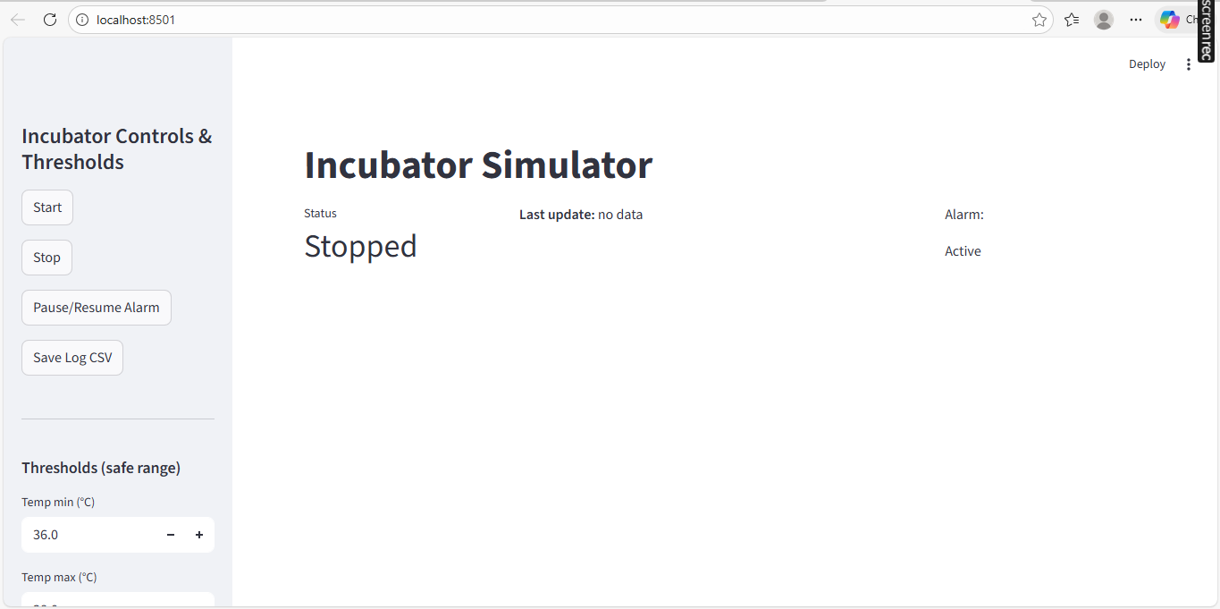

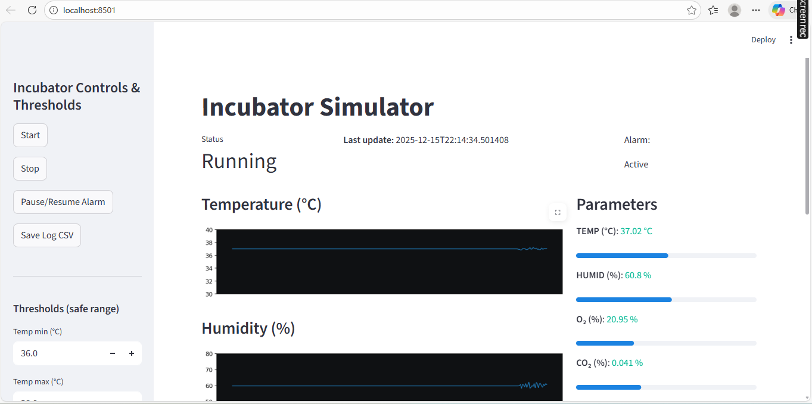

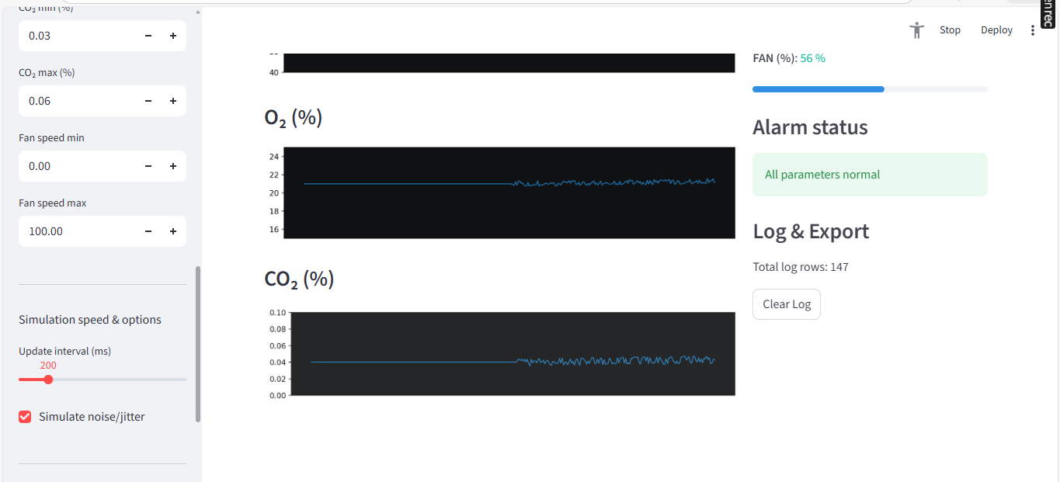

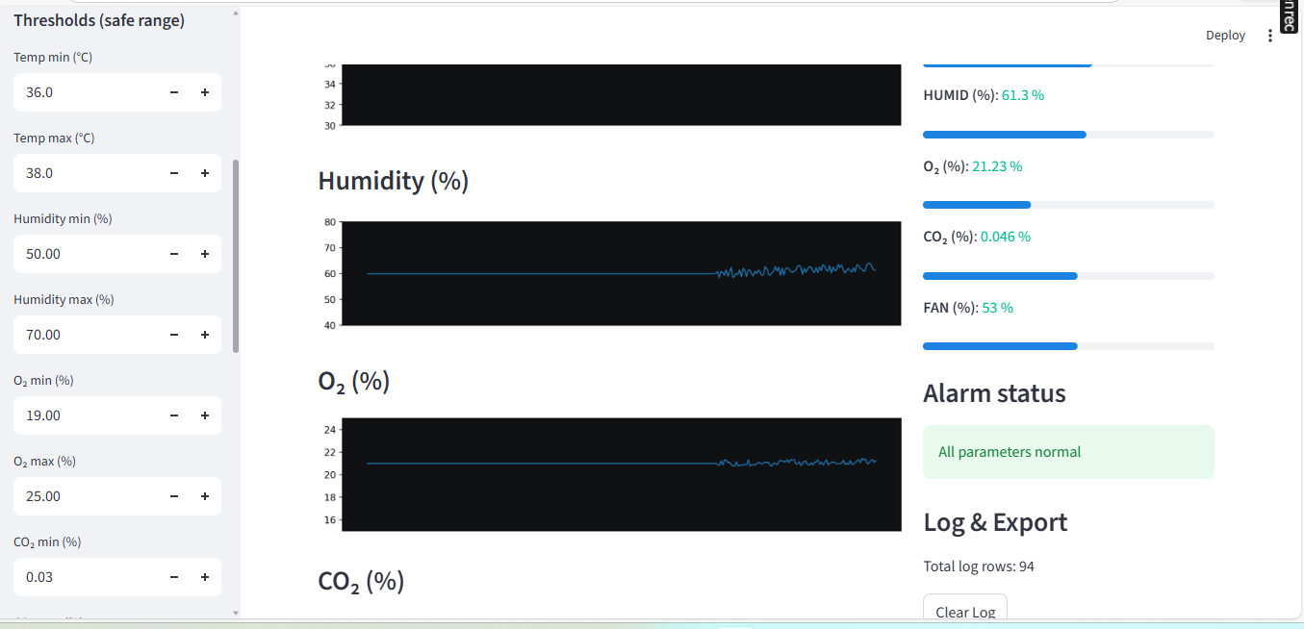

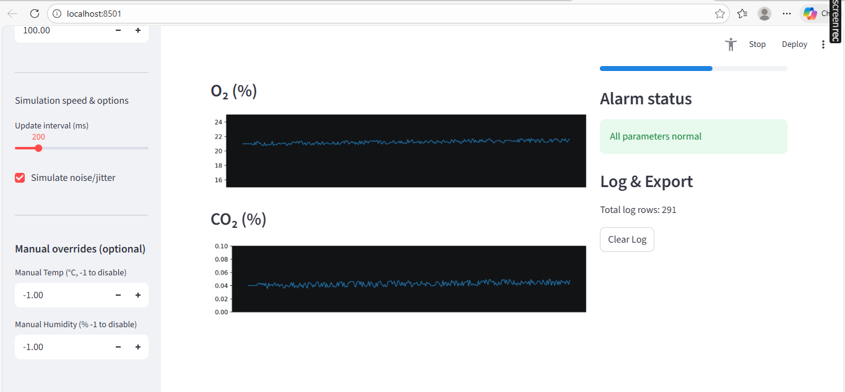

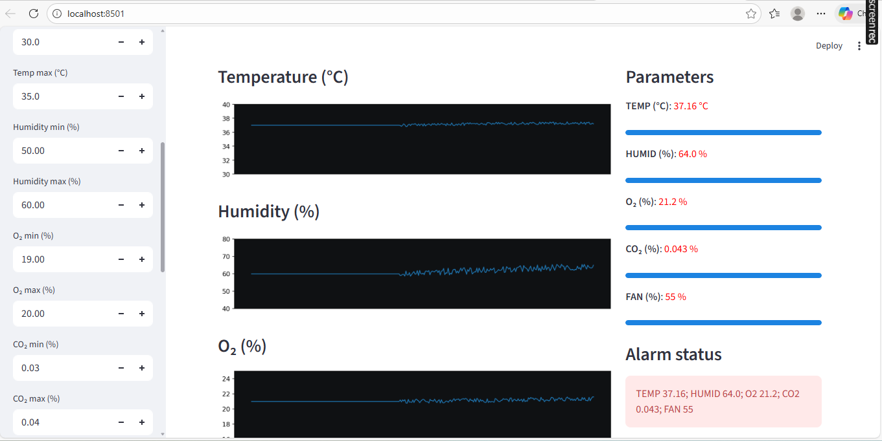

4. Standards Used & Safety Limits
4.1 Medical Standards Referenced
Standard | Description
IEC 60601-1 | Medical electrical equipment safety

4.2 Parameter Limits Used in Simulator
Parameter | Minimum | Maximum | Unit
Temperature | 36.0 | 38.0 | °C
Humidity | 50 | 70 | %
Oxygen (O₂) | 19 | 25 | %
Carbon Dioxide (CO₂) | 0.03 | 0.06 | %
Fan Speed | 0 | 100 | %

4.3 Safety Considerations
- All alarms are visual and immediate
- Manual override allows abnormal testing without real risk
- No real patient data is used
- System explicitly marked “Not for clinical use”
Conclusion
The Incubator Simulator demonstrates key concepts of medical device monitoring, alarm management, and user interface design.
It follows recognized medical standards and accurately models safe operating limits.

