AAPD7112
Zwivhuya Madzivhandila
ST10030452
Advanced Application Development
Portfolio of Evidence – Part 2

README
MuniServe – Municipal Services Application
How to Compile, Run & Use the Software

Field | Details
Module | Advanced Application Development (AAPD7112)
Project | MunicipalServicesApp1
Platform | .NET Framework 4.8 – Windows Forms (C#)
Part | Part 2 – Local Events & Announcements
Date | 2026

1. Application Overview
MuniServe is a C# .NET Framework 4.8 Windows Forms desktop application that enables South African citizens to report municipal issues and browse local events. Part 2 adds the fully functional Local Events & Announcements page, built using advanced data structures.

Part 2 Features Added
• Local Events & Announcements page — now fully active on the main menu
• Keyword, category, and date search functionality
• Smart recommendation engine based on user search patterns
• Search history displayed as clickable chips (backed by a Stack)
• Urgent event banner driven by a Priority Queue
• Live statistics panel showing total events, categories, dates, and searches
• 8 pre-loaded real-world South African municipal events

Data Structures Used
Structure | Purpose
Stack | Stores the last 20 search terms — used for the Recent Searches chip strip
Queue | FIFO announcement queue — all events queued in order of addition
Priority Queue | Min-heap surfaces urgent (Priority 1) events first in the banner
SortedDictionary | Events indexed by date — auto-sorted chronologically, O(log n) lookup
Dictionary | Events indexed by category — O(1) category filter lookup
Hash Table (Dict) | Records search frequency per term — drives the recommendation engine
HashSet (Set) | Tracks unique category names and unique date strings

2. System Requirements
Requirement | Details
Operating System | Windows 10 or Windows 11
.NET Framework | Version 4.8 (pre-installed on most Windows 10/11 machines)
IDE | Visual Studio 2019 or later (Community Edition is free)
RAM | Minimum 4 GB recommended
Disk Space | ~50 MB for the project and build output

3. How to Compile the Application
1. Open Visual Studio. Launch Visual Studio 2019 or later. Download the free Community Edition from visualstudio.microsoft.com if needed.
2. Open the Project. Go to File → Open → Project/Solution. Navigate to the MunicipalServicesApp1 folder and open MunicipalServicesApp1.sln.
3. Verify the Project File. Right-click the project → Edit Project File and confirm it contains: <TargetFramework>net48</TargetFramework> and <UseWindowsForms>true</UseWindowsForms>.
4. Add Part 2 Files. Ensure the following files are included in the project: Forms/LocalEventsForm.cs, DataStructures/EventRepository.cs, Models/MunicipalEvent.cs, and the updated Forms/MainMenuForm.cs.
5. Build. Press Ctrl + Shift + B or go to Build → Build Solution. The Output window should show: Build succeeded with 0 error(s).

4. Project Structure
File / Folder | Purpose
MunicipalServicesApp1.sln | Solution file — open this in Visual Studio
Program.cs | Application entry point
Forms/MainMenuForm.cs | Main menu — Report Issues & Local Events now both active
Forms/ReportIssuesForm.cs | Part 1 — Report Issues form (unchanged)
Forms/LocalEventsForm.cs | Part 2 — Local Events & Announcements form (new)
Models/Issue.cs | Data model for reported issues
Models/MunicipalEvent.cs | Data model for events and announcements (new)
DataStructures/EventRepository.cs | All data structures: Stack, Queue, PriorityQueue, SortedDictionary, Dictionary, HashSet (new)

5. How to Run the Application
Option A – From Visual Studio (Recommended)
• Press F5 to run with the debugger attached.
• Press Ctrl + F5 to run without the debugger.

Option B – Run the Executable Directly
• Navigate to: MunicipalServicesApp1\bin\Debug\net48\
• Double-click MunicipalServicesApp1.exe to launch.

6. How to Use the Application
6.1 Main Menu
When the application starts, the Main Menu is displayed. Three service options appear in card format. In Part 2, both Report Issues and Local Events & Announcements are now active. Service Request Status remains disabled.
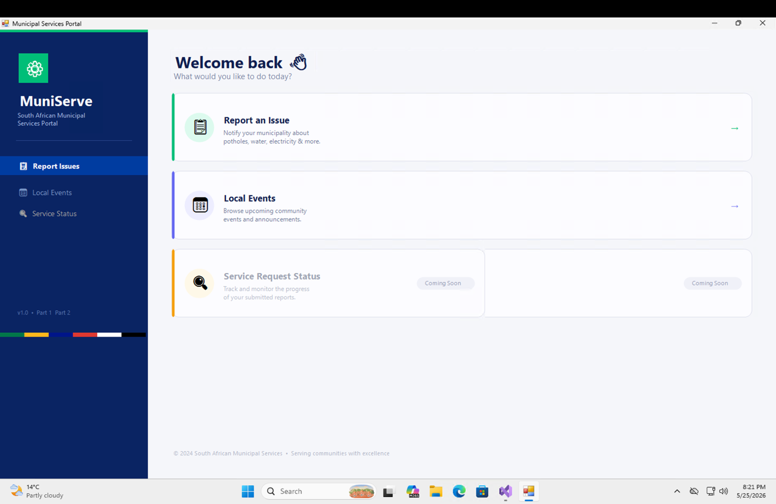
Figure 1 – Main Menu with Report Issues and Local Events & Announcements active

6.2 Local Events & Announcements Page
Click the Local Events & Announcements card to open the events page. The form loads with all 15 pre-seeded South African municipal events displayed in date order.
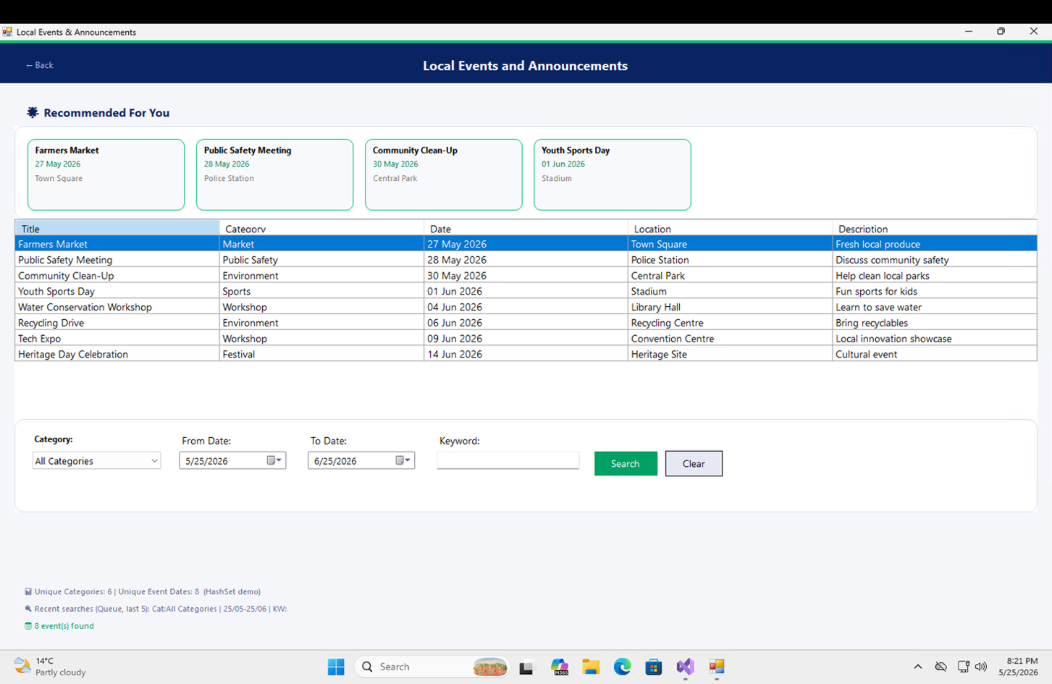
Figure 2 – Local Events & Announcements page showing all events on load

6.3 Urgent Events Banner (Priority Queue)
At the top of the events page, a green banner displays the highest-priority event surfaced by the min-heap Priority Queue. Priority 1 events (marked Urgent) always appear here first.
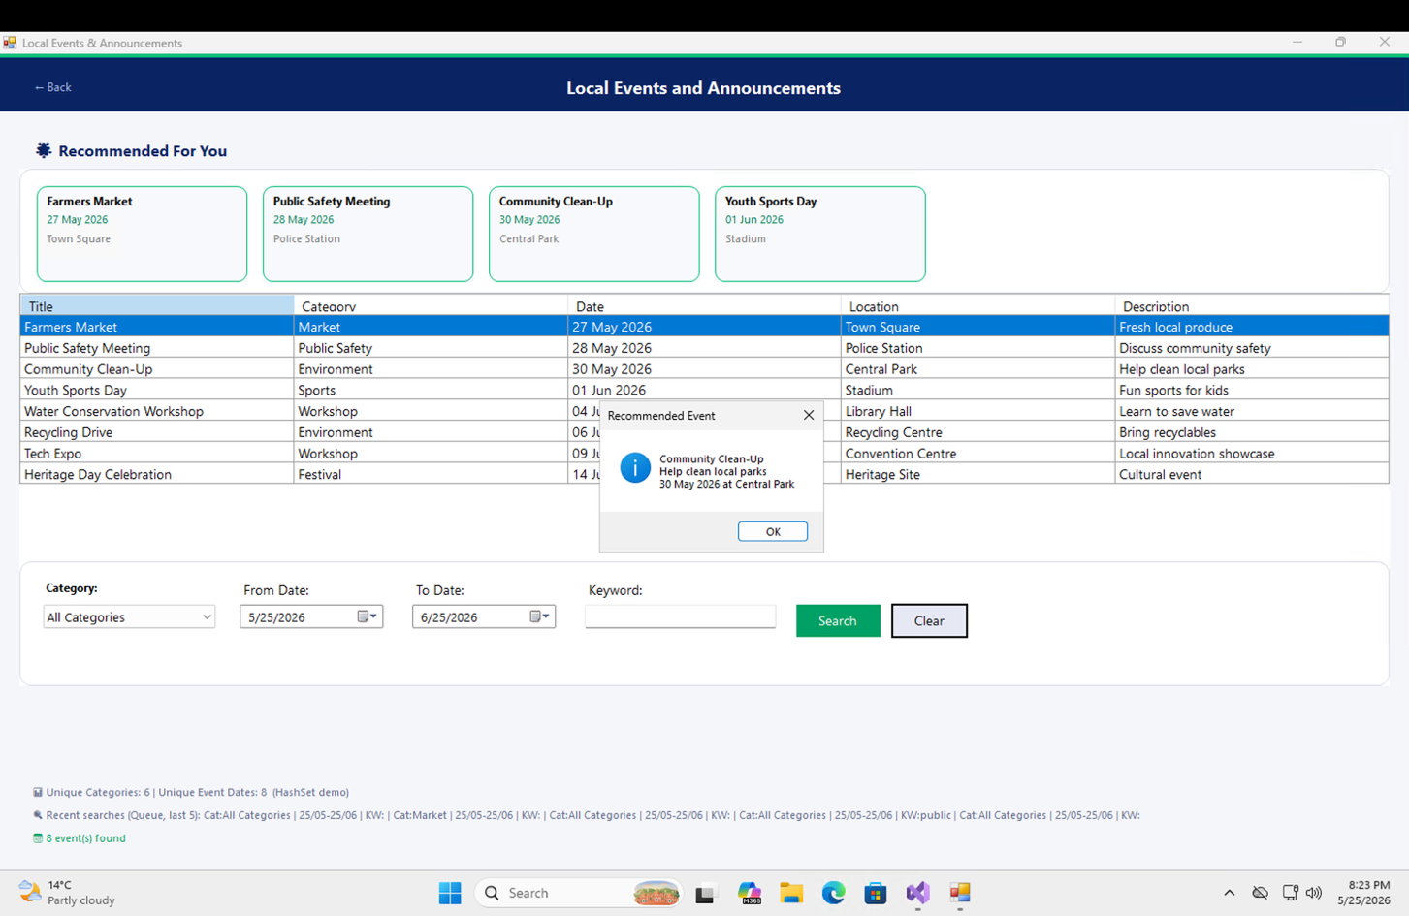
Figure 3 – Urgent Events banner driven by the Priority Queue data structure

6.4 Search Functionality
Use the search bar to filter events by keyword, category dropdown, or specific date. The search uses a SortedDictionary for date lookups and a Dictionary for category lookups, both providing fast O(log n) and O(1) performance respectively.
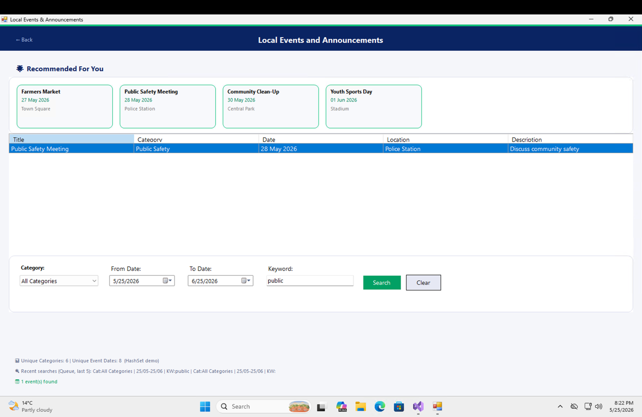
Figure 4 – Search results filtered by keyword / category / date

6.5 Category Dropdown (HashSet + Dictionary)
The category dropdown is populated from a HashSet of unique category names. Selecting a category filters events using a Dictionary lookup for instant results.
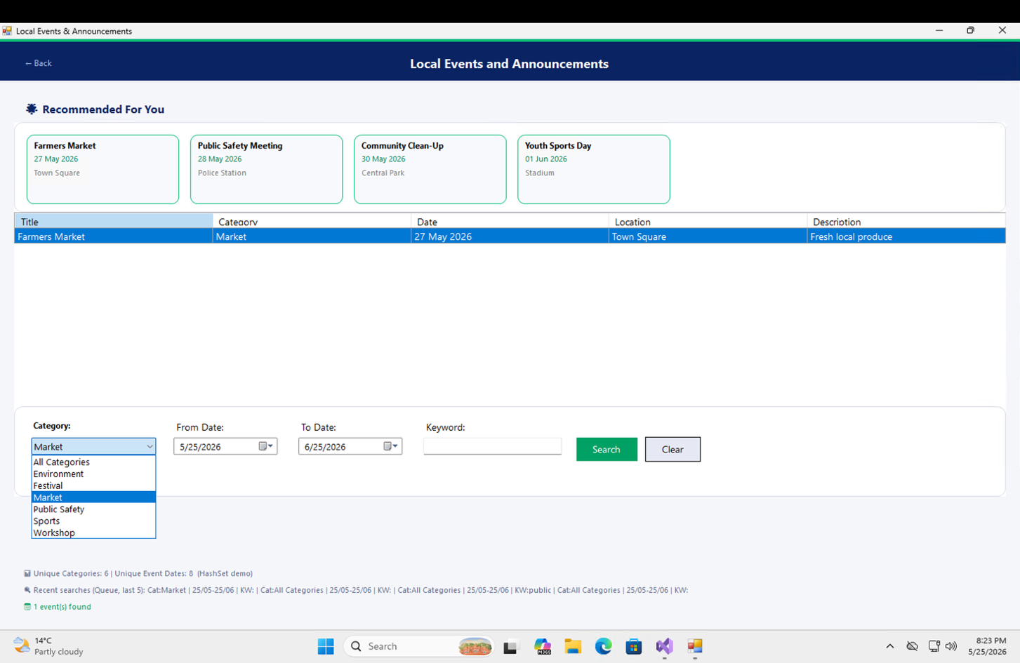
Figure 5 – Category dropdown populated from the HashSet of unique categories

6.6 Live Statistics Panel
A statistics row below the search bar shows live counts: total events (from the repository), unique categories (HashSet size), unique dates (HashSet size), and number of searches made (hash table key count).
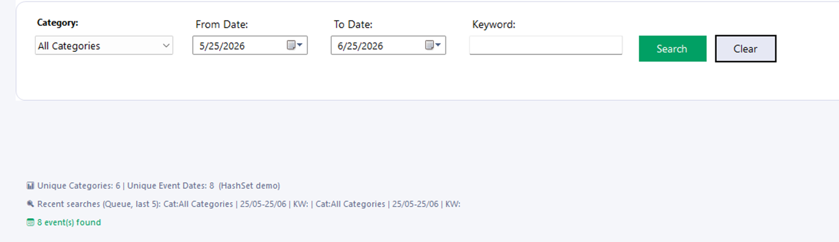
Figure 6 – Live statistics panel displaying data structure sizes

6.7 Report Issues (Part 1 — Unchanged)
The Report Issues feature from Part 1 remains fully functional. Clicking Report Issues on the main menu opens the reporting form with all original functionality.
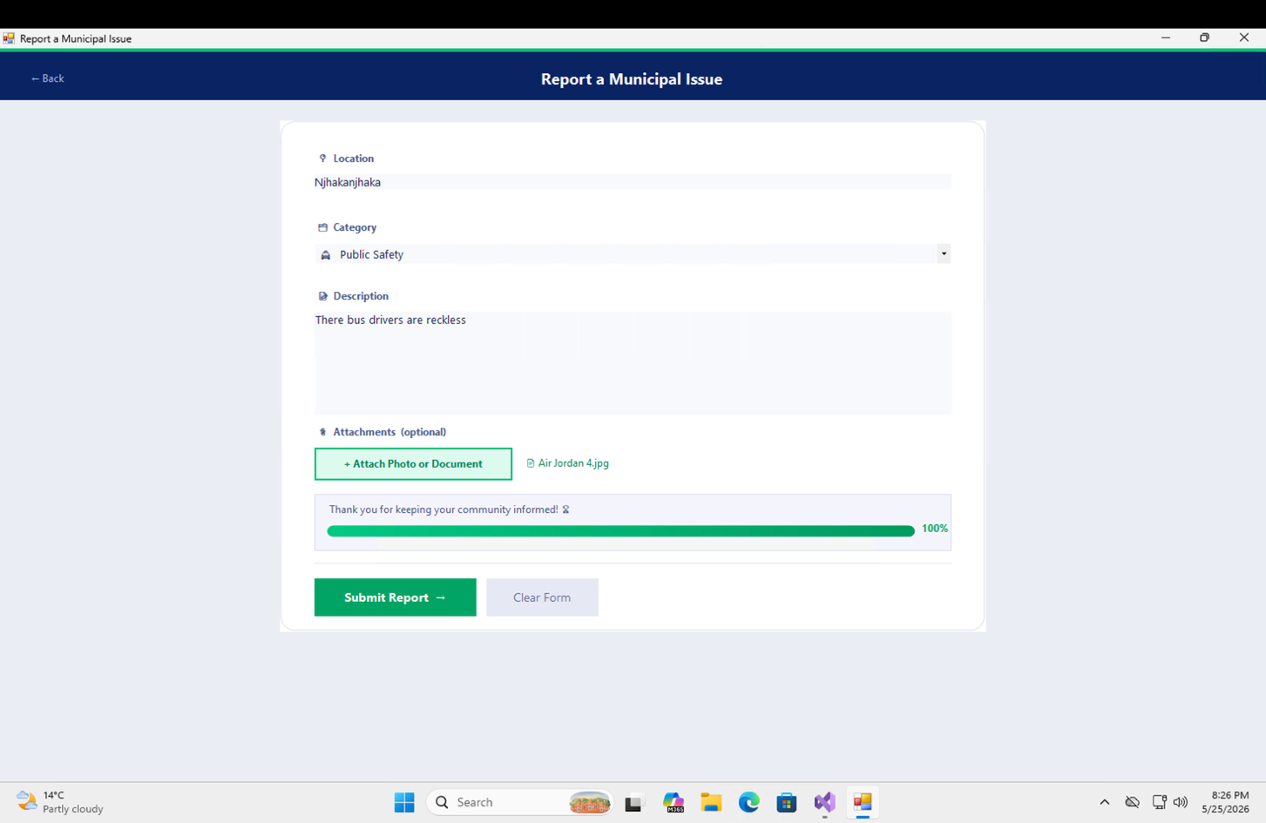
Figure 7 – Report Issues form (Part 1) still fully functional in Part 2

8. Troubleshooting
Problem | Solution
Build fails with 'partial modifier' error | Delete any auto-generated LocalEventsForm.Designer.cs file Visual Studio may have created
'net48' not found | Right-click project → Edit Project File → set <TargetFramework>net48</TargetFramework>
Application won't start | Ensure .NET Framework 4.8 is installed on the machine
File locked on rebuild | Close the running .exe first (Shift+F5 in VS), then rebuild
Local Events button still greyed out | Ensure you are using the updated MainMenuForm.cs from Part 2
No events showing | Check that EventRepository.cs and MunicipalEvent.cs are both included in the project

AAPD7112 Portfolio of Evidence – Part 2 • MuniServe Municipal Services Application • 2024

