CS 255 System Design Document
Jaden Gordon

UML Diagrams

UML Use Case Diagram

UML Activity Diagrams
Two activity diagrams are included, one for the Create Reservation use case and one for the Register Account use case. Each diagram shows the sequence of actions, decision points, and control flow required to complete the activity.
Activity Diagram 1: Create Reservation
The Create Reservation activity begins when a logged-in Customer selects the option to book a driving lesson. The system displays available dates and times, the Customer selects a preferred slot, and the system checks driver and car availability before assigning both to the reservation. If either resource is unavailable, the Customer is returned to the selection step. Once both resources are confirmed, the reservation is saved to the database and a confirmation is sent to the Customer.
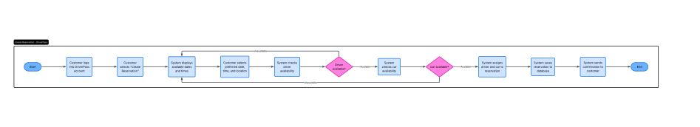
Activity Diagram 2: Register Account
The Register Account activity begins when a new Customer visits the DriverPass website and selects the registration option. The Customer enters personal information and selects a service package, and the system validates the input and checks for duplicate email addresses. If either check fails, the form is redisplayed with an error message. Once all information is validated, the system creates the account, sends a confirmation email, and activates the account after the Customer confirms.

UML Sequence Diagram
The sequence diagram details the Create Reservation use case by showing the time-ordered interactions between the Customer actor and the internal system objects. The Customer initiates the process through the Web Interface, which authenticates the Customer against the Database and then delegates reservation logic to the Reservation Controller. The controller verifies availability against the Driver and Car objects before persisting the reservation to the Database. Each message is returned up the chain until the confirmation reaches the Customer.

UML Class Diagram
The class diagram represents the structural components of the DriverPass system. A base User class holds shared authentication attributes, and the Customer, Secretary, Owner, and IT Officer classes inherit from it. The Reservation class is central to the scheduling workflow and associates with Customer, Driver, and Car. Supporting classes include Package, PracticeTest, TestAttempt, and ActivityLog, each capturing a distinc2t data concern identified in the business requirements document.

Technical Requirements

The following technical requirements specify the hardware, software, tools, and infrastructure needed to support the DriverPass system design. These requirements are derived from the functional and nonfunctional requirements documented in the business requirements document and from the needs expressed by Liam and Ian in the DriverPass interview transcript.

Hardware

DriverPass will operate as a cloud-hosted web application, which shifts the primary hardware burden to the cloud provider rather than to DriverPass directly.

Cloud-hosted application servers sized to handle concurrent Customer, Secretary, Owner, and IT Officer sessions

Cloud-hosted database servers with redundant storage for reservation, customer, test, and activity log data

Load balancer to distribute traffic across application instances

Firewall and network security appliances to protect the production environment

Client-side devices including desktops, laptops, tablets, and smartphones, since the system must be accessible from any device with internet connectivity

Software

Web application framework capable of serving a responsive interface across desktop and mobile browsers

Relational database management system to store all system data

Authentication and authorization module supporting role-based access for Customer, Secretary, IT Officer, and Owner

Encryption libraries implementing SSL or TLS for all data in transit

Server-side runtime environment compatible with the selected framework

Email service integration for account confirmation, password reset, and reservation confirmation messages

Tools

Version control system for source code management

Continuous integration and deployment pipeline for automated build, test, and release

Issue tracking platform for development tasks and bug reports

CASE tools such as Lucidchart for ongoing UML documentation

Logging and monitoring tools for system events, performance metrics, and security incidents

Automated testing frameworks for unit, integration, and end-to-end validation

Infrastructure

Cloud hosting platform with elastic scalability for variable user load

HTTPS enforced for all client connections

Daily automated backups with encrypted offsite storage for disaster recovery

DMV integration endpoint to receive updates on driving rules, policies, and sample test questions

Activity logging that records reservation transactions, account actions, and administrative operations to support the printable activity reports required by the Owner

Uptime monitoring with alerting to ensure availability during operating hours

