DSTI / MACHINE LEARNING WITH PYTHON

Predicting Goodreads Ratings
  - An end-to-end machine learning pipeline from raw book data to a deployed prediction service.

PROJECT REPORT | Academic Year 2026
Prepared by
Mayssem SAAD / Veronica CASTILLO / Hugo MAHIOU / Elias EL FERKH
Supervisor: Hanna Abi Akl
DATA SCIENCE TECH INSTITUTE / PARIS, FRANCE

Contents

SECTION | PAGE
Introduction | 1
1. Methodology | 1
1.1 Dataset, exploration and cleaning | 1
1.2 Feature engineering | 2
1.3 Candidate models | 3
1.4 Split and evaluation protocol | 3
1.5 Parameter tuning and final fit | 4
2. Results | 4
2.1 Model comparison and best performance | 4
2.2 Feature impact analysis | 5
2.3 Extended dataset training | 6
3. Deployment | 7
3.1 Application architecture | 7
3.2 Prediction interface | 7
Conclusion | 8

Introduction

In this group project, we built an end-to-end machine learning pipeline to predict a book's average rating from metadata and reader-engagement information. The initial Goodreads dataset contained 11,128 rows. An extended dataset from the same platform was then used to refit the selected model on 444,075 leakage-controlled training rows and measure the change in predictive accuracy.
The prediction target, average_rating, is continuous on a 0-5 scale, making this a supervised regression problem. The eight raw model inputs are title, authors, language_code, num_pages, ratings_count, text_reviews_count, publication_date, and publisher. Identifiers such as ISBN and bookID were not used as predictive features.
The full machine learning pipeline was built on a jupyter notebook, the best model from our analysis was then exported (with cloudpickle) and loaded into a web-app to be tested through a user interface. The deployed interface is shown in the BookWise demo video. Figure 1 summarizes this sequence, including model export and deployment.

1. Methodology
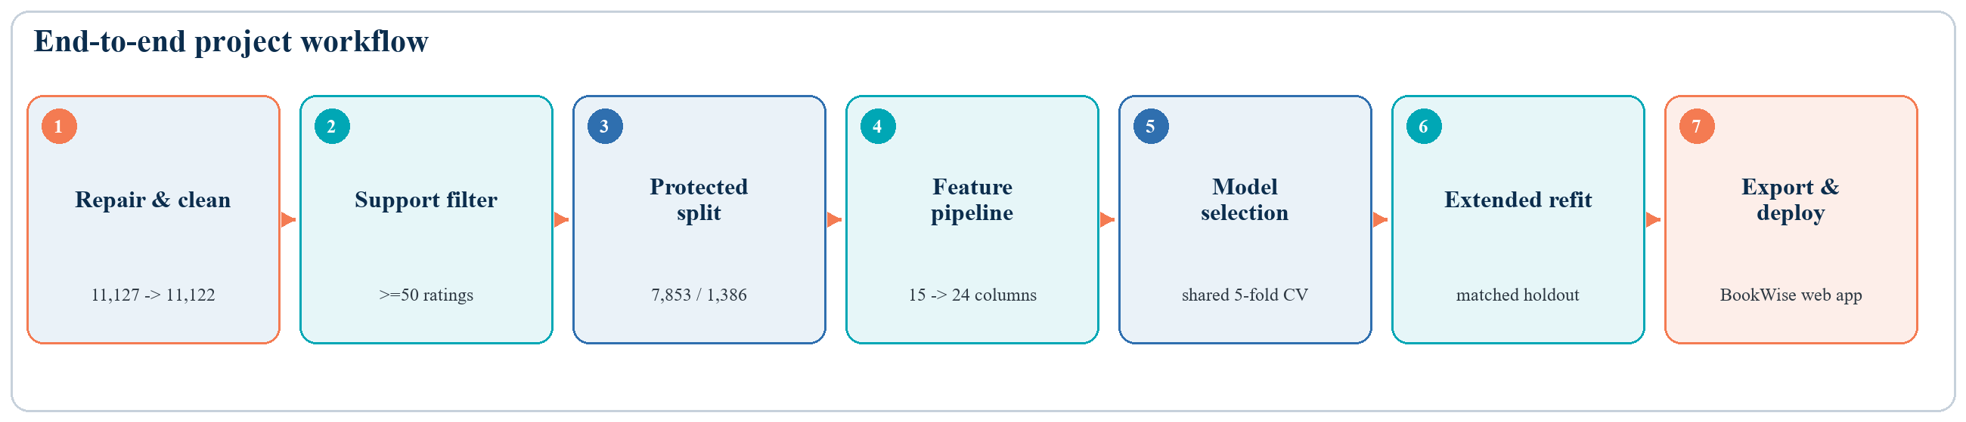
Figure 1. End-to-end workflow from repaired data to the deployed BookWise application.

1.1 Dataset, exploration and cleaning

The provided dataset contained 4 malformed rows which were repaired manually before being loaded into the notebook for exploration. Visual inspection then showed further issues: leading/trailing/inline whitespaces inconsistencies, impossible publication dates, books with zero ratings, zero pages, authors missing with ‘NOT A BOOK’ value etc. No true duplicates were found (ISBN all uniques).
A cleaning process was developed to standardize the string values (dealing with whitespaces, normalizing to lowercase) before diving into data analysis.

Target analysis
Main takeway: Average ratings are concentrated: the modelling population has a mean of 3.93, a median of 3.96, and a middle 90% from 3.44 to 4.38. This fact is already an issue for machine learning: the dataset contains almost no low to very low rated books. Any machine learning applied to this dataset will then struggle predicting low rated and very high rated books.
More importantly, ratings based on very few readers are much less stable. The rating standard deviation is 0.526 for books with 1-9 ratings and falls to 0.281 in the 50-99 band. We therefore made a decision to require at least 50 ratings for any model to learn from, in order to avoid volatile ratings. This decision removes 1,883 rows from the dataset but gives a more reliable target for this modelling exercise.
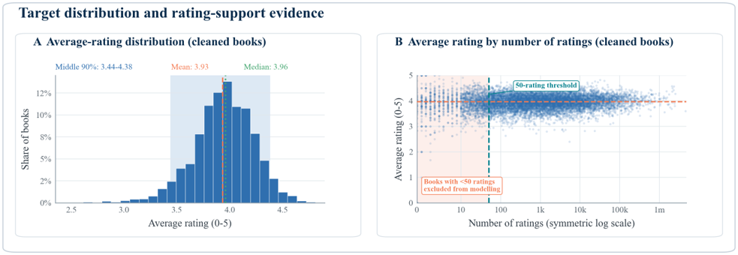
Figure 2. Target distribution and rating-support evidence. The shaded area contains books excluded from modelling, and the vertical line marks the 50-rating threshold.

Attributes analysis
Each attribute was inspected thoroughly in order to better understand the data and find weak spots, useful patterns, and feature ideas.
- ratings_count: a few books with zero rating (and sometimes with a positive average_rating) were found and excluded from the dataset. After comparing rating stability across support bands, we excluded books with fewer than 50 ratings.
- text_reviews_count: strongly right-skewed, a log scale was used to smooth that effect. Books with zero text reviews are kept (assuming they have more than 50 ratings). An additional text_reviews_count to ratings_count ratio was derived as a feature.
- publication_date: ranges from 1900 to 2016, with very few books in the 1900-1950 range. For feature engineering, only the year is kept.
- num_pages: several books with zero pages were found, most were identified as audiobooks through the publisher name or the title but some were not. This clue allowed us to define a pattern to identify audiobooks in the dataset. We decided to keep the zero-page entries with a num_pages_missing flag.
- language_code: more than 90% of books in the dataset are English books (including US-GB-CCA variant). Several languages have very low representation. We decided to apply a threshold of 20 books for a language to be kept in the feature engineering and one-hot encoded, the rest is folded into an “other” category.
- authors: this attribute seems to list not only authors, but all the contributors to the book (some books have more than 50 “authors”). In order to simplify, we decided to keep only the first listed author (first_author), which appears to be the main author of the book, as well as the number of listed authors. There are too many unique first_author (high cardinality) to realistically one-hot encode this feature, but since this attribute is likely the main driver for the average_rating, we decided to implement a safe target encoding during the modelling phase, i.e., mapping first_author to a cross-fitted mean average_rating across the learning dataset. We also computed the average_rating standard deviation and frequency of that author within the learning dataset as a feature.
- title: the dataset contains duplicate titles, but each with a unique ISBN, they vary only by publication date, language, publisher or contributors (“authors”). Multiple patterns can be identified in the titles, such as audio books, books that are part of a series or books that are not single books but a collection box. These patterns have been used to define new features (is_audio, is_collection, is_series). There are too many different titles to one-hot encode this attribute, but we can easily derive numerical features like number of characters or number of words. This seems counterintuitive as an average_rating signal but it can carry some information (related to genre, etc.).
- publisher: the number of unique publishers again prohibits the one-hot encoding method, but this attribute is the main driver for audio-books identification. Similar to authors, we decided to apply a safe target & frequency encoding during modelling.

Attributes correlation with average_rating
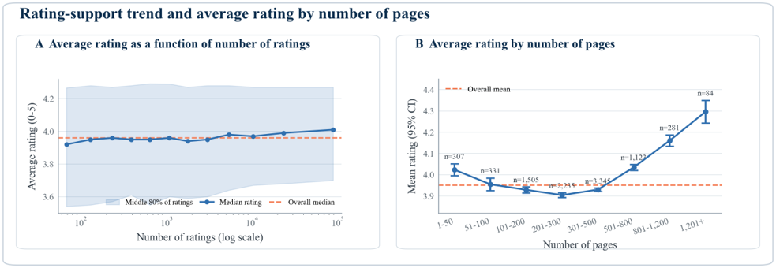
Figure 3. Rating-support trend and average rating by number of pages. The left panel shows the median and middle 80%; the right panel shows means, 95% confidence intervals, and band sample sizes.
None of the numerical features have a strong linear correlation with average_ratings. The right panel of Figure 3 shows that the page-count relationship is non-linear: mean ratings are similar through the central bands, then rise above 500 pages. The longest bands contain fewer books and include multi-volume collections, so this is an association rather than evidence that length causes higher ratings. Together with Figure 2, this supported using tree-based models and we expect that author identity would carry much of the useful signal.

1.2 Feature engineering
From the eight raw fields, a deterministic feature builder converts them into 15 feature groups. This stage also normalizes text, parses dates and numbers, and creates signals that match the data issues seen during exploration. The 15 engineered groups become 24 processed columns: 12 numeric values, six author/publisher statistics, and six language indicators. Keeping the feature builder inside the exported pipeline lets the web-app send the same eight raw fields used during training. The complete lineage is shown in Figure 4.

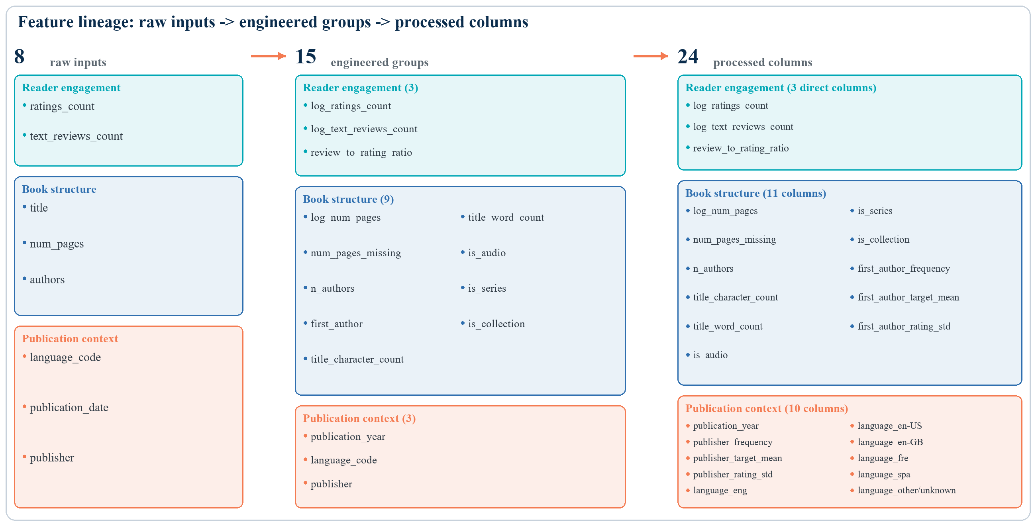
Figure 4. Feature lineage from eight raw inputs to 15 engineered groups and 24 processed columns. Colors indicate reader engagement, book structure, and publication context.

Leakage control: Feature construction is stored in the pipeline, while imputation and all learned encoders are fitted only on the current training data or training fold. Figure 5 shows this fold-fitted sequence.
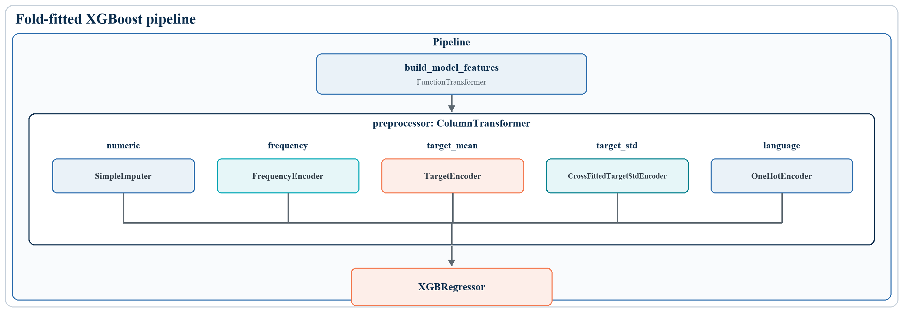
Figure 5. Fold-fitted XGBoost pipeline. Learned preprocessing remains inside each training fold.

1.3 Candidate models
Three regression algorithms were selected for evaluation. They were chosen to represent complementary modelling approaches, ranging from a simple linear model to advanced gradient boosting methods. Their complementary roles are summarized in Table 1.
Table 1. Candidate regression models and their role in the comparison.
Model | Role in the comparison
Lasso | Interpretable linear benchmark with regularization
XGBoost | Non-linear boosted trees on the engineered and encoded columns
CatBoost | Boosted trees using normalized categorical identities directly
Mean baseline | Same mean prediction for every book
Lasso is a regularized linear reference and shows whether mainly additive relationships are enough. XGBoost can learn non-linear relationships and interactions between numeric and encoded features. CatBoost offers a second boosted-tree approach with native handling of categories. A mean-rating dummy regressor provides the minimum baseline that a useful model should beat.
NB: None of the numerical attributes show a strong correlation with average_rating, not even reader engagement attributes (ratings_count or text_reviews_count). We can intuitively hypothesize that the strongest signal relies in the “author” attribute

1.4 Split, 5-fold Cross-Validation and evaluation protocol

The 9,239 remaining books (after cleaning & filtering) were split before any encoder, imputer, scaler, or estimator was fitted. We used a fixed 85%/15% train–test split (7,853 training and 1,386 test books). Quantile bands (10) of the target were used to stratify the split. The test set was held out for a single final evaluation, while all model selection and hyperparameter tuning were performed exclusively on the training set. The split preserved the rating distribution, ensuring that the test set remained representative Table 2 confirms that the target distribution remained balanced across the two subsets.
Table 2. Balance of the training and holdout sets after target-decile stratification.
Split | Rows | Mean | Median | Std.
Training | 7,853 | 3.951 | 3.96 | 0.268
Holdout | 1,386 | 3.952 | 3.96 | 0.265

NB: num_pages, ratings_count and text_reviews_count also have close enough median values between train and test dataset.
Within the training data, a shuffled five-fold splitter with random_state=42 was reused for every model. Each pipeline was fitted five times; four folds supplied training data and the remaining fold supplied validation data, with the average score providing a robust estimate of generalization performance. Because preprocessing is part of the pipeline, encoders are refitted inside each fold and cannot learn from that fold's validation ratings. Using the same folds for all candidates makes their scores directly comparable.
To evaluate and compare the three models, we used Mean Absolute Error (MAE) as the main selection measure because it is easy to interpret in rating points: an MAE of 0.16 means an average absolute miss of about 0.16 on the 0-5 scale. Root Mean Squared Error (RMSE) gives more weight to large misses. R² compares the model with a simple model that always predicts the mean rating: R² = 0 means no improvement over that mean prediction, while a higher positive value means that more of the variation between book ratings is explained.
In order to compare the 3 models based on their best performances, we implemented a hyperparameter tuning process to define the best parameters for each model given the 5-fold Cross-validation and random_state.

1.5 Parameter tuning and final fit
After establishing the common pipelines, we ran a randomized search over 24 parameter combinations for each candidate. The search reused the same five folds and MAE selection rule. Lasso varied its regularization strength. XGBoost varied the number and depth of trees, learning rate, minimum child weight, row and column sampling, and L2 regularization. CatBoost varied iterations, depth, learning rate, L2 leaf regularization, and random strength. Figure 6 shows the validation MAE and uncertainty for all search rounds.
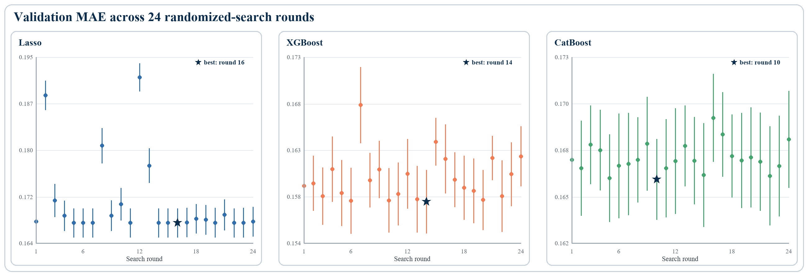
Figure 6. Validation MAE across 24 randomized-search rounds for each candidate model.

The winning model is XGBoost with the following settings (Table 3).
Table 3. Selected XGBoost hyperparameters and their interpretation.
Selected XGBoost setting | Value | Interpretation
Trees / learning rate | 200 / 0.0349 | Many small boosting steps
Maximum depth | 7 | Allows non-linear interactions
Minimum child weight | 5 | Limits very small leaf splits
Row / column sampling | 0.9 / 1.0 | Uses most rows and all columns per tree
L2 regularization | 0.141 | Mild weight penalty

We then refitted its complete pipeline on all 7,853 training rows and evaluated the remaining 1,386-book holdout to obtain the final evaluation. The next section reports that comparison and the later extended-data experiment.

2. Results

2.1 Model comparison and best performance

Five-fold cross-validation evaluation
XGBoost achieved the lowest five-fold MAE and also led on RMSE and R². Its mean MAE was 0.1577, compared with 0.1659 for CatBoost, 0.1673 for Lasso, and 0.2099 for the mean baseline. The fold standard deviation was only 0.0031, so the result was stable across the shared validation folds (Figure 7).
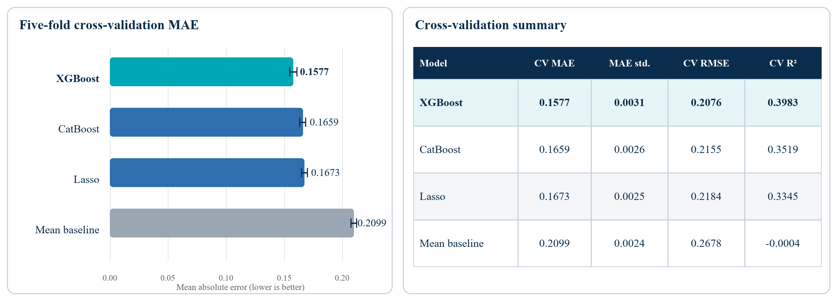
Figure 7. Five-fold cross-validation comparison. XGBoost achieved the lowest average validation error.

Finale evaluation
Initial holdout performance (Figure 8): MAE 0.1528 | RMSE 0.2018 | R² 0.4205.
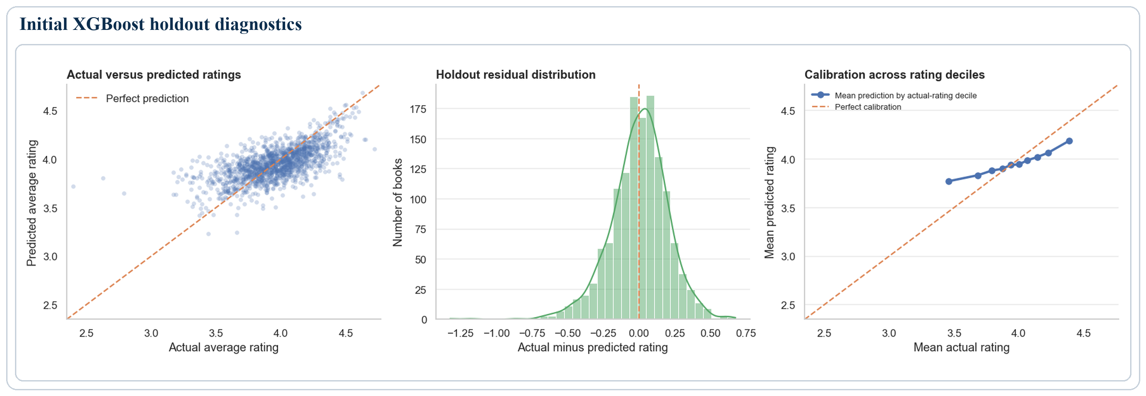
Figure 8. Initial XGBoost holdout diagnostics: actual versus predicted ratings, residuals, and calibration by decile.
Figure 8 shows residuals centered close to zero and predictions that generally follow the actual ratings. The calibration panel nevertheless reveals regression toward the mean: low ratings are predicted too high and high ratings too low. The overall MAE therefore hides weaker performance at the edges of the scale.

2.2 Feature impact analysis
Feature importance was extracted from the fitted final XGBoost pipeline using its gain-based importance scores. These scores measure how much splits involving each encoded input reduced the model’s training objective across the ensemble. To make the results interpretable, the importances of the frequency, target-mean, and target-standard-deviation encodings for author and publisher were summed back to their original features, as were the one-hot language indicators. The resulting values were normalized and ranked, showing which engineered features contributed most to the model’s decision rules. The grouped ranking is shown in Figure 9.
As hypothesized, first_author is the strongest feature in Figure 9. Language and publisher form the next most important group, while page information, title structure, and reader-engagement features provide smaller complementary contributions.
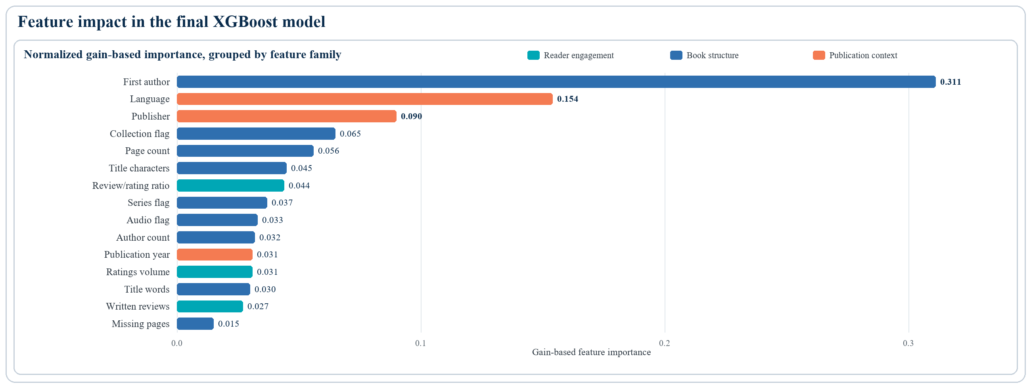
Figure 9. Gain-based importance of the engineered features in the final XGBoost model.

2.3 Extended dataset training
The extended Goodreads dataset comes from the UCSD Goodreads release described by Wan and McAuley and used in later work on large-scale Goodreads reviews [1, 2].
The dataset was collected in late 2017, so not far away from the initial dataset It contains 2,360,655 books, however once cleaned and filtering out books with fewer than 50 ratings, the dataset is reduced to 443,951 books.
The average rating is centered in a similar region to the original modelling data, but the extended population reaches closer to both ends of the scale. Figure 10 also shows lower typical reader support and a major completeness difference: 63.9% of extended rows have no language code. These differences broaden coverage while testing whether the same preprocessing can handle more missing and rare values.
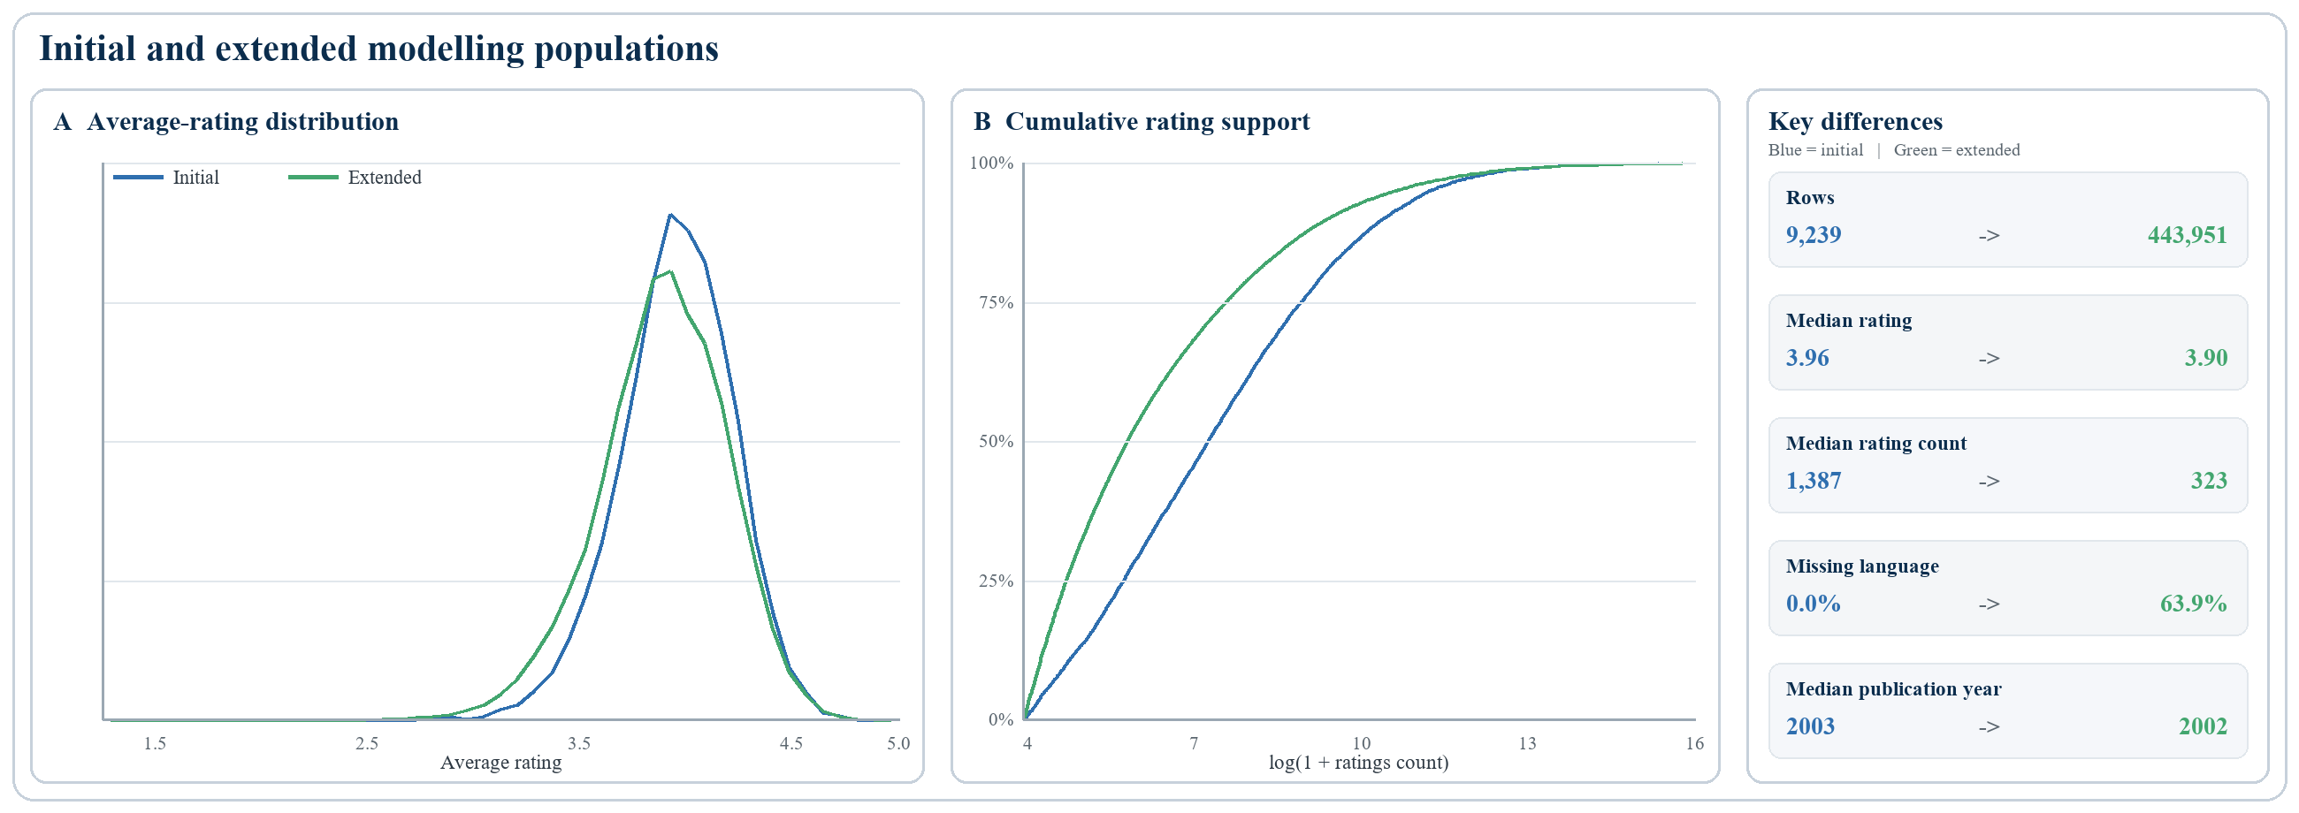
Figure 10. Comparison of the initial and extended modelling populations.
This extended Goodreads source is used to broaden the training population and test whether additional coverage improves the selected model. The comparison keeps the original holdout unchanged: no original test ISBN is allowed into the larger training set, and both fitted models are evaluated on exactly the same test rows. ISBN-10 values identified 7,618 overlaps between the two sources. We removed 1,260 extended rows linked to protected test ISBNs, then added 1,384 original-training rows not present in the extended source. The final training population contained 444,075 rows. We did not run a second model tuning on this training set, the same selected XGBoost configuration was refitted and evaluated on exactly the same 1,386 test books. The construction and matched metric changes are summarized in Figure 11.

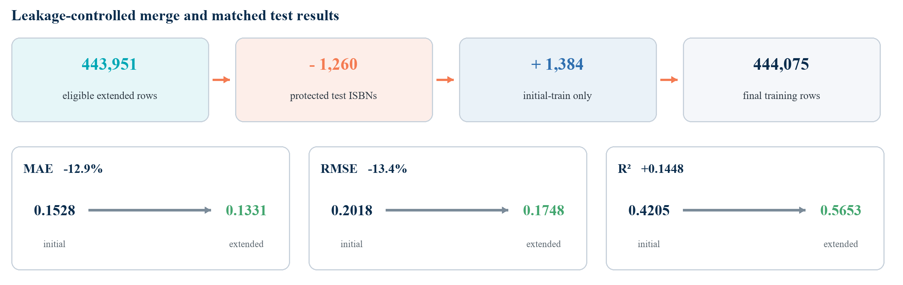
Figure 11. Leakage-controlled extended training-set construction and matched holdout improvement.
The broader fit lowered MAE from 0.1528 to 0.1331 and RMSE from 0.2018 to 0.1748, while R² rose from 0.4205 to 0.5653 (Figure 11). Its calibration moved closer to the ideal line, especially for the lowest rating groups, although both models still pull extreme ratings toward the centre (Figure 12).

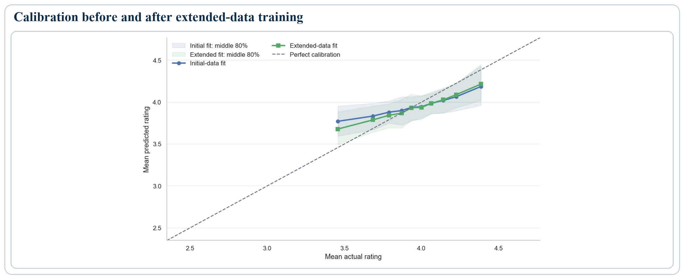
Figure 12. Calibration and prediction spread before and after extended-data training.

3. Deployment
To turn the selected model into a usable product, the trained pipeline is exported as a self-contained scikit-learn Pipeline serialised with cloudpickle. The artefact bundles every stage needed at inference: the feature-engineering transformer that converts a raw book row into model-ready inputs, the train-fitted encoders (frequency, target-mean and target-standard-deviation statistics for author and publisher, plus the language one-hot encoder) and the fitted XGBoost estimator. Because these transforms are carried inside the pipeline, the eight raw fields the user provides flow through the exact same steps used in training. The deployed artefact is the model retrained on the extended Goodreads dataset, which reaches the lowest holdout error (MAE 0.133, R² 0.57). Predictions are finally clipped to the valid [0,5] range by the model service before they are returned.
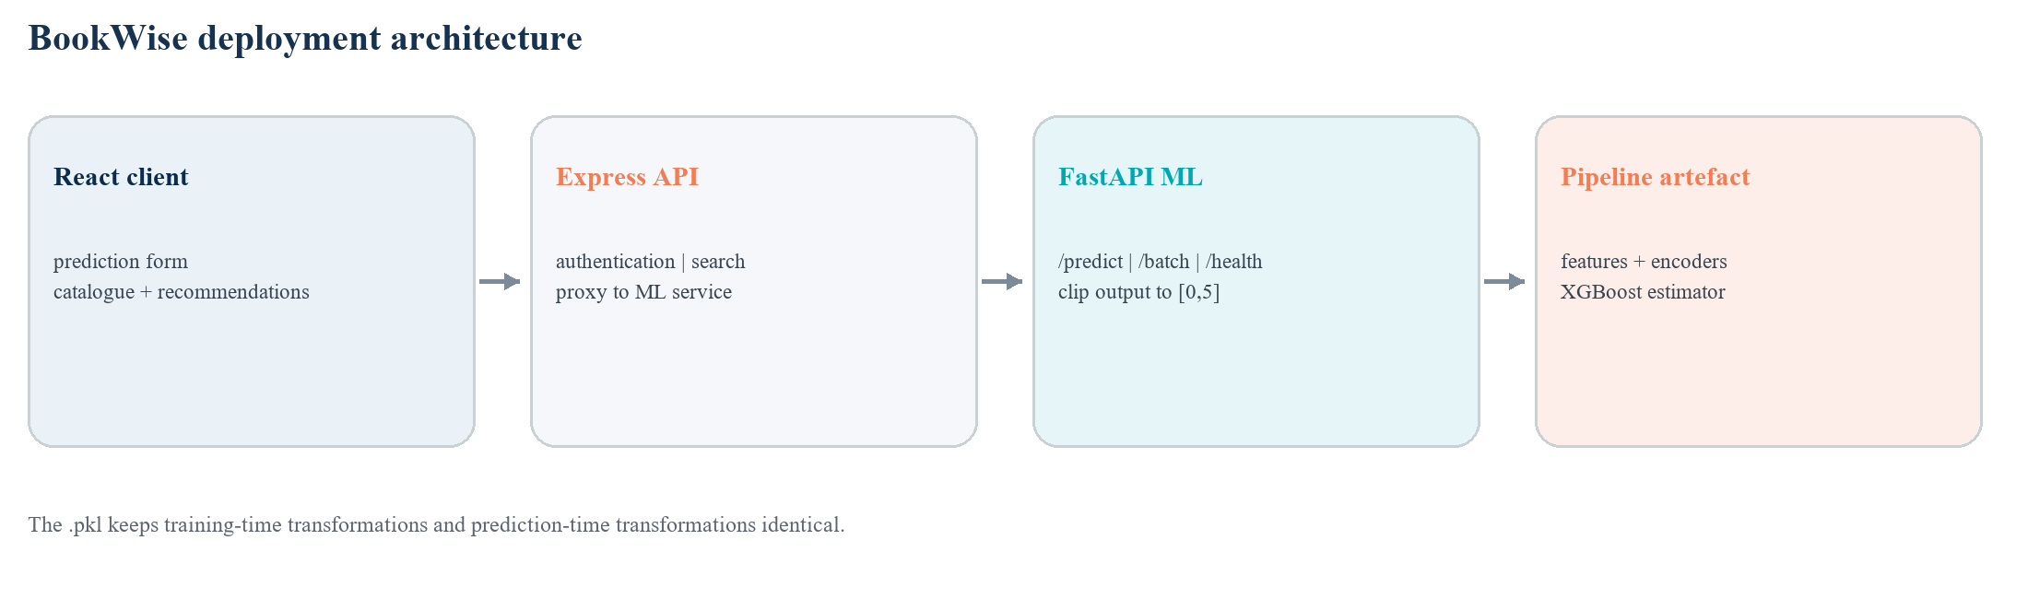
Figure 13. Deployment flow from the BookWise client to the exported prediction pipeline.

3.1 Application architecture
Around this predictor we built BookWise, a three-tier web application (Table 4). Separating the model service from the API and interface keeps the machine-learning code isolated and independently deployable.
Table 4. BookWise application stack.
Tier | Role and technology
ML service | Python FastAPI microservice that loads the .pkl and exposes /predict, /predict/batch and /health. It also applies the final [0,5] clipping to every returned rating.
API server | Node + TypeScript (Express, Prisma, SQLite): JWT authentication, book catalogue (≈ 11,100 seeded books), search, recommendations, and a proxy to the prediction service.
Web client | React + TypeScript (Vite, Tailwind): home page, prediction form, sign-up/log-in, filterable catalogue, and personalised recommendations.

3.2 Prediction interface
On the prediction page the user fills in a book's attributes, or loads a sample, and receives the estimated 0-5 rating as both a numeric score and a star gauge (Figure 14). Because the same transformations run at inference time, a book submitted through the form is processed exactly as it was during training.
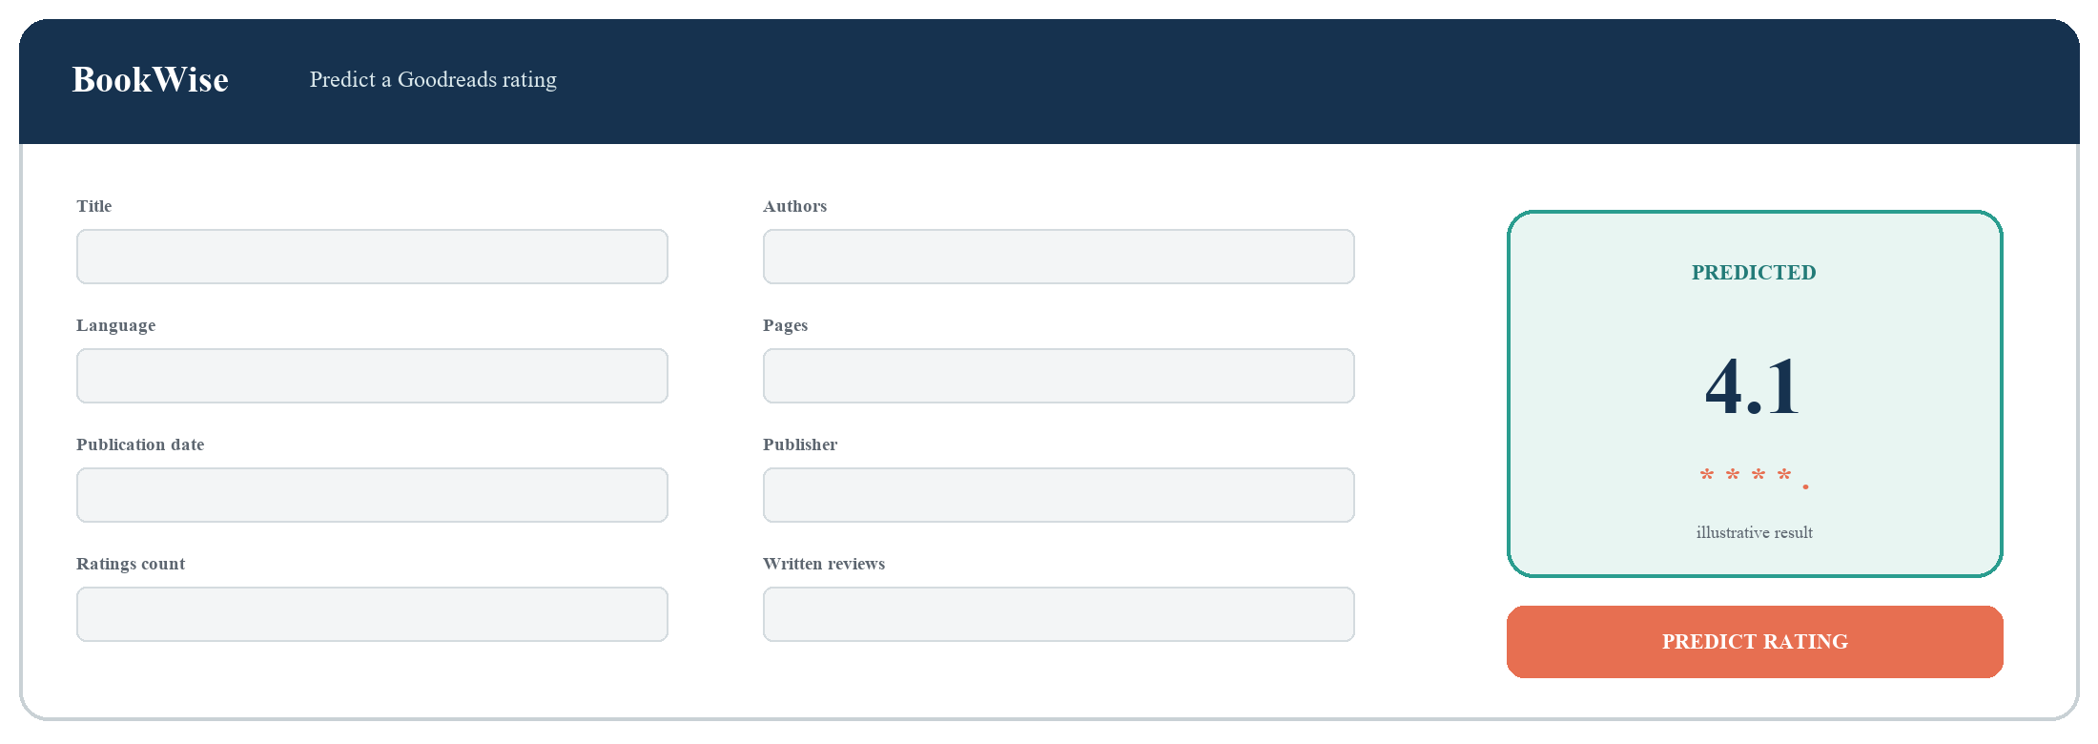
Figure 14. BookWise prediction form and returned rating. The displayed value is illustrative.

Conclusion
This project set out to predict a book's average rating from its descriptive metadata and early reader engagement, and showed that this is achievable with a typical error of about 0.15 rating points (MAE) on the initial modelling data - roughly a 26% improvement over simply predicting the dataset average. Retraining the selected XGBoost pipeline on a much larger, leakage-controlled Goodreads dataset lowered this error further to about 0.13 MAE (R² ≈ 0.57), and this extended-data model is the one packaged and deployed.
Table 5. Final XGBoost performance on the same original holdout set (n = 1,386).
Training fit | Training rows | MAE | RMSE | R²
Initial XGBoost | 7,853 | 0.1528 | 0.2018 | 0.4205
Extended XGBoost (deployed) | 444,075 | 0.1331 | 0.1748 | 0.5653
Change | +436,222 | -12.9% | -13.4% | +0.1448

The strongest signals are historical author and publisher rating levels, learned in a leakage-safe way from the training data only. Crucially, the gains come mainly from a handful of engineered features rather than from the choice of algorithm: the leading tree ensembles differ by only a few thousandths of a rating point. This shows that careful, EDA-driven feature engineering - not model selection alone - drove performance. The best model was packaged into a reproducible predictor and served through the BookWise web application, closing the loop from raw data to a usable tool.

Limitations and future work
The model's main limitation comes from the data itself rather than from the algorithm. Almost every book has an average rating between about 3.6 and 4.3, with few examples outside this range. Because the model sees only a limited number of low- and high-rated books, it struggles at the extremes and tends to regress toward the mean. The extended population is only slightly heavier at the tails, confirming that extreme ratings are genuinely rare. XGBoost and CatBoost also achieved similar errors, which suggests that the available signal is a stronger bottleneck than the choice between the two tree-based methods.
One caveat qualifies the extended-data gain: the original test set was isolated from the enlarged training set at the ISBN level only. A single work can appear under several ISBNs, and Goodreads often assigns such editions the same average rating. The improvement from 0.15 to 0.13 MAE may therefore be optimistic; a work-level split keyed on title and first author would test how much of the gain reflects genuine generalisation.
Several directions could improve the system further:
- Enforce work-level train/test separation (title and first author) to rule out alternate-edition leakage.
- Add richer text features from titles and descriptions, together with genre and subject metadata.
- Calibrate predictions to reduce the flattening observed at the rating extremes.
- Collect more books with very low and very high ratings instead of only increasing dataset size.
- Test additional tuning and model stacking after stronger validation is in place.
- Expose the existing batch endpoint in BookWise so several books can be uploaded and scored from a CSV file.
Taken together, these improvements would sharpen prediction accuracy at the rating extremes and broaden the practical usefulness of the system while preserving the leakage-safe, reproducible pipeline that supports the current results.

References
[1] M. Wan and J. McAuley, "Item Recommendation on Monotonic Behavior Chains," Proceedings of RecSys, 2018.
[2] M. Wan, R. Misra, N. Nakashole, and J. McAuley, "Fine-Grained Spoiler Detection from Large-Scale Review Corpora," Proceedings of ACL, 2019.

