Heuristic-ML hybrid architecture assistive system for human-computer interaction based on facial landmarks for people with reduced mobility

1st Maycol Acuña DiazFaculty of Sciences and EngineeringUniversity of Sciences and HumanitiesLima, Peru
https://orcid.org/0009-0005-2820-1319
line 1: 2nd Given Name Surnameline 2: dept. name of organization (of Affiliation)
line 3: name of organization (of Affiliation)
line 4: City, Countryline 5: email address or ORCID
line 1: 3rd Given Name Surnameline 2: dept. name of organization (of Affiliation)
line 3: name of organization (of Affiliation)
line 4: City, Countryline 5: email address or ORCID

Abstract— This article presents GIA, a multimodal, offline-first, and customizable assistive system for human-computer interaction aimed at people with reduced mobility. The proposal is based on a hybrid heuristic-ML architecture: a computer vision module obtains facial landmarks to estimate posture and facial states, from which cursor movement is derived and discrete gestures are recognized; while a voice module based on Whisper Small recognizes discrete commands for navigation, activation and contextual control. Above both inputs is a decision layer responsible for individual calibration, temporal filtering, disambiguation, and translation of signals into operating system events. The evaluated version uses a gesture scheme based on GRU and Logistic Regression temporal coding, reinforced with security rules to reduce involuntary activations. The motivation for the work is clear: significant disability affects about 1.3 billion people in the world, more than 2.5 billion require one or more assistive products, and the global demand for assistive technology will continue to grow over the coming decades. On this basis, the article argues that a local, low-cost, user-adaptable solution can improve autonomy, privacy, and continuity of use compared to unimodal or connectivity-dependent alternatives. In terms of contribution, GIA combines accessibility, customization and operational explainability in a single architecture, which makes it a pertinent proposal for home, educational and work scenarios.
Keywords— digital accessibility, multimodal interaction, facial landmarks, voice recognition, offline-first, reduced mobility

Introduction
The use of digital tools ceased to be a differentiating skill to become a transversal requirement in educational, labor and social spheres. The World Health Organization reports that around 1.3 billion people, approximately one in six globally, live with a significant disability [1]. In addition, assistive technology is no longer limited to conventional physical aids, but incorporates digital solutions such as voice recognition, assistive software, and accessible communication tools [2]. For this population, interacting with digital devices is decisive for accessing education, employment, communication and autonomy in daily life. Therefore, the design of accessible interfaces between person and computer is a priority line within research on inclusive technologies.
However, another WHO report revealed that more than 2.5 billion people require one or more assistive products, a figure that could increase to 3.5 billion by 2050 [2]. This need is crossed by a significant access gap. The WHO-UNICEF Global Report on Assistive Technology warns that global demand remains largely unmet and that in some low-income countries, access to required products can be as low as 3%, compared to 90% in some high-income countries [2], [3]. Consequently, for many people with reduced mobility, the barrier is not limited to not being able to use a keyboard or mouse; it implies being partially excluded from daily tasks such as writing, studying, surfing the internet, communicating or working independently.
Although scientific advances have made it possible to develop assistive interfaces, many current solutions still have limitations. Some rely on specialized hardware, which increases costs, and others require cloud processing, which can lead to higher latency, lower reliability in the face of unstable connections, and privacy risks associated with handling biometric and personal data. In addition, motor skills vary considerably between users, so generic control schemes may be ineffective for different motor disability profiles.
In this context, the study presents GIA, a local and multimodal assistant for computer interaction, built on a hybrid architecture that combines heuristic rules with machine learning. The proposal integrates interpretable rules and learning models to improve the robustness of recognition and adapt the behavior of the system to different users. The main objective is to develop a multimodal, local and configurable assistant for the control of essential computer functions through facial landmarks and voice commands. With this, it seeks to offer an accessible, customizable and low-cost solution that expands the digital autonomy of users with reduced mobility.

Literature review
Recent literature shows a growing interest in computer-assisted interaction. In alternative cursor control, an assistive controller based on head movements and facial contractions with low-cost sensors has been proposed, evaluated with the System Usability Scale [4]; this approach demonstrates the feasibility of hands-free control, but it usually relies on additional hardware and focuses almost exclusively on the pointer. In voice control, XULIA allows Windows to be operated only by spoken commands in people with quadriplegia [5], which shows the potential of voice as a primary modality, although being unimodal it is vulnerable to noise, vocal fatigue or contexts where speaking is not convenient.
From the multimodal perspective, the recognition of gestures accompanied by voice reached 97.3% accuracy for three gestures and 91.5% for eight [6], showing that combining modalities increases expressiveness and robustness. In inclusive home automation control with seven people with disabilities, the success of the recognition depended on both the model and the noise, intelligibility and synchronization of the audio [7], shifting the discussion towards realistic conditions of use. Sanvaad, on the other hand, combines MediaPipe landmarks – technology also used in this work – with live voice, with low computational load and without specialized hardware [8].
When contrasting these works, recurrent shortcomings are observed: dependence on a single input channel, scope limited to a specific task (moving the cursor, controlling home automation or mediating communication) and little attention to personalization, local execution and explainable behavior in the face of errors. GIA sits in that space by combining real-time facial detection and voice commands under a hybrid architecture that is interpretable and adjustable to the user's needs.

MATERIALS AND METHODS

Research Design
The study is part of applied development and seeks to build a system that allows people to interact with the computer, especially in scenarios of reduced mobility. To this end, an iterative prototyping model was adopted based on the design, implementation, evaluation and progressive improvement of each functional component. Unlike conventional solutions in which the user must adapt to predefined characteristics of the interface, the proposed system inverts this logic: the interaction parameters are adjusted to the motor skills of each person.
As a conceptual foundation, GIA separates the functions of perception from the functions of decision. Machine learning is used to extract and classify relevant patterns from visual and voice cues, while the interpretation of actions, the generation of decisions, and the production of control events are managed by heuristic rules and finite-state machines.
- Overall architecture of the proposed system
As can be seen in Fig. 1, the overall architecture of the system is structured in successive functional layers: multimodal data capture, perception by machine learning, heuristic processing, modality fusion, and execution of system commands.
In visual input, the webcam captures the user's face and extracts facial references used for cursor control and gesture recognition. At the same time, the microphone captures voice commands when the user activates the corresponding mode. The signals obtained are not directly translated into actions on the operating system; before they go through an interpretation and security layer that validates whether the input is stable, intentional, and consistent with the current state of the system.
The architecture distinguishes two moments of use. The first corresponds to the profile configuration, where the user calibrates their posture, registers facial samples and trains or updates the gesture model. The second corresponds to the runtime, where the launcher loads the current configuration, selects the most recent model in the profile and enables assistive interaction on the desktop environment.
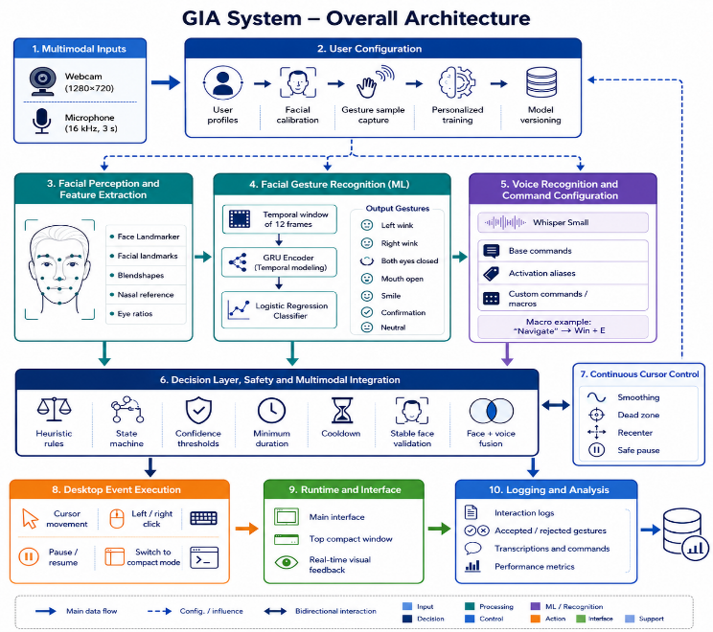
- Hybrid GIA architecture: multimodal capture, ML perception, heuristic interpretation, modality fusion, and system event execution.
GIA is a multimodal functional prototype designed to operate offline, without relying on remote infrastructure. Its architecture is organized into layers of facial signal capture, facial and voice perception, mixed processing (heuristic and supervised machine learning), multimodal fusion, execution of Windows operating system events and interaction logging, assigning each technology a specific role and reducing dependence on a single input channel or external services.
The capture layer works primarily with a conventional webcam and microphone as input devices. In visual processing, OpenCV is used as the main library to access the video stream, capture frames, check device availability, configure camera resolution, and prepare each frame before sending it to the facial perception module [16]. In the current prototype, OpenCV acts as the direct connection between low-cost peripherals and the computer vision pipeline, delivering real-time frames for later analysis.
Linked to the capture layer is the facial perception layer, implemented using MediaPipe Face Landmarker. This technology, based on machine learning, detects a dense set of three-dimensional facial landmarks and, optionally, expression coefficients (blendshapes) and facial transformation matrices [9]. GIA uses only a subset of 20 landmarks out of the 478 available, from which it calculates five facial metrics per frame: the relative aperture of each eye (eye aspect ratio), the aperture of the mouth, a smile index and the elevation of the eyebrows; the system does not employ blendshapes. In this architecture, MediaPipe does not execute commands directly, but instead provides high-level signals over the user's face. From these signals, GIA derives interaction variables such as the relative displacement of the nose with respect to the neutral posture, the ocular opening, the stability of the face and the probable presence of intentional facial gestures.
Facial signals are given a layer of normalization and heuristic control. During the initial calibration, this layer sets a neutral posture of the user and compares each landmark against that reference point. The cursor moves according to the displacement of the nose or the center of the face with respect to the neutral position. This displacement is not sent raw to the pointer: it passes through a dead zone that ignores involuntary micro-movements, an adjustable gain, smoothing to avoid sudden jumps and a speed limit to prevent extreme displacements. This decision keeps continuous control of the pointer within interpretable and user-adjustable logic, rather than delegating it entirely to an opaque model.
For discrete actions, such as clicking, selecting, pausing, or confirming, GIA combines time rules with a profile-trained classifier on facial features. In initial versions, Random Forest was considered as a baseline due to its adequacy to tabular data and its lower computational complexity [17]; however, the evaluated version adopts a two-stage hybrid scheme. The first is a GRU temporal encoder with deterministic weights fixed per seed, which are not adjusted by training: it acts as a reproducible projector that transforms a 12-frame window of the five facial metrics into a 32-dimensional vector. The second is a Logistic Regression classifier that is trained locally by user on these vectors, chosen for being light, fast (retraining in approximately one second) and interpretable. This separation allows the temporal dynamics of a gesture to be recognized—an intentional wink is distinguished from a blink by its evolution over several frames—while maintaining a very low-cost local training. In all cases, the predictions go through confidence thresholds, minimum duration, and cooldown periods before being executed.
The voice modality is implemented by automatic offline speech recognition with Whisper Small [19], executed locally on CPU with int8 quantization, in Spanish and with voice activity filtering. Although there are other local low-footprint ASR engines, such as Vosk [12], GIA adopts Whisper Small for its robustness in short offline commands. In the system, voice plays a complementary role to facial control: it allows global commands to be activated, actions to be confirmed or cancelled, the system to be paused, recalibration to be initiated or tasks that would be slower to be carried out by facial movement. This modality reinforces the multimodal approach, reduces motor load, and offers redundancy when the facial channel becomes unstable.

Dataset and training
The dataset is proprietary and is built by the user during a guided calibration phase; no public repositories are used. For each gesture, around 300 frames are captured while the user maintains the corresponding expression. A 12-frame sliding window is applied to each sequence (step 1), and each window is encoded in a 32-dimensional vector using the deterministic GRU encoder. The training/validation partition is temporary (75%/25%), without shuffling, to avoid leakage of information between adjacent frames of the same sequence. As a reference, the instrumented profile model grouped 1112 windows (833 for training and 279 for validation) distributed in seven classes (neutral posture and six gestures), with the following number of windows per class: left wink 287, neutral posture 250, smile 199, sustained O-mouth 141, closing of both eyes 111, right wink 78 and confirmation 46.
The multimodal fusion layer integrates facial and vocal signals using a state machine. The main states considered are calibration, active tracking, standby, command execution, pause, face loss, and recalibration. This layer decides at any given time which action is executed and which is discarded, combining order priority, current system status, and security conditions. For example, if the user says "pause" or "cancel," the voice command takes precedence over an ambiguous facial gesture received at the same time. Similarly, when the face leaves the frame or the detection confidence drops below the threshold, the system blocks critical clicks and movements until a reliable signal is recovered.
The last link is the layer that interacts with the operating system using a local automation library that emits mouse, keyboard, and shortcut events; in Windows it can rely on input functions such as SendInput [18]. It is deliberately simple: it only executes the actions already validated by the decision layer, reducing the risk of an unstable detection leading to an unwanted click. The system is complemented by a feedback interface and a local registry that stores calibration times, executed commands, false positives, face losses and voice usage; from these records, the metrics discussed in the following sections are obtained.

RESULTS
The results are based on a fully functional version of the system, developed and tested on Windows 11, the environment in which the current GIA prototype was built. Development used Python as the main language, OpenCV for video capture, and MediaPipe Face Landmarker to extract the facial coordinates required for gesture training and detection. GIA also incorporates a voice module based on Whisper Small, the offline model used by the system, which transforms spoken commands into reconfigurable instructions without requiring an internet connection. In addition, it includes profile persistence, versioned models, and debugging and real-time operation logs. Execution and integration tests were carried out on a laptop with 16 GB of DDR4 RAM, an integrated HD webcam, an integrated microphone and an Intel Core i5 processor. In that environment, the system operated at the configured target rate of 15 FPS, which supports its feasibility on basic or affordable computing equipment.

Experimental setup
This section describes a preliminary technical evaluation conducted on the most recent version of the GIA prototype. The test did not seek to validate the system in clinical terms or demonstrate its applicability to the entire target population; that scope corresponds to a later stage. The purpose was to verify if the changes introduced allowed the desktop to be used in a basic and stable way. To this end, the integrated behavior of the cursor's facial control, the recognition of discrete gestures, voice commands and security validations aimed at reducing involuntary activations were evaluated.
The evaluated version corresponds to the current prototype of GIA, with an interface built in Qt for Windows using PySide6 and registered internally as model_version = 3. It integrates cursor control from facial references using MediaPipe, uses a 12-frame window to infer gestures, and supports classification in a two-piece hybrid scheme: a GRU encoder followed by a Logistic Regression model.
The GRU is a recurrent neural network that processes sequences and retains information from previous frames using internal gates. It is used as a temporal encoder because a facial gesture cannot always be reliably recognized in a single frame. An intentional wink, for example, can resemble a blink when observing a single frame; what sets it apart is the evolution of the movement over several consecutive frames. The GRU sums up this evolution in a compact representation. Logistic Regression acts on this representation, in charge of assigning the final class: left wink, right wink, closing of both eyes, sustained O-shaped mouth, smile, confirmation or neutral posture. This classifier was chosen because it is lightweight, executable locally and interpretable for subsequent analysis of the system.
In the voice module, the audio input is picked up at 16 kHz in 3.0 s segments. The tested version includes six active facial gestures, a neutral sample, 17 set voice commands, and a custom macro called "Navigate". This command is associated with the shortcut Win + E, which in Windows opens the file explorer. Prior to reviewing usage records, an automated verification of the prototype code was performed, in which GIA passed 26 out of 26 unit and regression tests. This allowed us to corroborate that the main components and recent changes responded as expected before the analysis of pilot sessions, including the activation of key combinations using custom voice commands.
The evidence used for this evaluation comes from internal performance records obtained with the instrumented profile during pilot sessions. By their nature, the results are interpreted as initial technical evidence obtained in an internal test environment: they do not yet correspond to a study with end users or a statistically representative sample, but they allow us to observe the behavior of the prototype after recent modifications.
The sessions were conducted indoors under [[COMPLETAR: artificial LED ceiling lighting / mixed natural and artificial lighting]] with a predominantly frontal and diffuse incidence, and under a [[COMPLETAR: low / moderate]] ambient noise level originating mainly from [[COMPLETAR: e.g. a fan and occasional nearby conversation]]. The user remained seated at approximately [[COMPLETAR: 45-70]] cm from the camera, which was positioned at [[COMPLETAR: eye]] level. Visual capture used the laptop's integrated HD webcam at 1280 x 720 px and audio capture used the integrated microphone at 16 kHz.
- EVALUATED CONFIGURATION OF THE CURRENT GIA PROTOTYPE
Item | Value | Interpretation
System Version | Qt-based GIA prototype, model_version = 3 | Current modified version evaluated in the pilot logs.
Operating Environment | Windows Desktop | Main platform for mouse events and macro execution.
Camera Flow | 1280 x 720 | Configured webcam resolution for face tracking.
Execution rate | 15 FPS as a target set | Target processing rate configured in the system.
Gestural inference window | 12 frames | Temporal context used for inference of discrete gestures.
Gesture model | Deterministic GRU Encoder + Logistic Regression (32 dimensions, 12-frame window) | Combines time coding with a lightweight classifier.
Voice model | Whisper Small | Local model for speech transcription.
Audio Settings | 16 kHz, 3.0 s capture window | Fixed settings for voice command attempts.
Interaction Set | 6 active facial gestures + 1 neutral reference | Current gestural vocabulary deployed in the prototype.
Voice commands | 17 built-in commands + 1 custom macro | It includes "Navigate", assigned to Win + E.
Verification Base | 26/26 tests passed | Unit and regression tests approved in the current review.

Assessment tasks
The set of evaluation tasks was defined to cover the main interaction channels of the current prototype. Some tasks have already produced log-backed indicators, especially gesture and voice activity. Other indicators per task, such as completion time and formal false click counting, remain as part of the next controlled evaluation because they are not yet instrumented with sufficient precision in the current logs.
- TASKS AND CURRENT MEASUREMENT STATUS
Task | Purpose | Current status
T1. Moving the cursor towards a target | Evaluate cursor facial control, stabilization, and drift. | Defined for the protocol; time per task has not yet been formally measured.
T2. Left-click gesture | Evaluate intentional activation by left wink. | There are gestural events in logs; there is a lack of formal protocol of false/not detected.
T3. Right-click gesture | Evaluate intentional activation by right wink. | There are gestural events in logs; there is a lack of formal measurement of time by task.
T4. Pause/Resume | Verify safe interruption and recovery of the interaction. | Verified behavior in internal tests; structured measurement is lacking.
T5. Voice command execution | Evaluate transcription, command routing, and action execution. | Voice metrics available with log backup.
T6. Recentering/Recalibration | Evaluate recovery in the event of drift or change of posture. | System-supported function; average recalibration time pending.
T7. Continuous pilot use | Observe stability, rejected candidates, and audio behavior. | Internal execution records of the instrumented profile (pilot sessions).

Implementation and integration results
The first result was the consolidation of a functional architecture with two surfaces: a preparation launcher and an assistant runtime. The launcher concentrates the selection of profiles, guided calibration (capture of neutral posture and around 300 frames per gesture), training of the versioned classifier by profile – which generates a new version without overwriting the previous one – and the configuration of voice commands, including personalized accesses linked to key combinations.
The runtime integrates continuous cursor control, voice command activation, status feedback, and an action log tray into a single interface. In addition, it offers a compact, voice-activated upper window that displays only the essential information – face and voice control status, pause and tray messages – so as not to interfere with other applications during everyday use (Fig. 2).

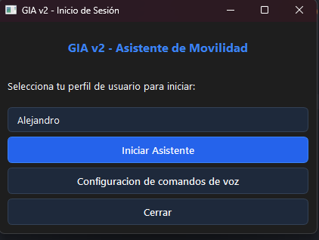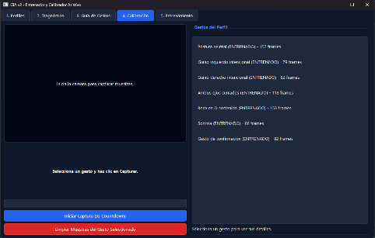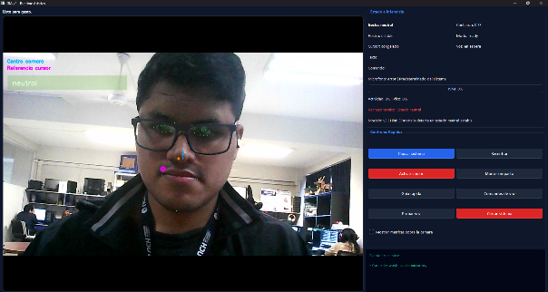
- GIA Interface: (a) launcher and profile selection; (b) gesture calibration; (c) Assistive runtime.

Technical performance
This section describes the technical behavior observed in internal tests of the GIA prototype in a local environment. The goal was to verify whether the current version allows for seamless interaction sessions without requiring specialized hardware or connection to cloud services. In the evaluated environment (laptop with Intel Core i5 processor, 16 GB of DDR4 RAM and integrated HD webcam), the cursor facial control was perceived as fluid for basic desktop tasks on Windows at the target rate of 15 FPS. The exact latency of the visual and voice loop as well as the fine precision of the pointer (jitter, target overshoot and stabilization time on small targets) are subject to a controlled measurement protocol.

The voice channel has higher end-to-end latency than the visual one, as voice interaction includes audio capture, local transcription using Whisper Small, internal text validation, and command resolution before executing the action. As a result, the voice channel is better suited for high-level commands—opening an application, activating a function, or executing a macro—than for actions that require immediate response. The exact quantification of this latency is pending a controlled measurement protocol.

In terms of profile preparation, the initial calibration includes capturing around 300 frames per gesture; once the set of landmarks is available, classifier training or retraining is completed in approximately one second, allowing the custom model to be updated without prolonged interruption of the flow of usage. The system also allows new samples to be added to existing gestures or replaced when a larger change in the gesture pattern is required. The total calibration time and CPU and memory consumption in continuous operation are subject to a controlled measurement protocol.

Taken together, these results indicate that the offline-first architecture is viable for a preliminary desktop version. However, the metrics should be interpreted as initial technical evidence. For a more complete validation, it will be necessary to repeat the measurements with more sessions, different lighting conditions, camera variations and users with different motor profiles.

Functional performance by tasks
Functional performance was evaluated on basic desktop tasks—cursor navigation, left and right clicking, pause and resume, recentering, activating or freezing the cursor, switching between full and compact interface, and voice commands—and considering the completed task successful without manual assistance or system restart. These results are interpreted as preliminary: the behavior per module is detailed in the subsequent analysis and the quantitative metrics per task are pending a controlled protocol (Table II).

Gesture Classifier Evaluation
To provide empirical evidence specific to the machine learning module, the gesture classifier was evaluated in isolation on the temporal validation set (25% reserved). The instrumented profile model achieved a validation accuracy of 98.2 % (macro-F1 = 0.978; F1 weighted = 0.983) over 279 windows, correctly identifying 274 of the 279 validation samples. This indicates stable performance across most of the gesture classes evaluated. Fig. 3 presents the confusion matrix: the only errors corresponded to five wink windows classified as closing both eyes (three from the left wink and two from the right), a pattern expected due to the visual closeness between both eye gestures. Table III details accuracy, recall, and F1 score by class.

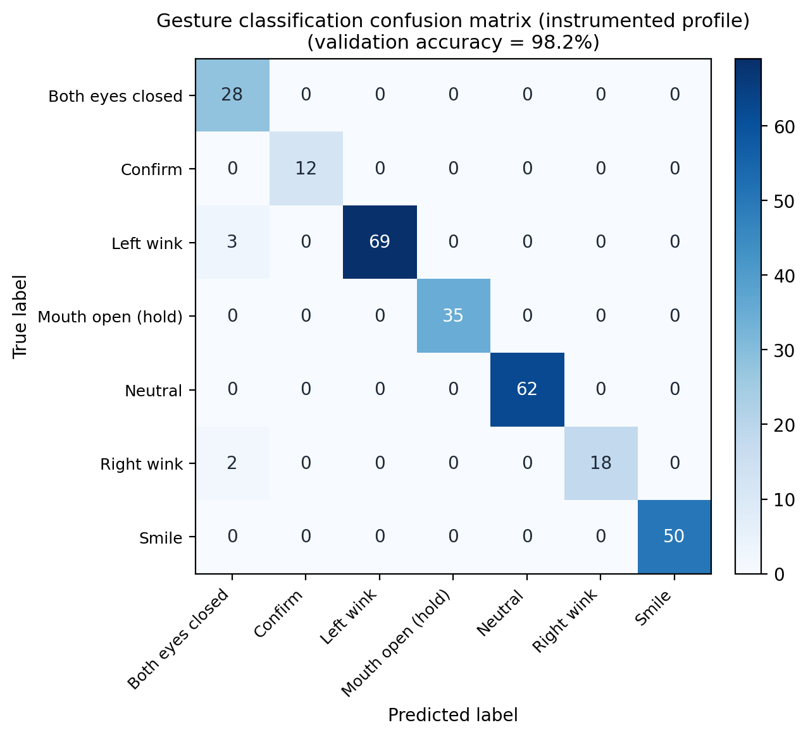
- Gesture classifier confusion matrix (instrumented profile; 279 validation windows; validation accuracy 98.2%).
The confusion matrix shows that all classification errors were associated with winking gestures that were predicted as closing both eyes. This result supports the need for the proposed hybrid architecture, in which gesture recognition based on machine learning is complemented by security heuristic mechanisms before executing actions on the operating system.
- Metrics by gesture classifier class (validation)
Class | Accuracy | Recall | F1 | n
Neutral | 1.00 | 1.00 | 1.00 | 62
Left wink | 1.00 | 0.96 | 0.98 | 72
Right wink | 1.00 | 0.90 | 0.95 | 20
Closing of both eyes | 0.85 | 1.00 | 0.92 | 28
Sustained O-mouth | 1.00 | 1.00 | 1.00 | 35
Smile | 1.00 | 1.00 | 1.00 | 50
Confirmation | 1.00 | 1.00 | 1.00 | 12
Macro Average | 0.98 | 0.98 | 0.98 | 279

Cross-user validation
To explore generalization beyond a single profile, the classifier was trained and validated with independent profiles captured by different users (Table IV). In four profiles with proper calibration, validation accuracy remained between 91.8% and 100%, with an average of 97.1%. A fifth profile, captured with a substantially lower number of windows, obtained a lower accuracy (74.4%), which reinforces the observation that the quality and quantity of samples per profile directly condition the performance of the classifier. These profiles were collected with users without disabilities as an intermediate step; a first evaluation with a target population is described below.
- Classifier validation accuracy by user profile
Profile | Windows (train/val) | Validation Accuracy
User A | 885 (663/222) | 100.0 %
User B | 737 (553/184) | 98.4 %
User C (instrumented) | 1112 (833/279) | 98.2 %
User D | 677 (507/170) | 91.8 %
User E (undersampled) | 157 (118/39) | 74.4 %

Preliminary test with target population
As a first approach to end users, the system was evaluated in a field session at an OMAPED center (Municipal Office for the Care of People with Disabilities) in Lima, with six children and adolescents (aged 10 to 15) with mild-to-moderate motor disabilities that limited the easy and coordinated movement of their limbs. The session was conducted with prior authorization from OMAPED, the entity in charge of their care, in the presence of their guardians and of staff from the University of Sciences and Humanities. Because of the limited availability of the participants, calibration was not performed individually; instead, a pre-existing profile model (the one with the most captured samples) was used, and each participant then attempted to control the cursor, execute the discrete gestures and issue voice commands over approximately three hours of testing distributed across sessions. Four of the six participants managed to move and position the cursor correctly, four of six triggered the discrete gestures, and three of six correctly executed the voice commands. Among the gestures, the sustained O-mouth was the easiest to trigger and identify for all participants, whereas the left and right winks were the most difficult, consistent with the confusion observed between ocular gestures in the classifier evaluation (Fig. 3). Although this is an uncontrolled field observation with a small sample, it constitutes the first evidence of use with the target population and guides the priority adjustments —in particular, the robustness of wink recognition and audio capture— for subsequent iterations.
Ethical considerations. The field session was carried out with the prior institutional authorization of the OMAPED center, the public body responsible for the care of the participants. [[COMPLETAR: Informed consent was obtained from the parents or legal guardians of all participants]], who were present throughout the session together with staff from the University of Sciences and Humanities. Participation was voluntary and could be interrupted at any time. No clinical records or personal health data were collected, and all facial processing was performed locally on the device, with no transmission of images or biometric data to external services. [[COMPLETAR o BORRAR - no inventar: The study protocol was reviewed and approved by the Ethics Committee of ______ under record No. ______.]]

Module Analysis
The continuous control of the cursor, based on the tracking of the tip of the nose with smoothing, dead zone and recentering, was the most stable component, as it depends on continuous tracking rather than on discrete decisions. Discrete gestures worked during the sessions, although with greater sensitivity to thresholds. Across the seven internal sessions logged with the evaluated model (model_version = 3), the decision layer accepted 69 gesture events and rejected 450 candidates, i.e. an acceptance rate of 13.3 %. This behavior responds to a deliberately conservative acceptance policy: blocking a doubtful gesture is preferable to executing an accidental click. The breakdown of rejections is informative: 435 (96.7 %) were blocked by low classifier confidence, only 13 (2.9 %) by unstable face tracking and 2 (0.4 %) by cooldown. This indicates that facial tracking remained reliable throughout the sessions and that the margin for adjustment lies in the classifier thresholds rather than in the face tracking.
In the voice channel, the router successfully resolved commands with usable transcription; the main limiting factor was audio capture, with a low signal level that produced empty transcriptions—preferable to executing a wrong command, but with room for improvement in audio capture and feedback during listening. The security layer, composed of cool-down times, confidence thresholds, stability verification, pause and re-centering, fulfilled its role of avoiding unintentional activations, with the expected cost of reducing sensitivity.
The quality of the interaction was directly dependent on the uniformity of the calibration samples: profiles with clear gestures and stable lighting performed better, confirming that local adjustment per user is a structural component and not just an initial stage. Overall, the hybrid scheme—continuous heuristic control and discrete gestures validated by rules—helped reduce accidental triggers and regain control after brief facial loss, although its thorough evaluation over extended sessions is pending.

Summary of results
In sum, GIA provides a stable functional base for multimodal desktop interaction for people with reduced mobility, covering computer control through facial and discrete gestures, established and personalized voice commands, and support functions such as personalized profiles and safety mechanisms. Its strongest evidence so far comes from classifier validation, technical verification and internal logs, rather than from an extensive evaluation with end users. The system does not fail uniformly: facial tracking remained stable and continuous cursor control was the most mature component, while discrete gestures and voice require adjusting thresholds and audio capture. Therefore, the hybrid architecture is defensible as a working base, and the next stage should broaden the tests with more sessions, users and controlled tasks.

DISCUSSION
The literature review supports the benefits of GIA compared with other projects of the same nature and helps to clearly locate the limits of this study. Compared with the Auxilio system, GIA shares the goal of operating the computer without using the hands or upper limbs, but it reduces the reliance on body-worn or specialized hardware by using peripherals common in any environment, such as a conventional webcam and microphone, which lowers initial adoption barriers, extra-hardware maintenance costs and deployment complexity [4]. In relation to XULIA, the difference is that GIA does not base all interaction on voice: cursor navigation is performed through facial landmarks, while voice is reserved for activating, confirming, canceling or executing pre-configured global commands [5]. This separation prevents interaction from relying on a single resource and allows complementary channels to be combined when one of them presents failures or limitations.
Compared to multimodal proposals such as that of Li et al. and recent frameworks, GIA orients its technical approach to the operation of the computer and not only to semantic recognition or communicative mediation [6], [8]. In the architecture, facial gesture recognition uses a hybrid machine learning approach that combines a GRU encoder, responsible for compressing the temporal evolution of facial metrics derived from landmarks into a compact vector, with a Logistic Regression classifier that decides the final class of the gesture. Sensitive system actions, such as clicks, pause or bilateral eye closure, do not depend solely on the output of the model, but are reinforced with heuristic rules, thresholds, minimum duration and cool-down periods. This distinction favors the interpretation of system behavior, error auditing, and reconfiguration according to the user's profile.
Therefore, the value of the work is not only in capturing the face or recognizing voice commands, but in transforming that data into a configurable, local and secure flow of interaction. In this line, GIA is characterized by four aspects: first, it separates continuous and discrete signals, controlling the cursor through continuous facial tracking and activating gestures through a more restrictive decision layer; second, it manages profiles processed and stored locally, which helps to counteract natural variability between users; third, it incorporates operational safety mechanisms such as confidence thresholds, minimum gesture duration, pause, recentering and cooldown; and fourth, it operates without relying on external services, consistent with the local processing approach and low-cost assistive technology [12]-[14].
However, the results should not be considered definitive evidence. Facial control could be less effective in extreme poses, poor lighting, occlusions or abrupt changes in distance from the camera, limitations also reported in contributions on face detection, landmarks and pose estimation [10], [11]. In the voice module, errors depend not only on the recognition engine, but also on ambient noise, the way the command is pronounced, the audio segmentation, and the interaction design [7]. Likewise, the interface needs to be perfected under motor accessibility criteria: the visual goals must be broad, the controls visible and the interactive elements sufficiently separated to reduce selection errors [15].
Overall, GIA can be considered an architectural foundation with potential for multimodal assistive interaction on the desktop. However, its scientific consolidation requires a broader evaluation with end users, different motor profiles and less controlled conditions of use. Future research should compare the performance of hybrid architecture against alternative configurations, analyze fatigue and accuracy over long sessions, and see if the combination of face and voice brings concrete improvements in autonomy during everyday tasks.

CONCLUSIONS
The development of GIA made it possible to test the initial feasibility of a human-computer interaction system aimed at people with reduced mobility, based on the use of a webcam, voice commands and local processing. Unlike a single-modality-focused solution, the prototype integrates continuous facial control, discrete gesture recognition, custom profiles, and security mechanisms to reduce involuntary actions while using the desktop.
From a technical point of view, one of the main learnings from the project was that not all interaction decisions should be resolved using machine learning alone. In the evaluated version, cursor movement and some recovery functions were kept in a heuristic layer, while discrete gestures were supported by a hybrid scheme with GRU encoder and Logistic Regression. This separation allowed for greater control over sensitive actions, such as clicks, pauses, or eye-closure activations, and made it easier to interpret errors during internal testing.
The results obtained show that GIA already has a functional basis to execute basic desktop tasks through a multimodal interaction. Profile customization, gesture calibration, local classifier training, and voice command configuration strengthen the system's adaptability to different forms of use. However, the results should be understood as preliminary technical evidence. The system still requires end-user validation, longer sessions, and testing under less controlled conditions to confirm its real usefulness in everyday scenarios.
As future work, it is recommended to extend the assessment with people with different motor profiles, measure in greater detail fatigue, cursor accuracy, false clicks and cognitive load during continuous use sessions. It will also be necessary to refine the set of discrete gestures, improve the visual and auditory feedback of the system, and strengthen the voice module to reduce attempts without transcription. Finally, the publication of the prototype with documentation, calibration guides and configuration examples could facilitate its review by other researchers and open up the possibility of collaborative improvements.

Recommendations
It is recommended to extend the evaluation with end users of different motor profiles – measuring time per task, fatigue, accuracy and false clicks – refine the set of discrete gestures to reduce their ambiguity and accidental activations, improve visual and auditory feedback of system states, strengthen capture and confirmation in the voice module, and document and release the prototype with installation and calibration guides to facilitate reproduction and future collaboration.

References

- World Health Organization, "Disability," fact sheet, Mar. 7, 2023.
- World Health Organization, "Assistive technology," fact sheet, Jan. 2, 2024.
- World Health Organization and UNICEF, Global report on assistive technology. Geneva, Switzerland: WHO, 2022.
- M. R. Kabir et al., "Auxilio and Beyond: Comparative Evaluation, Usability, and Design Guidelines for Head Movement-based Assistive Mouse Controllers," arXiv preprint arXiv:2210.04483, 2022, doi: 10.48550/arXiv.2210.04483.
- A. Losada Gonzalez, "XULIA — Comprehensive control system for Windows devices designed for people with tetraplegia," arXiv preprint arXiv:2408.17314, 2024, doi: 10.48550/arXiv.2408.17314.
- Z. Li et al., "Enabling Voice-Accompanying Hand-to-Face Gesture Recognition with Cross-Device Sensing," arXiv preprint arXiv:2303.10441, 2023, doi: 10.48550/arXiv.2303.10441.

- N. Vigouroux, F. Vella, G. Lepage, and É. Campo, "Design Recommendations Based on Speech Analysis for Disability-Friendly Interfaces for the Control of a Home Automation Environment," arXiv preprint arXiv:2311.13223, 2023, doi: 10.48550/arXiv.2311.13223.
- K. Revankar et al., "Sanvaad: A Multimodal Accessibility Framework for ISL Recognition and Voice-Based Interaction," arXiv preprint arXiv:2512.06485, 2025, doi: 10.48550/arXiv.2512.06485.
- Google AI Edge, "Face landmark detection guide for Python," documentation, Jan. 13, 2025.
- Q. Wu and L. Zhang, "A Real-Time Multi-Task Learning System for Joint Detection of Face, Facial Landmark and Head Pose," arXiv preprint arXiv:2309.11773, 2023, doi: 10.48550/arXiv.2309.11773.
- T. H. Sakib et al., "Real-Time Confidence Detection through Facial Expressions and Hand Gestures," arXiv preprint arXiv:2506.09153, 2025, doi: 10.48550/arXiv.2506.09153.
- Alpha Cephei, "Vosk Offline Speech Recognition API," documentation, accessed May 16, 2026.
- C. Cioflan, L. Cavigelli, and L. Benini, "Boosting keyword spotting through on-device learnable user speech characteristics," arXiv preprint arXiv:2403.07802, 2024, doi: 10.48550/arXiv.2403.07802.
- M. J. Torkamani and I. Zarin, "Adaptive Edge-Cloud Inference for Speech-to-Action Systems Using ASR and Large Language Models (ASTA)," arXiv preprint arXiv:2512.12769, 2025, doi: 10.48550/arXiv.2512.12769.
- A. Krishnavajjala, S. M. H. Mansur, J. Jose, and K. Moran, "MotorEase: Automated Detection of Motor Impairment Accessibility Issues in Mobile App UIs," arXiv preprint arXiv:2403.13690, 2024, doi: 10.48550/arXiv.2403.13690.
- OpenCV, "Getting Started with Videos," OpenCV-Python Tutorials, documentation, 2026.
- scikit-learn developers, "RandomForestClassifier," scikit-learn documentation, 2026.
- Microsoft, "SendInput function (winuser.h)," Microsoft Learn, Oct. 13, 2021.
- A. Radford, J. W. Kim, T. Xu, G. Brockman, C. McLeavey, and I. Sutskever, "Robust Speech Recognition via Large-Scale Weak Supervision," arXiv preprint arXiv:2212.04356, 2022.

