AstroGeoStats Extended Research Framework
This document extends the AstroGeoStats project by incorporating a new experimental probabilistic framework based on the spatial relationship between the Giza complex and proportional representations of the Solar System.

Experimental Reference Image
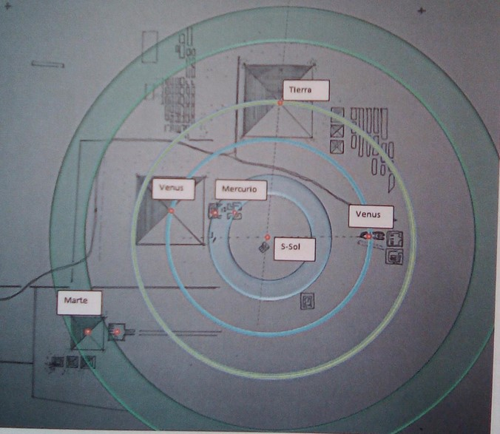
Figure 1. Proposed proportional model relating the Giza complex to Solar System geometry.

1. Integration into the AstroGeoStats Project
The proposed experiments can become a dedicated probabilistic and spatial-analysis module inside AstroGeoStats. Instead of only studying Orion correlations, the project can also evaluate whether the arrangement of monuments in Giza exhibits statistically unlikely proportional relationships with planetary orbital structures.

2. Scientific Interpretation
The proposed framework transforms the hypothesis into a measurable statistical problem. Rather than asking whether the monuments 'look similar' to the Solar System, the analysis asks whether the observed spatial arrangement is significantly improbable under randomized conditions within the same spatial domain.

3. Proposed New Research Line
A new research branch can be added to AstroGeoStats:
'Probabilistic Analysis of Planetary Proportionality in the Giza Complex'
This module would evaluate:
- geometric proportionality,
- orbital correspondence,
- radial distributions,
- and random spatial coincidence probabilities.

4. First Experiment — Exact Pixel Coincidence
The first experiment evaluates the probability that six randomly generated points inside the image domain exactly match the observed monument positions.
Methodological steps:
1. Use the full rectangular image as the sample space.
2. Discretize the image using pixel coordinates.
3. Identify the pixel coordinates corresponding to:
- Sun (S)
- Khafre funerary monument (Mercury)
- Khafre pyramid (Venus)
- Great Pyramid of Khufu (Earth)
- Menkaure pyramid (Mars)
- Sphinx (Venus)
4. Define a maximum number N of trials.
5. Generate six random coordinate pairs.
6. Compare them against the exact observed coordinates.
7. Assign 1 if all coordinates match exactly, otherwise 0.
8. Repeat N times.
This becomes an extreme combinatorial probability problem.

5. Statistical Interpretation of Experiment 1
The probability of exact coincidence in a large pixel space is expected to be extremely low. This experiment provides a baseline null model against purely random monument placement.
Potential statistical tools:
- Binomial probability
- Monte Carlo simulations
- Spatial randomness models
- Poisson spatial processes
- Entropy analysis

6. Second Experiment — Orbital Interval Constraint
The second experiment relaxes the exact-coordinate requirement and allows random points to appear only within radial intervals defined by perihelion and aphelion bands.
This introduces:
- constrained spatial probability,
- radial statistical distributions,
- orbital tolerance regions,
- annular geometry analysis.

7. Third Experiment — Full Annular Distribution
The third experiment allows points to appear anywhere inside orbital rings defined by perihelion and aphelion boundaries.
This creates a weaker but broader null hypothesis, allowing evaluation of whether the observed arrangement is still statistically distinguishable from random orbital distributions.

8. Keplerian Extension
An advanced future extension involves applying Keplerian orbital mechanics to estimate possible historical epochs associated with the proposed proportional arrangement.
This could include:
- orbital period reconstruction,
- ancient sky simulation,
- precession corrections,
- historical planetary alignment estimation.

9. New Computational Modules for AstroGeoStats
The project can now include:
- Pixel-space spatial analysis engine
- Orbital ring simulation module
- Randomized geometric generator
- Statistical significance analyzer
- Keplerian reconstruction module
- Historical planetary simulator

10. Mathematical Foundations
The expanded project now intersects multiple scientific domains:
- Probability theory
- Spatial statistics
- Celestial mechanics
- Computational geometry
- Monte Carlo methods
- Orbital dynamics
- Information theory

11. Suggested Future Papers
Potential future publications:
- Statistical Evaluation of Solar-System Proportionality in the Giza Plateau
- Monte Carlo Analysis of Planetary Spatial Correlations in Ancient Egyptian Architecture
- Computational Archaeoastronomy and Orbital Geometry in Monumental Structures
- Pixel-Based Probabilistic Analysis of the Giza Complex

12. Important Scientific Caution
The project must carefully avoid confirmation bias and retrospective pattern matching. All experiments should include explicit null hypotheses, reproducible computational procedures, and rigorous statistical controls.
The goal is not to prove a predetermined theory, but to quantitatively evaluate whether the observed structures exhibit statistically meaningful spatial organization beyond chance.
AstroGeoStats now evolves from a celestial-alignment investigation into a broader computational framework capable of analyzing planetary proportionality, orbital geometry, and probabilistic spatial organization in ancient monumental architecture.

