# **Ahsanullah University of Science & Technology**

Department of Computer Science & Engineering



**Information Pool System**

CSE 3224

Information System Design & Software Engineering Lab

Submitted By:

Amreen Tarannum Alam 16.02.04.007

Mayeesha Humaira 16.02.04.008

Shimul Paul 16.02.04.014

Ashna Nawar Ahmed 16.02.04.024

Date of Submission: **04 August, 2019**

**REQUIREMENTS SPECIFICATION**

**1. Introduction to the Project**

Information pool is an online site that will provide news and blogs on various topics, alongside ads. Our aim is to analyze local newspapers and online news sites to find out the needs of current users.

**2. Requirements Specification**

1. **Introduction**

On the basis of the analysis performed our goal is to develop a requirements specification document that supports all the functional and non-functional requirements with improvements suggested for the current deficiencies.

1. **Types of stakeholders [users] of the Proposed System**

The users of our proposed systems belong to 4 levels:

1. Level 0: Unregistered users
2. Level 1: Registered users
3. Level 2: Bloggers and Editors
4. Level 3: Administrators
5. **Functionality grouping according to the users**

The functionality grouping according to the users is as follows:

1. Level 0: They are unregistered users, who can only read articles and blogs, and see ads posted in the classified section.
2. Level 1: They are the registered users, who can comment on articles and blogs, as well as post ads of their own.
3. Level 2: They are the bloggers and editors, who have all the privileges of Level 0 and 1, and they can also post blogs of their own on relevant topics, can edit and delete their own blogs.
4. Level 3: They are the administrators, who have overall control over the whole system. They can post links from various sources, as well as monitor activities happening on the site. They can delete any irrelevant links, blogs or comments that they deem unsuitable or offensive.
5. **Functional Requirements**

**FR01: Add Users**

|  |  |
| --- | --- |
| FR01-01 | System shall enable people to register as users. |
| FR01-02 | System shall enable users to login to the system using username and password. |

**FR02: See Links**

|  |  |
| --- | --- |
| FR02-01 | System shall enable both registered and unregistered users to see news headlines from various sources and the first few lines of the news. |
| FR02-02 | System shall enable users to go to the links embedded within the headlines. |

**FR03: See Blogs**

|  |  |
| --- | --- |
| FR03-01 | System shall enable unregistered users to see blogs. |
| FR03-02 | System shall enable registered users to see blogs and write comments. |

**FR04: Add Links of News**

|  |  |
| --- | --- |
| FR04-01 | System shall enable administrators to add links from various sources that will appear on the homepage. |
| FR04-02 | System shall ensure a way so that the first few lines of each news link are visible on the homepage. |
| FR04-03 | System shall enable admins to view the links they previously added on the website. |

**FR05: Add Blogs**

|  |  |
| --- | --- |
| FR05-01 | System shall enable bloggers and editors to add blogs on various topics. |
| FR05-02 | System shall enable bloggers to view the blogs they previously added on the website. |

**FR06: Delete Links**

|  |  |
| --- | --- |
| FR06-01 | System shall enable admins to delete links they added previously. |
| FR06-02 | System shall enable admins to view their previously added links. |
| FR06-03 | System shall ensure a way that links get removed from homepage automatically after a certain amount of time has passed. |

**FR07: Delete Blogs**

|  |  |
| --- | --- |
| FR07-01 | System shall enable bloggers and editors to delete the blogs they previously posted. |
| FR07-02 | System shall enable bloggers to view their previously added blogs. |

**FR08: Edit Blogs**

|  |  |
| --- | --- |
| FR08-01 | System shall enable bloggers and editors to see the blogs they previously posted. |
| FR08-02 | System shall enable bloggers and editors to edit the blogs they previously posted. |

**FR09: Comment on blogs**

|  |  |
| --- | --- |
| FR09-01 | System shall enable registered users to comment on blogs. |
| FR09-02 | System shall enable registered users to delete their own comments on blogs. |
| FR09-03 | System shall enable admins to delete any comments they deem unsuitable and that violate community guidelines. |

**FR10: Advertisement Posting**

|  |  |
| --- | --- |
| FR10-01 | System shall enable registered users to post ads according to their needs such as-help wanted, land wanted, car for sale. |
| FR10-02 | System shall enable admins to review the ads that users are trying to post in order to see if they are suitable or not. |
| FR10-03 | System shall enable admins to delete inappropriate ads that users are trying to post while reviewing them. |

**FR11: Advertisement Payment System**

|  |  |
| --- | --- |
| FR11-01 | System shall enable users to pay for the ads they are going to post after they get approval using methods such as bKash, rocket or bank accounts. |

**FR12: Events**

|  |  |
| --- | --- |
| FR12-01 | System shall enable admins to post about upcoming events. |
| FR12-02 | System shall allow admins to delete events they previously posted. |
| FR12-03 | System shall maintain a way so that events automatically get removed after the date has passed. |

1. **Non-functional Requirements**

**NFR01: Performance**

|  |  |
| --- | --- |
| NFR01-01 | Average load time of the starting page of the system must be less than 2 seconds. |

**NFR02: Security**

|  |  |
| --- | --- |
| NFR02-01 | The system shall provide a way to ensure that the security levels are maintained. |
| NFR02-02 | System must not provide access to ANY user EXCEPT the admin to update the database. |

**NFR03: Defects-Maintenance**

|  |  |
| --- | --- |
| NFR03-01 | Post Release defects of the system must not exceed 1 critical bug per month. |
| NFR03-02 | Post Release bug fixing should not take more than 5 hours. |

**NFR04: Portability**

|  |  |
| --- | --- |
| NFR04-01 | As the site will run on any browser, the adaptation rate of the application will be favorable. |

1. **Overall Constraints**

If any issues occur with the network or database, it might propagate across the system. So the administration system should be maintained properly. Fake user accounts can be created, which can violate service policy as they can harass the bloggers and other users. The admin panel should verify user information and generate a report about the activities in order to control such issues.

**3. Interview and Questionnaire**

1. **Sampling Decisions**

We have undertaken target-oriented method for sampling. Our target research included Facebook, Direct Email, messages, university, and friends’ gatherings.

1. **Sample Design**
2. **Sample Size:** The sample size selected for the research is 88.
3. **Parameters of Interests:** The major parameter of interest is the subgroup of people having an experience in digital newspapers, hardcopy newspapers and blogs.
4. **Sampling Technique**: We have used Simple Random Sampling.
5. **Data Collection Tool Used**

The data collection tool used for the research is “Questionnaires” to get the primary data for the empirical research on customer preference on reading news online. The Questionnaire which is attached in the next page consists of several questions printed in a definite order on a form which the respondents read. We used Google Forms to gather data from our target audience.

1. **Questionnaire on “Information Pool System”**

**‘Information Pool Questionnaire’**

(We are collecting information about your preferences about news sources such as digital newspapers and old-fashioned newspaper as we are planning to make a site that brings together the best of both worlds. This survey will only take a few minutes of your precious time, please bear with us. Thank you for participating.)

**Close Ended Questions:**

**Personal Information**

**Email address \***

____________________________

**Name \***

____________________________

**Demographics Information**

**Gender \***

* Female
* Male

**Age-group \***

* Below 20
* 20-29
* 30-39
* 40 and above

**Place of Residence \***

* Gulshan
* Banani
* Dhanmondi
* Mirpur
* Mohammadpur
* Uttara
* Bashundhara
* Outside of Dhaka
* Other _________________

**Occupation \***

* Student
* Businessman
* Homemaker
* Job-holder
* Unemployed

**Monthly Income(per month)**

* No income
* Below 20,000
* 20,000-30,000
* 30,000-40,000
* 40,000-60,000
* Above 60,000

**Project Related Questions**

**Do you use the internet?**

* Yes
* No

**How long have you been using internet?**

* Less than 1 year
* 1-3 years
* 3-5 years
* More than 5 years

**On average, how much time a day do you spend surfing the web?**

* 0-1 hrs
* 1-3 hrs
* 3-5 hrs
* More than 5 hrs

**For what activities do you use internet?**

* Official Purposes
* Education
* Social networking
* General Information gathering
* Entertainment
* Banking purposes
* Shopping
* Other:__________________

**Where do you most often access the internet?**

* Home
* Office/University
* Cyber Café
* While travelling each day
* Other:__________________

**Do you read newspapers? \***

* Yes
* No

**Which one is better for reading news, in your opinion? \***

* Online Newspapers
* Physical Newspapers

**Which type of news do you read online? \***

* Breaking news
* Daily news
* Tech news
* Celebrity News
* Sports News
* Fashion News
* Stock market news
* Other:________________

**What type of blogs do you prefer?**

* Scientific Blogs
* Food Blogs
* Travel Blogs
* Fitness Blogs
* Tech Blogs
* Celebrity Blogs
* Sports Blogs
* Fashion Blogs
* Stock market Blogs
* Other:______________

**When do you feel the need to read news online? \***

* When I wake up, first thing in the morning
* While commuting to work/university
* When I have free time
* Never feel the need to read news online

**While reading digital newspapers, what affects your satisfaction the most? \***

**Not Important Somewhat Important Neutral Important Very Important**

**User friendly interface O O O O O**

**Proper search options O O O O O**

**(by keyword, author etc.)**

**Impartiality of news O O O O O**

**Ability to read anytime, O O O O O**

**anywhere**

**Free of charge O O O O O**

**Non-intrusive Ads O O O O O**

**Variety of Sources O O O O O**

**User friendly interface**

**Proper search options O O O O O**

**(by keyword, author etc.)**

**Impartiality of news O O O O O**

**Ability to read anytime, anywhere O O O O O**

**Free of charge O O O O O**

**Non-intrusive Ads O O O O O**

**Variety of Sources O O O O O**

**How much money do you spend buying newspapers a month? \***

* Less than 100
* 100-300
* 300-500
* More than 500

**While reading old-fashioned newspapers, what affects your satisfaction the most? \***

**Not Important Somewhat Important Neutral Important Very Important**

**Comfort of habit O O O O O**

**More trust in a popular/ O O O O O**

**national newspaper**

**Reliable sources O O O O O**

**Security in having a hard O O O O O**

**copy of newspaper**

**No annoying pop-up O O O O O**

**advertisement Comfort**

**of habit**

**More trust in a popular/ O O O O O**

**national newspaper**

**Reliable sources O O O O O**

**Security in having a hard O O O O O**

**copy of newspaper**

**No annoying pop-up O O O O O**

**advertisements**

**What are your issues regarding online newspapers? \***

* Uncomfortable to read on a digital medium
* Possibility of fraudulent news
* Too many distracting ads
* Costly
* Biased news sources
* Other:__________________

**How would you prefer to see classifieds ads in a digital newspaper?**

* All ads in one place
* Scattered throughout the site

**Would you like it if you could know about upcoming events in the same platform as where you are getting all daily news?**

* Yes
* No
* Maybe

**Which newspapers do you read? \***

* Prothom Alo
* Daily Star
* Daily Sun
* The Daily Ittefaq
* Kaler Kontho
* Bangladesh Pratidin
* Other:________________

**Which digital newspapers do you read? \***

* Prothom Alo
* Daily Star
* Daily Sun
* The Daily Ittefaq
* Kaler Kontho
* Bangladesh Pratidin
* BDNews24
* BBC
* CNN
* Google News
* Yahoo! News
* Other:_______________

**If given an option to read news from various sources online alongside blogs, will you use it?\***

* Yes
* No
* Maybe

**Do you think reading news online is beneficial? \***

* Yes
* No

**If yes, why do you think it is beneficial? \***

* Environmentally friendly
* Less expensive
* No need to waste space keeping papers
* Other:_________________

**Open Ended Questions**

**Do you have any suggestions for the type of features you would like to see in our system?**

**____________________________________________________________________________________________________________________________________**

**E. Data Analysis**

**Demographics Information**

**Ques: Gender**

|  |  |  |
| --- | --- | --- |
| **Gender** | | |
| **Male** | **Female** | **Total** |
| **45** | **43** | **88** |

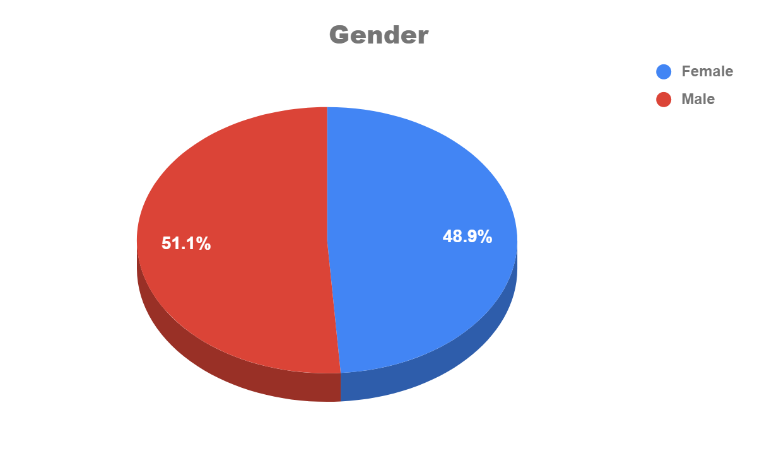

**Illustration:**

From the above pie chart it can be stated that 51.1% male and 48.9% female took part in our survey. As the objective was to study the behaviour of respondent with respect to online newspapers it can be said that approximately the same number of Male and female read newspaper.

**Ques: Age Group**

|  |  |  |  |  |
| --- | --- | --- | --- | --- |
| **Age Group** | | | | |
| **Below 20** | **20-29** | **30-39** | **40 & above** | **Total** |
| **4** | **83** | **1** | **0** | **88** |

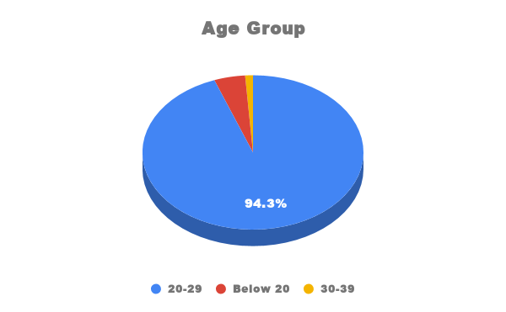

**Illustration:**

From the above pie chart it can be seen that majority of the people in our survey were from age group 20-29. About 94.3% of the people were from age group 20-29. Few people were below 20 and only one person was from the age group 30-39. So all the respondents are ready to adapt to changes.

**Ques: Place of Residence**

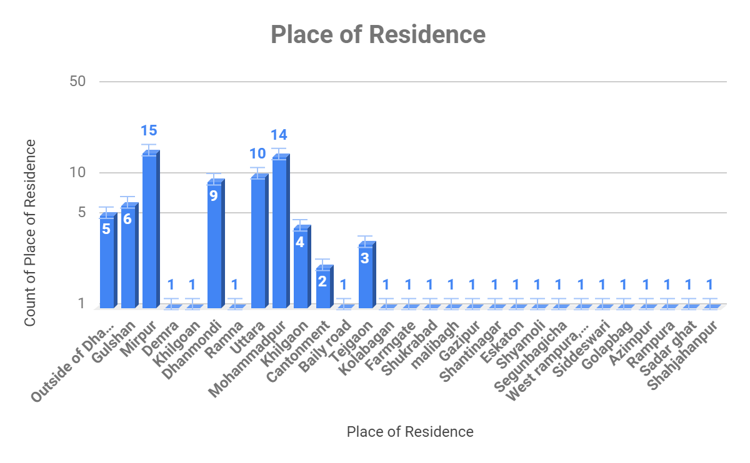

**Illustration:**

* Maximum people participating in our survey were from Mirpur. 15 out of 88 people were from Mirpur.
* 14 out of 88 people were from Mohammadpur.
* About 9 people were from Dhanmondi and 10 people from Uttara.
* Rest of the areas(Gulshan, Khilgaon, Tejgaon and others) had 6 and below 6 out of 88 people living in them.

**Ques: Occupation**

|  |  |  |  |  |  |
| --- | --- | --- | --- | --- | --- |
| **Occupation** | | | | | |
| **Student** | **Businessman** | **Homemaker** | **Job Holder** | **Unemployed** | **Total** |
| **87** | **0** | **0** | **1** | **0** | **88** |

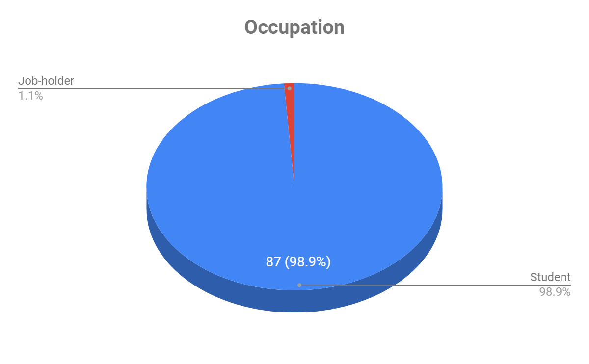

**Illustration:**

From the above pie chart it can be said that 98.9% of the respondent which is 87 out of 88 people were students and only one person in the survey was a job holder. So all respondents are well educated and can quickly adapt to online newspapers.

**Ques: Monthly Income**

|  |  |  |  |  |  |  |
| --- | --- | --- | --- | --- | --- | --- |
| **Monthly Income** | | | | | | |
| **No Income** | **Below 20000** | **20,000-30,000** | **30,000-40,000** | **40,000-60,000** | **Above 60,000** | **Total** |
| **60** | **25** | **0** | **0** | **0** | **1** | **86** |

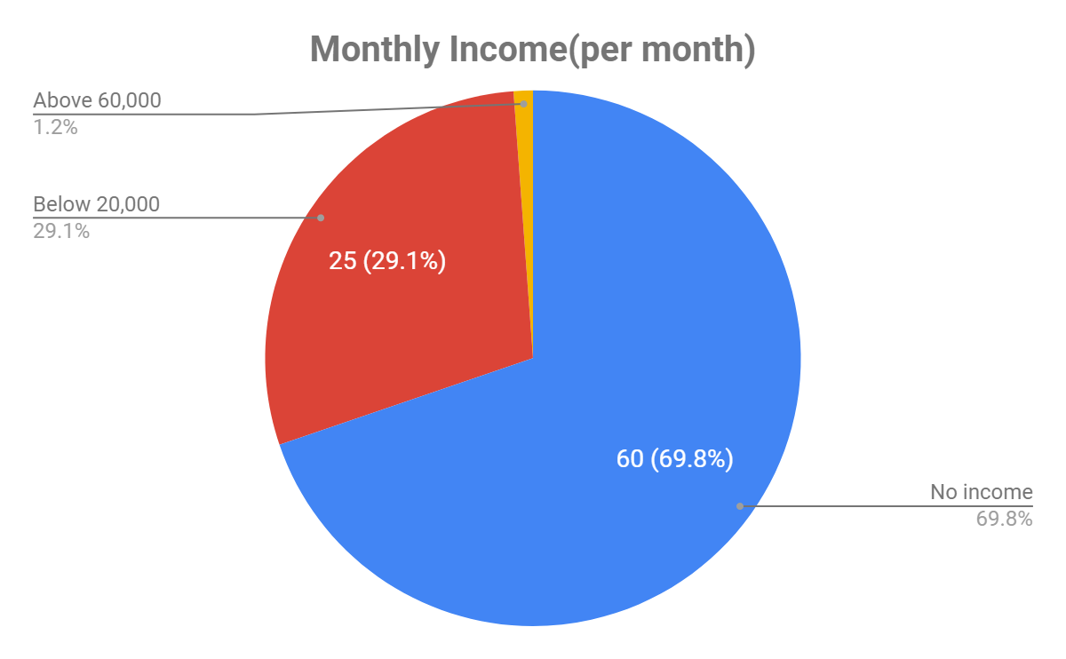

**Illustration:**

From the above diagram it can be seen that:

* Maximum respondent about 69.8% people has no monthly income

so they are in need of a free platform to get news

* 29.1% of the respondent has income below 20000 taka per month
* Only 1.2% respondent has income per month more than 60000 taka

**Ques: Do you use internet?**

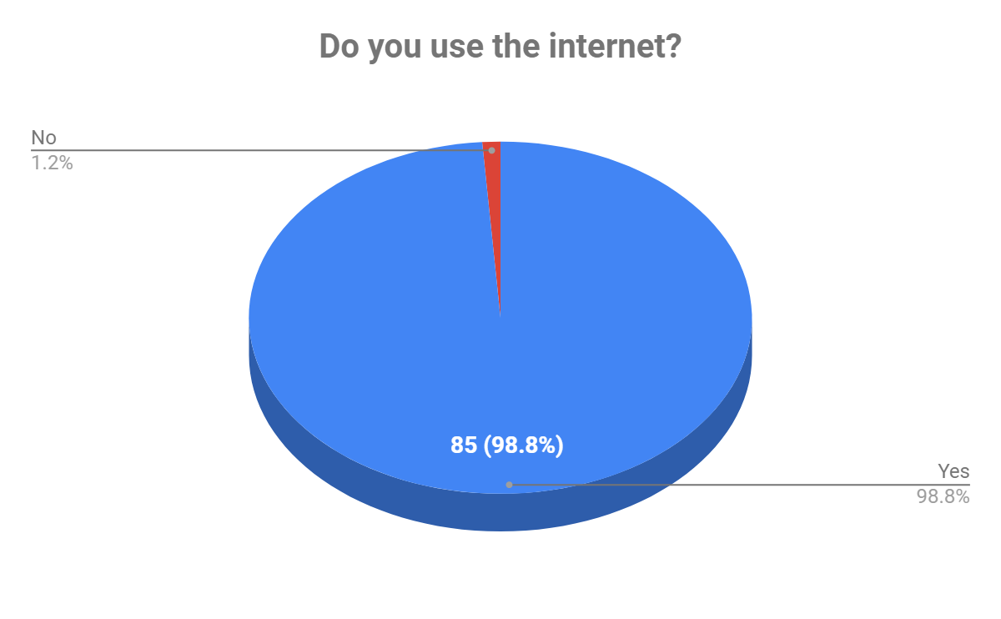

**Illustration:**

The above pie chart shows 98.8% people which is 85 out of 88 respondents use the internet, whereas 1.2% of people responded that they do not use the internet. So, most of the people might find it beneficial to read news online.

**Ques: How long have you been using internet?**

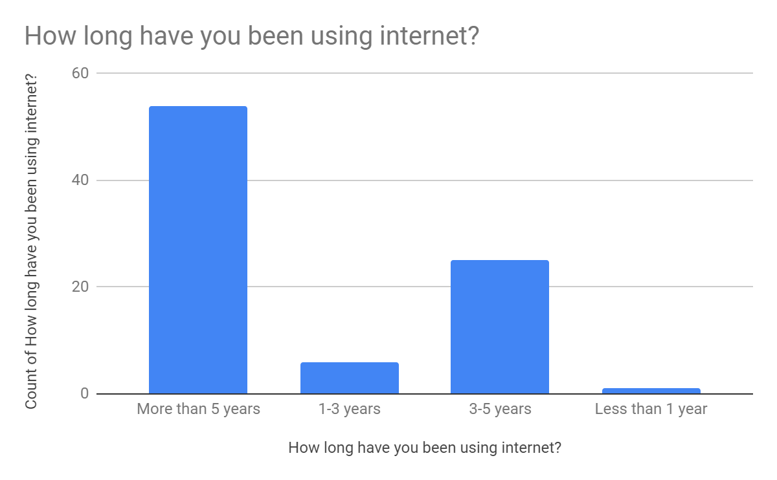

**Illustration:**

Among the people who responded that they use the internet:

* Greater than 50 people use the internet for more than 5 years
* About 10 people use internet for 1-3 years
* More than 20 people use the internet for 3-5 years
* Approximately 1 to 2 people use the internet for less than 1 year

**Ques: On average,how much time a day do you spend surfing the web?**

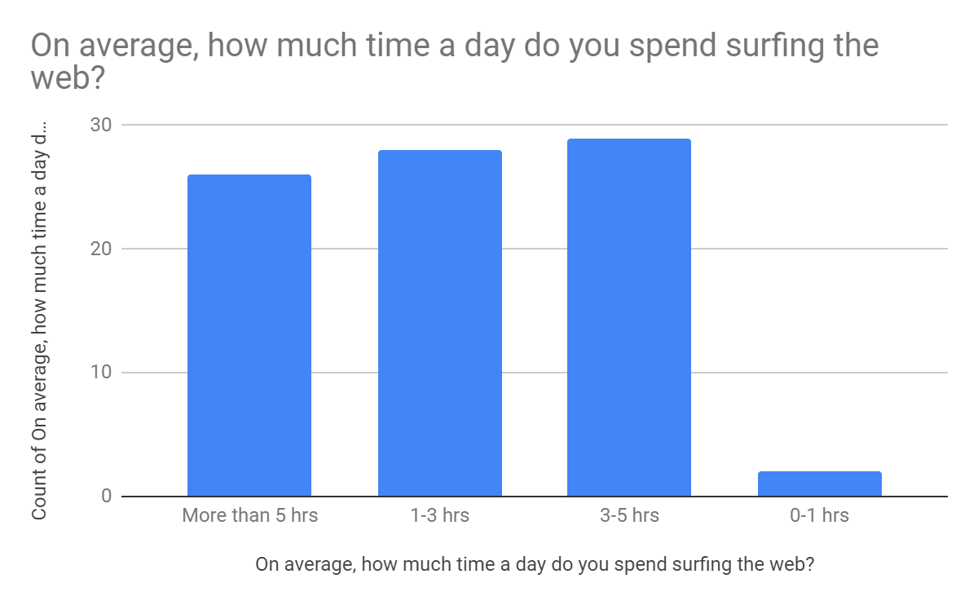

**Illustration:**

The above diagram shows on average:

* About 25 people spend more than 5 hours surfing the web
* Greater than 25 people spend 1-3 hours surfing the web
* Approximately 28 people spend 3-5 hours surfing the web
* About 2 to 3 people spend less than 1 hour surfing the web

**Ques: For what activities do you use internet?**

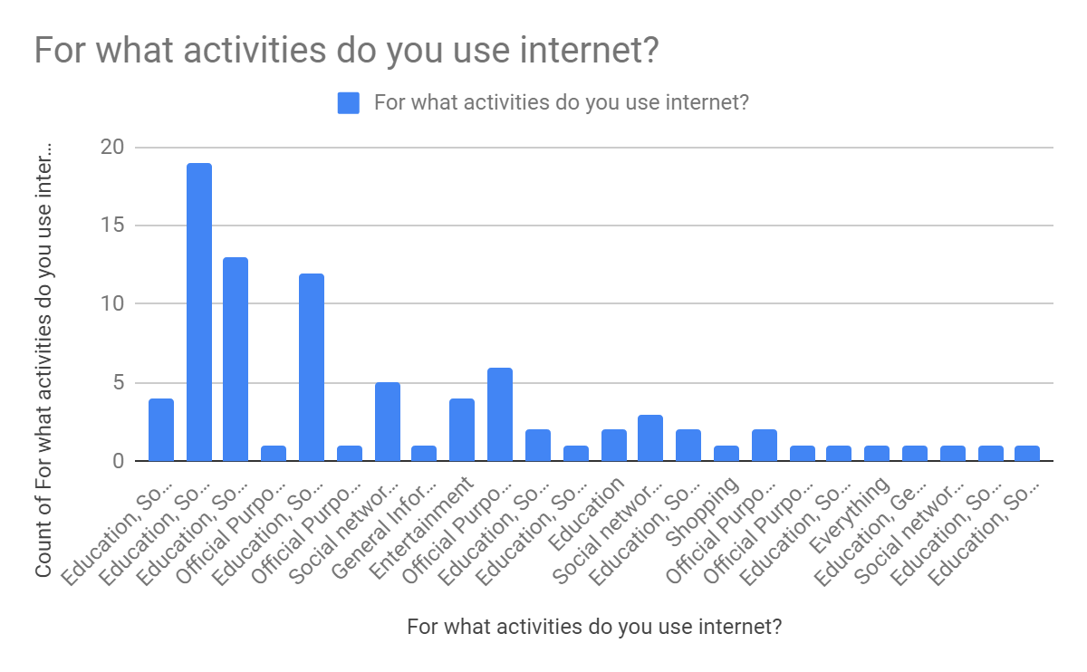

**Illustration:**

The above diagram shows maximum people use the internet for educational purposes. Respondent also use internet for other purposes like official purpose, social networking, gathering general information, entertainment and shopping. All these information they can get in one website which is information pool system.

**Ques: Where do you most often access the internet?**

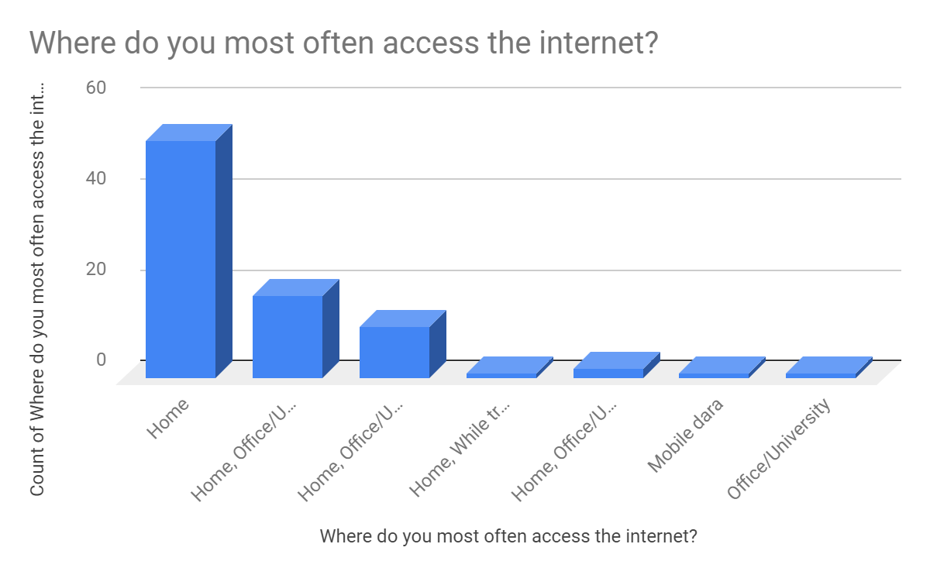

**Illustration:**

According to the above diagram, maximum people like 97.7% from our survey list access Internet from their home. 37.2% of people access the internet from their Office/university,2.3% uses internet from cyber cafe, 16.3% access internet while travelling each day and 1.2% people from our survey list uses mobile data for using the internet.

**Ques: Do you read newspapers?**

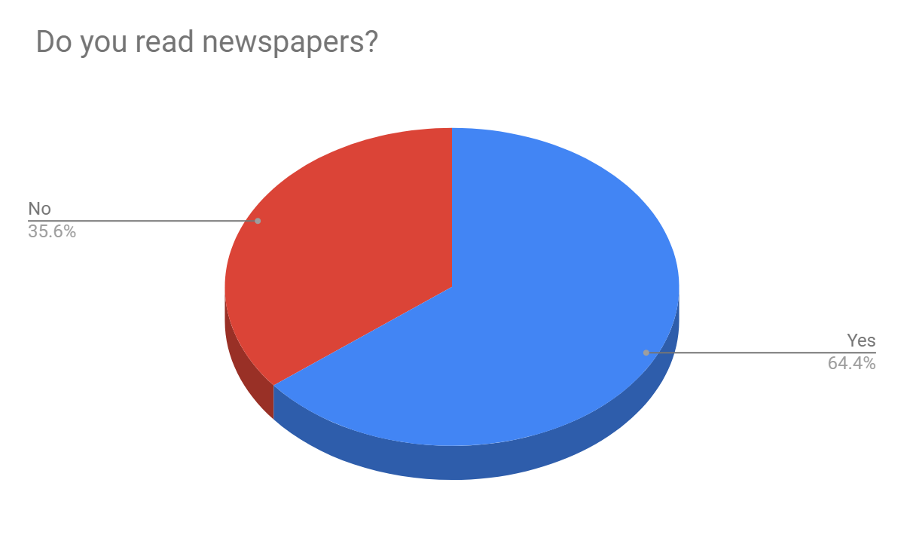

**Illustration:**

From the above pie chart it can be stated that, around 64.4% of people who participated in our survey reads newspaper and around 35.6% people do not read newspapers. These 35.6% users might get interest to read newspapers as they get all sorts of news online in one place.

**Ques: Which one is better for reading news, in your opinion?**

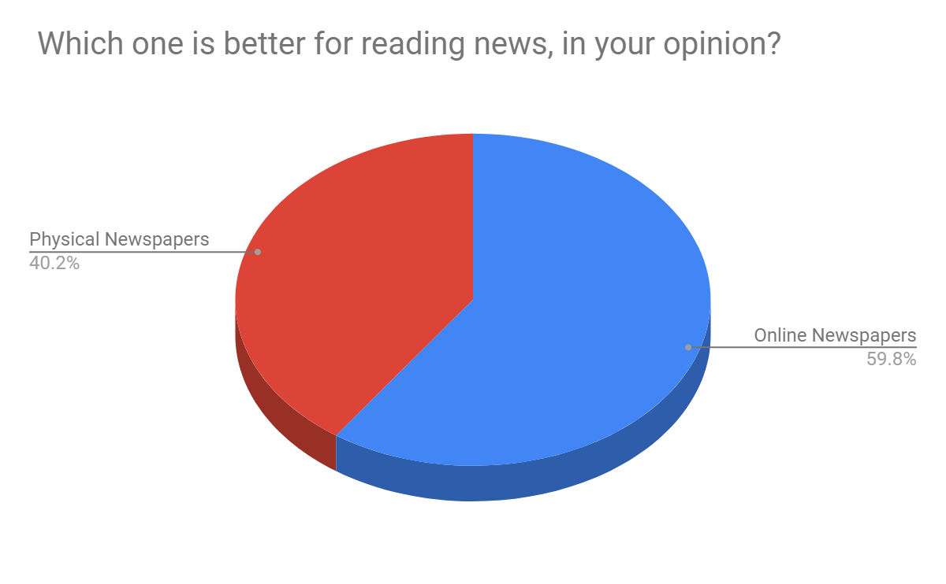

**Illustration:**

From the above pie chart, it can be seen that 59.8% respondents prefer online Newspaper and 40.2% respondents prefer reading physical newspapers. Therefore maximum percentage prefer online newspaper.

**Ques: Which type of news do you read online?**

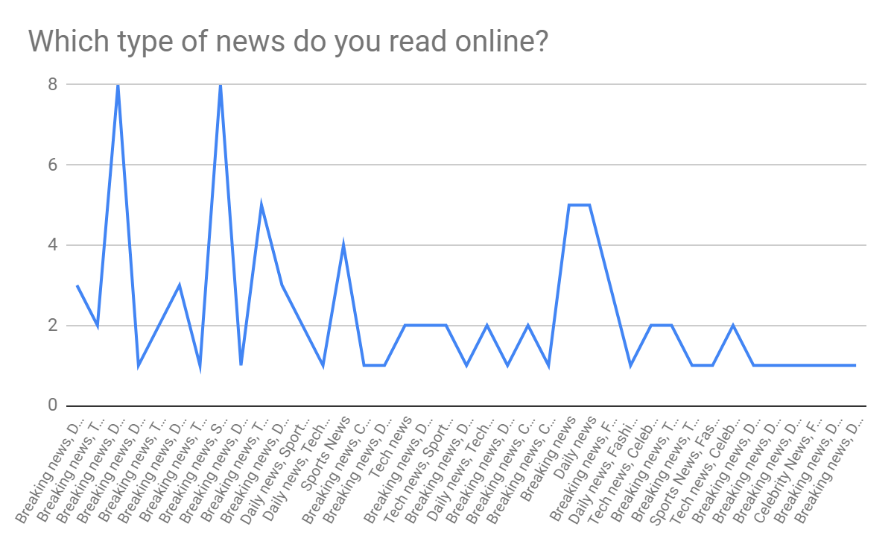

**Illustration:**

From the above chart, it can be seen that around 71.3% of our survey list reads Breaking News from online, 46% reads daily news, 46% reads tech news, 27.6% reads Celebrity News, 56.3% reads sports news, 20.7% reads fashion news, 2.3% stock market news and 1.1% reads anime news, manga news.

**Ques: What type of blogs do you prefer?**

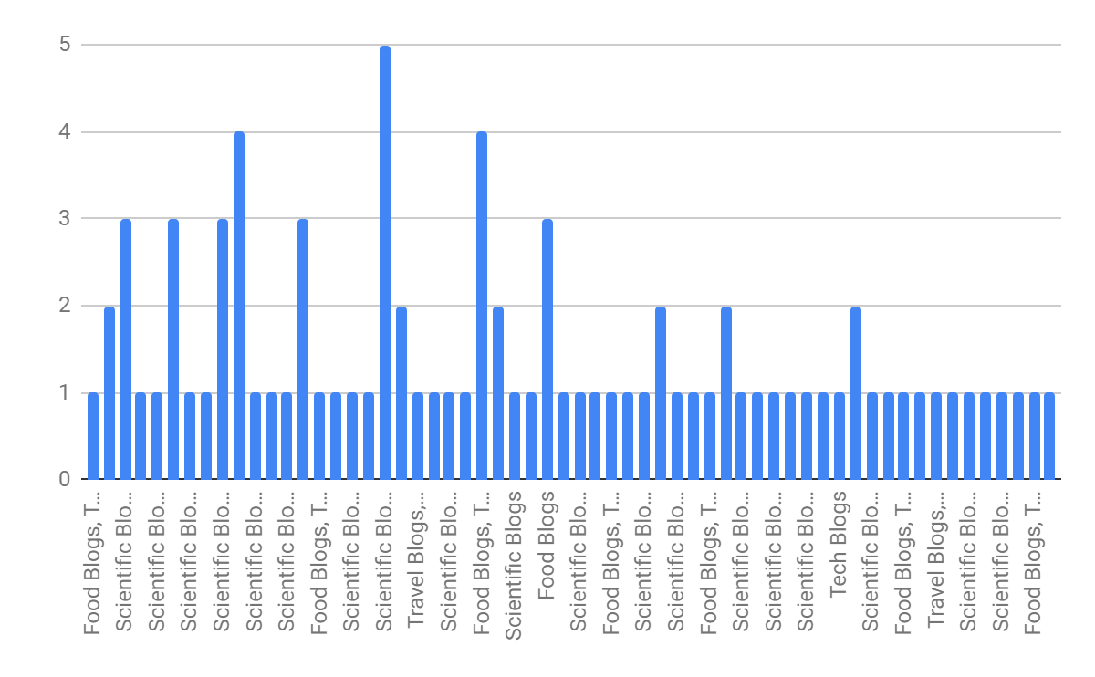

**Illustration:**

The above diagram shows what blogs respondents generally prefer. It can be seen that maximum respondent prefer scientific blogs. Average number of respondents also follow food blogs, travel blogs and tech blogs.

**Ques: When do you feel the need to read news online?**

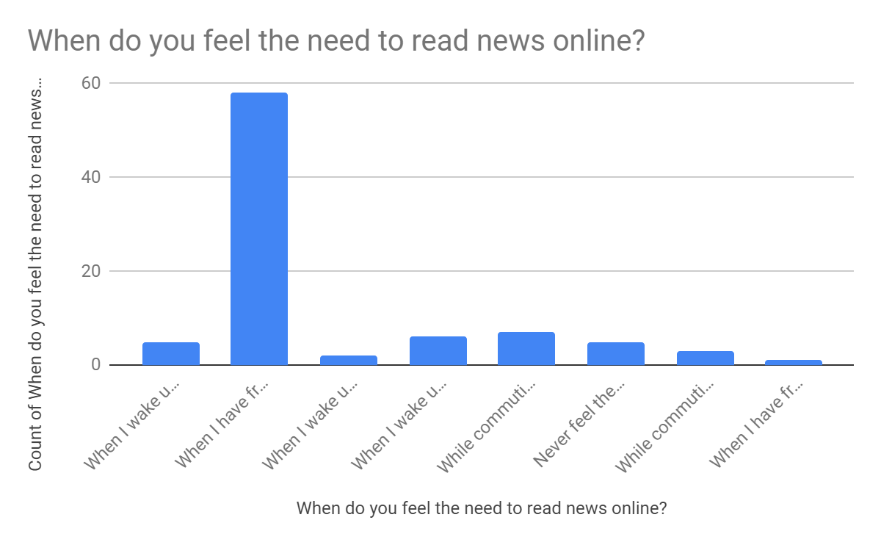

**Illustration:**

From the diagram given above, it can be seen that around 72 people out of 88

People like to read newspapers in their free time. 13 people out of 88 voted to read the newspaper in the morning after waking up. 12 people from 88 reads the newspaper while Commuting to work/university and very few people like 6 voted for not reading online news.

**Ques: While reading newspaper,what affects your satisfaction the most?**

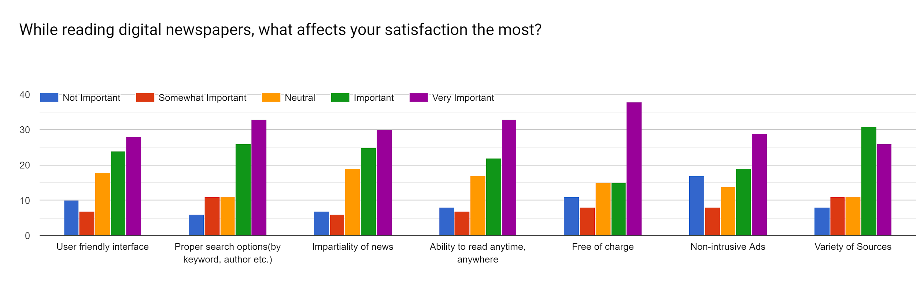

**Illustration:**

From the above diagram, it can be seen that, according to the maximum respondents, it is very important to have a user friendly interface while reading digital newspaper, as well as proper search options, impartiality of news, ability to read anytime, free of charge, non-intrusive ads and variety of sources is very important for their satisfaction.

**Ques: How much money do you spend buying newspapers a month?**

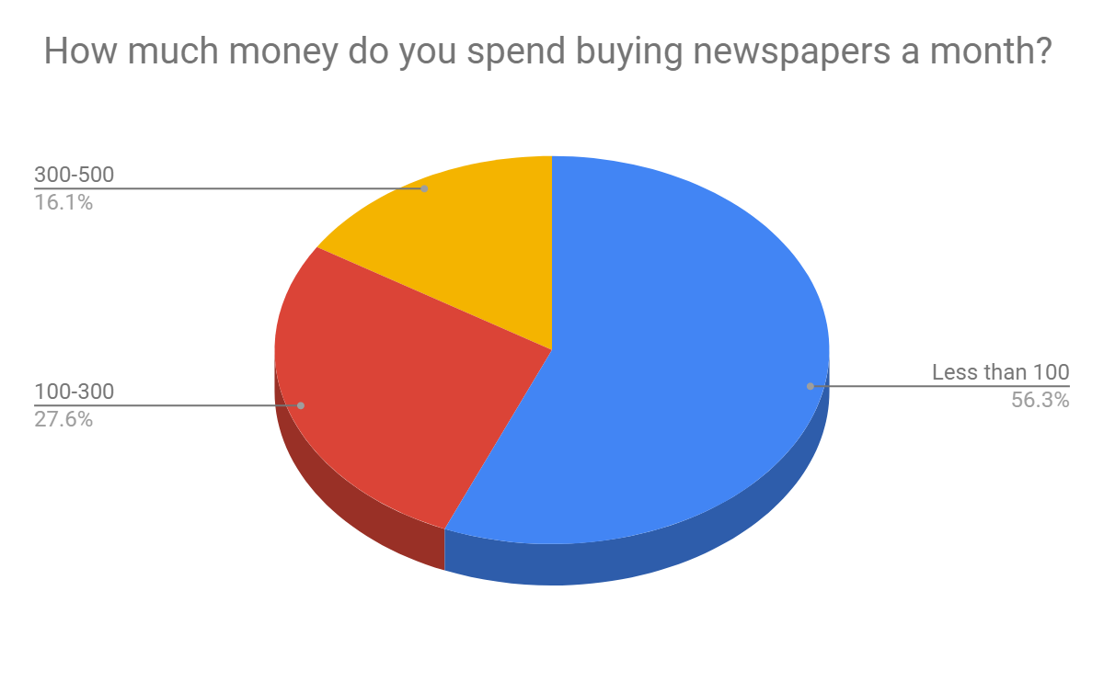

**Illustration:**

From the above pie chart, it can be stated that the majority of people use less than 100BDT per month for buying newspapers. Around 27.6% from our survey list spends around 100-300 BDT per month and 16.1% spends 300-500BDT for buying newspapers which is infact a large amount, so by reading digital newspapers they can save their money.

**Ques: While reading old-fashioned newspapers, what affects you satisfaction the most?**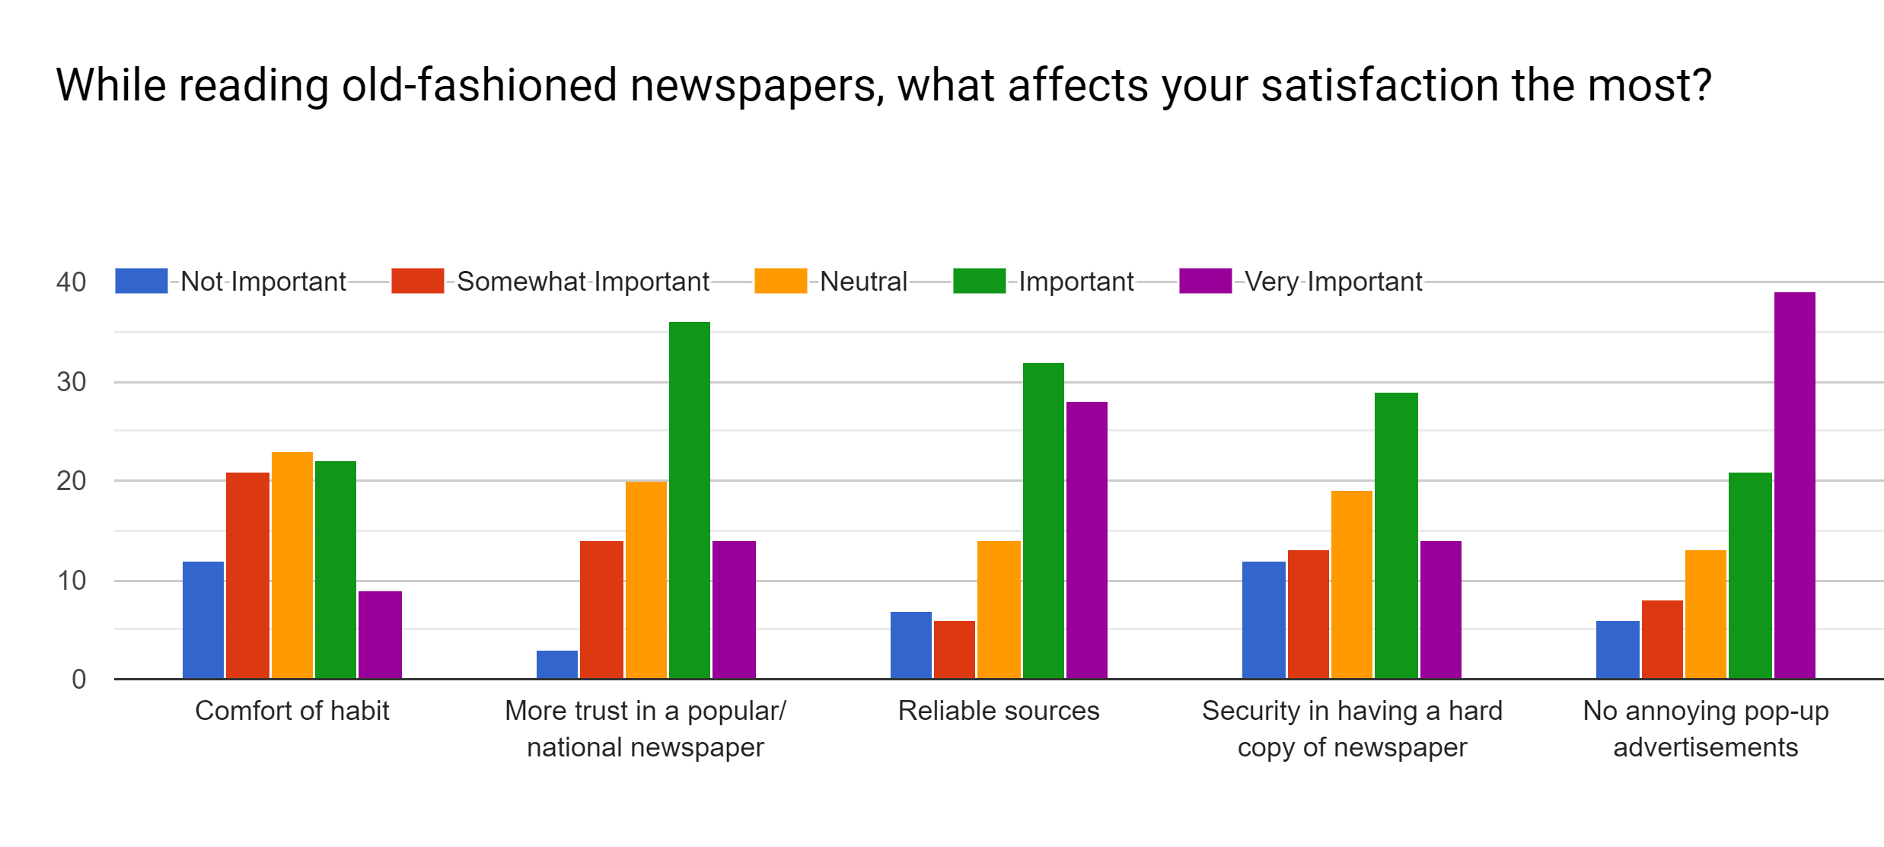

**Illustration:**

From the above chart, it can be seen that:

* + Average number of people voted neutral for reading old fashioned newspaper because of their comfort. Likewise some people voted important, some people voted somewhat important, few voted for not important and very few voted for very important for reading old fashioned newspaper.
  + Above 35 people voted important as they have more trust in a popular/national newspaper.
  + Maximum people voted important for reliable sources in old fashioned newspaper
  + Maximum people voted important for security in having a hardcopy of newspaper
  + Majority of respondents said it is very important as no annoying pop-up advertisements in old fashioned newspaper

**Ques: What are you issues regarding online newspapers?**

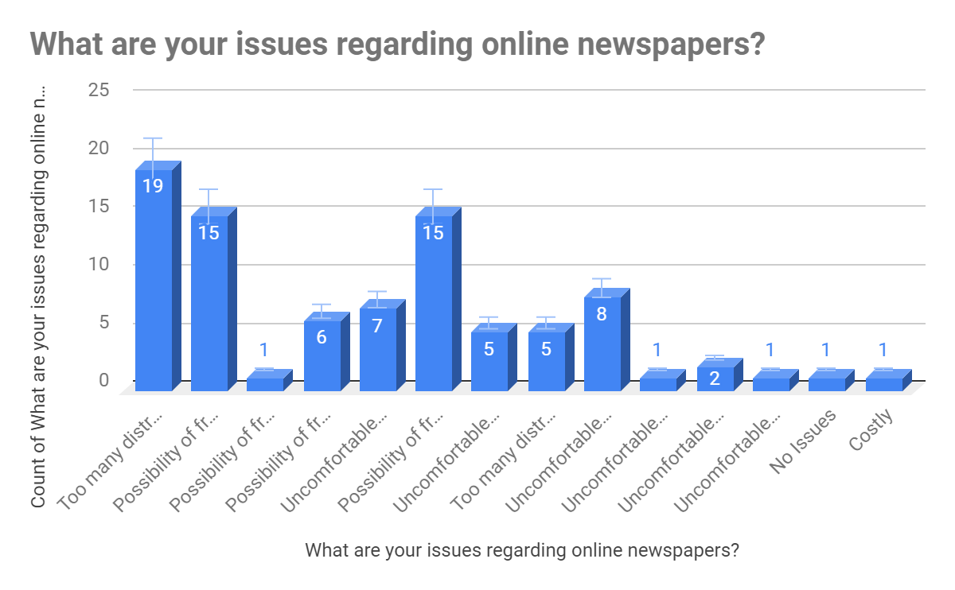

**Illustration:**

From the above diagram, it can be stated that, 79.3% respondents which is majority of them said online newspaper contains too many distracting ads. 56.3% said online newspaper contains the possibility of fraudulent news. 27.6% said uncomfortable to read from digital medium, 33.3% voted for biased news sources, 1.1% voted for costly and another 1.1% from our survey list voted for no issues regarding online newspaper.

**Ques: How would you prefer to see classifieds ads in a digital newspaper?**

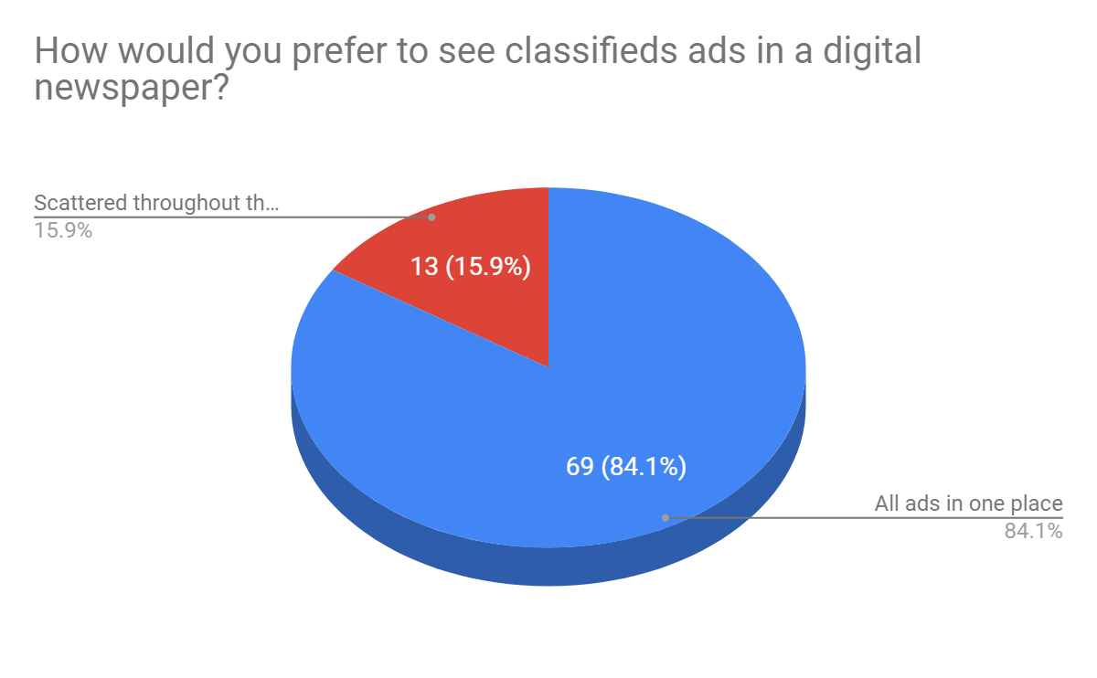

**Illustration:**

From the above chart, it can be seen that, 84.1% people prefers all ads in one place and 15.9% prefers ads to be scattered throughout the site.

**Ques: Would you like it if you could know about upcoming events in the same platform as where you are getting all daily news?**

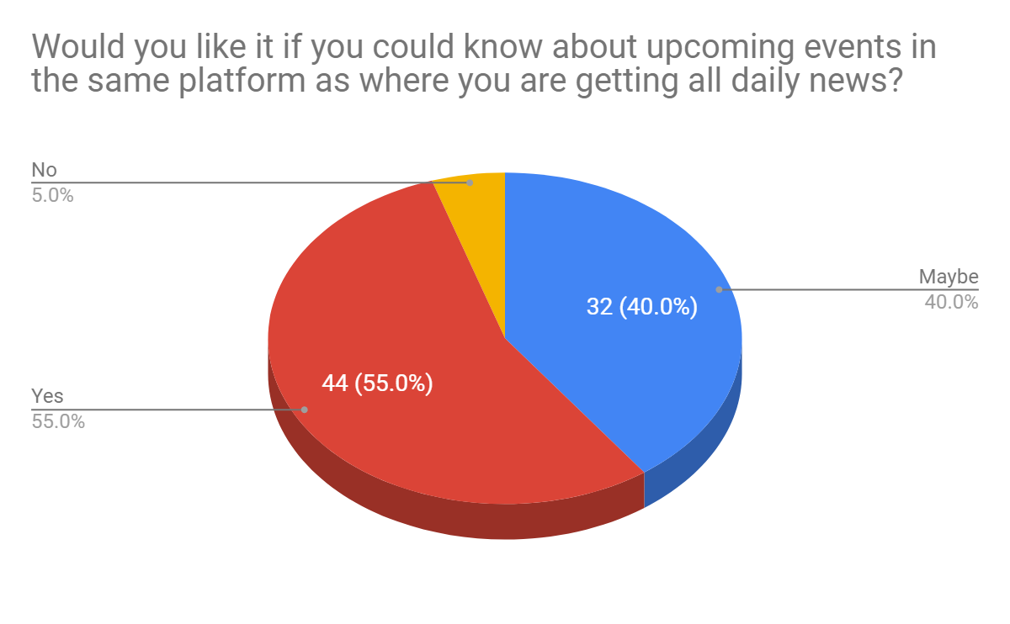

**Illustration:**

According to the above pie chart, maximum people of our survey list said they prefer knowing about the upcoming events in the same platform where there is daily news. 40% responded may be and very few people like 5% responded no. As the majority wanted to know about the upcoming events from the same platform, they can know it from Information Pool System.

**Ques: Which newspapers do you read?**

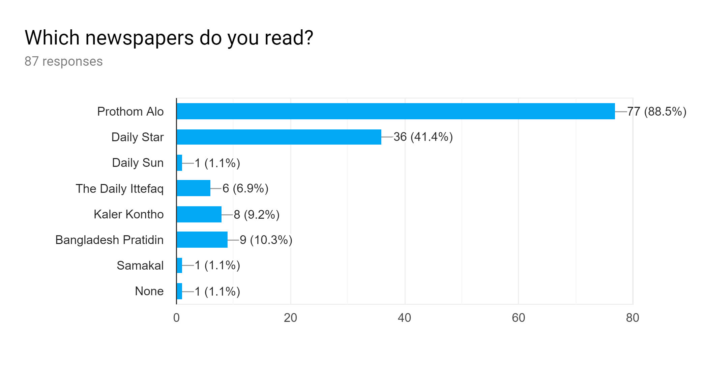

**Illustration:**

From the above chart, it can be seen that maximum people like 88.5% reads Prothom Alo, 41.4% reads Daily Star, 1.1% reads Daily Sun, 6.9% reads The Daily Ittefaq, 9.2% reads Kaler Kontho 10.3% reads Bangladesh Pratidin, 1.1% reads Samakal and 1.1% reads none of these newspaper.

**Ques: Which digital newspapers do you read?**

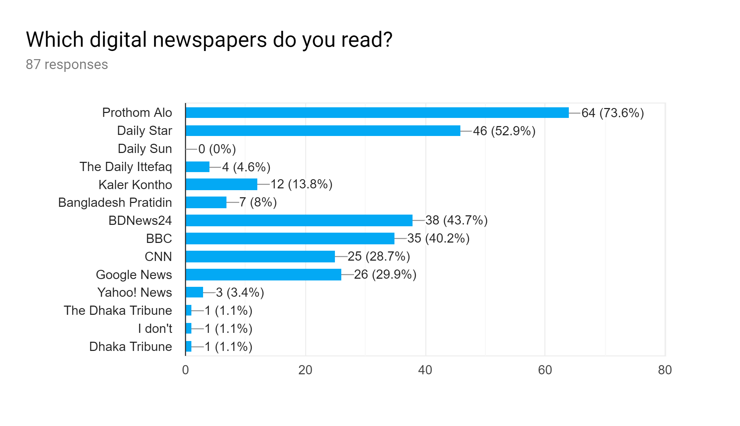

**Illustration:**

From the above chart, it can be seen that people who reads digital newspaper:

* 73.6% reads Prothom Alo
* 52.9% reads Daily Star
* 0% read Daily Sun
* 4.6% reads Daily Ittefaq
* 13.8% reads Kaler Kontho
* 8% reads Bangladesh Pratidin
* 43.7% reads BDNews24
* 40.2% reads BBC
* 28.7% reads CNN
* 29.9% reads Google News
* 3.4% reads Yahoo! News
* 1.1% reads The Dhaka Tribune
* 1.1% reads Dhaka Tribune
* 1.1% do not read any of these online newspaper

**Ques: If given an option to read news from various sources online alongside blogs, will you use it?**

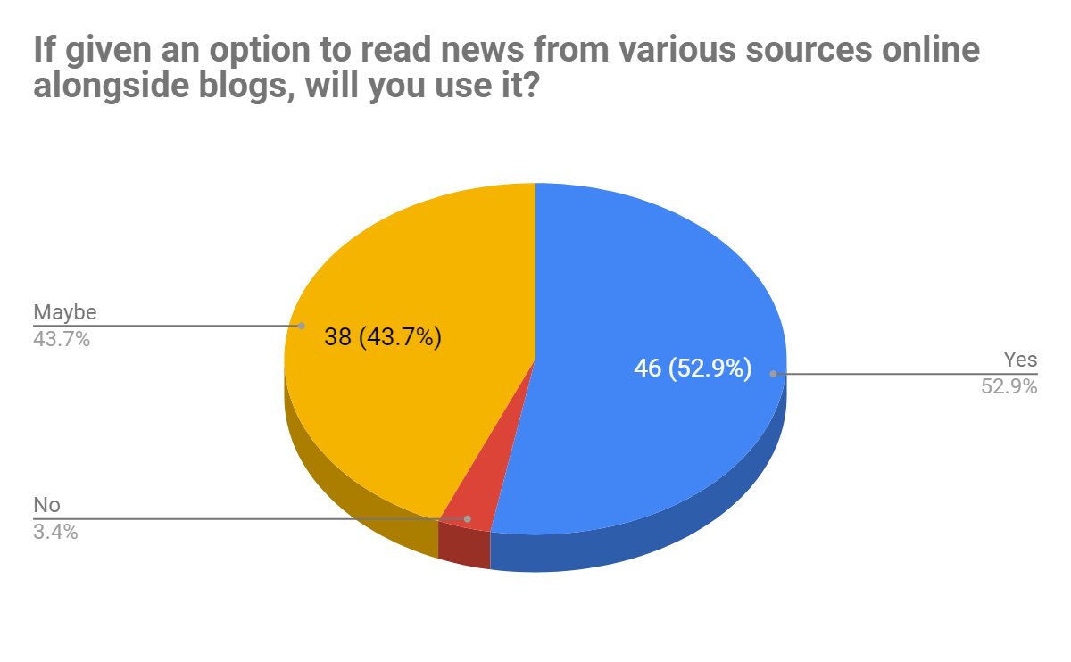

**Illustration:**

From the above pie chart, it can be seen that, 52.9% respondents said they would like to read news from various sources online alongside blogs, which Information Pool system will provide. 43.7% responded may be so they might like to read it when available and few people like 3.4% responded no.

**Ques: Do you think reading news online is beneficial?**

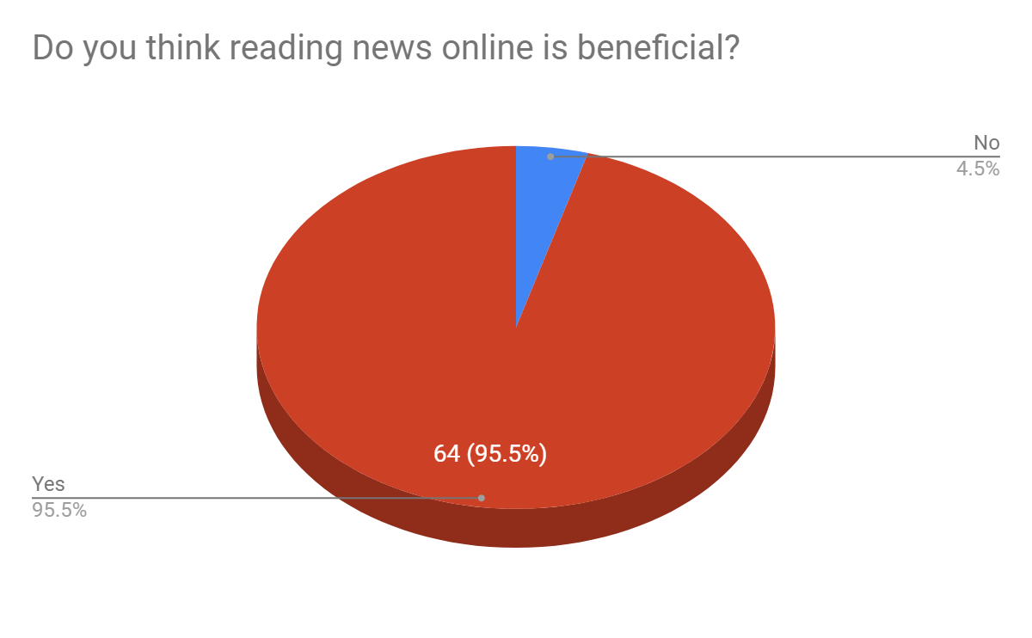

**Illustration:**

From the above pie chart, it can be seen that, the majority of our survey list like 95.5% said online news is beneficial and 4.5% people think online news is not beneficial. As the majority supports online news so our website will be useful to them.

**Ques: If yes, why do you think it is beneficial?**

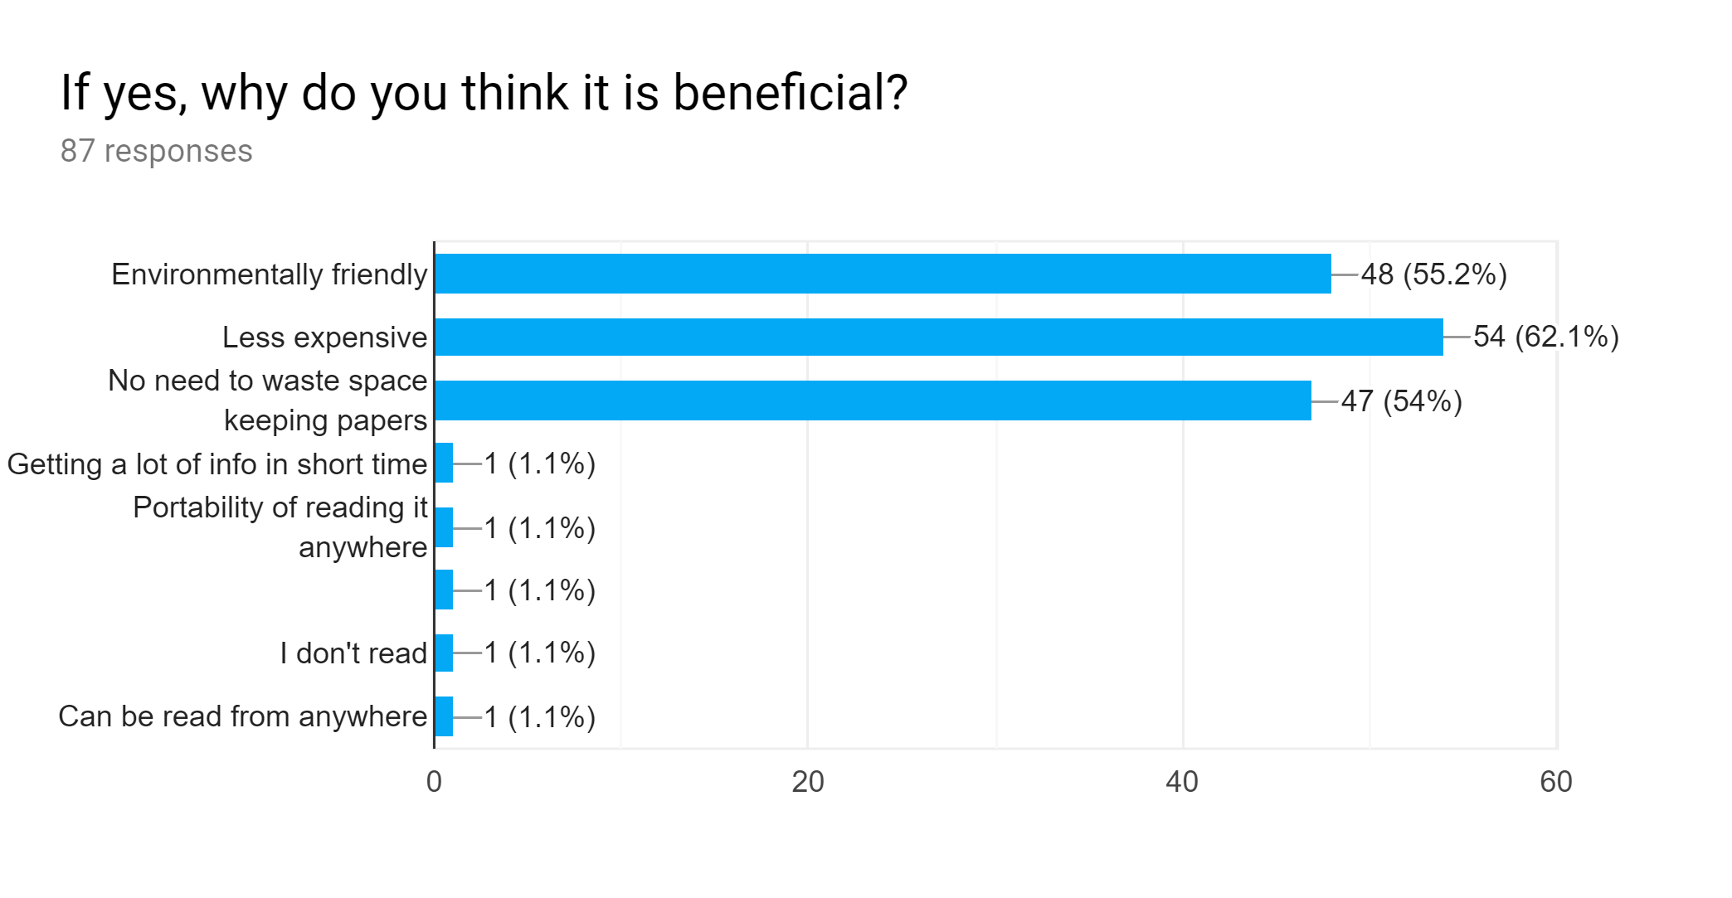

**Illustration:**

From the above chart, it can be stated that, 62.1% people of our survey list thinks online newspaper is beneficial because it is less expensive. 55.2% thinks it is environmentally friendly. 54% said no need to waste space by keeping papers, and few people voted for getting a lot of info in a short time, portability of reading it, can be read from anywhere and 1.1% do not read.

**F. Overall Findings of the survey**

* 58.8% people aged 20-29 prefer online newspapers over physical newspaper
* 38% people prefer online news portals because the are free
* 73% people would, if given an option to read various sources alongside blogs, use it
* 79% people would prefer fewer distraction ads on online news portals and 84% would prefer to see all ads in one place

**4. Conclusion**

From the conducted survey, we found that the majority of people are supporters of development of a project like ours. Most of our target audience admitted that given an option to read news alongside blogs, where they could also view events and ads, they would use that system. So using these findings along with their suggestions for an optimum news platform, we can develop a system that will benefit all potential stakeholders.